

**Report for Programming Lab #6**

Charles Daigle

**Bala Maheswaran**

**Code Outputs**

1. 1. 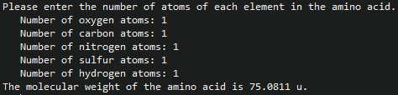
   2. 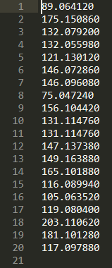
2. 1. 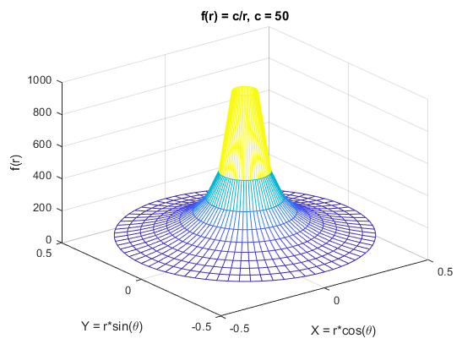
   2. 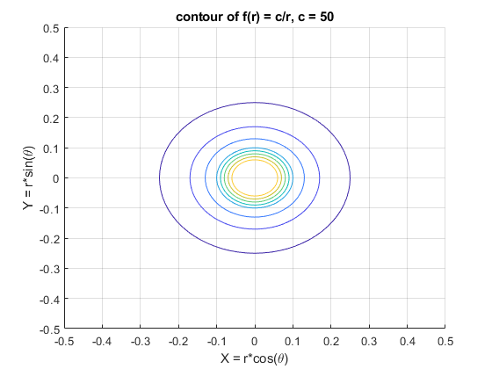
   3. 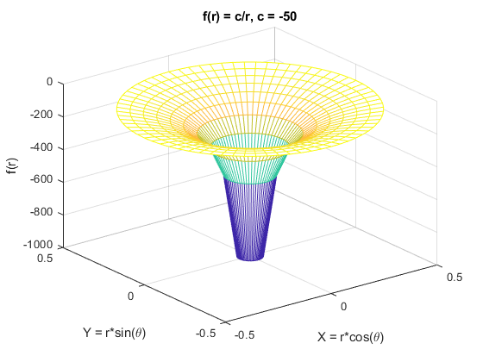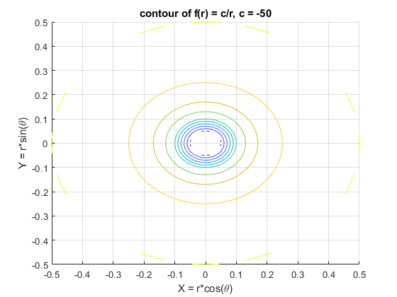
3. 1. 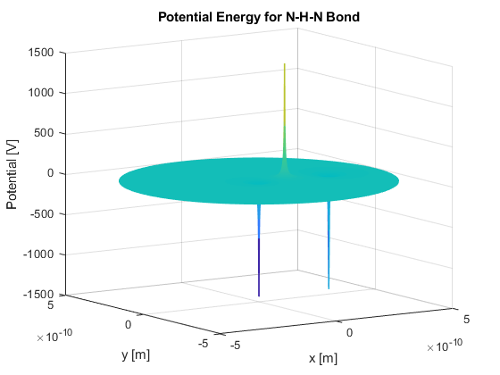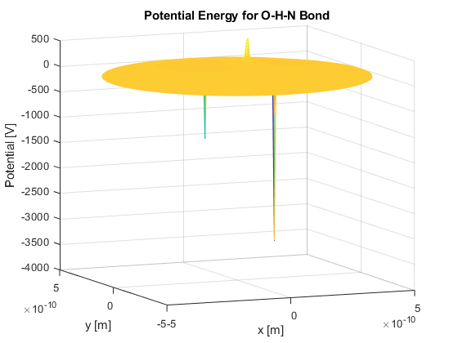

* 1. 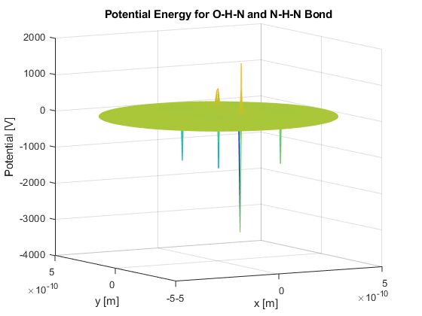

**Results/Discussion**

In this lab, we used MATLAB to demonstrate two different concepts: file input and output (data processing), and mesh graphs. I found the mesh graphs the most difficult part, because for question 3, there was an issue with how the potential gets arbitrarily large in magnitude as you get closer to the point. Due to the “spiky” nature of these graphs, it was also hard to find a balance between a fine enough meshgrid and having it be too dense.

Other than that, this was a solid final programming lab. A bit different than what I had been used to, but it still was a fun challenge.