Data Structure and Algorithm

Laboratory Activity No. 2

Algorithm Analysis and Flowchart

|  |  |
| --- | --- |
| *Submitted by:* | *Instructor:* |
| Tan, Charles Dominic S. | Engr. Maria Rizette H. Sayo |

Augaust, 01, 2025

# Objectives

Introduction

Data structure is a systematic way of organizing and accessing data, and an algorithm is a step-by-step procedure for performing some task in a finite amount of time. These concepts are central to computing, but to be able to classify some data structures and algorithms as “good,” we must have precise ways of analyzing them.

This laboratory activity aims to implement the principles and techniques in:

* Writing a well-structured procedure in programming
* Writing algorithm that best suits to solve computing problems to improve the efficiency of computers
* Convert algorithms into flowcharting symbols

# Methods

* 1. Explain algorithm and flowchart

-x, x<0

x, x ≥ 0

* 1. Write algorithm to find the result of equation: f (x) = and draw its flowchart
  2. Write a short recursive Python function that finds the minimum and maximum values in a sequence without using any loops

A.

**An algorithm** is a list of simple steps that help you finish a task or fix a problem. It tells you what to do, step by step, so it’s easy to follow even if you don’t know much about computers. Sometimes, we write these steps in a pretend code called **pseudocode** to plan before using real coding.

**A flowchart** is a drawing that shows how an algorithm works. It uses shapes like circles and arrows to show each step and the order to follow them.

B.

1. Start
2. Ask the user to enter a number and store it in the variable x.
3. Check whether the value of x is less than zero.
4. If it is, assign the value of -x to the variable f.
5. If not, assign the value of x to the variable f.
6. Show the value stored in f as the result.
7. End

C.

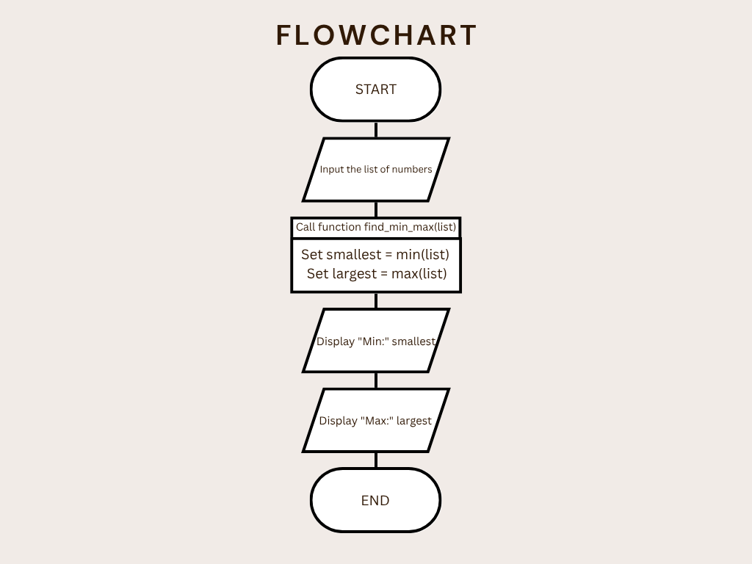

Figure 1 Screenshot of program

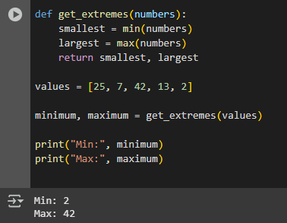

Figure 2 Screenshot of program

# Results

Present the visualized procedures done. Also present the results with corresponding data visualizations such as graphs, charts, tables, or image . Please provide insights, commentaries, or explanations regarding the data. If an explanation requires the support of literature such as academic journals, books, magazines, reports, or web articles please cite and reference them using the IEEE format.

Please take note of the styles on the style ribbon as these would serve as the style format of this laboratory report. The body style is Times New Roman size 12, line spacing: 1.5. Body text should be in Justified alignment, while captions should be center-aligned. Images should be readable and include captions. Please refer to the sample below:

Image

Figure 1 Screenshot of program

If an image is taken from another literature or intellectual property, please cite them accordingly in the caption. Always keep in mind the Honor Code [1] of our course to prevent failure due to academic dishonesty.

# Conclusion

The conclusion expresses the summary of the whole laboratory report as perceived by the authors of the report.

**This activity I think help me especially in making flowcharts and also made me better at solving problems and writing programs.**

**References**

[1] Co Arthur O.. “University of Caloocan City Computer Engineering Department Honor Code,” UCC-CpE Departmental Policies, 2020.

[W3Schools Online Web Tutorials](https://www.w3schools.com/)

[pyflowchart · PyPI](https://pypi.org/project/pyflowchart/)

<https://www.canva.com/design/DAGu1hPMMC0/huniejP3D0Gpr8DlfSEoNg/edit?utm_content=DAGu1hPMMC0&utm_campaign=designshare&utm_medium=link2&utm_source=sharebutton>