Data Structure and Algorithm

Laboratory Activity No. 3

Translating Algorithm to Program

|  |  |
| --- | --- |
| *Submitted by:* | *Instructor:* |
| Tan, Charles Dominic S. | Engr. Maria Rizette H. Sayo |

August 2, 2025

# Objectives

Introduction

Data structure is a systematic way of organizing and accessing data, and an algorithm is a step-by-step procedure for performing some tasks in a finite amount of time. These concepts are central to computing, but to be able to classify some data structures and algorithms as “good,” we must have precise ways of analyzing them.

This laboratory activity aims to implement the principles and techniques in:

* Writing a well-structured procedure in programming
* Writing algorithm that best suits to solve computing problems
* Writing an efficient Python program from translated algorithms

# Methods

• Design an algorithm and the corresponding flowchart (Note: You may use LucidChart or any application) for adding the test scores as given below if the number is even: 26,49,98,87,62,75

• Translate the algorithm to a Python program (using Google Colab)

• Save your source codes to GitHub

# Results

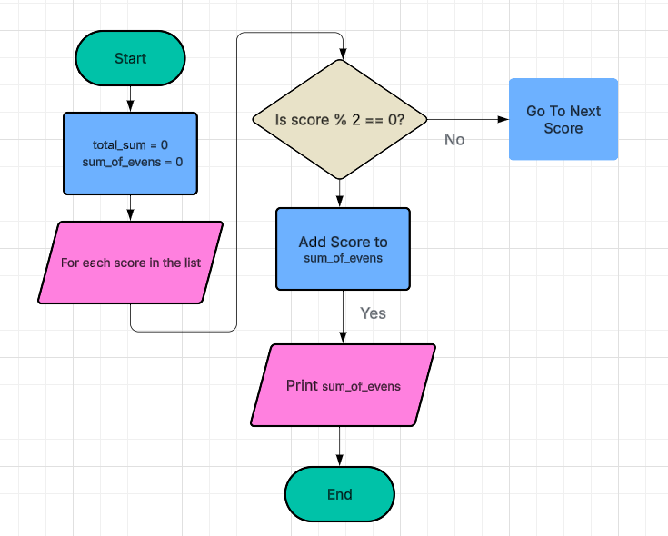

Figure 1 Screenshot of program

grades = [26, 49, 98, 87, 62, 75]

total_even = 0

for grade in grades:

if grade % 2 == 0:

total_even = total_even + grade

print("Even number total is:", total_even)

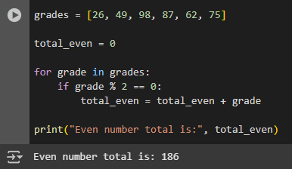

Figure 2 Screenshot of program

Present the visualized procedures done. Also present the results with corresponding data visualizations such as graphs, charts, tables, or image . Please provide insights, commentaries, or explanations regarding the data. If an explanation requires the support of literature such as academic journals, books, magazines, reports, or web articles please cite and reference them using the IEEE format.

Please take note of the styles on the style ribbon as these would serve as the style format of this laboratory report. The body style is Times New Roman size 12, line spacing: 1.5. Body text should be in Justified alignment, while captions should be center-aligned. Images should be readable and include captions. Please refer to the sample below:

Figure 1 Screenshot of program

If an image is taken from another literature or intellectual property, please cite them accordingly in the caption. Always keep in mind the Honor Code [1] of our course to prevent failure due to academic dishonesty.

# Conclusion

The conclusion expresses the summary of the whole laboratory report as perceived by the authors of the report.

In this activity, we made a simple set of steps (called an **algorithm**) to add only the **even numbers** from a list of test scores.

The algorithm checks each score one by one. If the number is even (like 26 or 98), it adds that number to the total. If it's not even, it skips it.

We also drew a **flowchart** to show how the steps work in order. This helps us see clearly how the computer follows the steps: checking, deciding, and adding.

We used **Python** to write the code. The program works well and adds up all the even scores. We can also change it easily to use other numbers next time!

**References**

[1] Co Arthur O.. “University of Caloocan City Computer Engineering Department Honor Code,” UCC-CpE Departmental Policies, 2020.

[Flowchart: Lucidchart](https://lucid.app/lucidchart/883c9e8f-2d2d-487c-b976-275200dee44e/edit?invitationId=inv_68f1606c-1ce6-4df6-bf89-a55a51b6ded0&page=0_0)

[Welcome To Colab - Colab](https://colab.research.google.com/" \l "scrollTo=DNKF-QT5qDKv)