Data Structure and Algorithm

Laboratory Activity No. 4

Arrays

|  |  |
| --- | --- |
| *Submitted by:* | *Instructor:* |
| Tan, Charles dominic S. | Engr. Maria Rizette H. Sayo |

August, 09, 2025

# Objectives

Introduction

Array, in general, refers to an orderly arrangement of data elements. Array is a type of data structure that stores data elements in adjacent locations. Array is considered as linear data structure that stores elements of same data types. Hence, it is also called as a linear homogenous data structure.

This laboratory activity aims to implement the principles and techniques in:

* Writing algorithms using Array data structure
* Solve programming problems using dynamic memory allocation, arrays and pointers

# Methods

Jenna’s Grocery

Jenna wants to buy the following fruits and vegetables for her daily consumption. However, she needs to distinguish between fruit and vegetable, as well as calculate the sum of prices that she has to pay in total.

Problem 1: Create a class for the fruit and the vegetable classes. Each class must have a constructor, deconstructor, copy constructor and copy assignment operator. They must also have all relevant attributes (such as name, price and quantity) and functions (such as calculate sum) as presented in the problem description above.

Problem 2: Create an array GroceryList in the driver code that will contain all items in Jenna’s Grocery List. You must then access each saved instance and display all details about the items.

Problem 3: Create a function TotalSum that will calculate the sum of all objects listed in Jenna’s Grocery List.

Problem 4: Delete the Lettuce from Jenna’s GroceryList list and de-allocate the memory assigned.

# Results

Present the visualized procedures done. Also present the results with corresponding data visualizations such as graphs, charts, tables, or image . Please provide insights, commentaries, or explanations regarding the data. If an explanation requires the support of literature such as academic journals, books, magazines, reports, or web articles please cite and reference them using the IEEE format.

Please take note of the styles on the style ribbon as these would serve as the style format of this laboratory report. The body style is Times New Roman size 12, line spacing: 1.5. Body text should be in Justified alignment, while captions should be center-aligned. Images should be readable and include captions. Please refer to the sample below:

mage

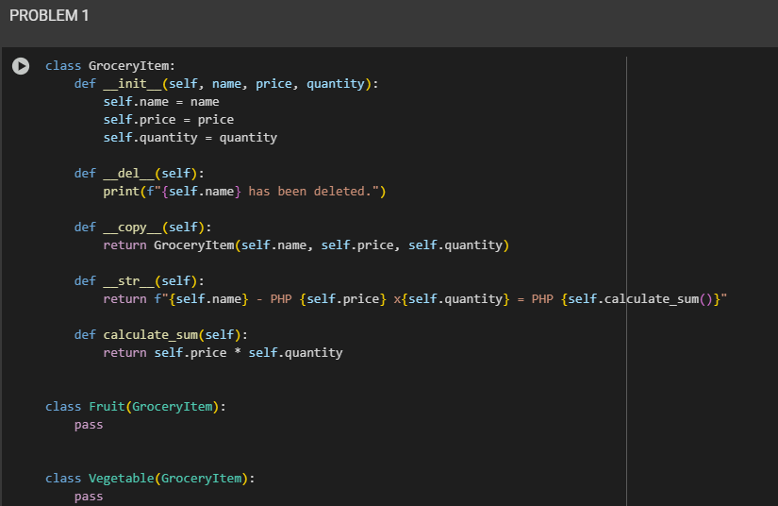

Figure 1 Screenshot of program

creates a class called GroceryItem to represent items with a name, price, and quantity. It includes functions to show details, calculate total cost, copy the item, and print a message when deleted. Two other classes, Fruit and Vegetable, inherit these features without adding anything new.

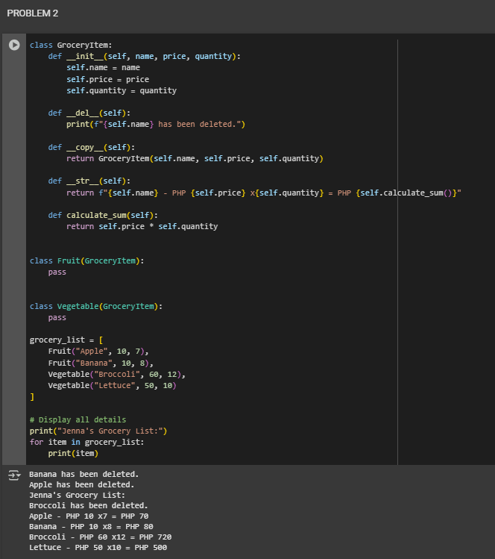

Figure 2 Screenshot of program

makes a list of grocery items like apples and broccoli using the classes from Problem 1. It prints each item’s name, price, quantity, and total cost. It also shows messages when items are deleted, and uses a loop to display all the details.

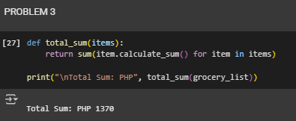

Figure 3 Screenshot of program

defines a function to calculate the total cost of all items in the grocery list. It adds up each item’s total using a loop and prints the final result: “Total Sum: PHP 1370.” This shows how to use functions to solve problems neatly and quickly.

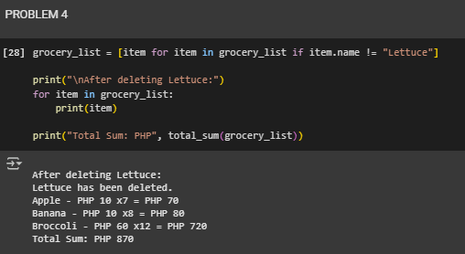

Figure 4 Screenshot of program

hows how to remove an item from a grocery list. In this case, the item named **“Lettuce”** is taken out using a filter. After that, the code prints the updated list, showing only the remaining items: Apple, Banana, and Broccoli. It also prints a message saying Lettuce has been deleted. Finally, it calculates and shows the new total cost, which is **PHP 870**. This part teaches how to clean up a list by removing specific items and updating the results.

If an image is taken from another literature or intellectual property, please cite them accordingly in the caption. Always keep in mind the Honor Code [1] of our course to prevent failure due to academic dishonesty.

# Conclusion

The conclusion expresses the summary of the whole laboratory report as perceived by the authors of the report.

This program helps Jenna organize her grocery items into fruits and vegetables, shows their prices, and adds up the total cost. It also lets her remove items like Lettuce and updates the total. It’s a simple way to manage her shopping and spending.

**References**

[1] GeeksforGeeks, “Constructors in Python,” *GeeksforGeeks*, Jul. 11, 2025.

<https://www.geeksforgeeks.org/python/constructors-in-python/>

[2]S. Somani, “Destructor in Python - Scaler topics,” *Scaler Topics*, Oct. 11, 2022. <https://www.scaler.com/topics/destructor-in-python/>

[3] GeeksforGeeks, “Assignment operators in Python,” *GeeksforGeeks*, Jul. 15, 2025. <https://www.geeksforgeeks.org/python/assignment-operators-in-python/>