Data Structure and Algorithm

Laboratory Activity No. 5

Implementation of Arrays

|  |  |
| --- | --- |
| *Submitted by:* | *Instructor:* |
| Tan, Charles Dominic S. | Engr. Maria Rizette H. Sayo |

August, 16, 2025

# Objectives

Introduction

Array, in general, refers to an orderly arrangement of data elements. Array is a type of data structure that stores data elements in adjacent locations. Array is considered as linear data structure that stores elements of same data types. Hence, it is also called as a linear homogenous data structure.

This laboratory activity aims to implement the principles and techniques in:

* Writing algorithms using Array data structure
* Writing a python program that can implement Array data structure

# Methods

* Write a Python program to create an array of 10 integers and display the array items. Access individual elements through indexes and compute for the sum.
* Write a Python program to append a new item to the end of the array. Original array: numbers = [1, 2, 3, 4, 5, 6, 7, 8, 9, 10]
* Write a Python program to insert a new item before the second element in an existing array. Original array: numbers = [1, 2, 3, 4, 5, 6, 7, 8, 9, 10]
* Write a Python program to reverse the order of the items in the array. Original array: numbers = [5, 4, 3, 2, 1]
* Write a Python program to get the length of the array. Original array: numbers = [5, 4, 3, 2, 1]

# Results

Present the visualized procedures done. Also present the results with corresponding data visualizations such as graphs, charts, tables, or image . Please provide insights, commentaries, or explanations regarding the data. If an explanation requires the support of literature such as academic journals, books, magazines, reports, or web articles please cite and reference them using the IEEE format.

Please take note of the styles on the style ribbon as these would serve as the style format of this laboratory report. The body style is Times New Roman size 12, line spacing: 1.5. Body text should be in Justified alignment, while captions should be center-aligned. Images should be readable and include captions. Please refer to the sample below:

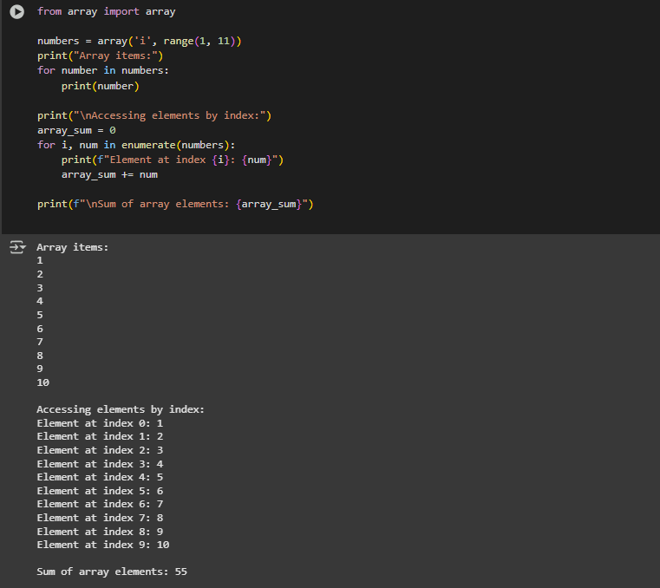

Figure 1 Screenshot of program

This code creates a group of numbers from 1 to 10 with an entity called the array. First, it presents all numbers one at a time. Next, it goes through each of the numbers and declares the index of each. For example, we say that 1 is at index 0, 2 is at index 1, and so on. Additionally, we keep adding the numbers together to get the total. Finally, the total of all the numbers is displayed as 55.

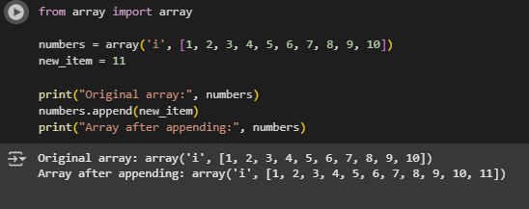

Figure 2 Screenshot of program

This sequence starts with a similar aggregation of 1-10 digits and then the next digit that needs to be added is 11. To add that last digit, we use a specific line of code, and it simply stores at the end of the entire previous set. Then, when we show the group again, they will have 11 in their numbers. So, from 1, the array goes to 11.

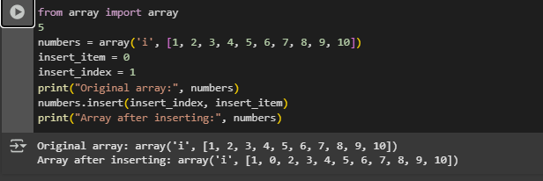

Figure 3 Screenshot of program

Here again, the numbers from 1 to 10 are considered, but this time instead of adding a number which is 10 at the end, we want to add the number 0 immediately after the first number. So, we choose spot number 1 for this placement. The other numbers move back one position to accommodate this insertion. Upon adding, the numbers will look like this: 1, 0, 2, 3, 4, 5, 6, 7, 8, 9, 10.

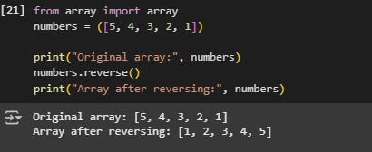

Figure 4 Screenshot of program

In this code, we start with a group of numbers: 5, 4, 3, 2, 1. We want to change the order of these numbers. To do that, we use a command called .reverse(). After running that, the numbers change to 1, 2, 3, 4, 5. The first number becomes the last, and the last becomes the first. It’s like flipping the list around.

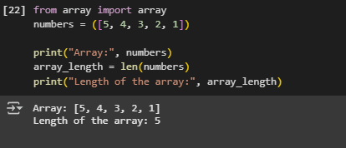

Figure 5 Screenshot of program

This code also starts with the numbers 5, 4, 3, 2, 1. We want to count how many numbers are in the array. To do this, we use a command called len(). It tells us the length. In this case, it shows that the length is 5 because there are 5 numbers in the array.

If an image is taken from another literature or intellectual property, please cite them accordingly in the caption. Always keep in mind the Honor Code [1] of our course to prevent failure due to academic dishonesty.

# Conclusion

The conclusion expresses the summary of the whole laboratory report as perceived by the authors of the report.

In all of these codes, we learned how to work with arrays, which are just groups of numbers. We saw how to show numbers, add them together, add new numbers, and even put numbers in a certain spot. We also learned how to flip the order of the numbers and how to count how many numbers are in the array. These are all basic and useful skills when working with arrays in Python. Once you know how to do these steps, you can start creating your own number lists and change them however you want.

**References**

1. W“W3Schools.com.” <https://www.w3schools.com/python/>
2. GeeksforGeeks, “Python Arrays,” *GeeksforGeeks*, Jul. 28, 2025. <https://www.geeksforgeeks.org/python/python-arrays/>

[3]“Python array of numeric values.” [https://www.programiz.com/python-programming/array?utm](https://www.programiz.com/python-programming/array?utm_source=chatgpt.com)