Data Structure and Algorithm

Laboratory Activity No. 6

Singly Linked Lists

|  |  |
| --- | --- |
| *Submitted by:* | *Instructor:* |
| Tan, Charles Dominic S. | Engr. Maria Rizette H. Sayo |

August 23, 2025

# Objectives

Introduction

A linked list is an organization of a list where each item in the list is in a separate node. Linked lists look like the links in a chain. Each link is attached to the next link by a reference that points to the next link in the chain. When working with a linked list, each link in the chain is called a Node. Each node consists of two pieces of information, an item, which is the data associated with the node, and a link to the next node in the linked list, often called next.

This laboratory activity aims to implement the principles and techniques in:

* Writing algorithms using Linked list
* Writing a python program that will perform the common operations in a singly linked list

# Methods

* Write a Python program to create a singly linked list of prime numbers less than 20. By iterating through the list, display all the prime numbers, the head, and the tail of the list. (using Google Colab)
* Save your source codes to GitHub

# Results

Present the visualized procedures done. Also present the results with corresponding data visualizations such as graphs, charts, tables, or image . Please provide insights, commentaries, or explanations regarding the data. If an explanation requires the support of literature such as academic journals, books, magazines, reports, or web articles please cite and reference them using the IEEE format.

Please take note of the styles on the style ribbon as these would serve as the style format of this laboratory report. The body style is Times New Roman size 12, line spacing: 1.5. Body text should be in Justified alignment, while captions should be center-aligned. Images should be readable and include captions. Please refer to the sample below:

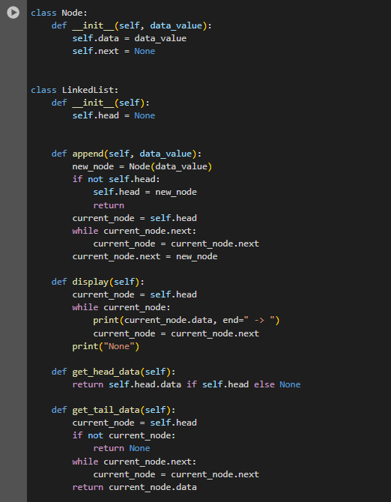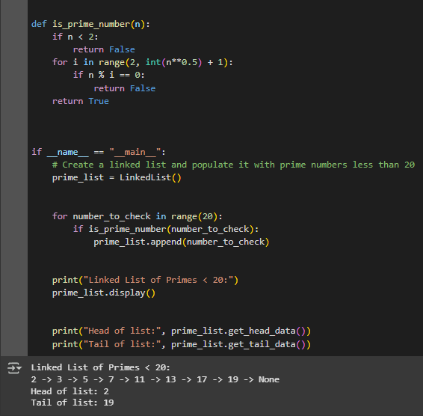

Figure 1 Screenshot of program

All prime numbers under 20 are found by this Python program and added to a linked list, which resembles a chain of boxes. A number is displayed in each box, indicating the next one. The program displays every number in the list, along with the head and tail numbers, after the primes have been added.

If an image is taken from another literature or intellectual property, please cite them accordingly in the caption. Always keep in mind the Honor Code [1] of our course to prevent failure due to academic dishonesty.

# Conclusion

The conclusion expresses the summary of the whole laboratory report as perceived by the authors of the report.

This small program ultimately functions as a sort of assistant that locates unique numbers, or primes, and arranges them in a tidy chain. It displays the first, last, and everyone else in line. It's an easy and entertaining way to demonstrate how code and numbers can function as a cohesive unit.

**References**

1. “Google Colab.” <https://colab.research.google.com/#scrollTo=-G3zpqAJko2X>
2. W“W3Schools.com.” <https://www.w3schools.com/python/>

[3]“Python array of numeric values.” [https://www.programiz.com/python-programming/array?utm](https://www.programiz.com/python-programming/array?utm_source=chatgpt.com)