Data Structure and Algorithm

Laboratory Activity No. 7

Doubly Linked Lists

|  |  |
| --- | --- |
| *Submitted by:* | *Instructor:* |
| LastName, FirstName MI. | Engr. Maria Rizette H. Sayo |

Month, DD, YYYY

# Objectives

Introduction

A doubly linked list is a type of linked list data structure where each node contains three components:

Data - The actual value stored in the node

Previous pointer - A reference to the previous node in the sequence

Next pointer - A reference to the next node in the sequence.

This laboratory activity aims to implement the principles and techniques in:

* Writing algorithms using Linked list
* Writing a python program that will perform the common operations in a Doubly linked list
* A doubly linked list is particularly useful when you need frequent bidirectional traversal or easy deletion of nodes from both ends of the list.

# Methods

* Using Google Colab, type the source codes below:

class Node:

"""Node class for doubly linked list"""

def __init__(self, data):

self.data = data

self.prev = None

self.next = None

class DoublyLinkedList:

"""Doubly Linked List implementation"""

def __init__(self):

self.head = None

self.tail = None

self.size = 0

def is_empty(self):

"""Check if the list is empty"""

return self.head is None

def get_size(self):

"""Get the size of the list"""

return self.size

def display_forward(self):

"""Display the list from head to tail"""

if self.is_empty():

print("List is empty")

return

current = self.head

print("Forward: ", end="")

while current:

print(current.data, end="")

if current.next:

print(" ↔ ", end="")

current = current.next

print()

def display_backward(self):

"""Display the list from tail to head"""

if self.is_empty():

print("List is empty")

return

current = self.tail

print("Backward: ", end="")

while current:

print(current.data, end="")

if current.prev:

print(" ↔ ", end="")

current = current.prev

print()

def insert_at_beginning(self, data):

"""Insert a new node at the beginning"""

new_node = Node(data)

if self.is_empty():

self.head = self.tail = new_node

else:

new_node.next = self.head

self.head.prev = new_node

self.head = new_node

self.size += 1

print(f"Inserted {data} at beginning")

def insert_at_end(self, data):

"""Insert a new node at the end"""

new_node = Node(data)

if self.is_empty():

self.head = self.tail = new_node

else:

new_node.prev = self.tail

self.tail.next = new_node

self.tail = new_node

self.size += 1

print(f"Inserted {data} at end")

def insert_at_position(self, data, position):

"""Insert a new node at a specific position"""

if position < 0 or position > self.size:

print("Invalid position")

return

if position == 0:

self.insert_at_beginning(data)

return

elif position == self.size:

self.insert_at_end(data)

return

new_node = Node(data)

current = self.head

# Traverse to the position

for _ in range(position - 1):

current = current.next

# Insert the new node

new_node.next = current.next

new_node.prev = current

current.next.prev = new_node

current.next = new_node

self.size += 1

print(f"Inserted {data} at position {position}")

def delete_from_beginning(self):

"""Delete the first node"""

if self.is_empty():

print("List is empty")

return None

deleted_data = self.head.data

if self.head == self.tail: # Only one node

self.head = self.tail = None

else:

self.head = self.head.next

self.head.prev = None

self.size -= 1

print(f"Deleted {deleted_data} from beginning")

return deleted_data

def delete_from_end(self):

"""Delete the last node"""

if self.is_empty():

print("List is empty")

return None

deleted_data = self.tail.data

if self.head == self.tail: # Only one node

self.head = self.tail = None

else:

self.tail = self.tail.prev

self.tail.next = None

self.size -= 1

print(f"Deleted {deleted_data} from end")

return deleted_data

def delete_from_position(self, position):

"""Delete a node from a specific position"""

if self.is_empty():

print("List is empty")

return None

if position < 0 or position >= self.size:

print("Invalid position")

return None

if position == 0:

return self.delete_from_beginning()

elif position == self.size - 1:

return self.delete_from_end()

current = self.head

# Traverse to the position

for _ in range(position):

current = current.next

# Delete the node

deleted_data = current.data

current.prev.next = current.next

current.next.prev = current.prev

self.size -= 1

print(f"Deleted {deleted_data} from position {position}")

return deleted_data

def search(self, data):

"""Search for a node with given data"""

if self.is_empty():

return -1

current = self.head

position = 0

while current:

if current.data == data:

return position

current = current.next

position += 1

return -1

def reverse(self):

"""Reverse the doubly linked list"""

if self.is_empty() or self.head == self.tail:

return

current = self.head

self.tail = self.head

while current:

# Swap next and prev pointers

temp = current.prev

current.prev = current.next

current.next = temp

# Move to the next node (which is now in prev due to swap)

current = current.prev

# Update head to the last node we processed

if temp:

self.head = temp.prev

print("List reversed successfully")

def clear(self):

"""Clear the entire list"""

self.head = self.tail = None

self.size = 0

print("List cleared")

# Demonstration and testing

def demo_doubly_linked_list():

"""Demonstrate the doubly linked list operations"""

print("=" * 50)

print("DOUBLY LINKED LIST DEMONSTRATION")

print("=" * 50)

dll = DoublyLinkedList()

# Insert operations

dll.insert_at_beginning(10)

dll.insert_at_end(20)

dll.insert_at_end(30)

dll.insert_at_beginning(5)

dll.insert_at_position(15, 2)

# Display

dll.display_forward()

dll.display_backward()

print(f"Size: {dll.get_size()}")

print()

# Search operation

search_value = 20

position = dll.search(search_value)

if position != -1:

print(f"Found {search_value} at position {position}")

else:

print(f"{search_value} not found in the list")

print()

# Delete operations

dll.delete_from_beginning()

dll.delete_from_end()

dll.delete_from_position(1)

# Display after deletions

dll.display_forward()

print(f"Size: {dll.get_size()}")

print()

# Insert more elements

dll.insert_at_end(40)

dll.insert_at_end(50)

dll.insert_at_end(60)

# Display before reverse

print("Before reverse:")

dll.display_forward()

# Reverse the list

dll.reverse()

# Display after reverse

print("After reverse:")

dll.display_forward()

dll.display_backward()

print()

# Clear the list

dll.clear()

dll.display_forward()

# Interactive menu for user to test

def interactive_menu():

"""Interactive menu for testing the doubly linked list"""

dll = DoublyLinkedList()

while True:

print("\n" + "=" * 40)

print("DOUBLY LINKED LIST MENU")

print("=" * 40)

print("1. Insert at beginning")

print("2. Insert at end")

print("3. Insert at position")

print("4. Delete from beginning")

print("5. Delete from end")

print("6. Delete from position")

print("7. Search element")

print("8. Display forward")

print("9. Display backward")

print("10. Reverse list")

print("11. Get size")

print("12. Clear list")

print("13. Exit")

print("=" * 40)

choice = input("Enter your choice (1-13): ")

if choice == '1':

data = int(input("Enter data to insert: "))

dll.insert_at_beginning(data)

elif choice == '2':

data = int(input("Enter data to insert: "))

dll.insert_at_end(data)

elif choice == '3':

data = int(input("Enter data to insert: "))

position = int(input("Enter position: "))

dll.insert_at_position(data, position)

elif choice == '4':

dll.delete_from_beginning()

elif choice == '5':

dll.delete_from_end()

elif choice == '6':

position = int(input("Enter position to delete: "))

dll.delete_from_position(position)

elif choice == '7':

data = int(input("Enter data to search: "))

pos = dll.search(data)

if pos != -1:

print(f"Element found at position {pos}")

else:

print("Element not found")

elif choice == '8':

dll.display_forward()

elif choice == '9':

dll.display_backward()

elif choice == '10':

dll.reverse()

elif choice == '11':

print(f"Size: {dll.get_size()}")

elif choice == '12':

dll.clear()

elif choice == '13':

print("Exiting...")

break

else:

print("Invalid choice! Please try again.")

if __name__ == "__main__":

# Run the demonstration

demo_doubly_linked_list()

# Uncomment the line below to run interactive menu

# interactive_menu()

* Save your source codes to GitHub

Answer the following questions:

* + 1. What are the three main components of a Node in the doubly linked list implementation, and what does the __init__ method of the DoublyLinkedList class initialize?
    2. The insert_at_beginning method successfully adds a new node to the start of the list. However, if we were to reverse the order of the two lines of code inside the else block, what specific issue would this introduce? Explain the sequence of operations that would lead to this problem:

def insert_at_beginning(self, data):

new_node = Node(data)

if self.is_empty():

self.head = self.tail = new_node

else:

new_node.next = self.head

self.head.prev = new_node

self.head = new_node

self.size += 1

* + 1. How does the reverse method work? Trace through the reversal process step by step for a list containing [A, B, C], showing the pointer changes at each iteration

def reverse(self):

if self.is_empty() or self.head == self.tail:

return

current = self.head

self.tail = self.head

while current:

temp = current.prev

current.prev = current.next

current.next = temp

current = current.prev

if temp:

self.head = temp.prev

# Results

Present the visualized procedures done. Also present the results with corresponding data visualizations such as graphs, charts, tables, or image . Please provide insights, commentaries, or explanations regarding the data. If an explanation requires the support of literature such as academic journals, books, magazines, reports, or web articles please cite and reference them using the IEEE format.

Please take note of the styles on the style ribbon as these would serve as the style format of this laboratory report. The body style is Times New Roman size 12, line spacing: 1.5. Body text should be in Justified alignment, while captions should be center-aligned. Images should be readable and include captions. Please refer to the sample below:

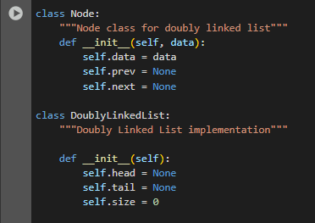

Figure 1 Screenshot of program

There are essentially three components in every node of a doubly linked list: data or value, a previous pointer, and a next pointer. The previous pointer points to the previous node, the next pointer points to the next node, and the data is the value we want to store. The __init__ method in the DoublyLinkedList class sets size to zero so that it may be indicated that no node exists yet and sets both head and tail to None since the list is empty to begin with.

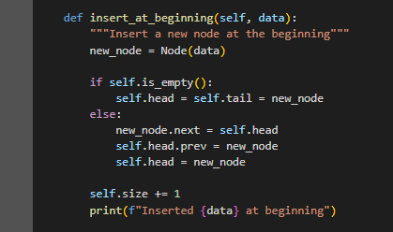

Figure 2 Screenshot of program

Initially, the method links a new node to the old head before the head itself points back to the new node. This way, we can link new node's pointers before we switch the old head pointer to new node. If we violate this order, the old head points to new node at premature times before we even link forward the new node, making the chain all messy and possibly breaking the list while trying to traverse it.

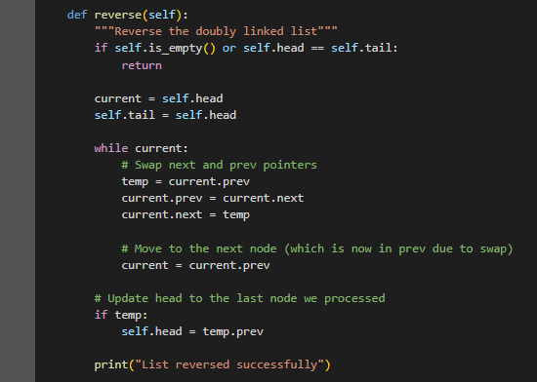

Figure 3 Screenshot of program

This procedure is the reversal of the doubly linked list. It begins from the front and traverses through the items, making every forward link point backward instead. Thus, instead of pointing to the next element, each element now points to the previous one. Such operation is conducted in the front and is continued till the end of the list. After that, the list is updated such that the last element is now the first element. Now, the list has been completely reversed-what was the front has turned to the back, and everything in between has also been flipped.

If an image is taken from another literature or intellectual property, please cite them accordingly in the caption. Always keep in mind the Honor Code [1] of our course to prevent failure due to academic dishonesty.

# Conclusion

The conclusion expresses the summary of the whole laboratory report as perceived by the authors of the report.

This code develops a doubly linked list. Each node has pointers; one to the previous node and one to the following node. The Node class holds data, along with the all-important links, of course. The DoublyLinkedList class, though, manages the entire list. It uses head, tail, and size attributes. Adding a node at the beginning can be done with the insert_at_beginning method. If there are no items, then the new node becomes both the head and the tail, it's as easy as that. Else; it is put before the current head. Linked lists can be rather complicated structures in my opinion. The reverse method inverts the order of the list, such as when it needs it. The links between the nodes get swapped; reversing is very important here. Thus, the former last node will become the list’s head, naturally. Oh! it reverses so easily. Insertion and also the reversal; these are easily done this way.

**References**