Data Structure and Algorithm

Laboratory Activity No. 8

Stacks

|  |  |
| --- | --- |
| *Submitted by:* | *Instructor:* |
| LastName, FirstName MI. | Engr. Maria Rizette H. Sayo |

October, 4, 2025

# Objectives

Introduction

A stack is a collection of objects that are inserted and removed according to the last-in, first-out (LIFO) principle.

A user may insert objects into a stack at any time, but may only access or remove the most recently inserted object that remains (at the so-called “top” of the stack)

This laboratory activity aims to implement the principles and techniques in:

* Writing Python program using Stack
* Writing a Python program that will implement Stack operations

# Methods

Instruction: Type the python codes below in your Colab. After running your codes, answer the questions below.

# Stack implementation in python

# Creating a stack

def create_stack():

    stack = []

    return stack

# Creating an empty stack

def is_empty(stack):

    return len(stack) == 0

# Adding items into the stack

def push(stack, item):

    stack.append(item)

    print("Pushed Element: " + item)

# Removing an element from the stack

def pop(stack):

    if (is_empty(stack)):

        return "The stack is empty"

    return stack.pop()

stack = create_stack()

push(stack, str(1))

push(stack, str(2))

push(stack, str(3))

push(stack, str(4))

push(stack, str(5))

print("The elements in the stack are:"+ str(stack))

Answer the following questions:

1. Upon typing the codes, what is the name of the abstract data type? How is it implemented?
2. What is the output of the codes?
3. If you want to type additional codes, what will be the statement to pop 3 elements from the top of the stack?
4. If you will revise the codes, what will be the statement to determine the length of the stack? (Note: You may add additional methods to count the no. of elements in the stack)

# Results

1. A stack is made using the Python list, We use the push() and with append() to add an item to the top and then we use pop() to take away the last item on top, and then we use is the empty() with len(stack) = 0 to check if the stack has no items. A stack works like a pile of booksand then the last one you put on is the first one you take it off.

2.

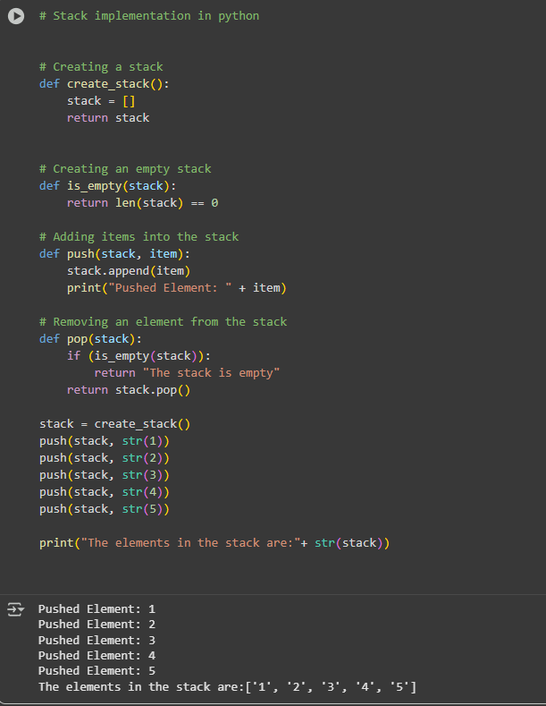

Figure 1 Screenshot of program

3.

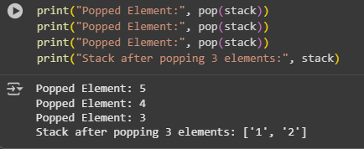

Figure 2 Screenshot of program

4.

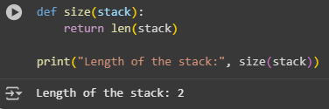

Figure 3 Screenshot of program

Present the visualized procedures done. Also present the results with corresponding data visualizations such as graphs, charts, tables, or image . Please provide insights, commentaries, or explanations regarding the data. If an explanation requires the support of literature such as academic journals, books, magazines, reports, or web articles please cite and reference them using the IEEE format.

Please take note of the styles on the style ribbon as these would serve as the style format of this laboratory report. The body style is Times New Roman size 12, line spacing: 1.5. Body text should be in Justified alignment, while captions should be center-aligned. Images should be readable and include captions. Please refer to the sample below:

Image

Figure 1 Screenshot of program

If an image is taken from another literature or intellectual property, please cite them accordingly in the caption. Always keep in mind the Honor Code [1] of our course to prevent failure due to academic dishonesty.

# Conclusion

The conclusion expresses the summary of the whole laboratory report as perceived by the authors of the report.

Also on this activity, here we learned how to use a stack in the Python and we practiced the adding and removing the items and then the our last item added is the first to be removed, And also This show us how the stacks work in the simple way.

**References**

[1] Co Arthur O.. “University of Caloocan City Computer Engineering Department Honor Code,” UCC-CpE Departmental Policies, 2020.