**COLLAGE BUSINESS EDUCATION**

**DODOMA COMPAS**

**DEPARTMENT OF INFORMATION AND COMMUNICATION TECHNOLOGY**

**OF BACHELOR DEGREE IN INFORMATION TECHNOLOGY (BIT)**

**LECTURES NAME:ATUPELE CAIRO**

**STUDENT NAME: CHARLES ELINEEMA**

**REGISTRATION NUMBER: 03.7508.01.02.2023**

**COURSE NAME :BIT2**

**NAME OF THE PROJECT: MILITARY ONLINE APPLICATION FORM**

**SUBMISSION DATE: JAN/28/2025**

**MILITARY ONLINE APPLICATION FORM REPORT**

**INTRODUCTION**

Military management involves the efficient and effective coordination of resources (personnel, equipment, and finances) within the armed forces to achieve mission objectives.

****Strengths of Military Online Application Forms:****

* ****Increased Accessibility:****
  + ****24/7 Availability:**** Applicants can apply at their convenience, regardless of location or office hours.
  + ****Wider Reach:**** Applications can be submitted from anywhere with internet access, expanding the pool of potential recruits.
* ****Improved Efficiency:****
  + **Streamlined Process:** Automates data entry and reduces manual paperwork.
  + ****Faster Processing:**** Applications can be processed more quickly, accelerating the recruitment process.
  + ****Reduced Administrative Burden:**** Reduces the administrative workload for recruiters.
* ****Enhanced Data Collection:****
  + **Comprehensive Information:** Online forms can capture a wider range of information about applicants, such as educational background, work experience, and preferences.
  + ****Data Analysis:**** Collected data can be easily analyzed to identify trends, identify qualified candidates, and improve recruitment strategies.
* ****Improved Communication:****
  + ****Faster Communication:**** Online platforms facilitate faster communication between applicants and recruiters.
  + **Automated Notifications:** Automated notifications can be sent to applicants regarding the status of their applications.

****Objectives of Military Online Application Forms:****

* ****Attract Qualified Candidates:**** To reach a wider pool of potential recruits and attract qualified individuals who meet the military's requirements.
* **Streamline the Recruitment Process:** To simplify and expedite the application process for both applicants and recruiters.
* ****Improve Data Accuracy:**** To ensure that accurate and complete information is collected from applicants.

**Key Areas of Focus:**

* **Personnel Management:** Recruiting, training, developing, and managing military personnel, including officer and enlisted personnel.
* **Resource Management:** Allocating and managing resources effectively, including budgets, equipment, and infrastructure.
* **Operational Planning and Execution:** Developing and executing military operations, including combat operations, peacekeeping missions, and humanitarian assistance.
* **Logistics and Supply Chain Management:** Ensuring the timely and efficient supply of personnel, equipment, and supplies.
* **Intelligence and Surveillance:** Gathering and analyzing intelligence to inform decision-making and support military operations.
* **Cybersecurity:** Protecting military networks and systems from cyber threats.

According to the subject given I made an online military application form that allowed user to register and sign in as showed in abelow diagram 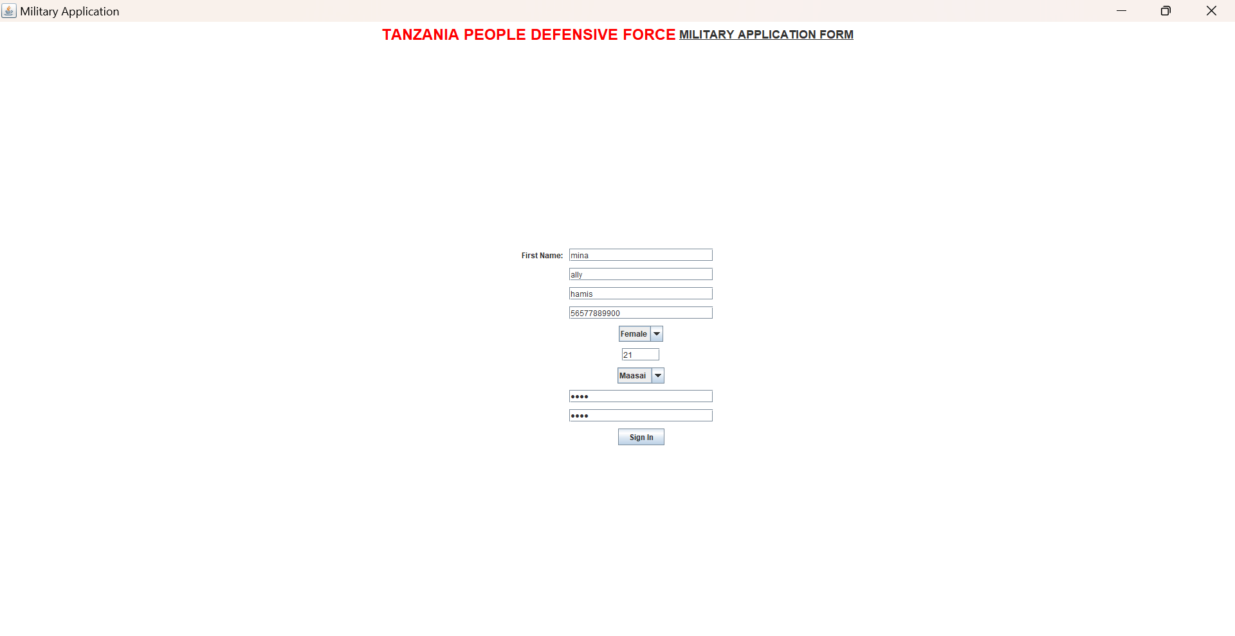

The system allowed users to sign in after confirming the password and if the password did not match the system could not proceed as shown in below diagram 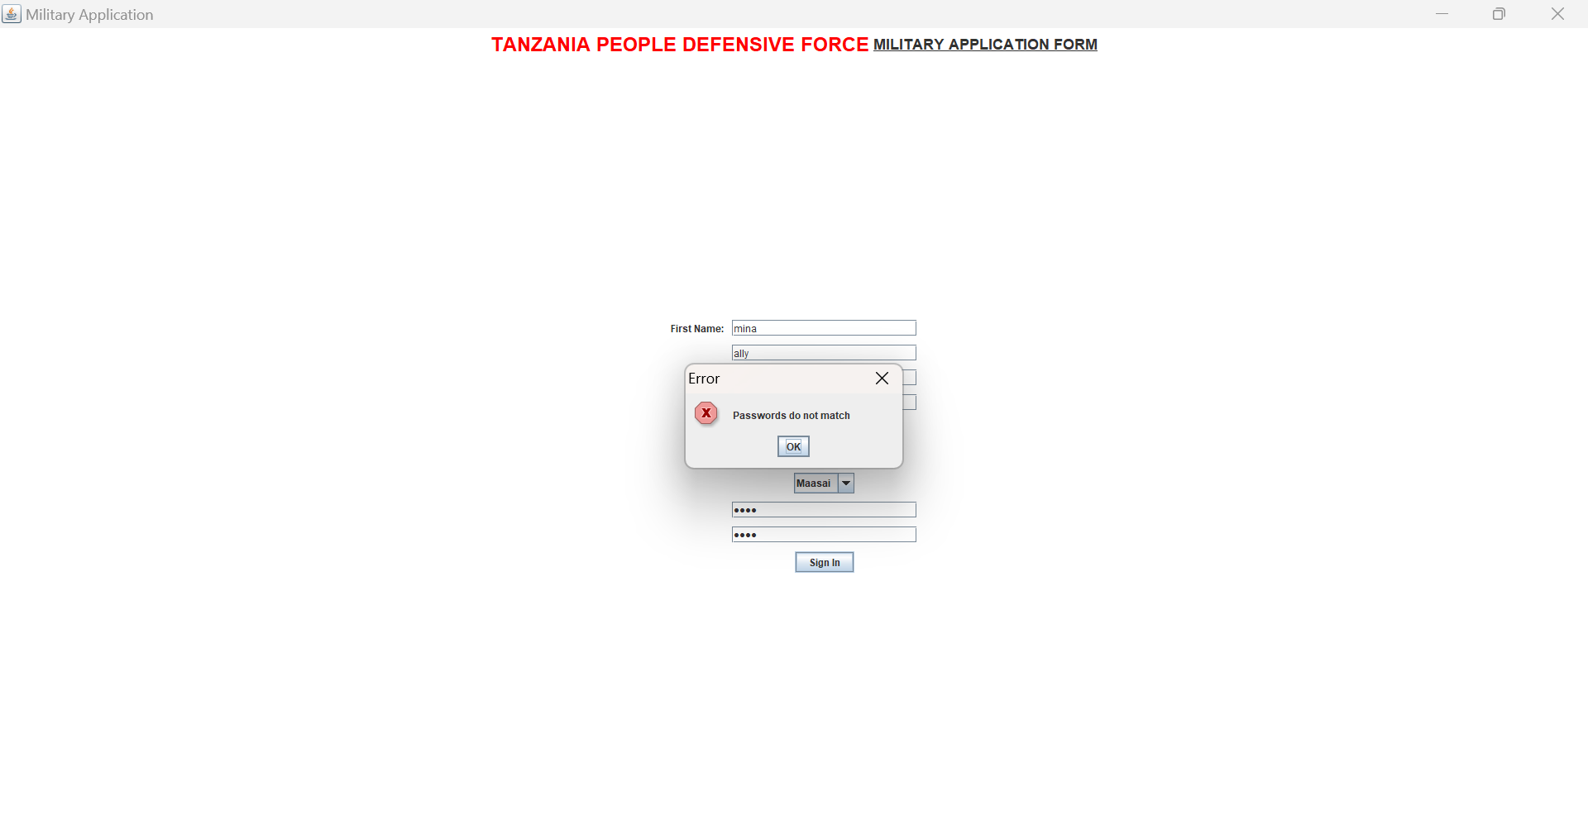

The code also allowed the end user to type his or her criterial qualifications

As seen im the below diagram and finaly allowed to submit the form and results reply interval was given in responce 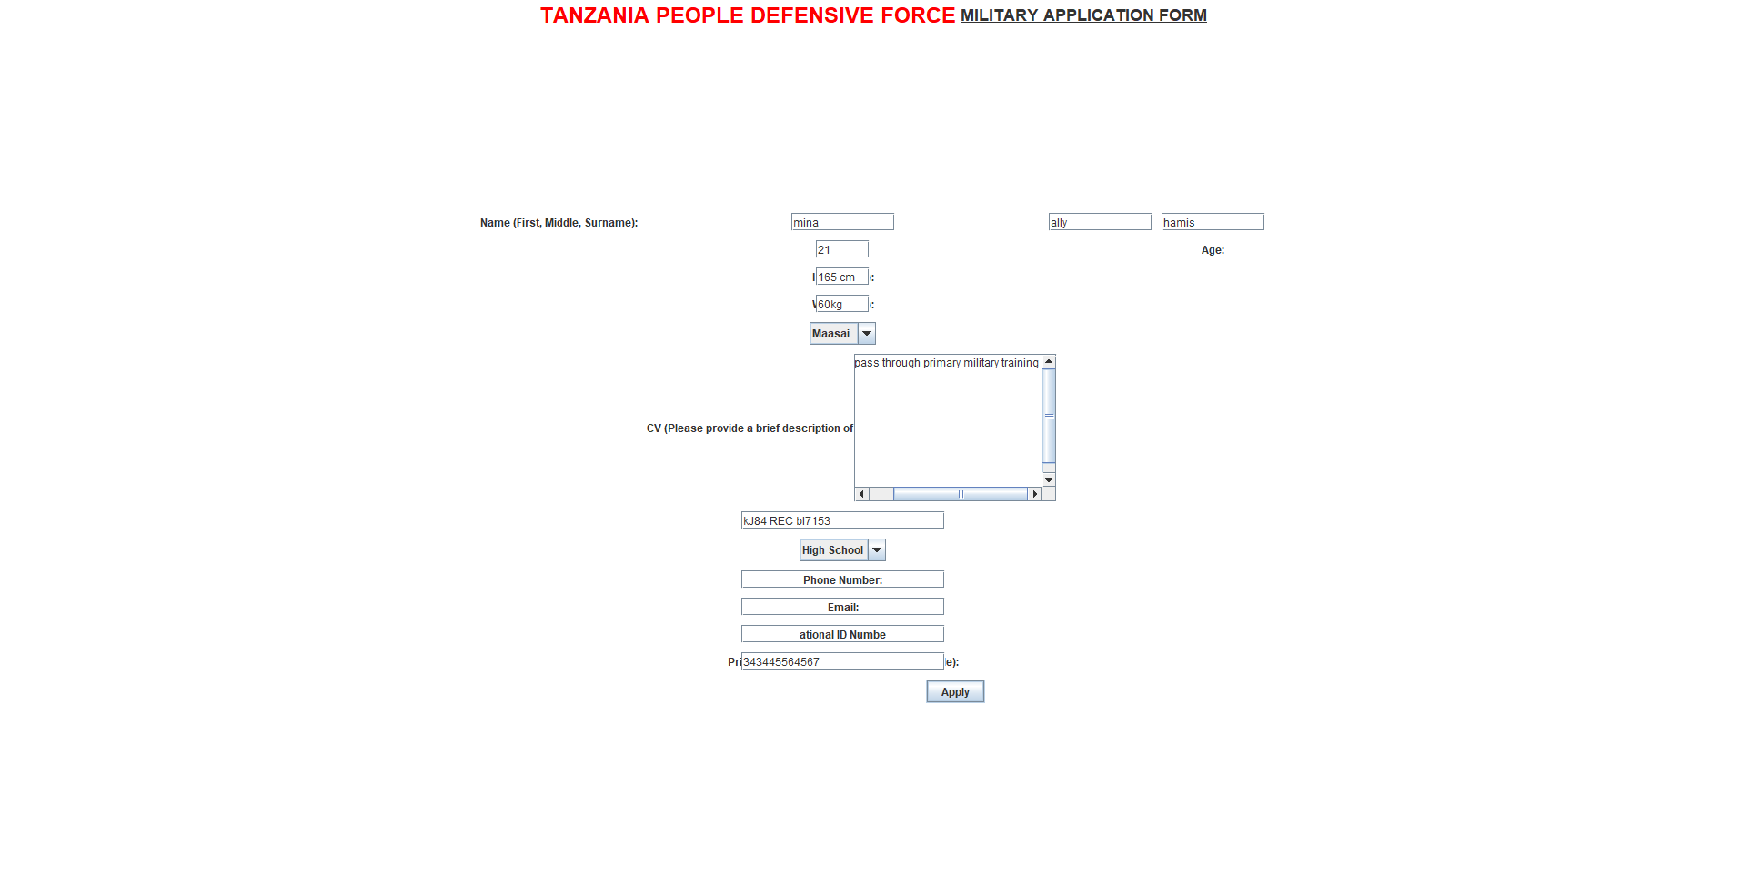

And finally user was required to apply and wait for the results..

The code executed was basedon the jswing as showed below 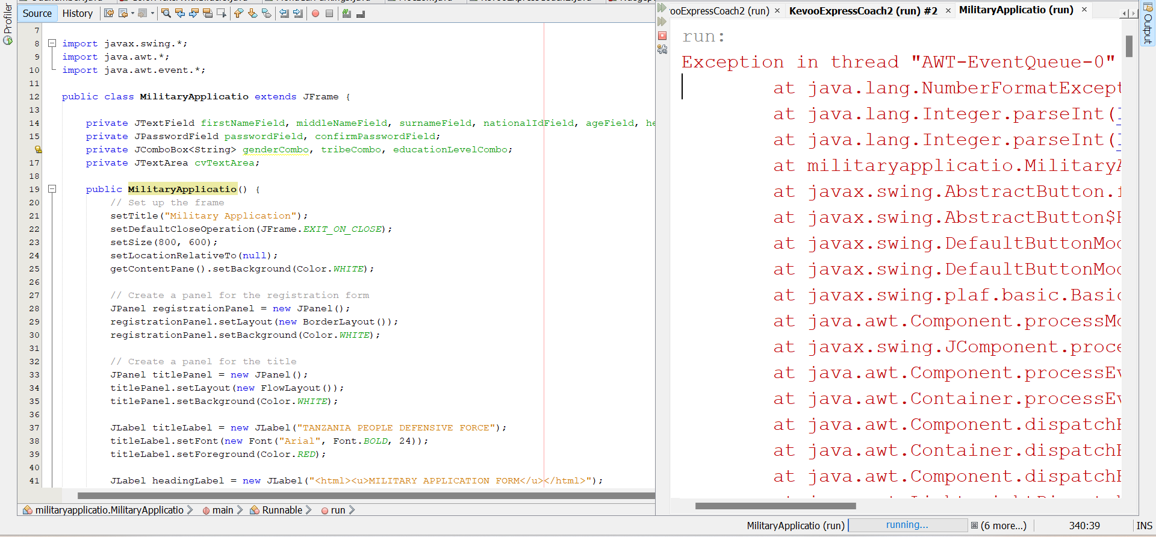 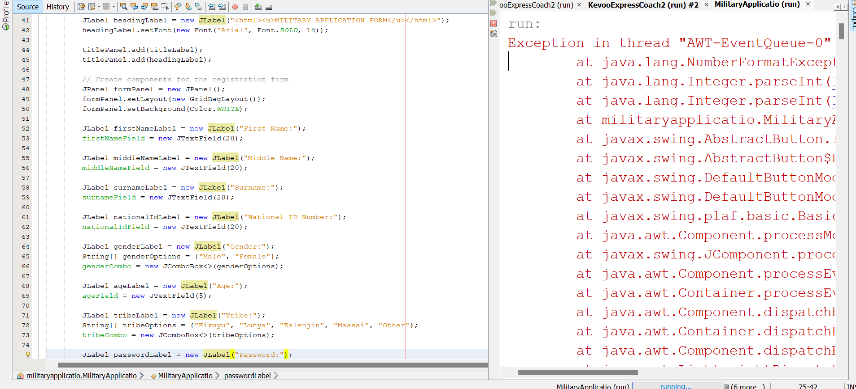 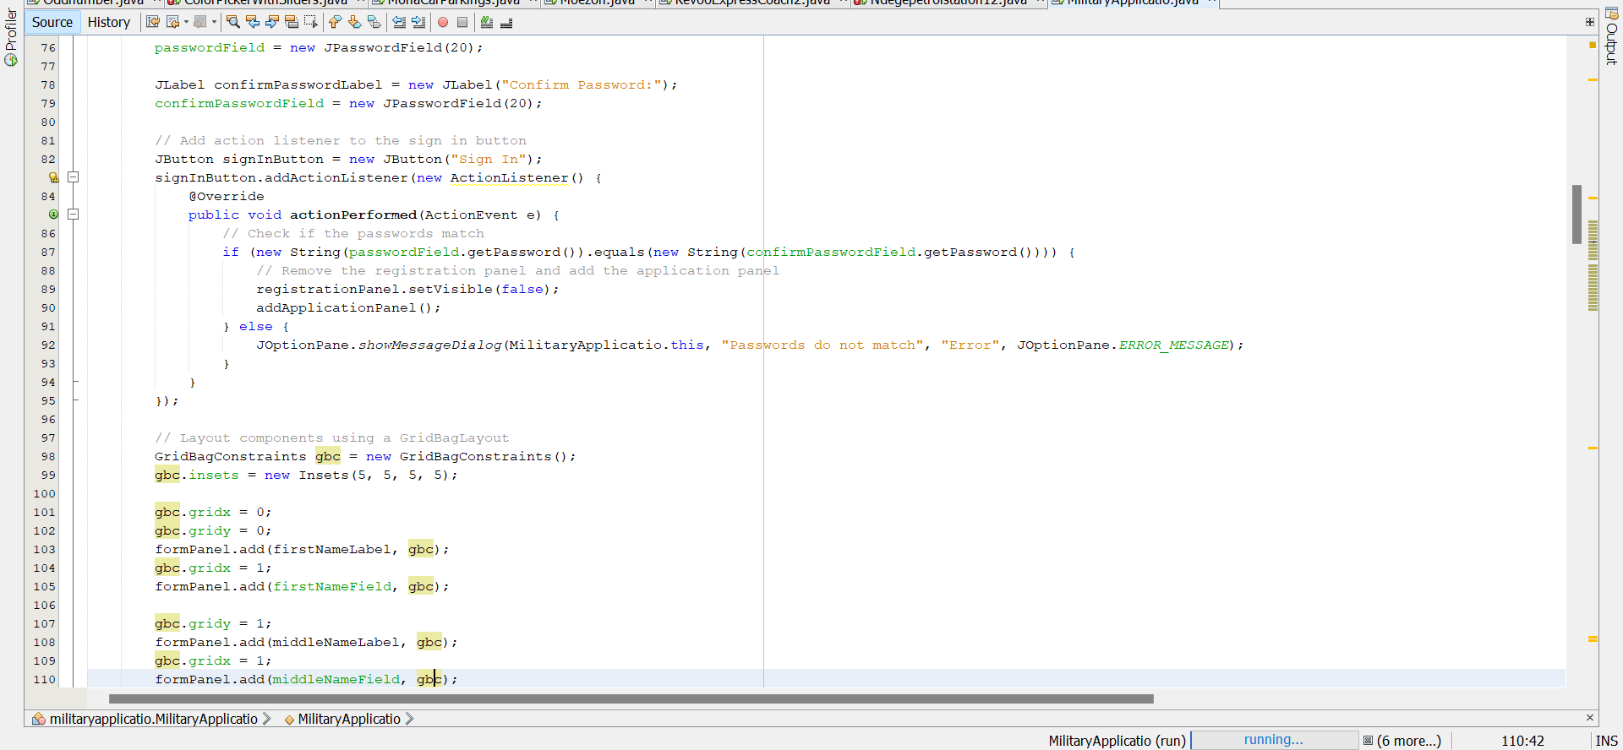 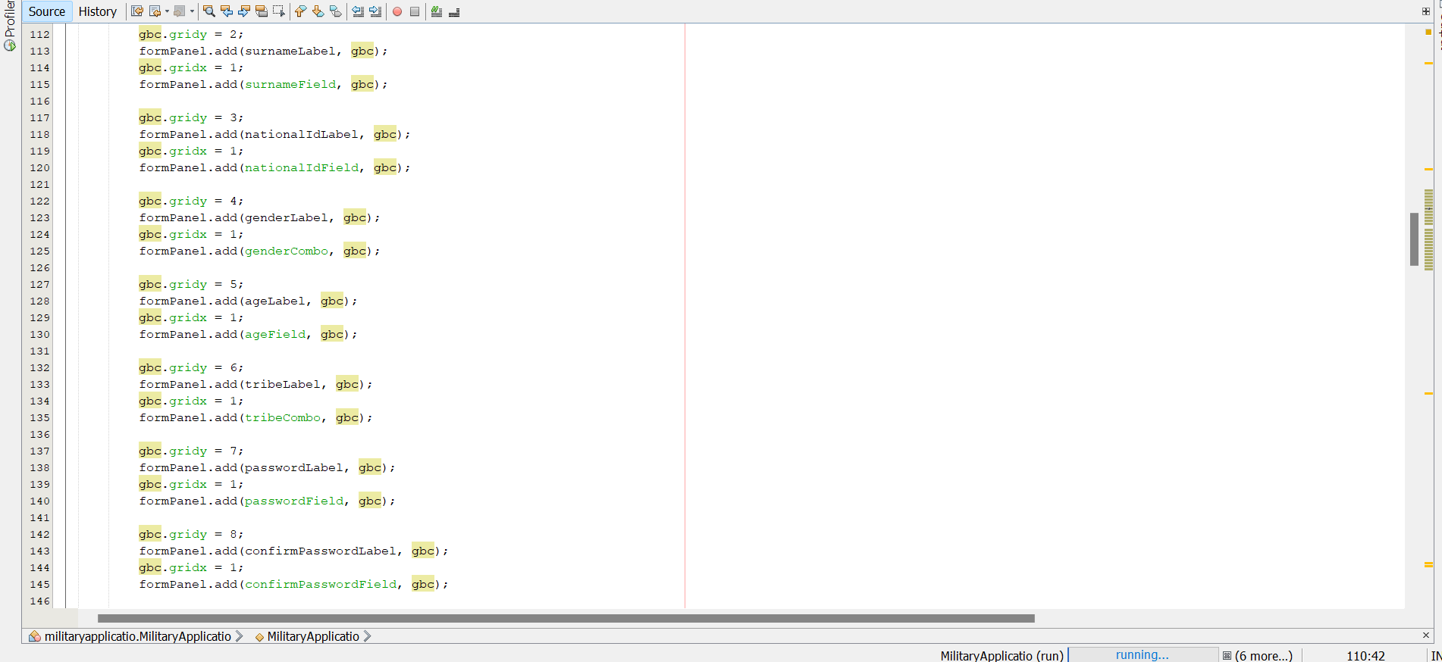 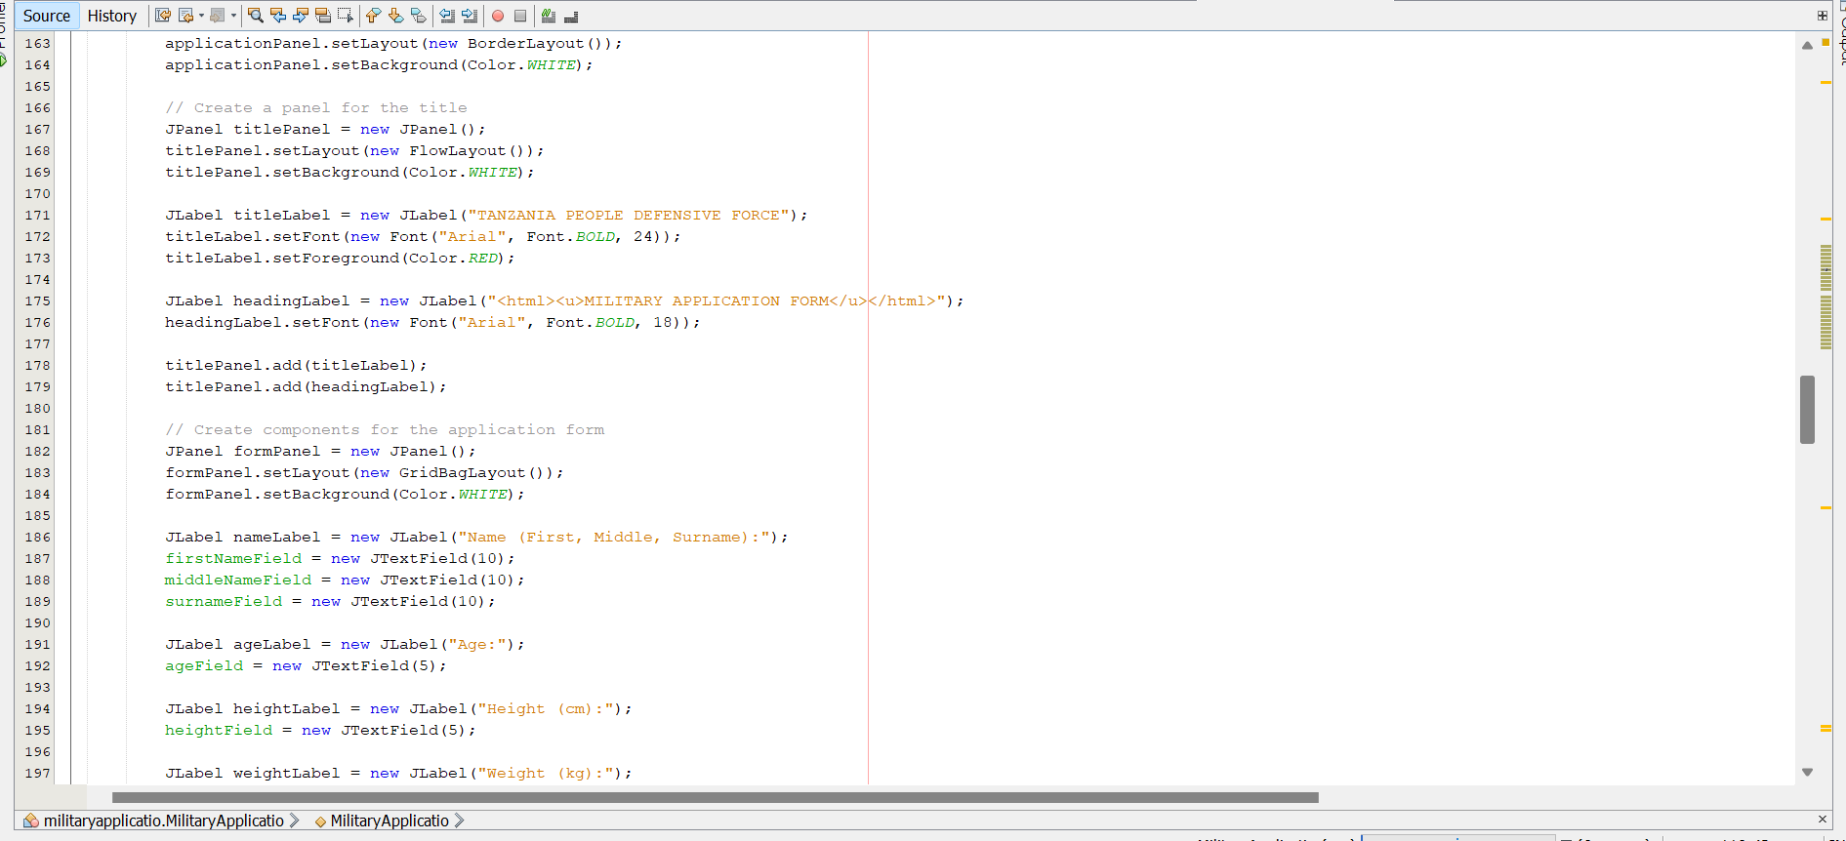 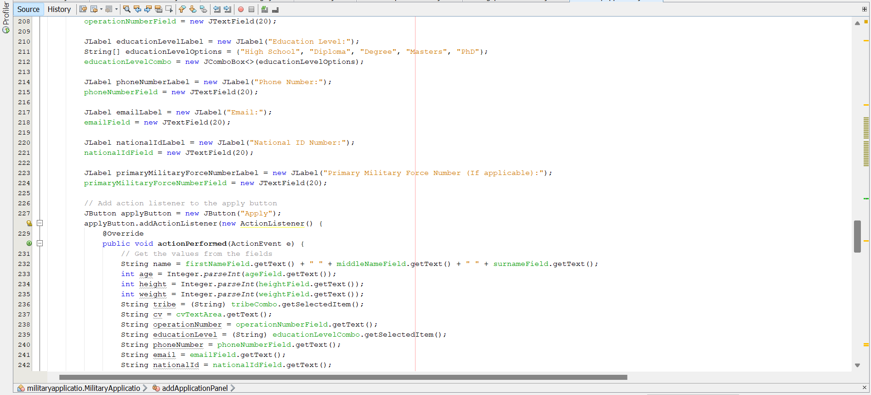 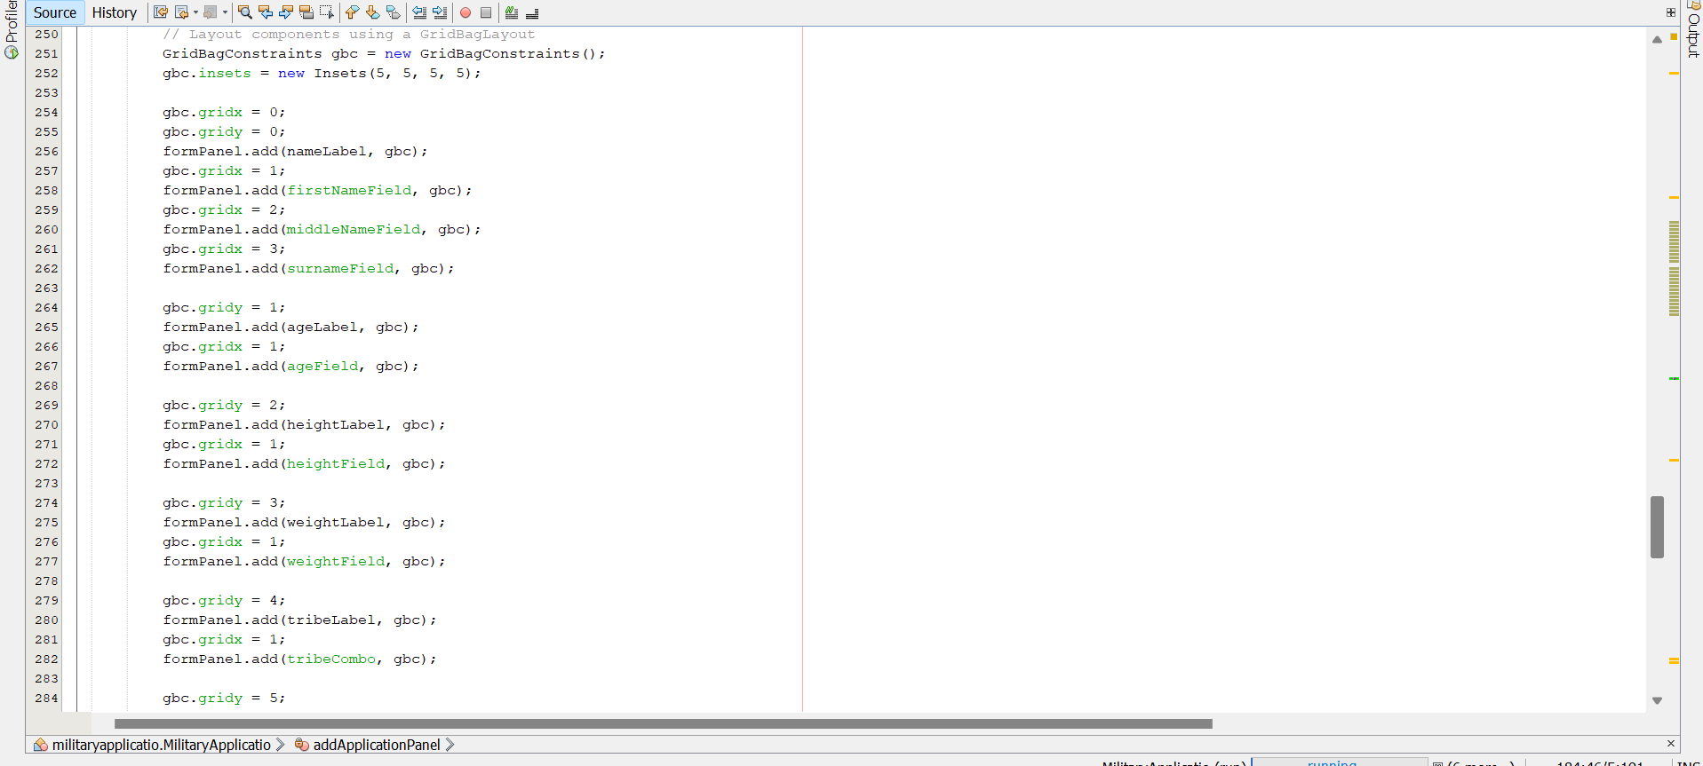 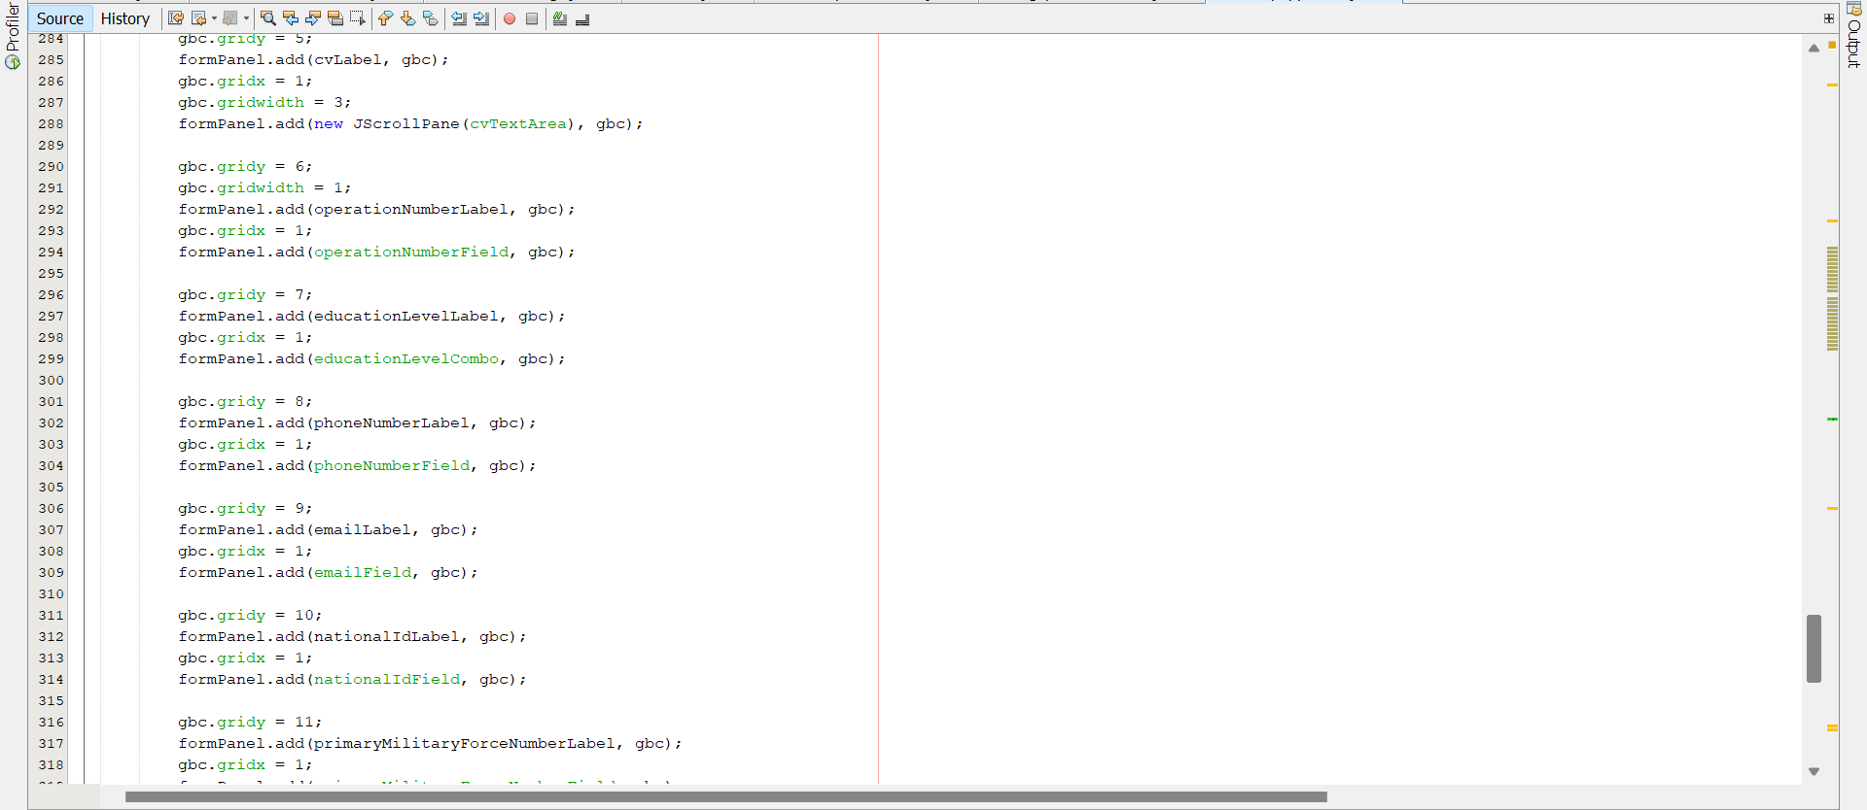 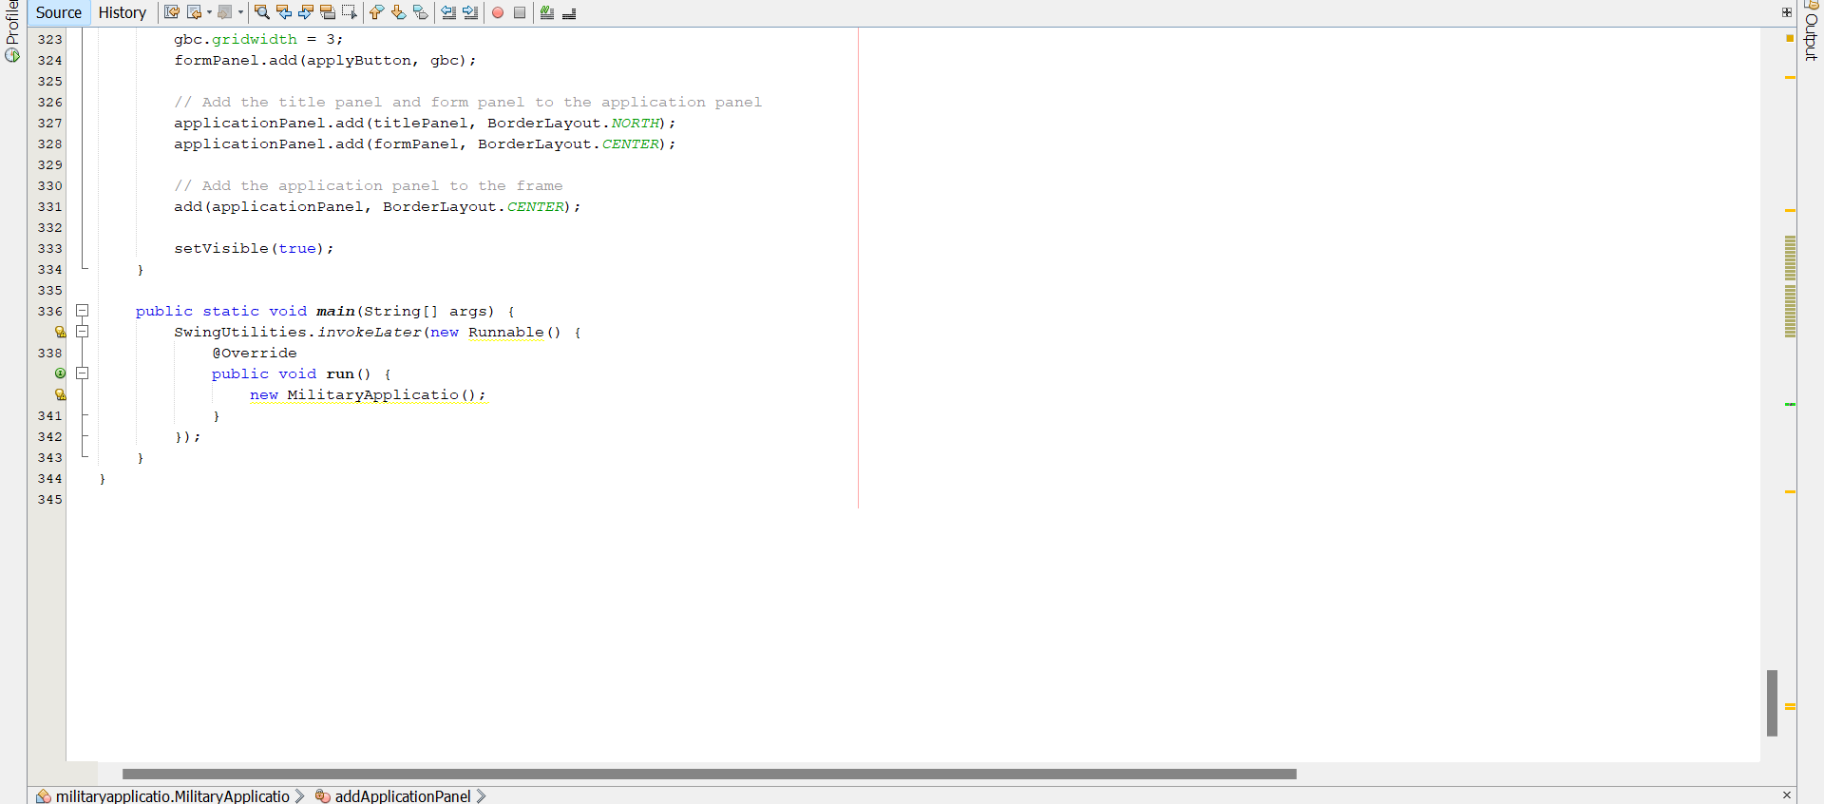

Those above were the codes for making th application form

**Challenges:**

* **Rapid Technological Change:** The military must constantly adapt to evolving technologies and threats.
* **Complex Global Security Environment:** Addressing global challenges such as terrorism, cyber warfare, and climate change requires innovative and adaptable approaches.
* **Maintaining Readiness:** Ensuring the military is always prepared to respond to a wide range of threats and contingencies.
* **Ethical Considerations:** Navigating ethical dilemmas and ensuring the ethical conduct of military operations.

**REFFERENCE**

• ****Contact the recruitment offices directly.**** You can reach out to a local recruitment office by phone or email. They can provide you with the most up-to-date information on application procedures and any relevant forms.

• **Government Websites:Search the official government websites of the relevant country.** Look for departments of defense or military recruitment websites.

• **Check the official websites of the military branches you're interested in.** Look for recruitment sections, FAQs, or application portals. They may provide links to downloadable application forms or instructions on how to apply online.