**CASE REPOSITORY**

**CONCEPTUAL DATABASE MODELING - ER DIAGRAM**

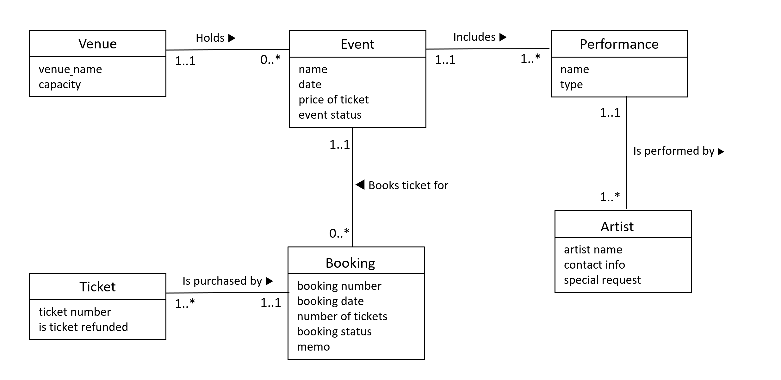

**ENTITY TYPE DESCRIPTIONS**

|  |  |  |
| --- | --- | --- |
| **ENTITY TYPE** | **Description** | **Synonyms, aliases** |
| **Event** | A is an organized show with a set of performances | Show, concert, event |
| **Venue** | Is the place where events are held | Location, setting, area |
| **Performance** | Is an act of presenting a song, dance and other forms of entertainment | Set, act |
| **Artist** | Someone who performs art or other forms of entertainment | Performer, singer, dancer |
| **Booking** | An act of reserving a ticket in advance | Reservation |
| **Ticket** | A paper that grants the holder to participate in an event | Pass, admission slip |

**ATTRIBUTE TYPE DESCRIPTIONS**

**Event**

|  |  |  |  |  |  |
| --- | --- | --- | --- | --- | --- |
| **Attribute type** | **Description** | **Data type** | **Value**  **required** | **Identity attribute**  **or part of it** | **Special domain** |
| name | Name of the event | Text | Yes | Yes | - |
| date | The date when event is to be held | Date | Yes | - | - |
| price of ticket | Price of one ticket for the event | Decimal | Yes | - | - |
| event status | Event cancel status.  ‘Cancelled’, if event is cancelled | Text | No | - | ‘Cancelled’ |

**Venue**

|  |  |  |  |  |  |
| --- | --- | --- | --- | --- | --- |
| **Attribute type** | **Description** | **Data type** | **Value**  **required** | **Identity attribute**  **or part of it** | **Special domain** |
| venue name | Name of the venue | Text | Yes | Yes | - |
| capacity | Maximum capacity of the venue | Integer | Yes | - | - |

**Performance**

|  |  |  |  |  |  |
| --- | --- | --- | --- | --- | --- |
| **Attribute type** | **Description** | **Data type** | **Value**  **required** | **Identity attribute**  **or part of it** | **Special domain** |
| name | Name of the performance | Text | Yes | Yes | - |
| type | Type of performance | Text | Yes | - | ‘Theater’, ‘Dance’,  ‘Music’, ‘Opera’,  ‘Musical theatre’,  ‘Others’ |

**Artist**

|  |  |  |  |  |  |
| --- | --- | --- | --- | --- | --- |
| **Attribute type** | **Description** | **Data type** | **Value**  **required** | **Identity attribute**  **or part of it** | **Special domain** |
| name | Artist’s name | Text | Yes | Yes | - |
| contact info | Artist’s contact details | Text | Yes | - | - |
| special request | Dietary requests for catering and refreshment | Text | No | - | - |

**Booking**

|  |  |  |  |  |  |
| --- | --- | --- | --- | --- | --- |
| **Attribute type** | **Description** | **Data type** | **Value**  **required** | **Identity attribute**  **or part of it** | **Special domain** |
| booking number | Unique booking identifier | Integer | Yes | Yes | - |
| booking date | Time when booking was made | Date | Yes | - | - |
| number of tickets | Number of tickets booked in the booking | Integer | Yes | - | - |
| booking status | Defines whether booking is just booked, or paid | Text | Yes | - | ‘Booked’,  ‘Paid’ |
| memo | Contact information of the person who made the booking | Text | No | - |  |

**Ticket**

|  |  |  |  |  |  |
| --- | --- | --- | --- | --- | --- |
| **Attribute type** | **Description** | **Data type** | **Value**  **required** | **Identity attribute**  **or part of it** | **Special domain** |
| ticket number | Unique identifier of a ticket | Integer | Yes | Yes | - |
| is ticket refunded | Checks whether money for ticket were returned in case of event cancel | Text | No | - | ‘Yes’ |

**LOGICAL DATABASE DESIGN**

**Initial Diagram**

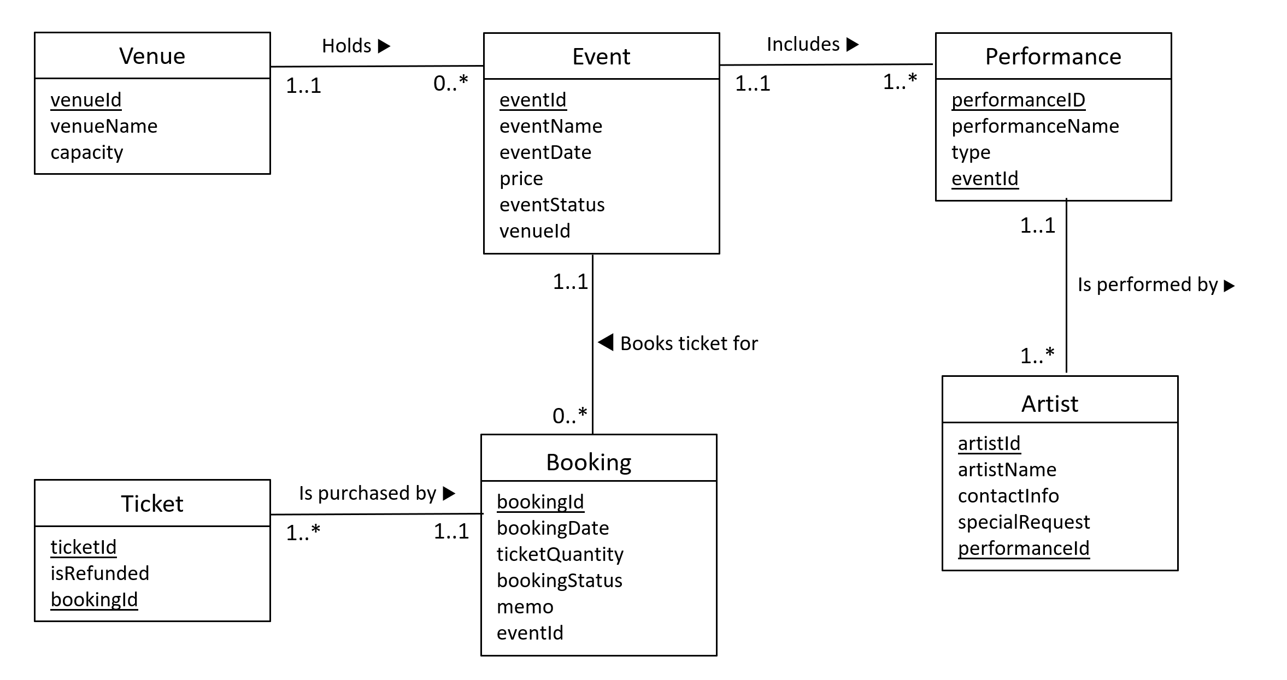

**Initial Relational Schema**

**VENUE (venueId, venueName, capacity)**

**EVENT (eventId, eventName, eventDate, price, eventStatus, venueId)**

**FK (venueId) Ref VENUE (venueId)**

**BOOKING (bookingId, bookingName, ticketQuantity, bookingStatus, memo, eventId)**

**FK (eventId) Ref VENUE (eventId)**

**TICKET (ticketId, isRefunded, bookingID)**

**FK (bookingId) Ref BOOKING (bookingId)**

**PERFORMANCE (performanceId, performanceName, type, eventId)**

**FK (eventId) Ref EVENT (eventId)**

**ARTIST (artistId, artistName, contactInfo, specialRequest, performanceId)**

**FK (performanceId) Ref PERFORMANCE (performanceId)**

**Revised Relational Schema**

**VENUE (venueId, venueName, capacity)**

**EVENT (eventId, eventName, eventDate, price, eventStatus, venueId)**

**FK (venueId) Ref VENUE (venueId)**

**BOOKING (bookingId, bookingName, ticketQuantity, bookingStatus, memo, eventId)**

**FK (eventId) Ref VENUE (eventId)**

**TICKET (ticketId, isRefunded, bookingID)**

**FK (bookingId) Ref BOOKING (bookingId)**

**PERFORMANCE (performanceId, performanceName, type)**

**ARTIST (artistId, artistName, contactInfo, specialRequest)**

**EVENT_PERFORMANCE (eventId, performanceId)**

**FK (eventId) Ref EVENT (eventId)**

**FK (performanceId) Ref PERFORMANCE (performanceId)**

**PERFORMANCE_ARTIST (performanceId, artistId)**

**FK (performanceId) Ref PERFORMANCE (performanceId)**

**FK (artistId) Ref ARTIST (artistId)**