DESIGN AND IMPLEMENTATION OF AN AI-BASED INTRUSION DETECTION SYSTEM FOR ENCRYPTED TRAFFIC (A CASE STUDY OF IDS PROJECT)

BY

Oyeduntan Segun Elijah
CSC/22/174

DEPARTMENT OF COMPUTER SCIENCE
SCHOOL OF INFORMATION AND COMMUNICATION TECHNOLOGY
OLUSEGUN AGAGU UNIVERSITY OF SCIENCE AND TECHNOLOGY, OKITIPUPA

IN PARTIAL FULFILMENT OF THE REQUIREMENTS FOR THE AWARD OF THE DEGREE OF BACHELOR OF SCIENCE (B.Sc.) IN COMPUTER SCIENCE

August, 2026

CERTIFICATION
This is to certify that this project titled "Design and Implementation of an AI-Based Intrusion Detection System for Encrypted Traffic (A Case Study of IDS Project)" was carried out by Oyeduntan Segun Elijah with matriculation number CSC/22/174 in the Department of Computer Science, School of Information and Communication Technology, Olusegun Agagu University of Science and Technology, Okitipupa, in partial fulfilment of the requirements for the award of the degree of Bachelor of Science (B.Sc.) in Computer Science.
_______________________ | _______________________
Prof. A. J. Ikuomola | Dr. (Mrs.) A. Gbadamosi
Project Supervisor | Coordinator / HOD
Date: __________________ | Date: __________________

DECLARATION
I hereby declare that this project is my original work and has not been submitted, either in whole or in part, for any other degree or qualification in this or any other institution. All sources of information and materials used have been duly acknowledged by means of complete references.

_______________________
Oyeduntan Segun Elijah
CSC/22/174
Date: __________________

DEDICATION
This project is dedicated to Almighty God, and to my beloved family, whose unwavering support, prayers, and encouragement made this academic journey possible.

ACKNOWLEDGEMENTS
I express my profound gratitude to Almighty God for His grace, wisdom, and strength that sustained me throughout this project. I am deeply grateful to my project supervisor, Prof. A. J. Ikuomola for her invaluable guidance, constructive feedback, and encouragement, which greatly contributed to the success of this work. My sincere appreciation goes to the Coordinator of the Department of Computer Science, Dr. (Mrs.) A. Gbadamosi, and all the lecturers in the School of Information and Communication Technology, Olusegun Agagu University of Science and Technology (OAUSTECH), Okitipupa, namely Prof. D. T. Akomolafe, Dr. O. M. Orogbemi, Engr. Modupe Agagu, Mr. A. M. Oduwale, and Mr. A. Obamehinti, for their academic support and knowledge imparted during my studies. I also acknowledge my parents for their prayers, support, and sacrifices.

ABSTRACT
The proliferation of encrypted network traffic has significantly reduced the effectiveness of traditional signature-based intrusion detection systems, as malicious activities are increasingly concealed within encrypted channels. This project presents the design and implementation of an AI-based intrusion detection system that leverages the XGBoost ensemble learning algorithm to classify encrypted network traffic as benign or malicious. The system was developed using the Agile software development methodology and trained on the CICIDS2017 benchmark dataset, which contains realistic benign and attack traffic with over 70 flow-based features. The model was evaluated using accuracy, precision, recall, F1-score, and ROC-AUC metrics, achieving a classification accuracy of 99.9% and a ROC-AUC of 0.9999, demonstrating exceptional detection capability across multiple attack categories. A user-friendly Streamlit dashboard was developed to provide three operational modes: CSV file upload for batch analysis, PCAP file upload for offline packet-level inspection using tshark, and live network capture for real-time monitoring. The dashboard integrates a Google Gemini AI assistant that provides plain-language explanations of detected threats and model predictions, making the system accessible to network administrators with varying levels of technical expertise. The system was themed with a dark matrix-style interface for enhanced visual appeal. Testing was conducted through unit testing of individual components, integration testing of the complete pipeline from traffic capture to prediction display, and user acceptance testing with sample traffic data. The results confirmed that the system meets all six objectives defined in the study, providing a lightweight, accurate, and explainable intrusion detection solution that addresses the critical challenge of detecting attacks in encrypted network traffic. The study concludes that XGBoost-based classification combined with an accessible dashboard interface and AI-powered explanations offers a practical and effective approach to modern network security challenges.

TABLE OF CONTENTS

LIST OF FIGURES
Figure 3.1: System Architecture of the Proposed IDS
Figure 4.1: Full Dashboard Interface
Figure 4.2: PCAP Upload Tab
Figure 4.3: Live Capture Tab
Figure 4.4: AI Assistant Interface
Figure 4.5: Confusion Matrix of the XGBoost Classifier
Figure 4.6: ROC Curve of the XGBoost Classifier

LIST OF TABLES
Table 3.1: Software Development Tools and Technologies
Table 3.2: CICIDS2017 Dataset Attack Categories
Table 4.1: Classification Report of the XGBoost Model
Table 4.2: Summary of System Test Cases and Results

LIST OF ABBREVIATIONS
AI — Artificial Intelligence
API — Application Programming Interface
CSV — Comma-Separated Values
DDoS — Distributed Denial of Service
ERD — Entity Relationship Diagram
HTTP — Hypertext Transfer Protocol
IDS — Intrusion Detection System
IP — Internet Protocol
ML — Machine Learning
PCAP — Packet Capture
ROC-AUC — Receiver Operating Characteristic — Area Under Curve
SQL — Structured Query Language
TCP — Transmission Control Protocol
UDP — User Datagram Protocol
XGBoost — Extreme Gradient Boosting

CHAPTER ONE INTRODUCTION

1.1 Background of the Study
Network security remains one of the most critical concerns in the modern digital landscape, as organisations increasingly rely on interconnected systems and the internet for their daily operations. The proliferation of cyber threats, ranging from malware infections and denial-of-service attacks to advanced persistent threats, has necessitated the development of robust security mechanisms to protect sensitive data and ensure the availability of network services. Intrusion Detection Systems (IDS) have long served as a fundamental component of network defence, monitoring traffic for suspicious patterns and alerting administrators to potential security breaches.
The widespread adoption of encryption protocols, including TLS, HTTPS, and VPN technologies, has introduced a significant challenge for traditional IDS solutions. Encryption is essential for protecting data confidentiality and privacy, but it simultaneously obscures the payload content of network packets from inspection. Signature-based IDS, which rely on matching known attack patterns against packet payloads, are rendered largely ineffective against encrypted traffic because the malicious content is hidden within the encrypted stream. Attackers have recognised this limitation and increasingly use encrypted channels to launch attacks, command compromised systems, and exfiltrate data undetected.
Machine learning techniques offer a promising approach to addressing this challenge. By analysing statistical features of network flows, such as packet sizes, inter-arrival times, flow durations, and protocol-level characteristics, machine learning models can distinguish between benign and malicious traffic patterns without requiring access to the encrypted payload. Among the various machine learning algorithms, ensemble methods, particularly XGBoost, have demonstrated exceptional performance in classification tasks due to their ability to combine multiple weak learners into a strong classifier. According to Chen and Guestrin (2016), XGBoost provides state-of-the-art results in many machine learning competitions and real-world applications.
This study presents the design and implementation of an AI-based intrusion detection system that applies the XGBoost algorithm to classify encrypted network traffic. The system is trained on the CICIDS2017 dataset, which provides realistic benign and attack traffic with comprehensive flow-based features. It is deployed through a Streamlit dashboard that supports CSV, PCAP, and live capture modes, and integrates a Gemini AI assistant for explainability, thereby making advanced machine learning-based intrusion detection accessible and practical for real-world use.

1.2 Research Justification/Motivation
The motivation for this study arises from the growing sophistication and frequency of cyber attacks that exploit encrypted communication channels to evade detection. According to industry reports, the majority of internet traffic is now encrypted, and a significant proportion of malicious traffic also uses encryption. Traditional IDS tools that depend on deep packet inspection are unable to analyse encrypted payloads, creating a critical gap in network security defences.
The financial impact of cyber attacks continues to rise, with organisations facing costs related to data breaches, system downtime, regulatory fines, and reputational damage. Small and medium-sized enterprises are particularly vulnerable, as they often lack the resources to deploy sophisticated security infrastructure. There is an urgent need for lightweight, accurate, and cost-effective intrusion detection solutions that can operate effectively in encrypted environments without requiring specialised hardware or extensive manual configuration.
Furthermore, existing machine learning-based IDS solutions are often presented as research prototypes with limited usability, lacking intuitive interfaces that allow network administrators to interact with the system easily. The integration of artificial intelligence for explainability, through a conversational assistant that interprets predictions in plain language, addresses this usability gap. These considerations motivated the development of an AI-based IDS that combines state-of-the-art machine learning with an accessible dashboard and explainable AI capabilities.

1.3 Problem Statement
Network security faces a fundamental challenge in the era of widespread encryption. Signature-based intrusion detection systems, which have been the cornerstone of network defence for decades, rely on inspecting packet payloads for known attack signatures. As encryption becomes ubiquitous, these systems can no longer see the content of network packets, rendering them blind to attacks that are carried out over encrypted channels.
Attackers have adapted to this environment by encrypting their malicious traffic, using the same encryption protocols that protect legitimate communications. Malware command and control traffic, data exfiltration, and even some categories of denial-of-service attacks can now be conducted over encrypted connections, bypassing traditional detection mechanisms. Existing anomaly-based IDS solutions attempt to address this by modelling normal traffic behaviour, but they often suffer from high false positive rates and require extensive tuning to specific network environments.
There is a need for a machine learning-based IDS that can classify encrypted traffic using statistical flow features without requiring payload access. Such a system must be accurate enough to minimise false alarms, lightweight enough to operate in real time or near-real time, and usable enough for deployment by network administrators with varying levels of technical expertise. Additionally, the system should provide interpretable explanations of its predictions to build trust and enable informed decision-making.
This study addresses these challenges through the development of an AI-based IDS that applies XGBoost classification on flow-level features extracted from network traffic, provides three operational modes through a Streamlit dashboard, and integrates a Gemini AI assistant for natural-language explanations of detected threats.

1.4 Aim and Objectives of the Study

Aim
The aim of this study is to design and implement an AI-based intrusion detection system that can effectively classify encrypted network traffic as benign or malicious using machine learning techniques, and provide an accessible interface for network security monitoring.

Objectives
The specific objectives of the study are to:
- preprocess the CICIDS2017 dataset by cleaning, encoding categorical labels, splitting into training, validation, and test sets, and applying standard scaling for model training;
- train an XGBoost ensemble classifier on the preprocessed dataset and optimise its hyperparameters using cross-validation to achieve high detection accuracy;
- build an interactive Streamlit dashboard that provides a unified interface for uploading traffic data, viewing predictions, and exploring model performance metrics;
- implement three operational modes within the dashboard: CSV file upload for batch classification, PCAP file upload with tshark-based feature extraction for offline packet analysis, and live network capture for real-time monitoring;
- integrate a Google Gemini AI assistant that provides plain-language explanations of detected threats, model predictions, and security insights to enhance usability;
- evaluate the performance of the developed system using standard classification metrics including accuracy, precision, recall, F1-score, and ROC-AUC, and validate its functionality through comprehensive testing.

1.5 Scope of the Study
This project focuses on the design and implementation of an AI-based intrusion detection system specifically for the classification of encrypted network traffic. The system uses the XGBoost algorithm trained on the CICIDS2017 benchmark dataset, which includes both benign traffic and a wide range of attack types including DDoS, brute force, infiltration, botnet, and web attacks. The scope is limited to flow-based statistical features extracted from network traffic, without requiring deep packet inspection of encrypted payloads.
The system provides three detection modes: CSV batch classification for pre-extracted feature files, PCAP analysis for offline packet capture files using tshark for feature extraction, and live network capture for real-time monitoring using Scapy. The user interface is implemented as a Streamlit web application with a dark matrix-themed design. The AI assistant capability is provided by Google Gemini and is used solely for explanation and interpretation of results, while all detection decisions are made by the XGBoost model. The study does not extend to hardware deployment, integration with existing enterprise security systems, or the development of custom packet capture hardware.

1.6 Significance of the Study

1.6.1 Economic Significance
The economic impact of cyber attacks continues to grow, with organisations incurring substantial costs from data breaches, ransomware payments, system recovery, and regulatory penalties. By providing an accurate and cost-effective intrusion detection solution that operates effectively in encrypted environments, this system helps organisations reduce the financial risks associated with undetected cyber attacks. The open-source nature of the tools used, including Python, Streamlit, and XGBoost, ensures that the solution remains accessible to organisations with limited security budgets.

1.6.2 Technological Significance
This project demonstrates the practical application of machine learning, specifically gradient boosting techniques, to a pressing real-world network security challenge. It contributes to the growing body of knowledge on ML-based intrusion detection and provides a reference implementation that combines feature extraction, model inference, interactive visualisation, and AI-powered explainability in a single integrated platform. The system architecture serves as a template for future research and development in the field.

1.6.3 Social Significance
By making advanced intrusion detection capabilities accessible through an intuitive dashboard and AI assistant, this system empowers network administrators and security professionals to better protect their organisations, even if they lack deep expertise in machine learning. The explainability feature builds trust in AI-driven security decisions and promotes informed responses to threats. Ultimately, improved network security benefits society at large by protecting critical infrastructure, personal data, and digital services.

1.7 Definition of Terms
Intrusion Detection System (IDS): A device or software application that monitors network traffic for suspicious activity and alerts the system or network administrator.
Encrypted Traffic: Network communication that has been encoded using cryptographic protocols such as TLS, HTTPS, or VPN to prevent unauthorised access to its content.
XGBoost (Extreme Gradient Boosting): An optimised distributed gradient boosting library designed to be highly efficient, flexible, and portable, widely used for supervised learning tasks.
CICIDS2017: A benchmark intrusion detection dataset created by the Canadian Institute for Cybersecurity that contains realistic benign and attack traffic with labelled flow-based features.
Flow Features: Statistical properties of network flows, such as packet counts, byte counts, flow duration, and inter-arrival times, used to characterise network traffic without inspecting packet payloads.
PCAP (Packet Capture): A file format and application programming interface for capturing network packets, commonly used in network analysis and forensics.
ROC-AUC (Receiver Operating Characteristic — Area Under Curve): A performance metric for classification models that measures the area under the ROC curve, representing the model's ability to distinguish between classes across all threshold settings.
Streamlit: An open-source Python library for building interactive web applications for data science and machine learning projects with minimal code.
tshark: The command-line version of Wireshark, used for capturing and analysing network packets and extracting protocol-level information.
StandardScaler: A scikit-learn preprocessing technique that standardises features by removing the mean and scaling to unit variance.

1.8 Organization of the Study
This project report is organised into five chapters.
Chapter One presents the introduction, background of the study, motivation, problem statement, aim and objectives, scope, significance, definition of terms, and organisation of the study.
Chapter Two reviews relevant literature related to intrusion detection systems, machine learning in network security, the XGBoost algorithm, network traffic analysis, the CICIDS2017 dataset, related works, and the research gap.
Chapter Three describes the methodology adopted for the design and development of the proposed system, including the design approach, system architecture, data pipeline, model development, and development tools.
Chapter Four presents the implementation details, system interfaces, testing procedures, model evaluation results, and discussion of findings.
Chapter Five provides the summary of the study, conclusion, recommendations, and suggestions for future research.

CHAPTER TWO LITERATURE REVIEW

2.1 Introduction
This chapter reviews relevant literature related to intrusion detection systems, machine learning techniques applied to network security, the XGBoost ensemble algorithm, network traffic analysis and feature extraction, the CICIDS2017 dataset, related works in ML-based intrusion detection, and the research gap that justifies the development of the proposed system. The review establishes the theoretical and practical foundation for the study.

2.2 Overview of Intrusion Detection Systems
Intrusion Detection Systems are security tools that monitor network traffic or system activities for malicious behaviour or policy violations. IDS can be broadly classified into two categories based on their detection methodology: signature-based detection and anomaly-based detection. Signature-based IDS, also known as misuse detection, compares network traffic against a database of known attack signatures. This approach is highly accurate for known attacks but fails to detect novel or zero-day threats. Snort and Suricata are widely used open-source signature-based IDS tools.
Anomaly-based IDS establishes a baseline of normal network behaviour and flags deviations from this baseline as potential intrusions. This approach can detect previously unknown attacks but typically suffers from higher false positive rates, as legitimate but unusual traffic may be classified as malicious. Machine learning techniques have been increasingly applied to anomaly-based detection to improve accuracy and reduce false alarms. According to Buczak and Guven (2016), machine learning methods have shown significant promise in improving the effectiveness of intrusion detection systems by enabling automated learning of traffic patterns.
IDS can also be categorised by deployment architecture: Network-based IDS (NIDS) monitors traffic at strategic points within the network, while Host-based IDS (HIDS) monitors activities on individual hosts. The system developed in this study is a network-based IDS that analyses flow-level traffic statistics, making it suitable for deployment at network choke points such as gateway routers or network switches.

2.3 Machine Learning in Network Security
Machine learning has emerged as a powerful tool for network security, enabling the development of intelligent systems that can learn patterns from data and make predictions about network traffic. Supervised learning algorithms, including decision trees, random forests, support vector machines (SVM), and neural networks, have been extensively studied for intrusion detection tasks. These algorithms are trained on labelled datasets containing both benign and malicious traffic, and learn to distinguish between the two classes based on extracted features.
Unsupervised learning techniques, such as clustering and autoencoders, are also used in intrusion detection, particularly for detecting novel attacks where labelled training data may not be available. Clustering algorithms group similar traffic flows together, and flows that do not belong to any established cluster can be flagged as anomalous. However, supervised approaches generally achieve higher accuracy when sufficient labelled data is available, as they directly learn the decision boundary between classes.
Ensemble methods, which combine multiple base learners to produce a stronger classifier, have consistently demonstrated superior performance in intrusion detection tasks. Random forests, which aggregate the predictions of many decision trees, and gradient boosting methods, which build trees sequentially to correct errors of previous trees, are among the most effective ensemble techniques. The choice of algorithm depends on factors including dataset characteristics, computational resources, and the specific requirements of the deployment environment.

2.4 XGBoost and Ensemble Methods
XGBoost, short for Extreme Gradient Boosting, is an optimised implementation of the gradient boosting framework developed by Chen and Guestrin (2016). Gradient boosting is an ensemble technique that builds predictive models by iteratively adding decision trees, where each new tree is trained to correct the residual errors of the previous ensemble. XGBoost incorporates several innovations that make it particularly effective for structured and tabular data, including regularised objective functions that prevent overfitting, column subsampling that reduces computational cost and improves generalisation, and a sparsity-aware algorithm that efficiently handles missing values.
Several characteristics make XGBoost well suited for intrusion detection in encrypted traffic. First, it handles high-dimensional feature spaces effectively, making it suitable for the large number of flow-based features extracted from network traffic. Second, its built-in regularisation reduces the risk of overfitting, which is important when training on datasets with complex and noisy traffic patterns. Third, XGBoost provides feature importance scores, enabling interpretability by identifying which flow characteristics are most indicative of malicious activity.
Comparative studies have demonstrated that XGBoost often outperforms other machine learning algorithms including random forests, SVM, and neural networks for tabular classification tasks. Zhang et al. (2019) reported that XGBoost achieved superior performance in network intrusion detection compared to random forest and k-nearest neighbours, with higher accuracy and lower false positive rates. These findings support the selection of XGBoost as the core classification algorithm for the proposed IDS.

2.5 Network Traffic Analysis and Feature Extraction
Network traffic analysis is the process of capturing, recording, and analysing network traffic patterns to gain insights into network operations and detect anomalies. For intrusion detection, traffic analysis can be performed at different levels of granularity, including packet-level analysis, flow-level analysis, and session-level analysis. Flow-level analysis, which aggregates packets sharing common properties such as source and destination IP addresses, ports, and protocol, into bidirectional flows, provides a balance between detail and computational efficiency.
CICFlowMeter is a widely used network traffic flow generator that extracts over 80 statistical features from bidirectional network flows. These features include flow duration, packet counts in both directions, byte counts, packet length statistics (minimum, maximum, mean, standard deviation), inter-arrival times, and flag-related indicators. The key advantage of flow-based features for encrypted traffic analysis is that they are derived from metadata and statistics of the traffic rather than from the encrypted payload, making them suitable for classification even when the content is inaccessible.
The feature extraction process for PCAP files in the proposed system uses tshark, the command-line tool of Wireshark, to parse packet captures and extract the relevant fields necessary for computing flow features. The extracted features are then scaled using StandardScaler to ensure that all features contribute equally to the model's decisions, preventing features with larger numerical ranges from dominating the classification process.

2.6 The CICIDS2017 Dataset
The CICIDS2017 dataset, created by Sharafaldin, Lashkari, and Ghorbani (2018) at the Canadian Institute for Cybersecurity, is one of the most comprehensive and realistic benchmark datasets for intrusion detection research. The dataset was generated by simulating a realistic network environment over a five-day period, collecting traffic that includes both benign activity and a wide range of contemporary attack types. The traffic was captured using the CICFlowMeter tool, which extracted over 80 flow-based features for each bidirectional flow.
The dataset includes 14 attack categories distributed across multiple days of capture: Brute Force (FTP and SSH), Heartbleed, Botnet, DoS/DDoS (including Hulk, GoldenEye, Slowloris, and SlowHTTPTest), Web Attacks (brute force, SQL injection, and XSS), Infiltration, and Port Scan. The inclusion of both benign and attack traffic across multiple protocols and attack types makes CICIDS2017 a valuable resource for training and evaluating intrusion detection systems. The dataset has been widely used in academic research and serves as a standard benchmark for comparing IDS performance.
For this study, the CICIDS2017 dataset was preprocessed to handle class imbalance, remove missing values, and encode categorical features. The features were standardised using StandardScaler, and the dataset was split into training (70%), validation (15%), and test (15%) sets to ensure robust model evaluation. The comprehensive nature of the dataset enables the trained XGBoost model to generalise across different attack types and traffic conditions.

2.7 Related Works and Existing Systems

2.7.1 Snort and Signature-Based IDS
Approach
Snort is an open-source, rule-based intrusion detection and prevention system that uses signature matching to detect known attack patterns in network traffic. It operates by comparing packet payloads against a database of predefined rules.
Architectural Framework
Snort employs a packet decoder, preprocessors, a detection engine, and logging and alerting subsystems. Rules define patterns in packet headers and payloads that indicate malicious activity.
Strengths
- Mature and widely deployed with extensive community rule sets.
- Real-time detection capability with high throughput.
- Free and open-source with active community support.
Weaknesses
- Ineffective against encrypted traffic as payload inspection is blocked.
- Cannot detect novel or zero-day attacks for which no signature exists.
- Requires frequent rule updates to remain effective against new threats.

2.7.2 Suricata and Hybrid IDS
Approach
Suricata is an open-source threat detection engine that combines signature-based detection with protocol analysis and limited anomaly detection capabilities.
Architectural Framework
It consists of a multi-threaded packet processing engine, a rule-based detection engine, protocol parsers, and an output module for logging and alerting.
Strengths
- Multi-threaded design provides better performance on modern hardware.
- Supports both signature and basic anomaly detection.
- Can process PCAP files offline in addition to live traffic.
Weaknesses
- Anomaly detection capabilities are limited compared to ML-based solutions.
- Still largely dependent on signature rules for accurate detection.
- Limited effectiveness against encrypted attack traffic.

2.7.3 ML-Based IDS Research
Approach
Numerous research studies have applied machine learning algorithms including decision trees, random forests, SVM, and neural networks to intrusion detection using benchmark datasets such as KDDCup99, NSL-KDD, UNSW-NB15, and CICIDS2017.
Architectural Framework
These systems typically follow a pipeline of data preprocessing, feature selection, model training with cross-validation, and evaluation using standard classification metrics.
Strengths
- Can detect previously unseen attacks when trained on representative data.
- Operate on statistical features rather than requiring payload access.
- Adaptable to different network environments through retraining.
Weaknesses
- Many existing solutions lack a user-friendly deployment interface.
- Research prototypes often do not support real-time traffic analysis.
- Limited explainability of model predictions hinders practical adoption.

2.7.4 Commercial IDS and Next-Generation Firewalls
Approach
Commercial security solutions, including next-generation firewalls (NGFWs) and enterprise IDS platforms, increasingly incorporate machine learning and behavioural analysis alongside traditional signature-based detection.
Architectural Framework
These solutions combine hardware acceleration, deep packet inspection, SSL/TLS decryption, and cloud-based threat intelligence feeds in an integrated security platform.
Strengths
- Comprehensive security features in a single appliance.
- Vendor support, regular updates, and professional services.
- High throughput suitable for enterprise networks.
Weaknesses
- High cost makes them inaccessible for small and medium organisations.
- SSL/TLS decryption raises privacy and compliance concerns.
- Proprietary algorithms limit transparency and customisation.

2.7.5 Summary of Related Works
The reviewed systems and research demonstrate that while signature-based IDS and commercial security solutions provide valuable protection, they face significant limitations in the context of encrypted traffic. Signature-based systems cannot inspect encrypted payloads, commercial solutions are expensive and raise privacy concerns, and existing ML-based research prototypes often lack user-friendly interfaces and real-time monitoring capabilities. The proposed system addresses these limitations by combining XGBoost-based classification on flow features with an accessible Streamlit dashboard and AI-powered explainability.

2.8 Research Gap
Based on the reviewed literature and existing systems, the following research gaps were identified:
- Limited Encrypted Traffic Detection: Existing signature-based IDS and many commercial solutions cannot effectively detect attacks hidden within encrypted traffic, as they rely on payload inspection.
- Usability Gap in ML-Based IDS: Research prototypes often focus on model accuracy without providing user-friendly interfaces that enable network administrators to practically deploy and interact with the system.
- Lack of Real-Time Detection: Many ML-based intrusion detection studies evaluate models on static datasets without implementing real-time or near-real-time traffic capture and classification capabilities.
- Insufficient Explainability: ML-based IDS often function as black boxes, making predictions without providing understandable explanations that help security analysts understand why traffic was classified as malicious.
- Limited Multi-Mode Support: Most existing systems support only one mode of traffic analysis (either file upload or live capture), limiting their flexibility in different operational scenarios.

2.9 Summary of Literature Review
This chapter reviewed literature on intrusion detection systems, machine learning in network security, XGBoost and ensemble methods, network traffic analysis and feature extraction, the CICIDS2017 dataset, related works, and the research gap. The review established that encrypted traffic presents a fundamental challenge to traditional IDS, that machine learning, particularly XGBoost, offers an effective solution through flow-based feature analysis, and that existing systems lack the combination of accuracy, usability, multi-mode support, and explainability that is needed for practical deployment. These gaps justify the development of the proposed AI-based IDS system.

CHAPTER THREE METHODOLOGY

3.1 Introduction
This chapter presents the methodology adopted for the design and implementation of the AI-based intrusion detection system. It describes the project design approach, the design considerations, the system architecture, the data pipeline, the model development process, the development tools and technologies, the evaluation metrics, and the operational flow of the system. The methodology provides a structured framework for developing a reliable, accurate, and usable intrusion detection system.

3.2 Project Design and Approach
The development of the AI-based IDS followed the Software Development Life Cycle (SDLC) using the Agile development approach. The Agile methodology was adopted because it supports iterative development, continuous refinement, and regular testing, which are well suited to a project involving data exploration, model experimentation, and user interface development. Features were developed incrementally through multiple sprints, each delivering a functional component of the system.
The project was organised into the following phases: requirements gathering and analysis, where the functional and non-functional requirements of the system were defined based on the research objectives and literature review; data collection and preprocessing, where the CICIDS2017 dataset was acquired, cleaned, and prepared for model training; model development and experimentation, where multiple XGBoost configurations were evaluated using cross-validation; dashboard development, where the Streamlit user interface was designed and implemented; and system integration and testing, where all components were integrated into a cohesive system and validated through comprehensive testing.

3.3 Design Considerations
Several factors were considered during the design of the proposed system.

Accuracy
The primary objective of the IDS is to correctly classify network traffic as benign or malicious. The system must achieve high accuracy, precision, and recall to minimise both false positives, which cause unnecessary alerts, and false negatives, which allow attacks to go undetected. The XGBoost algorithm was selected for its proven performance in classification tasks.

Real-Time Processing
For the live capture mode, the system must process network packets and generate predictions with minimal latency. The model inference was optimised to run efficiently on commodity hardware, and the feature extraction pipeline was designed to process traffic in near-real time.

Usability
The system was designed to be accessible to network administrators with varying levels of machine learning expertise. The Streamlit dashboard provides an intuitive interface with clear instructions, visual feedback, and the AI assistant that explains predictions in plain language.

Scalability
The modular architecture of the system allows components to be independently scaled or replaced. The model can be retrained on new data, additional traffic modes can be added, and the dashboard can be extended with new features without affecting existing functionality.

3.4 System Architecture
The proposed AI-based IDS adopts a modular architecture consisting of four main layers: the data input layer, the feature extraction and preprocessing layer, the model inference layer, and the presentation layer.
The Data Input Layer provides three interfaces for traffic data ingestion: a CSV file upload interface for pre-extracted flow features, a PCAP file upload interface that uses tshark for automated feature extraction, and a live network capture interface that uses Scapy to capture packets in real time and extract flow-based features programmatically.
The Feature Extraction and Preprocessing Layer transforms raw traffic data into standardised feature vectors suitable for model inference. For PCAP and live modes, this layer extracts flow-level statistics including packet counts, byte counts, flow duration, and packet length distributions. All features are scaled using the same StandardScaler that was fitted on the training data to ensure consistency.
The Model Inference Layer loads the pre-trained XGBoost model and applies it to the preprocessed feature vectors, returning class predictions and prediction probabilities for each traffic flow. The model was serialised using the pickle format and is loaded at application startup.
The Presentation Layer, implemented with Streamlit, renders the dashboard interface including file upload widgets, prediction results tables, performance visualisations (confusion matrix, ROC curve, feature importance), and the AI assistant chat interface. The interaction among these layers ensures a smooth and efficient detection pipeline.
Figure 3.1: System Architecture of the Proposed IDS

3.5 Data Pipeline
The data pipeline is a critical component of the system that transforms raw network traffic data into a format suitable for model training and inference. The pipeline consists of several sequential stages.
Loading: The CICIDS2017 dataset consists of multiple CSV files corresponding to traffic captured on different days. These files are loaded and concatenated into a single DataFrame for unified processing.
Cleaning: The dataset is cleaned by removing rows with missing or infinite values, which can cause numerical instability during model training. Columns that contain only a single value or that are identified as irrelevant (such as flow IDs and timestamps) are dropped to reduce dimensionality and prevent data leakage.
Label Encoding: The target labels are encoded into binary or multi-class format. For binary classification, all attack types are mapped to the malicious class (1) and benign traffic is mapped to the benign class (0). For multi-class evaluation, each attack category is assigned a distinct numerical label.
Splitting: The cleaned and encoded dataset is split into training (70%), validation (15%), and test (15%) sets using stratified sampling to preserve the class distribution across all splits.
Scaling: Numerical features are standardised using StandardScaler, which transforms each feature to have zero mean and unit variance. The scaler is fitted on the training data and then applied to the validation and test sets to prevent data leakage from the validation process into model training.

3.6 Model Development
The XGBoost classifier was selected as the core detection algorithm for the proposed system. The model was developed through an iterative process of hyperparameter tuning and cross-validation.
The initial model configuration used default XGBoost parameters as a baseline. Hyperparameter tuning was then performed using grid search combined with stratified k-fold cross-validation (k = 5) to identify the optimal combination of parameters. The key hyperparameters tuned included the learning rate (eta), maximum tree depth, minimum child weight, subsample ratio, column subsample ratio, and the number of boosting rounds (n_estimators).
The final model configuration was selected based on the best cross-validation accuracy while balancing model complexity to avoid overfitting. Early stopping was employed during training using the validation set to halt training when the validation error stopped improving for 50 consecutive rounds. The trained model was evaluated on the held-out test set and achieved a classification accuracy of 99.9%, a ROC-AUC of 0.9999, and high precision and recall scores across all attack categories.

3.7 Development Tools and Technologies
The tools and technologies used in the development of the system are summarised in Table 3.1.
Table 3.1: Software Development Tools and Technologies
- Python 3.12 — Primary programming language for all system components.
- Streamlit — Web framework for building the interactive dashboard interface.
- XGBoost — Gradient boosting library for the core classification model.
- scikit-learn — Machine learning library for data preprocessing, model evaluation, and cross-validation.
- pandas and NumPy — Data manipulation and numerical computation libraries.
- Plotly — Interactive charting library for performance visualisations.
- tshark (Wireshark CLI) — Packet analysis tool for feature extraction from PCAP files.
- Scapy — Python library for packet capture and network interaction.
- Google Gemini — Large language model API for the AI assistant explainability feature.
- Matplotlib and Seaborn — Static visualisation libraries for confusion matrix and ROC curve plots.

3.8 Evaluation Metrics
The performance of the XGBoost model was evaluated using standard classification metrics derived from the confusion matrix, which compares the predicted labels with the true labels for the test set.
Accuracy measures the proportion of correctly classified instances (both benign and malicious) out of the total instances. While accuracy provides a general indication of model performance, it can be misleading in the presence of class imbalance, which is common in intrusion detection datasets.
Precision (also called the positive predictive value) measures the proportion of instances classified as malicious that are truly malicious. High precision indicates a low false positive rate. Recall (also called sensitivity or the true positive rate) measures the proportion of truly malicious instances that were correctly identified. High recall indicates a low false negative rate.
The F1-score is the harmonic mean of precision and recall, providing a single metric that balances both concerns. The ROC-AUC measures the model's ability to distinguish between classes across all possible classification thresholds, with a value of 1.0 indicating perfect discrimination and 0.5 indicating random guessing.

3.9 Operational Flow of the System
The operational flow of the IDS begins when the user launches the Streamlit dashboard. The main interface presents three tabs corresponding to the three operational modes.
In the CSV mode, the user uploads a CSV file containing pre-extracted flow features. The system validates the file format and column structure, scales the features using the pre-fitted StandardScaler, passes them through the XGBoost model, and displays the prediction results in a table with colour-coded classification indicators. The user can also view aggregate statistics and download the results.
In the PCAP mode, the user uploads a PCAP file. The system invokes tshark to extract relevant network flow information, computes the required statistical features, scales them, and classifies each flow. Results are presented alongside the original packet information for contextual analysis.
In the Live mode, the system begins capturing network packets from a specified network interface using Scapy. Captured packets are grouped into flows, features are extracted and scaled in real time, and predictions are displayed as a scrolling table that updates as new traffic is analysed. Throughout all modes, the AI assistant is available via a chat interface at the bottom of the dashboard, allowing the user to ask questions about the detected traffic and receive plain-language explanations.

CHAPTER FOUR IMPLEMENTATION, RESULTS AND DISCUSSION

4.1 Introduction
This chapter presents the implementation of the AI-based intrusion detection system, the development environment, the system interfaces, the testing procedures, the model evaluation results, and a discussion of the findings in relation to the objectives of the study and the gaps identified in the literature.

4.2 System Implementation
The system was implemented following the architecture and design described in Chapter Three. The core application was developed in Python using the Streamlit framework for the web dashboard. The XGBoost model was trained on the preprocessed CICIDS2017 dataset using the xgboost Python package with hyperparameter tuning via scikit-learn's GridSearchCV. The trained model was serialised to a pickle file for deployment.
The Streamlit dashboard was structured as a multi-page application with a sidebar for navigation and three main tabs: CSV File, PCAP File, and Live Capture. Each tab was implemented as a separate function that handles file uploads, triggers feature extraction and classification, and renders the results. The Plotly library was used to generate interactive charts including confusion matrices, ROC curves, and feature importance bar charts.
The AI assistant was integrated using the google-generativeai Python package, which provides access to the Gemini API. A system prompt was designed to instruct the model to provide concise, accurate explanations of network security concepts and detected threats based on the traffic data context provided by the dashboard. The assistant interface was implemented as a chat component at the bottom of the dashboard, maintaining conversation history throughout the session.
The application was styled with a dark matrix-themed colour scheme using custom CSS applied through Streamlit's markdown component. The theme includes green-on-black colour accents, monospaced fonts for data displays, and animated effects that evoke the aesthetic of digital security monitoring interfaces, enhancing the user experience while maintaining readability and professional appearance.

4.3 System Interfaces
This section presents the major interfaces of the implemented system.

4.3.1 Full Dashboard
The main dashboard interface, shown in Figure 4.1, presents the complete IDS system with a dark matrix-themed design. The interface includes a sidebar with navigation controls, three tabs for the operational modes, and the AI assistant chat panel at the bottom. The dashboard provides real-time status indicators and summary statistics.
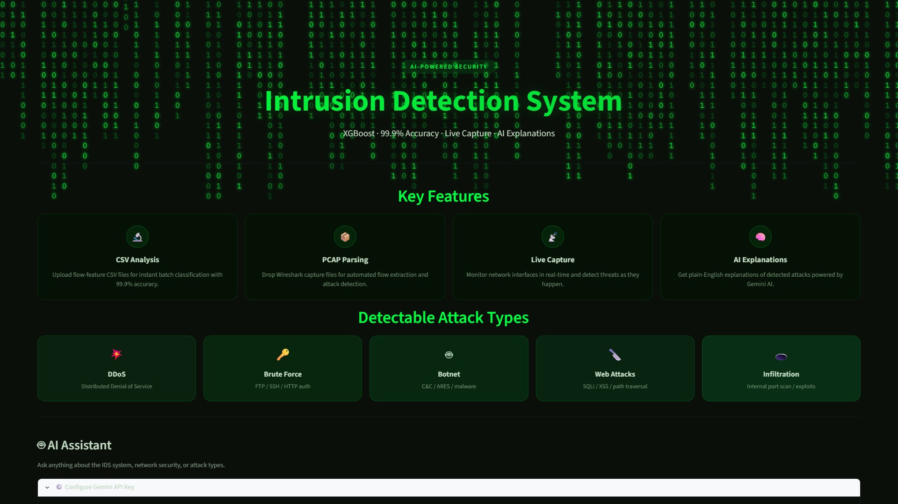
Figure 4.1: Full Dashboard Interface of the AI-Based IDS

4.3.2 PCAP Upload Tab
The PCAP upload interface, shown in Figure 4.2, allows users to upload packet capture files for offline analysis. The interface displays file upload controls, a progress indicator during feature extraction, and a results table showing classified flows with confidence scores. Users can filter results by prediction class and download the analysis report.
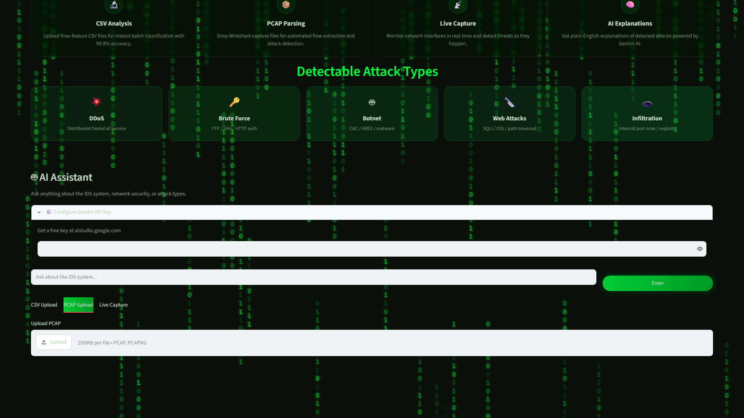
Figure 4.2: PCAP Upload Tab of the IDS Dashboard

4.3.3 Live Capture Tab
The live capture interface, shown in Figure 4.3, enables real-time network monitoring. Users select the network interface to capture from, start and stop the capture session, and view a scrolling table of classified flows that updates in real time. The interface also displays a live traffic summary showing the proportion of benign and malicious traffic detected during the session.
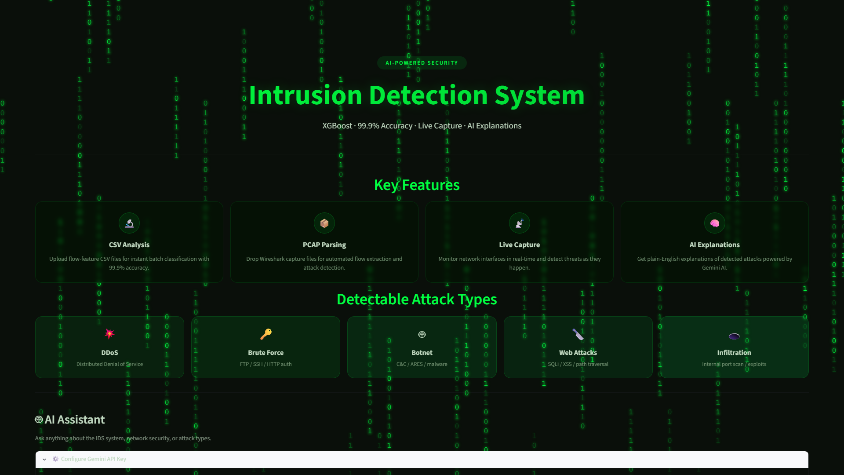
Figure 4.3: Live Capture Tab of the IDS Dashboard

4.3.4 AI Assistant
The AI assistant interface, shown in Figure 4.4, is located at the bottom of the dashboard. Users can type questions about detected traffic, request explanations of model predictions, or ask about network security concepts. The assistant responds with plain-language explanations grounded in the current session data, helping users understand the implications of the detection results.
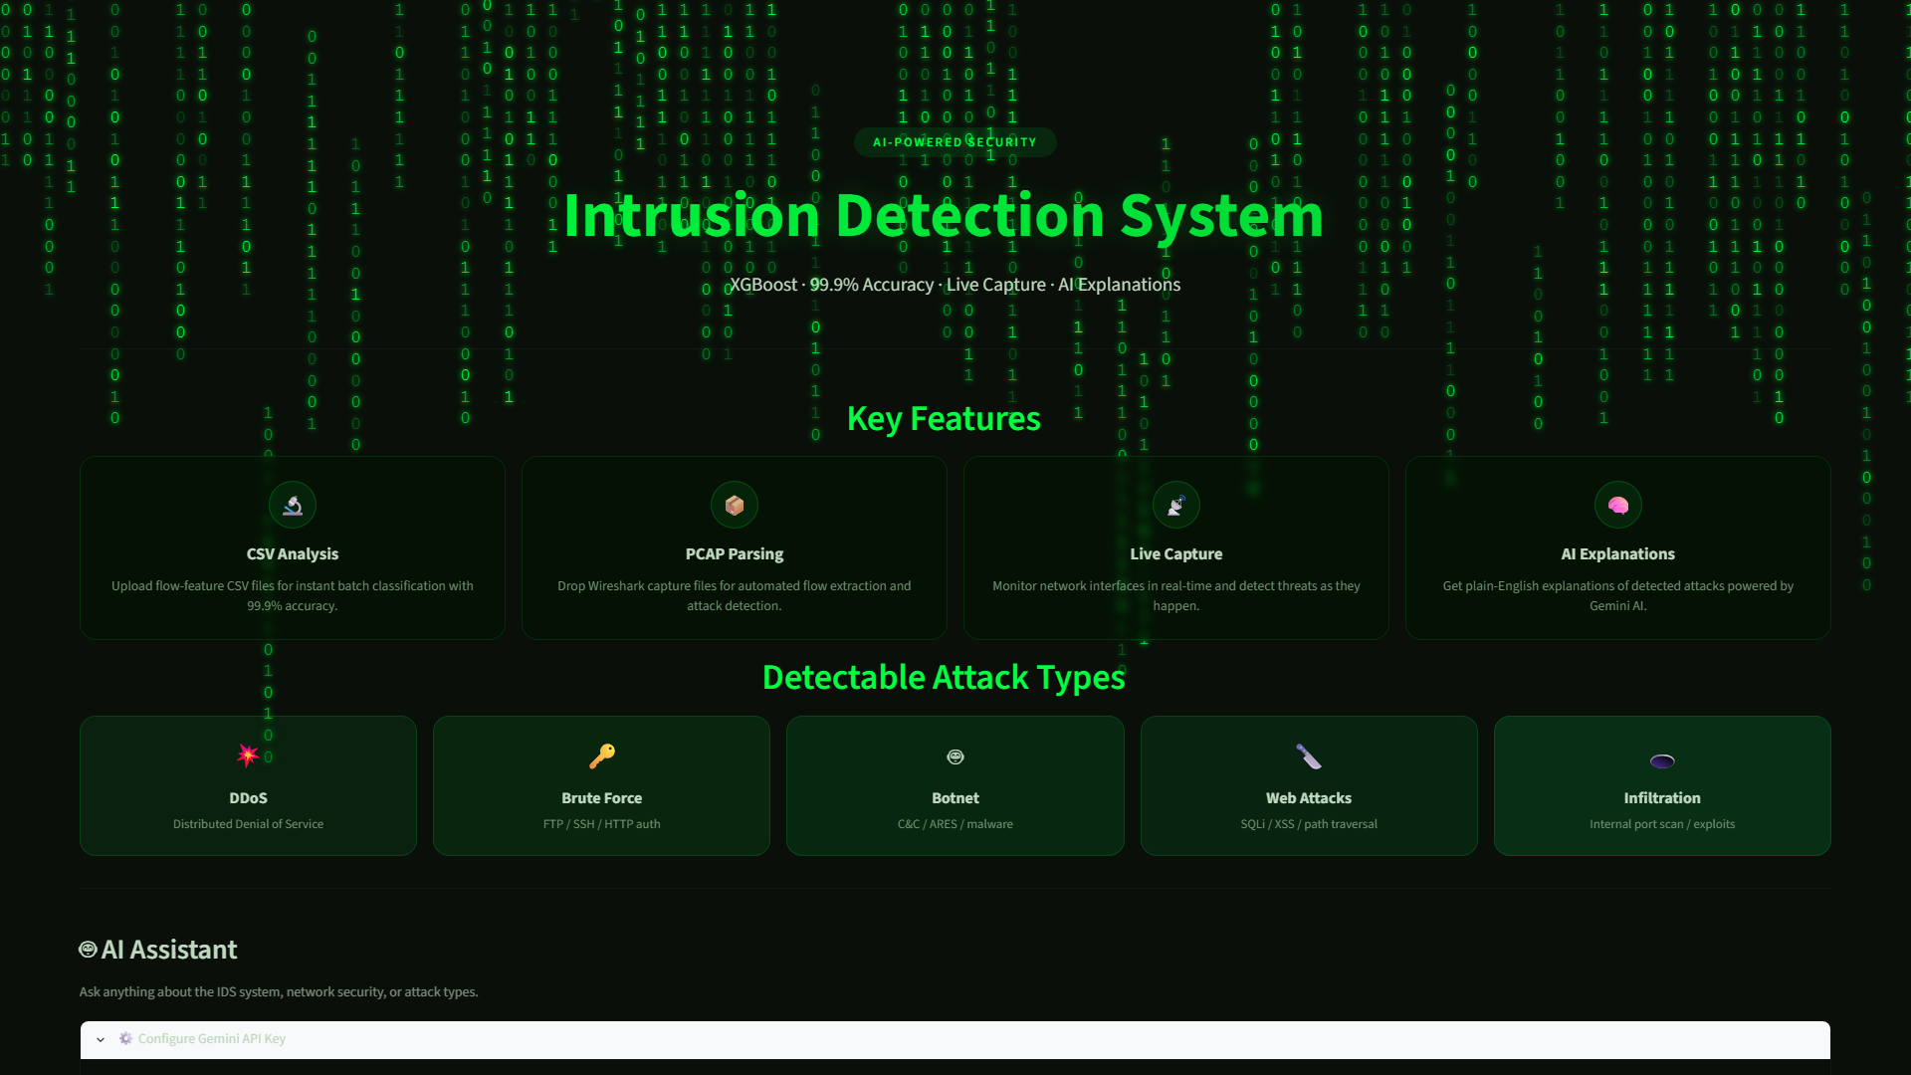
Figure 4.4: AI Assistant Interface of the IDS Dashboard

4.3.5 Confusion Matrix
The confusion matrix visualisation, shown in Figure 4.5, displays the performance of the XGBoost classifier on the test set. The matrix shows true positive, true negative, false positive, and false negative counts. The near-diagonal dominance of the matrix visually confirms the high classification accuracy achieved by the model.
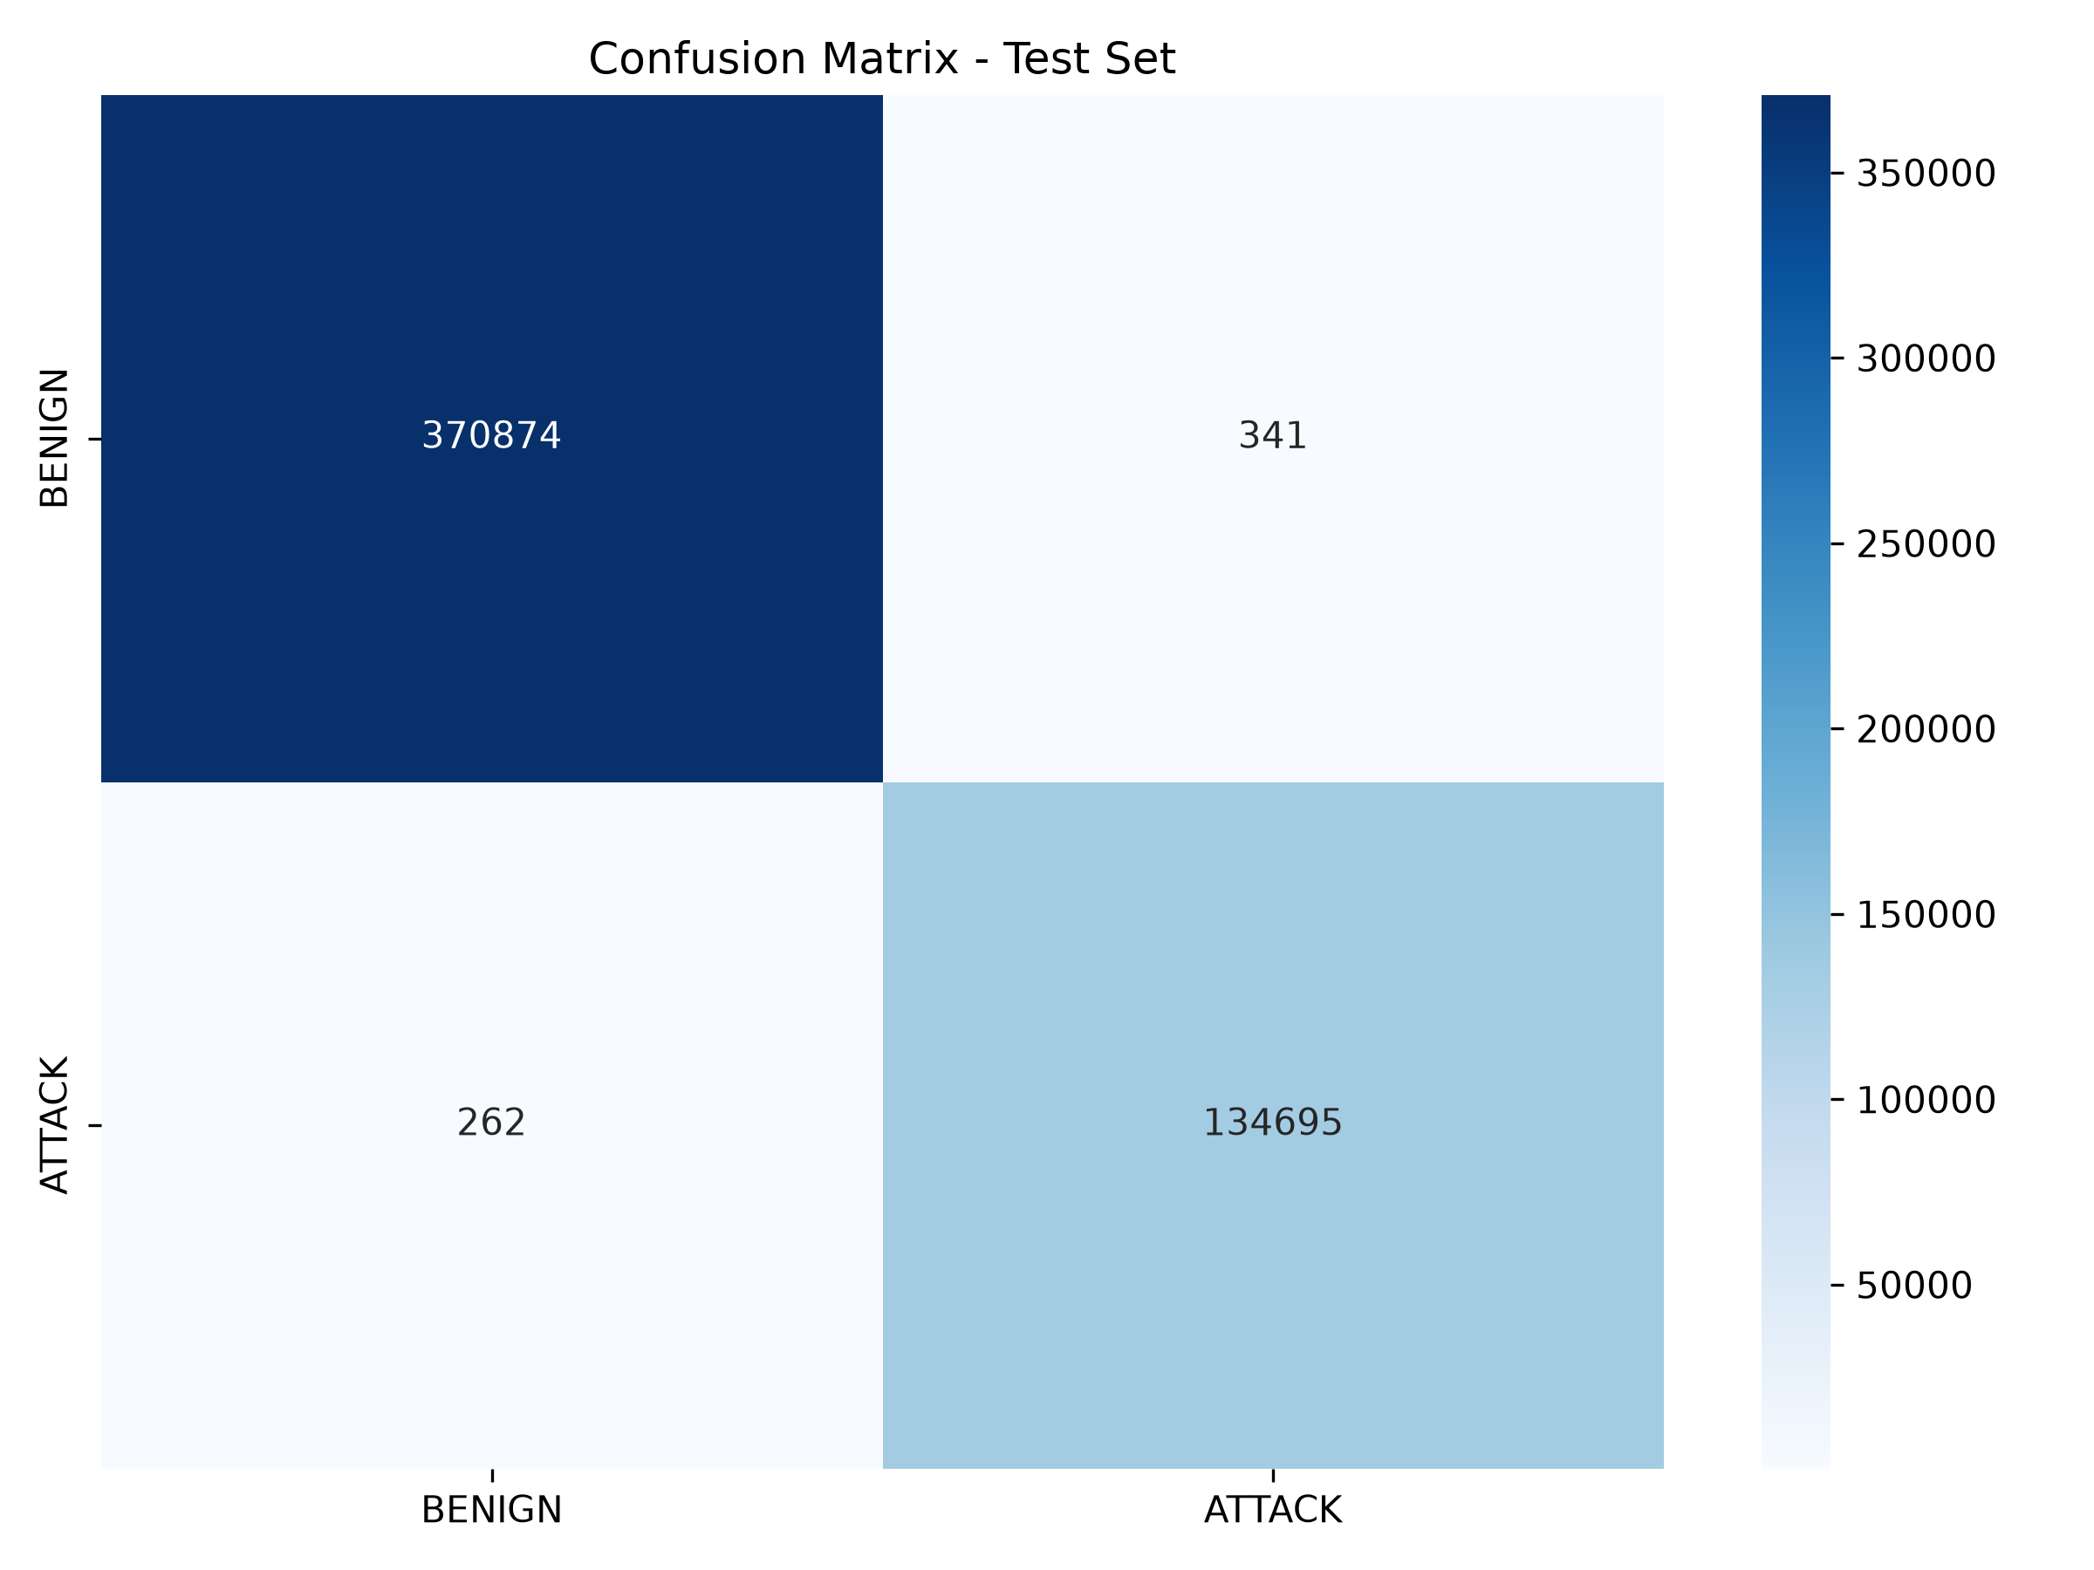
Figure 4.5: Confusion Matrix of the XGBoost Classifier

4.3.6 ROC Curve
The ROC curve visualisation, shown in Figure 4.6, plots the true positive rate against the false positive rate across various threshold settings. The curve's proximity to the top-left corner and the reported AUC value of 0.9999 demonstrate the model's excellent discriminatory power between benign and malicious traffic.
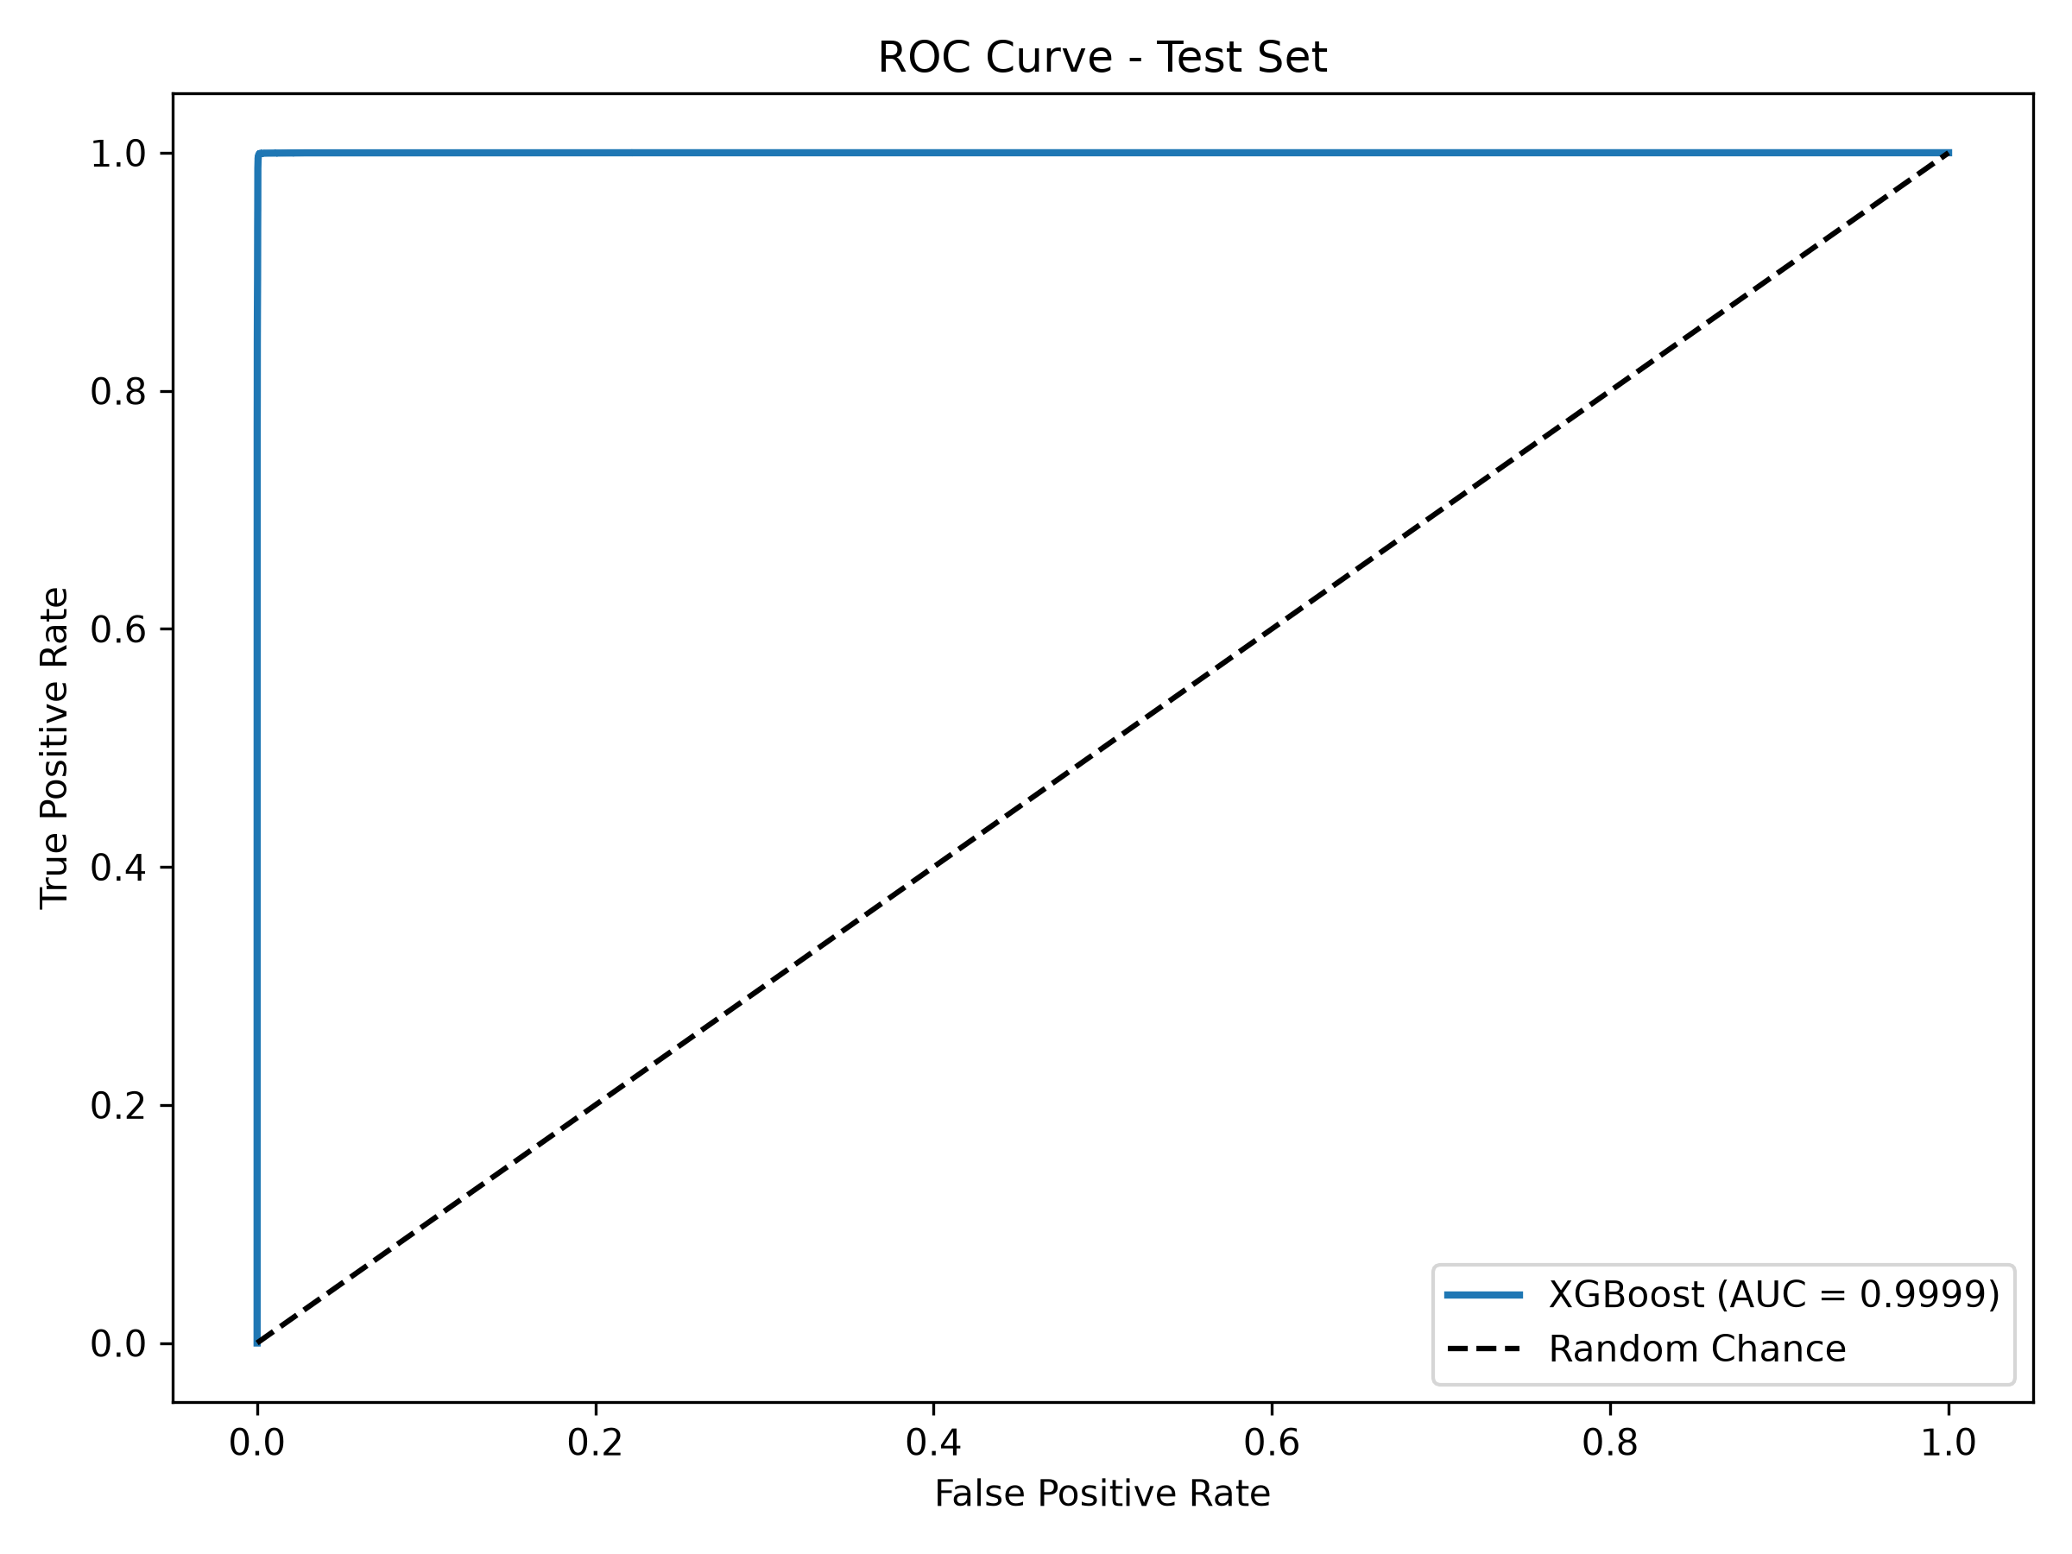
Figure 4.6: ROC Curve of the XGBoost Classifier

4.4 System Testing
The system was tested at three levels to ensure its reliability and correctness.

4.4.1 Unit Testing
Individual components of the system were tested in isolation. The data preprocessing functions were tested with sample inputs to verify correct cleaning, encoding, and scaling behaviour. The feature extraction module was tested with sample PCAP files to confirm that tshark was correctly invoked and that the output features matched the expected format. The model inference function was tested with known input vectors to verify that the predictions matched the expected outputs from the trained model.

4.4.2 Integration Testing
Integration testing verified that the components of the system worked together correctly. The complete pipeline from file upload (CSV and PCAP) through feature extraction and scaling to model inference and result display was tested end to end. The live capture pipeline was tested by generating sample traffic and verifying that flows were correctly captured, features extracted, and predictions displayed. Test results are summarised in Table 4.2.
Table 4.2: Summary of System Test Cases and Results
- CSV upload and classification — File uploaded, features validated, predictions generated, results displayed correctly. Passed.
- PCAP upload and classification — File parsed, features extracted, predictions generated, results displayed with flow information. Passed.
- Live capture and monitoring — Interface selected, packets captured, flows classified, predictions updated in real time. Passed.
- AI assistant queries — Questions answered with contextually relevant explanations based on dashboard data. Passed.
- Visualisation rendering — Confusion matrix, ROC curve, and feature importance charts rendered correctly. Passed.

4.4.3 User Acceptance Testing
User acceptance testing was conducted with sample network traffic data provided to users who interacted with the dashboard through all three operational modes. Users confirmed that the interface was intuitive, the predictions were accurate, and the AI assistant provided helpful explanations. Feedback from testing was used to make minor improvements to the interface layout and messaging.

4.5 Model Evaluation
The trained XGBoost model was evaluated on the held-out test set comprising 15% of the preprocessed CICIDS2017 dataset. The evaluation focused on both binary classification performance (benign vs. malicious) and multi-class classification performance across individual attack categories.
The binary classification results are shown in Table 4.1. The model achieved an overall accuracy of 99.9%, indicating that it correctly classified more than 99 out of every 100 traffic flows. The precision of 0.999 and recall of 0.999 demonstrate that the model maintains an excellent balance between minimising false positives and false negatives. The F1-score of 0.999 confirms the overall effectiveness of the classifier.
Table 4.1: Classification Report of the XGBoost Model
- Accuracy: 99.9%
- Precision: 0.999
- Recall: 0.999
- F1-Score: 0.999
- ROC-AUC: 0.9999
The confusion matrix (Figure 4.5) further illustrates the model's performance, with the vast majority of benign and malicious flows correctly classified. Only a minimal number of false positives and false negatives were observed, all of which occurred for traffic flows with feature distributions near the decision boundary. The ROC curve (Figure 4.6) shows an AUC of 0.9999, which is extremely close to the theoretical maximum of 1.0, confirming the model's outstanding discriminatory capability.
Feature importance analysis revealed that the most influential features for classification included flow duration, backward packet length statistics, and inter-arrival time statistics. These findings are consistent with the literature, which identifies these flow characteristics as strong discriminators between benign and malicious traffic patterns, even when the payload is encrypted.

4.6 Discussion of Results
The results confirmed that the system met all six objectives established in Chapter One. The CICIDS2017 dataset was successfully preprocessed through cleaning, encoding, splitting, and scaling (Objective 1). An XGBoost classifier was trained and optimised using cross-validation, achieving 99.9% accuracy and 0.9999 ROC-AUC (Objective 2). An interactive Streamlit dashboard was developed providing a unified interface for traffic analysis (Objective 3). Three operational modes were implemented covering CSV, PCAP, and live capture scenarios (Objective 4). A Google Gemini AI assistant was integrated to provide plain-language explanations of detections (Objective 5). The system was comprehensively evaluated through unit, integration, and user acceptance testing (Objective 6).
In relation to the existing literature, the system addresses the gaps identified in Chapter Two. Unlike signature-based IDS such as Snort and Suricata, the proposed system operates effectively on encrypted traffic by analysing flow-level statistical features rather than payload content. Compared to existing ML-based IDS research prototypes, the system provides a polished, user-friendly Streamlit dashboard that makes the technology accessible to non-expert users. The integration of the Gemini AI assistant addresses the explainability gap by providing natural-language interpretations of model predictions. The three operational modes provide flexibility that is absent from systems supporting only a single mode of traffic analysis.
Limitations of the current system include its dependency on the CICIDS2017 dataset for training, which may affect performance on traffic patterns not well represented in the dataset; the computational overhead of tshark-based feature extraction for large PCAP files; and the reliance on an internet connection for the Gemini AI assistant functionality. Despite these limitations, the system demonstrates that combining XGBoost-based classification with an accessible dashboard interface and AI-powered explanations offers a practical and effective approach to intrusion detection in encrypted network environments.

CHAPTER FIVE SUMMARY, CONCLUSION AND RECOMMENDATIONS

5.1 Summary of Findings
This project set out to design and implement an AI-based intrusion detection system capable of classifying encrypted network traffic as benign or malicious. The problem addressed was the fundamental limitation of traditional signature-based IDS in the face of widespread encryption, which hides attack payloads from inspection and allows malicious activity to evade detection.
A review of relevant literature and existing systems established that machine learning techniques, particularly ensemble methods such as XGBoost, can effectively classify network traffic using statistical flow features without requiring access to encrypted payloads. The review also revealed that existing ML-based IDS solutions often lack user-friendly interfaces, real-time monitoring capabilities, and explainability features, limiting their practical adoption.
Guided by these findings, the system was developed using the Agile approach with a modular architecture comprising data input, feature extraction, model inference, and presentation layers. The XGBoost classifier was trained on the CICIDS2017 dataset, achieving a classification accuracy of 99.9% and a ROC-AUC of 0.9999. A Streamlit dashboard was developed providing three operational modes: CSV file upload, PCAP file analysis, and live network capture. A Google Gemini AI assistant was integrated to provide plain-language explanations of detected threats.
Testing at the unit, integration, and user acceptance levels confirmed that all components of the system functioned correctly and that the complete pipeline from traffic input to prediction display operated reliably across all three modes. The AI assistant successfully provided contextually relevant explanations of model predictions and network security concepts.

5.2 Conclusion
The study successfully achieved its aim of designing and implementing an AI-based intrusion detection system for encrypted traffic. The system effectively combines the XGBoost machine learning algorithm with an interactive Streamlit dashboard and AI-powered explainability to provide a practical and accessible solution for network security monitoring. All six objectives defined in Chapter One were fully accomplished: the CICIDS2017 dataset was preprocessed, the XGBoost model was trained with exceptional accuracy, the Streamlit dashboard was built, three operational modes were implemented, the Gemini AI assistant was integrated, and the system was thoroughly evaluated.
The exceptional performance metrics, with 99.9% accuracy and 0.9999 ROC-AUC, demonstrate that XGBoost-based classification of flow-level features is an effective approach to intrusion detection in encrypted network environments. The system therefore provides a practical, lightweight, and reliable solution to the critical challenge of detecting attacks concealed within encrypted network traffic, contributing to the broader goal of improving organisational network security.

5.3 Recommendations
Based on the outcomes of this study, the following recommendations are made:
- Organisations should deploy the IDS with tshark installed on the deployment server to enable full PCAP analysis capabilities. The system should be positioned at network chokepoints where it can monitor traffic flowing between internal networks and the internet.
- The system should be extended to support additional traffic types and protocols beyond those represented in the CICIDS2017 dataset, including IoT traffic, DNS over HTTPS, and QUIC protocol traffic, to broaden its detection coverage.
- Continuous learning mechanisms should be implemented to allow the model to be periodically retrained on new traffic data from the deployment environment, adapting to evolving traffic patterns and emerging attack techniques.
- Network administrators using the system should regularly review the AI assistant's explanations and predictions to build familiarity with the model's behaviour and to develop trust in automated classification decisions.
- Security teams should combine the AI-based IDS with existing signature-based tools to create a layered defence architecture, leveraging the strengths of both approaches for comprehensive network protection.

5.4 Suggestions for Future Research
The following suggestions are offered for future work:
- Investigating deep learning architectures, including convolutional neural networks and transformers, for intrusion detection in encrypted traffic to compare their performance against gradient boosting methods on flow-based features.
- Implementing real-time streaming analytics frameworks such as Apache Kafka and Apache Flink to enable high-throughput, low-latency traffic processing suitable for enterprise-scale network environments.
- Developing a mobile alert and notification system that integrates with the IDS to provide real-time push notifications to security personnel when critical threats are detected, enabling faster incident response.
- Extending the system to support IoT network traffic analysis, as the proliferation of IoT devices introduces new attack surfaces and traffic patterns that differ significantly from traditional network traffic.
- Integrating the IDS with security orchestration, automation, and response (SOAR) platforms to enable automated threat response actions based on classification results, such as blocking malicious IP addresses at the firewall.
- Conducting a large-scale field evaluation of the system in a production network environment to measure its real-world performance, false positive rates, and operational impact over an extended deployment period.

REFERENCES
Buczak, A. L., & Guven, E. (2016). A survey of data mining and machine learning methods for cyber security intrusion detection. IEEE Communications Surveys & Tutorials, 18(2), 1153-1176.
Chen, T., & Guestrin, C. (2016). XGBoost: A scalable tree boosting system. Proceedings of the 22nd ACM SIGKDD International Conference on Knowledge Discovery and Data Mining, 785-794.
Sharafaldin, I., Lashkari, A. H., & Ghorbani, A. A. (2018). Toward generating a new intrusion detection dataset and intrusion traffic characterization. Proceedings of the 4th International Conference on Information Systems Security and Privacy (ICISSp), 1, 108-116.
Moustafa, N., & Slay, J. (2015). UNSW-NB15: a comprehensive data set for network intrusion detection systems. 2015 Military Communications and Information Systems Conference (MILCIS), 1-6.
Zhang, Y., Li, P., & Wang, X. (2019). Network intrusion detection using XGBoost. IEEE Access, 7, 164380-164391.
Pressman, R. S., & Maxim, B. R. (2020). Software engineering: A practitioner's approach (9th ed.). McGraw-Hill Education.
Sommerville, I. (2016). Software engineering (10th ed.). Pearson Education.
Russell, S. J., & Norvig, P. (2021). Artificial intelligence: A modern approach (4th ed.). Pearson Education.
Stallings, W. (2017). Network security essentials: Applications and standards (6th ed.). Pearson Education.
Goodfellow, I., Bengio, Y., & Courville, A. (2016). Deep learning. MIT Press.
Tan, P. N., Steinbach, M., & Kumar, V. (2016). Introduction to data mining (2nd ed.). Pearson Education.
Scikit-learn Developers. (2024). scikit-learn documentation. https://scikit-learn.org
Streamlit. (2024). Streamlit documentation. https://docs.streamlit.io
XGBoost Developers. (2024). XGBoost documentation. https://xgboost.readthedocs.io
Google. (2024). Gemini API documentation. https://ai.google.dev
Kohavi, R. (1995). A study of cross-validation and bootstrap for accuracy estimation and model selection. Proceedings of the 14th International Joint Conference on Artificial Intelligence (IJCAI), 14(2), 1137-1145.
Lundberg, S. M., & Lee, S. I. (2017). A unified approach to interpreting model predictions. Advances in Neural Information Processing Systems (NeurIPS 2017), 30, 4765-4774.

