who

Tim Roosevelt
about me

Charles Finney
about me

^{Experience a new}
Feeling
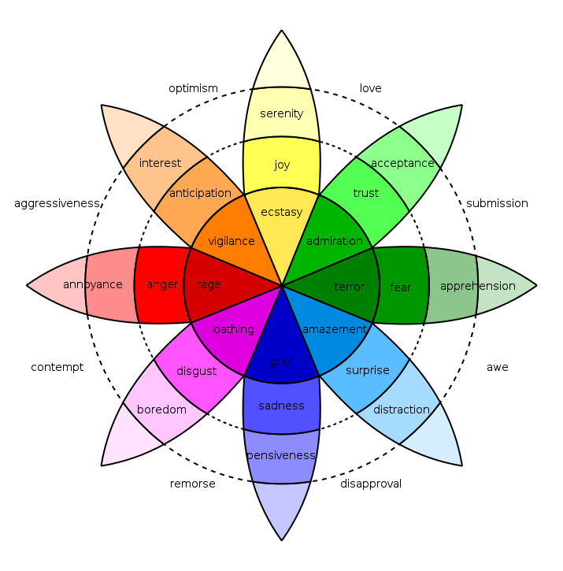
SAUdade
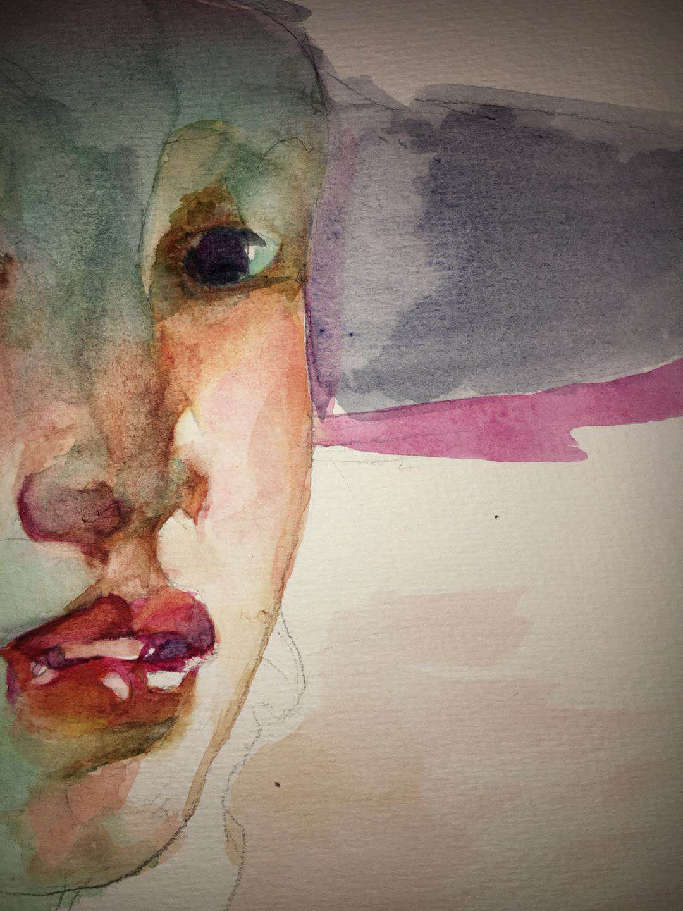
Joint Exhibit
Charles Finney
Tim Roosevelt

Charcoal & Watercolor

WHY

Two Friends who dreamed of continuing the tradition of a Western Art school in Shanghai like it was before the war. Their vision was interrupted after Charles got sick and had some of his toes amputated after frostbite and infection.

Now these two friends want to raise money for Charles’ medical expenses and to start their lives a new. After chasing the gleam of Adventure and roaming exploration around the globe so long they no longer fit in in there native land. So they are asking for help for their last adventure from which they most likely not return to America. For they need “to seek, to find and yet not to yield! “
WHAT

an elusive word saudade, a Portuguese and Galician term that is a common fixture in the literature and music of Brazil, Portugal, Cape Verde and beyond. The concept has many definitions, including a melancholy nostalgia for something that perhaps has not even happened. It often carries an assurance that this thing you feel nostalgic for will never happen again
Some specialists say the word may have originated during the Great Portuguese Discoveries, giving meaning to the sadness felt about those who departed on journeys to unknown seas and disappeared in shipwrecks, died in battle, or simply never returned

A melancholic feeling of longing of incompleteness a constant feeling of absence, the sadness of something that's missing, wishful longing for completeness or wholeness and the yearning for the return of that now gone

Saudade may be felt towards people and things whose whereabouts are unknown, such as old ways and sayings; a lost lover who is sadly missed; a faraway place where one was raised; loved ones who have died; feelings and stimuli one used to have; and the faded, yet golden memories of youth. Although it relates to feelings of melancholy and fond memories of things/people/days gone by, it can be a rush of sadness coupled with a paradoxical joy derived from acceptance of fate and the hope of recovering or substituting what is lost by something that will either fill in the void or provide consolation.

https://youtu.be/dNVrdYGiULM

HOW

You can help by;
join our celebration of life on our American Art Tour

L.A.
Austin
Houston
New Orleans
New York

