SDLC:

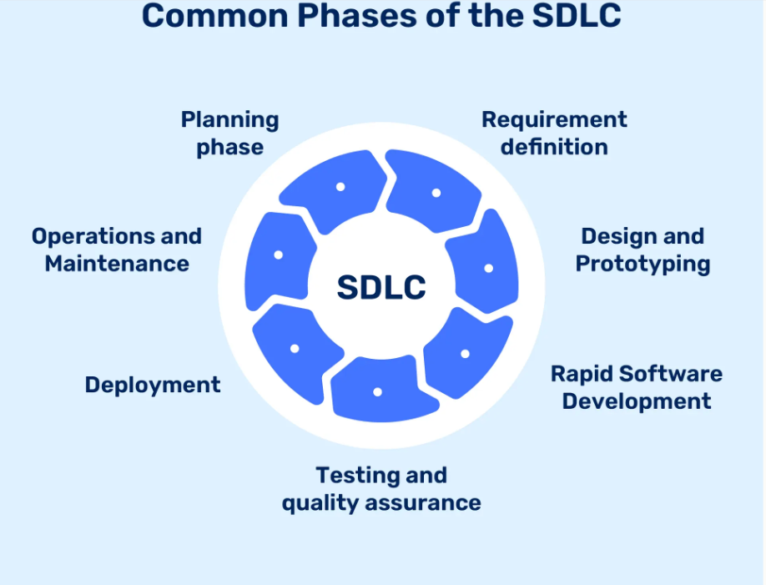

1. Planning

2. Requirement analysis

3. Design

4. Coding

5. Testing

6. Deployment

7.Maintenance

Waterfall Model:

------------------------

It is also called as Linear model. It uses linear sequential approach to the software development.

Phases:

1. Requirement Phase : Understand the Project and document what the project need to achieve. Here Business analyst or Project Manager , prepare SRS document.
2. Design Phase : Plan how to build the project. Create a blur print of the project and design.
3. Implementation Phase ( Coding or Development) : Here developers will build the project ( writing code) based on the design.
4. Testing: Test the project thoroughly to find and fix the bugs.
5. Deployment Phase : Release final product to the users.
6. Maintenance Phase : Fix any issues that comeup after the project Is in use.

Advantages of Water fall model:

----------------------------------------

1.Simply and easy to understand.

2.Clearly defines stages and milestones.

3.Easy to manage.

Disadvantages of Waterfall model:

1. Not flexible, hard to go previous phase.
2. Poor for complex and changing project.
3. Issues can be found late in the process, making them expensive to fix.

Iterative model:

-------------------

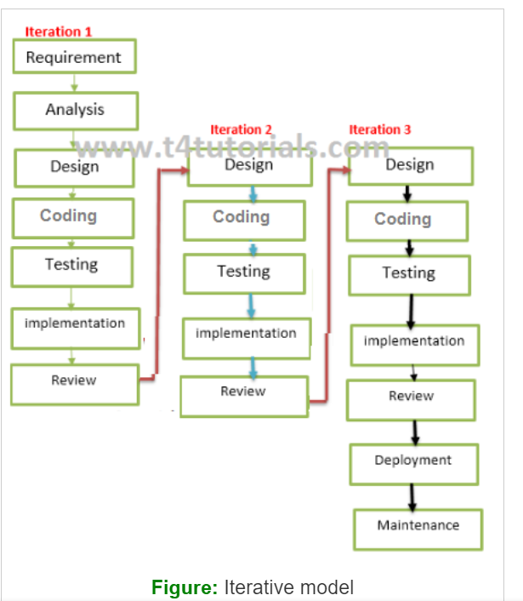

In this model, you can start with some of the software specifications and develop the first version of the software.  
  
When to use iterative model:

1.When requirements are defined clearly and easy to understand.

2.When the software application is large.

3.when there is a requirement of changes in the future.

Advantages of Iterative model:

1.Testing and debugging during small iterations is easy.

2.A parallel development can plan.

3.It is easily acceptable to ever-changing needs of the project.

4.Risks are identified and resolved during the iterations.

5.limited time spent on documentation and extra time on designing.

Disadvantage of Iterative model:

1.It is not suitable for small project.

2.More Resources may be required.

3.Design can be changed again and again because of imperfect requirements.

4. Requirement changescan cause over budgets.

5.Project completion date not confirmed because of changing requirements.

----------------------------------------------------------------------------------------------------------------------

V model : (verification and validation model)

It also follows a sequential design process same as waterfall model.

Verification phase: Developer life cycle

It involves a static analysis method done without executing.In this process of evaluation of the product development process to find whether specified requirements meet or not.

Validation Phase : Testers life cycle.

It is dynamic analysis phase, testing is done by executing the code. Validation is a process to classify the software after completion of the development process to determine whether the software meet the customers expections and requirement.

Eg: In application

Individual modules like Login page, Registration, Homepage…..

Click on submit button on the Login page we will directly move to the Home page.

When to use the V model:

1. When the requirements is well defined and not ambiguous.
2. This model should be used for small and medium-sized projects where requirements are clearly defined.
3. The V-shaped model should be chosen when the sample technical resources are available with essential technical expertise.  
     
   Advantages of V_model:

---------------------------------

1.Time Saving  
2.Good understanding of the project in the beginning.  
3. Every component must be testable.

4.Progress can be tracked easily.

5.suitable for small and medium sized project.

6.Cost effective model.

Disadvantages of V-model:

------------------------------------

1. No feedback, so less scope of changes.( No feedback from the customers)

2.Risk analysis not done.

3.Not good for big projects.

Spiral Model:

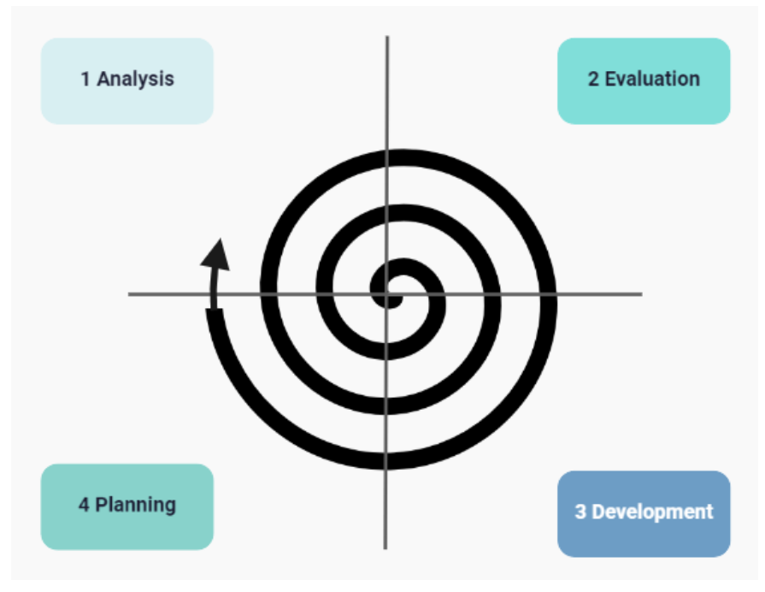

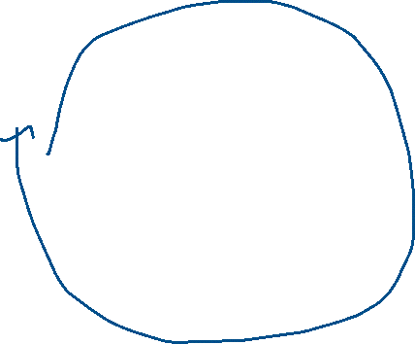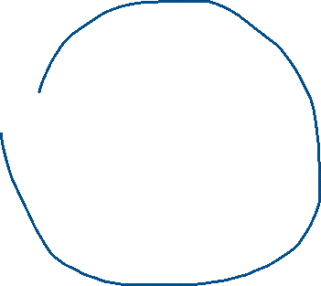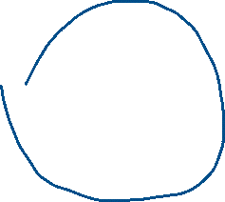

Spiral model in SDLC is a risk-driven model that combines the iterative development process with the systematic, controlled aspects of the waterfall model.

In a spiral model, software is developed in a series of Incremental releases.

Spiral model is divided into several framework activities or task regions.

Suitable for Large or complex project.  
Each spirals have deliverable product.

Feedback of each spiral is incorporated in the next spiral.

Customer can start using the system after every spiral.

Each spiral consists of waterfall model.( In each spiral, here we have all phases of waterfall model)

Phases of Spiral Model:

---------------------------

1.Risk Analysis Phase:Identify and evaluate the risk associated with the project.

2.Evaluation Phase: Evaluate the software to determine if it meets the customer's requirements and it is of High Quality.

3.Developement Phase: Develop the software based on the requirements gathered in the previous iteration.

4.Planning Phase: Determine the scope of the project and create a plan for the next iteration.

When to Use Spiral model:

-----------------------------------

1.Large and Complex Projects.

2. High-risk projects: It is suitable for projects with many unknown risks that occur during the development process.

3.Projects with Unclear or Complex requirements

4.Project with Frequent release:

Advantages of Spiral Model:

-------------------------

1.Risk handling:

2.Flexibility in requirements: Change requests can be incorporated accurately at any phase.

3.Customer satisfaction: Customers can see the development of the product at early stages, allowing them to provide feedback and adapt to the system .

4. Iterative and Incremental approach: This model provides an iterative and incremental approach to software development, allowing for flexibility and adaptability.

5.Improved Communication: Regular evaluations and reviews improve the communication between the customer and development team.

6.Improved Quality: This model allows for multiple iteration of the software development process, resulting in improved software quality.

Disadvantages of Spiral model:

---------------------------------------

1.Complexity : This model is more complex compared to other SDLC models

2.Expensive : It is not suitable for Small project due to its high cost.

3. Dependence of Risk Analysis: The successful completion of the project depends on the effective risk analysis.

4.Difficulty in Time management: The Number of Phases is unknown at the start of the project, making the time estimation is challenging.

5.Complex Documentation: The model requires extensive documentation due to the multiple iterations and phases involved.

Prototype Model:

----------------------

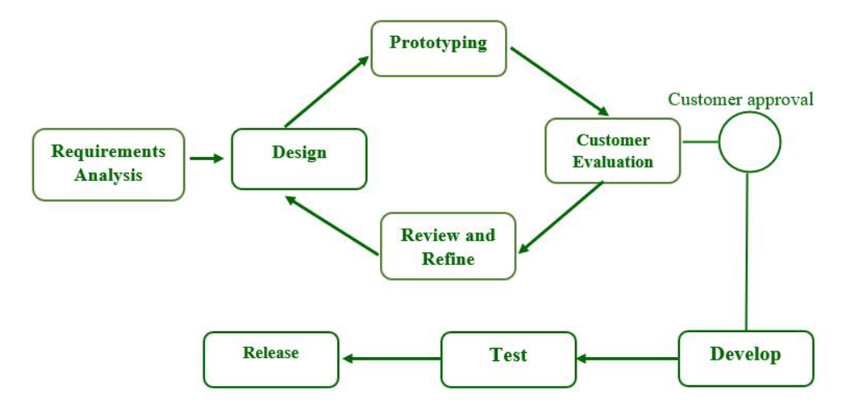

Prototype model in SDLC is a software development methodology that involved creating a initial prototype of the software product before developing the final product.

This model is particularly used for the projects where the requirements are not clear or not well defined or likely change over a time.

The Prototype is a working model of the software product that can be used to gather feedback and refine the design before the final product is developed.

Phases of Prototype Model:

-------------------------------

1. Requirement Gathering And Analysis: This stpe involves the Understanding the customer requirements and identifying thr basic features of the product.
2. Design: A high-level design of the system is created based on the gathered customer requirements.
3. Build a Prototype: The initial prototype is developed , focusing on the basic functionality and Userinterface ( i.e., initially they develop only user interface i.e., HTML)
4. Initial user Evaluation:The prototype is presneted to te customer for feedback , which helps to refine the design.
5. Review and Refine: The prototype is further refined based on the customer feedback until it meets the final requirements.
6. Implement the product and Maintain:The final system is developed and maintained based on the refined prototype.

When to use Prototype:

1. It can be used when the customer is not sure about what he wants.
2. Useful for New technologies or New domains.

Advantages Of Prototype Model:

---------------------------------------

1.Increaded User involvement and understanding of the system

2. Reduced time and cost due to early defect detection.

3.Quicker User feedback and better solution

4.Identifies missing functionalities and confusing Functions.

5.Flexibilty in design and easier accomadation of new requiremets.

Disadvantages of Prototype model:

1.Risk of insufficient requirement analysis.

2. Users may get confusion between Prototype and actual product.

3.Complexity of the system may increases due to the scope expansion.

4.Developers may reuse the prototypes even when not technically feasible(capable).

5. High costs and potential for poor documentation due to changing requirements.

-------------------------------------------------------------------------------------------------------------

RAD Model ( Rapid Application Development)

----------------------------------------------------

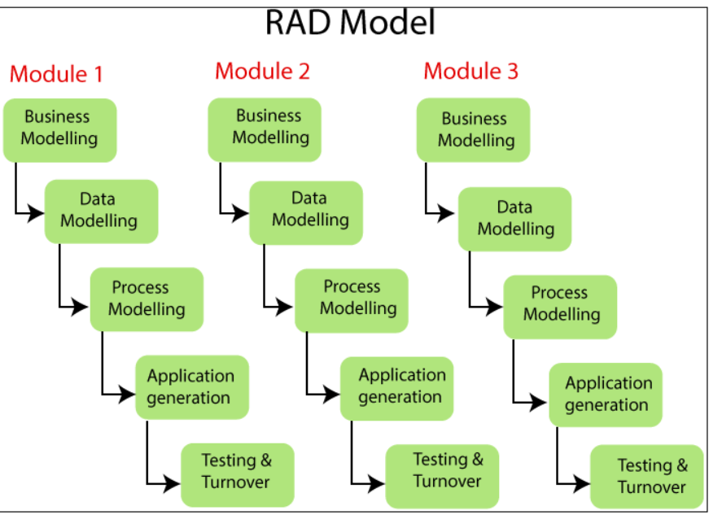



RAD model is a software development process that emphasizes rapid prototyping and iterative development without any specific planning.. ( which means it focuses on rapid prototyping and iterative development, that is instead of spending a lot of time planning, developers will create prototypes ( sample or dummy) early and refine them through multiple iterations).

*** It is useful when there is time deadline.

**** Each module developed independently and later integrated.( any number of teams will develop each module separately , instead of 1 team there will be two or more teams)

(Login page ---Home page ---add items ---- go to cart page --- payment)

*** It is useful for Large and Complex projects.

*** The endusers and the developers should committed to completing the system in a mentioned time frame. It a Lack of commitment then RAD will fail.

Phases in RAD Model:

1.Business Modeling: This phase involves understanding and Designing the product based on the flow of information and distribution between various business channels.

** The main purpose of this phase is to ensure that the system requiremnts align with the business objectives and the user needs.

@. Data Modeling:

In this phase, the information gathered during the business modeling phase is refined to set of data objects that are vital for business.It included the data structures, relationships betweeen the data objects.

The main pupose of this modeling is to create clear and efficient data model that supports the business processes and meets the data requirements.

Process Modeling:

This Phase involves converting the data objects sets into business information flows ( Flow charts) needed to achieve specific business objectives.

The main purpose of this model is to ensure that the processes supports the business operations and data flows effectively.

Application Generation Modeling:

In this phase they will use automation tools, which converts the process and data models into actual prototypes( sample or dummy application). It invoves coding, compiling, Building the application , often using the RAD tools to speed up the the development process.

The main purpose of this model is to rapidly create a working system that can be iteratively fefined based on the user feedack.

RAD tools:

MS Visual Studio( IDE), Database Management tools ,Pre-buils components and libraries( like in python PANDAS, NumPy….)

Testing and Turnover(deployment and maintianance):

This phase involves testing the prototypes individually during each iteration and ensuring thorough testing of data flow and interface.

The main purpose of this model is to ensure that the system is meeting the specified requirements before it is fully deployed.

Advantages of RAD model:

1.Flexible and adaptable to changes:

2.Reduced overall projets Risks:Testing the prototypes during each iteration before deploying.

3.Increased productivity:Smaller team of developers can complete th eproject more quickly compared remaining traditional models.

4.Reduced development time:

5.Improved Customer satisfaction:  
  
Disadavantages of RAD Model:

1.Required Highly skilled developers and designers:

2.Not suitable for smaller projects:

3.Limited scalability:RAD projects becomes complex and difficult manage.

4.Requires user involvement through out the life cycle:

5.Technical risk is high:If the team lacks the necessary skills then the project may fail.

Big Bang model:

______________

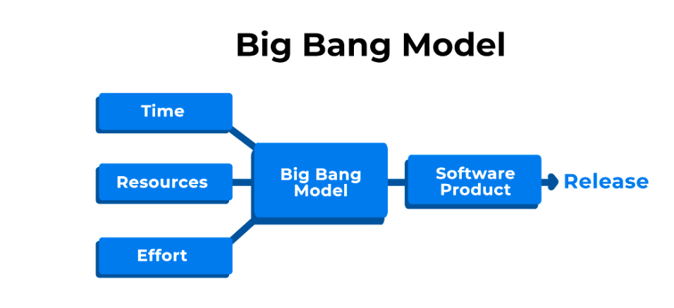

The Bigbang model in the SDLC involves allocating available resources for the software development process, primarily in terms of coding, without any specific planning or requirement analysis.

It is known for its simplicity and minimal planning requirements but it is considered high risk due to lack of planning and potential for misunderstanding in the requirements.

No planning required.

High Risk

Simple and easy to implement

Flexible for developers.

Not suitable for large project

When to Use BigBAng Model:

Small projects

Learning purpose

Experimental projects

Advantages of Bigbang model:

1.Simple and easy to implement

2,Less cost

3.Good for learning

4.Flexible for developers

Disadvantages of the Bigbang model:

1. High Risk

2. Not suitable for large projects

3. Poor model for ongoing projects.

------------------------------------------------------------------------------------------------------------------------

Hybrid model:

Hybrid model is a way of developing the software that mixes the parts of different traditional models to fit the needs or requirements of the project.

**Combines different approaches; It takes best parts from the various SDLC like., waterfall , spiral model, v model….

*** Customized for each project: the conmibination is tailored to what the project needs making it flexible and efficient.

Hybrid model lets teams to create a development process just right for their projects unique requirements.

Common combinations for Hybrid model are:

1. Spiral model and Prototype model:
2. V model and Prototype model
3. Waterfall model and Agile Model

When is suitable:

1.Customer requirements are not fixed or change rapidly.

2.A single SDLC model cannot meet the All project requirements.

3.The organisation wants to use agile methodologies but complexity is a barrier.

4.A fully planned approach to the budget is needed.

5. Teams in the Organisation want collaboration.

Advantages of Hybrid model:

1.Combining the benefits of two or more models.

2.Resolving the dependencies n=between the models.

3.Suitable for small and medium sized projects.

4.Involving customers at all phases of development.

5. Enabling early delivery of software to the customer.

Disadvantages of Hybrid model:

1. Increased Complexity in handling two models together for large application/projects.
2. Higher cost due to changes.
3. Uneven working pattern as the same patterns cannot be followed for all Hybrid models.

Agile model / Agile Methodology / Agile process:

It is a process model with Iterative and Incremental approaches.

This model is comfortable for client because each and every activity is carried out by client interaction.

Principles of Agile:

1.Customer no need to wait for a long time. ( if the application have 100 features, they will finish 10 features and release 1st version)

2.We develop, test and release piece of software with few number of features.

3.We can accept or accommodate requirements changes from the customer.

The main goal of Agile is to deliver the quality product to the customers with a short period of time.

Everyone ( team members including customer and Business Analyst) collaborates to work together to achieve the goal.

Advantages of Agile:

-------------------------

1.Customer satisfaction with rapid, continuous delivery of useful software.

2.Working software is delivered frequently. Release will very fast.

3.People and interactions are emphasized rather than process and tools.

4.It is very easy model to accommodate.

Disadvantages of Agile:

--------------------------------

1.In case of some software deliverables, especially for large project, it is difficult to to assess the efforts required in the beginning of the project.

2.Their will be less focus on design and documentation.  
  
3.The project can easily get taken off the track if the customer representative is not clear what the final outcome they they want.

SCRUm:

Agile: Agile is a process model. Usally agile defines some principles and how the process should be,To follow these principles they will use scrum.

Scrum: It is a kind of **framework** through which we build the software product by following Agile process.

Agile SDLC breaks build into small incremental builds(SPRINTS) and these builds are provided into iterations( Releases)

Scrum included group of people called **Scrum team**. Normally this team contains 5 to 9 members.

**Product owner**

**Scrum master**

**Dev Team ( Development team)**

**QA team(Quality assurance team/ testing team)**

Roles:

***Product owner:

He is the person who is responsible for managing and controlling product backlogs.

He is the person who is officially responsible for the value of workdone.

He is the person who is actually interacting with the customer and collect the requiremnts

Defines the features of the product.

He will prioritize and adjust the features of the product according to the market value in every iteration of the product.

Accept or reject the workdone( he will finalize the bit of software to release or not )

***Scrum master:

It is a specific role ( he is not Dev member, testing member or any other project management team)

He is responsible for ensuring that the Scrum values, practices and rules are followed correctly.

Scrum master is the driving force behind scrum and helps the scrum team and organisation , adopt the use of scrum to produce a high quality product.

Most of the meeting are organised by scrum master.

*** Development Team And Testing Team:

Developers will build the application and they will do Unit testing and Intergration testing and after their testing they will deploy the product Staging Environment(QA environment), Here testers will start testing the application and find the defects after resolving the defects , they will retest the application until the software reaches to customer requiremnts.

Important terminologies in Scrum:

1. User Story:

A feature or Functionality or module in a software. Product owner is responsible for preparation of this.

2.Epic:

A collection of User stories.

3.Product backlogs:

The requiremnts of the product being developed by the scrum team are listed in the product backlog. The PO is responsible for the product backlogs , and its content, availability and prioritization.

4.Sprint (Iterations):

It is time period to complete the user stories.It is decided by PO along with remaing team members, normally it will 2 to 4 week.

5.Sprint Planning meeting:

It is meeting conducted with the team to define what can be delivered in the sprint or duration. (mostly it is one day meeting at the beginning of the project starts)

6.Sprint Backlogs:

List of commited User stories by the DEV and QA team for a specific sprint.

7.Scrum meeting /Daily Scrum/standup meeting:

Meeting conducted by the scrum master everyday 15min. , it is called as Scrum meeting.Each member will explain about 3 things here.

I)What you did yesterday?

II)What you will today?

III)Are there are any blockers or challenges or obstacles in his or her way?

8.Sprint retrospective meeting:

It is conducted once only after completion of the Sprint.

Entire team including both scrum master and PO should participate.

They will discuss about few things like,

I)What went well or wrong with the current sprint?

II)What can be done differently for the next sprint?

III) what other improvemnets are needed in the upcoming sprint?

9. Story points:

It is a rough estimation time for completion of user story, it will be given by Dev ( Designing and developing) and QA team ( writing testcases and execution of testcases, finding defects, retesting).They will usually represent in fibinocci series.

0 1 1 2 3 5 8 13 ……….

1 story point = 1 day or 6 to 8 hrs.

**Example:**

**Login -- User story**

**Dev team --- 5 hr**

**Qa ---- 3 hrs**

**5+3 = 8 hrs**

10.Brundown/up chart:

It is a kind of graph ot tabular format.It shows how much work is still remaining, how much they have completed, todo list.

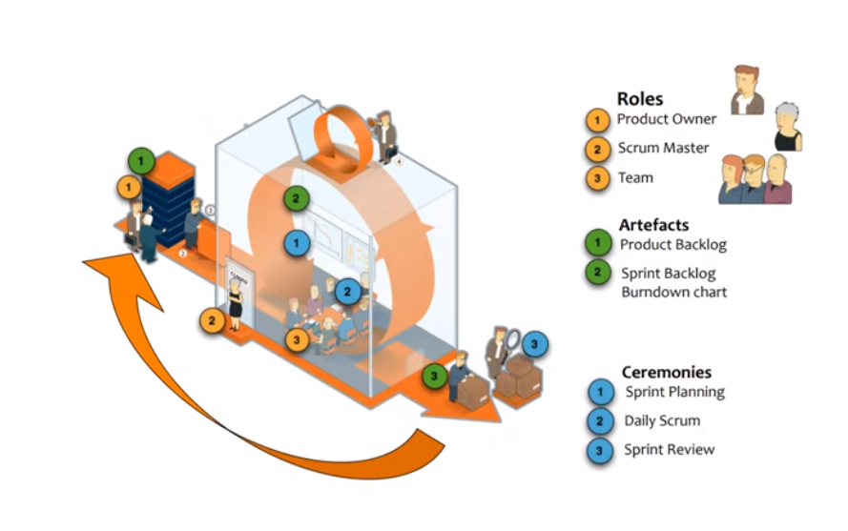

Artefacts means Documentations.

11. Sprint Review:

After completion of the sprint, sprint review will conducted , before sprint retrospective meeting. Here they will give Demo of the User stories to the product owner, If he is satisfied with features, then it will released to the customer before starting the next sprint.

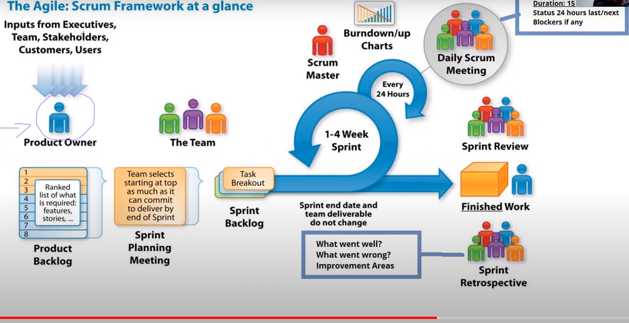

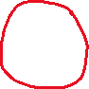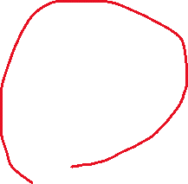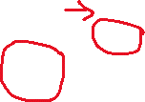

Po will gather the requorements from the customer and preapare Product backlog( documnetation relating to list of epics).

He will conduct Sprint planning meeting before beginning the project, here they will discuss about the flow of the project. Dev and QA will give commitment( Sprint backlog i.e., list of committed user stories).

With in the sprint(2 to 4 weeks of time) they will design , develop, test the application and go for Sprint review. Meanwhile everyday scrum master will organise daily daily scrums to discuss with the team members what they did yesterday and going to today, if we struck with any blockers , then he going to resolve it.

After sprint review if the PO is satisfied with the piece of software then he will release it to customer. After completion of sprint , they will Sprint Retrospective meeting.

This is a continuos iteration and incremental process, until the customer satisfied with fulpledged software.

Scrum board: they will track the user stories on day to day basis. It is maintianed by the whole team.

When to say the User story is Ready and done:

Ready:

======

Is clear

Is testable

Sized by dev team

Scrum team accepts user experience artefacts

Team has a good idea what it will mean to demo the user story.

Done:

Code produced

Code commented, checked in and run

Unit tests written and passing.

Passed UAT(User acceptance testing)

Any build/ deployment/configurations changes are implemented/documented/communicated.

Remaining hours for task set to zero and task closed.

Product backlog

Sprint plan in the sprint planning meeting

For particular user story developer tasks and tester tasks should complete.After completion it will go to demo for product owner.