Weather Underground ArcMap Add-in

This software was developed and executed under ArcGIS 10.2.2 for Desktop. The add-in makes use of a Python script located in g:\586\final\source and must be in this location in order for the add-in to function properly. The script can also be executed directly from the toolbox by double clicking the wunderground script.

This software will use the country name parameter to retrieve almanac data from wunderground.com.

The script checks for the existence of the lowTemp and highTemp fields in the attribute table, and creates them if they do not exist.

If the country name does not match, or no data is returned for a selected city in a coutry, “unavailable” is written to the lowTemp and highTemp columns in the attribute table.

The supplied map document, CMH_Final.mxd, has both country and city names in the attribute table. This script can be adapted to work with any feature class that has both city and country in its attribute table.

Installation:

1. Unzip the contents of the zip file into g:\586\final\
2. Double click the addin file to install the ArcMap addin (Figure 1)

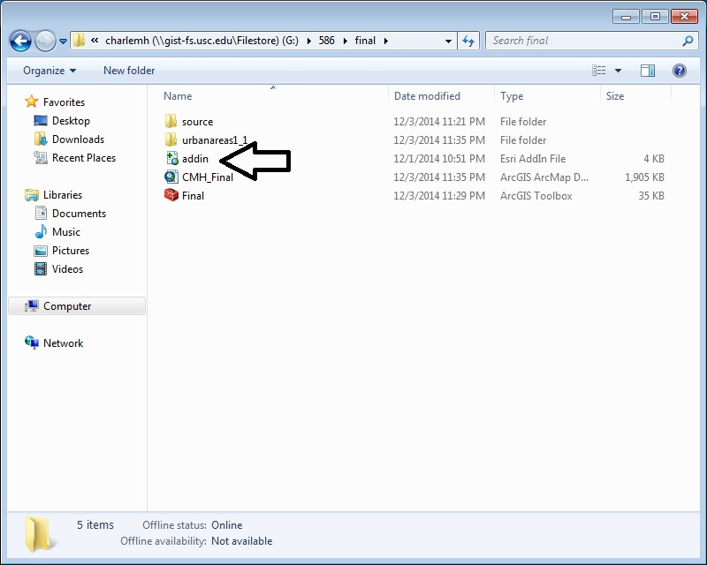

Figure 1

1. Launch ArcMap
2. Click on Customize -> Add-In Manager to confirm the installation
3. If the tool bar with the AlmanacData button does not show, right click on the toolbar and click the check box next to the Wunderground add-in in order to show the button.
4. Open the CMH_Final.mxd map document
5. Open the attribute table and confirm that the low and high temp fields do not exist and do not contain data, they are the last fields on the right. (Figure 2)

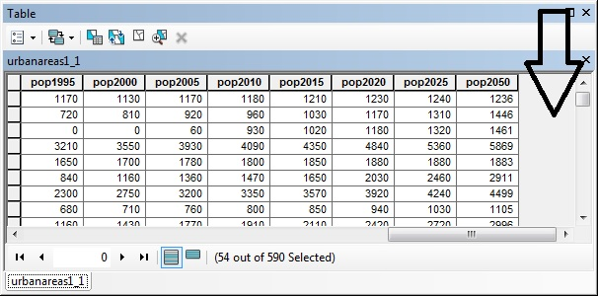

Figure 2

1. Run the tool
   1. Set the input feature class to G:\586\final\urbanareas1_1\urbanareas1_1.shp
   2. Enter Bulgaria for the Country and click ok. (Figure 3)
      1. Other countries are also available such as Canada, USA, China, etc. I would ask that you limit your choices to countries with fewer entries in the attribute table.

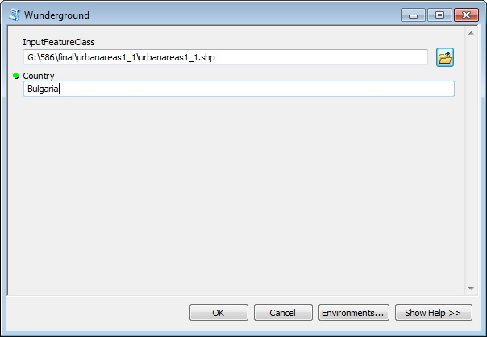

Figure 3

1. Review the results
   1. The script dialog should show successful execution (Figure 4)
   2. The attribute table will now have lowTemp and highTemp fields containing temperature data for the cities in the selected country (Figure 5)

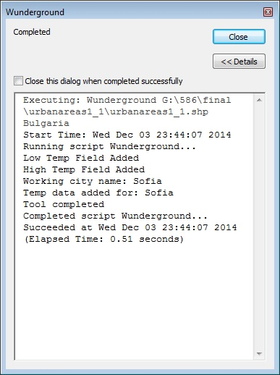

Figure 4

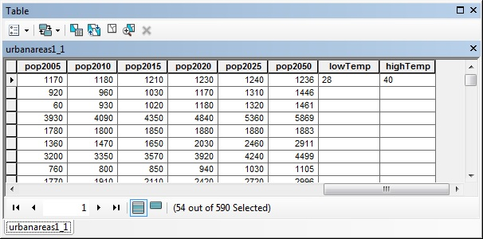

Figure 5