Weather Underground ArcMap Add-in

Installation:

1. Unzip the contents of the zip file into g:\586\final\
2. Double click the addin file to install the ArcMap addin (Figure 1)

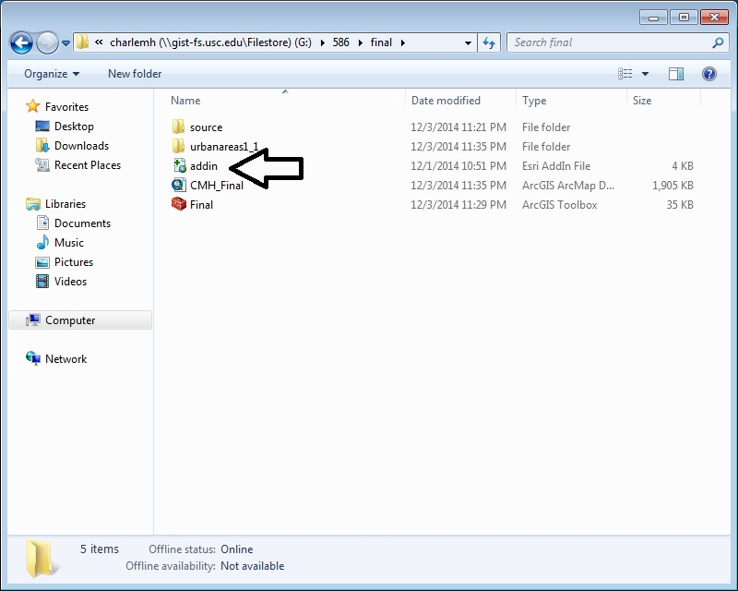

Figure 1

1. Launch ArcMap
2. Click on Customize -> Add-In Manager to confirm the installation
3. If the tool bar with the AlmanacData button does not show, right click on the toolbar and click the check box next to the Wunderground add-in in order to show the button.
4. Open the CMH_Final.mxd map document
5. Open the attribute table and confirm that the low and high temp fields do not exist and do not contain data, they are the last fields on the right. (Figure 2)

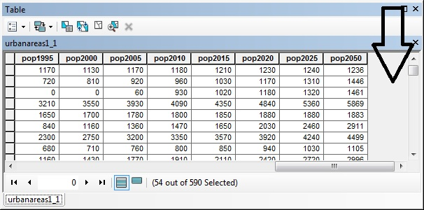

Figure 2

1. Run the tool
   1. Set the input feature class to G:\586\final\urbanareas1_1\urbanareas1_1.shp
   2. Enter Bulgaria for the Country and click ok. (Figure 3)
      1. Other countries are also available such as Canada, USA, China, etc. I would ask that you limit your choices to countries with fewer entries in the attribute table.

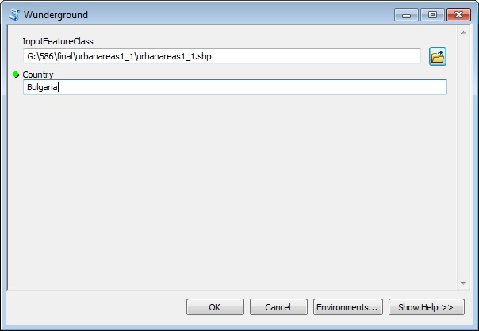

Figure 3

1. Review the results
   1. The script dialog should show successful execution (Figure 4)
   2. The attribute table will now have lowTemp and highTemp fields containing temperature data for the cities in the selected country (Figure 5)

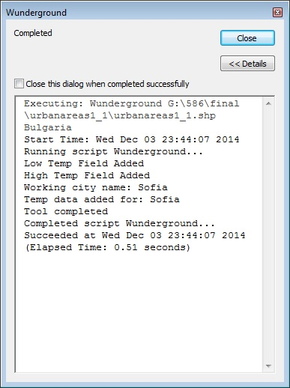

Figure 4

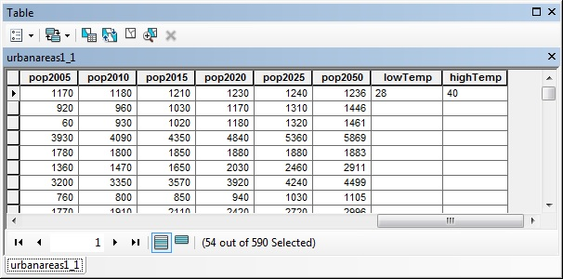

Figure 5