Use the git below for Jenkins deploy

* <https://github.com/charleshoanduong1111/create-new-angular-app-for-beginners.git>

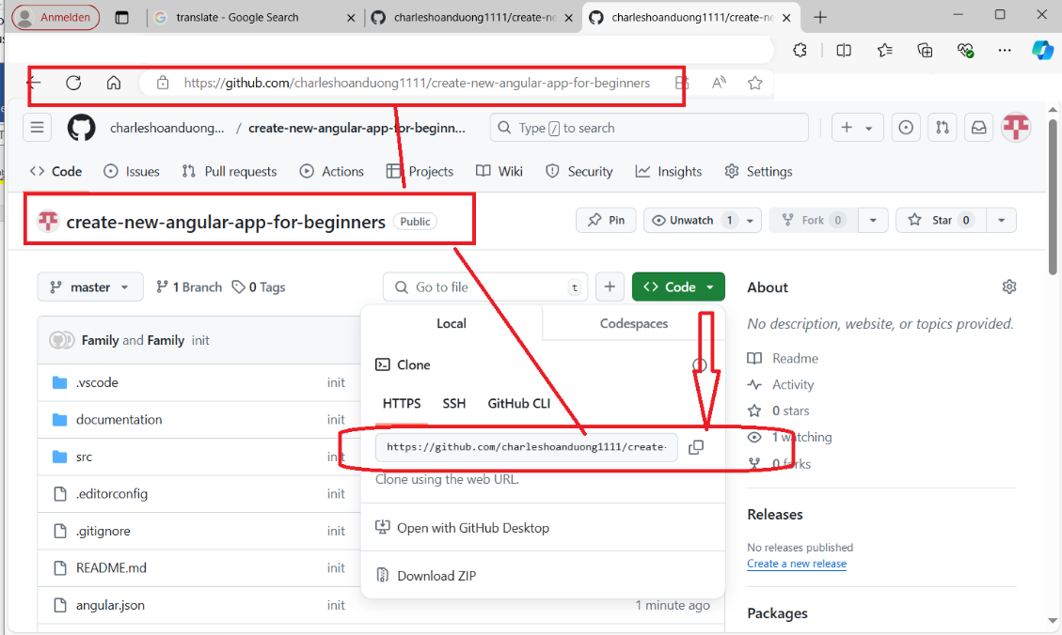

**WINDOWS INFO**

C:\Users\Family\git\jenkins-build-deploy-nodejs-with-docker-app>node –version  
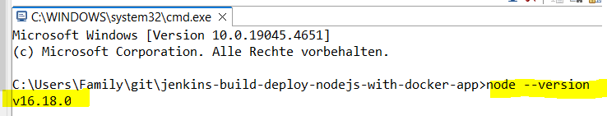

C:\Program Files\Jenkins>where node  
C:\Program Files\nodejs\node.exe  


C:\Users\Family\git\jenkins-build-deploy-nodejs-with-docker-app>npm --version

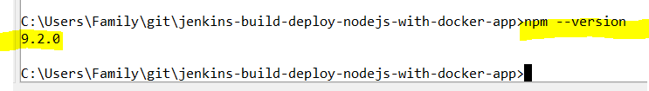

C:\Users\Family\git\jenkins-build-deploy-nodejs-with-docker-app>git –version 

C:\Users\Family\git\jenkins-build-deploy-nodejs-with-docker-app>where git  
🡪 C:\Users\Family\AppData\Local\Programs\Git\cmd\git.exe



C:\Users\Family\git\jenkins-build-deploy-nodejs-with-docker-app>where cmd  
C:\Windows\System32\cmd.exe



**JENKINS**

**HOW TO START, RESTART, STOP Jenkins on Window 10**

I have extracted zip file and installed Jenkins on Windows 10 successfully.   
Jenkins runs at http://localhost:8080/ well.   
How can I do that? What's the way to start, restart and stop through console/command line?

On Windows, open Console/Command line --> Go to your Jenkins installation directory (very likely cd "C:\Program Files\Jenkins\"). Execute the following commands respectively:

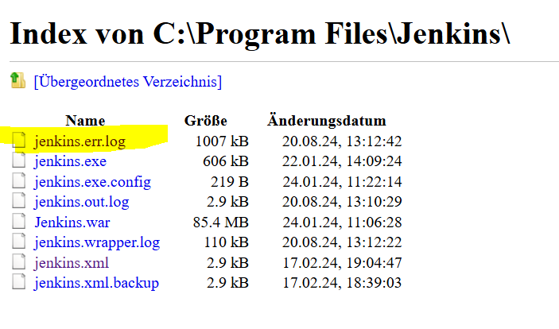

**cd C:\Program Files\Jenkins\**

**to stop:  
.\jenkins.exe stop**

**to start:  
.\jenkins.exe start**

**to restart:  
.\jenkins.exe restart**

Start Jenkins

C:\Users\Family\git\jenkins-demo-with-node-js-react-npm-app>cd C:\Program Files\Jenkins  
C:\Program Files\Jenkins>dir

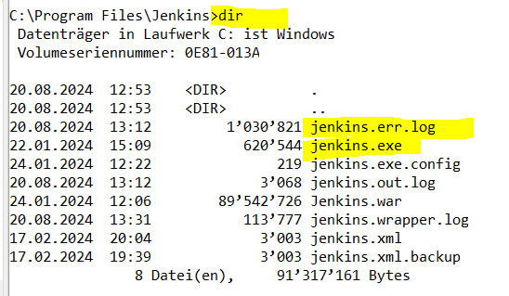

C:\Program Files\Jenkins>.\jenkins.exe start



* <http://localhost:8080/login?from=%2F>

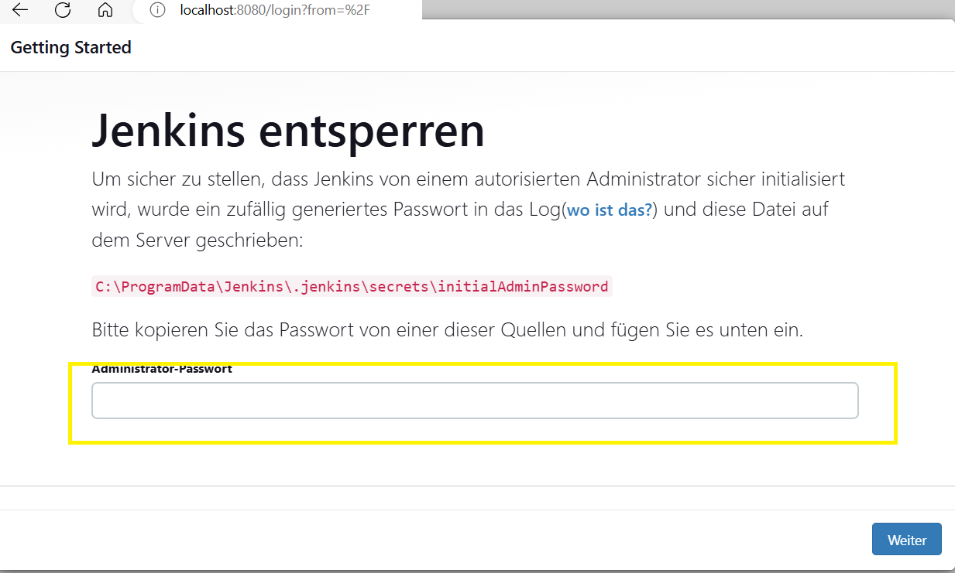



In Jenkins.err.log file contains the Jenkins login password as shown below:

Jenkins initial setup is required. An admin user has been created and a password generated.  
Please use the following password to proceed to installation:  
c51a111bd6fe414f9ccfd15848e72ef9

This may also be found at: C:\ProgramData\Jenkins\.jenkins\secrets\initialAdminPassword

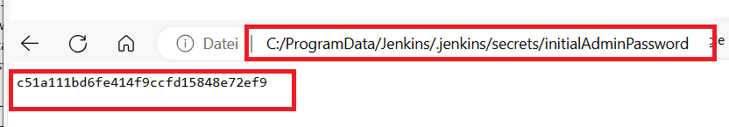

On browser 🡪 localhost:8080

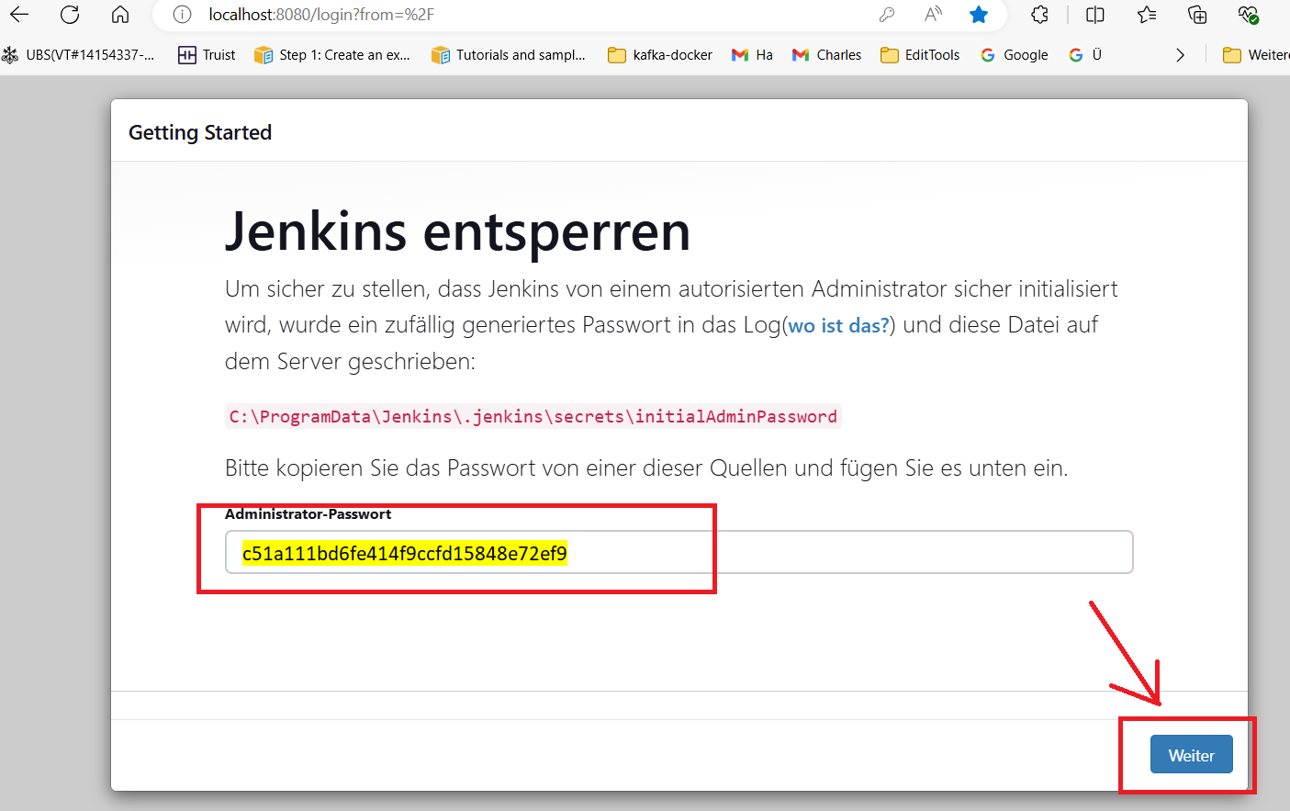

Jenkins 🡪 Getting Started page shows.

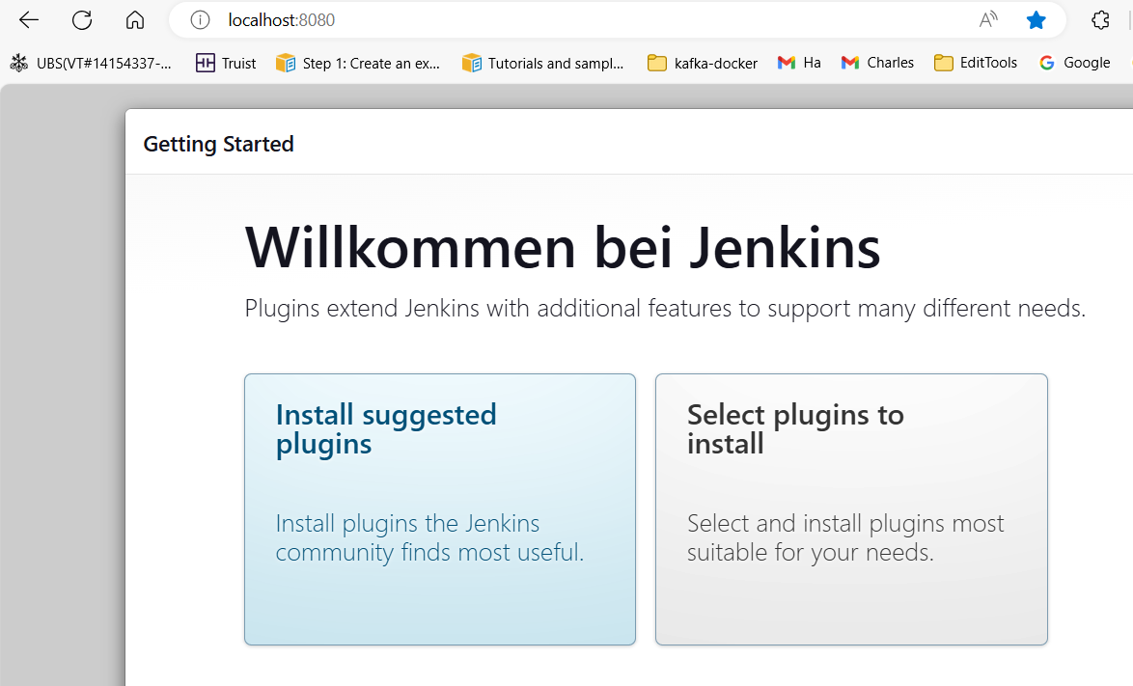

Click 🡪 Install suggested plugins

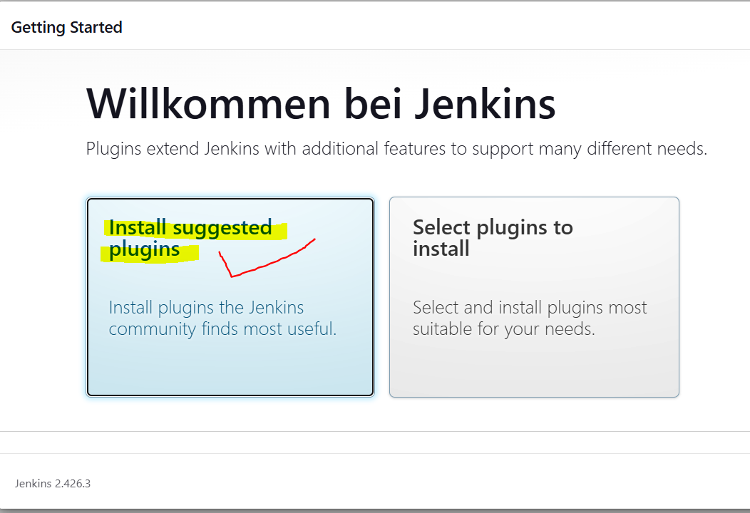

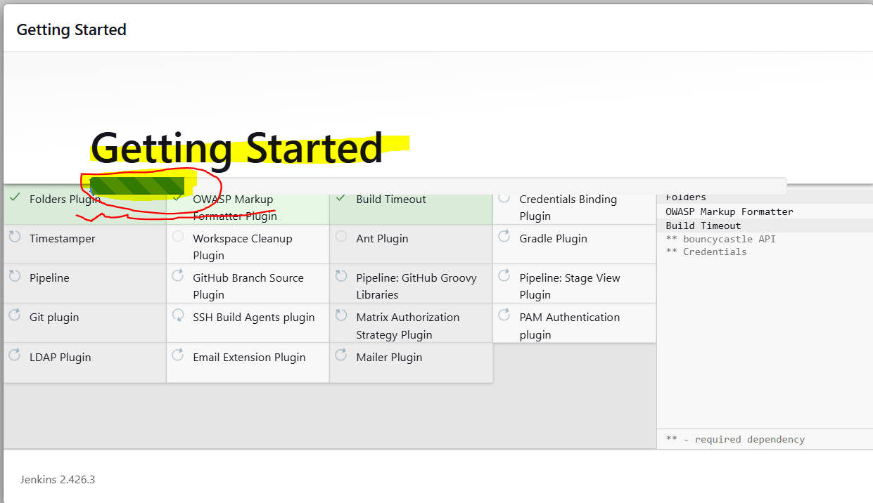

Give 🡪 UserID=admin and Password=admin and then click 🡪 “Save and Continue”-Button.

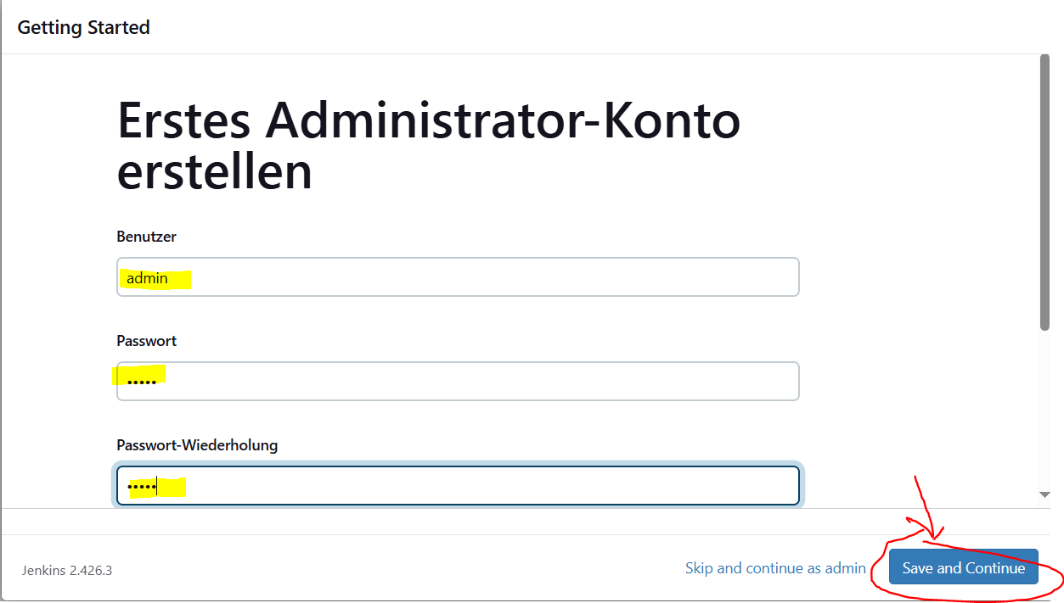

Forget E-mail Address 🡪 Give 🡪Email and then click 🡪 “Save and Continue”-Button.

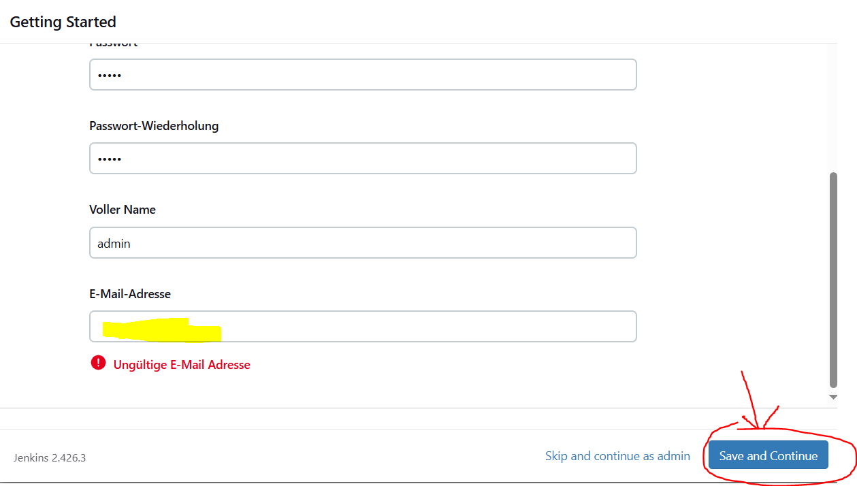

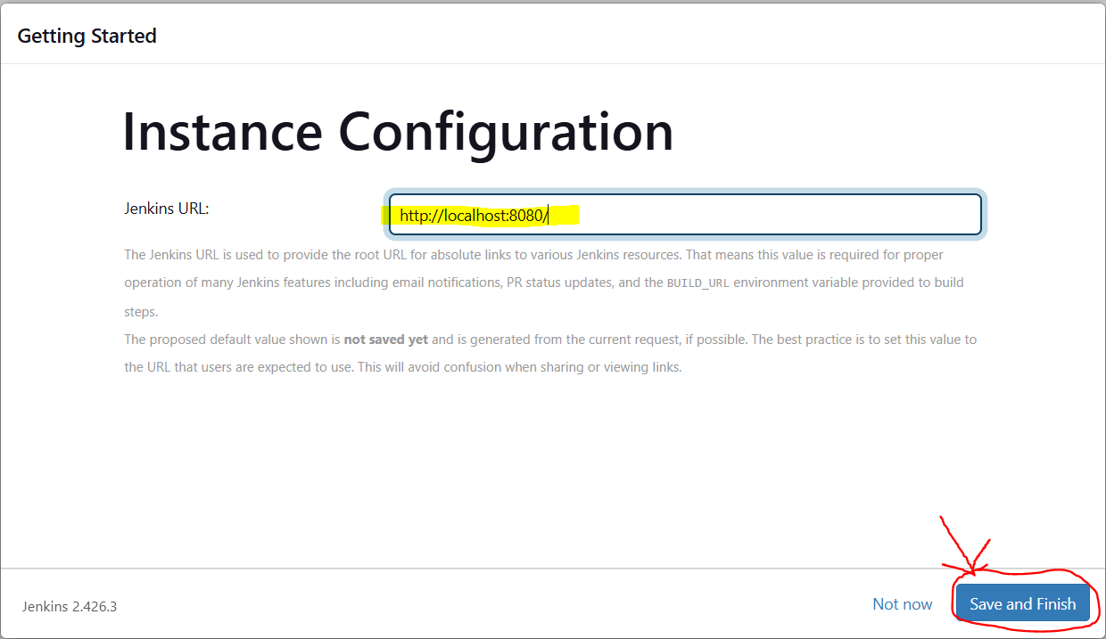

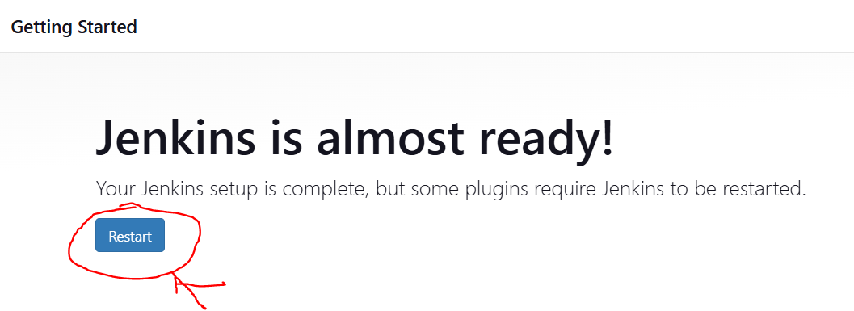

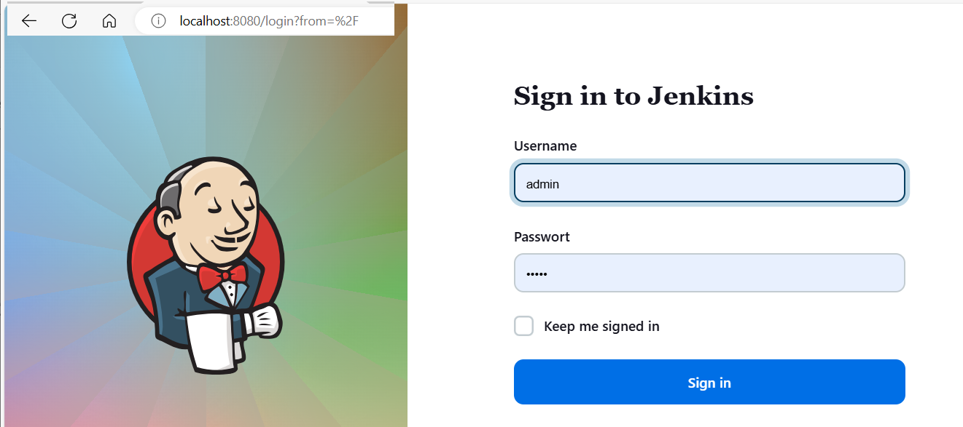

Username=admin and Password=admin 🡪 Click Sign in

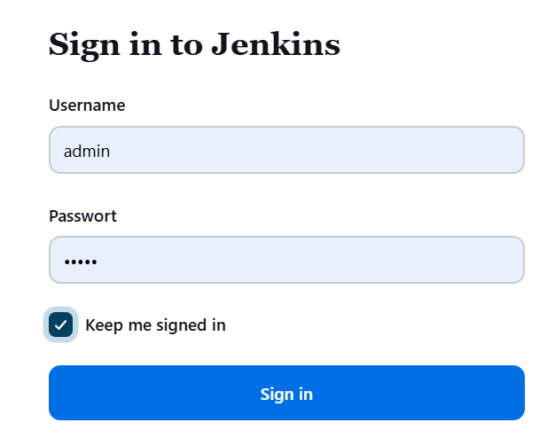

Successful 🡪 Jenkins welcome page shows.

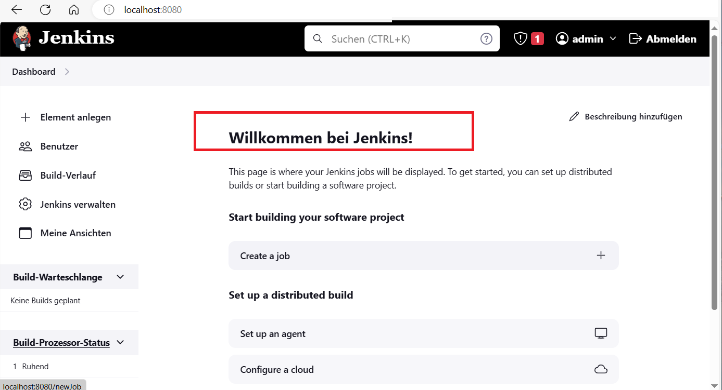

STOP Jenkins

C:\Program Files\Jenkins>.\jenkins.exe stop



<http://localhost:8080/> 🡪 shows that the connection is broken. 🡪 OK

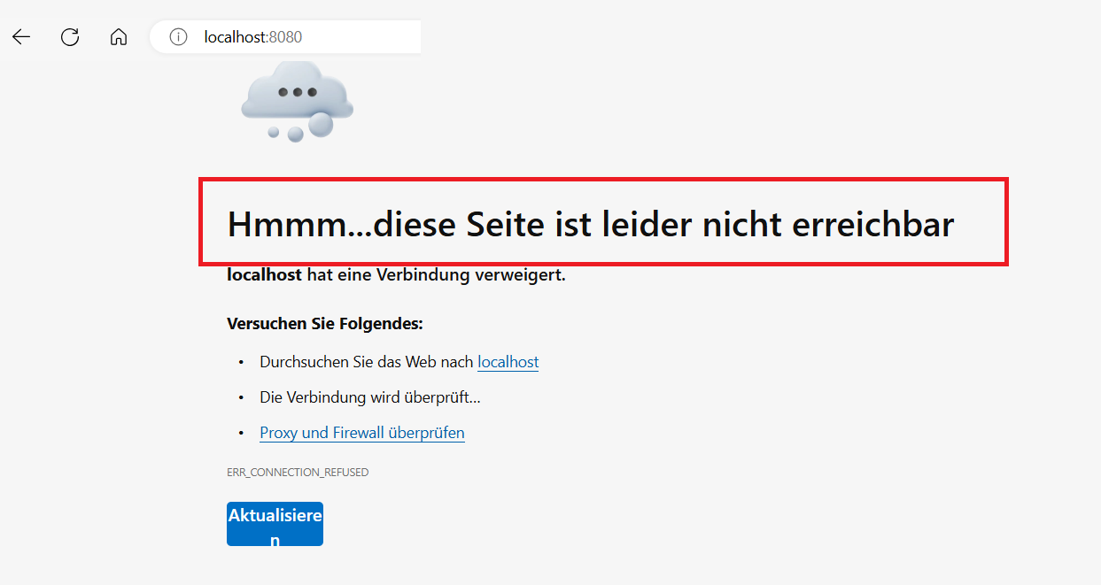

Start Jenkins 🡪 C:\Program Files\Jenkins>.\jenkins.exe start  
and login Jenkins 🡪 Jenkins open as shown below.

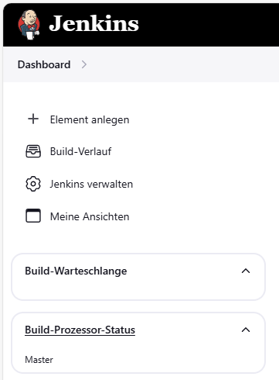

Jenkins 🡪 Build and deploy angular app

* Building with “Pipeline”
* Add new element

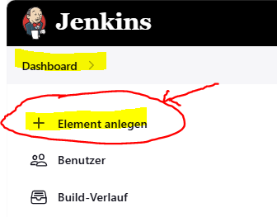

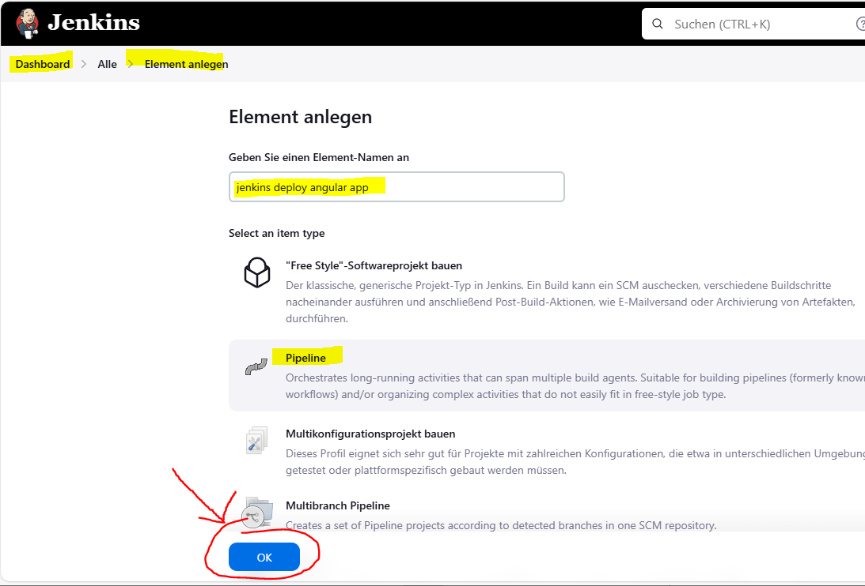

Go to your GitHub repository and copy the public URL of your project:

* GitHub 🡪 <https://github.com/charleshoanduong1111/create-new-angular-app-for-beginners.git>

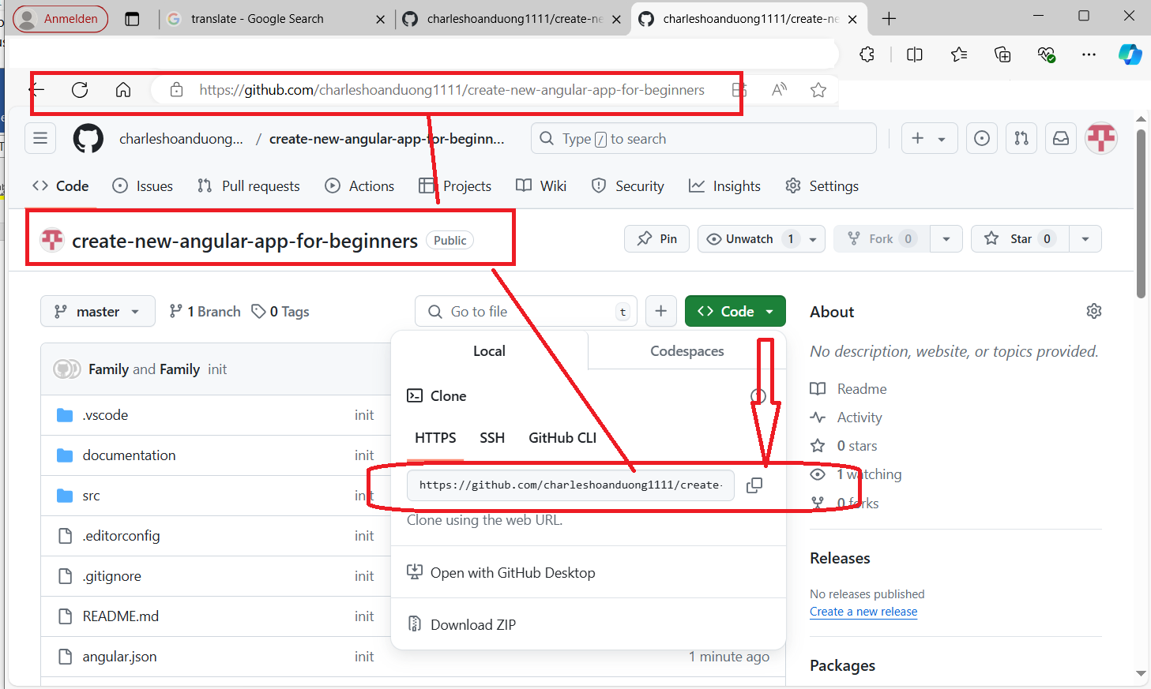

Now configure pipeline settings as follows:

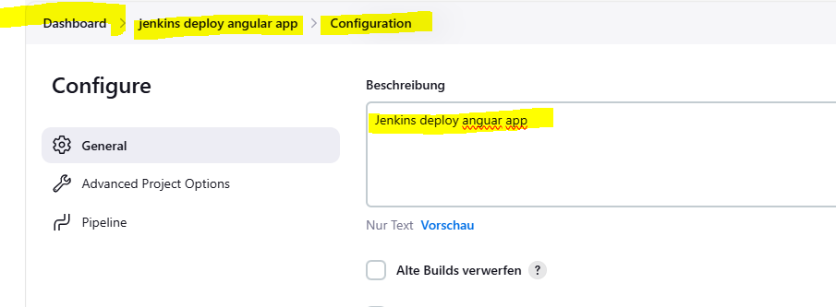

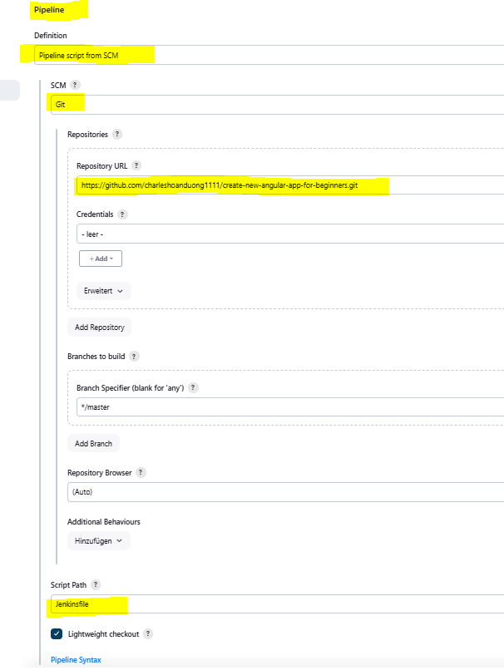

**Create Jenkinsfile in the project | app**

Now, open the project you created earlier in your IDE and create folder called Jenkins inside the root directory of your project. Create another folder called scripts inside this folder. This folder will hold our bash scripts.

There are two text files have been created inside the jenkins/bat/ folder called deliver.bat and kill.bat (not used for a moment)

NOTE: For the bash scripts Jenkins/sh/* not used here but WINDOWS BAT files here instead.

* The content for deliver.bat will be as follows:

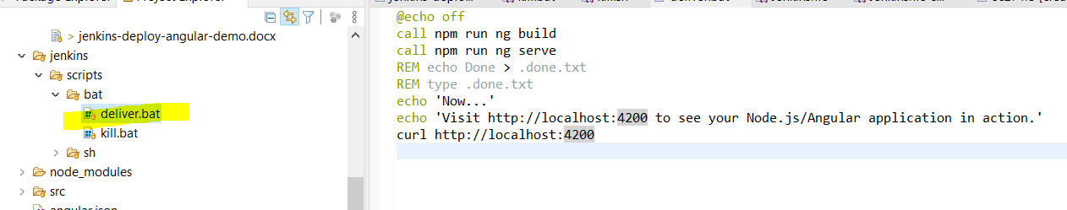

@echo off  
call npm run ng build  
call npm run ng serve  
REM echo Done > .done.txt  
REM type .done.txt  
echo 'Now...'  
echo 'Visit http://localhost:4200 to see your Node.js/Angular application in action.'  
curl http://localhost:4200

This script is responsible for building and serving your angular application.

* The content for kill.bat will be as follows:

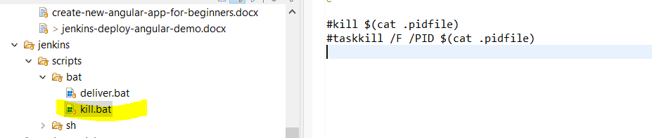

NOTE: This script will properly close down your angular application. 🡪 THIS SCRIPT NOT USED FOR A MOMENT

Now create another file in the root directory of your project called the Jenkinsfile. This file will contain all the settings that jenkins will read from when it fetches code from GitHub.

The content of Jenkinsfile is as follows:

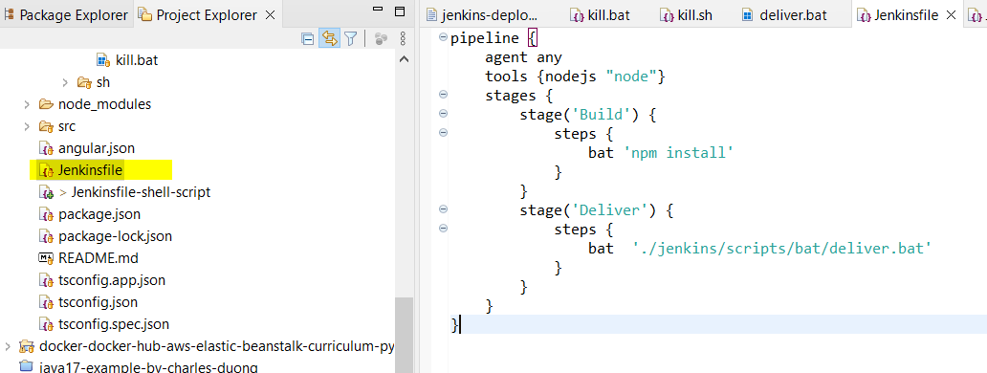

pipeline {

agent any

tools {nodejs "node"}

stages {

stage('Build') {

steps {

bat 'npm install'

}

}

stage('Deliver') {

steps {

bat './jenkins/scripts/bat/deliver.bat'

}

}

}

}

Make sure that your directory structure matches the following:  
