**BUILD AND TEST NODE.JS APP**

C:\Users\Family\git\jenkins-build-deploy-nodejs-with-docker-app>node –version  
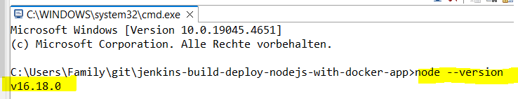

C:\Users\Family\git\jenkins-build-deploy-nodejs-with-docker-app>npm --version

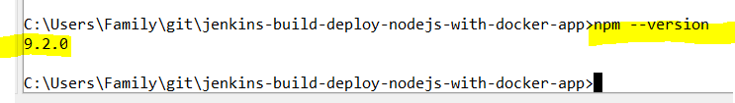

C:\Users\Family\git\jenkins-build-deploy-nodejs-with-docker-app>git –version 

C:\Users\Family\git\jenkins-build-deploy-nodejs-with-docker-app>where git  
🡪 C:\Users\Family\AppData\Local\Programs\Git\cmd\git.exe



C:\Users\Family\git\jenkins-build-deploy-nodejs-with-docker-app>where cmd  
C:\Windows\System32\cmd.exe



BUILD AND RUN NODE.JS

* node modules not yet installed

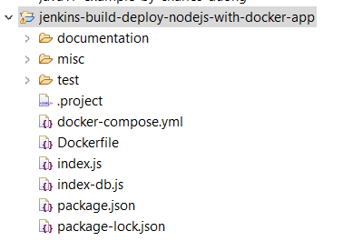

C:\Users\Family\git\jenkins-build-deploy-nodejs-with-docker-app>npm install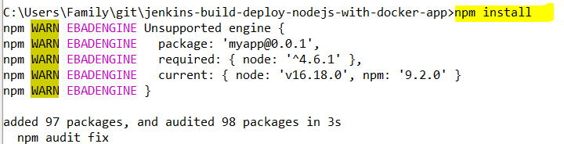

🡪 node module installed

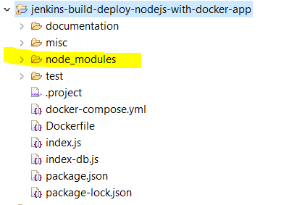

**C:\Users\Family\git\jenkins-build-deploy-nodejs-with-docker-app>npm start  
> myapp@0.0.1 start  
> node index.js   
Example app listening at** [**http://:::3000**](NULL)

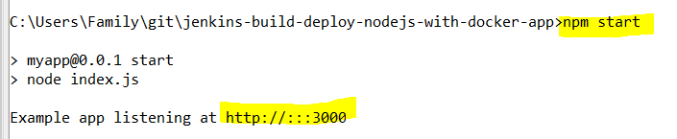

**ON BROWSER**

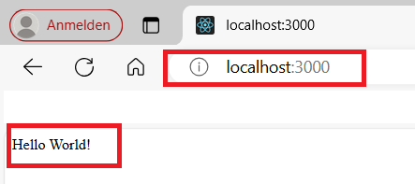

**See index.js 🡪 “Hello World”**

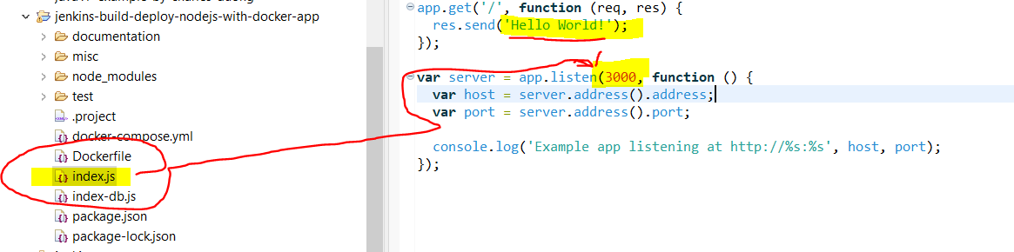

**START JENKINS**

**HOW TO START, RESTART, STOP Jenkins on Window 10**

I have extracted zip file and installed Jenkins on Windows 10 successfully.   
Jenkins runs at http://localhost:8080/ well.   
How can I do that? What's the way to start, restart and stop through console/command line?

On Windows, open Console/Command line --> Go to your Jenkins installation directory (very likely cd "C:\Program Files\Jenkins\"). Execute the following commands respectively:

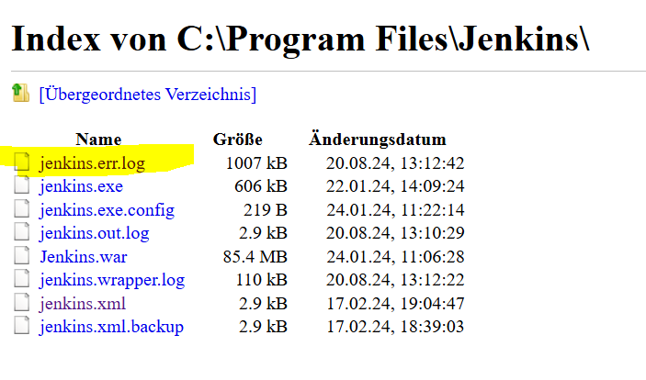

**cd C:\Program Files\Jenkins\"**

**to stop:  
.\jenkins.exe stop**

**to start:  
.\jenkins.exe start**

**to restart:  
.\jenkins.exe restart**

Jenkins start

C:\Users\Family\git\jenkins-demo-with-node-js-react-npm-app>cd C:\Program Files\Jenkins  
C:\Program Files\Jenkins>dir

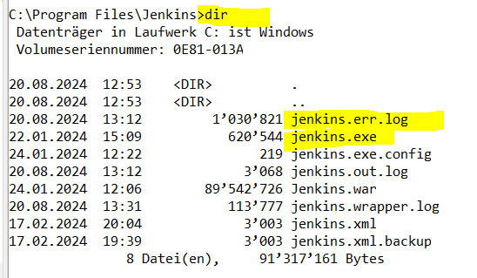

C:\Program Files\Jenkins>.\jenkins.exe start



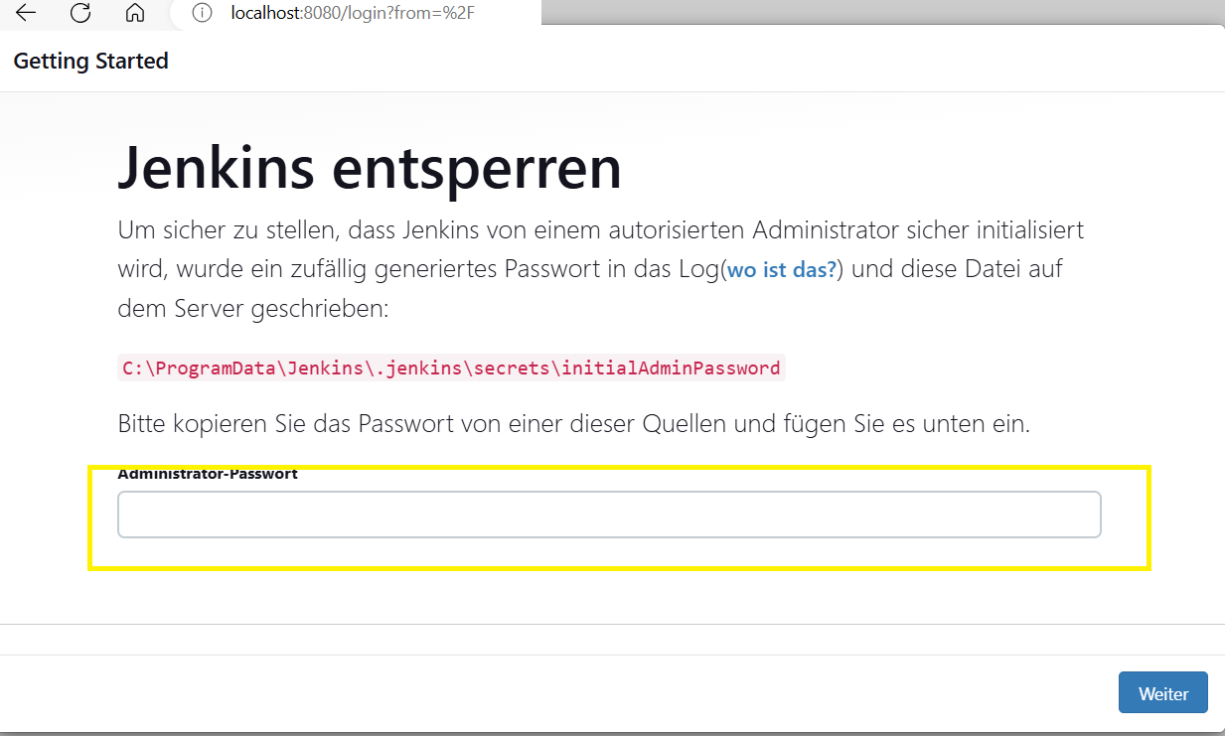



In Jenkins.err.log file contains the Jenkins login password as shown below:

Jenkins initial setup is required. An admin user has been created and a password generated.  
Please use the following password to proceed to installation:  
c51a111bd6fe414f9ccfd15848e72ef9

This may also be found at: C:\ProgramData\Jenkins\.jenkins\secrets\initialAdminPassword

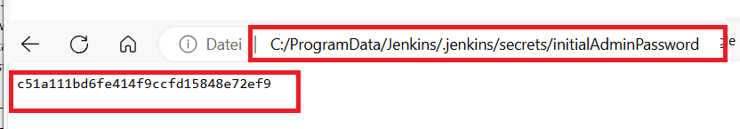

On browser 🡪 localhost:8080

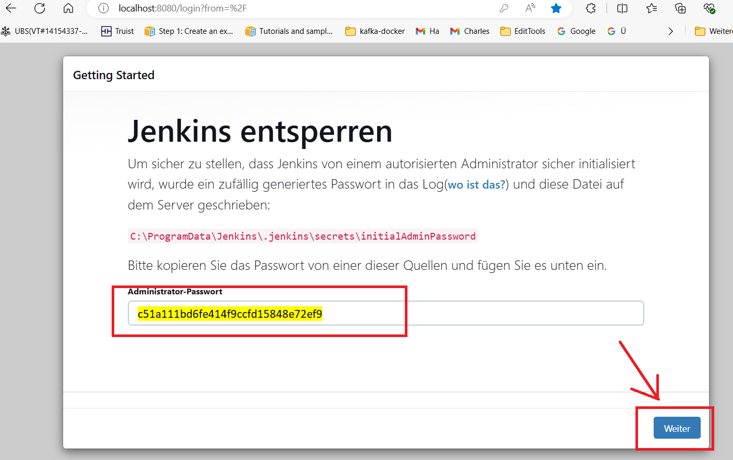

Jenkins 🡪 Getting Started page shows.

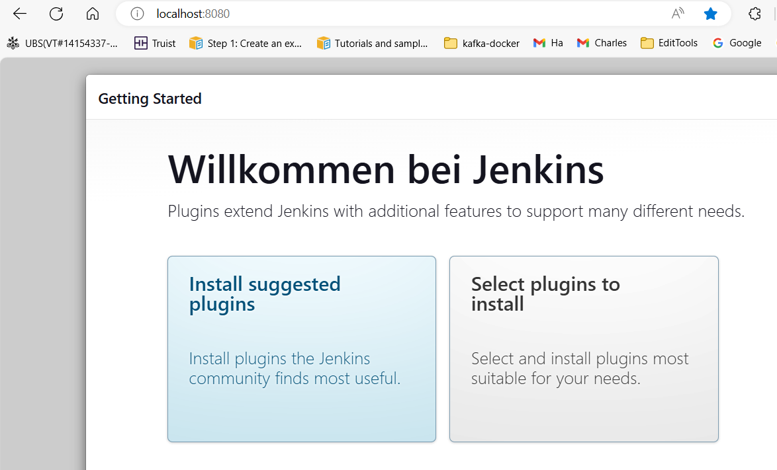

Click 🡪 Install suggested plugins

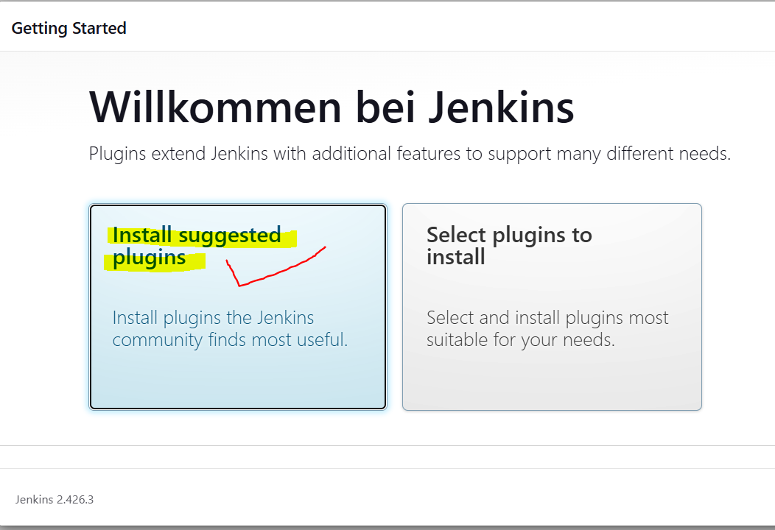

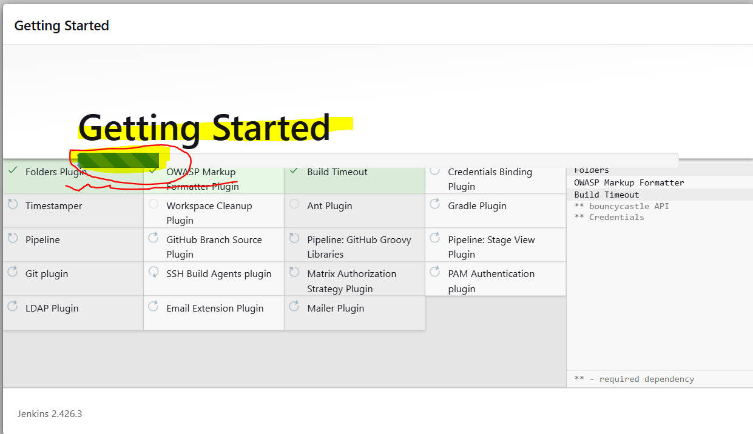

Give 🡪 UserID=admin and Password=admin and then click 🡪 “Save and Continue”-Button.

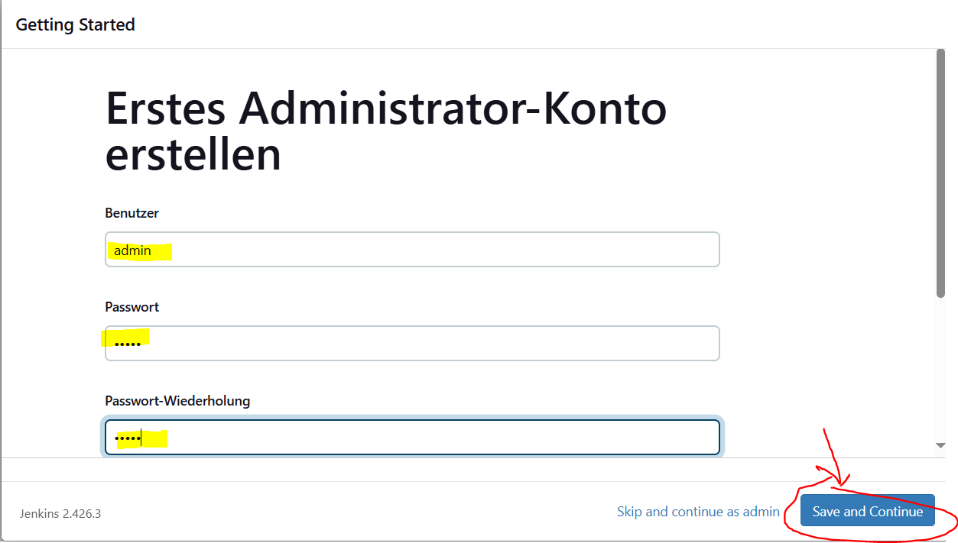

Forget E-mail Address 🡪 Give 🡪Email and then click 🡪 “Save and Continue”-Button.

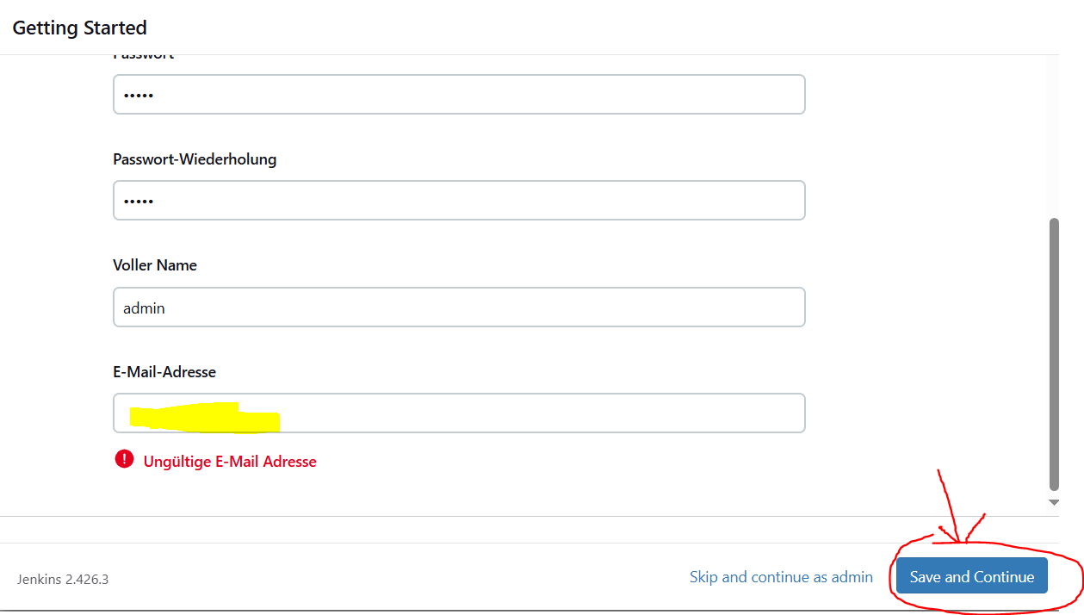

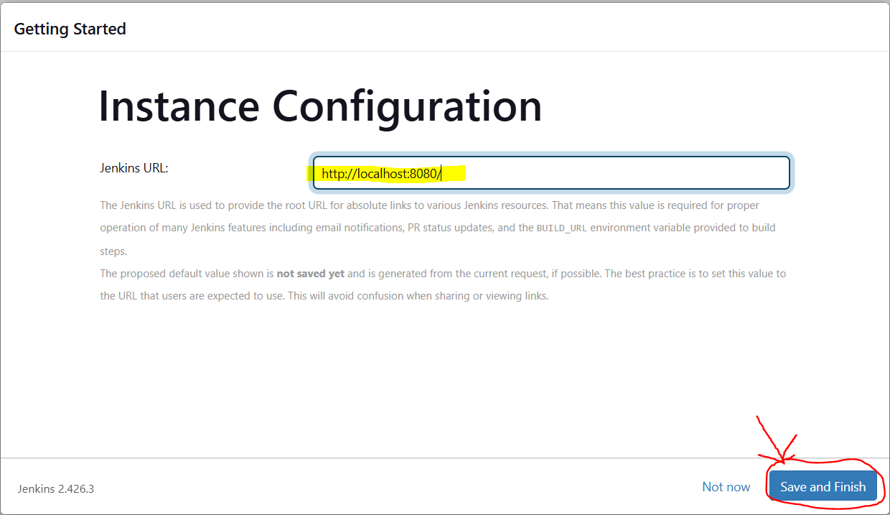

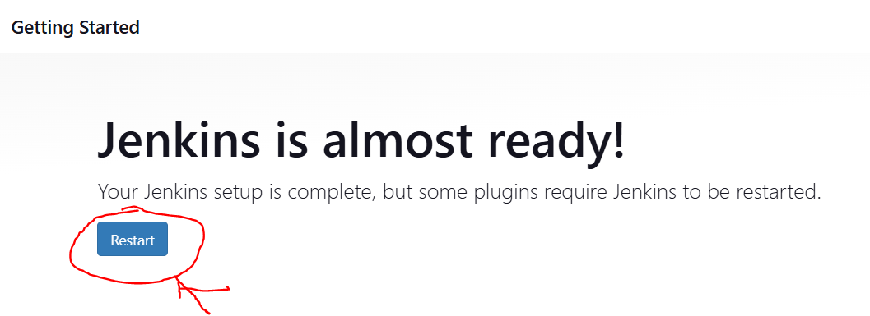

Jenkins 🡪 Restart

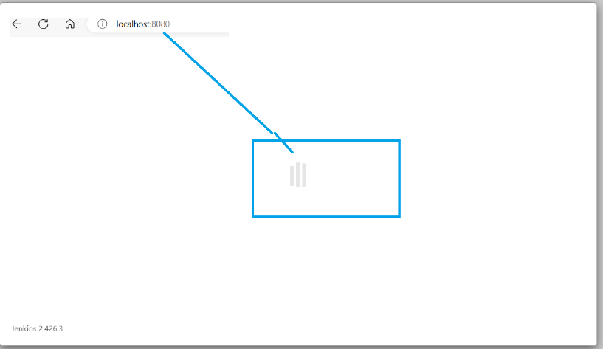

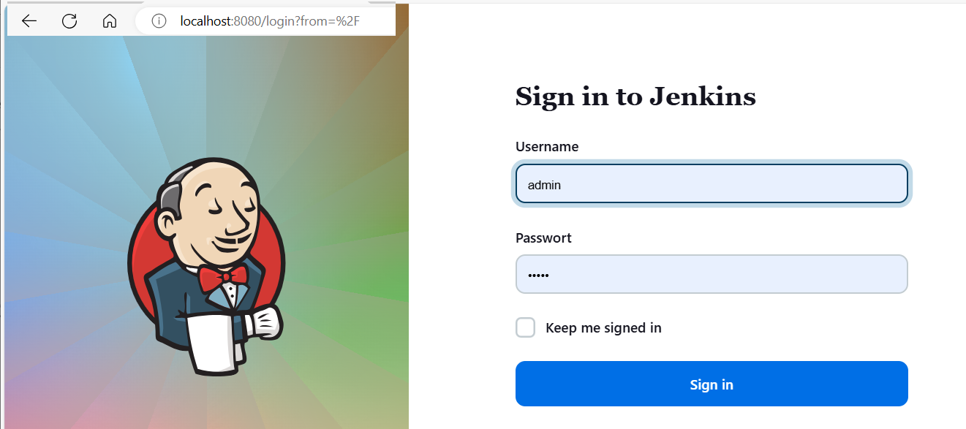

Username=admin and Password=admin 🡪 Click Sign in

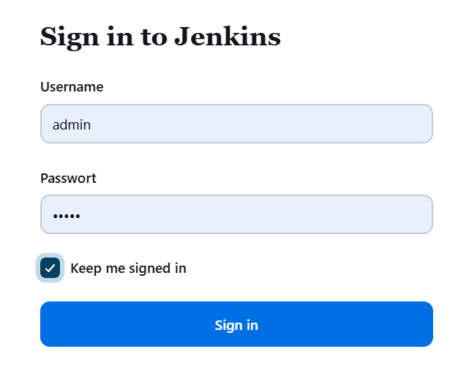

Successful 🡪 Jenkins welcome page shows.

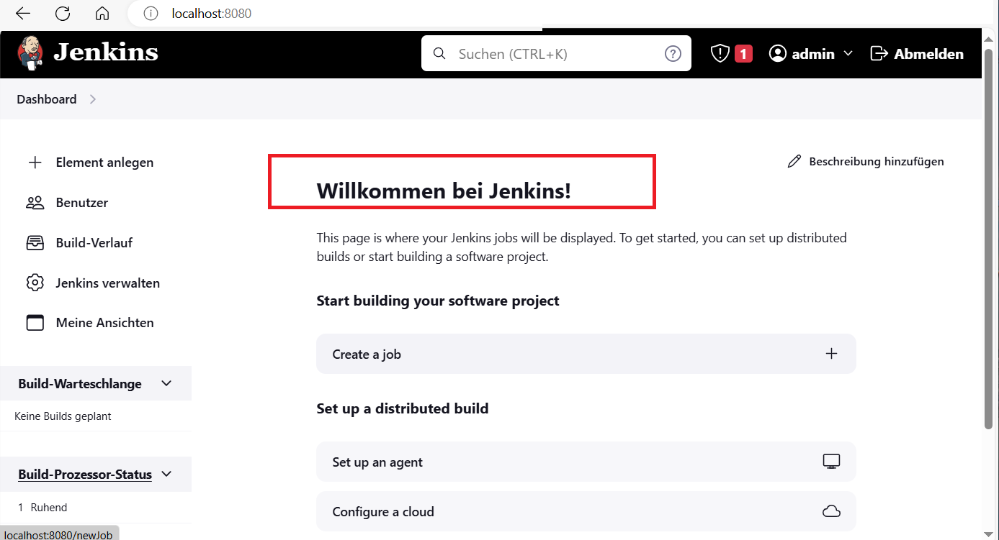

STOP Jenkins

C:\Program Files\Jenkins>.\jenkins.exe stop



<http://localhost:8080/> 🡪 shows that the connection is broken. 🡪 OK

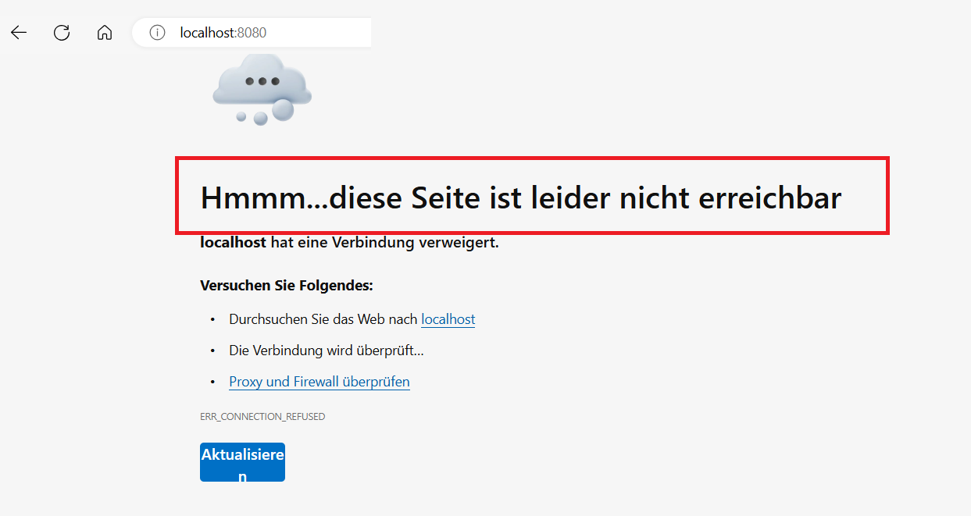

Start Jenkins 🡪 C:\Program Files\Jenkins>.\jenkins.exe start  
and login Jenkins 🡪 Jenkins open as shown below.

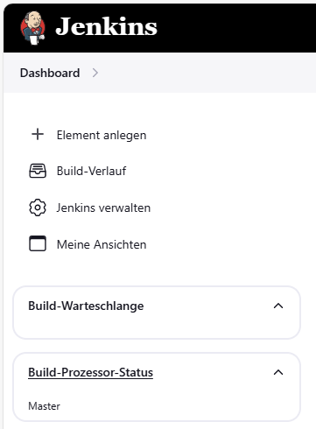

Jenkins

* Start Jenkins 🡪 C:\Program Files\Jenkins>.\jenkins.exe start
* Add new element

