* npm install -g @angular/cli

C:\Users\Family\git>ng version

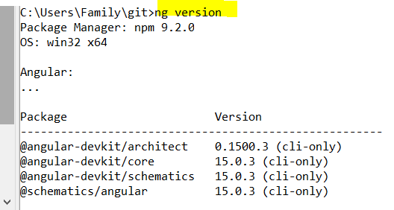

C:\Users\Family\git>npm –version



C:\Users\Family\git>node –version



Create new angular app

C:\Users\Family\git>ng new jenkins-depoly-angular-app-demo

New angular app was created

C:\Users\Family\git>cd jenkins-depoly-angular-app-demo  
C:\Users\Family\git\jenkins-depoly-angular-app-demo>

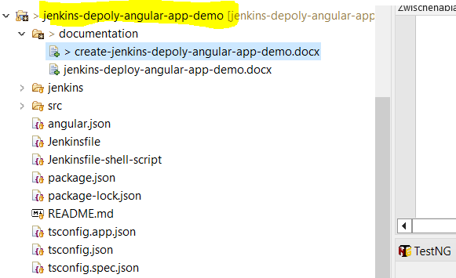

Run 🡪 ng serve

Build at: 2024-08-25T19:24:35.244Z - Hash: cae3f81576fe6b81 - Time: 17828ms  
\*\* Angular Live Development Server is listening on localhost:4200, open your browser on http://localhost:4200/ \*\*   
√ Compiled successfully.

On browser type 🡪 http://localhost:4200/

