Refer to 🡪 <https://medium.com/swlh/jenkins-pipeline-to-create-docker-image-and-push-to-docker-hub-721919512f2>

* docker build -t <tag-name> -f <file-name> .
* docker build -t charleshoanduong1111/angular-docker-image -f Dockerfile .

**C:\Users\Family\git\jenkins-pipeline-to-create-angular-docker-image-and-push-to-docker-hub-demo>docker build -t charleshoanduong1111/angular-docker-image -f Dockerfile .**



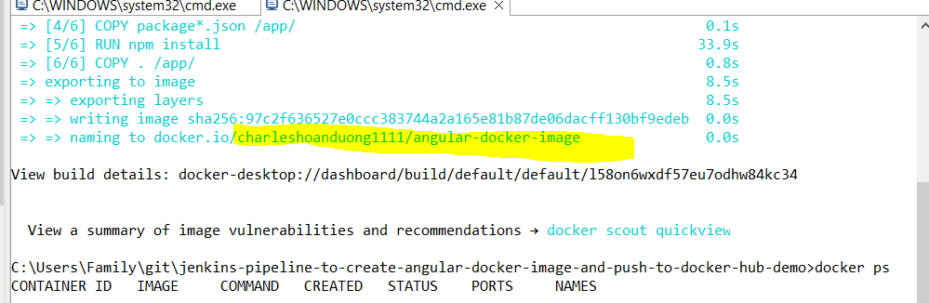

C:\Users\Family\git\jenkins-pipeline-to-create-angular-docker-image-and-push-to-docker-hub-demo>docker images

