HOW TO START, RESTART, STOP Jenkins on Window 10

**I have extracted zip file and installed Jenkins on Windows 10 successfully.   
Jenkins runs at http://localhost:8080/ well.   
How can I do that? What's the way to start, restart and stop through console/command line?**

**On Windows, open Console/Command line --> Go to your Jenkins installation directory (very likely cd   
"C:\Program Files\Jenkins\"). Execute the following commands respectively:**

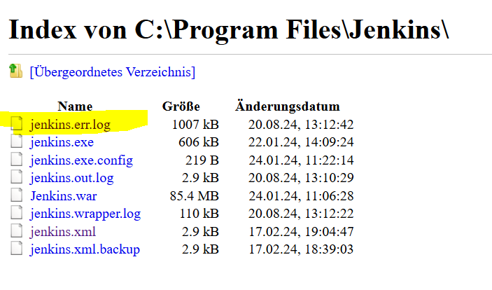

**to stop:  
.\jenkins.exe stop**

**to start:  
.\jenkins.exe start**

**to restart:  
.\jenkins.exe restart**

Jenkins start

C:\Users\Family\git\jenkins-demo-with-node-js-react-npm-app>cd C:\Program Files\Jenkins  
C:\Program Files\Jenkins>dir

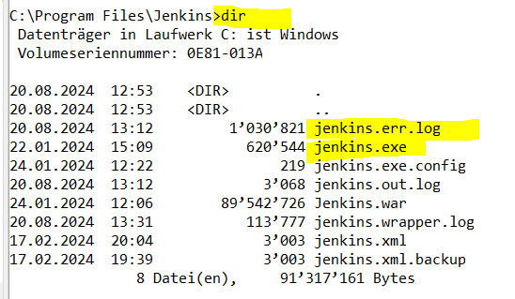

C:\Program Files\Jenkins>.\jenkins.exe start



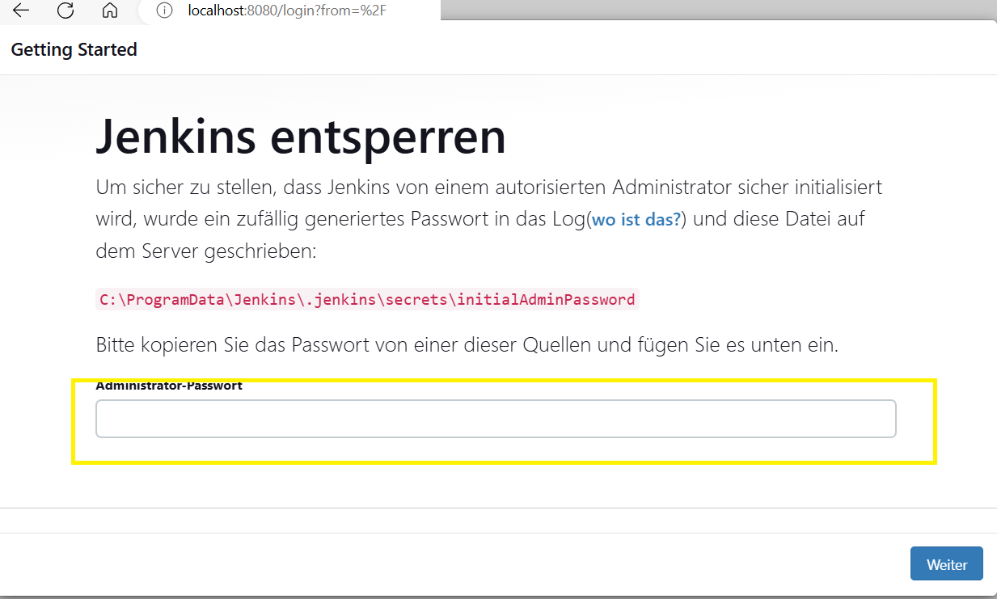



In Jenkins.err.log file contains the Jenkins login password as shown below:

Jenkins initial setup is required. An admin user has been created and a password generated.  
Please use the following password to proceed to installation:  
c51a111bd6fe414f9ccfd15848e72ef9

This may also be found at: C:\ProgramData\Jenkins\.jenkins\secrets\initialAdminPassword

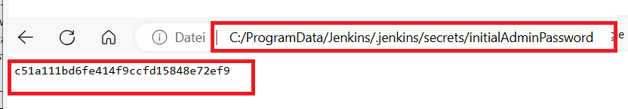

On browser 🡪 localhost:8080

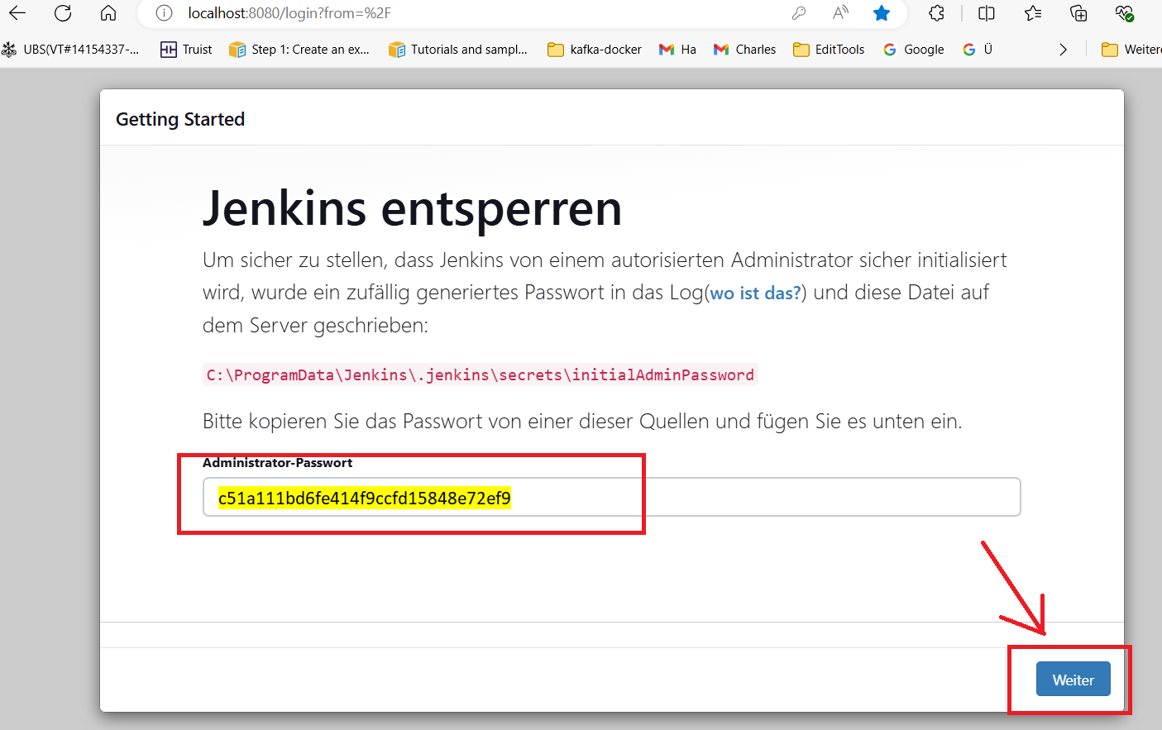

Jenkins 🡪 Getting Started page shows.

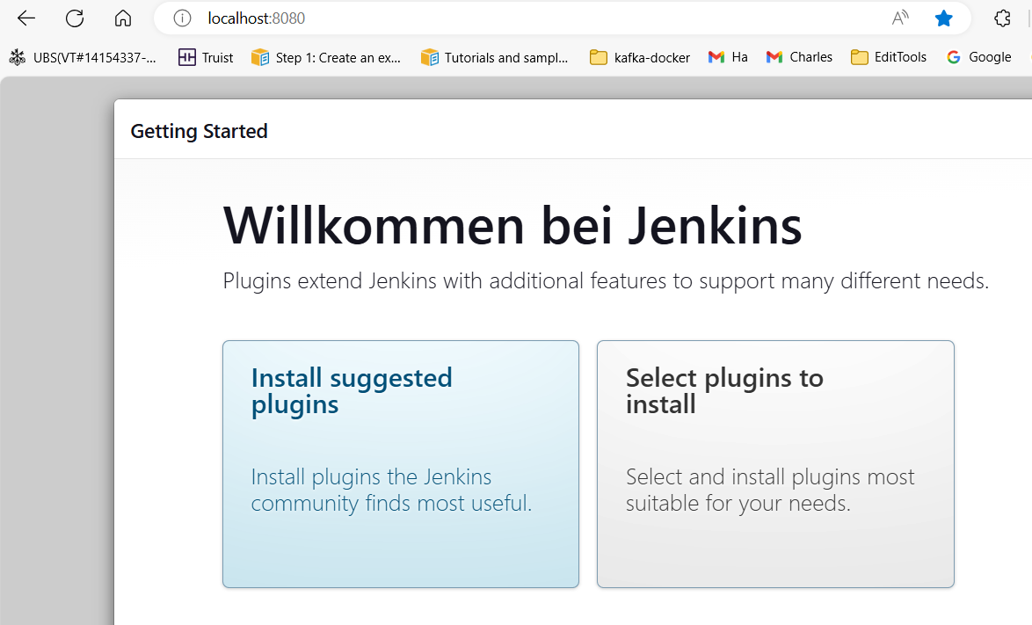

Click 🡪 Install suggested plugins

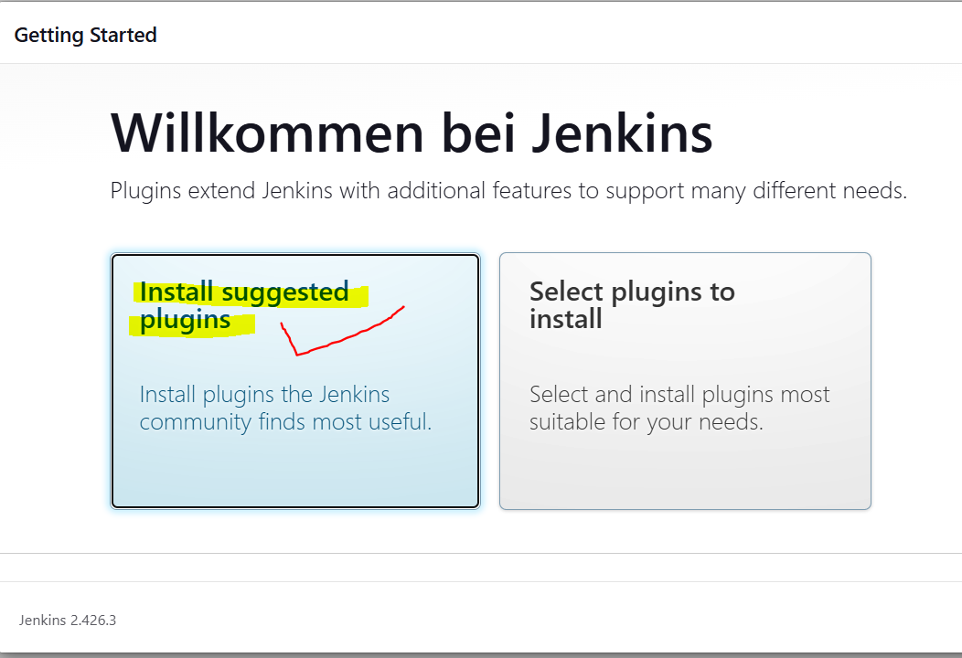

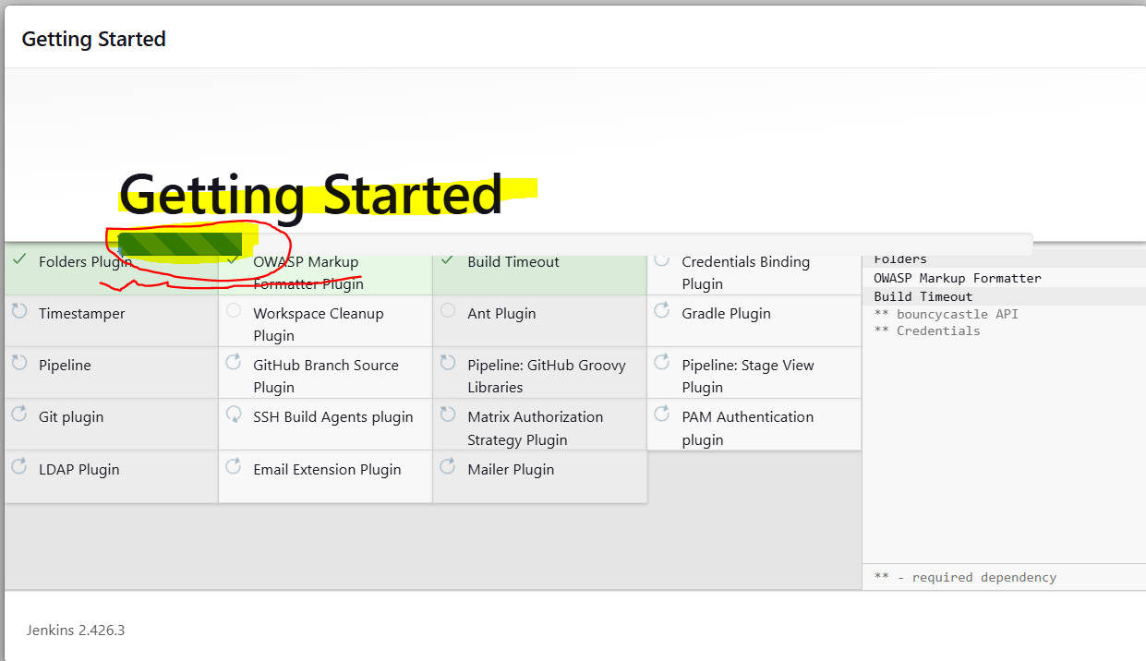

Give 🡪 UserID=admin and Password=admin and then click 🡪 “Save and Continue”-Button.

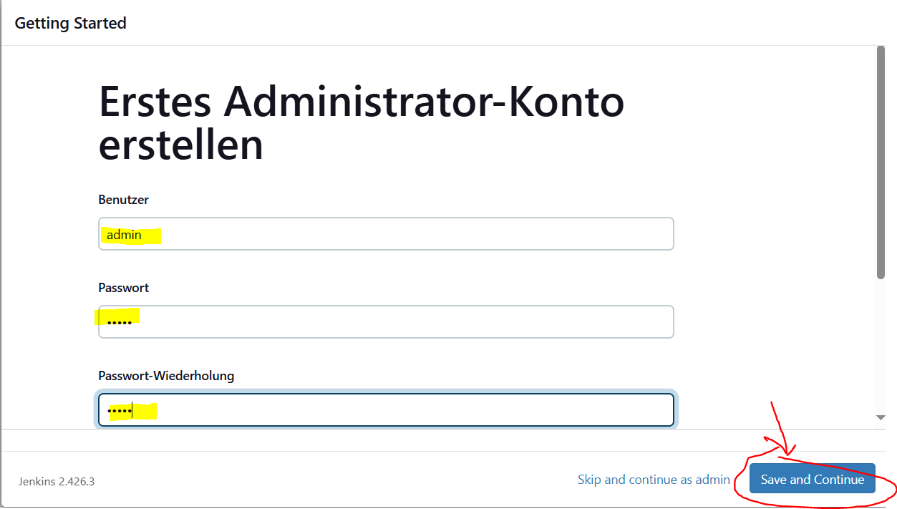

Forget E-mail Address 🡪 Give 🡪Email and then click 🡪 “Save and Continue”-Button.

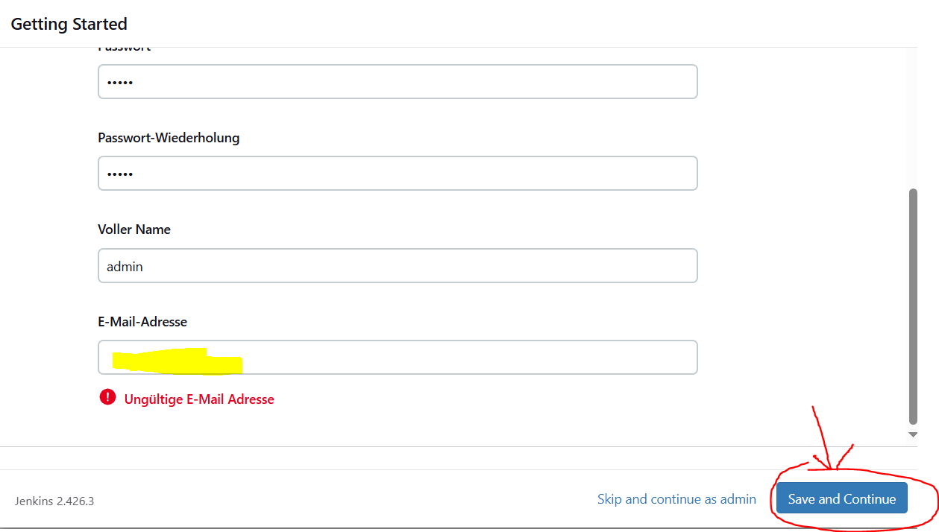

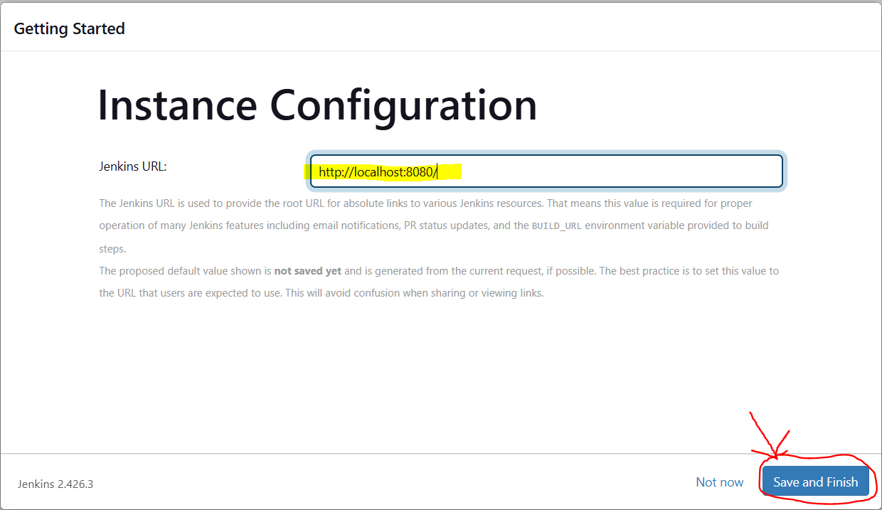

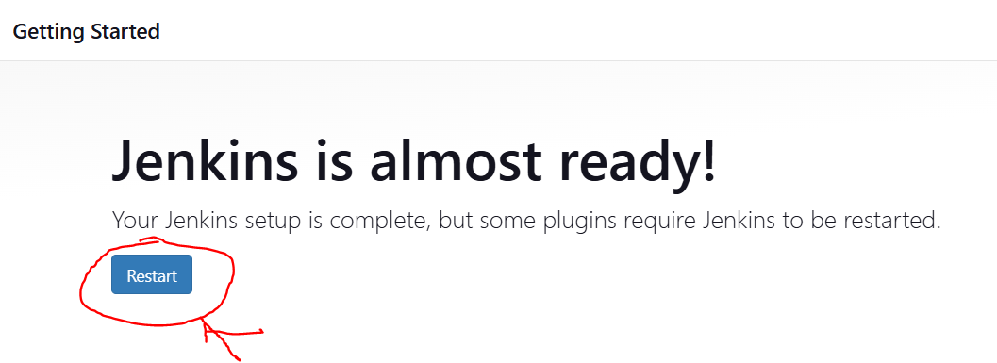

Jenkins 🡪 Restart

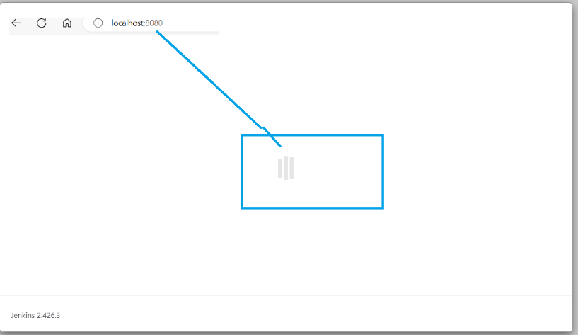

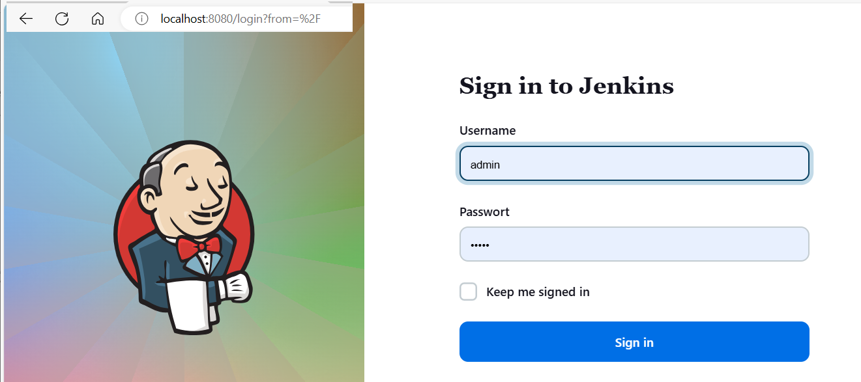

Username=admin and Password=admin 🡪 Click Sign in

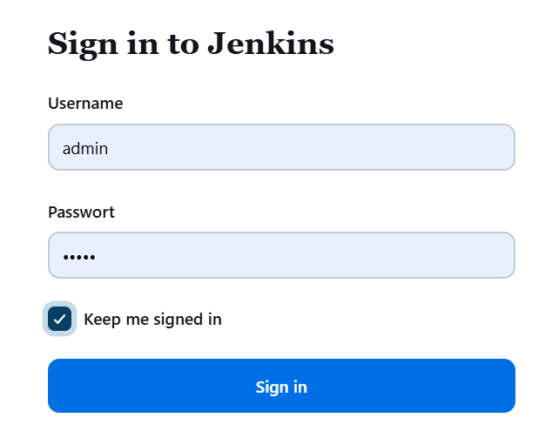

Successful 🡪 Jenkins welcome page shows.

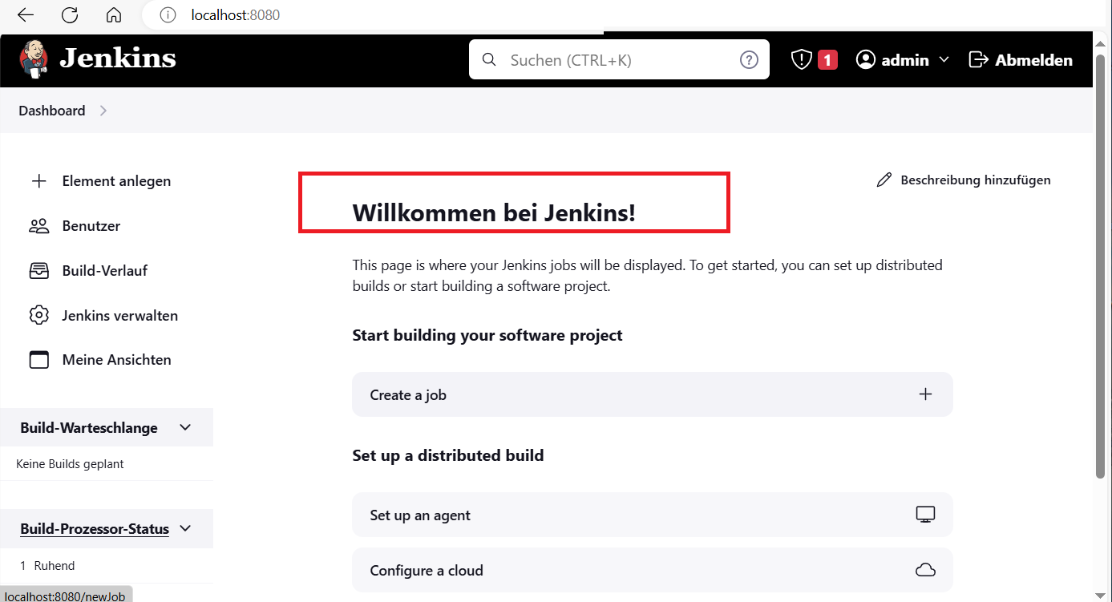

STOP Jenkins

C:\Program Files\Jenkins>.\jenkins.exe stop



<http://localhost:8080/> 🡪 shows that the connection is broken. 🡪 OK

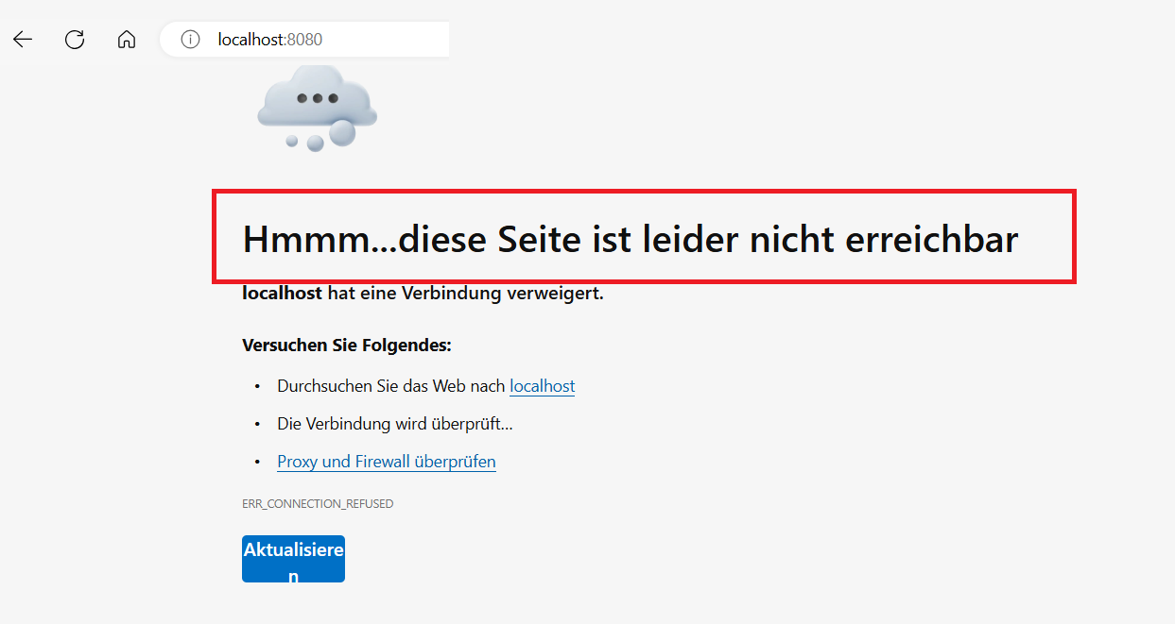

Jenkins

See VIDEO 🡪 <https://www.youtube.com/watch?v=xWCQpSDArb4>

Jenkins 🡪 Start

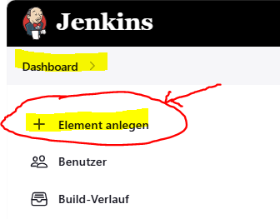

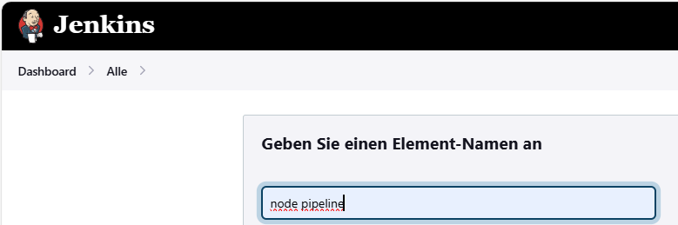

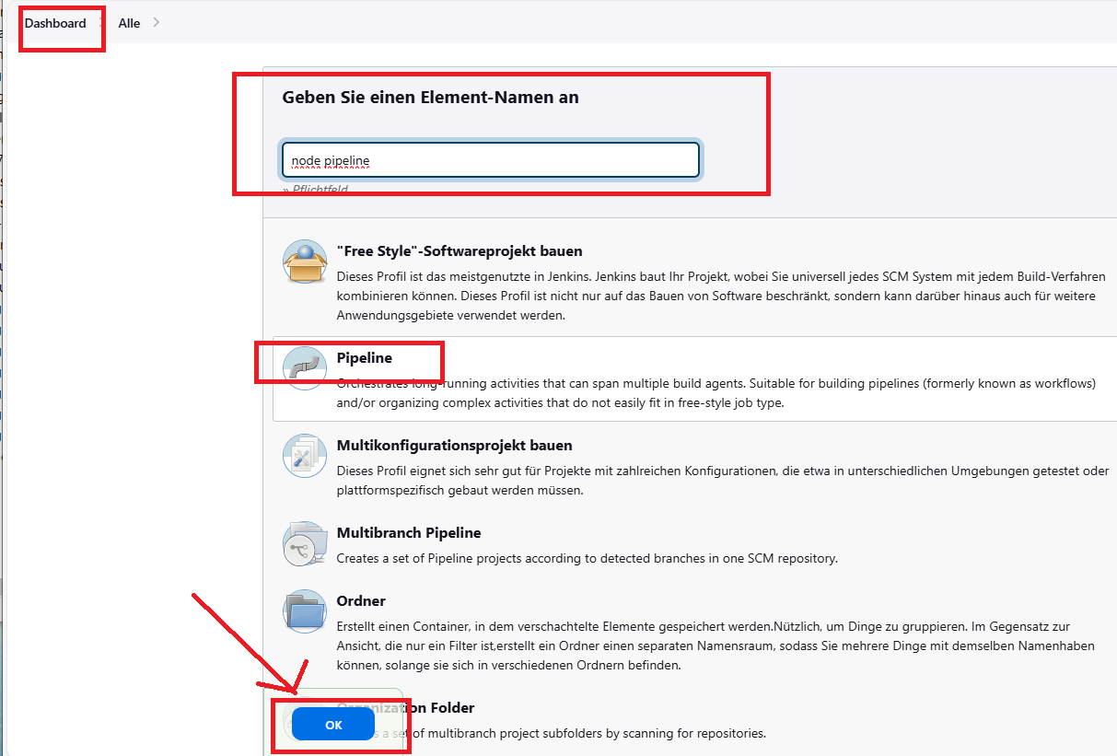

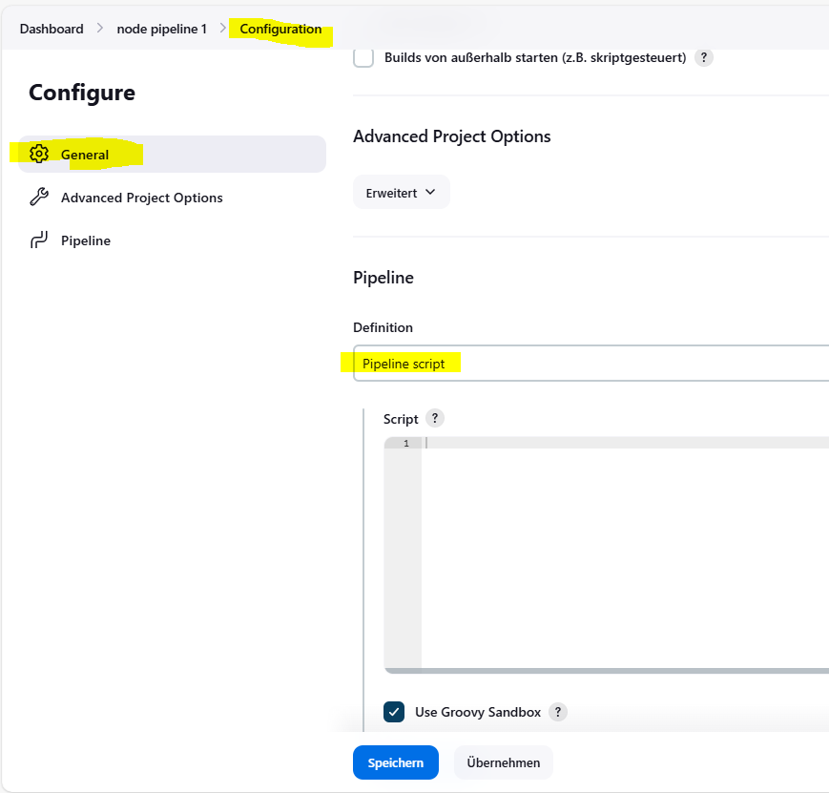

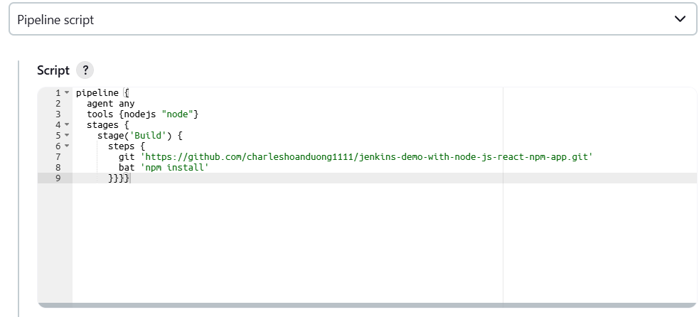

pipeline {

agent any

tools {nodejs "node"}

stages {

stage('Build') {

steps {

git 'https://github.com/charleshoanduong1111/jenkins-demo-with-node-js-react-npm-app.git'

bat 'npm install'

}}}}

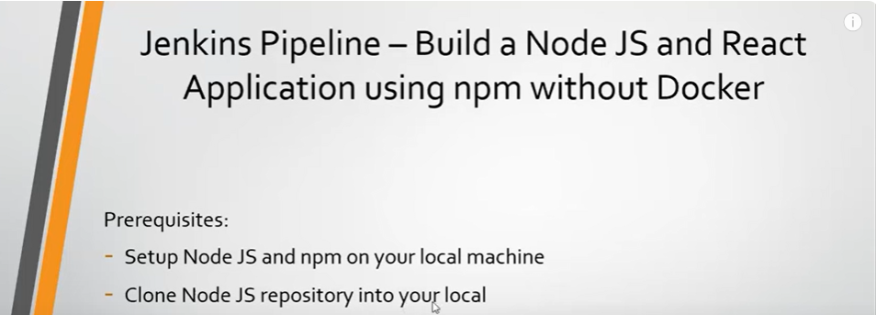

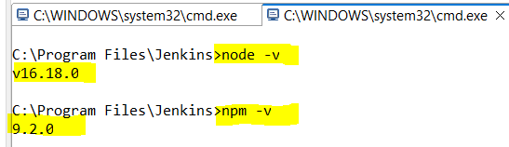

Click 🡪 Configure

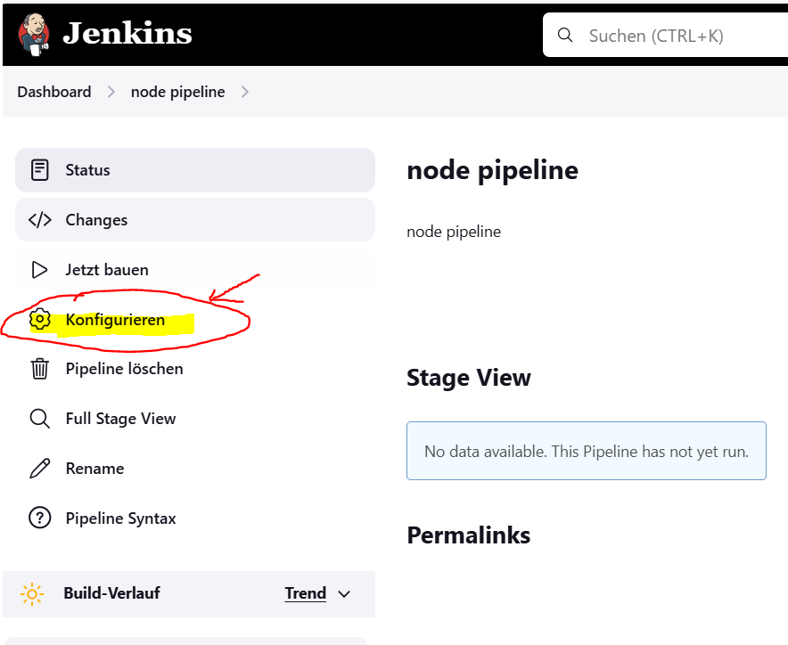

Plugins

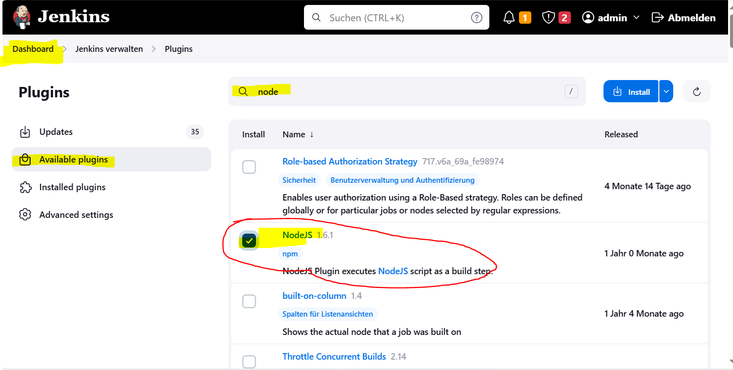

Click 🡪 Install NodeJS

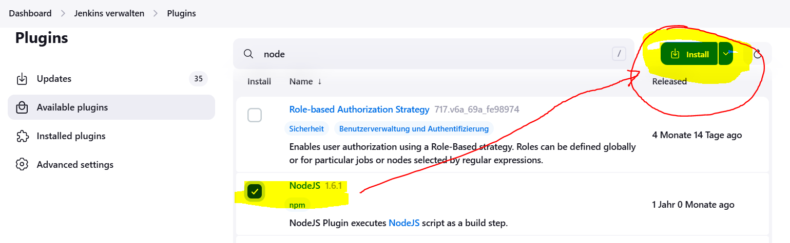

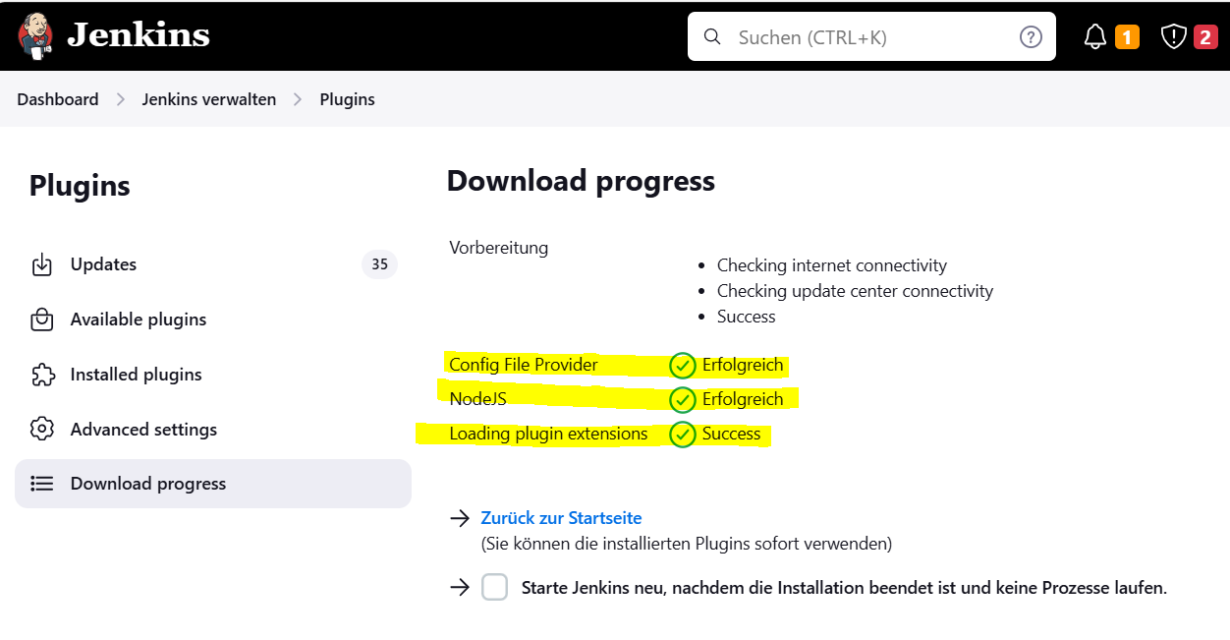

**Tools**

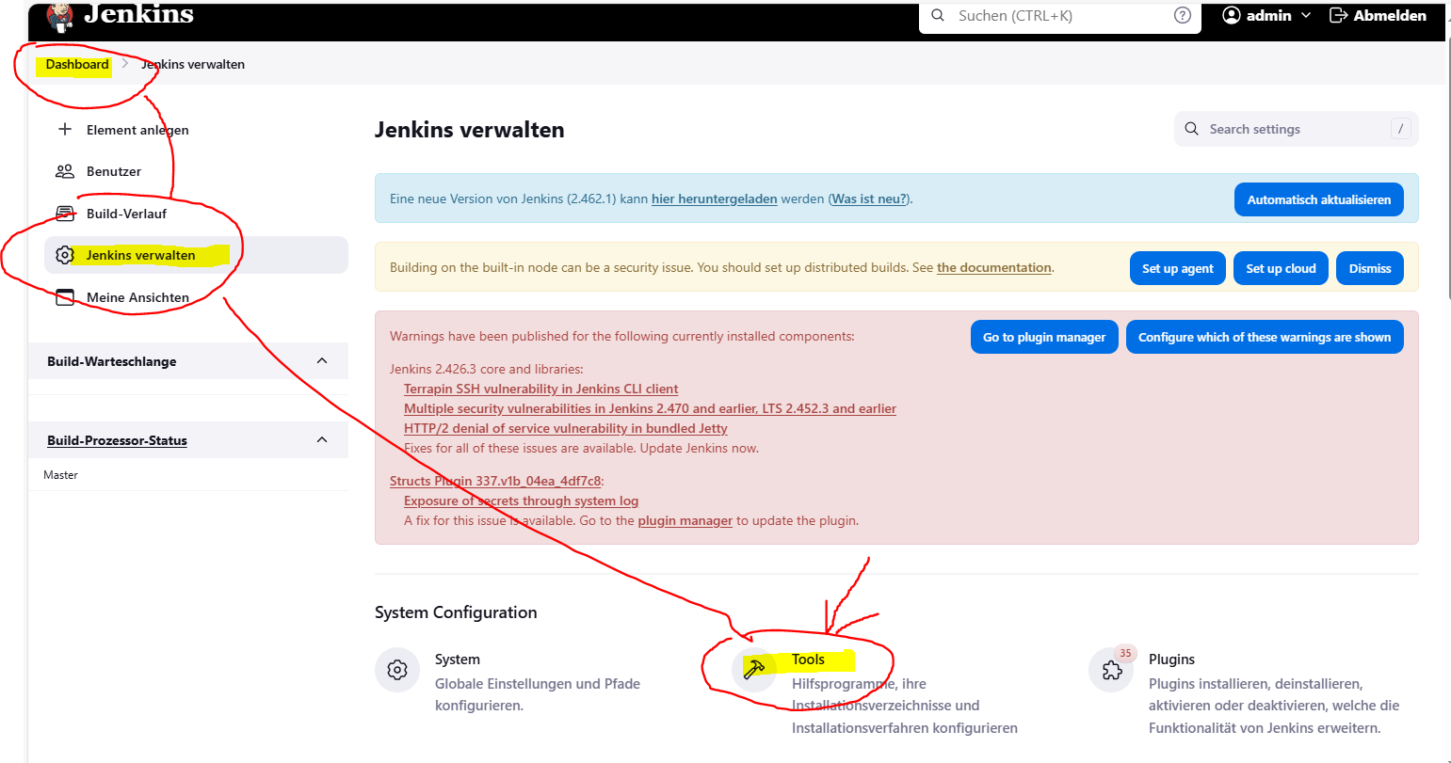

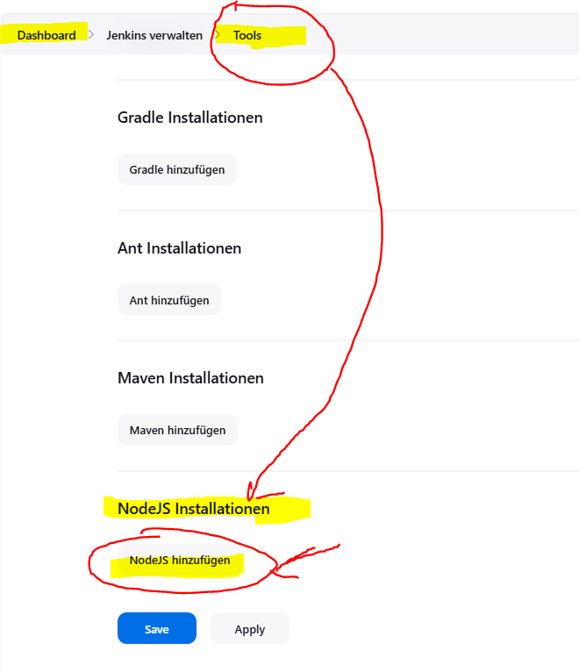

Click 🡪 Install automatically 🡪to remove the automatically installation

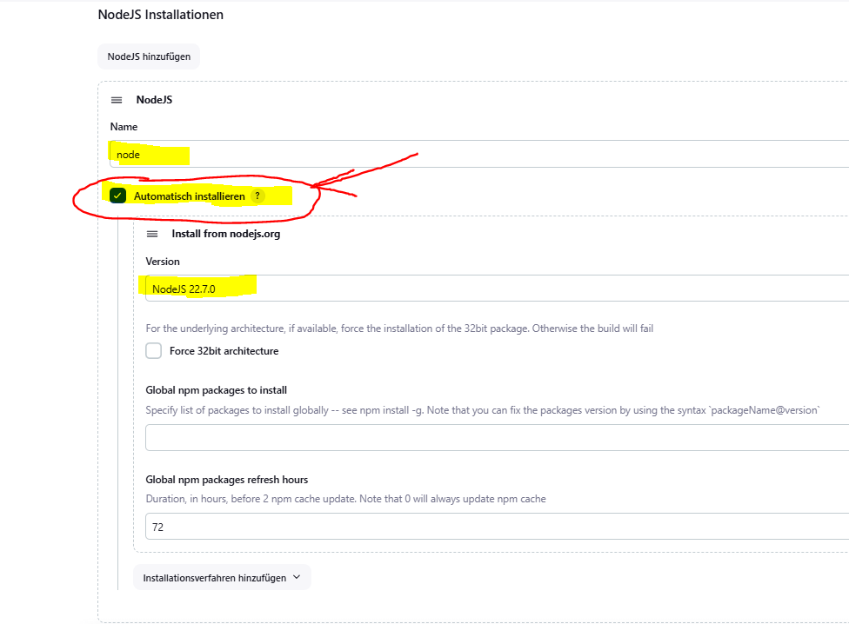

Find the local nodejs

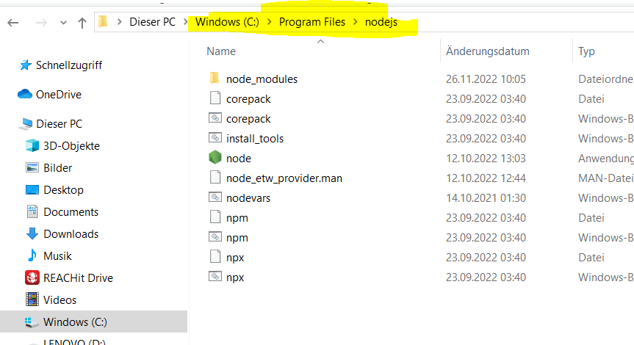

Install manually 🡪 Give name and local nodejs 🡪 Click Save

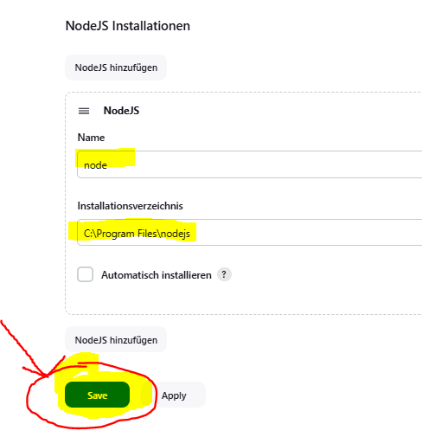

DONE 🡪 TEST NOW

Click 🡪 Build now

