STLC Login Feature Project
Simulated stakeholder: ChatGPT
Tester: Charles Hojdus

Feature: Standard User Login

Source User Story Functional Requirement and Acceptance Criteria — 10/1/26
User Story — US-LOGIN-001
As a registered user, I want to log in using my username and password so that I can securely access my account.
Functional Requirement — FR-LOGIN-001
The system shall allow a registered user to authenticate using a valid username and valid password. Upon successful authentication, the user shall be redirected to the application's main page.
Acceptance Criteria
- AC-LOGIN-001 — Valid credentials
Given that the user has a registered account, when the user enters a valid username and valid password and selects Login, then the system shall authenticate the user and redirect them to the main page.
- AC-LOGIN-002 — Invalid password
Given that the user enters a valid username with an invalid password, when the user selects Login, then authentication shall fail and an error message shall be displayed.
- AC-LOGIN-003 — Invalid username
Given that the user enters an unregistered username with a password, when the user selects Login, then authentication shall fail and an error message shall be displayed.
- AC-LOGIN-004 — Required username
Given that the username field is empty, when the user attempts to log in, then authentication shall not occur and the system shall indicate that a username is required.
- AC-LOGIN-005 — Required password
Given that the password field is empty, when the user attempts to log in, then authentication shall not occur and the system shall indicate that a password is required.
- AC-LOGIN-006 — Both fields empty
Given that both the username and password fields are empty, when the user attempts to log in, then authentication shall not occur and the system shall display appropriate validation.
Source wording note: FR-LOGIN-001 and AC-LOGIN-001 originally named two alternative destinations. The destination is standardized as “main page” in this edited document following the documented clarification. The source wording has been normalized rather than reproduced verbatim.
Stakeholder Clarification — 10/1/26
A clarification request was submitted to ChatGPT in its role as a simulated stakeholder concerning the ambiguous redirect destination. The documented response specified the main page.

Requirement Analysis

10/2/26
User Story — US-LOGIN-001
As a registered user, I want to log in using my username and password so that I can securely access my account.
FR-LOGIN-001— Functional Requirement
The system shall allow a registered user to authenticate using a valid username and password. Usernames and passwords shall each contain 8 to 24 characters, inclusive. Upon successful authentication, the user shall be redirected to the application’s main page.
Test Conditions
- Valid Credentials — Verify login with a valid username and valid password.
- Minimum Username Length — Verify login with a minimum-length username and valid password.
- Minimum Password Length — Verify login with a valid username and minimum-length password.
- Minimum Username and Password Length — Verify login when both username and password are at their minimum allowed length.
- Maximum Username Length — Verify login with a maximum-length username and valid password.
- Maximum Password Length — Verify login with a valid username and maximum-length password.
- Maximum Username and Password Length — Verify login when both username and password are at their maximum allowed length.
- Invalid Username — Verify login behavior with an invalid username and valid password.
- Invalid Password — Verify login behavior with a valid username and invalid password.
- Invalid Username and Password — Verify login behavior when both username and password are invalid.
- Blank Username — Verify login behavior when the username field is blank and the password is populated.
- Blank Password — Verify login behavior when the username is populated and the password field is blank.
- Blank Username and Password — Verify login behavior when both username and password fields are blank.

Scope
In scope: username field, password field, Login button, successful authentication, unsuccessful authentication, required-field validation, and resulting navigation after successful login.
Out of scope: Forgot Password, Forgot Username, account registration/sign-up, MFA, account lockout, password reset, and functionality occurring after the user reaches the main page.

Test Plan
10/3/26
1 Functional Requirement User Story and Test Conditions

Feature: Standard User Login
User Story — US-LOGIN-001
As a registered user, I want to log in using my username and password so that I can securely access my account.
Functional Requirement — FR-LOGIN-001
The system shall allow a registered user to authenticate using a valid username and valid password. Upon successful authentication, the user shall be redirected to the application's main page.
Test Conditions
- Valid Credentials — Verify login with a valid username and valid password.
- Minimum Username Length — Verify login with a minimum-length username and valid password.
- Minimum Password Length — Verify login with a valid username and minimum-length password.
- Minimum Username and Password Length — Verify login when both username and password are at their minimum allowed length.
- Maximum Username Length — Verify login with a maximum-length username and valid password.
- Maximum Password Length — Verify login with a valid username and maximum-length password.
- Maximum Username and Password Length — Verify login when both username and password are at their maximum allowed length.
- Invalid Username — Verify login behavior with an invalid username and valid password.
- Invalid Password — Verify login behavior with a valid username and invalid password.
- Invalid Username and Password — Verify login behavior when both username and password are invalid.
- Blank Username — Verify login behavior when the username field is blank and the password is populated.
- Blank Password — Verify login behavior when the username is populated and the password field is blank.
- Blank Username and Password — Verify login behavior when both username and password fields are blank.
2 Critical Functions
The username field, password field, and Login button support access to the application’s main page.
3 Nonfunctional Requirements
No nonfunctional requirements were specified for this exercise.
4 Risks
Invalid credential handling: The application may fail to reject invalid credentials or display an appropriate error. Error responses may disclose account information.
Incorrect redirect: Following successful authentication, the application may navigate to the wrong page or fail to navigate. Clarifying the destination does not eliminate this implementation risk.
Login button behavior: Incorrect handling of the loading state may prevent the user from submitting a login request.
Other risks
Security, session management, usability, and compliance were not assessed beyond the documented scope.
5 Scope
In scope: username field, password field, Login button, successful authentication, unsuccessful authentication, required-field validation, and resulting navigation after successful login.
Out of scope: Forgot Password, Forgot Username, account registration/sign-up, MFA, account lockout, password reset, and functionality occurring after the user reaches the main page.
6 Constraints
Planned duration: 8–11 days to test closure.
Exercise budget: $25 for the coffee.
7 Pass and Fail Criteria
Compare each observed result with the test case’s expected result. Record a failure when implemented behavior contradicts that expectation. Identify checks that cannot be completed because of environmental limitations as blocked or partially verified, as appropriate. Classify the original cases separately from individual API checks. Final classifications and limitations are documented in the closure section.
8 Tools
Postman, Microsoft Word, and ChatGPT.
9 Environment
Dell Latitude 3520, Windows 11, and a local mock server used with Postman at http://localhost:2084.
10 Test Closure
Review the exit criteria and execution records. Identify completed checks, blocked checks, and any planned checks that were not executed.
Document observed responses and any defects. Record each defect’s disposition, if applicable.
11 Closure Deliverables
Planned exit criteria: No open blocking or critical defects. If such defects are found, fixes, retesting, and relevant regression testing are required. Deliver the test summary, defect summary, lessons learned, and supporting artifacts in the GitHub repository.
The closure report summarizes execution results, coverage limitations, defects, and lessons learned.
The exercise uses ChatGPT as a simulated stakeholder. No real product-owner or independent QA sign-off is established by this document.

Mock Server
10/4/26
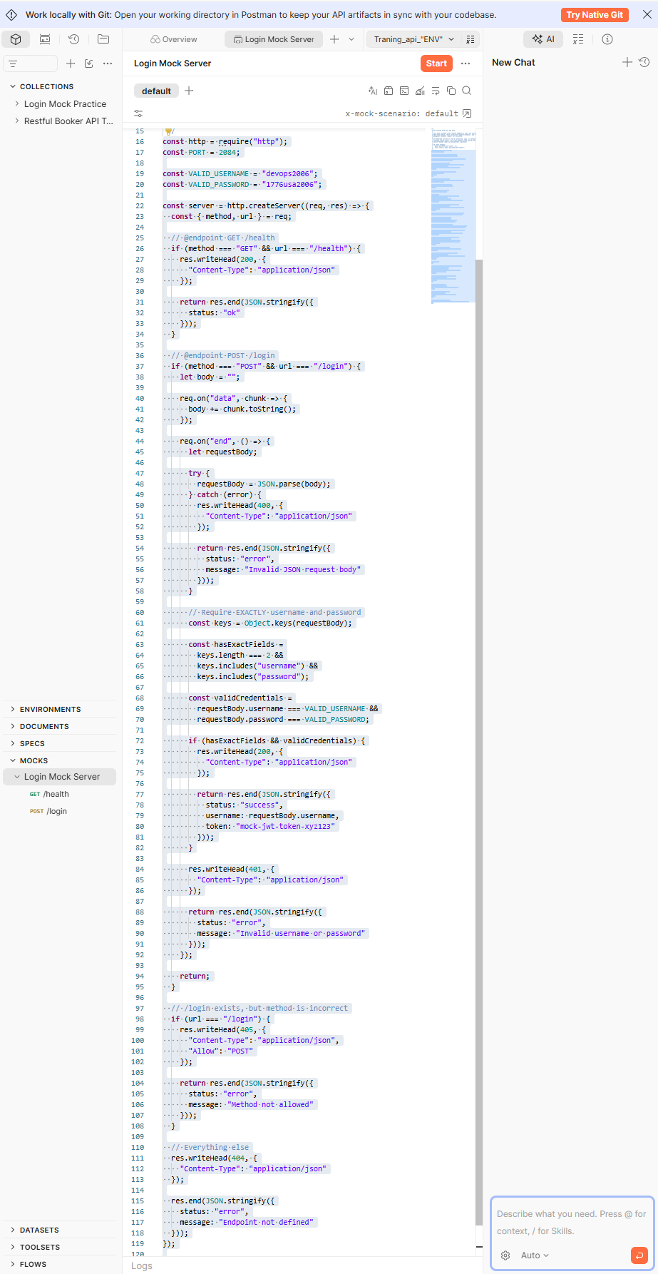
/**
* Get started with your new mock.
*
* This mock includes a GET /health endpoint — start the server to try it.
* Add routes below, reuse collection requests/examples, and tag handlers with
* @endpoint <method> /<path> for discovery.
*
* Use Generate with AI or drop a collection, spec, or dataset here to
* scaffold routes faster. For cross-request state use pm.state; for
* dataset-backed reads use pm.datasets (optional).
*
* pm.state example:
* await pm.state.set("count", 1);
* const count = await pm.state.get("count");
*/
const http = require("http");
const PORT = 2084;
const VALID_USERNAME = "devops2006";
const VALID_PASSWORD = "1776usa2006";
const server = http.createServer((req, res) => {
const { method, url } = req;
// @endpoint GET /health
if (method === "GET" && url === "/health") {
res.writeHead(200, {
"Content-Type": "application/json"
});
return res.end(JSON.stringify({
status: "ok"
}));
}
// @endpoint POST /login
if (method === "POST" && url === "/login") {
let body = "";
req.on("data", chunk => {
body += chunk.toString();
});
req.on("end", () => {
let requestBody;
try {
requestBody = JSON.parse(body);
} catch (error) {
res.writeHead(400, {
"Content-Type": "application/json"
});
return res.end(JSON.stringify({
status: "error",
message: "Invalid JSON request body"
}));
}
// Require EXACTLY username and password
const keys = Object.keys(requestBody);
const hasExactFields =
keys.length === 2 &&
keys.includes("username") &&
keys.includes("password");
const validCredentials =
requestBody.username === VALID_USERNAME &&
requestBody.password === VALID_PASSWORD;
if (hasExactFields && validCredentials) {
res.writeHead(200, {
"Content-Type": "application/json"
});
return res.end(JSON.stringify({
status: "success",
username: requestBody.username,
token: "mock-jwt-token-xyz123"
}));
}
res.writeHead(401, {
"Content-Type": "application/json"
});
return res.end(JSON.stringify({
status: "error",
message: "Invalid username or password"
}));
});
return;
}
// /login exists, but method is incorrect
if (url === "/login") {
res.writeHead(405, {
"Content-Type": "application/json",
"Allow": "POST"
});
return res.end(JSON.stringify({
status: "error",
message: "Method not allowed"
}));
}
// Everything else
res.writeHead(404, {
"Content-Type": "application/json"
});
res.end(JSON.stringify({
status: "error",
message: "Endpoint not defined"
}));
});
server.listen(PORT, () => {
console.log(`Mock server running on port ${PORT}`);
});

Test Scenario
10/5/26
LOGIN FEATURE A-001
ENV: QA
Test Condition

TC-Login-001
Positive Login Condition
- A registered user submits valid credentials, authenticates successfully, and reaches the main page.
Originally Planned UI Steps
1. Navigate to the application’s login page. The selected mock at http://localhost:2084 does not provide this page.
2. Enter a valid username.
3. Enter a valid password.
4. Select Login.
Expected outcome: The user reaches the main page after successful authentication.
Expected Results
- The system accepts the valid credentials and redirects the user to the main page.
Test Execution Deviation and Environment Limitations
At the start of execution, the selected environment was found to support HTTP requests and responses but not a login UI, Login button interaction, or page navigation. The original UI-specific outcomes could not be verified. The mock accepted only one hardcoded credential pair and did not enforce the specified length boundaries. These constraints limited coverage; they did not invalidate the original test designs.
Common API execution procedure: Start the mock server. In Postman, select POST http://localhost:2084/login, choose a raw JSON body, and set Content-Type to application/json. Submit the test data recorded for the case. Compare the status code and response body with the expected API behavior. This procedure does not execute the original UI steps.

Test Cases and Execution Records
10/5/26 - 10/6/26

TC-Login-001
Login with Valid Credentials
Test area: Authentication
Planned precondition: A registered account is available. The mock uses hardcoded credentials and provides no account-registration verification.
Request format: Postman raw JSON
Environment: Local mock server with Postman
Reference valid username: devops2006
Reference valid password: 1776usa2006
Priority: High | Functional | Positive
TE-Login-001
Expected Results
The system accepts the valid credentials and redirects the user to the main page.
Submitted
{
"username": "devops2006",
"password": "1776usa2006"
}
Observed
The mock accepted the submitted hardcoded credentials and returned a success response. Redirect behavior could not be verified.
“200 OK”
{
"status": "success",
"username": "devops2006",
"token": "mock-jwt-token-xyz123"
}
Execution
Executed. Acceptance of the hardcoded credential pair was verified through the API response. Redirect verification was blocked because the environment provides no navigation behavior.
Status
Partially verified; redirect verification blocked by the mock environment. Recorded execution date: 10/6/26.
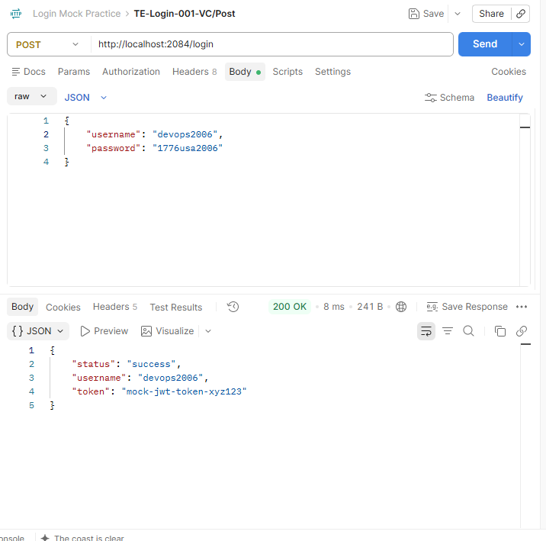

TC-Login-002
Valid Minimum Username
Planned precondition: A registered account is available. The mock uses hardcoded credentials and provides no account-registration verification.
Request format: Postman raw JSON
Environment: Local mock server with Postman
Reference valid username: devops2006
Reference valid password: 1776usa2006
Priority: Medium | Functional | Positive
Expected Results
The system accepts a registered account’s credentials with an eight-character username and redirects the user to the main page.
Submitted
{
"username": "devop200",
"password": "1776usa2006"
}
Observed
The mock rejected the submitted credentials. It does not implement username-length validation or page navigation.
"status": "error",
"message": "Invalid username or password"
“401 Unauthorized”
Execution
Re-executed with the eight-character username “devop200.” The supplied replacement screenshot shows 401 and the JSON message “Invalid username or password.” Minimum-length acceptance and navigation remain unverified because the mock accepts only its hardcoded credential pair and provides no redirect behavior.
Status
Blocked for minimum-boundary acceptance and redirect verification. Replacement evidence supplied on 10/12/26; the earlier execution record was dated 10/6/26.
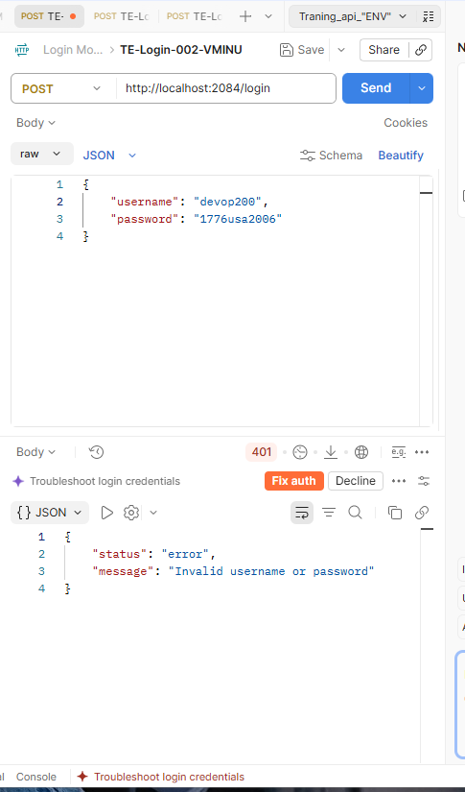

TC-Login-003
Valid Minimum Password
Test area: Authentication
Planned precondition: A registered account is available. The mock uses hardcoded credentials and provides no account-registration verification.
Request format: Postman raw JSON
Environment: Local mock server with Postman
Reference valid username: devops2006
Reference valid password: 1776usa2006
Priority: Medium | Functional | Positive
Expected Results
The system accepts a registered account’s credentials with an eight-character password and redirects the user to the main page.
Submitted
{
"username": "devops2006",
"password": "17762006"
}
Observed
The mock rejected the submitted credentials. It does not implement password-length validation or page navigation.
"status": "error",
"message": "Invalid username or password"
“401 Unauthorized”
Execution
The request was submitted. The intended boundary acceptance and redirect outcomes could not be verified in this environment.
Status
Blocked for the intended boundary and redirect checks because of mock limitations. Recorded execution date: 10/6/26.

TC-Login-004
Valid Minimum Username & Password
Test area: Authentication
Planned precondition: A registered account is available. The mock uses hardcoded credentials and provides no account-registration verification.
Request format: Postman raw JSON
Environment: Local mock server with Postman
Reference valid username: devops2006
Reference valid password: 1776usa2006
Priority: Medium | Functional | Positive
Expected Results
The system accepts a registered account’s credentials with an eight-character username and an eight-character password and redirects the user to the main page.
Submitted
{
"username": "devops20",
"password": "17762006"
}
Observed
The corrected request used “devops20” and “17762006,” each eight characters. The supplied screenshot shows 401 Unauthorized and the JSON message “Invalid username or password.” The mock does not implement credential-length rules or page navigation.
"status": "error",
"message": "Invalid username or password"
“401 Unauthorized”
Execution
Re-executed with both credentials at the eight-character minimum. Request rejection was observed. Acceptance of registered credentials at the minimum boundary and redirect behavior remain blocked by the mock environment.
Status
Blocked for minimum-boundary acceptance and redirect verification. Recorded execution date: 10/6/26 . Corrected execution evidence supplied on 10/12/26.
TC-004 corrected execution evidence supplied on 10/12/26
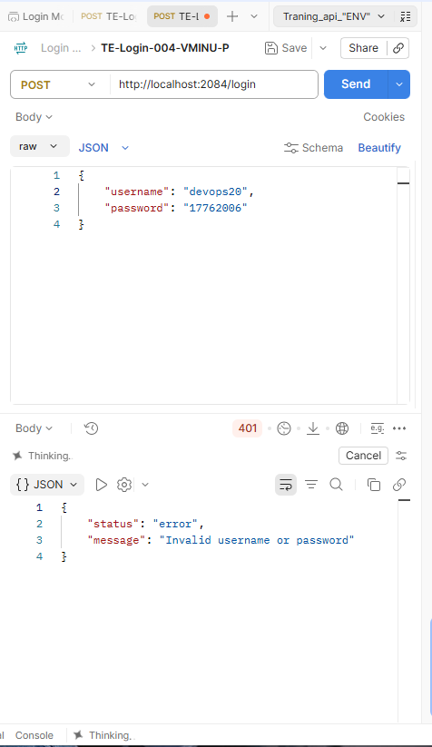

TC-Login-005
Valid Maximum Username
Test area: Authentication
Planned precondition: A registered account is available. The mock uses hardcoded credentials and provides no account-registration verification.
Request format: Postman raw JSON
Environment: Local mock server with Postman
Reference valid username: devops2006
Reference valid password: 1776usa2006
Priority: Medium | Functional | Positive
Expected Results
The system accepts a registered account’s credentials with a 24-character username and redirects the user to the main page.
Submitted
{
"username": "automationdevelopers2006",
"password": "1776usa2006"
}
Observed
The mock rejected the submitted credentials. It does not implement username-length validation or page navigation.
"status": "error",
"message": "Invalid username or password"
“401 Unauthorized”
Execution
The request was submitted. The intended boundary acceptance and redirect outcomes could not be verified in this environment.
Status
Blocked for the intended boundary and redirect checks because of mock limitations. Recorded execution date: 10/6/26.

TC-Login-006
Valid Maximum Password
Request format: Postman raw JSON
Environment: Local mock server with Postman
Test area: Authentication
Planned precondition: A registered account is available. The mock uses hardcoded credentials and provides no account-registration verification.
Reference valid username: devops2006
Reference valid password: 1776usa2006
Priority: Medium | Functional | Positive
Expected Results
The system accepts a registered account’s credentials with a 24-character password and redirects the user to the main page.
Submitted
{
"username": "devops2006",
"password": "1776americanSDETtest2006"
}
Observed
The mock rejected the submitted credentials. It does not implement password-length validation or page navigation.
"status": "error",
"message": "Invalid username or password"
“401 Unauthorized”
Execution
The request was submitted. The intended boundary acceptance and redirect outcomes could not be verified in this environment.
Status
Blocked for the intended boundary and redirect checks because of mock limitations. Recorded execution date: 10/6/26.

TC-Login-007
Valid Maximum Username & Password
Test area: Authentication
Planned precondition: A registered account is available. The mock uses hardcoded credentials and provides no account-registration verification.
Request format: Postman raw JSON
Reference valid username: devops2006
Reference valid password: 1776usa2006
Priority: Medium | Functional | Positive
Expected Results
The system accepts a registered account’s credentials with a 24-character username and a 24-character password and redirects the user to the main page.
Submitted
{
"username": "automationdevelopers2006",
"password": "1776americanSDETtest2006"
}
Observed
The mock rejected the submitted credentials. It does not implement username- or password-length validation or page navigation.
"status": "error",
"message": "Invalid username or password"
“401 Unauthorized”
Execution
The request was submitted. The intended boundary acceptance and redirect outcomes could not be verified in this environment.
Status
Blocked for the intended boundary and redirect checks because of mock limitations. Recorded execution date: 10/6/26.
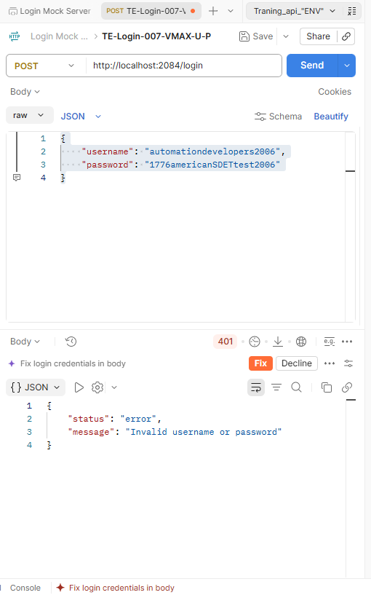

TC-Login-008
Invalid Username
Test area: Authentication
Planned precondition: A registered account is available. The mock uses hardcoded credentials and provides no account-registration verification.
Request format: Postman raw JSON
Environment: Local mock server with Postman
Reference valid username: devops2006
Reference valid password: 1776usa2006
Priority: High | Functional | Negative
Expected Results
The system rejects the login attempt with an invalid username and displays an error requesting valid credentials.
Submitted
{
"username": "Jr.Tester",
"password": "1776usa2006"
}
Observed
The mock returned 401 Unauthorized with the JSON message “Invalid username or password.” This establishes rejection of the submitted login request; it does not identify independent validation results for each field. UI error display was not verified.
“401 Unauthorized”
{
"status": "error",
"message": "Invalid username or password"
}
Execution
Submitted the documented JSON request through Postman. Verified the recorded 401 Unauthorized response and JSON error message. This execution did not verify UI error display.
Status
Partially verified. The API rejection check passed. UI error display could not be verified because the mock provides no login UI. Recorded execution date:10/6/26
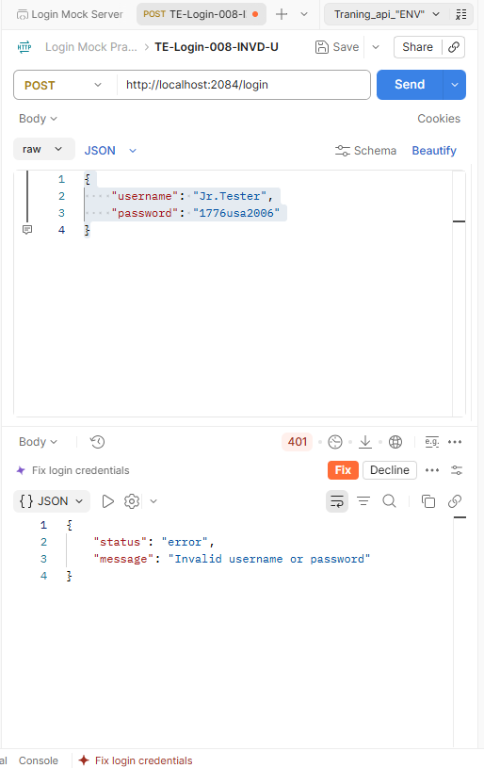

TC-Login-009
Invalid Password
Test area: Authentication
Planned precondition: A registered account is available. The mock uses hardcoded credentials and provides no account-registration verification.
Request format: Postman raw JSON
Environment: Local mock server with Postman
Reference valid username: devops2006
Reference valid password: 1776usa2006
Priority: High | Functional | Negative
Expected Results
The system rejects the login attempt with an invalid password and displays an error requesting valid credentials.
Submitted
{
"username": "devops2006",
"password": "Sen.Developer"
}
Observed
The mock returned 401 Unauthorized with the JSON message “Invalid username or password.” This establishes rejection of the submitted login request; it does not identify independent validation results for each field. UI error display was not verified.
“401 Unauthorized”
{
"status": "error",
"message": "Invalid username or password"
}
Execution
Submitted the documented JSON request through Postman. Verified the recorded 401 Unauthorized response and JSON error message. This execution did not verify UI error display.
Status
Partially verified. The API rejection check passed. UI error display could not be verified because the mock provides no login UI.

TC-Login-010
Invalid Username & Password
Test area: Authentication
Planned precondition: A registered account is available. The mock uses hardcoded credentials and provides no account-registration verification.
Request format: Postman raw JSON
Environment: Local mock server with Postman
Priority: High | Functional | Negative
Expected result: The system rejects the login attempt when both credentials are invalid and displays an error requesting valid credentials.
Submitted
{
"username": "Jr.Tester",
"password": "Sen.Developer"
}
Observed
The mock returned 401 Unauthorized with the JSON message “Invalid username or password.” This establishes rejection of the submitted login request; it does not identify independent validation results for each field. UI error display was not verified.
“401 Unauthorized”
{
"status": "error",
"message": "Invalid username or password"
}
Execution
Submitted the documented JSON request through Postman. Verified the recorded 401 Unauthorized response and JSON error message. This execution did not verify UI error display.
Status
Partially verified. The API rejection check passed. UI error display could not be verified because the mock provides no login UI. Recorded execution date: 10/6/26

TC-Login-011
Blank Username
Test area: Authentication
Planned precondition: A registered account is available. The mock uses hardcoded credentials and provides no account-registration verification.
Request format: Postman raw JSON
Environment: Local mock server with Postman
Reference valid username: devops2006
Reference valid password: 1776usa2006
Priority: High | Functional | Negative
Expected Results
The system rejects an empty-username login attempt and indicates that a username is required.
Submitted
{
"username": "",
"password": "1776usa2006"
}
Observed
The corrected empty-username request returned 401 Unauthorized with the JSON message “Invalid username or password.” The screenshot verifies request rejection. A username-required indication and UI error display were not verified.
“401 Unauthorized”
{
"status": "error",
"message": "Invalid username or password"
}
Execution
Executed with an empty username and the reference valid password. Verified the rejection status and JSON error response.
Status
Partially verified. The API rejection check passed. The required-username indication and UI error display remain unverified because the mock provides neither field-specific validation messages nor a login UI. Recorded execution date: 10/6/26. Corrected execution evidence supplied on 10/12/26.
TC-011 corrected execution evidence supplied on 10/12/26
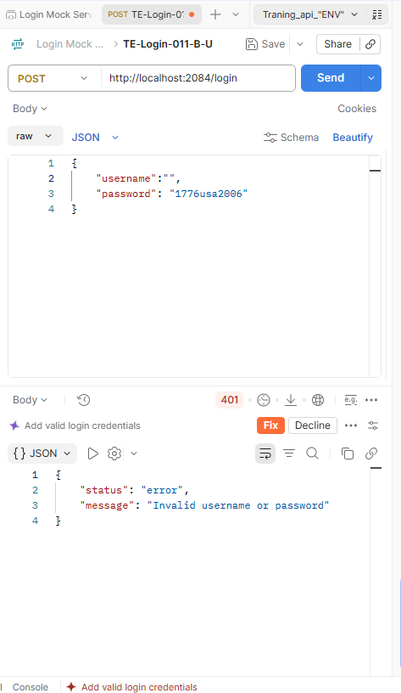

TC-Login-012
Test area: Authentication
Blank Password
Planned precondition: A registered account is available. The mock uses hardcoded credentials and provides no account-registration verification.
Request format: Postman raw JSON
Environment: Local mock server with Postman
Reference valid username: devops2006
Reference valid password: 1776usa2006
Priority: High | Functional | Negative
Expected Results
The system rejects an empty-password login attempt and indicates that a password is required.
Submitted
{
"username": "devops2006",
"password":""
}
Observed
The mock returned 401 Unauthorized with the JSON message “Invalid username or password” for an empty-password request. The screenshot supports request rejection. A password-required indication and UI validation were not verified.
“401 Unauthorized”
{
"status": "error",
"message": "Invalid username or password"
}
Execution
Submitted the documented JSON request through Postman. Verified the recorded 401 Unauthorized response and JSON error message. This execution did not verify UI error display.
Status
Partially verified. API request rejection was verified. The required-field indication and UI validation could not be verified in the mock environment. Recorded execution date: 10/6/26. Corrected execution evidence supplied on 10/12/26.

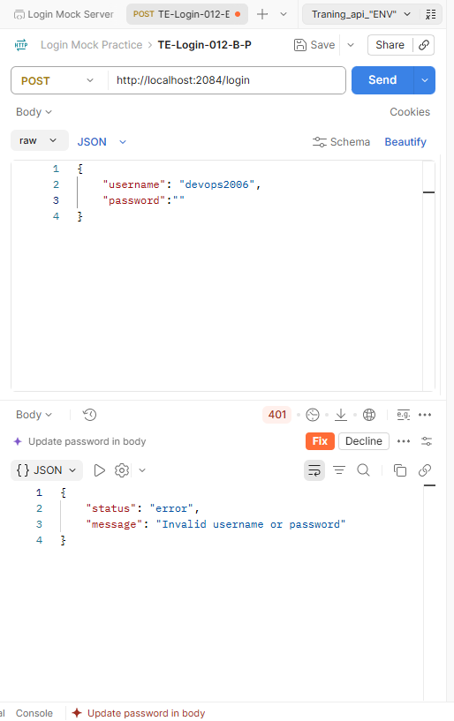

TC-Login-013
Blank Username & Password
Test area: Authentication
Planned precondition: A registered account is available. The mock uses hardcoded credentials and provides no account-registration verification.
Request format: Postman raw JSON
Environment: Local mock server with Postman
Reference valid username: devops2006
Reference valid password: 1776usa2006
Priority: High | Functional | Negative
Expected Results
The system rejects a login attempt with both fields empty and displays appropriate required-field validation.
Submitted
{
"username": "",
"password": ""
}
Observed
The written execution record reports rejection of two empty strings with “Invalid username or password.” No TC-013 screenshot is embedded in this document.
“401 Unauthorized”
{
"status": "error",
"message": "Invalid username or password"
}
Execution
Submitted the documented JSON request through Postman. Verified the recorded 401 Unauthorized response and JSON error message. This execution did not verify UI error display.
Status
Partially verified. API request rejection was verified. The required-field indication and UI validation could not be verified in the mock environment. Recorded execution date: 10/6/26. Corrected execution evidence supplied on 10/12/26.

Test Closure

Summary
This learning project documents 13 intended login cases: one valid-credential case, six boundary cases, three invalid-credential cases, and three empty-field cases. Execution used a Dell Latitude 3520, Windows 11, and a local mock server with Postman. The mock returned 200 OK for its hardcoded credential pair and 401 Unauthorized for rejected requests. Seven intended cases were partially verified and six boundary cases were blocked. All corrected request inputs are now represented in execution records. None of the original cases was fully verified. No defects were reported within the executed mock-response checks. Corrected TC-002, TC-004, and TC-011 evidence was supplied on 10/12/26; earlier execution records are dated 10/6/26.
PostmanMock Server
The mock was selected to simplify API execution. It compares the submitted username and password with one hardcoded pair and requires exactly those two JSON fields. A successful response contains a fixed mock token; it does not establish production authentication or session security. The mock has no login UI or redirect behavior.

Simulated Stakeholder
ChatGPT was prompted to act as a simulated stakeholder for this learning project. Its role was limited to providing the initial user story and requirements and responding to clarification requests. These responses supported the exercise and did not represent approval from a real product owner or independent QA reviewer.

Final Scope and Coverage
The documented stakeholder clarification specified the main page. The original scope included login fields, the Login button, authentication outcomes, required-field validation, and navigation after successful authentication. Execution was limited to API responses from the mock.
TC-001 verified acceptance of the hardcoded credential pair, while redirect verification was blocked. TC-002–007 could not establish the intended boundary acceptance or redirect outcomes. TC-008–010 verified rejection responses but could not verify UI error display. TC-011–013 recorded empty-input rejection responses, but required-field indications and UI validation remain unverified. The corrected TC-011 screenshot now establishes an empty-username rejection response.
A successful redirect is required only after successful authentication. Successful redirection is not an expected outcome of these negative cases. No browser navigation behavior was exercised by the mock. Partial API results do not establish full UI acceptance-criteria coverage.
Total intended cases: 13
Partially verified cases: 7 — TC-001 and TC-008–013
Blocked cases: 6 — TC-002–007
Not executed as designed: 0
Fully verified PASS cases: 0
Confirmed FAIL cases: 0; blocked and incomplete outcomes are reported separately.
Reported defects: 0

Coverage Notes
API success or rejection can be verified independently of a case’s complete expected outcome. The classifications above describe the original intended cases. Corrected input records resolve the earlier TC-002 and TC-004 length errors and TC-011 whitespace mismatch; the mock’s functional limitations remain.
Environmental limitations and documentation discrepancies must be distinguished from observed application defects.

Defect Summary
No defects were reported within the executed mock-response checks. This does not establish that the original login feature is defect-free.

Closure Recommendation
The STLC learning exercise is closed with documented limitations and incomplete functional coverage. The educational objective was to practice requirements analysis, planning, design, environment setup, execution, and closure. Repository preparation does not constitute approval of a fully tested login feature. The remaining coverage gaps are retained for transparency; rebuilding the environment is outside this exercise’s closure scope. Supporting evidence will be packaged as test artifacts in the repository.

Execution Data and Coverage Notes
TC-002: The replacement screenshot shows “devop200,” an eight-character username, with a 401 response. TC-004: The new screenshot shows “devops20” and “17762006,” both eight characters, with a 401 response. Both cases have corrected execution evidence. Their intended boundary acceptance and redirect outcomes remain blocked by the mock.
TC-011: The replacement screenshot shows an empty username ("") and the reference valid password, with a 401 response and the generic credential error. It supersedes the earlier setup-only screenshot. Empty-input rejection is verified; the required-username indication and UI display remain unverified.
TC-008–010: Rejection status and JSON errors were verified, but UI error display was not. TC-012 has an empty-password screenshot. TC-013 has a written record of both fields empty. Screenshots are supporting artifacts; their absence alone does not invalidate an execution record. The generic error response does not establish the field-specific indications required by AC-LOGIN-004–005.

Lessons Learned
The STLC Login Project helped me understand the planning and analysis behind testing. Quality assurance, risk reduction, and verification require preparation, patience, analytical thinking, and problem solving. The Software Testing Life Cycle provides a structure for this work. This exercise extended my understanding beyond executing individual manual tests or automation scripts.
Requirement analysis: Starting with the prompted user story and acceptance criteria, I documented the functional requirements and scope. I reviewed clarity, ambiguity, conflicts, coverage, testability, and alignment. I acknowledged prioritization and impact, although this exercise did not explore them in depth.
Test planning: I outlined the objectives, risks, tools, environment, entry and exit criteria, and deliverables. These included execution records, a defect summary, the closure report, and lessons learned.
Environment setup: I used a local mock server with Postman and documented its code and screenshots. The initial Postman AI attempt left the server incomplete after the available credits ran out. I then used ChatGPT guidance to make the mock accept the chosen valid credentials. I later recognized that accepting only one credential pair would block much of the intended boundary coverage.
Test design: I described the login scenario, planned steps, and expected results. I recorded test IDs, titles, preconditions, data, expected results, observed responses, and statuses. Reviewing the work exposed the ambiguous main-page destination and strengthened my understanding of why requirements must be revisited throughout the lifecycle.
Stakeholder clarification: ChatGPT acted as a simulated stakeholder. I requested clarification of the redirect destination, and the documented decision specified the main page. This helped me understand the value of reviewing requirements before judging results.
Test execution: The mock did not provide the UI, boundary rules, or navigation behavior needed to verify every expected outcome. I learned to distinguish a successful API check from a fully verified test case and to describe the remaining limitations accurately.
Closure and documentation: Writing the summary exposed gaps in my technical terminology, expression, and description. The project gave me a working understanding of the STLC and a clearer view of professional testing.

