How Many Labelled EEG Windows Does Each Model Family Need? A Learning-Curve Study of Harmful Brain Activity Classification
Take-Home Lab 1 and Project Proposal, ET4248E Machine Learning in Healthcare, Group N42
Group N42
Student ID 20260147S, Hanoi University of Science and Technology (HUST), Hanoi, Vietnam

Abstract—Seizures and other rhythmic and periodic patterns in the EEG of hospitalised patients can harm the brain, and the experts who can read them are scarce. This proposal uses the HMS Harmful Brain Activity dataset (106,800 labelled EEG windows, 17,089 recordings, 1,950 patients), in which each 10 s window carries the votes of several experts over six classes. The task is supervised six-class classification with soft labels, scored by the KL divergence between the predicted and the expert vote distributions. We review 11 journal papers in four areas (classification methods, limited data, foundation models, label disagreement) and find three gaps: split protocols differ, no study compares model families as a function of the number of labelled windows on this task, and label quality varies with the class. The exploratory analysis shows that class balance depends on the counting level (imbalance ratio 1.4 over all windows, 7.6 with one window per recording, 10.4 over patients) and that 18.5% of the windows have a single vote. We describe a patient-level split checked by assertions and a preprocessing pipeline whose only fitted step uses training windows only.
Index Terms—EEG, harmful brain activity, seizure, learning curve, soft labels, data leakage.
I. Introduction
A. Clinical Problem and Learning Task
Patients in hospital, many of them critically ill, often undergo EEG monitoring. Besides seizures, their EEG can show lateralized and generalized periodic discharges (LPD, GPD) and lateralized and generalized rhythmic delta activity (LRDA, GRDA). These ictal-interictal-injury continuum (IIIC) patterns can damage the brain, especially when prolonged, and the specialists who can identify them are scarce [1].
Population: hospitalised patients undergoing clinical EEG, as in the HMS data from Massachusetts General Hospital [1]. Input X: one 10 s window of scalp EEG (19 electrodes of the 10–20 system, 200 Hz), taken from the centre of a 50 s segment. The models receive it either as 16 bipolar channels at 100 Hz (an array of 1000 samples × 16 channels) or as 160 band-power features. Output Y: the distribution of expert votes over six classes (seizure, LPD, GPD, LRDA, GRDA, other). Task: supervised, multi-class classification with soft labels: the model outputs a probability for each of the six classes, and its target is the vote share of each class, not only the majority label.
Two families of models compete on clinical EEG. Handcrafted features with classical classifiers reached the same accuracy as deep networks for EEG pathology detection [2], while deep features learned without labels help most when few labels are available [3]. In-context foundation models are built for small datasets: TSPFN [4], built on TabPFN [5], was tested with 100 to 1,000 labelled samples. Since expert labels are the expensive part, the number of labelled windows a model needs matters as much as its final score. The project therefore compares model families by their learning curves: test performance as a function of the number N of labelled training windows, on one frozen patient-level split.
B. Clinical Urgency and Risk-Cost Analysis
An automated decision support tool would screen hours of EEG and flag windows for expert review, which matters most where no expert is available around the clock. A false negative (a missed seizure or LPD) leaves a harmful pattern untreated and may never be reviewed, since the tool decides what the expert sees. A false positive costs review time and, if acted on without review, can lead to unneeded antiseizure drugs or sedation; many false alarms also cause alarm fatigue. For the harmful classes a false negative is the more costly error, because a false alarm is caught at the review step while a miss is not. For the class “other” the reverse holds.
Experts often disagree on these patterns: two experts agree on 52% of the segments (κ = 0.42) [6], so many windows have no single true label. The primary metric is therefore the KL divergence between the expert vote distribution p and the prediction q, KL(p‖q) = Σₖ pₖ log(pₖ/qₖ), averaged over the test windows with a bootstrap 95% confidence interval (lower is better). It rewards a model that is uncertain where the experts are, and it is the metric of the HMS competition. Accuracy is misleading under the imbalance of Section III (“other” alone is 42% of the recordings), so we add per-class one-vs-rest ROC-AUC against the majority label, the sensitivity for seizure and LPD at a fixed specificity (the cost analysis above), and the KL on windows with at least 10 votes, whose labels are more reliable.
II. Related Work
A. Literature Comparison Matrix
We searched for journal papers from 2020 to 2026 in the four areas agreed with the instructor: EEG classification methods, learning with limited labelled data, foundation models for small data, and label disagreement. Table I lists 11 papers in Q1 journals (SCImago) and the TSPFN preprint [4], which motivated the project but does not count toward the 10 because it is an arXiv preprint. Two papers use the same patients as this project: SPaRCNet [1] was trained on these 1,950 patients, and VIPEEGNet [7] uses the HMS data directly, with the same KL metric. SCORE-AI [8] interprets whole routine EEGs, and [9] trains a seizure detector on weak clinical labels. On limited data, [10] adds 15,300 automatically labelled recordings to the TUH Abnormal corpus, and [11] compares 13 data augmentations. The CNN used here, xresnet1d, comes from the PTB-XL ECG benchmark [12].

TABLE I
Literature comparison matrix (locations refer to the PDFs in 05 Reference papers)
Author, year, venue [n] | DOI | Dataset (name, size) | Split protocol | Architecture / method | Primary results (source) | XAI | Limitations
Jing et al., 2023, Neurology [1] | 10.1212/WNL.0000000000207127 | MGH IIIC EEG: 6,095 EEGs, 2,711 patients, 50,697 segments, 20 experts (p. e1750; Table 1, p. e1752) | Patient-level (pp. e1752–e1753) | CNN (SPaRCNet), 6 classes, multi-rater labels | % of 20 experts below its ROC: SZ 45, LPD 20, GPD 50, LRDA 75, GRDA 55, other 40 (Abstract, p. e1751; p. e1755) | UMAP embedding map (Fig. 3, p. e1755) | Single centre; other patterns (e.g. burst suppression) not covered; no false alarms per hour (p. e1759)
Gemein et al., 2020, NeuroImage [2] | 10.1016/j.neuroimage.2020.117021 | TUH Abnormal v2.0.0: 2,993 recordings (Table 2, p. 3) | Patient-level test set (Table 2, p. 3); recording-level 5-fold CV for tuning (p. 6) | Handcrafted features + RF / SVM / Riemannian vs CNNs and TCN | Accuracy 81–86% for all models (Abstract, p. 1); best 86.16%, BD-TCN (Sec. 3.3, p. 7) | Input perturbation (p. 7); RF feature importance (Fig. 12) | Binary task; accuracy may saturate near 90% due to label agreement (Abstract, p. 1)
Banville et al., 2021, J. Neural Eng. [3] | 10.1088/1741-2552/abca18 | PC18: 994 subjects; TUH Abnormal: 2,993 recordings, 2,329 subjects (Tables 1–2) | Recording-level (Sec. 2.6.3) | Self-supervised pretext tasks (RP, TS, CPC) + linear classifier | Balanced accuracy up to 72.3% (PC18) and 79.4% (TUH Abnormal) (Sec. 3.1, Fig. 3) | UMAP of learned features (Figs. 4–5) | Fixed hyperparameters across data sizes; limited architecture search (Sec. 4.4)
Stym-Popper et al., 2026, arXiv preprint [4] (not counted) | arXiv:2608.31013 | Pretraining: TUEV, TUAB, PTB-XL, HiRID (~140k); tests: 5 datasets, N = 100 (Sec. 4) | Record-level, stratified 5-fold CV (Sec. 4, p. 6) | TabPFN adapted to multichannel time series (in-context) | Mean AUC 82.5 vs 78.1 for MiniRocket (Table 1, p. 8) | None | Input limited to T × C ≤ 500 values (Sec. 3, p. 4); weights not released
Hollmann et al., 2025, Nature [5] | 10.1038/s41586-024-08328-6 | 29 classification + 28 regression tabular datasets, ≤ 10,000 samples (p. 323) | Not applicable: random 90/10 splits, 10 repeats (p. 323) | Transformer pretrained on synthetic data, in-context prediction (TabPFN) | Normalised ROC AUC 0.939 vs 0.752 for CatBoost (Fig. 4a, p. 323); 2.8 s vs 4 h tuning (Abstract, p. 319) | SHAP (Extended Data Fig. 3) | ≤ 10,000 samples and 500 features; memory grows with data (Methods)
Jing et al., 2023, Neurology [6] | 10.1212/WNL.0000000000201670 | MGH: 2,711 EEGs, 50,697 segments (Abstract, p. e1737); 30 experts | Not applicable (no model) | Inter-rater reliability study (pairwise and majority agreement, κ) | Pairwise: 52%, κ 0.42; to majority: 65%, κ 0.61 (Abstract, p. e1737) | Not applicable | Single centre; some patterns (BiPDs, spike-wave) not scored (Discussion)
Sun et al., 2025, npj Digit. Med. [7] | 10.1038/s41746-025-02154-4 | HMS: 1,950 patients, 17,089 records, 106,800 segments (Table 1, p. 2); external: 1,532 patients (p. 4) | Patient-level 5-fold CV (p. 2) | ImageNet-pretrained vision backbone on EEG mapped to images (VIPEEGNet) | KL 0.225 (5-fold, p. 4); external KL 0.223 / 0.273 (Abstract, p. 1) | t-SNE of outputs (p. 6) | Not causal: needs the 50 s around the window (p. 8)
Tveit et al., 2023, JAMA Neurol. [8] | 10.1001/jamaneurol.2023.1645 | Development: 30,493 EEGs; tests: 100, 9,785 and 60 EEGs (Abstract, p. 805) | Recording-level hold-out of 2,549 EEGs, patient overlap not reported (p. 806); independent test sets | CNN (SCORE-AI): normal vs 4 abnormal categories | AUC 0.89–0.96; accuracy 88.3% (Abstract, p. 805; p. 809) | None | Routine EEG only: ICU patients and neonates excluded (p. 811)
Saab et al., 2020, npj Digit. Med. [9] | 10.1038/s41746-020-0264-0 | Stanford: 136,014 EEGs, 12,430 patients (p. 2) | Not reported (gold-labelled clips split into development and test, p. 3) | CNN trained on weak clinical annotations | AUROC 0.93 paediatric, 0.94 adult (Abstract, p. 1) | Occlusion heatmaps (pp. 4–5) | Single institution (p. 8)
Kiessner et al., 2023, NeuroImage: Clin. [10] | 10.1016/j.nicl.2023.103482 | TUABEX: 15,300 recordings; TUABEXB subset: 8,879 recordings (Secs. 2.3–2.4) | Patient-level (Sec. 2.4) | Same CNNs and TCN as [2], trained on automatically labelled data | BD-TCN on the TUABEXB test set: 74.96% if trained on TUAB, 83.73% if trained on TUABEXB (Table 4) | None | Generalisation to other datasets not verified (Sec. 4)
Rommel et al., 2022, J. Neural Eng. [11] | 10.1088/1741-2552/aca220 | Sleep Physionet: 78 subjects; BCI IV 2a: 9 subjects (Sec. 2.1) | Subject-level k-fold (Sec. 2) | 13 EEG data augmentations, 2 CNNs | Up to 45% accuracy gain with few training data (Abstract; Sec. 4.3) | None | Small non-clinical datasets; best augmentation depends on the task (Secs. 3.3, 4.3)
Strodthoff et al., 2021, IEEE JBHI [12] | 10.1109/JBHI.2020.3022989 | PTB-XL: 21,837 ECGs, 18,885 patients (Sec. II-A) | Patient-level (recommended folds, Sec. III-A) | 1D CNNs (xresnet1d101, inception1d), LSTM, wavelet + NN | Macro AUC 0.925 (xresnet1d101) vs 0.849 (wavelet + NN) (Table II) | LRP attribution maps (Fig. 8) | ECG only; XAI exploratory, two examples (Fig. 8)

B. Research Gaps
Gap 1: results depend on the split, and splits differ. Patient- or subject-level splits are used in [1], [2] (test set), [7], [10], [11] and [12], but [3] splits by recording, [8] does not report patient overlap in its hold-out set, and [9] does not report how patients were separated. TSPFN reports its gains with stratified 5-fold cross-validation on 100 samples per task, without patient grouping [4]. How in-context models behave on a patient-level split of clinical EEG is not known.
Gap 2: no learning curves across model families for these six patterns. [1] and [7] train one model on all 1,950 patients. [2] compares feature-based and deep models, but only with all the data and on a binary task. [3], [10] and [11] vary the amount of labelled data, but for sleep staging, pathology detection or motor imagery, with accuracy as the metric. TabPFN stops at 10,000 samples [5] and TSPFN at 500 input values [4]; whether they help below these limits on EEG is open.
Gap 3: label quality is uneven and tied to the class, but results are rarely split by it. Experts agree only moderately [6]; SPaRCNet is evaluated against the majority of at least 10 experts [1], and [7] reports one KL for all windows. In HMS, seizure windows mostly have 3–5 votes while “other” and LPD windows often have at least 10 (Section III-C), so an average KL mixes label noise with model error. [9] shows that noisy labels can still train a good model.
C. Baseline Models
All models use the same split and training subsets and are trained on the vote shares. (1) Mean-vote baseline: predicts the mean vote distribution of the training windows for every window; every model must beat it. (2) LightGBM on the 160 band-power features: each window is repeated once per class with its vote share as weight, so the weighted log-loss equals the cross-entropy with the vote shares. (3) 1D-CNN, xresnet1d (depth 18) on the 16 × 1000 bipolar signal, trained with cross-entropy on the vote shares; this architecture is among the best on PTB-XL [12]. (4) TabPFN [5] on the band-power features, up to its sample limit. TSPFN [4] cannot take a 16-channel, 1000-sample window (16,000 values > 500) and its weights are not released, so it is discussed but not run. The learning curves use N ∈ {100, 300, 1,000, 3,000, 10,000, 13,671} training windows, 3 seeds each.
III. Dataset and Exploratory Data Analysis
A. Dataset Description
Origin and access. HMS – Harmful Brain Activity Classification is a Kaggle competition dataset built from EEGs recorded at Massachusetts General Hospital. It can be downloaded from Kaggle after accepting the competition rules (registered users only); no credentialing or data use agreement is needed. The labelled file (train.csv) has 106,800 windows from 17,089 EEG recordings of 1,950 patients. Each row points to a 50 s window of a recording, of which the experts labelled the central 10 s. Recordings have 19 scalp electrodes (10–20 system) and one EKG channel at 200 Hz; spectrograms are also provided but not used. Each window has a number of votes per class (median 3, max 28). A recording has a median of 3 labelled windows (max 743), and a patient a median of 3 recordings (max 270). The labelled part of a recording spans a median of 58 s (90th percentile 130 s, max 3,422 s); full recording lengths are in the notebook. The 1,950 patients are those of the SPaRCNet training set (Table 1 of [1]).
Demographics. train.csv has no age or sex column, so bias by age or sex cannot be measured and the splits cannot be balanced on them. The only information is reported in [1] for the same 1,950 patients: mean age 47.7 years (SD 25.5), 49.4% women (Table 1, p. e1752). The wide age range suggests that children are included, and any age effect on the model will remain unknown.
B. Signal Statistics and Representative Samples
We analyse one window per recording (17,089 windows, Section IV). Fig. 1 shows a unanimous window of each class. After filtering, the median within-window standard deviation of a channel is 9.9 to 16.1 µV, highest on the frontopolar chains (Fp2-F8: 16.1 µV), probably because of eye movements; the 95th percentile is 52.9 to 82.7 µV. As the domain equivalent of a correlation matrix, Fig. 2 gives the relative band power per class and the correlation of log band power between bands. GRDA has the most delta power (0.82 of the total), GPD the most theta (0.22), and seizure and “other” the most beta (0.11). Adjacent bands are strongly correlated, so the 160 features are partly redundant.
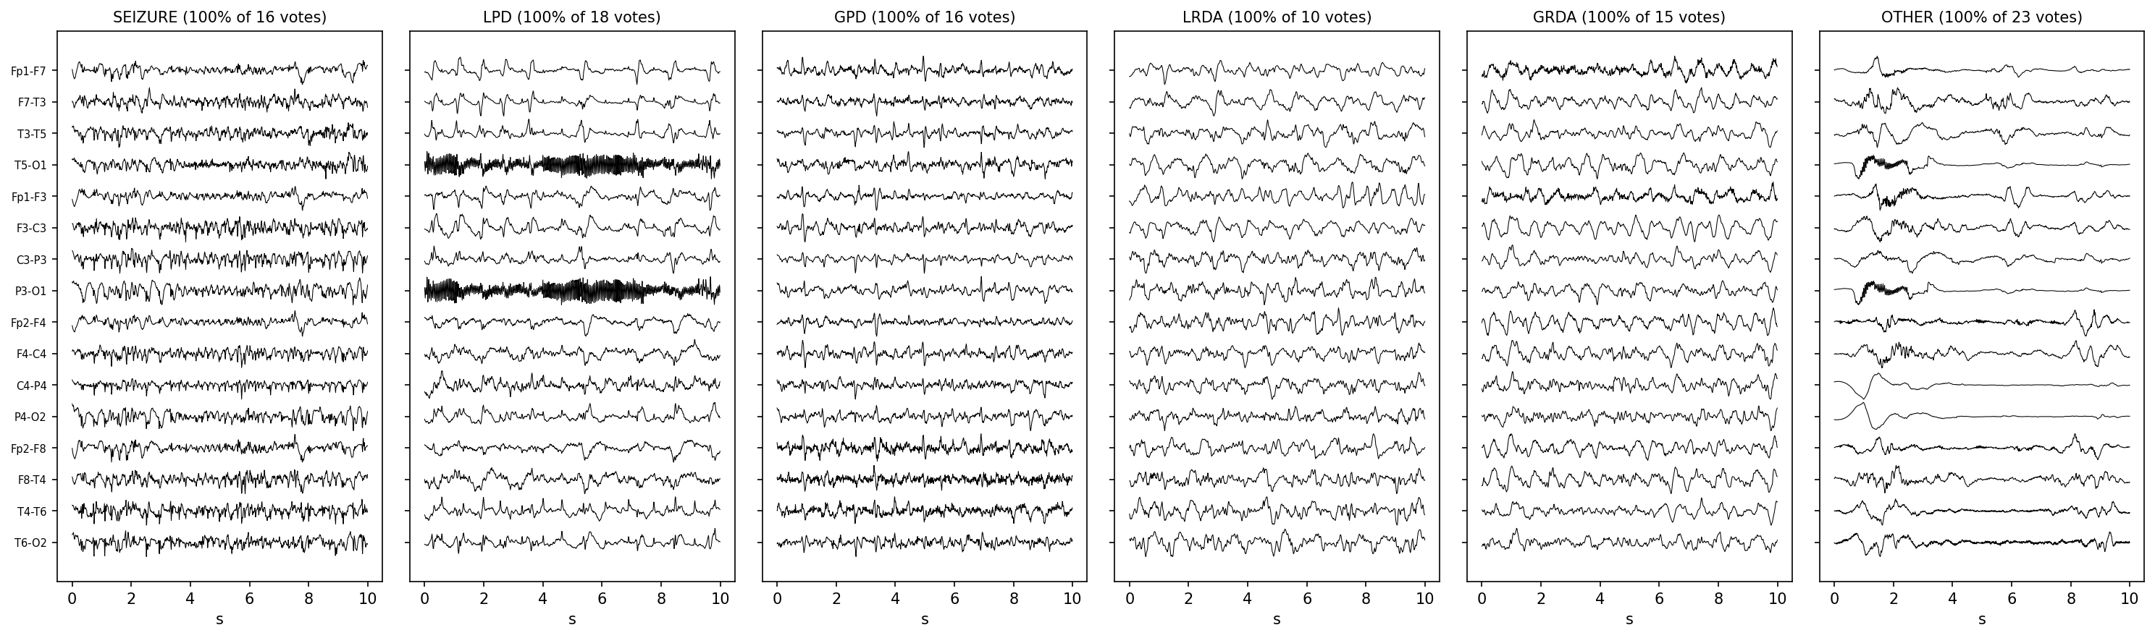
Fig. 1. One window per class with unanimous votes (10 s, 16 bipolar channels, 100 Hz, each trace scaled to its own range).
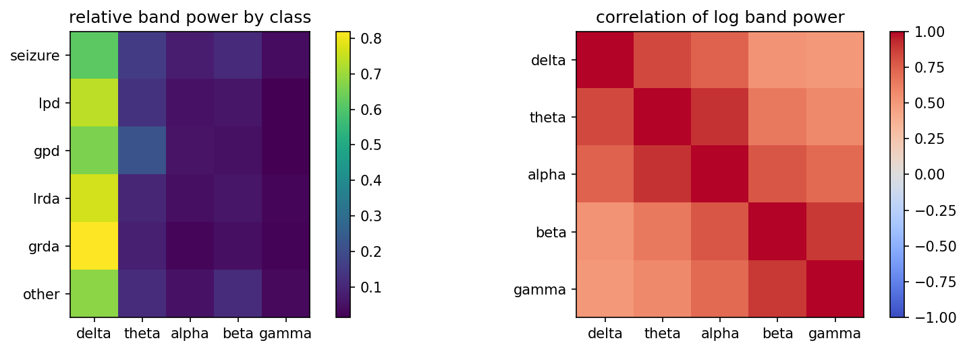
Fig. 2. Left: mean relative band power per class (majority label). Right: correlation of log band power between the five bands.
C. Class Imbalance and Label Quality
Table II counts the majority label at four levels. Over all 106,800 windows the classes look balanced (ratio 1.4), but this comes from many overlapping windows per recording. With one window per recording the ratio is 7.6, and over patients it reaches 10.4: LPD appears in only 251 patients and is the main class of 69. The useful sample size for rare classes is the number of patients, not of windows (Fig. 3).
TABLE II
Majority-label counts at four levels
Class | All windows | 1 per recording | Patients with class | Patients, main class
Seizure | 20,933 | 2,753 | 993 | 717
LPD | 14,856 | 2,601 | 251 | 69
GPD | 16,702 | 1,808 | 225 | 105
LRDA | 16,640 | 935 | 317 | 171
GRDA | 18,861 | 1,841 | 722 | 459
Other | 18,808 | 7,151 | 1,117 | 429
Ratio max/min | 1.4 | 7.6 | 5.0 | 10.4
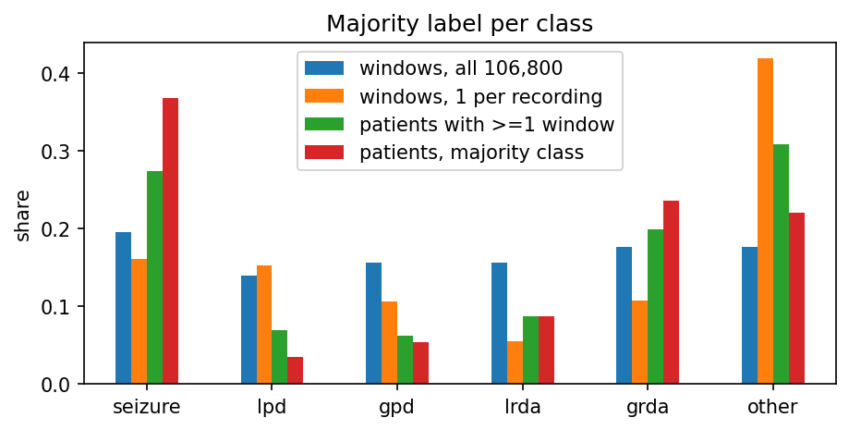
Fig. 3. Share of each majority class at the four counting levels.
Among the 17,089 windows, 18.5% have a single vote, 32.4% have at least 10 votes, and 57.2% are unanimous. Label quality depends on the class: 35.8% of the windows with 3–5 votes are seizures, against 3.3% of those with at least 10 votes, where LPD (19.3%) and “other” (52.3%) dominate. A model that is good on seizures is therefore evaluated mostly on few-vote labels, which is why KL is also reported for the windows with at least 10 votes.
D. Missing Data, Noise and Duplicates
3.3% of the windows have at least one missing electrode, and 0.141% of all samples are missing. Five windows are entirely flat (4 in training, 1 in test) and 6 have at least one flat channel. 1,092 windows (6.4%) have a channel with a standard deviation above 200 µV, which suggests artifacts. Mains noise is at 60 Hz (US recordings). Near-duplicates are the main issue: a recording has 6.2 labelled windows on average, and 89,711 pairs of consecutive windows of the same recording start less than 50 s apart, so their signals overlap. We keep one window per recording; after this, no two windows from different recordings are identical (flat windows excluded).
Executable EDA notebook (public, Kaggle): https://www.kaggle.com/code/charleshusson/hms-eda-ipynb
IV. Preprocessing and Leakage Control
A. Domain-Specific Preprocessing
Each window is processed on its own, with fixed parameters: (1) one labelled window per recording, drawn at random with a fixed seed; (2) 16-channel bipolar “double banana” montage, median of each chain removed, missing samples set to zero (a missing electrode silences its two chains); (3) amplitude clipped at ±1024 µV; (4) 60 Hz notch and 0.5–45 Hz Butterworth band-pass (order 3), both zero-phase and applied to the full 50 s so that edge effects fall outside the labelled 10 s; (5) decimation to 100 Hz and extraction of the central 10 s, giving a 1000 × 16 array; (6) 160 features: log absolute and relative power in five bands (delta 0.5–4, theta 4–8, alpha 8–13, beta 13–30, gamma 30–45 Hz) for each of the 16 chains (Welch, 2 s segments). The only fitted step is a per-channel robust normalisation (median and interquartile range) of the signals, described below. The targets are the vote shares.
B. Patient-Level Split and Fit-on-Train-Only
The independent unit is patient_id. Patients are assigned to 10 folds of similar window count; fold 0 is the test set, fold 1 the validation set and folds 2–9 the training pool. All learning-curve subsets are drawn from the training pool only, and the test set is the same for every model, size and seed. The notebook checks that no patient and no recording appear in two sets:
train_ids = set(m.patient_id[m.split == "train"])
val_ids = set(m.patient_id[m.split == "val"])
test_ids = set(m.patient_id[m.split == "test"])
assert train_ids.isdisjoint(test_ids), \
"DATA LEAKAGE DETECTED: Train/Test overlap!"
assert train_ids.isdisjoint(val_ids), \
"DATA LEAKAGE DETECTED: Train/Val overlap!"
assert val_ids.isdisjoint(test_ids), \
"DATA LEAKAGE DETECTED: Val/Test overlap!"
rec = {s: set(m.eeg_id[m.split == s])
for s in ("train", "val", "test")}
assert rec["train"].isdisjoint(rec["test"]) and \
rec["train"].isdisjoint(rec["val"]) and \
rec["val"].isdisjoint(rec["test"])
TABLE III
Patient-level split
Set | Patients | Windows | ≥ 10 votes | LPD share
Train pool | 1,562 | 13,671 | 4,422 | 13.5%
Validation | 194 | 1,709 | 507 | 21.9%
Test | 194 | 1,709 | 608 | 21.9%
All assertions pass (Table III). The folds balance window counts but not classes; because LPD comes from few patients, its share differs between sets (13.5% vs 21.9%). We keep this frozen split so that all results stay comparable, and report per-class results. Every data-dependent step is fitted on the training windows only: the normalisation statistics come from training windows of the current subset, the mean-vote baseline uses training votes, LightGBM early stopping and the CNN’s best epoch use the validation set, and the test set is used only for the final score. No oversampling or augmentation is used. The excerpt below is from the split function:
xtr = np.asarray(data.X[tr], np.float32)
pick = np.random.default_rng(seed).choice(
len(tr), min(len(tr), stat_windows), replace=False)
med = np.median(xtr[pick], axis=(0, 1))
q75, q25 = np.percentile(xtr[pick], [75, 25], axis=(0, 1))
iqr = np.where(q75 - q25 > 1e-6, q75 - q25, 1.0)
Here tr indexes the training subset only; validation and test windows are transformed with the same med and iqr.
Preprocessing script (hms_data.py, public Kaggle dataset used by the notebook): https://www.kaggle.com/datasets/charleshusson/hms-eda-code
Group Contribution and AI Usage Statement
TABLE IV
Group contribution
Member | Student ID | Main contributions
N42 (single member) | 20260147S | All parts: literature search and matrix [1]–[12], data pipeline, EDA notebook, split and leakage checks, report (single-member group)
AI usage. Claude (Anthropic), used through Claude Code: search for candidate papers and their DOIs; finding, in the PDFs, the passages used for the split, results, XAI and limitation fields of Table I (every entry checked against the PDF by the author); drafting the data-preparation and EDA code, which the author reviewed and ran; drafting and English editing of the report text, which the author reviewed and corrected. The tool ran on the author’s computer and saw notebook outputs (summary statistics and figures). HMS is de-identified open competition data, not a credentialed dataset.
References
[1] J. Jing et al., “Development of expert-level classification of seizures and rhythmic and periodic patterns during EEG interpretation,” Neurology, vol. 100, no. 17, pp. e1750–e1762, 2023, doi: 10.1212/WNL.0000000000207127.
[2] L. A. W. Gemein et al., “Machine-learning-based diagnostics of EEG pathology,” NeuroImage, vol. 220, Art. no. 117021, 2020, doi: 10.1016/j.neuroimage.2020.117021.
[3] H. Banville, O. Chehab, A. Hyvärinen, D.-A. Engemann, and A. Gramfort, “Uncovering the structure of clinical EEG signals with self-supervised learning,” J. Neural Eng., vol. 18, 2021, doi: 10.1088/1741-2552/abca18.
[4] J. Stym-Popper, C. Rambour, F. Granese, N. Thome, and O. Bernard, “TSPFN: A temporal tabular foundation model for physiological time series classification,” arXiv:2608.31013, 2026.
[5] N. Hollmann et al., “Accurate predictions on small data with a tabular foundation model,” Nature, vol. 637, pp. 319–326, 2025, doi: 10.1038/s41586-024-08328-6.
[6] J. Jing et al., “Interrater reliability of expert electroencephalographers identifying seizures and rhythmic and periodic patterns in EEGs,” Neurology, vol. 100, no. 17, pp. e1737–e1749, 2023, doi: 10.1212/WNL.0000000000201670.
[7] Y. Sun et al., “An automated classifier of harmful brain activities for clinical usage based on a vision-inspired pre-trained framework,” npj Digit. Med., vol. 8, Art. no. 768, 2025, doi: 10.1038/s41746-025-02154-4.
[8] J. Tveit et al., “Automated interpretation of clinical electroencephalograms using artificial intelligence,” JAMA Neurol., vol. 80, no. 8, pp. 805–812, 2023, doi: 10.1001/jamaneurol.2023.1645.
[9] K. Saab, J. Dunnmon, C. Ré, D. Rubin, and C. Lee-Messer, “Weak supervision as an efficient approach for automated seizure detection in electroencephalography,” npj Digit. Med., vol. 3, Art. no. 59, 2020, doi: 10.1038/s41746-020-0264-0.
[10] A.-K. Kiessner, R. T. Schirrmeister, L. A. W. Gemein, J. Boedecker, and T. Ball, “An extended clinical EEG dataset with 15,300 automatically labelled recordings for pathology decoding,” NeuroImage: Clin., vol. 39, Art. no. 103482, 2023, doi: 10.1016/j.nicl.2023.103482.
[11] C. Rommel, J. Paillard, T. Moreau, and A. Gramfort, “Data augmentation for learning predictive models on EEG: a systematic comparison,” J. Neural Eng., vol. 19, no. 6, Art. no. 066020, 2022, doi: 10.1088/1741-2552/aca220.
[12] N. Strodthoff, P. Wagner, T. Schaeffter, and W. Samek, “Deep learning for ECG analysis: Benchmarks and insights from PTB-XL,” IEEE J. Biomed. Health Inform., vol. 25, no. 5, pp. 1519–1528, 2021, doi: 10.1109/JBHI.2020.3022989.

