Charles Lambert

CPTR 245

Lab 2

**The Project**

**Description**

I wrote the board game Othello in ruby back in my Objects and Frameworks class. The game uses gosu for the gui and test/unit for testing. The orginal project was poorly made and had minimal testing.

**# of Tests**

### 13

**Tools**

I chose to use CodeClimate, Codacy, Git(Github), and Travis CI

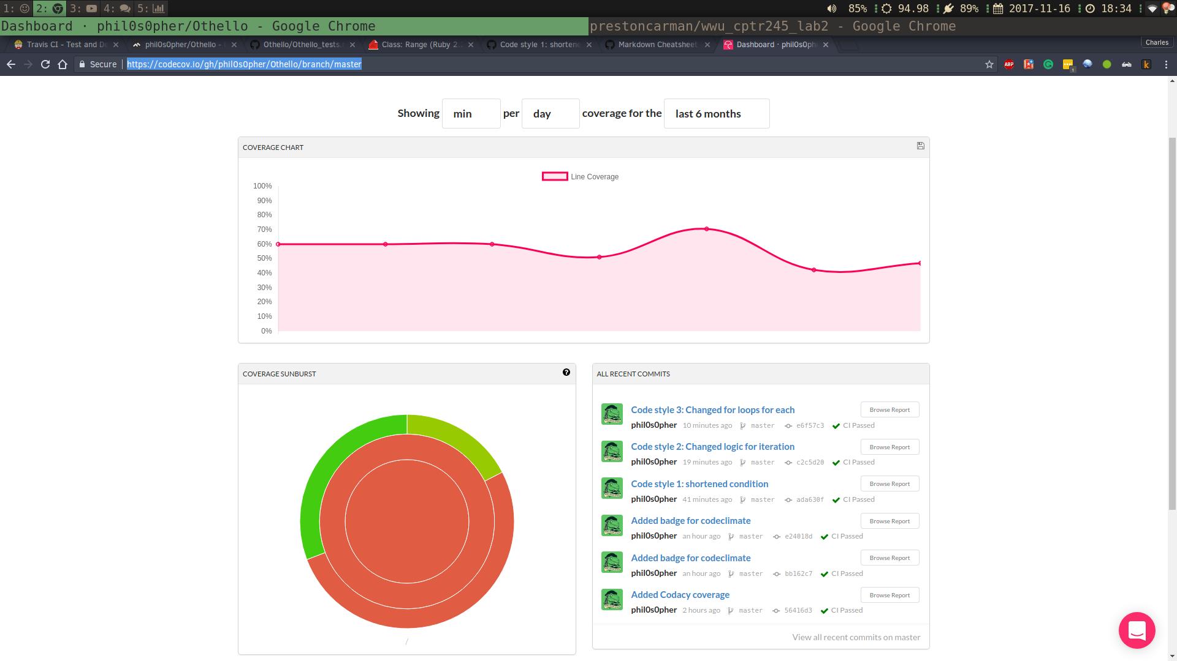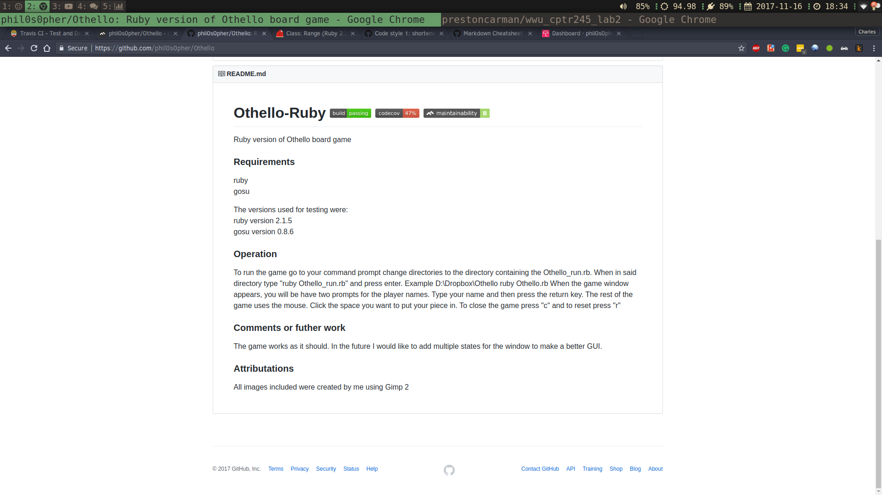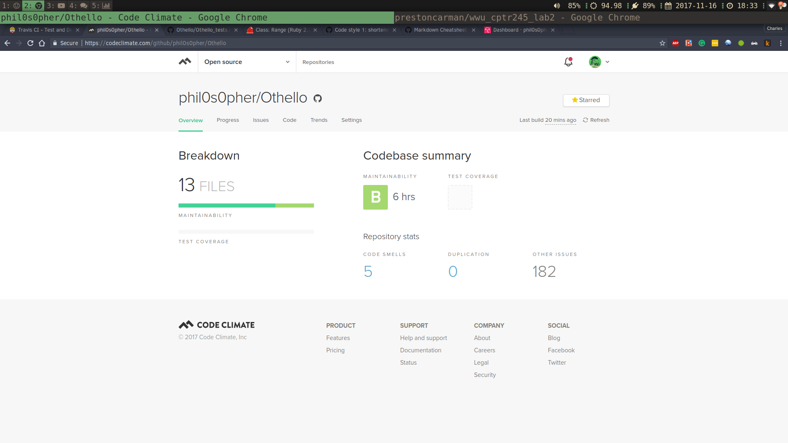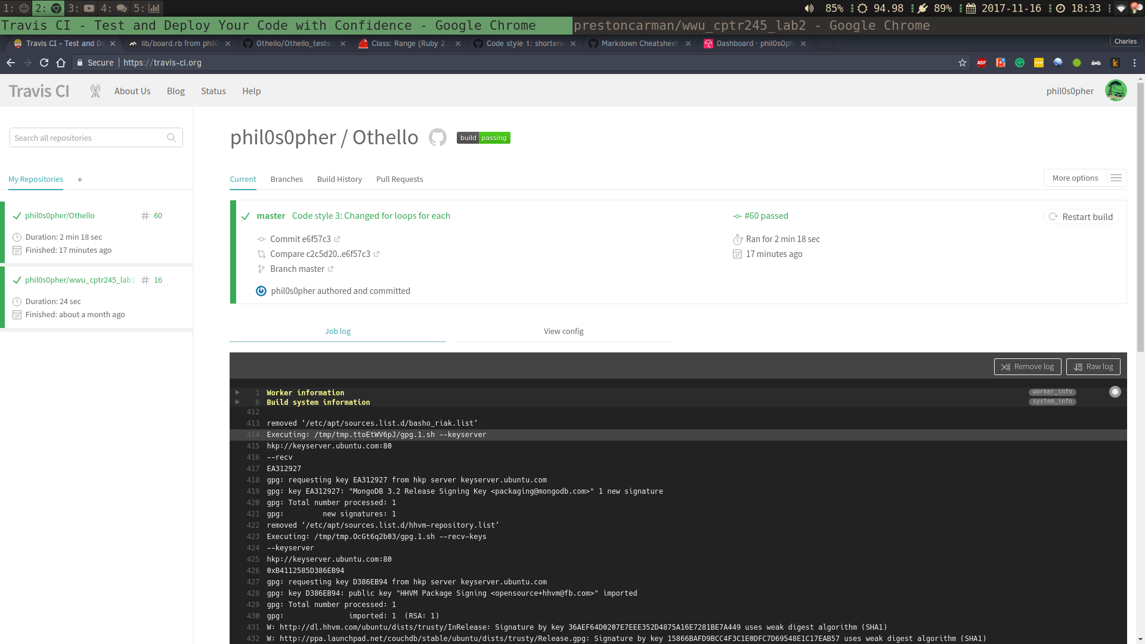

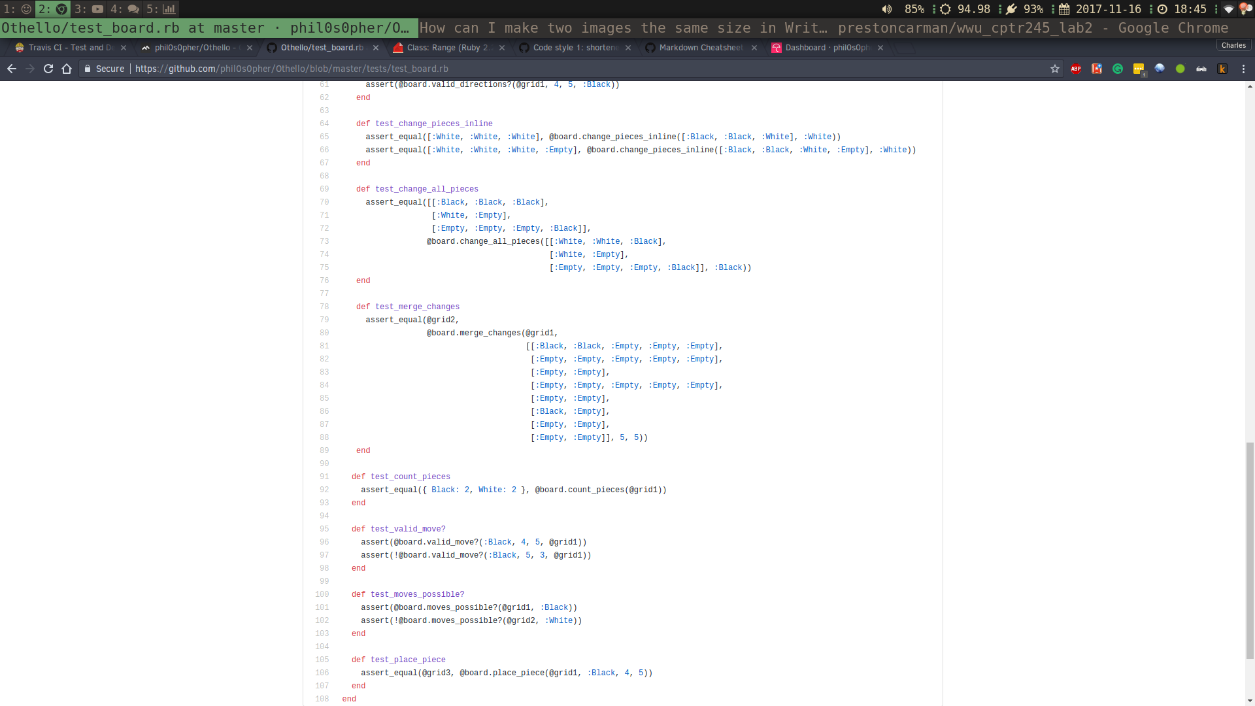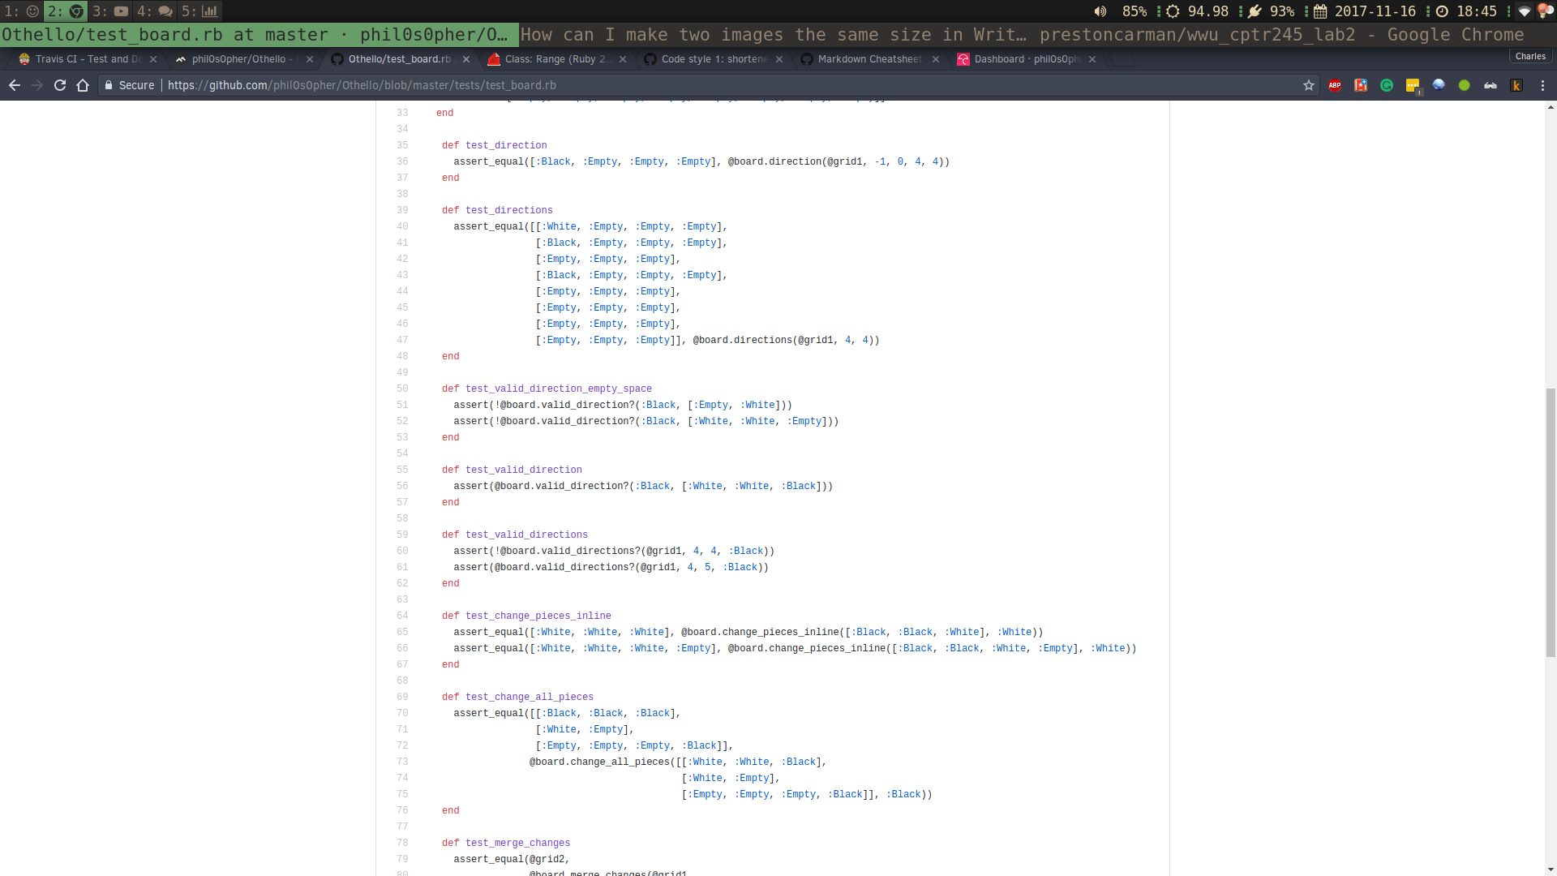**Added Tests**

**Updated Quality**

