Jiminy Cricket



Charles Madere, Geonathan Sena, Jarrad Pinestraw, and Joseph Gautier
Advisor: Dr. Kuo-pao Yang
Abstract- We Paint is a 100% web browser paint application that allows two Facebook friends to socialize and enjoy their very own private paint room. It also allows the users to download their paintings and chat with the Facebook friend that they are currently painting with.
Keywords – Paint, Canvas, HTML5, Chat, Color, PHP, JavaScript, CSS, MySQL

Introduction
Team Jiminy Cricket is a new software development group that consist of; Charles Madere (The Group Leader), Geonathan Sena, Jarrad Pinestraw, and Joseph Gautier. The self-titled project, “We Paint”, is a project that leans heavily towards the web based aspect of developing. By using the browser as a paint program combined with Facebook and its own built in chat all without using flash they hope to create something that not many have been able to do or even thought of doing. This technical report goes into the details of the “We Paint” project, its reason for coming to existence, its implementation, the approach taken to get it there, and finally the conclusion to this project.

The Problem
There aren’t too many web painting programs that allow friends to socialize and have fun while sharing a canvas to paint on. There also aren’t many that are powered by HTML5 and use the Facebook API to help keep friends connected in a unique way.

Software Approach and Implementation
“We Paint” was developed using HTML5 as a true platform basis and the group used the Facebook API to blend in their Facebook features. They also used a lot of PHP, JavaScript, and a small amount of CSS. The site is being hosted on Southeastern’s Netsal server, and is able to run on any browser that supports HTML5.

Conclusion
Although everything works as it’s supposed to Team Jiminy Cricket is still searching for and implementing new things in order to make this site the best HTML5 non-flash painting site on the net as any true innovator would.

References
Chuan Yue and Haining Wang. 2009. Characterizing insecure javascript practices on the web. In Proceedings of the 18th international conference on World wide web (WWW '09). ACM, New York, NY, USA, 961-970. http://doi.acm.org/10.1145/1526709.1526838
Henry Van Styn. 2011. Git. Linux J. 2011, 208, pages.
Merelo-Guervos, J.J.; Castillo, P.A.; Laredo, J.L.J.; Mora Garcia, A.; Prieto, A.; , "Asynchronous distributed genetic algorithms with Javascript and JSON," Evolutionary Computation, 2008. CEC 2008. (IEEE World Congress on Computational Intelligence). IEEE Congress on , vol., no., pp.1372-1379, 1-6 June 2008 URL: http://ieeexplore.ieee.org/
stamp/stamp.jsp?tp=&arnumber=4630973&isnumber=4630767
Saeed Aghaee and Cesare Pautasso. 2010. Mashup development with HTML5. In Proceedings of the 3rd and 4th International Workshop on Web APIs and Services Mashups (Mashups '09/'10). ACM, New York, NY, USA, , Article 10 , 8 pages. http://doi.acm.org/10.1145/1944999.1945009
Shahriar, H.; Zulkernine, M.; , "Injecting Comments to Detect JavaScript Code Injection Attacks," Computer Software and Applications Conference Workshops (COMPSACW), 2011 IEEE 35th Annual , vol., no., pp.104-109, 18-22 July 2011 URL: http://ieeexplore.ieee.org/
stamp/stamp.jsp?tp=&arnumber=6032221&isnumber=6032200
Suzumura, T.; Trent, S.; Tatsubori, M.; Tozawa, A.; Onodera, T.; , "Performance Comparison of Web Service Engines in PHP, Java and C," Web Services, 2008. ICWS '08. IEEE International Conference on , vol., no., pp.385-392, 23-26 Sept. 2008 URL: http://ieeexplore.ieee.org/
stamp/stamp.jsp?tp=&arnumber=4670199&isnumber=4670130
Taivalsaari, Antero; Mikkonen, Tommi; , "The Web as an Application Platform: The Saga Continues," Software Engineering and Advanced Applications (SEAA), 2011 37th EUROMICRO Conference on , vol., no., pp.170-174, Aug. 30 2011-Sept. 2 2011 URL: http://ieeexplore.ieee.org/
stamp/stamp.jsp?tp=&arnumber=6068340&isnumber=6068309

Veglis, A.; Leclercq, M.; Quema, V.; Stefani, J.-B.; , "PHP and SQL made simple," Distributed Systems Online, IEEE , vol.6, no.8, Aug. 2005 URL: http://ieeexplore.ieee.org/
stamp/stamp.jsp?tp=&arnumber=1510592&isnumber=32340
Wei, K.; Muthuprasanna, M.; Suraj Kothari; , "Preventing SQL injection attacks in stored procedures," Software Engineering Conference, 2006. Australian , vol., no., pp. 8 pp., 18-21 April URL: http://ieeexplore.ieee.org/
stamp/stamp.jsp?tp=&arnumber=1615052&isnumber=33896
Werner Kieling and Gerhard Kstler. 2002. Preference SQL: design, implementation, experiences. In Proceedings of the 28th international conference on Very Large Data Bases (VLDB '02). VLDB Endowment 990-1001.

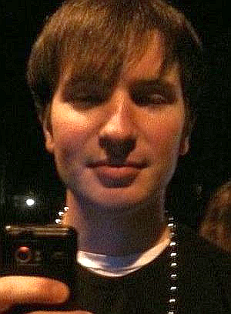
Team Biography
Charles Madere is the team leader of We Paint and a senior at Southeastern. He has been attending Southeastern since the fall of 2008 and plans to graduate in the spring of 2013. His favorite sport is paintball and he hopes to move out of Louisiana someday. He will feel much better once this semester is over with. The picture on the left was taken at Mardi Gras this year in Mandeville, Louisiana.

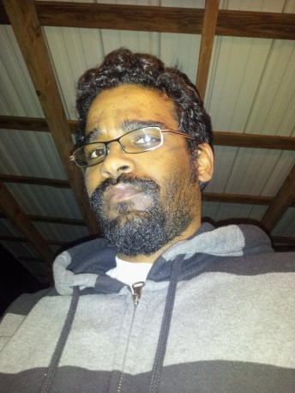
Geonathan Sena is blah blah blah blah blah blah blah blah blah blah blah blah blah blah blah blah blah blah blah blah blah blah blah blah blah blah blah blah blah blah blah blah blah blah blah blah blah blah blah blah blah blah blah blah blah blah blah blah blah blah blah blah blah blah blah blah blah blah blah blah blah blah blah blah blah blah blah blah blah blah blah blah blah blah blah blah blah blah blah

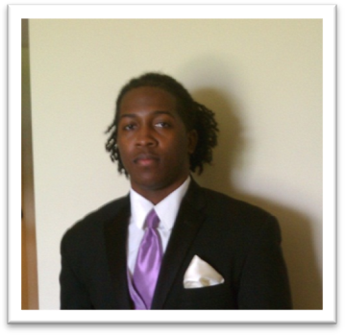
Jarrad Pinestraw is a junior at Southeastern. He started his freshman year as undecided, but by his sophomore year he found his curiosity for technology growing in a world now surrounded by many technological advancements that just continues to take over our world. He then set his college career on what he calls the future of mankind, computer science. He chose the information technology concentration and thinks this is the best decision he could have made as a career. He strives to do his best.


Joseph Gautier is blah blah blah blah blah blah blah blah blah blah blah blah blah blah blah blah blah blah blah blah blah blah blah blah blah blah blah blah blah blah blah blah blah blah blah blah blah blah blah blah blah blah blah blah blah blah blah blah blah blah blah blah

