Determining aerosol optical thickness
from multi-spectral night sky radiance measurements

Theme: Measurement and Modeling

C. Marseille^{1*}, M. Aubé,^{1,2} and J. Roby²
¹ Université de Sherbrooke, Sherbrooke, Canada
² Cégep de Sherbrooke, Sherbrooke, Canada
charles.marseille@usherbrooke.ca
* presenting author

Aerosols are now known to affect weather and climate (***cite AEMET). The measurement of these small particules present in the atmosphere is limited to certain weather conditions, mainly limited by the techniques used to this day. This work presents a novel approach for caracterizing the aerosol optical depth (AOD) by establishing an empirical relationship with the night sky radiance, be it with or without the presence of clouds. The main advantage of this technique is the possibility of gathering data in weather conditions which render useless the other available instruments (no observable moon, too much atmospheric pollution, etc).
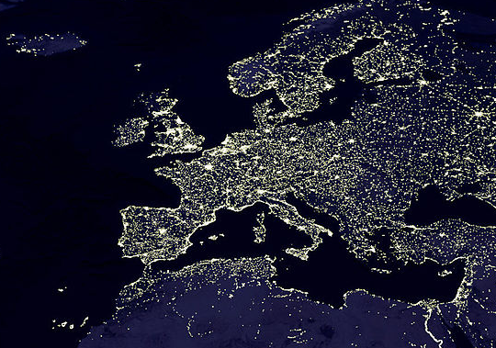
Fig. 1: ***change picture

Since sky radiance measurement results depend upon the illumination strategies of urban sites or urban proximity for remote sites, the relationship between AOD and night sky radiance changes with geographic position, which implies that a study of different observation sites. Three sites were selected on Tenerife Island in the Canarias: Santa-Cruz-de-Tenerife (Urban), Observatory of Izana (above cloud cover) and Teide volcano summit. Also, a comparison with a site at the Université de Sherbrooke (Sherbrooke, Quebec, Canada) shows the impact of the important presence of snow and winter conditions on the derived relationship. The night sky radiance measurements are obtained with a CoSQM (***cite CoSQM martin aubé wiki) (multi-spectral sky quality meter) and the AOD comparison values are taken from AERONET's (***cite aeronet site) international lunar photometer network from NASA. Previous work in this field dates to 2009 (cite martin Vienne ppt), where sun photometer data was used for comparison. The new method presented further confirms that night sky radiance is in fact a solution for the non-observable sites and weather conditions to date.

References

Aubé M, Kocifaj M (2012) Using two light-pollution models to investigate artificial sky radiances at Canary Islands observatories. Mon Not R Astron Soc 422: 819-830

