Temporal variation of the multispectral night sky brightness on Tenerife Island

Theme: Measurement and Modelling

C. Marseille,^{1*} M. Aubé,^{1,2} and J. Roby²
¹ Université de Sherbrooke, Sherbrooke, Canada
² Cégep de Sherbrooke, Sherbrooke, Canada
charles.marseille@usherbrooke.ca
* presenting author

Light pollution on Tenerife Island is of concern for astronomers as well as a health issue for different species, including humans. There is little research of the spectral evolution of the night sky radiance at this site, which is due to changes in the lighting of the islands surrounding cities and which monitoring should be existent. The measurement of sky brightness can be used as comparison to the output of the light pollution model Illumina to help improve its capabilities and functionalities and understand its limits. Also, as currently researched in the context of atmospherical science, the relationship with aerosol properties is strongly dependent upon good characterization as well as evaluation of temporal variation of the sky radiance.
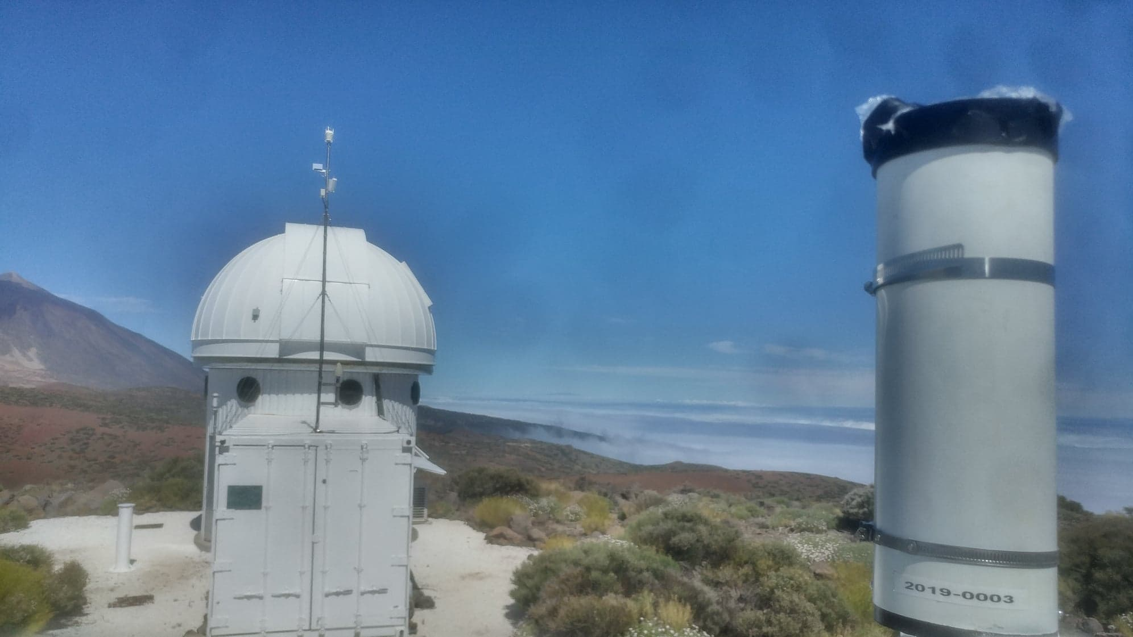
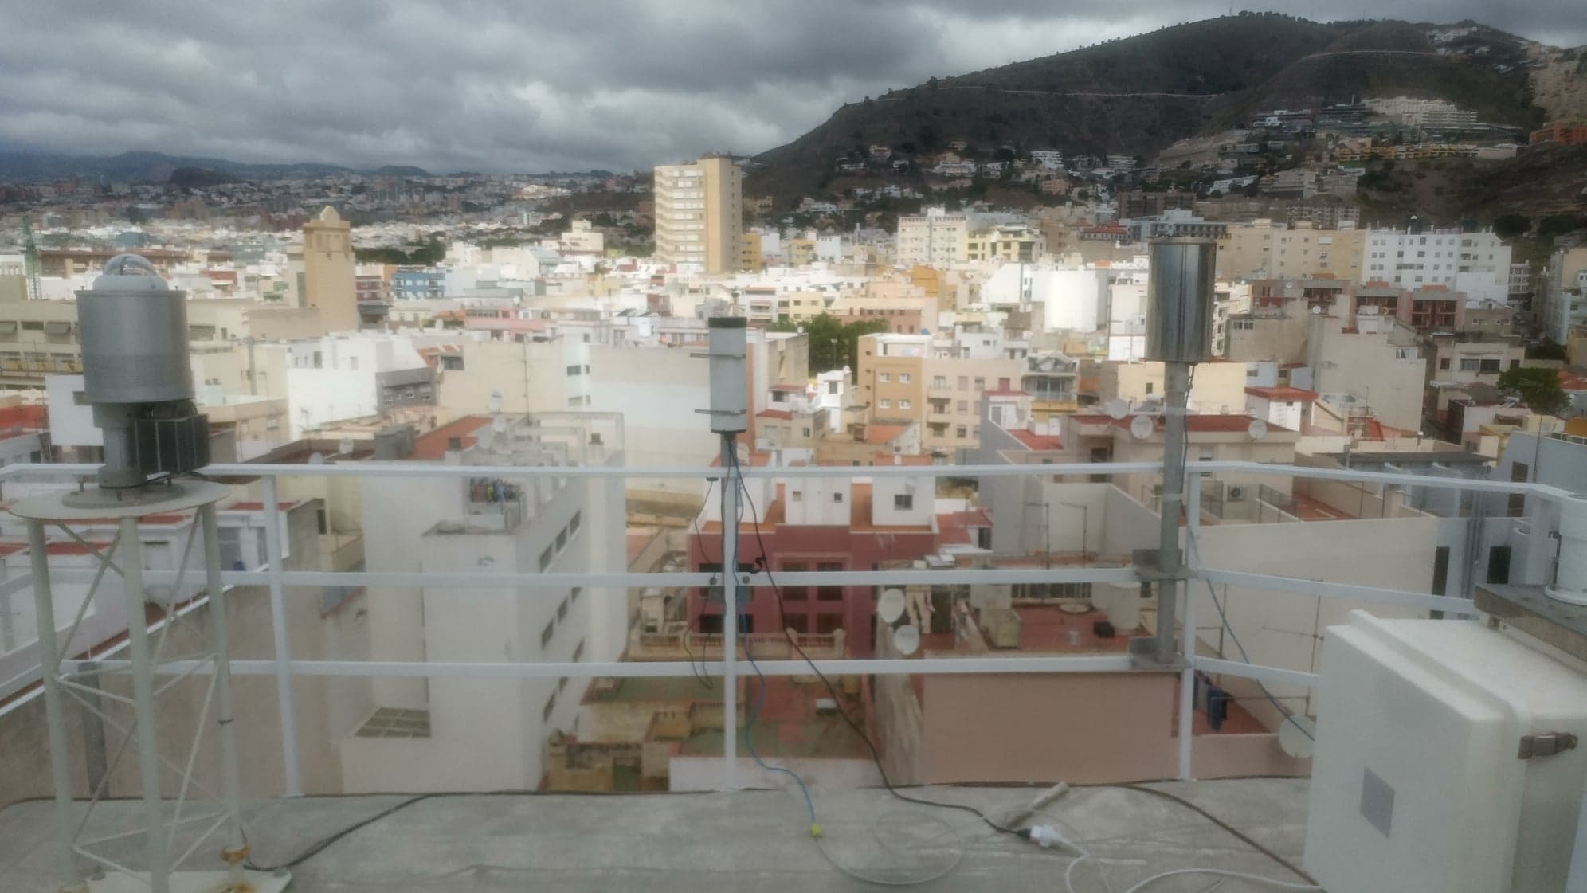

Fig. 1: (up) Santa Cruz de Tenerife, 32 m
(middle) Teide Observatory, 2390 m
(down) Teide summit, 3520 m

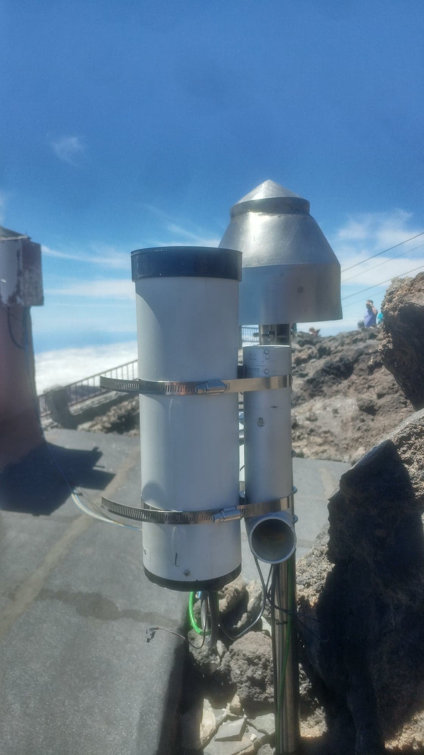
This work presents a one-year study of the evolution of the night sky radiance on three different sites of Tenerife Island in the Canary Islands: Santa Cruz de Tenerife (Urban), Teide Observatory (above cloud cover) and Teide volcano summit (highest peak on the island). At each location was installed a CoSQM, a 4 visible bands filtered sky quality meter (SQM). The multispectral measurement helps in the characterization of the effect of variation of lighting in the case of the city of Santa Cruz de Tenerife and its impact on the observatory and the near located Izana atmospheric research center (AEMET). Also, the observation of the effect on the sky radiance of the calima, a Saharan dust storm, is presented and gives a good idea of the potential of gathering information on atmospheric properties from sky radiance multispectral measurements.

References

Sanchez de Miguel, A., Aubé M., Zamorano, J., Kocifaj, M., Roby, J., Tapia, C. (2017). Sky Quality Meter measurements in a colour-changing world, Mon Not R Astron Soc, 467(3), 2966-2979.
Aubé, M., Simoneau, A., (2018). New Features to the Night Sky Radiance Model Illumina: Hyperspectral Support, Improved Obstacles and Cloud Reflexion, J Quant Spectrosc Radiat Transf, 211, 25-34.

Aubé, M., Franchomme-Fosse, L., Robert-Staehler, P., Houle, V., (2005). Light pollution modelling
and detection in a heterogeneous environment: toward a night-time aerosol optical depth retreival method, Proc. SPIE 5890, Atmospheric and Environmental Remote Sensing Data Processing and Utilization: Numerical Atmospheric Prediction and Environmental Monitoring, 589012

