AIP/123-QED
]Confinement Induced Electron Capture
[Also at ]Physics Department, XYZ University. Second.Author@institution.edu.
Abstract
We describe a Gedankenexperiment in which a bare proton can capture an electron due solely to confinement. We first briefly review the aspects around bare electron proton capture. We then provide a numerical solution of the Fermi VA-Theory for electron capture for an electron-proton pair confined in a classical box of size L. Interestingly, we find that the capture is most likely for L=0.004-0.009 Angstroms, well beyond the radius of the proton and the Compton wavelength of the electron. We also examine the implications for theoretical minimal power output for such a process.
Valid PACS appear here
Key words: Suggested keywords

[
R. Godes
Authors’ institution and/or address

1 Background
We briefly review orbital electron capture and some considerations, like environmental effects on the rate, that motivate this study.

1.1 Orbital Electron Capture
In 1935, Yukawa proposed that a proton, bound in an atomic nucleus, could capture a low lying, bound atomic electron, transforming into a neutron, and releasing an electron neutrino.

This may be called orbital electron capture, K-electron capture, or just electron capture (E.C.)
Electron capture usually occurs in unstable radioisotopes which lack the nuclear binding energy Q to decay by the more familiar Beta decay processes (). The typical Q energies necessary are

When Q<1.02MeV, which is twice the rest mass of an electron , a proton rich nucleus must decay by electron capture.
In particular, heavy elements may decay by E.C. and/or (positron emission) to a lower ’magic number’ of stable nuclei, and by decay to achieve a higher magic number. E.C. is favored for high Z nuclei, but because of the energetic constraint, very light elements, such as , decay by primarily by E.C. Lacking any binding energy and/or internal nucleon structure, bare proton electron capture is not observed, and requires extreme, exotic conditions.
We observe electron capture by observing the resulting transmuted nuclei and/or the radiative relaxation processes. The captured electron is bound to the atom, and it is usually a K-shell electron, but may be L or higher. The nucleus may then absorb some energy, becoming excited, and then undergo internal conversion. During this, another higher lying, bound atomic electron is absorbed, and either an X-ray or Auger electron released [see Figure 1].
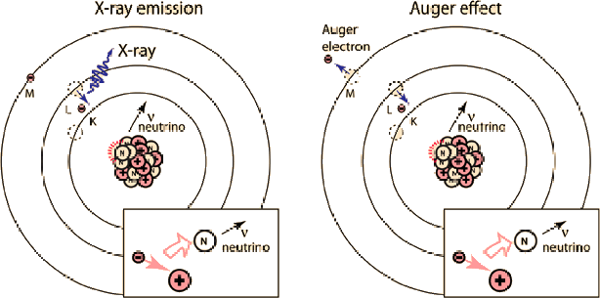
Figure 1: orbital electron capture relaxation processes
Because electron capture occurs in proton-rich nuclei, and, subsequently, releases a X-Ray photon, the reaction is also sometimes written as

(where Z is the total number of protons and neutrons, A the number protons, and is an X-ray photon)
Indeed, orbital electron capture is evidenced by high intensity x-rays and soft electrons. In 1938, Luis W. Alvarez observed the x-ray signature of orbital electron capture in activated Titanium [Error: Reference source not found]. Since then, electron capture has been observed in about 150 radioactive isotopes.

1.1.1 Effect of Chemical Environment of Electron Capture rate
The lightest element that E.C. has been observed in is [Error: Reference source not found]. In fact, there is so little energy that the competing positron emission process (described below) is prohibited, leading to a fairly long E.C. half-life of .
Being so light, and having such a large rate, electron capture in can be slightly modified by both changing the chemical environment and/or the external pressure [Error: Reference source not found, Error: Reference source not found, Error: Reference source not found]. In particular, in 2004, Ohtsuki et. al. demonstrated a change of 0.83% by embedding Be in C-60 cages [Error: Reference source not found].
How could such changes occur? The nuclear energy levels are in the keV to MeV region, and it is generally thought to be very difficult to impossible to effect. But the electron capture rate is proportional to electronic density at the surface of the nucleus–the nuclear charge. The electronic energy levels are in the eV range, so intense EM fields can alter the electronic structure and therefore slightly affect the E.C. rate.

1.2 The Weak Interaction and V-A theory
Electron capture is mediated by the Weak interaction, described most concisely by the Fermi V-A (Vector Axial) theory [Error: Reference source not found, Error: Reference source not found, Error: Reference source not found]. The V-A theory is a simple phenomenological approach, readily amenable to numerical calculations. While It is now understood in terms of ElectroWeak Unification and can be derived from the Standard Model, the original paper by Fermi, for which he won the 1938 Nobel Prize in Physics, was initially rejected by Nature because "It contained speculations too remote from reality to be of interest to the reader" [Error: Reference source not found].
V-A theory is used to compute cross sections for scattering experiments and decay rates for electron capture for various atoms, even in different environments, chemical and otherwise. We can use machinery of the V-A theory to explore E.C. in a simple, idealized environment. To properly describe any reaction, however, we need to understand what reactions we can apply the theory to, and the other, potential competing reactions.

1.2.1 Electron Capture and other Weak processes
The Weak interaction describes several related processes within a single framework. Neutron-rich nuclei may become more stable as a result by undergoing one or more of the following:
• orbital electron capture
• positon emission ( decay)
• β decay
There are also several related reactions, including
• reverse electron capture
• free neutron decay
• inverse beta decay

1.2.2 Neutron Decay
By detailed balance, reverse electron capture has the same rate as orbital electron capture–but is more favorable energetically. Indeed, inside the nucleus, the neutron is relatively stable. Free neutron decay has mean lifetime of τ=881.5±1.5 sec, or about 15 minutes.
In contrast, orbital electron capture by a free proton is unspoken-of outside of a stellar environments. Even if the bare reaction could proceed, the reverse reaction would still dominate un less it is suppressed or is kinetically unfavorable.

1.2.3 Inverse Beta Decay
Electron capture is also sometimes called inverse β decay, but, here, we mean this to be the scattering of a proton and an electron anti-neutrino . It is characterized by emission of a positron .

1.2.4 Positron emission
In particular, any high energy relativisitic process, we have to worry about positron emission. We noted above, however, that in , the competing positron decay reaction can not occur because there is not enough energy. Generally, this occurs at length scales below the Compton length of the electron, which, is smaller than we will need to consider.

1.2.5 Radiative Electron Capture
Also, in very rare cases, a gamma ray photon is emitted with the neutrino; this is called Radiative Electron Capture (REC) [Error: Reference source not found, Error: Reference source not found, Error: Reference source not found, Error: Reference source not found]. This can be thought of as a kind of Internal Bremsstrahlung (or so-called braking) radiation, caused by the electron accelerating toward the nucleus during capture, taking energy away from outbound neutrino[Error: Reference source not found]. It is traditionally been treated as a second order QED correction to the V-A theory [Error: Reference source not found]. REC is 1000X less likely, but does occur. The resulting gamma rays are called soft because they do not exhibit sharp spectral lines. Recent, detailed rate calculations have elucidated the quantum mechanical details [Error: Reference source not found].

1.3 Rate calculations
The electron capture rate can be computed using the Fermi VA-Theory [Error: Reference source not found, Error: Reference source not found]. The most basic calculations require a only specifying the electronic wavefunctions(s), averaging over the possible electron-proton momenta, and numerically integrating over the outbound neutrino momentum. We describe this below.
The V-A theory is based on second order perturbation theory. It assumes an incoherent nuclear process, it is local, and that the interaction is phenomenological. It is treated as a simply a contact potential at the surface of the nucleus. Here, this means we need to compute the nuclear charge–the electron density on the surface of the nucleus , which we obtain from a classical particle-in-the-box wavefunction (below).
More complicated calculations are used for larger nuclei, second order processes, etc. They only require modifications to treat either atomic electronic structure of reactant and product atoms, and/or specific considerations for nuclear internal conversion and other second order processes.

1.3.1 Bare proton-electron capture
We frequently write electron capture as if it were simply proton-electron capture

At zero energy, proton electron capture is not possible because it violates energy-momentum conservation. Theoretically, a free proton can could capture an electron from the continuum, but the interaction energy must be above threshold for neutron production. This is a huge amount of energy, although this happens regularly in accelerators, and, presumably, in stellar environments.
Observing proton electron capture outside of an accelerator, on the desktop, so to speak, would be an incredibly hard experiment because both final particles are neutral, and the neutrino is extremely weakly interacting.

1.3.2 Stellar Nucleosynthesis
Bare proton-electron capture is thought to occur in the early stages of the big bang and in stellar nucleosynthesis. It is thought to drive the formation of primordial elements, and to occur in the forming of neutron stars.
At very high temperatures, the proton electron collisions have sufficient energy to overcome the reaction barrier. For example, Bachall and coworkers have studied the electron capture rate in stellar media, and have computed the electron capture rate of in the Sun [Error: Reference source not found, Error: Reference source not found]. And it is believed that ionized Hydrogen captures an electron during the core collapse supernovae and in neutron stars [14]; in fact, it is thought to create stellar instability.
While we usually characterize a star by it’s temperature, these are also very dense systems, with . In contrast, the smallest star has density [?] As important, the reverse reaction is prohibited because, inside the dense neutron star, it is impossible to create a new electron; the Fermi sea is full.
So electron capture can occur by bare protons, but, presumably, only under extreme confinement (and with the reverse reaction is suppressed).

1.3.3 Metallic Hydrides
It has been suggested that bare proton-electron capture could actually arise metallic hydrides, such as PdH and NiH, as a result of some exotic, here-to-fore unrecognized physical mechanism. Widom and Larsen, in particular, have proposed that the effective Q value for bare proton E.C. would be lowered because the surface electrons may undergo mass renormalization due surface plasmon radiation, leading to high order radiative corrections to the Weak interaction pair production process [Error: Reference source not found]. One may define an effective mass using

where is the gauge potential for the fluctuating surface plasmon radiation, and assuming
They argue that such a renormalization may be possible because the neutron scattering experiments on PdH show a collective proton oscillation that would be resonate with electronic surface plasmons.
Outside of any new physics, is there any other plausible mechanism for E.C. in a metallic hydride ? Any such process would be energetically bound by the uncertainty principle, meaning that the hydrogen atom would be under extreme confinement.
Curiously, neutron scattering experiments do show that in PdH, that the hydrogen atoms have a root-mean-square vibrational amplitude of 0.25A (at T=293K), which is anomalously small [Error: Reference source not found].

2 Confinement Induced Electron Capture
We pose the following Gedankenexperiment: Suppose we confine a bare proton (and an electron) in a particle-in-a-box of volume . What box size L will ’induce’ electron confinement ? Here, we examine what do detailed calculations look like that employ the full machinery of the Weak interaction, as an illustrative exercise.
We write this as

where is the confinement energy, which is induced by the box constraints.

2.0.4 Neutron post-reaction
To prevent the reverse reaction, we assume that the free neutron subsequently combines with another proton, and gives us 2.2 MeV of energy in the process. This post-process contributes to the power output, and prevents the reverse reaction. Realistically, we expect this to happen at the maximum box size, at the energy threshold, where the outbound neutron has very low momentum and therefore a very small mean free path.
Still, for illustrative purposes, we will compute the power output, assuming this post-reaction, at all box sizes.

2.1 Compton length
The first obvious question is, should we use a classical or a relativisitic box?
Most electron capture rate calculations use ab initio classical wavefunctions [Error: Reference source not found, Error: Reference source not found], perhaps with some relativisitic corrections to the electronic Hamiltonian [Error: Reference source not found].
We argue that we can safely use a classical box as long as , where is Compton wavelength of an electron [Error: Reference source not found, Error: Reference source not found, Error: Reference source not found]. The Compton wavelength sets the scale, accounting for both quantum mechanics and special relativity.

For an electron, the minimum L is on the order of 0.004 Angstrom

In any high energy, relativisitic system, positrons can be produced; here it is through -decay. This generally occurs at or below the Compton length. We are seeking the maximum box size which can induce electron capture, and we assume that, at the max, positron emission will be very rare.
We also assume that the electron wavefunction does not change appreciably during the interaction, so that we may use a very simplified form for the cross section (σ) and rate (Γ). Again, this is reasonable for boxes .

2.1.1 Klein Paradox
Klein noted that a relativistic (Dirac) particle-in-a-box will leak out at box sizes near the Compton wavelength; this called the Klein paradox [Error: Reference source not found, Error: Reference source not found]. And while this is usually taught as being simply particle-antiparticle creation, it has been suggested that the Klein paradox it can occur even at larger boxes sizes, and it is a general phenomena of confined relativistic particles. And recent experiments on Graphene have reopened the debate [Error: Reference source not found]. Still, we will assume the traditional interpretation and that we can ignore the Klein paradox.
So we use a classical box, with minimum size . We compute the maximum size below.

2.2 Theory

2.2.1 Particle production under the Weak interaction
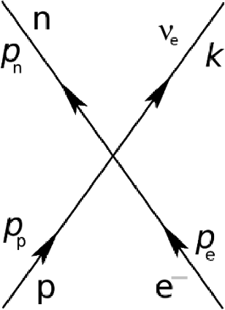
Figure 2: EC particle production process
Electron capture is mediated by the Weak Interaction, through the particle production process, given by the 4-point Interaction (see Figure 2). It requires at least 0.511 MeV energy to overcome the reaction barrier, which, here, is provided by the box.

We want to compute the rate of E.C. and the (minimum) power generated, as a function of the box size (L), using the full Weak Interaction Hamiltonian. To do this, we need to express the rate in terms of the differential cross section, and in a form suitable for numerical calculations.

2.3 Transition Rates and Power Calculations
Orbital electron capture and other Beta-decay processes follow first order kinetics, so the capture rate is described by a single number. To calculate the rate, we require a full relativistic, quantum mechanical treatment because the capture process involves both creating particles and the kinetic energy spectrum is of order .
The capture rate is given by multiplying the cross section by the incident velocity and electronic (box) density of the pair at the origin

We will compute the electronic density classically, using box wavefunctions, and, for each box size, determine the incident velocity (really momentum). We then compute the cross section using full relativistic kinematics and Dirac spinors.

2.3.1 Cross Section
We write the differential cross section in the C.M. frame as
[Sorry. Ignored \begin{multline} ... \end{multline}]
where is a matrix element of the weak interaction Hamiltonian, k represents the neutrino momentum components , and we use natural units (ħ=1,c=1).

2.3.2 Rate
This gives the (differential) rate as
[Sorry. Ignored \begin{multline} ... \end{multline}]
where we explicitly specify the electronic wavefunction.
We represent the pair using a 3D box wavefunction, and obtain the Energies and 3-momenta from the relativistic kinematics. We then average over all 8 permutations of the incident velocities (really momenta ) for the 3D box, and integrate over outbound neutrino solid angle using numerical quadrature. The final rate is computed as, for each box size, as a function the kinematics, using

where is given by the box size (described below).

2.3.3 Power
We estimate the excess power generated by the confined electron capture, resulting if/when the outbound neutron reacts with the environment. The power P is

where is the nuclear decay energy, or Q-value, and ϱ is the density of confined elements. We choose the density to that of a typical material, of order Avogadro’s number, .
We estimate the power for both the bare proton-electron capture

and the subsequent neutron post-reaction

.
We also define an excess power as

which we argue is a good measure of the potential reactive power output of the confined E.C. process. We are interested in box lengths where the excess power is significant enough to drive the reaction.

2.3.4 Particle-in-the-box Wavefunctions
While most electron capture calculations assume a specific, bound, atomic electronic wavefunction(s), we perform a much simpler calculation; we treat the electron-proton pair as classical particle-in-a-box, and analyze the problem just above the Compton scale using the low order VA theory.

.
expressions for momentum.
Because the VA theory assumes an incoherent process, the electron, proton wavefunction is usually factored as an electron wavefunction, with a point-particle in the center

We only consider the ground state wavefunction.
We note, in ab initio electronic structure calculations, it is now generally possible to treat the Hydrogen proton wavefunction explicitly, and to treat the electron-proton coupling at the level of Hartree Fock [Error: Reference source not found]. This has proved useful, for example, for describing isotope effects on electronic structure.
Here, we treat the confined electron, proton pair in the C.M. frame so that the 3-momentum of the electron and proton related

and we consider all 8 permutations for a given box size L:

2.3.5 Relativistic Kinematics and Energetics
For consistency with the particle production process, we treat all kinematics and energetics relativistically. Given energy-momentum conservation

and the 3D particle-in-the-box energy ground state energy

we use to write

and

The threshold Kinetic energy in the center of momentum (C.M.) frame is given as

which is approximately 781.6 KeV (or 783.1 KeV in the proton rest frame).
Of course, the proton rest frame is approximately the electron rest frame, but it should be mentioned that the in the electron rest frame, the threshold kinetic energy is 2000X greater. Therefore, it is assumed that the energy transfer to induce electron capture is in the C.M. frame of the (e,p) pair.
The minimum momentum is

For the final state, the neutrino (ν) kinetic energy is

and the neutron (n) kinetic energy is

At this point, we can compute the relativistic energies for all particles, simply as a function of box length (L), for a confined pair. Of interest is the shape of the curve, and when the excess power output becomes favorable. To compute the exact rate and estimate the power, we need to evaluate the matrix element(s) of the Weak Interaction Hamiltonian. While most practitioners simply estimate this, for our purpose, we can simply compute them exactly.
[maybe show the curve, and state the maximum box size. or wait until later ?]
[say something about estimating the size of the interaction here, which should be enough for a baseline calculation]

2.4 Weak Interaction Hamiltonian and Matrix Elements
The Hamiltonian for the V-A theory for E.C. is [Error: Reference source not found, Error: Reference source not found]

where and are (in modern parlance) the Hadron and Lepton currents, resp., and are given by

where are Dirac (free-particle) wavefunctions.
is the Universal Fermi Weak Coupling Constant, and , which is determined by experiment (and subject to minor changes). is the Axial-Vector Weak Coupling Constant, and is the vector weak coupling constant. The most recent value is , and [Error: Reference source not found].

2.4.1 VA Matrix Elements
In our calculations, however, we use a slightly different, more modern convention for the matrix elements, multiplying through by [Error: Reference source not found]. The matrix elements are then given by
[Sorry. Ignored \begin{multline} ... \end{multline}]
where u(p,s) are Dirac 4-spinors, with the convention

and . The γ are 4-component Gamma matrices, and is the Einstein summation convention.
Writing the matrix elements in terms of the currents gives

Notice that when applying the VA theory this way, we assume that the electron-proton interaction is a contact potential, operating at the surface of the nucleus, and that the underlying quantum process is incoherent.

2.4.2 Sum over all spin combinations
Electron capture is similar to Beta decay in that there are allowed (Singlet-like) and disallowed (Triplet-like) transitions, as well as some very low order disallowed contributions. These are, of course, different from Beta decay since we need to consider the total angular momentum of the initial ( and final states.
By Singlet-like states, we effectively mean total spin 0, and by Triplet-like, we mean total spin -1 or 1. Since we are using particle-in-the-box electronic wave functions, we do not consider orbital angular momentum, and therefore only have to consider if and . Notice, however, we use the Dirac-spinor convention for s=1 (up) and s=2 (down), so total s=0 corresponds to (up,down) or (down,up), etc.
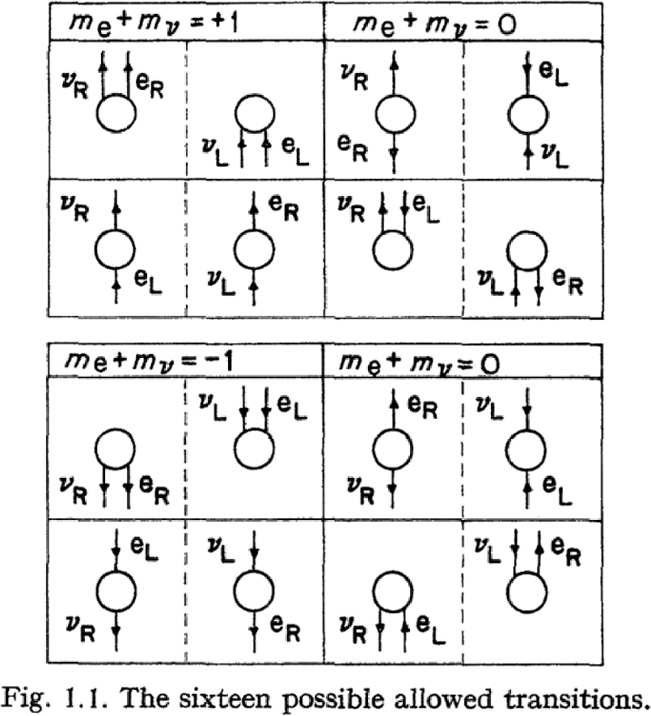
Figure 3: Allowed spin transitions
We sum over the 16 allowed transitions in the V-A theory, as depicted in Figure [Error: Reference source not found] (taken from Beta Decay for Pedestrians; we need to replicate , but use p-e as the states, not e-k)
Similar to Beta, s, we have four spin dominate (allowed) spin combinations, consisting of Singlet-like (or Fermi-like) initial and final states, which is of order 50 (in natural units)

,

.
There are two weaker (dis-allowed) combinations, similar to Gamow-Teller transitions, where are all spins are the same (Triplet-like states), and are of order (that is, smaller in magnitude)

.
There are four remaining, non-zero contributions, consisting of a single spin flip in the initial or final state, and is of order in magnitude

.

The remaining (single and double flip) transitions have zero amplitude.

2.5 Numerical Calculations
The full calculations sums of over all 8 possible incident momenta permutations , and the 16 allowed spin transitions (see figure below). By conservation of momenta, we can eliminate the neutron and only need to average over the outbound neutrino momenta solid angle (); we do this using an 8-point gaussian quadrature.
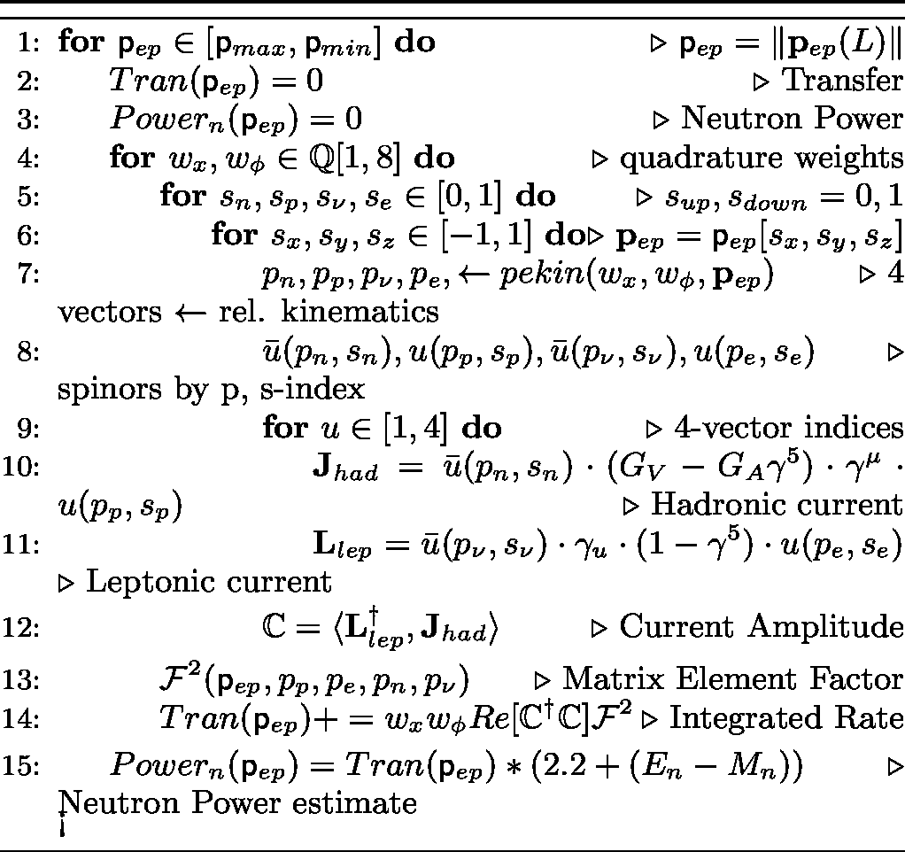
Figure 4: Rate and Power Calculations

2.5.1 Power Calculations
Let us write the Real part of the current density as

where
[Sorry. Ignored \begin{multline} ... \end{multline}]
We can express the rate as

where
[Sorry. Ignored \begin{multline} ... \end{multline}]
We write power as

and compute these as a function of the box size using the relativistic kinematic and Weak interaction matrix elements.

2.6 Results
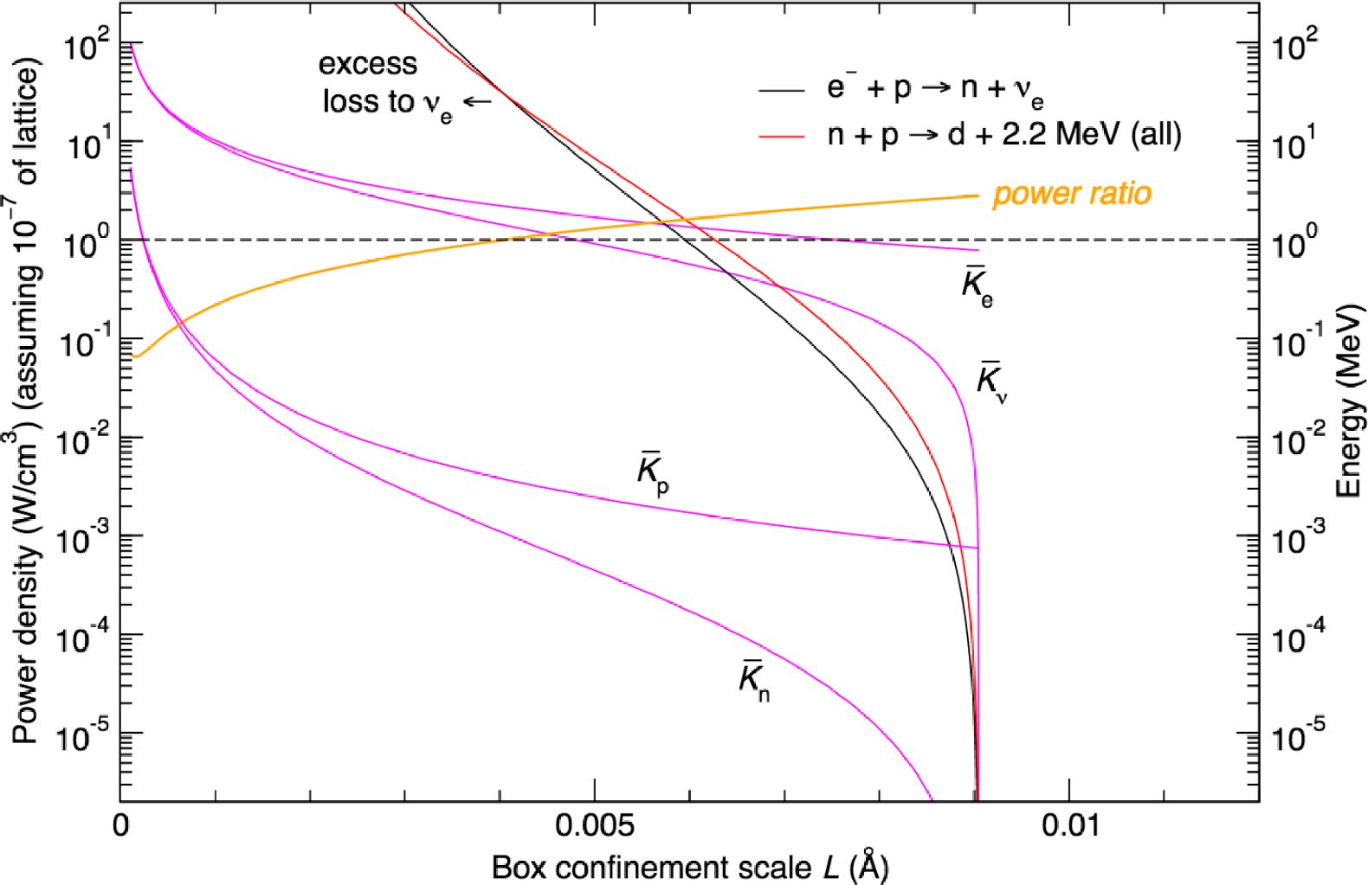
Figure 5: Kinetic Energy and Power as a function of Box Length
Figure 5 presents the results of relativistic kinematics and excess power calculations, as a function of box length. For illustrative purposes, we include results box sizes even below the Compton length. The excess power ratio is positive for L>0.004A, with a maximum of almost a factor of 3.
Acknowledgments
We wish to acknowledge the support of the Anthropocene Institute ….
@PREAMBLE "" # "
@BOOKBire82, author = N. D. Birell and P. C. W. Davies, year = 1982, title = Quantum Fields in Curved Space, publisher = Cambridge University Press
@ARTICLEfeyn54, author = "R. P. Feynman", year = "1954", journal = "Phys. Rev.", volume = "94", pages = "262",
@ARTICLEyukawa,author= Yukawa and Sakata, title=On the Nuclear Transformation with the Absorption of the Orbital Electron, publisher= Phys. Rev, volume="51",pages="677" , year="1937"
@ARTICLEalvarez,author= Luis W. Alvarez, title=The Capture of Orbital Electrons by Nuclei, publisher= Phys. Rev.,volume="54", pages="486", year="1938"
@ARTICLEwang,author= B. Wang; et al, title=Change of the electron capture half-life in metallic environments, publisher=The European Physical Journal A, 28, 375-Ð377 , year="2006"
@ARTICLEraydas,author=A. Ray and P. Das and S. K. Saha and A. Goswami and A. De, title=Enhanced orbital electron-capture nuclear decay rate in compact medium, publisher= Physics Letters B, volume="679", pages="106", year="2009"
@ARTICLEohtsuki,author=T. Ohtsuki and H. Yuki and M. Muto and J. Kasagi and and K. Ohnol, title=Enhanced Electron-Capture Decay Rate of Be-7 Encapsulated in C-60 Cages, publisher=Phys. Rev. Lett., volume="93(11)", pages="112501", year="2004"
@ARTICLEec-review1,author=W. Bambynek and H. Behrens and M. H. Chen and R. L. Intemann, title=Orbital electron capture by the nucleus, publisher= Review of Modern Physics, volume="49", pages="1", year="1976"
@ARTICLEec-review2,author=R. Bouchez and P. Deponimier, title=Orbital electron capture by the nucleus, publisher= Rep. Prog. Phys., volume="23", pages="395", year="1960"
@ARTICLEglauber1,author=R. J. Glauber and P. C. Martin, title=Radiative Capture of Orbital Electrons, publisher= Phys. Rev.,volume="104", pages="158", year="1956"
@ARTICLEglauber2,author=R. J. Glauber and P. C. Martin, title=Relativistic Theory of Radiative Orbital Electron Capture, publisher= Phys. Rev.,volume="109", pages="1307", year="1958"
@ARTICLEroec2007,author=K. Pachucki and U.D. Jentschura, title=Radiative orbital electron capture by the atomic nucleus, publisher= Phys. Rev. C,volume="75", pages="055502", year="2007"
@ARTICLEbachall62,author=John N. Bahcall, title=Electron Capture and Nuclear Matrix Elements of , publisher= Phys. Rev.,volume="128", pages="1297", year="1962"
@ARTICLEbachall69,author=Andrei V. Gruzinov and John N. Bahcall, title=The electron capture rate in the sun, publisher= Astrophysical Journal, volume="155", pages="511", year="1969"
@ARTICLErelbox,author=P Alberto and C Fiolhais and V M S Gil, title=Relativistic particle in a box,published=Eur. J. Phys., volume="17", pages="19", year="1996"
@ARTICLEcompton,author=Garay and Luis J, title=Quantum Gravity And Minimum Length, publisher= Int. J. Mod. Phys., volume="A10", pages="145", year="1995"
@ARTICLEplanck,author=B.G. Sidharth, title=Planck scale to Compton scale, year="2006"
@ARTICLEaxial,author= J. Liu et. al, title=Determination of the Axial-Vector Weak Coupling Constant with ultracold neutrons,journal=Phys. Rev. Lett., volume="105", pages="181803", year="2010"
@ARTICLEwheeler,author=J. A.Wheeler, title=Polyelectrons, publisher= Ann. NY Acad. Sci., volume="48", pages="219Ð238", year="1946"
@ARTICLEpenning1,author= S. F. Hoogerheide et. al, title=Experiments with Highly-Ionized Atoms in Unitary Penning Traps, publisher= Atoms, pages="3", volume="367", year="2015"
@ARTICLEbrem1,author=Jo Me Jauch , title=On the theory of Inner Bremsstrahlung in β processes, publisher= ORNL 1102 Report , year="1951"
@ARTICLEpenning2,author=T Brunner1, title=Design of a ?-detector for TITAN-EC and the first electron-capture branching ratio measurement in a Penning trap, publisher=J. Phys.: Conf. Ser., volume="312", pages="072006", year="2011"
@BOOKradbook,author=Michael F. L’Annunziata, title=Radioactivity: Introduction and History and From the Quantum to Quarks, publisher= Second Edition and Elsevier and , year="2016"
@BOOKjackson,author=John D. Jackson, title=Classical Electrodynamics, publisher= Third Edition and Wiley and , year="1998"
@ARTICLEiaea,author=International Atomic Energy Agency, title=Methods for the Minimization of Radioactive Waste from Decontamination and Decommissioning of Nuclear Facilities, publisher= Vienna , year="2001"
@ARTICLEreiss,author=Howard R. Reiss, title=Accelerated Beta Decay for the Disposal of Fission Fragment Wastes
@ARTICLEclose,author=Frank Close, title=Small Things and Nothing, publisher= OUP Oxford , year="2013"
@ARTICLEfermi1,author=E. Fermi, title=An attempt of a theory of beta radiation.1, publisher= Z. Phys.,,volume="88", pages="161", year="1934"
@ARTICLEJauch,author=Jo Me Jauch, title=On the Theory of Inner Bremsstrahlung in β decay, publisher= Oak Ridge National Laboratory and Contract No and W-7405 and eng 26 , year="1951"
@BOOKmartin,author=C. H. Martin and M. C. Zerner, title=Electronic Structure Calculations on Transition Metal Complexes: Ab Initio Models and Approximate Models, publisher= Inorganic Electronic Structure and Spectroscopy and Volume I: Methodology and E. I. Solomon and A. B. P. Lever and Wiley , year="2006"
@ARTICLEWeisskopf,author=J. M. Blatt and V. F. Weisskopf, title=Theoretical Nuclear Physics, publisher= Dover Books on Physics
@BOOKSen,author=K.D. Sen, title=Electronic Structure of Quantum Confined Atoms and Molecules, publisher=Springer, year="2014"
@ARTICLEfeynman,author=Feynman and Gelmann, title=The Theory of the Fermi Interaction, journal=Physical Review, volume="101", pages="193", year="1958"
@ARTICLEzuber,author=C. Itzykson and J.B. Zuber, title=Quantum Field Theory, publisher= McGraw-Hill and ISBN 9780486445687 , year="1985"
@ARTICLEvacoupling,author=Mund et. al, title=Determination of the Weak Axial Vector Coupling from a Measurement of the Beta-Asymmetry Parameter A in Neutron Beta Decay
@BOOKklein1,author=Bjorken and Drell, title=Relativistic Quantum Mechanics, publisher= McGraw-Hill, ISBN="0-07-005493-2", year="1964"
@ARTICLEklein2,author=N. Dombey and Alex Calogeracos, title=70 years of the Klein paradox, publisher= Physics Reports,volume="315d", year="1999"
@ARTICLEklein3,author=M. I. Katsnelson1 and K. S. Novoselov2 and A. K. Geim,title=Chiral tunnelling and the Klein paradox in graphene, publisher= Nature Physics, volume="2", pages="620", year="2006"
@ARTICLEwidlar1,author=A. Widom and L. Larsen,title=Theoretical Standard Model Rates of Proton to Neutron Conversions Near Metallic Hydride Surfaces, year="2007"
@ARTICLEferguson,author=G. A. Ferguson Jr. and A. I. Schindler and T. Tanaka and and T. Morita, title=Neutron Diffraction Study of Temperature-Dependent Properties of Palladium Containing Absorbed Hydrogen, journal="Phys. Rev", volume="137(A483)" , year="1965"

