Naca sample - Online sample

- Introduction

This document states that naca-x.y.z.zip has been unzipped in D:\Dev\nacaOSS directory. All configuration paths are set on this directory by default. It can be changed, but with more efforts.

Note: These sample are run using Java 5.
A Tomcat 5.5 is required for executing online sample.

- Transcoding the samples

To transcode Naca sample Cobol files, you need to launch NacaTrans with the following parameters:
Project: NacaTrans
Main class: NacaTrans
Command line argument: D:\Dev\nacaOSS\NacaSamples\trans\NacaTransSamples.cfg
The details of this configuration file is explained in NacaSampleTranscodingUsage.pdf file.

After transcoding, the following directories are created:
- D:\Dev\naca\NacaSamples\src\batch: containing generated batch java files
- D:\Dev\naca\NacaSamples\src\online: containing generated online java files
- D:\Dev\naca\NacaSamples\src\online\resources: containing generated screen resources for online sample
- D:\Dev\naca\NacaSamples\src\common\include: Contains copy files
- D:\Dev\naca\NacaSamples\trans\info\ItemCount.html: file giving statistics on various verbs, constructions, …
- D:\Dev\naca\NacaSamples\trans\stat: Contains temporary files used during transcoding

- Eclispe / Tomcat plugin configuration

To launch the online sample in Eclipse, you need to install sysdeo plugin (http://www.eclipsetotale.com/tomcatPlugin.html).
Server Eclispe plugin for J2EE application is not supported yet, but is planned in a near future.

The Tomcat preferences (in Eclispe, menu windows/preference) must be declared as:

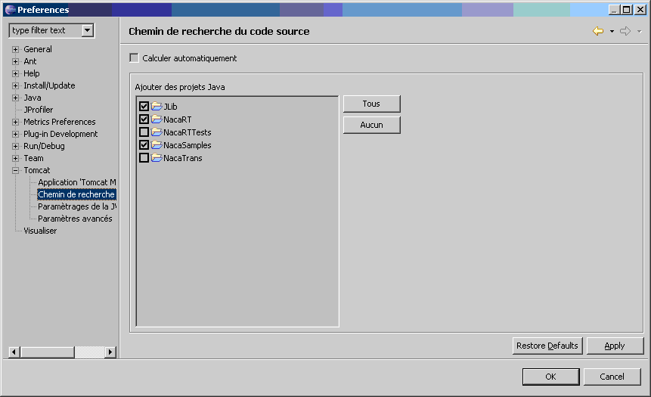

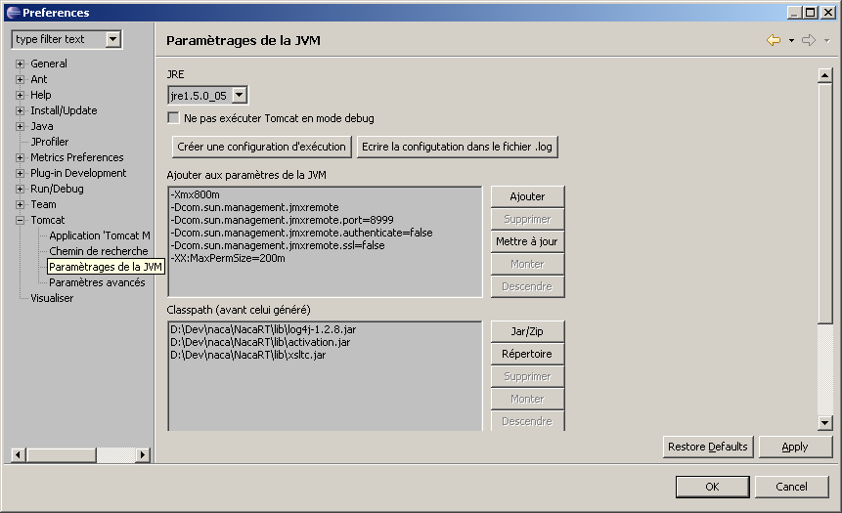

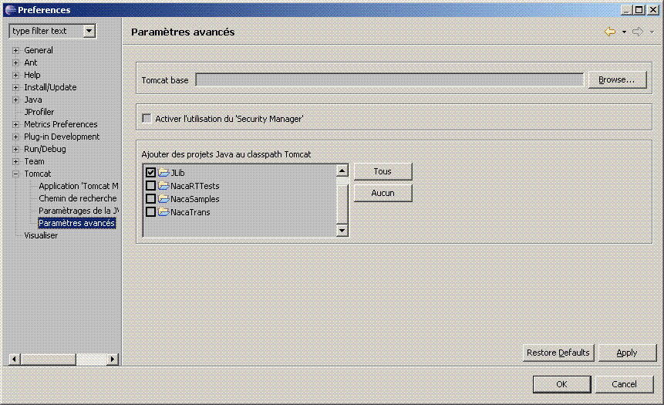

NacaRT must be declared as a Tomcat project: right click on NacaRT project, select "properties", and Choose "Tomcat":
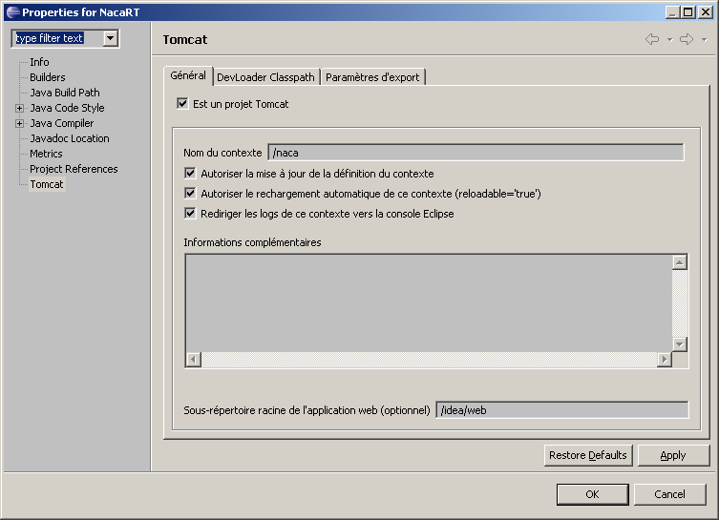

Tomcat context must also by declared (right click on NacaRT project, select "Project Tomcat", then select in popup menu "Update context".

- Execution of the online sample

Launch "Start tomcat" form sysdeo menu or tooltip. The following output should by displayed in Eclipse console:

NacaRT/Log4J:09:12:58 The Apache Tomcat Native library which allows optimal performance in production environments was not found on the java.library.path: C:\Program Files\Java\jre1.5.0_05\bin; . . .
NacaRT/Log4J:09:12:58 Initialisation de Coyote HTTP/1.1 sur http-8080
NacaRT/Log4J:09:12:58 Initialization processed in 1044 ms
NacaRT/Log4J:09:12:59 Démarrage du service Catalina
NacaRT/Log4J:09:12:59 Starting Servlet Engine: Apache Tomcat/5.5.20
NacaRT/Log4J:09:12:59 XML validation disabled
Naca>2009/03/02 09:21:38 (main): ImportantEvent:Beginning to cache 2 resources files from d:/dev/naca/CobolAppOnline/Resources/
Naca>2009/03/02 09:21:39 (main): ImportantEvent:Beginning to cache 1 resources files from D:/Dev/naca/NacaSamples/src/online/resources/
Naca>2009/03/02 09:21:39 (main): NormalEvent:LoadResourceCache Unique XML files loaded=3; XML from jar resource=0; Total load Time (ms)=156
NacaRT/Log4J:09:21:39 org.apache.webapp.balancer.BalancerFilter: init(): ruleChain: [org.apache.webapp.balancer.RuleChain: [org.apache.webapp.balancer.rules.URLStringMatchRule: Target string: News / Redirect URL: http://www.cnn.com], [org.apache.webapp.balancer.rules.RequestParameterRule: Target param name: paramName / Target param value: paramValue / Redirect URL: http://www.yahoo.com], [org.apache.webapp.balancer.rules.AcceptEverythingRule: Redirect URL: http://jakarta.apache.org]]
NacaRT/Log4J:09:21:39 ContextListener: contextInitialized()
NacaRT/Log4J:09:21:39 SessionListener: contextInitialized()
NacaRT/Log4J:09:21:39 ContextListener: contextInitialized()
NacaRT/Log4J:09:21:39 SessionListener: contextInitialized()
NacaRT/Log4J:09:21:39 Démarrage de Coyote HTTP/1.1 sur http-8080
NacaRT/Log4J:09:21:40 JK: ajp13 listening on /0.0.0.0:8009
NacaRT/Log4J:09:21:40 Jk running ID=0 time=0/62 config=null
NacaRT/Log4J:09:21:40 Find registry server-registry.xml at classpath resource
NacaRT/Log4J:09:21:40 Server startup in 521480 ms
NacaRT/Log4J:09:21:52 No FormBeanConfig found under 'null'

Launch an Internet Explorer browser with URL: http://127.0.0.1:8080/Naca/naca
The following screen is produced:
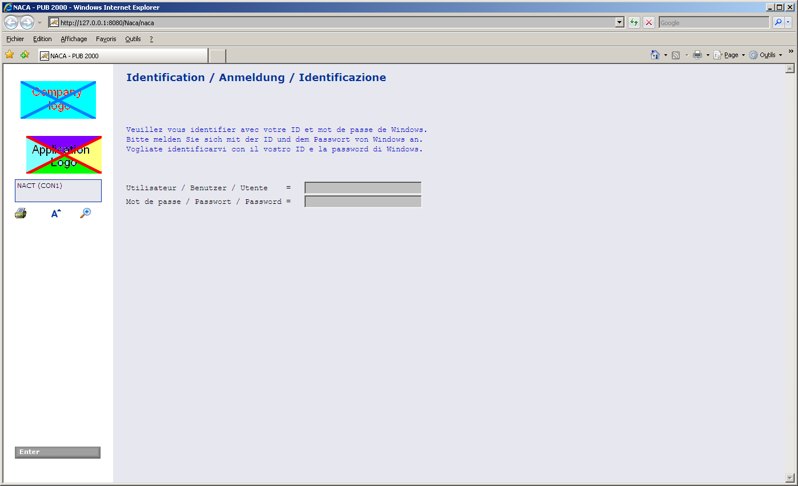

This screen is the standard login screen provided by NacaRT. It's not part of your application. Changing this default screen currently requires an update of NacaRT idea package. this will be improved in future release.
However, the company and application images are defined in D:\Dev\naca\NacaRT\idea\web\images as logoCompany.gif and logoApplication.gif. You can change it at will.

Log in the system, using a default login:
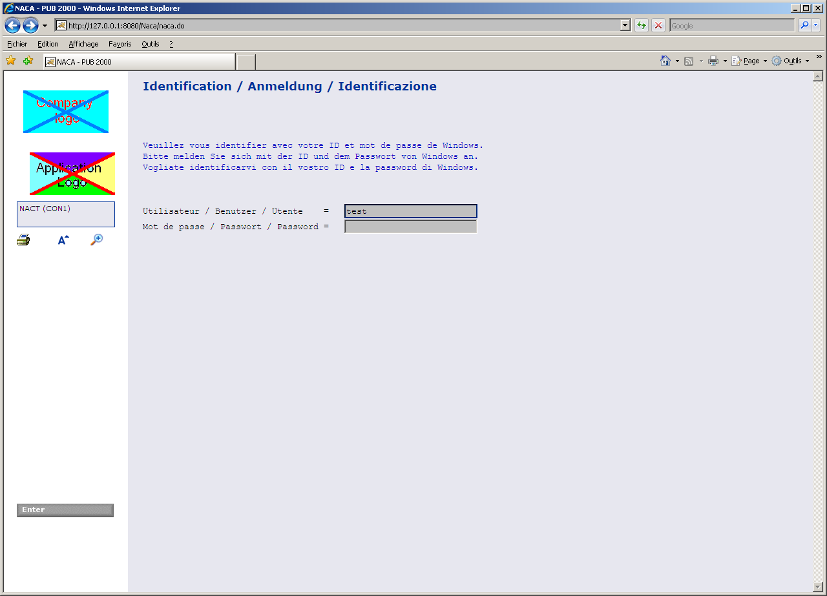

Fill-in user name with "test", and let password blank.
LDAP authentication is disabled because the NacaRT.cfg's "SimulateRealEnvironment" is set to true.
This disables configuration of database and LDAP.

Validate screen with Enter button or key.

If you had setup a breakpoint in Online1.java file, at line 113, you would hit this breakpoint:
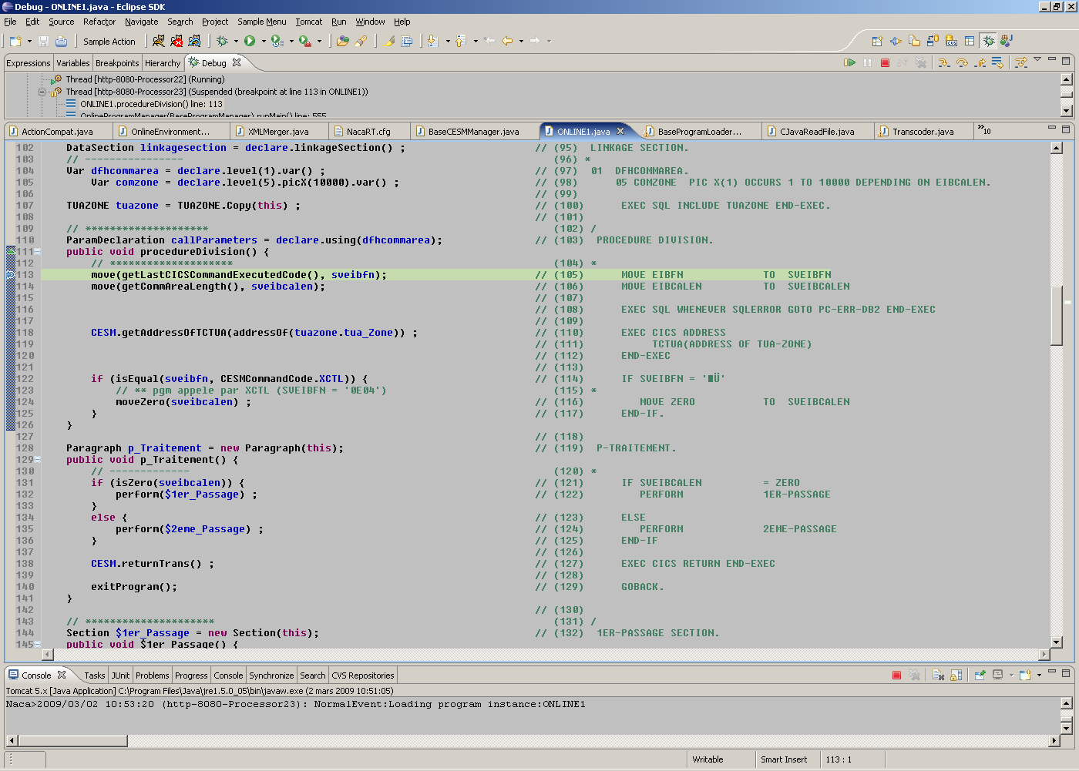

You can then execute step by step the program code.
After resuming execution, the following screen is displayed in the browser:
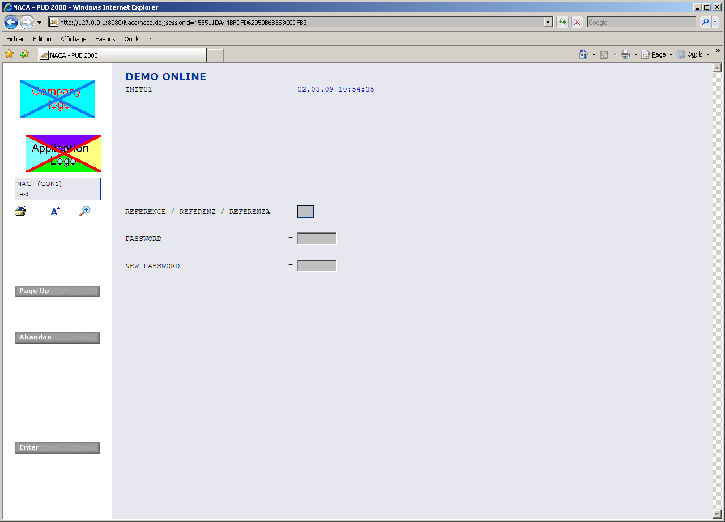

This screen is managed by the transcoded ONLINE1 program.

A sample SQL access is performed on ONLINE1 paragraph "test_Sql" (line 215). It's triggered by hitting function key "F7". In the sample, it won't work, as DB has been disabled.

If you wanted to test the DB access, you would need to remove SimulateRealEnvironment from NacaRT.cfg (or set it to false).
Then, the <SQLConfig> section must be filled with your DB specific parameters (in that case, it's configured for DB2 or UDB):

<SQLConfig
dburl="jdbc:db2://IpAddress:0/Name:"
dbuser="DbUser"
dbpassword="DbPassword"
dbConnectionUrlOptionalParams="currentPackageSet=NACA;keepDynamic=yes;clientProgramName=$FoundPoolName;"
dbenvironment="TEST"
driverClass="com.ibm.db2.jcc.DB2Driver"
CloseCursorOnCommit="true"
AutoCommit="false"
validationQuery="select * from SYSIBM.SYSDUMMY1"
>

What's more, LDAP configuration must also be filled:

LDAPServer="xxx1.domain.net"
LDAPServer2="xxx2.domain.net"
LDAPServer3="xxx3.domain.net"
LDAPRootOU="OU=DOMAIN_OU,DC=Domain,DC=net"
LDAPGenericUser="LDapUser"
LDAPGenericPassword="LDapPassword"

- Execution of the batch sample

In Eclispe, create a new debug profile:
Select Run/Debug
Right click Java Application, and select "New" in the popup menu.
Fill Name field with "NacaSamples - Batch"
In the right panel, the "Main" tab shold be selected.
In Project Browse button, select "NacaRT".
In main class Browse button, select "BatchMain - nacaLib.batchPrgEnv"

Select "Arguments" tab.

In Program arguments, set the following values:
-Program=BATCH1
-ConfigFile=D:\Dev\nacaOSS\NacaSamples\nacaRT.cfg
-Path=D:\Dev\nacaOSS\NacaSamples\bin
-FileIn=D:\Dev\nacaOSS\NacaSamples\BatchFiles\In\FileIn.data,advancedMode,ascii,fixed,CRLF
-fileOut=D:\Dev\nacaOSS\NacaSamples\BatchFiles\Out\FileOut.data,advancedMode,ascii,fixed,CRLF

Launch execution by pressing "Debug" button.

