Naca sample - Online sample - Tomcat configuration

- Introduction

This document states that naca-x.y.z.zip has been unzipped in D:\Dev\nacaOSS directory. All configuration paths are set on this directory by default. It can be changed, but with more efforts.

Note: These sample are run using Java 5.
A Tomcat 5.5 is required for executing online sample.

- Transcoding the samples

You should have first done correctly the steps described in the readme.txt file.

- Eclispe / Tomcat plugin configuration

To launch the online sample in Eclipse, you need to install sysdeo plugin (http://www.eclipsetotale.com/tomcatPlugin.html).
You can download tomcatPluginV321.zip file for Eclispe 3.3 (Ganymede).
Follw the installation instructions on the web page.

Download Tomcat 5.5 core at http://tomcat.apache.org/download-55.cgi
Unzip it in c:\Program Files for example.

Server Eclispe plugin for J2EE application is not supported yet, but is planned in a near future.

The Tomcat preferences (in Eclispe, menu windows/preference) must be declared as:

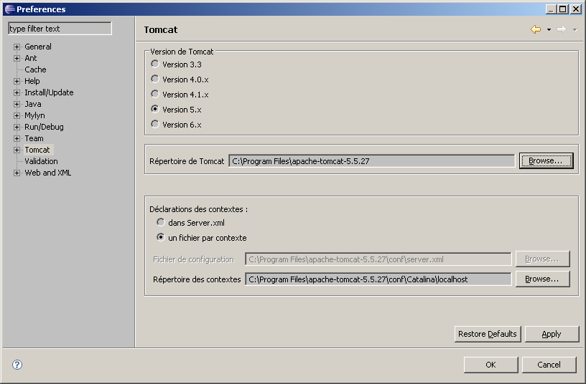

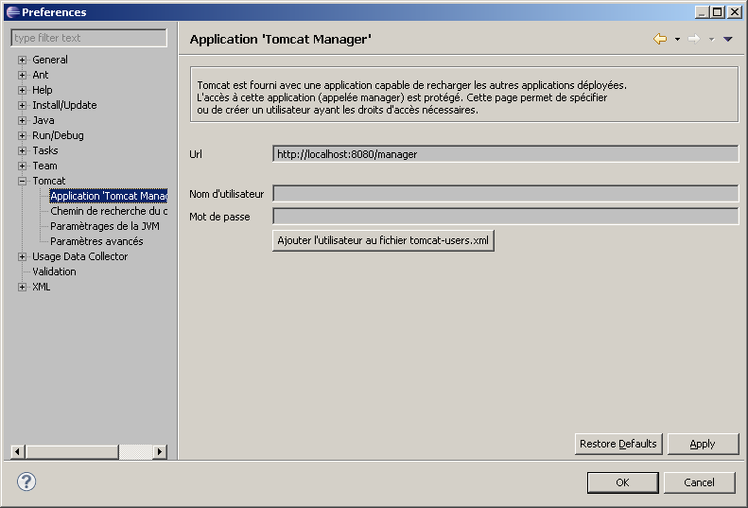

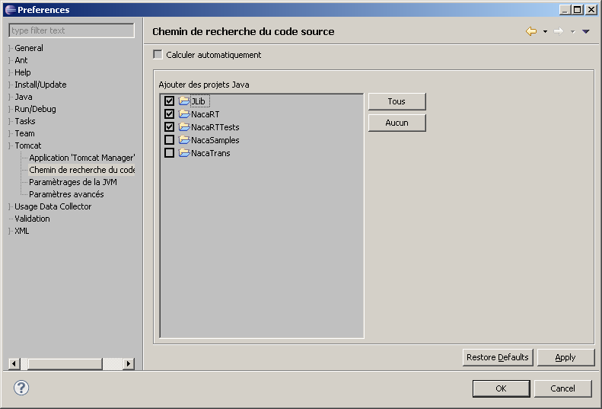

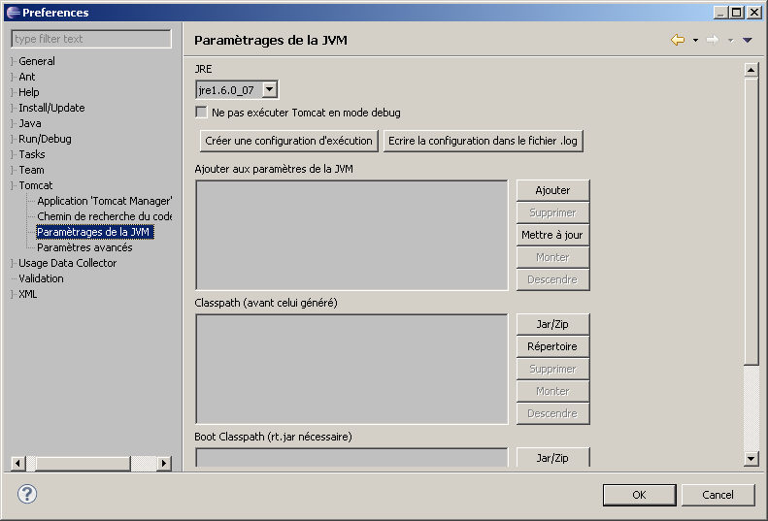

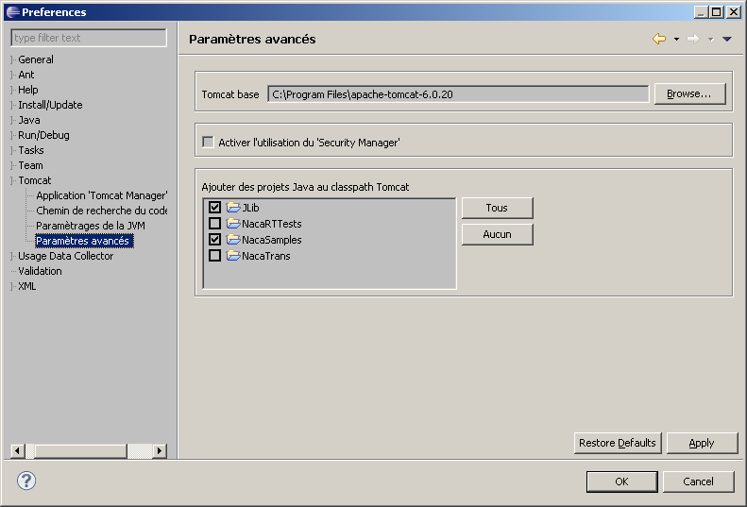

NacaRT must be declared as a Tomcat project: right click on NacaRT project, select "properties", and chose "Tomcat":
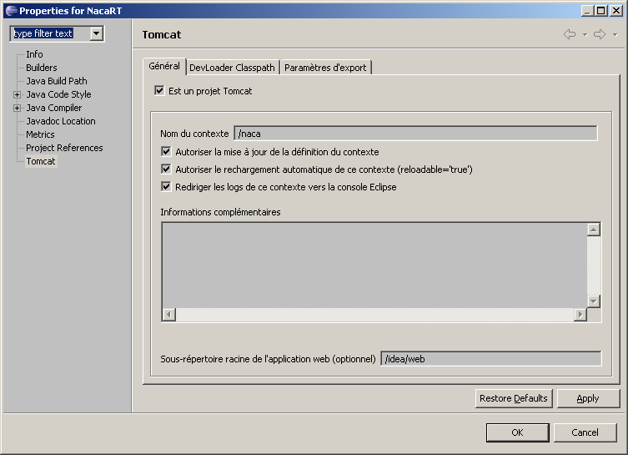

The other tabs keeps the default settings:
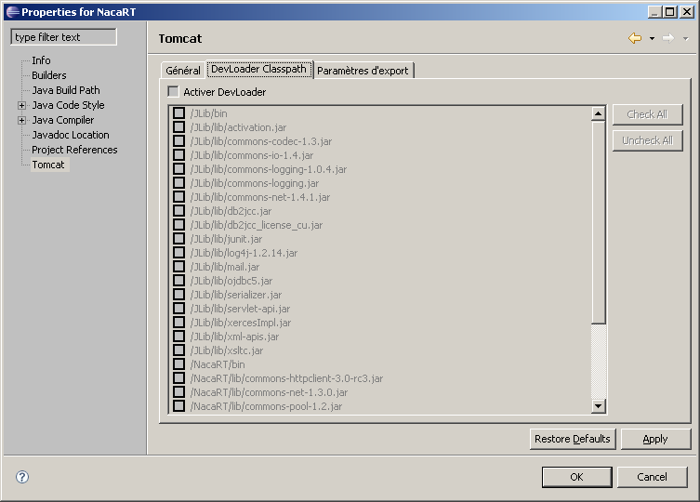

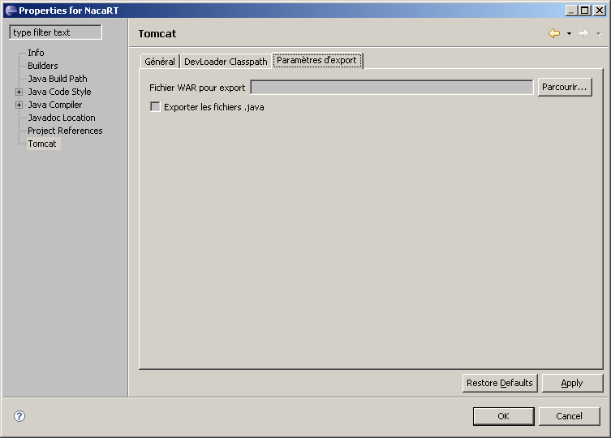

Then validate by "Apply", OK.

Tomcat context must also by declared (right click on NacaRT project, select "Project Tomcat", then select in popup menu "Update context" or "Mise à jour du contexte" (in French).

- Execution of the online sample

Launch "Start tomcat" form sysdeo menu or tooltip. The following output should by displayed in Eclipse console:

NacaRT/Log4J:09:12:58 The Apache Tomcat Native library which allows optimal performance in production environments was not found on the java.library.path: C:\Program Files\Java\jre1.5.0_05\bin; . . .
NacaRT/Log4J:09:12:58 Initialisation de Coyote HTTP/1.1 sur http-8080
NacaRT/Log4J:09:12:58 Initialization processed in 1044 ms
NacaRT/Log4J:09:12:59 Démarrage du service Catalina
NacaRT/Log4J:09:12:59 Starting Servlet Engine: Apache Tomcat/5.5.20
NacaRT/Log4J:09:12:59 XML validation disabled
Naca>2009/03/02 09:21:38 (main): ImportantEvent:Beginning to cache 2 resources files from d:/dev/naca/CobolAppOnline/Resources/
Naca>2009/03/02 09:21:39 (main): ImportantEvent:Beginning to cache 1 resources files from D:/Dev/naca/NacaSamples/src/online/resources/
Naca>2009/03/02 09:21:39 (main): NormalEvent:LoadResourceCache Unique XML files loaded=3; XML from jar resource=0; Total load Time (ms)=156
NacaRT/Log4J:09:21:39 org.apache.webapp.balancer.BalancerFilter: init(): ruleChain: [org.apache.webapp.balancer.RuleChain: [org.apache.webapp.balancer.rules.URLStringMatchRule: Target string: News / Redirect URL: http://www.cnn.com], [org.apache.webapp.balancer.rules.RequestParameterRule: Target param name: paramName / Target param value: paramValue / Redirect URL: http://www.yahoo.com], [org.apache.webapp.balancer.rules.AcceptEverythingRule: Redirect URL: http://jakarta.apache.org]]
NacaRT/Log4J:09:21:39 ContextListener: contextInitialized()
NacaRT/Log4J:09:21:39 SessionListener: contextInitialized()
NacaRT/Log4J:09:21:39 ContextListener: contextInitialized()
NacaRT/Log4J:09:21:39 SessionListener: contextInitialized()
NacaRT/Log4J:09:21:39 Démarrage de Coyote HTTP/1.1 sur http-8080
NacaRT/Log4J:09:21:40 JK: ajp13 listening on /0.0.0.0:8009
NacaRT/Log4J:09:21:40 Jk running ID=0 time=0/62 config=null
NacaRT/Log4J:09:21:40 Find registry server-registry.xml at classpath resource
NacaRT/Log4J:09:21:40 Server startup in 521480 ms
NacaRT/Log4J:09:21:52 No FormBeanConfig found under 'null'

Launch an Internet Explorer browser with URL: http://127.0.0.1:8080/Naca/naca
The following screen is produced:
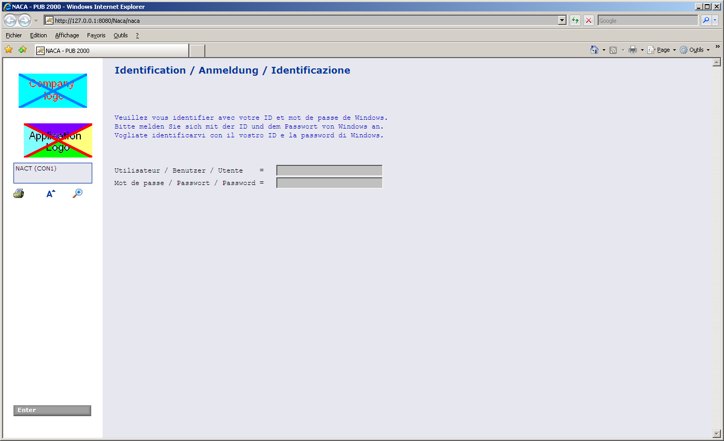

This screen is the standard login screen provided by NacaRT. It's not part of your application. Changing this default screen currently requires an update of NacaRT idea package. this will be improved in future release.
However, the company and application images are defined in D:\Dev\naca\NacaRT\idea\web\images as logoCompany.gif and logoApplication.gif. You can change it at will.

Log in the system, using a default login:
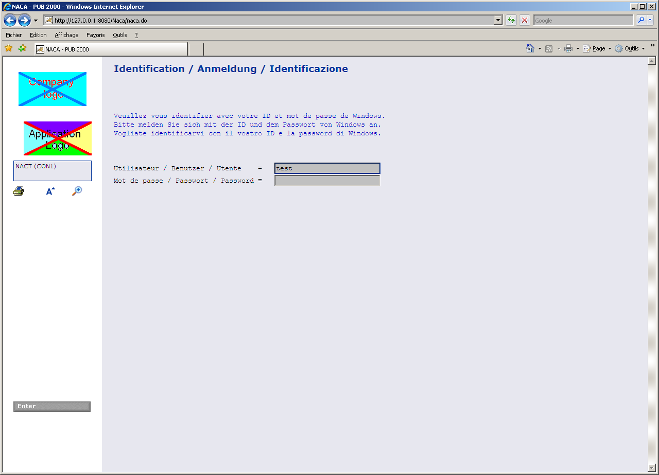

LDAP authentication is disabled because the NacaRT.cfg's "SimulateRealEnvironment" is set to true.
This disables configuration of database and LDAP.

Fill-in user name with "test", let password blank and press Enter or click the "Enter" button.

If you had setup a breakpoint in Online1.java file, at line 113, you would hit this breakpoint:
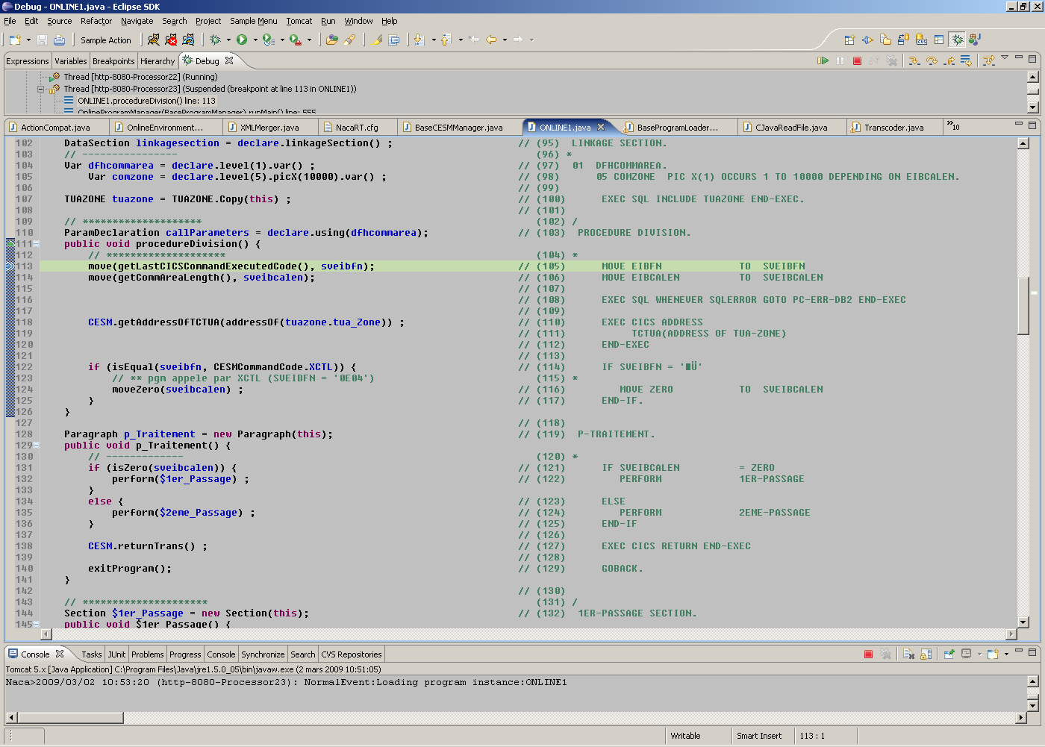

You can then execute step by step the program code.
After resuming execution, the following screen is displayed in the browser:
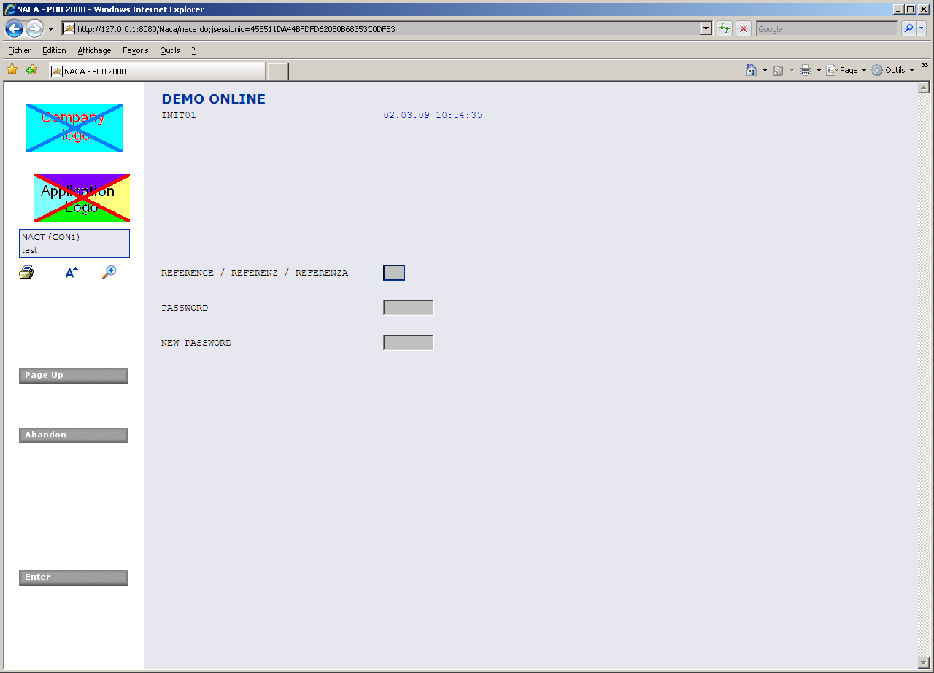

This screen is managed by the transcoded ONLINE1 program.

A sample SQL access is performed on ONLINE1 paragraph "test_Sql" (line 215). It's triggered by hitting function key "F7". In the sample, it won't work, as DB has been disabled.

If you wanted to test the DB access, you would need to remove SimulateRealEnvironment from NacaRT.cfg (or set it to false).
Then, the <SQLConfig> section must be filled with your DB specific parameters (in that case, it's configured for DB2 or UDB):

<SQLConfig
dburl="jdbc:db2://IpAddress:0/Name:"
dbuser="DbUser"
dbpassword="DbPassword"
dbConnectionUrlOptionalParams="currentPackageSet=NACA;keepDynamic=yes;clientProgramName=$FoundPoolName;"
dbenvironment="TEST"
driverClass="com.ibm.db2.jcc.DB2Driver"
CloseCursorOnCommit="true"
AutoCommit="false"
validationQuery="select * from SYSIBM.SYSDUMMY1"
>

What's more, LDAP configuration must also be filled:

LDAPServer="xxx1.domain.net"
LDAPServer2="xxx2.domain.net"
LDAPServer3="xxx3.domain.net"
LDAPRootOU="OU=DOMAIN_OU,DC=Domain,DC=net"
LDAPGenericUser="LDapUser"
LDAPGenericPassword="LDapPassword"

