Click on this link and follow the steps below to generate a contract

**Step 1**

[Jobox Application (jobox-fe-project22.netlify.app)](https://jobox-fe-project22.netlify.app/)

**Step 2**

fill in your details and click “Generate Contract”

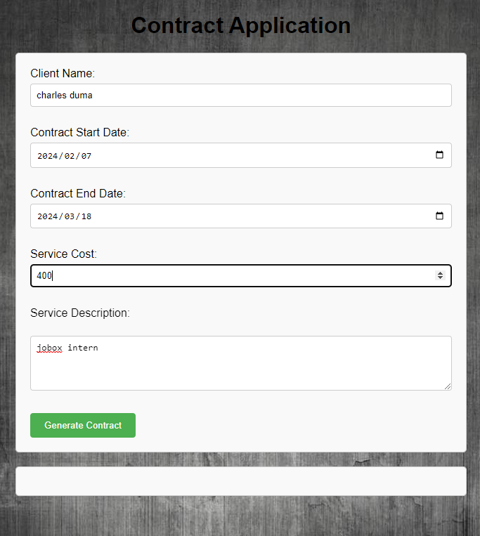

**Step 3**

After generating THE CONTRACT , scroll down so see it, with the relevant details

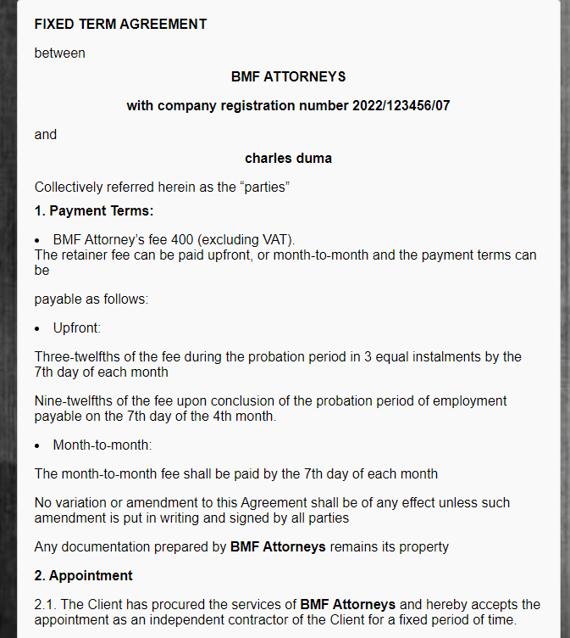

**GIthub repository**

Primary link to main branch

<https://github.com/charlespetros44/jobox-fe-project>

click on the main icon

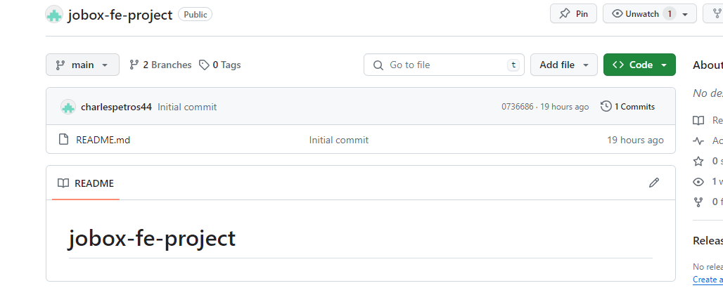

shortcut link to master branch

[charlespetros44/jobox-fe-project at master (github.com)](https://github.com/charlespetros44/jobox-fe-project/tree/master)

click on the main a drop down should appear , click on master(branch)

that’s where the application is.

