Charles Pittman
2014-12-10
ELEC-401

7.75) An emitter-follower amplifier is shown below. Using a computer simulation, determine the upper 3dB frequency and the mid-band voltage gain for: (a) R_L = 0.2 kohm, (b) R_L = 2 kohm, (c) R_L = 20 kohm. Use a standard transistor. Explain any differences between the results of the three parts.

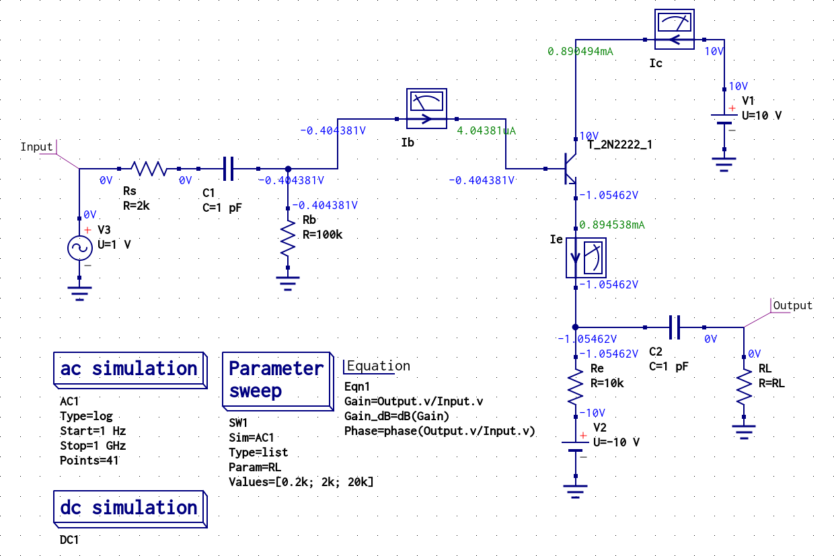
As shown in the first figure, RL does not affect quiescent (DC) values, because the capacitors are effectively open-circuits. At higher frequencies RL is in parallel with Re, affecting the gain. The magnitude of the gain increases with RL, but bandwidth decreases.
