DA AgriManage: Agricultural Distribution, Scheduling & Insurance System

A Midterm Project
Presented to the Faculty of the
Bachelor of Science in Information Technology
Mindoro State University—Main Campus

In Partial Fulfillment of the Requirements
for System Integration and Architecture I

By
Marvin J Gabia

NICKO ALVAREZ MAGNAYE, MSIT
ITP314 Professor

October 2024

TABLE OF CONTENTS

- INSTITUTIONAL/ ORGANIZATIONAL PROFILE
The Department of Agriculture (DA) - Municipal Agriculture Office of Bulalacao, Oriental Mindoro is a government agency mandated to promote agricultural development, provide essential support services to farmers, and ensure food security within the municipality. It is tasked with delivering quality agricultural extension services, facilitating the distribution of farm inputs, implementing crop insurance programs, and coordinating disaster response and recovery efforts for the farming communities. As a local government unit office under the Department of Agriculture, its core business is the delivery of accessible, efficient, and transparent agricultural services that contribute to the livelihood improvement and economic sustainability of Bulalacao's rural population (Department of Agriculture, 2023).
The Municipal Agriculture Office operates as the primary implementer of national and regional agricultural programs within Bulalacao's territorial jurisdiction. It serves multiple barangays across the municipality, ensuring that farmers and rural residents have equitable access to certified seeds, organic and inorganic fertilizers, pesticides, and other farm supplies essential for crop production. The office functions under the supervision of the Municipal Agriculturist, supported by agricultural technicians, field coordinators, and barangay agricultural workers who facilitate direct engagement with farmer-beneficiaries. Through these personnel, the office ensures that agricultural interventions are responsive to seasonal planting cycles, environmental conditions, and the specific needs of local farming communities (Local Government Code of 1991; DA Administrative Order No. 13, Series of 2020).
A critical component of the Municipal Agriculture Office's mandate is the coordination and implementation of the Philippine Crop Insurance Corporation (PCIC) programs in partnership with the DA. This collaboration enables small-scale farmers to access affordable crop insurance coverage, protecting them from production losses caused by natural calamities such as typhoons, floods, droughts, and pest infestations. The office facilitates the entire insurance lifecycle from farmer registration and premium collection to damage assessment and claims processing ensuring that affected farmers receive timely financial assistance for recovery and replanting. This function is vital in a disaster-prone area like Bulalacao, where agricultural productivity is frequently threatened by extreme weather events and climate variability (PCIC Annual Report, 2023; Climate Risk and Adaptation Country Profile Philippines, World Bank, 2021).
In addition to resource distribution and insurance facilitation, the Municipal Agriculture Office plays a significant role in information dissemination and community organizing. The office regularly conducts farmer orientations, training sessions, and technology demonstrations aimed at improving agricultural productivity and promoting sustainable farming practices. Announcements regarding distribution schedules, available programs, insurance deadlines, and disaster preparedness measures are communicated through barangay officials, community assemblies, and physical postings. However, the current manual and paper-based communication system presents challenges in terms of timeliness, reach, and accuracy, often resulting in delayed or incomplete information delivery to intended beneficiaries (Alvarez & Gonzales, 2024).
The organizational structure of the DA - Municipal Agriculture Office of Bulalacao reflects a decentralized yet coordinated governance model. At the municipal level, the office is headed by the Municipal Agriculturist, who reports to both the Municipal Mayor and the Provincial Agriculture Office. The structure includes technical staff assigned to specific program areas such as crop production, livestock, fisheries, and extension servicesas well as field officers who serve as liaisons to barangay-level agricultural workers. This structure ensures that national agricultural policies and programs are contextualized and implemented effectively at the grassroots level, fostering inclusive participation and community-driven development (Department of the Interior and Local Government [DILG], 2022).
Bulalacao, as a predominantly agricultural municipality in Oriental Mindoro, relies heavily on farming as the primary source of livelihood for its residents. The majority of the population engages in rice and corn farming, with supplementary production of high-value crops such as vegetables, root crops, and fruit-bearing trees. Given this economic reality, the role of the Municipal Agriculture Office extends beyond service deliveryit serves as a catalyst for rural development and poverty alleviation. By improving access to quality inputs, reducing production risks through insurance, and enhancing farmer knowledge through extension programs, the office directly contributes to household income stability, food sufficiency, and overall community resilience (Philippine Statistics Authority [PSA], 2022; National Economic and Development Authority [NEDA], 2023).
Despite its essential functions, the Municipal Agriculture Office of Bulalacao faces significant operational challenges rooted in outdated manual processes. Current systems for scheduling distribution activities, managing farmer records, processing insurance applications, and disseminating information are largely paper-based and labor-intensive. This results in inefficiencies such as delayed notifications, inconsistent record-keeping, limited transparency in resource allocation, and slow response times during calamity situations. Farmers often
travel long distances to the municipal office only to find out that schedules have changed or that supplies have not yet arrived. Similarly, insurance claims processing can take weeks or even months due to manual documentation and lack of centralized data management (Local Government Performance Management System [LGPMS] Report, 2023).
The introduction of the DA AgriManage: Agricultural Distribution, Scheduling & Insurance System represents a transformative step toward modernizing agricultural service delivery in Bulalacao. This digital platform is designed to address the limitations of the current manual system by providing an integrated, web-based solution that enables real-time scheduling, automated notifications via SMS and email, online insurance application and tracking, and centralized data management. By leveraging information and communication technology (ICT), the system aims to enhance transparency, improve efficiency, and increase farmer satisfaction and participation in DA programs. The system aligns with the government's broader digital transformation agenda and supports the goals of the Philippine Development Plan (PDP) 2023–2028, which emphasizes the use of technology to improve public service delivery and promote inclusive growth (NEDA, 2023; DICT National Cybersecurity Plan, 2022).
The DA AgriManage system will serve multiple user groups within the municipality. Admin users, including the Municipal Agriculturist and technical staff, will have access to a comprehensive dashboard that allows them to schedule distribution activities per barangay, post announcements, manage farmer profiles, process insurance applications, and send bulk notifications. Resident users, which include registered farmers and rural residents, will be able to log in using their email or mobile number to view schedules, receive personalized alerts, apply for crop insurance online, report calamity damage, and track the status of their applications. This two-tiered structure ensures role-based access, data security, and user-friendly navigation tailored to the digital literacy levels of the target audience (ISO/IEC 27001:2013 Information Security Standards).
Moreover, the system incorporates a calamity response module that enables rapid damage reporting and claims processing during disaster events. When a typhoon, flood, or drought affects crops in a particular barangay, farmers can immediately report the damage through the system, attaching photos and descriptions. The Municipal Agriculture Office can then conduct validation and assessment remotely or through field verification, expediting the approval of insurance claims and distribution of rehabilitation packages. Automated notifications keep farmers informed at every stage of the process, reducing uncertainty and fostering trust in government response mechanisms (PCIC Guidelines on Crop Insurance Claims, 2023).
In summary, the Department of Agriculture - Municipal Agriculture Office of Bulalacao, Oriental Mindoro operates as a vital public institution dedicated to advancing agricultural productivity, ensuring farmer welfare, and promoting rural development. Its business encompasses the distribution of farm inputs, facilitation of crop insurance, provision of extension services, and coordination of disaster response efforts. However, the persistence of manual, paper-based processes has limited its capacity to serve the farming community efficiently and equitably. The DA AgriManage system offers a strategic solution that leverages digital technology to modernize operations, enhance communication, improve transparency, and ultimately empower the farmers of Bulalacao to achieve greater resilience and prosperity in an increasingly unpredictable agricultural landscape.

- BUSINESS PROCESS ANALYSIS
- Current Business Process

i. Discussion of the Current Process to Be Improved
The current agricultural distribution, scheduling, and insurance process of the Department of Agriculture - Municipal Agriculture Office of Bulalacao, Oriental Mindoro operates through a predominantly manual and paper-based system that involves multiple steps across various barangays and municipal offices. While the process ensures farmer verification and proper documentation of resource distribution and insurance claims, it is time-consuming, prone to communication gaps, and inefficient during peak planting seasons and post-calamity periods. At present, the process begins with the Municipal Agriculture Office preparing an inventory of available farm inputs such as certified seeds, fertilizers, pesticides, and other agricultural supplies based on allocations received from the Provincial Agriculture Office or directly from the Department of Agriculture central office.
Once the inventory is confirmed, the Municipal Agriculturist and technical staff manually prepare a distribution schedule indicating which barangays will receive specific types and quantities of farm inputs on particular dates. This schedule is then communicated to Barangay Captains and Barangay Agricultural Workers (BAWs) through physical meetings, phone calls, or written memoranda. The barangay officials are then responsible for disseminating the information to their respective farming communities through word-of-mouth announcements, community assemblies, or posted notices on barangay bulletin boards. This manual method of information dissemination often results in incomplete or delayed communication, causing farmers to miss distribution schedules or travel to distribution sites only to find that supplies have not yet arrived or have already been distributed.
On the scheduled distribution day, farmers must physically present themselves at the designated barangay hall or municipal agriculture office to claim their allocated farm inputs. The Municipal Agriculture Office staff manually records each farmer's name, barangay, type and quantity of inputs received, and signature on a paper-based logbook or tally sheet. This manual recording process is labor-intensive and susceptible to errors such as illegible handwriting, missing entries, duplicate records, or misplaced documentation. Furthermore, there is no centralized database that consolidates distribution records across all barangays, making it difficult for the Municipal Agriculture Office to generate accurate and timely reports on resource utilization, beneficiary coverage, and inventory status.
In addition to distribution management, the Municipal Agriculture Office also facilitates crop insurance enrollment and claims processing in partnership with the Philippine Crop Insurance Corporation (PCIC). Farmers who wish to avail of crop insurance must visit the municipal office in person to submit application forms, land title documents, planting schedules, and premium payments. The Municipal Agriculture Office staff manually reviews each application, verifies the farmer's eligibility and land area, and forwards the compiled applications to the PCIC regional office for approval and policy issuance. This process can take several weeks, and farmers often do not receive timely updates on the status of their applications due to the lack of a tracking system.
When a calamity such as a typhoon, flood, or drought occurs and damages crops, affected farmers must immediately report the damage to the Barangay Agricultural Worker, who then consolidates the reports and submits them to the Municipal Agriculture Office. The Municipal Agriculturist assigns field staff to conduct damage assessment and validation, which involves physically visiting each affected farm, inspecting the damaged crops, and documenting the extent of loss through handwritten forms and photographs. The assessment results are then manually encoded into summary reports and submitted to PCIC for claims processing. This entire process from damage reporting to claims approval can take several months, leaving farmers without timely financial assistance for recovery and replanting.
Despite the dedication and effort of the Municipal Agriculture Office personnel, the persistence of manual processes creates significant operational challenges. Issues such as delayed communication, inconsistent record-keeping, difficulty in generating real-time reports, lack of transparency in resource allocation, and slow response times during calamity situations frequently occur. Farmers often express frustration over the need to make multiple trips to the municipal office for updates, the uncertainty of distribution schedules, and the lengthy waiting period for insurance claims. Furthermore, the lack of digital documentation makes it difficult for the office to track program performance, analyze trends, and provide evidence-based reports to higher authorities.
The proposed DA AgriManage: Agricultural Distribution, Scheduling & Insurance System aims to automate and integrate these core functions into a unified digital platform accessible via web portal. By doing so, the Municipal Agriculture Office can streamline the workflow, minimize human errors, enhance data accuracy, and improve service efficiency. The system will enable the Municipal Agriculturist and staff to schedule distribution activities per barangay through an online dashboard, automatically generate and send SMS and email notifications to registered farmers, manage farmer profiles and distribution records in a centralized database, facilitate online crop insurance applications and claims tracking, and produce real-time reports on program performance. For farmers and rural residents, the system will provide online access to view distribution schedules, receive personalized alerts, apply for crop insurance, report calamity damage, and track the status of their applications all without the need for multiple office visits. This digital transformation will reduce congestion at the municipal office, improve transparency and accountability, and ultimately enhance farmer satisfaction and participation in DA programs.
ii. Illustration and Process Discussion (Flowchart Description)
The current agricultural distribution, scheduling, and insurance process at the Department of Agriculture - Municipal Agriculture Office of Bulalacao, Oriental Mindoro follows a series of sequential and often fragmented stages that require coordination between the municipal office, barangay officials, and farmer-beneficiaries. The process begins with the Resource Allocation and Inventory Management Stage, wherein the Municipal Agriculture Office receives farm input allocations (seeds, fertilizers, pesticides) from the Provincial Agriculture Office or DA central office. The Municipal Agriculturist and technical staff conduct a physical inventory count and record the types, quantities, and specifications of available supplies in a paper-based logbook. Based on this inventory and considering the planting season and barangay requests, the staff manually prepares a distribution schedule indicating which barangays will receive specific inputs on particular dates.
After the distribution schedule is prepared, the process advances to the Information Dissemination Stage. The Municipal Agriculturist or designated staff calls or sends written memoranda to Barangay Captains and Barangay Agricultural Workers (BAWs) to inform them of the scheduled distribution dates and quantities allocated for their respective barangays. The barangay officials then relay this information to farmers through community assemblies, loudspeaker announcements, or posted notices on barangay bulletin boards.
However, this manual method of communication is unreliable and often results in incomplete information reach. Farmers who do not attend barangay assemblies or who live in remote sitios may not receive timely notification, leading to confusion and missed opportunities to claim their allocated inputs.
Once farmers are informed (or assume) of the distribution schedule, they proceed to the Physical Distribution and Recording Stage. On the scheduled date, farmers travel to the designated distribution site usually the barangay hall or municipal agriculture office and wait in line to receive their allocated farm inputs. Municipal Agriculture Office staff manually verify each farmer's identity by checking identification cards or barangay certifications, then distribute the appropriate type and quantity of inputs. After receiving the supplies, farmers are required to sign a paper-based tally sheet or logbook that records their name, barangay, type and quantity of inputs received, and signature. This manual recording process is time-consuming, especially when hundreds of farmers are queued, and is prone to errors such as illegible signatures, duplicate entries, or missing information.
Following the distribution event, the Municipal Agriculture Office staff consolidates the paper-based tally sheets from multiple barangays and manually encodes the data into spreadsheet files or summary reports. This encoding process, known as the Data Consolidation and Reporting Stage, is labor-intensive and can take several days or even weeks to complete, depending on the volume of distributions conducted. The lack of a centralized database means that each distribution event is recorded separately, making it difficult to track cumulative beneficiary coverage, inventory depletion rates, or barangay-level distribution patterns. The resulting reports are often submitted to the Provincial Agriculture Office or DA regional office after significant delays, hindering timely decision-making and program evaluation.
Parallel to the distribution process is the Crop Insurance Enrollment and Management Process, which also operates manually. Farmers who wish to enroll in crop insurance must visit the Municipal Agriculture Office in person to submit application forms, proof of land ownership or tenancy, and premium payment. The Municipal Agriculture Office staff manually reviews each application to verify eligibility criteria such as land area, crop type, and planting schedule. Once verified, the staff compiles the applications and forwards them in batches to the PCIC regional office for approval. The farmer receives no confirmation or tracking information during this period and must periodically return to the municipal office to inquire about the status of their application. Policy issuance can take several weeks, and the lack of digital tracking results in uncertainty and frustration for farmers.

When a calamity occurs, the process transitions to the Damage Reporting and
Assessment Stage. Affected farmers report crop damage to their Barangay Agricultural Worker, who manually compiles the reports and submits them to the Municipal Agriculture Office. The Municipal Agriculturist then assigns field staff to conduct on-site damage assessments, which involves traveling to each affected farm, physically inspecting the damaged crops, and documenting the extent of loss using handwritten forms and camera photographs. The assessment results are manually encoded into damage assessment reports and submitted to PCIC for claims processing. This entire process from initial damage reporting to final claims approval can take several months due to the manual documentation, lack of centralized data management, and multiple layers of validation required by PCIC.
Finally, the process concludes with the Claims Processing and Notification Stage, wherein PCIC evaluates the damage assessment reports submitted by the Municipal Agriculture Office and determines the insurance payout amount for each affected farmer. Once approved, PCIC issues checks or deposits funds into farmers' accounts, and the Municipal Agriculture Office is notified to inform the beneficiaries. However, due to the lack of an automated notification system, farmers often do not receive timely updates and must repeatedly visit the municipal office to inquire about the status of their claims. The disbursement of funds can be further delayed if there are discrepancies in documentation or if farmers fail to complete post-claim requirements.
Overall, the current process remains linear, fragmented, and heavily dependent on manual documentation, physical transactions, and verbal communication. This workflow leads to inefficiencies such as delayed notifications, long queues during distribution, redundant data entry, incomplete record-keeping, lack of transparency in resource allocation, and slow response times during calamity situations. The need for an automated and integrated DA AgriManage: Agricultural Distribution, Scheduling & Insurance System is therefore essential to improve transaction speed, ensure data accuracy, enhance communication effectiveness, and promote transparency and accountability in agricultural service delivery within the Municipality of Bulalacao, Oriental Mindoro.
In a flowchart representation, the current process follows this order:
For Agricultural Distribution: Municipal Agriculture Office (Inventory & Scheduling) → Barangay Officials (Manual Notification) → Farmers (Physical Attendance) → Distribution Site (Manual Recording) → Municipal Agriculture Office (Data Consolidation & Reporting) → Provincial/Regional Office (Submission of Reports)
For Crop Insurance: Farmer (Physical Application Submission) → Municipal Agriculture Office (Manual Verification) → PCIC Regional Office (Approval & Policy Issuance) → Farmer (Policy Receipt - Manual Inquiry)
For Calamity Claims: Farmer (Damage Report to Barangay) → Barangay Agricultural Worker (Consolidation) → Municipal Agriculture Office (Field Assessment) → PCIC (Claims Evaluation) → Municipal Agriculture Office (Notification) → Farmer (Claims Receipt - Manual Inquiry)
Figure 1. Current Process Flow of the DA Agricultural Distribution, Scheduling & Insurance System
B. Identified Pain Points
The existing agricultural distribution, scheduling, and insurance process at the Department of Agriculture - Municipal Agriculture Office of Bulalacao, Oriental Mindoro presents several inefficiencies and operational bottlenecks that hinder the institution's ability to provide timely, transparent, and equitable services to the farming community. One of the most prominent challenges lies in the manual and paper-based nature of information dissemination. Distribution schedules, program announcements, and insurance deadlines are communicated through verbal notifications, physical postings, and barangay assemblies, which often fail to reach all intended beneficiaries. Farmers who live in remote sitios, work in distant fields, or are unable to attend community meetings frequently miss important announcements, resulting in lost opportunities to receive farm inputs or enroll in insurance programs. This approach creates confusion, frustration, and inequitable access to agricultural services, particularly for marginalized and vulnerable farmer groups.
Another major inefficiency is the lack of a centralized digital database for managing farmer information, distribution records, and insurance applications. Currently, the Municipal Agriculture Office, Barangay Agricultural Workers, and PCIC maintain separate paper-based logbooks and spreadsheets, causing redundant data entry, frequent discrepancies, and difficulty in tracking individual farmer participation across multiple programs. When errors occur such as duplicate entries, missing signatures, illegible handwriting, or misplaced documents they require time-consuming manual verification and reconciliation. This fragmented record-keeping system not only increases the workload of administrative staff but also compromises data accuracy, transparency, and accountability. The absence of historical records and beneficiary profiles makes it nearly impossible to conduct trend analysis, assess program impact, or identify underserved barangays and farmer demographics.
The manual scheduling and coordination process also contributes to delays
and logistical challenges. Distribution schedules are prepared weeks in advance based on estimated supply arrivals and seasonal planting cycles, but unforeseen delays in transportation, weather conditions, or supply shortages often necessitate last-minute changes. However, because there is no automated notification system in place, the Municipal Agriculture Office must rely on phone calls and personal visits to inform barangay officials of schedule adjustments, who in turn must manually relay the updated information to farmers. This chain of communication is slow, unreliable, and prone to breakdown, resulting in farmers traveling long distances to distribution sites only to be turned away or to wait for hours without receiving their allocated inputs. Such experiences erode trust in government services and discourage future participation in DA programs.
From a farmer's perspective, the current system lacks transparency and accessibility. Farmers have no way to independently verify their eligibility status, view upcoming distribution schedules, check the status of their insurance applications, or track the progress of their calamity claims. They are forced to rely on in-person inquiries at the municipal office or through barangay officials, which consumes valuable time that could otherwise be spent on farm work. This lack of real-time information creates uncertainty and anxiety, particularly during critical periods such as planting season or post-calamity recovery. Additionally, the absence of online application options for crop insurance means that farmers must take time off from their work, travel to the municipal center (often incurring transportation costs), and endure long waiting times just to submit or follow up on paperwork. This inconvenience is especially burdensome for elderly farmers, persons with disabilities, and those residing in geographically isolated barangays.
The crop insurance enrollment and claims processing workflow suffers from severe delays due to manual documentation and multi-layered validation requirements. Farmers must submit multiple copies of paper forms, land documents, and proof of planting, which are then manually reviewed, verified, and forwarded in batches to PCIC regional offices. The absence of digital tracking means that applications can be misplaced, overlooked, or delayed without the farmer's knowledge. Similarly, during calamity events, the damage assessment process requires field staff to physically visit each affected farm, manually document losses using handwritten forms, and then encode the data into summary reports for submission to PCIC. This process can take weeks or even months, delaying the release of insurance payouts at a time when farmers urgently need financial assistance for replanting and recovery. The lack of automated notifications throughout the claims process leaves farmers in the dark, forcing them to make repeated trips to the municipal office to inquire about updatesa frustrating and demoralizing experience.
Communication between the Municipal Agriculture Office, barangay
officials, and PCIC also poses a significant bottleneck. The lack of a centralized
communication and monitoring platform makes it difficult to coordinate real-time updates, share accurate data, and ensure consistent implementation of programs across all barangays. For instance, when the Municipal Agriculture Office receives new supply allocations or policy updates from the Provincial Agriculture Office, there is no efficient mechanism to instantly disseminate this information to all barangay officials and farmers simultaneously. Instead, staff must manually prepare and distribute physical memoranda or make individual phone calls, which is time-consuming and often incomplete. Similarly, when PCIC approves insurance claims or issues policy updates, the Municipal Agriculture Office must manually receive, process, and relay this information to farmers, creating unnecessary delays and opportunities for miscommunication.
The manual recording and reporting process during distribution events is labor-intensive and prone to errors. Staff members must manually write down the names, barangays, and signatures of hundreds of farmers in tally sheets, often under crowded and chaotic conditions. Illegible handwriting, duplicate entries, missed signatures, and lost pages are common occurrences that compromise the integrity of distribution records. After the event, staff must spend days manually encoding the paper-based data into digital spreadsheets for reporting purposes, a process that is tedious, error-prone, and delays the submission of accurate program performance reports to higher authorities. The lack of real-time data capture also means that the Municipal Agriculture Office cannot monitor distribution progress, track inventory depletion rates, or identify issues (such as insufficient supplies or unequal allocation) until after the event has concluded.
Furthermore, the current system offers limited transparency and accountability in resource allocation and program implementation. Because distribution records and insurance claims are managed through fragmented paper-based systems, it is difficult for stakeholders including farmers, barangay officials, local government leaders, and oversight agencies to independently verify whether resources are being distributed equitably, whether all eligible farmers are being served, or whether insurance claims are being processed fairly and promptly. This lack of transparency can erode public trust, create opportunities for favoritism or corruption, and undermine the credibility of the Municipal Agriculture Office and the Department of Agriculture as a whole.
Overall, the current agricultural distribution, scheduling, and insurance process suffers from redundant documentation, limited automation, inefficient communication, slow response times, and lack of transparency. These issues collectively contribute to administrative burden, farmer dissatisfaction, inequitable access to services, and missed opportunities for rural development
and disaster resilience. Therefore, there is a pressing need for an integrated, automated DA AgriManage: Agricultural Distribution, Scheduling & Insurance System that can centralize farmer information, streamline workflows,
enable real-time scheduling and notifications, facilitate online insurance applications and claims tracking, minimize human errors, and enhance transparency, accountability, and service delivery across all stakeholders involved in agricultural service provision within the Municipality of Bulalacao, Oriental Mindoro.

- CMS Selection and Justification

A. Content Management System Used
The proposed DA AgriManage: Agricultural Distribution, Scheduling & Insurance System for the Department of Agriculture - Municipal Agriculture Office of Bulalacao, Oriental Mindoro will utilize WordPress (Version 6.7) as its Content Management System (CMS). WordPress is an open-source CMS designed to facilitate website development, content management, and system customization without requiring extensive programming expertise (WordPress Foundation, 2024). It offers a user-friendly administrative interface, a modular structure, and a vast library of plugins that support advanced functionalities such as database integration, user authentication, SMS and email notification systems, online form processing, and data visualization.
WordPress operates on the PHP programming language and utilizes MySQL or MariaDB as its database management system, enabling efficient data storage, retrieval, and scalability (Mullenweg & WordPress Community, 2024). Its open-source nature allows developers to modify source code and integrate third-party APIs such as SMS gateways (e.g., Semaphore, Twilio) and email services (e.g., SMTP, SendGrid) making it suitable for building interactive and dynamic web-based systems such as the DA AgriManage platform. Additionally, WordPress supports role-based access control (RBAC), allowing administrators, municipal staff, barangay agricultural workers, and registered farmers to access the system according to their designated permissions, thus enhancing security, accountability, and user experience within the system's operations.
The platform's responsive design capabilities ensure that the system is accessible across multiple devices, including desktop computers, laptops, tablets, and smartphones. This is particularly important for rural and agricultural communities where mobile phone usage is prevalent and internet connectivity may vary. By leveraging WordPress's mobile-friendly themes and frameworks, the DA AgriManage system can provide farmers with seamless access to schedules, notifications, and insurance information regardless of their location or device type (Kinsta, 2024).

B. Justification for CMS Selection
The selection of WordPress Version 6.7 as the CMS for the DA AgriManage system is based on its scalability, ease of use, cost efficiency, high degree of customization, and strong community support. From a scalability perspective, WordPress supports both small and large-scale institutional websites through its flexible architecture and cloud hosting capabilities. This enables the system to accommodate the growing number of registered farmers, barangay users, and administrative staff across multiple municipalities without compromising performance or system stability (Rouse, 2024). As the Municipal Agriculture Office expands its digital services to include additional barangays, programs, or partner municipalities, WordPress's scalable infrastructure ensures that the system can grow seamlessly to meet increasing demands.
In terms of ease of use, WordPress provides an intuitive dashboard and graphical user interface (GUI) that allow administrators and non-technical users to manage content, schedule distributions, post announcements, process insurance applications, and generate reports efficiently. Its learning curve is minimal compared to proprietary CMS platforms or custom-built systems, allowing Municipal Agriculture Office staff many of whom may have limited technical expertise to operate and maintain the system with minimal training and external support (Kinsta, 2024). This accessibility is critical in a local government setting where resources for specialized IT personnel may be limited and where staff members must be able to quickly adapt to new digital tools.
The cost-effectiveness of WordPress also makes it an ideal choice for a local government unit with limited budgetary allocations. Since WordPress is open-source, there are no licensing fees associated with its use. The Municipal Agriculture Office only needs to allocate a modest budget for web hosting, domain registration, SSL certificates for secure transactions, and potential premium plugins for specialized functionalities such as SMS gateways, advanced form builders, or analytics tools. This makes the DA AgriManage system highly sustainable in the long term and aligns with the fiscal constraints typically faced by municipal offices (Mullenweg & WordPress Community, 2024). Furthermore, the open-source community provides continuous updates, security patches, and technical documentation at no additional cost, ensuring that the system remains secure and up-to-date without requiring expensive maintenance contracts.
Moreover, customization and extensibility are among WordPress's strongest
features. Thousands of free and premium plugins such as WPForms (for online insurance applications and damage reporting forms), Fluent CRM (for managing farmer profiles and communication), WP SMS (for SMS notification integration), WP Mail SMTP (for reliable email delivery), Toolset (for custom post types and database structures), and Gravity Forms (for advanced form logic and conditional fields) can be integrated to handle the specific functionalities essential to the DA AgriManage system. These plugins eliminate the need for extensive custom coding, reduce development time and costs, and provide tested, reliable solutions that are regularly updated by their respective developers (WordPress Plugin Directory, 2024).
The platform also supports custom themes and templates, allowing developers to align the system's design with the branding and visual identity of the Department of Agriculture and the Municipality of Bulalacao. The user interface can be designed to be simple, intuitive, and culturally appropriate for the target audience, with considerations for local language support (Tagalog/Filipino), clear navigation, and accessibility features for users with varying levels of digital literacy. Additionally, WordPress's REST API allows seamless integration with existing government systems, such as the Philippine Statistics Authority (PSA) databases, PCIC online platforms, or the Department of the Interior and Local Government (DILG) reporting portals, promoting interoperability, data consistency, and compliance with national digital governance standards (WordPress REST API Documentation, 2024).
Another critical advantage of WordPress is its strong community support and extensive documentation. With millions of users worldwide and thousands of developers contributing to forums, tutorials, and knowledge bases, WordPress offers unparalleled access to troubleshooting resources, best practices, and technical guidance. This is particularly valuable for local government units that may not have dedicated IT departments or access to expensive technical consultants. Municipal staff can easily find solutions to common issues, learn new features, and stay updated on security best practices through the WordPress community (WordPress Support Forums, 2024).
From a security perspective, WordPress has a dedicated security team that continuously monitors vulnerabilities, releases patches, and provides guidelines for secure configuration. When combined with security plugins such as Wordfence, Sucuri Security, or iThemes Security, the DA AgriManage system can implement robust protection against common threats such as SQL injection, cross-site scripting (XSS), brute force attacks, and malware. Regular backups, SSL encryption, two-factor authentication, and role-based access controls further enhance the system's security posture, ensuring that sensitive farmer data, insurance records, and administrative information are protected in compliance with the Data Privacy Act of 2012 (Republic Act No. 10173) (National Privacy Commission, 2023).
Furthermore, WordPress's multilingual capabilities through plugins such as WPML (WordPress Multilingual Plugin) or Polylang enable the DA
AgriManage system to support both English and Filipino/Tagalog languages, making it accessible to farmers who may be more comfortable reading and navigating in their native language. This linguistic inclusivity is essential for ensuring equitable access to information and services, particularly in rural and indigenous communities where English proficiency may be limited (WPML, 2024).
Overall, WordPress Version 6.7 provides an optimal balance of flexibility, reliability, affordability, and community support, aligning well with the operational, technological, and budgetary needs of the Department of Agriculture - Municipal Agriculture Office of Bulalacao, Oriental Mindoro. Its modularity and open-source framework empower the institution to continuously improve, scale, and customize the system according to evolving agricultural policies, farmer needs, and technological advancements. By adopting WordPress as its CMS, the Municipal Agriculture Office ensures that the DA AgriManage system will remain adaptable, secure, maintainable, and sustainable in supporting the municipality's mission to enhance agricultural services, promote farmer welfare, and strengthen rural resilience through technology-driven innovation.

IV. System Design and Architecture

A. Flowchart Showing the Improved Business Process
The improved business process for the DA AgriManage: Agricultural Distribution, Scheduling & Insurance System introduces automation, real-time communication, and centralized data management, eliminating repetitive manual procedures, paper-based documentation, and fragmented information dissemination. The process begins when the Municipal Agriculture Office Administrator logs into the system using secure credentials and accesses the administrative dashboard. The administrator uploads the inventory of available farm inputs (seeds, fertilizers, pesticides) received from the Provincial Agriculture Office or DA central office, and the system automatically updates the centralized database with product types, quantities, specifications, and arrival dates.
Once the inventory is confirmed, the administrator creates a distribution schedule by selecting target barangays, assigning specific dates, specifying the types and quantities of inputs to be distributed, and designating distribution sites (barangay halls or municipal office). Upon saving the schedule, the system automatically generates and sends SMS and email notifications to all registered farmers in the selected barangays, informing them of the distribution date, time, location, and items available. Farmers receive these notifications instantly on their mobile phones and email accounts, eliminating the need for barangay assemblies, physical postings, or word-of-mouth announcements.
On the scheduled distribution day, farmers present themselves at the designated site and provide their registered mobile number or email address for verification. The Municipal Agriculture Office staff uses a mobile-friendly interface or tablet to search for the farmer's profile in the system, verify their eligibility and barangay affiliation, and record the distribution transaction in real-time. The system captures the farmer's name, barangay, type and quantity of inputs received, date and time of transaction, and staff member who conducted the distribution. Farmers can also receive an automatic SMS confirmation acknowledging the successful receipt of their allocated inputs. All distribution data is instantly synchronized with the centralized database, allowing the Municipal Agriculture Office to monitor real-time distribution progress, track inventory depletion, and identify any discrepancies or issues immediately.
For crop insurance enrollment, farmers log into the DA AgriManage portal using their registered credentials and access the "Apply for Crop Insurance" module. They fill out an online application form that includes personal information, farm location, land area, crop type, planting schedule, and upload digital copies of required documents such as land titles or certificates of tenancy. Upon submission, the system automatically validates the data for completeness and accuracy, assigns a unique application tracking number, and sends a confirmation notification to the farmer's mobile phone and email. The Municipal Agriculture Office staff reviews submitted applications through the administrative dashboard, verifies eligibility criteria, and approves or requests additional information. Once approved, the application is digitally forwarded to PCIC through API integration or secure file transfer, and the farmer receives an automated status update at each stage of the process from submission, to verification, to PCIC approval, to policy issuance.
When a calamity event occurs (typhoon, flood, drought, pest outbreak), affected farmers log into the system and access the "Report Crop Damage" module. They fill out an online damage report form specifying the type of calamity, date of occurrence, estimated percentage of crop loss, and upload photographs of the damaged crops. Upon submission, the system automatically generates a
damage report reference number, sends a confirmation notification to the farmer, and alerts the Municipal Agriculture Office administrator of the new report. The administrator assigns field staff to conduct on-site damage assessment, and the staff uses the mobile interface to access the farmer's report, verify the damage extent, update the assessment results directly in the system, and upload additional validation photos. Once the assessment is completed, the system automatically compiles the data into a standardized damage assessment report and submits it to PCIC for claims processing. Farmers receive real-time notifications throughout the entire claims lifecycle from damage report submission, to field assessment, to PCIC evaluation, to claims approval, to payout release ensuring transparency, reducing uncertainty, and eliminating the need for repeated office visits.
Finally, the reporting and analytics module enables the Municipal Agriculture Office administrator to generate real-time reports on distribution coverage, beneficiary demographics, inventory status, insurance enrollment rates, claims processing timelines, and program performance metrics. These reports can be exported in PDF or Excel format and submitted to the Provincial Agriculture Office, DA regional office, or local government officials for monitoring and evaluation purposes. The system also provides data visualization dashboards with charts and graphs that display trends, comparisons, and insights, supporting evidence-based decision-making and continuous improvement of agricultural service delivery.
Process Flow (Simplified Narrative):
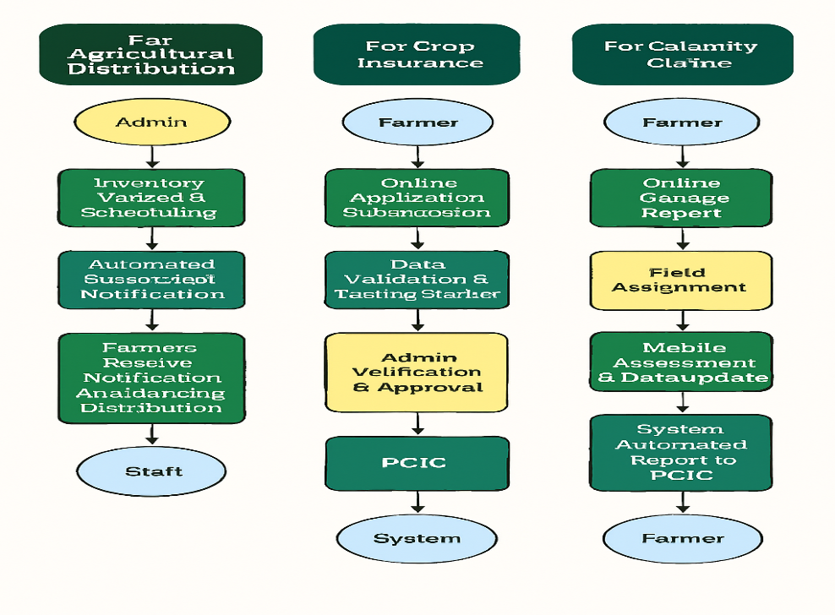
This enhanced workflow ensures minimal human error, faster processing,
improved transparency, equitable access, and enhanced farmer
satisfaction through digital transformation of agricultural service delivery.

B. Diagram of System Architecture
The DA AgriManage system follows a three-tier architecture composed of the Presentation Layer, Application Layer, and Database Layer, ensuring scalability, security, and efficient data management: 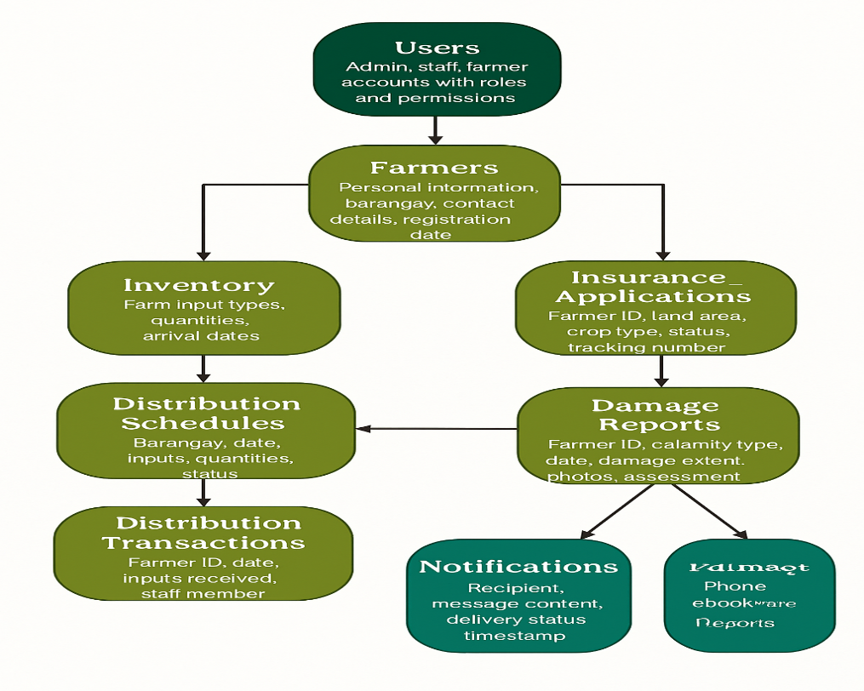

System Hosting and Infrastructure
The DA AgriManage system is hosted on a secure web server with the following infrastructure components:
- Web Server: Apache 2.4 or Nginx for handling HTTP/HTTPS requests and serving web pages
- SSL/TLS Certificates: HTTPS encryption for secure data transmission and protection of user credentials and sensitive information
- Firewall and Security Software: Server-level firewall rules, intrusion detection systems, and malware protection
- Cloud or Local Hosting: Option for cloud-based hosting (e.g., AWS, Google Cloud, local Philippine hosting providers) or on-premises server at the Municipal Hall depending on budget, technical capacity, and data sovereignty preferences
This three-tier architecture ensures system scalability, data integrity, security, and real-time synchronization among all user modules, supporting the long-term sustainability and effectiveness of the DA AgriManage platform.

C. Data Flow Diagram (DFD)
The Data Flow Diagram (Level 1) of the DA AgriManage system illustrates how data
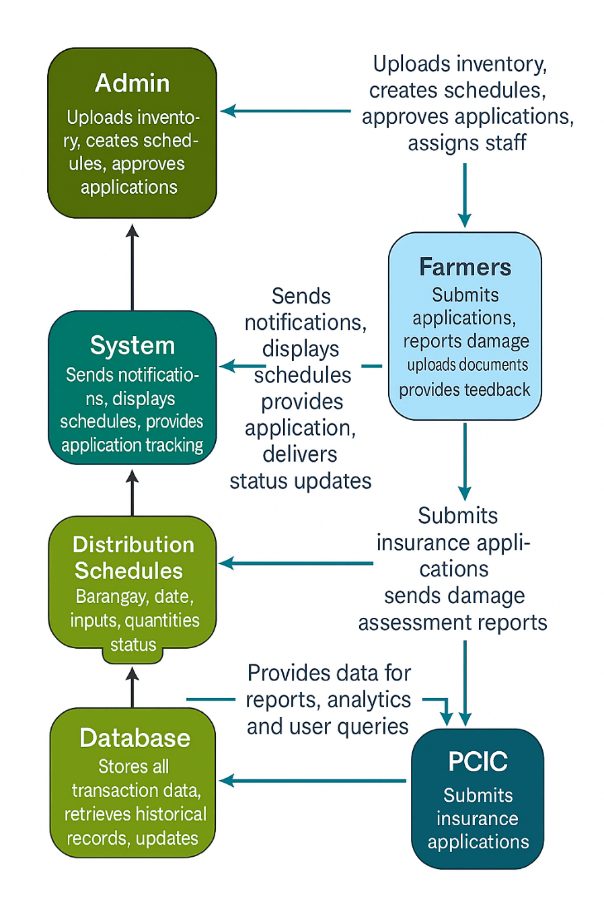
D. Hardware and Software Requirements
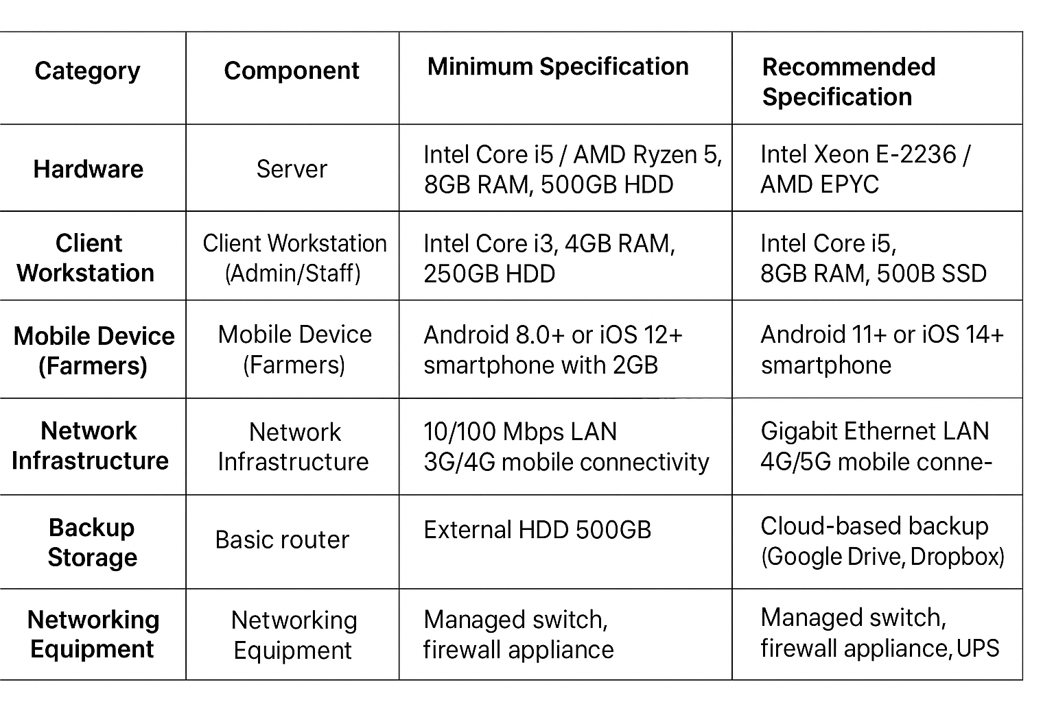

E. Actual Prototype / User Interface with Description
The prototype design of the DA AgriManage: Agricultural Distribution, Scheduling & Insurance System is built using WordPress 6.7 CMS integrated with PHP-based plugins, custom post types, MySQL database connections, and third-party API services for SMS and email notifications. The user interface is designed to be simple, intuitive, mobile-responsive, and culturally appropriate, ensuring compatibility with desktops, laptops, tablets, and smartphones commonly used in rural agricultural communities. The design emphasizes clear navigation, large buttons, readable fonts, and Filipino/Tagalog language support to accommodate users with varying levels of digital literacy.
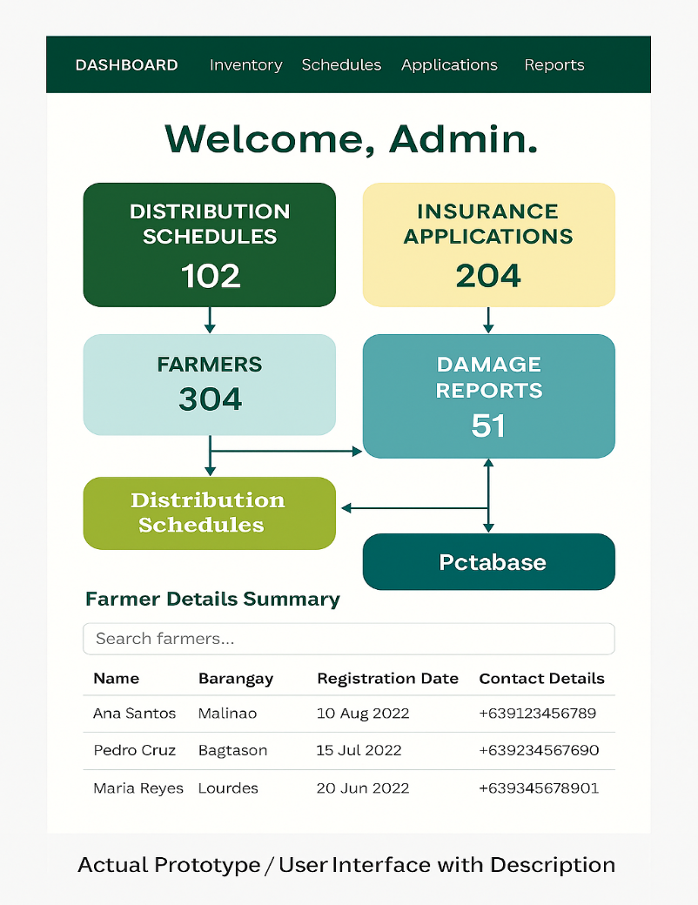

F.Installation and Deployment Procedure
1. Server Setup
Install Apache, PHP, and MySQL on the Municipal Agriculture Office's local server or cloud-based hosting service (LAMP Stack for Linux or WAMP Stack for Windows). Configure server security settings, enable firewall, and ensure stable internet connectivity.
2. CMS Installation
Download and install WordPress Version 6.7 from the official site (https://wordpress.org) and configure the database connection through wp-config.php. Set up administrative credentials and complete initial WordPress installation wizard.
3. Plugin Integration
Install required plugins for SMS gateway integration (e.g., WP SMS, Twilio SMS), email notification (e.g., WP Mail SMTP), form automation (e.g., WPForms Pro, Gravity Forms), security (e.g., Wordfence Security), and backup management (e.g., UpdraftPlus). Configure API credentials for SMS and email services.
4. Theme Customization
Apply a responsive WordPress theme that aligns with the Department of Agriculture and Municipality of Bulalacao's visual identity and branding. Customize colors, logos, typography, and navigation menus to ensure user-friendly interface for both admin and farmer users.
5. Database Configuration
Import the pre-defined SQL schema containing custom tables for farmers, inventory, distribution schedules, distribution transactions, insurance applications, damage reports, and notifications. Establish table relationships, indexes, and constraints for data integrity and performance optimization.
6. Testing and Debugging
Conduct comprehensive system testing including functional testing, security vulnerability scanning, performance and load testing, mobile responsiveness testing, SMS/email notification testing, and user acceptance testing (UAT) with Municipal Agriculture Office staff and selected farmers. Address all identified bugs and issues.
7. User Training
Train Municipal Agriculture Office administrators, field staff, and barangay agricultural workers on system operation, including distribution scheduling, farmer verification, damage assessment, report generation, and troubleshooting. Conduct community orientation sessions for farmers on portal registration, schedule viewing, insurance application, and damage reporting.
8. Deployment
Launch the system on the official domain (e.g., agromanage.bulalacao.gov.ph), configure SSL/TLS certificate for secure HTTPS connections, set up automated daily database backups to cloud storage or external drive, and establish help desk support channels. Conduct soft launch with pilot barangays before full municipal deployment.
This procedure ensures a stable, secure, and scalable deployment environment for the DA AgriManage system supporting the Municipality of Bulalacao's digital agricultural service operations.

REFERENCES
M. Mullenweg and WordPress Community, "WordPress 6.7 Release Notes," WordPress.org, 2024. [Online]. Available: https://wordpress.org/news/category/releases/. [Accessed: Oct. 11, 2025].
WordPress Foundation, "About WordPress - Open Source CMS," WordPress.org, 2024. [Online]. Available: https://wordpress.org/about/. [Accessed: Oct. 11, 2025].
Kinsta, "What is WordPress? A Complete Guide to the World's Most Popular CMS," Kinsta Blog, 2024. [Online]. Available: https://kinsta.com/knowledgebase/what-is-wordpress/. [Accessed: Oct. 11, 2025].
M. Rouse, "Content Management System (CMS) - Definition, Benefits, and Use Cases," TechTarget, 2024. [Online]. Available: https://www.techtarget.com/whatis/definition/content-management-system-CMS. [Accessed: Oct. 11, 2025].
Department of Agriculture, Republic of the Philippines, "Strategic Plan 2023-2028: Building a Resilient and Sustainable Agriculture Sector," Manila, Philippines, 2023.
Philippine Crop Insurance Corporation (PCIC), "Annual Report 2023: Protecting Filipino Farmers Against Agricultural Risks," Quezon City, Philippines, 2023.
Republic of the Philippines, "Local Government Code of 1991 (Republic Act No. 7160)," Official Gazette, Manila, Philippines, 1991.
Department of Agriculture, "Administrative Order No. 13, Series of 2020: Guidelines on the Implementation of Agricultural Extension Programs at the Local Government Level," Manila, Philippines, 2020.
National Economic and Development Authority (NEDA), "Philippine Development Plan 2023-2028: Transforming the Economy for a Prosperous, Inclusive, and Resilient Society," Pasig City, Philippines, 2023. [Online]. Available: https://pdp.neda.gov.ph. [Accessed: Oct. 11, 2025].
Philippine Statistics Authority (PSA), "Census of Agriculture and Fisheries 2022: Provincial Profile - Oriental Mindoro," Quezon City, Philippines, 2022.

