KidsExpress: Hire Me E-Bike, Driven by Women

A Project Portfolio in ITE322—Technopreneurship
Presented to the Faculty of College of Computer Studies
Mindoro State University

In Partial Fulfillment
of the Requirements for the Degree of
Bachelor of Science in Information Technology

By

Ballesteros, Maria Trixia Genesis
Moreno, Lei Kathleen Mae
Nale, Jonathan

Submitted to

HAROLD Y. BANGALISAN
ITE322—Technopreneurship

July 2021



TABLE OF CONTENTS

Page
- INTRODUCTION………………………………………………………. 4
- Why KidsExpress………………….……………………..……….….. 5
- NAME AND DESCRIPTION OF THE PRODUCT/SERVICE….…. 6
- BUSINESS MODEL CANVAS………………………………….……. 7
  - Value Proposition……………………………………………….…. 8
  - Customer Segments……………………………………….……… 8
  - Channel……………………………………………………….……. 8
  - Relationship……………………………………………………….. 8
  - Key Partners……………………………………………………….. 8
  - Cost…………………………………………………………………. 8
  - Key Resources…………………………………………….………. 8
    - Manpower requirements…………………………….…….……………. 8
    - Organization structure……………………………………….…………. 9
  - Key Activities……………………………………………….……… 9
  - Revenue Stream…………………………………………………... 9
- BROCHURE……………………………………………………………10
- MARKET VALIDATION……………………………….………………11
- FINANCIAL ASPECT…………………………………………………14
  - Projected Cost…………………………………………………….. 14
  - Financial Statement – Project Cash Flow……………………… 15
- PROTOTYPING………………………………………………………. 16
- PITCHING DIALOG……………………………………………………17
- CONCLUSION………………………………………………………… 18
- APPENDICES…………………….…………………………………... 19
- REFERENCES……………………………………………….……….. 24

- INTRODUCTION
Technopreneurship 101, a subject written and crafted by PhilDev, encourages science and engineering students to explore the entrepreneurial and R&D career paths. The class is based on PhilDev’s entrepreneurship modules which cover topics such as introduction to entrepreneurship, idea creation, feasibility and differentiation, market validation, and business planning and execution. Technopreneurship 101 is implemented by CHED across all 539 HEIs that offer engineering programs in the Philippines.

The course should be designed to explore the entrepreneurial mindset and culture utilizing a technology or engineering background. This should fit into goals of starting a company or being involved in an entrepreneurial or R&D effort in companies of all sizes and industries. Hence this should be applicable also in training future scientist and engineers to participate in Research and Development (R&D) activities.

We live in a world where the history of technological innovation and change (and its organizational equivalent) has been nothing short of remarkable. Indeed, it has long been recognized that these two forms of innovation sit at the core of capitalism and largely account for the successes of capitalist societies over other forms of economic and social relations (Harvey, 2010). Approaching this issue from entirely different ideological perspectives, Karl Marx in the nineteenth century and Joseph Schumpeter in the mid twentieth century both recognized technological and organizational innovation as a fundamental feature of the ‘creative-destructive’ tendencies of capitalism, although the extent to which the costs of the destructive aspect of this phenomenon are considered acceptable is a subject that divides opinion to this day.

Many of us would probably accept that technological and organizational innovation is often something of a double-edged sword: as new developments occur, they inevitably destabilize existing technological and organizational arrangements, and sometimes social and economic relations more broadly. One common result, for example – and one with which many of us are familiar – is what often seem to be endless cycles of organizational change, and the constant pursuit of technological ‘fixes’ that, if the claims made for them are to be believed, result in cheaper, more efficient, and productive work processes. Similarly, developments in information and communication technology (ICT) have transformed many aspects of the teaching and learning environment.

Joseph Schumpeter, a seminal thinker on innovation and economics, argued that capitalism is fundamentally a system of change; capitalism is incapable of remaining static (Schumpeter, 1934). He describes the ‘perennial gales’ of ‘creative destruction’ unleashed by innovation. In 1912 Schumpeter made an early characterization of innovation as any of five phenomena:
1. the introduction of a new good
2. the introduction of a new method of production
3. the opening of a new market
4. access to (‘conquest of’) new sources of raw materials or components
5. the introduction of new forms of organization.

The term ‘innovation’ has since been extensively debated and used in a wide range of ways. One study (Baregheh et al., 2009) identified 60 definitions of innovation in organizations alone. In part, at least, these differences are a result of the different concerns of different academic disciplines, the perspectives of different stakeholders in the innovation process and the different contexts in which innovation is considered. Whereas an economist may be concerned with the contribution of innovation to the performance of a national economy and so be interested in the generation of entirely new products or processes, a social scientist interested in how individuals decide whether to adopt an innovation may be concerned simply with whether a product is new to an individual. Managers may be concerned with how to prepare their organization to generate innovations that are new to their industries and markets or with how their organization might most effectively adopt or configure innovations generated elsewhere for use in their own structures and practices. What the term ‘innovation’ means, then, appears to depend on who is using the term and the context in which it is used. In the next section we look in a little more detail at some of these uses.
- WHY KidsExpress?

In the locality, there is no existing application or service as this project. This means that completing this project can offer a change in Victoria households. This service can scratch out the problem of numerous parents who find sending and fetching their children to and from school difficult and too time consuming.
This business is not expensive, meaning small savers in the locality can afford to hire registered e-bikers. Through the application, parents and/or guardians can select to multiple available e-bikers in the locality, they can select those who are closest to their home and also, they can select who have the highest rating among those closest to them.
As previously stated, the application can track e-bikers. It can display who the available e-bikers are. It can detect the closest e-biker to the searcher. It can display the ratings of the e-bikers. And it can display the fees based on the meter of the loading to destination.

- NAME AND DESCRIPTION OF THE PRODUCT/SERVICE

The team come up with the general idea of creating an online platform for hiring e-bikes as a safe service of sending and fetching of children to and from their schools through a numerous brainstorming and meeting of the whole team. After defining this specific purpose of the project, they construct the title, “Hire Me E-Bike, Driven by Women.” This first attempt is a bit long, so they focused on the specific subject of the project, the children. The first title became the business phase, and therefore came up with “KidsExpress: Hire Me E-bike, Driven by Women.”

Now that the title is polished, the team created their business model (figure at the following page). In the business model, the team enumerate the what’s and the how’s of the product/service.

As stated in the value proposition, the service will have women as the driver of the e-bikes. They fetch and send elementary children to and from school, as a result, they receive extra revenues. For the parents or guardians’ side, they hire these women drivers to send and fetch their children to and from school. Since this business will provide an application or a website that can track available e-bikes around their locality, they can save their money by hiring those e-bikers closer to their home. This is more convenient for the parents, and to add to this, they can see the ratings of the e-biker that they want to hire through the application. This will reflect how safe these e-bikers are.

- BUSINESS MODEL CANVAS
Customer Segments  • Parents or guardians around Victoria that are capable of accessing the internet  • Small savers  • Women drivers |  | Revenue Streams  • Registration Fee  • Commission on transaction  • App downloads
Relationship  • Do business  • Participation  • Collaborative  • Driver Rating | Channels  • Website  • FAQ  • App  • Digital
Value Propositions
• Women Drivers: fetch and send elementary children to and from school and take extra revenues
• Parents/ Guardians: hire drivers that can take and fetch their children to and from school for cheaper, closer and more convenient way
Cost Structure
• IT Systems to disseminate and make data useful to bolster management's decision-making processes.
• IT Operations and Maintenance such as enhanced visibility & optimization
• Insurance for drivers and children safety
• Marketing
• Staffs including those that develop the app as well as the drivers
Key Activities  • Service deployment around Victoria  • Insurance Agreements  • Platform Maintenance  • Business Networking  • Drivers’ Mental & Physical Health | Key Resources  • Network of e-bike hiring platform  • Insurance coverage (drivers and children safety)
Key Partners
• Victoria Negosyo Center
• Financial Institutions (Cash on Site, GCash, Palawan Express)
• Vehicle Licensing Agents
• IT Vendors
In every business, the business model canvas is a key aspect that needs to be polished before jumping into the actual deployment or other phases of building or running a business. In this current venture, the team specified the parts of the business model canvas according to their proposed business:
  - Value Proposition
The team came up with the idea of only having women drivers as the ones who fetch and send elementary children to and from school because based on the online survey that they conducted, most parents see and trust women than men in the aspect of driving. The women drivers can take extra revenues out of this business.
While the parents and/or guardians hire drivers that can take and fetch their children to and from school for cheaper, closer and more convenient way from the application.
The app can display e-bikers ratings, location and fares. With these available information, hirers can choose the right e-bikers for them.
  - Customer Segments
Based on the survey conducted by the team, the target customers will be parents or guardians around Victoria that are capable of accessing the internet, small savers and of course, our women drivers.
  - Channel
The channel is where the transaction happens. In this business the following are the identified channels for transaction:
- Website – in here, details and description of the business and the transaction process will be presented;
- FAQ – frequently asked questions will be included in the website, viewers can also send emails to the team in this part;
- Application – this is where available e-bikers will appear, or the actual platform of the business; users, including parents and/or guardians and e-bikers, must download this to engage with hirers and e-bikers;
- Digital – via smartphone.
  - Relationship
This defines the engagement of the users or customers of this business, the relationship might be:
      - By doing business;
      - Their active participation, including rating e-bikers;
      - By collaboration, such as spreading good words about the app or advertising it to other parents;
      - Through driver rating, e-bikers will feel more attached and involved with the business and the users.
  - Key Partners
The key partners of this business are chosen for they have direct association with the business. They can also be the ones to fund and implement the system, and might also be the one who advertise the business. They are the following:
      - Victoria Negosyo Center
      - Financial Institutions (Cash on Site, GCash, Palawan Express)
      - Vehicle Licensing Agents
      - IT Vendors
  - Cost
This is where financial debates exists. They include:
      - IT Systems to disseminate and make data useful to bolster management's decision-making processes.
      - IT Operations and Maintenance such as enhanced visibility & optimization
      - Insurance for drivers and children safety
      - Marketing
      - Staffs including those that develop the app as well as the drivers
Stated above are the expected expenses to be.
  - Key Resources
    - Manpower requirements
KidsExpress Team
Person | Requirements
Marketing Manager /  Project Manager | Handles all the aspects related to promoting and selling the product.  Proven experience developing marketing plans and campaigns.  Strong project management, multitasking, and decision-making skills.
Supervisor /  Sales Talker | Excellent communication and interpersonal skills.  Good knowledge of MS Office.  The second in command and will oversee in the absence of the owner, general manager or the president.
Operation Manager /  Hacker | Knowledge of organizational effectiveness and operations management.  Experience budgeting and forecasting.  Familiarity with business and financial principles.  He has the overall responsibility for the financial success of the business. the operations manager handles external relations with lenders, community leaders, and vendors.
    - Organization structure

As stated in the previous table, there are three staffs behind this business venture: (1) Marketing Manager / Project Manager, (2) Supervisor / Sales Talker, and (3) Operation Manager / Hacker.
  - Key Activities
These are the most important actions your company must perform to operate successfully. The following are the key activities in this business:
- Service deployment around Victoria
- Insurance Agreements
- Platform Maintenance
- Business Networking
- Drivers’ Mental & Physical Health
  - Revenue Stream
This is the component in the BMC that encompasses the money that the company generates with each previously defined Customer Segment. But that does not mean the “profit” earned, but the revenue flow involved. The following are the revenue stream of this business:
- Registration Fee
- Commission on transaction
- App downloads

- BROCHURE
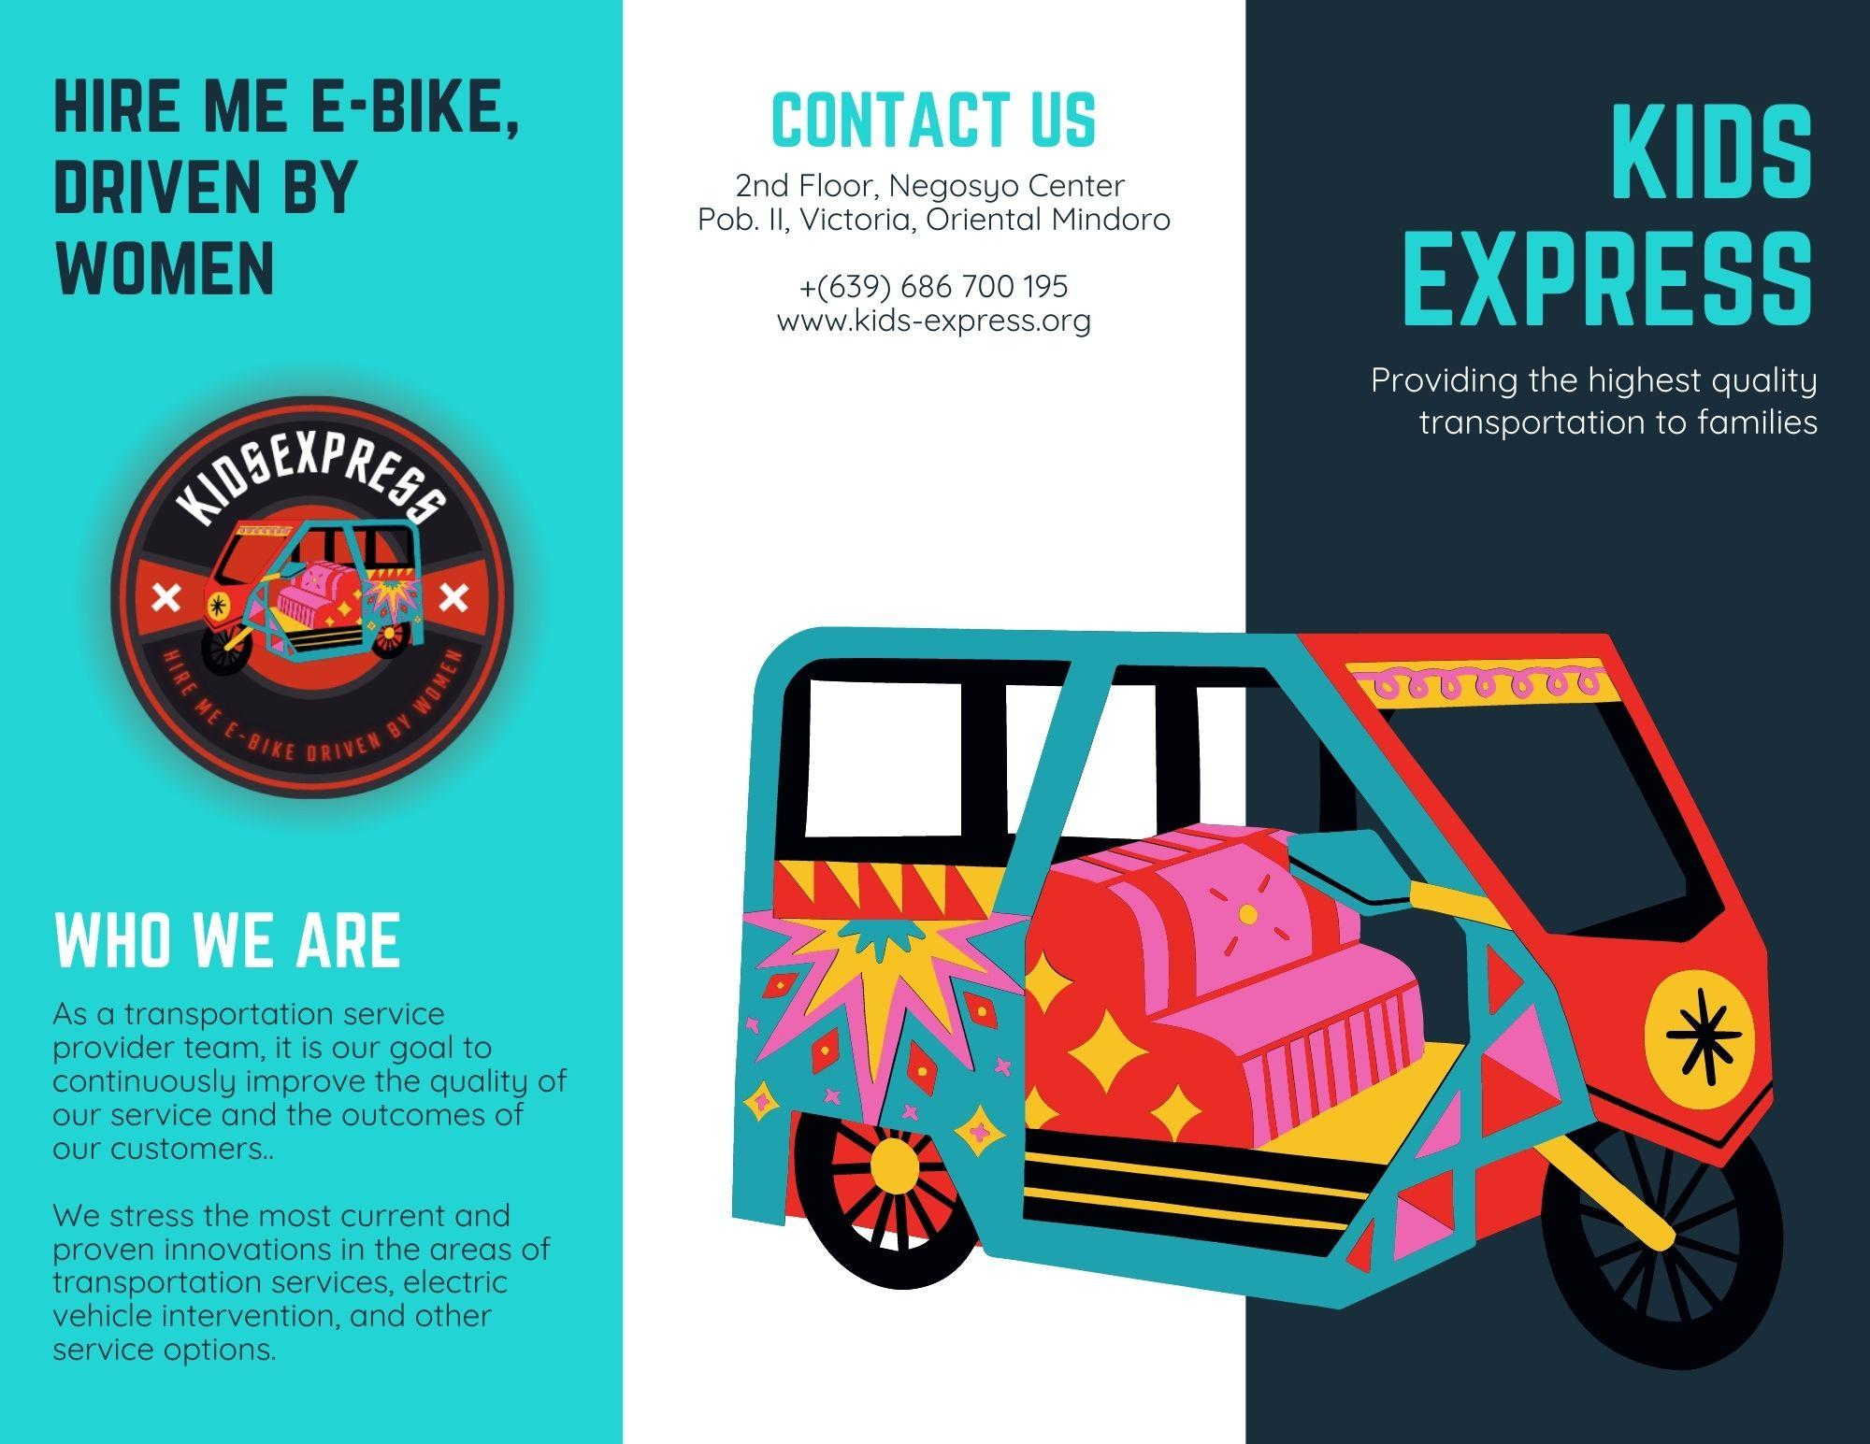
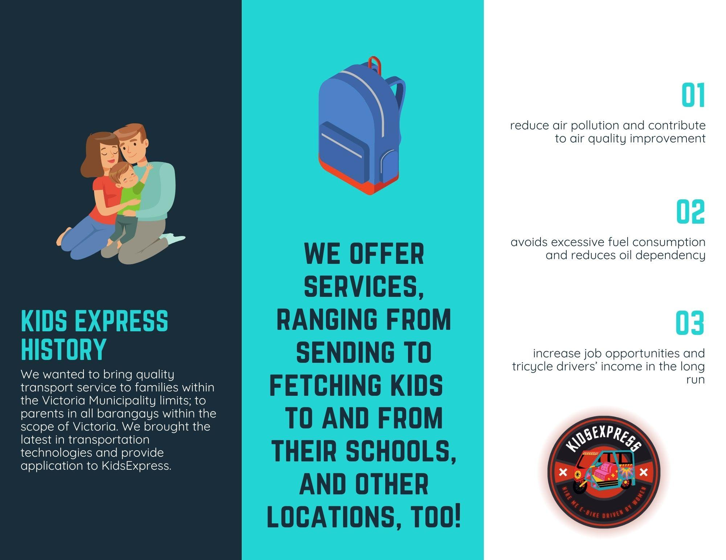
- MARKET VALIDATION
The following are the structured questionnaires used by the team for online survey:
1. What are the things you are having problems with, before your child leaves for school? (Ano-ano ang mga bagay na pinoproblema mo bago umalis ang iyong anak papunta sa paaralan?)

2. What are the things you neglect just to deliver your children to school? (Ano-ano ang mga gawaing bahay na napapabayaan mo para lang maihatid ang iyong mga anak sa paaralan?)

3. What ways can you think of to get your child to school safely? (Ano-ano ang mga paraan na naiisip mo para maihatid ng ligtas ang iyong anak sa paaralan?)

4. How can it be possible to deliver your child safely? (Sa paanong posibleng paraan kaya maihahatid ng ligtas ang iyong anak?)

5. Who are the people you trust who can deliver your child to school? (Sino-sino ang mga taong pinagkakatiwalaan mo na maaaring maghatid sa iyong anak sa paaralan?)

The following are the analyzed answers from the responses of 20 parents in the survey:
Question 1.
- Security – ‘Ang kanyang siguridad pag siya ay pumapasok sa skwelahan’
- Money – ‘Perang ipapabaon’
- Food – ‘Pagkain sa umaga, mahirap pakainin ang bata sa umaga at paliguan’
- Transportation – ‘Paano ihhatid at susunduin ( ang apo ko)’
Question 2.
- Household chores – ‘Lahat ng gawain bahay, pag huhugas ng pinagkainan, pag lalaba, pag lilinis ng bahay’
- Cooking or preparing meals – ‘Cleaning the house, cooking lunch for myself and relaxation time’
Question 3.
- Send them myself – ‘Ako nalang maghahatid’
- Ask someone I trust to send them – ‘Ipahatid sa pinagkakatiwalaang tao’
- Send them by my spouse – ‘ipahatid sa aking asawa’
Question 4.
- Hire a service vehicle – ‘Kumukuha kami nang mag service sa anak namin na mapag kakatiwalaan namin’
- Send them myself – ‘By sending them to school personally or letting them send by others that you trust’
- Drive slowly – ‘Magdrive lang ng mabagal’
Question 5.
- Family member – ‘Sa lolo at lola niya sa mga tito tita ligtas sya maihahatid sa school’
Summary

The survey was conducted or accepted responses within 12 business days. The platform used for distributing forms is Google Forms. The responses showed that (1) parents set aside important chores to send and fetch their children to and from home, (2) parents trust few people in sending and fetching their children to and from school, and (3) parents are willing to hire e-bikes that are driven by women.

- FINANCIAL ASPECT
  - Projected Cost
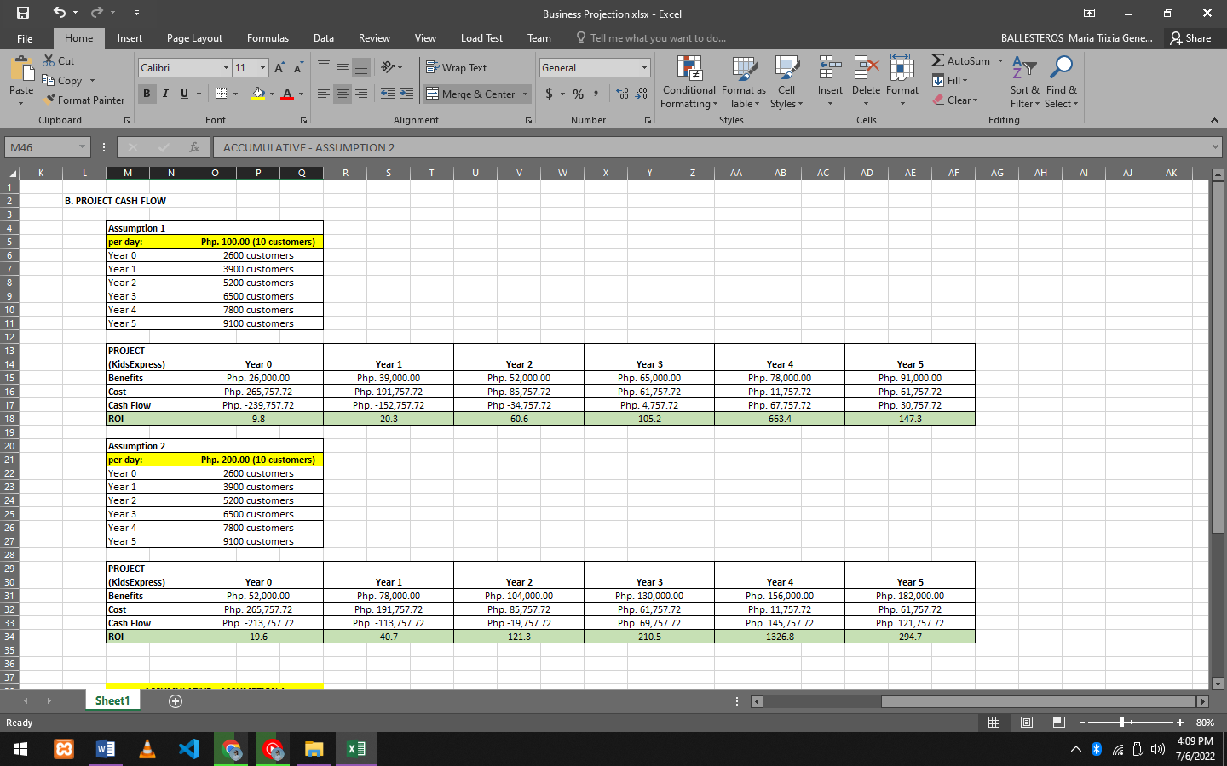
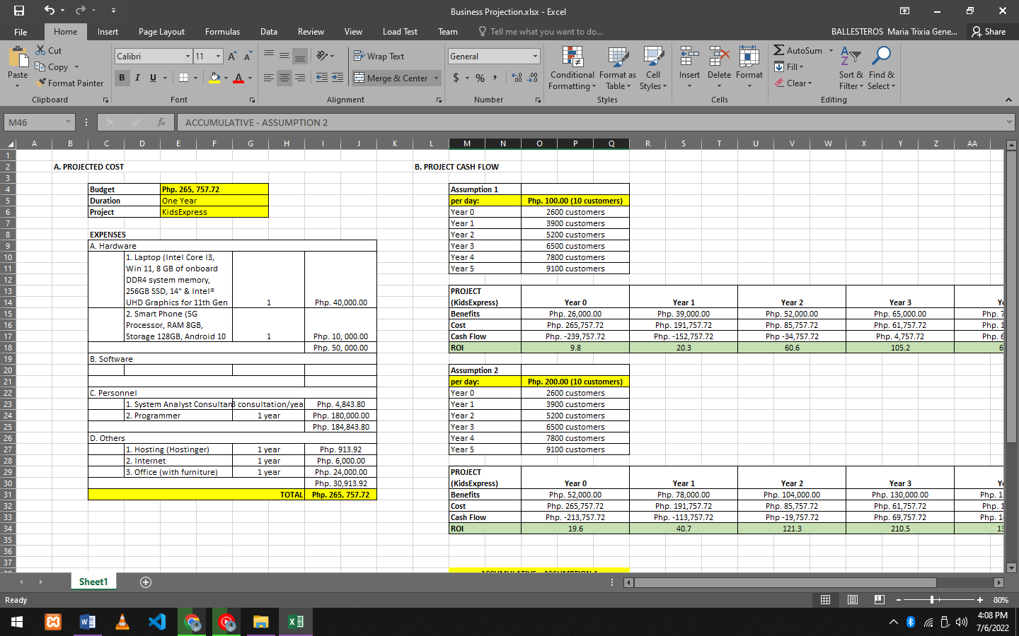

  - Financial Statement – Project Cash Flow
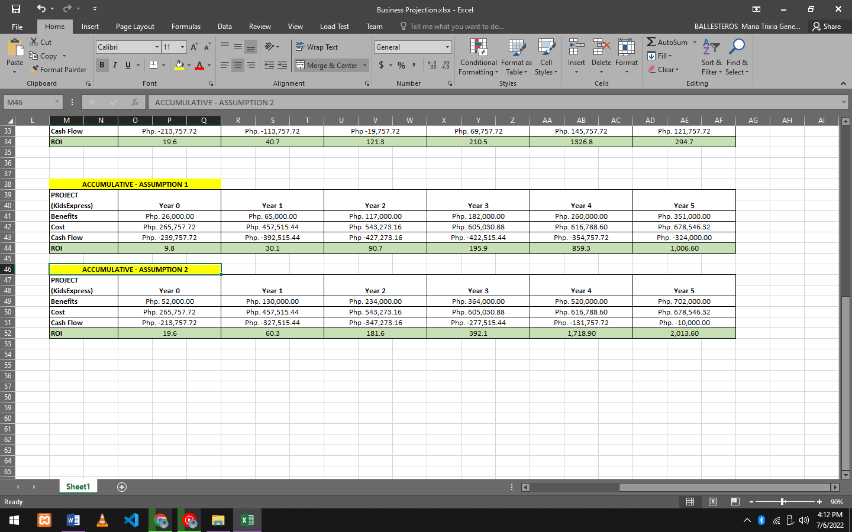

- PROTOTYPING

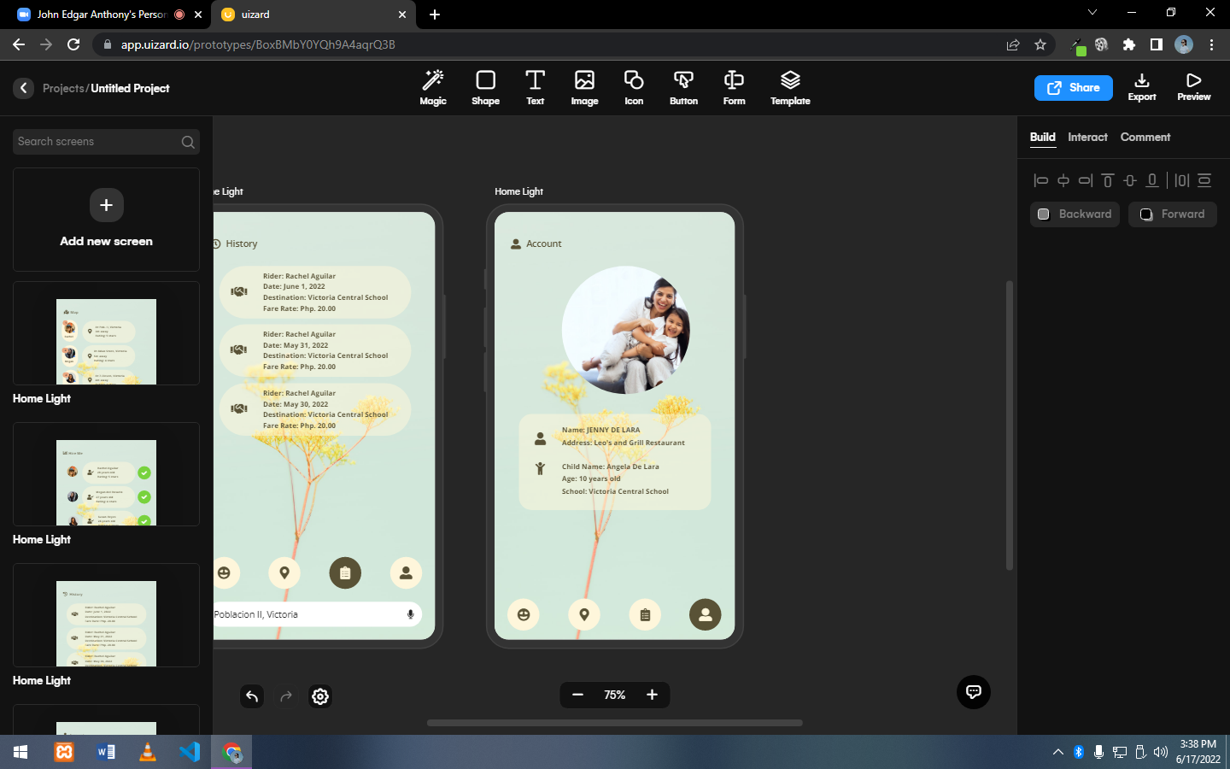

Account Interface

This interface displays the user image and its data, including the user full name and their current address. This interface also displays the child’s full name and his/her school.

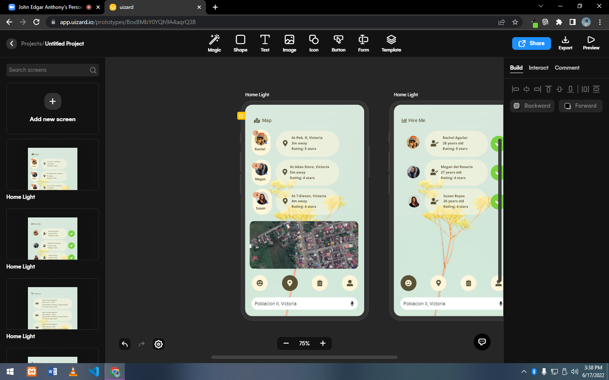

Map Interface

The user can search where the general destination is. This interface will show available e-bike riders and their current location. The information for each available riders include how far they are to you as a user and each rider’s ratings.

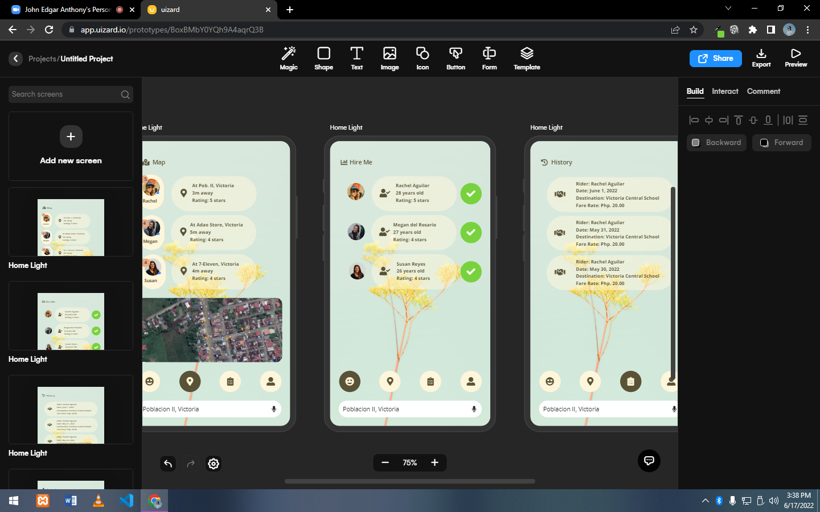

Hire Me Interface

This interface displays the available riders and their data which includes the rider’s image, full name, age and rating. The check icon means that the user choose the rider or hire the rider.

History Interface

This interface shows the user’s hiring history. The data displayed in this interface are the rider full name, the date the transaction happened, the destination and the fare of the transaction.
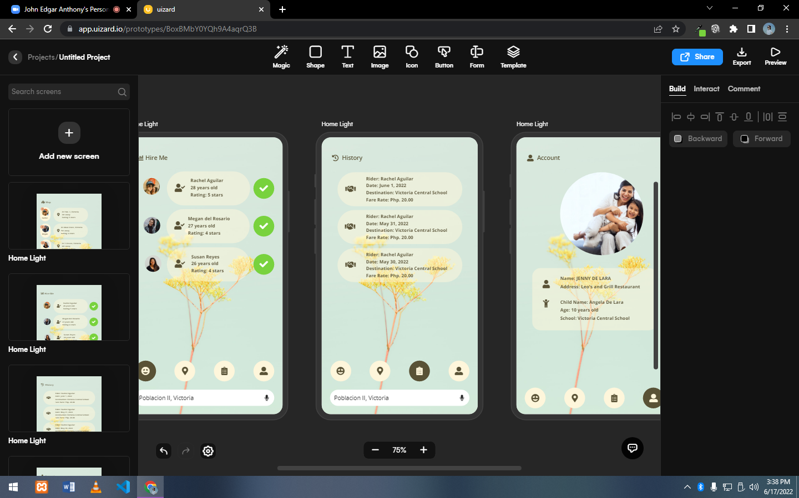
- PITCHING DIALOG

These days schools have implemented a scheduled entering and exiting school premises all because of the COVID-19 virus. Parents are more challenged on how they will send and fetch their children to and from their schools.
Our solution, create an application that can hire e-trike drivers to send and fetch children to and from schools. And right now, we are on the planning stage of opening a company called KidsExpress, which is an e-trike hiring app for parents that wants 100% security in delivering their child to and from school.
The company aims to hire women drivers to send and fetch children to and from school and take extra revenues, and offer parents a cheaper, closer and more convenient and safer way for their child’s transportation.
What do you think? Shall I send you a draft?

- CONCLUSION
We are confident that we can achieve our conservative financial projections, generating a gross revenue in excess of Php. 78,000.00 in year one after the opening of the business. In addition, our management has carefully considered its market, potential customer base, and its ability to grow its sales average to capture market share in our area of business. With our projected numbers and the total market share and revenue in the transportation industry, we confidently project over a Php. 156,000.00 entity value in year four.
We firmly believe that our business has the potential to become a highly regarded resource in local and regional markets. Due to the company’s aggressive marketing strategy as well as the careful development of company products and services, the establishment of the company as a regarded entity in our industry is now within grasp.
As owners, the Managers’ commitment is to take personal accountability for all financial debt. The Company has taken the necessary precautions to ensure the business is fully capitalized and has addressed all financial shortfalls to ensure a successful business expansion. Providing that the company is able to continue operations and fulfill requirements during our first year of operation, KidsExpress will be able to secure repayment of the investment and achieve operational success for many years to come.
In all the above we intend to communicate our ability to serve our community or customers with products and services that will satisfy & exceed our customers’ needs and wants. All the above promotional tools that we have mentioned throughout the plan shall be well integrated and utilized in tandem so as to maximize their effect.
Entrepreneurs have a tendency to paint any business plan with a very optimistic brush, highlighting strengths and camouflaging the risks. The Company Managers, as business owners, have a vested stake and financial commitment in the success of this business. The Company has taken all precautions to validate the Company business and financial models, focusing on realistic projections. If you have any questions, please contact the Founders directly.
- APPENDICES
CURRICULUM VITAE

MARIA TRIXIA GENESIS A. BALLESTEROS

Permanent Residence:
Macatoc, Victoria, Oriental Mindoro
09686700195
mtgballesteros2001@gmail.com

Personal Profile:

Age: 20 Mother: Flordeliza A. Ballesteros
Birthdate: February 5, 2001 Occupation: Business woman
Birth Place: Macatoc, Victoria, Or. Mindoro Father: Geronimo S. Ballesteros
Gender: Female Occupation: Teacher

Education:

2013-2014: Graduated at Macatoc Elementary School
2017-2018: Graduated at Macatoc National High School
2018-2019: Graduated at Good Shepherd Academy
2020-Present: Studying at Mindoro State University - Main Campus

Internships:

2018: NIA, Calapan City
- Assisted on auditing financial reports.
- Reviewed financial statements.
- Organized irrigation files in accordance with specific department standards.
- Completed training program including business etiquette, ethics, organization skills, accounting methods and, computer technology.

LEI KATHLEEN MAE B. MORENO

Permanent Residence:
Babangonan, Victoria, Oriental Mindoro
0977709281
leikathleenmaemoreno0@gmail.com

Personal Profile:

Age: 21 Mother: Leah B. Moreno
Birthdate: January 26, 2001 Occupation: Sales Clerk
Birth Place: Babangonan, Victoria, Or. Mindoro Father: Romeo J. Moreno
Gender: Female Occupation: Mechanic

Education:

2012-2013: Graduated at Victoria Central School
2016-2017: Graduated at Good Shepherd Academy
2018-2019: Graduated at Good Shepherd Academy
2020-Present: Studying at Mindoro State University – Main Campus

Internships:

2018: Department of Agriculture RFO IV – Mimaropa Research Division, Barcenaga, Naujan
- Encoding of data such involving Rice Crop Manager Project.
- Measuring weights and moisture content of rice crop cuts.
- Determining percent germination of seeds under the Corn Project.
- Completed a 10-day (80 hours) work immersion with the excellent of a quality desired for future public servants and leaders.

JONATHAN G. NALE

Permanent Residence:
Malabo, Victoria, Oriental Mindoro
09774530766
nalejonathan108@gmail.com

Personal Profile:

Age: 22 Mother: Joyce Nale
Birthdate: January 23, 2001 Occupation: None
Birth Place: , St.Cruz Laguna Father: Sixto Nale
Gender: Male Occupation: None

Education:

2012-2013: Graduated at Hemogenes Bautista Memorial Elementary School
2016-2017: Graduated at Aurelio Arago National High School
2018-2019: Graduated at Aurelio Arago National High School
2020-Present: Studying at Mindoro State University – Main Campus

Internships:

2018: Johndor Welding Shop – Babangonan
• Assisting to make a high quality sidecar..
• Completed a 10-day (80 hours) work immersion with the excellent of a quality desired.

- REFERENCES (APA Format)

Journals

Baregheh, A., Rowley, J. and Sambrook, S. (2009) ‘Towards a multidisciplinary definition of innovation’, Management Decision, vol. 47, no. 8, pp. 1323–39.

Harvey, D. (2010) The Enigma of Capital, London, Profile Books.

Schumpeter, J. (1934 [1912]) The Theory of Economic Development: An Inquiry into Profits, Capital, Credit, Interest, and the Business Cycle, Cambridge, MA, Harvard University Press.

Internet Resources

Technology, innovation and management: View as single page. (n.d.). Distance Learning Courses and Adult Education - The Open University. https://www.open.edu/openlearn/money-business/technology-innovation-and-management/content-section-0/?printable=1

Technopreneurship 101. (2021, March 16). PhilDev. https://www.phildev.org/technoprenuership-101/

