Document Category: | A-DOC | Version | 03 | Effective date | {effective_date}5
TOMY Review |  | Date |  | Page | 1 OF X
供应商名称（{supplier_name} {supplier_code} ），在此郑重承诺，针对CMD红灯和蓝灯标示的化学物质，我司已做尽职调查，具体如下.We declare that we make investigation to handle the chemical substance warned by red light and blue light in CMD:
No  序号 | Substance name  化学物质名称  (填英文) | CAS No.  唯一的化学  物质编号 | Category /Origin  法规类别（如SVHC, CHCC...） | Concentration % in final product  在产品中的浓度百分比 % | Concentration % in HM Material  在均质材料中的浓度百分比 % | Affected material name?  受影响的材料名称 | Intentionally use or not?  是否有意使用?
{row_no} | {substance_name} | {cas_no} | {category} | {concentration_product} | {concentration_hm} | {material_name} | {intentional_use}

Note: Intentionally use—The material is used directly in process and becomes a part of product, like ABS,PP,Paint etc.
我司保证，针对上述物料，经我司评估为低风险后，才用于TOMY产品生产，以确保符合国际市场和TOMY化学安全管控要求。同时我司对相关技术文档保存10年，以备查验。如有成分变更，我司将第一时间通知TOMY。
We declare that we won’t use the mentioned material in the product of TOMY until we evaluate these materials is low risk to comply with chemical safety requirement of TOMY and global market. The supportive documents will be retained for 10yrs for checking any time. If any change, we will inform TOMY at the first time.
Declared By： 骆逢春 Job Tittle： (Manager level or above)
公司承诺人骆逢春 工作职位
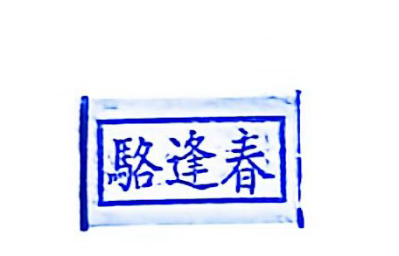
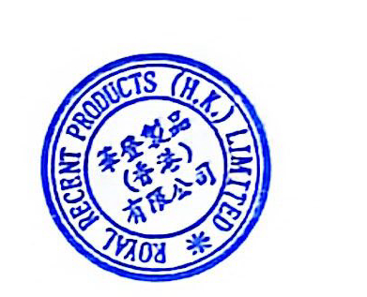
Signed & Company chop： Signed Date：
签名&盖章 签署时间

