CodeX

**<January 6, 2023>**

**<Group 7>**

**<BSIT 301>**

**<Lyceum of the Philippines - Cavite>**

CodeX

January 6, .2023

**─**

Charles Joshua Tacda | Hanna Panganiban | Mark Anthony Luna | Myka Factolerin | Raniel Del Rosario

Group 7

BSIT 301

**<Charles Joshua Tacda / Hanna Panganiban /**

**Mark Anthony Luna / Myka Factolerin /**

**Raniel Del Rosario>**

Lyceum of the Philippines - Cavite

# 

# Table of Contents

**App Name .………………………………………………………………...** Page 1

**App Icon ………………………………………………………………..……** Page 1-2

**Android Version …………………………………………………….....** Page 2

**Android Variant ………………………………………………………...** Page 3

**App Description ……………………………………………………..….** Page 3-4

**Motivation ………………………………………………………………....** Page 4

**Target Audience ………………………………………………………..** Page 4-5

**Features ……………………………………………………………………...** Page 5-7

**Navigation ………………………………………………………………….** Page 7-10

**UI & Graphics ……………………………………………………………..** Page 11-37

# App Name



Our team chose the name "CodeX" for our app because it reflects the central role that coding plays in our app. The term "CodeX" is derived from the word "codex," which refers to an ancient book that was bound together by text and codes. By naming our app after this concept, we wanted to emphasize the idea that our app is like an online book that provides a wealth of information and resources to support and promote anyone with an interest in advancing their programming skills and knowledge. We also incorporate the word "code," which is a central element of our app. As a programming assistant app, our main focus is on helping users learn, understand, and work with different types of code. By including the word "code" in our app name, we wanted to make it clear to users that our app is specifically designed to support and enhance their coding skills and knowledge. We also felt that the name "CodeX" was easy to remember and would clearly convey to users what our app is all about.

# App Icon



The logo for "CodeX" is a visual representation of the app's focus on programming and learning. The logo features a booklet with a code icon in the middle, which symbolizes the idea that our app is like an online book that is bound together by text and codes. The book represents the wealth of information and resources that are available in our app, while the code icon reflects the central role that coding plays in our app. By combining these two elements in our logo, we wanted to create a visual image that captures the essence of our app and its mission. The logo is intended to be a simple yet powerful symbol of our commitment to helping users learn and improve their programming skills, and to providing a wealth of information and resources to support them in their journey." We designed the logo using Figma, and carefully selected an attractive color scheme and an icon that would be visually appealing and connected to the theme of the app.

# Android Version



We decided to target Android 10 for our app because it offers a good balance between the latest features and APIs and the resources required to support them. Android 10 has a relatively high market share among Android users, making it a good choice for reaching a large audience. It also includes a number of useful features and APIs that can enhance the user experience of our app, such as the dark theme and gesture navigation. The dark theme allows users to switch from the standard white theme to a darker theme, which can be easier on the eyes in certain lighting conditions. The gesture navigation eliminates the need for the standard home, back, and recent buttons in favor of swipe and pull motions, which can make it easier and more intuitive to navigate the app.

While we did consider Android 11, we ultimately chose to stick with 10 since 11 has multiple features that will not benefit our app, especially those that are targeted with multiple variants like auto and TV. By targeting Android 10, we can ensure that our app is optimized to take advantage of these features and provide a high-quality user experience on devices running this version of Android.

# Android Variant



We chose to target phones and tablets for our android programming assistant app because these devices offer the best combination of functionality and accessibility for our users. While Android phones and tablets are popular and functional, they are also able to run our app effectively because they have the necessary hardware and software capabilities. In contrast, Android Auto and Android TV are unable to run our app because they do not have a camera, which is a necessary component for some of the features and functionality in our app. By focusing on phones and tablets, we can ensure that our app is optimized for the best possible user experience on these devices.

# App Description

CodeX, an android programming assistant app, is a safe space for learning, training, and testing different programming languages. It provides crash courses with video guides for users to learn. An A.I. assistance is also provided for beginners to interact with, as it can help the users with programming tasks and projects. There are fun activities such as short quizzes and games to test their knowledge and help them improve their programming skills. This mobile application enables users to check their errors by scanning snippets of codes with our scanner. And it creates a healthy environment of learning with various users by communicating within the forum.

# Motivation

The goal of CodeX is to provide a fun, interactive, and supportive learning environment for programmers at all levels, from beginners to aspiring professionals. We aim to help users improve their programming skills through a variety of resources and tools, such as lesson courses, video guides, quizzes, games, a forum, and a code scanner.

At CodeX, we believe that learning should be enjoyable and engaging, and our app is designed to provide a positive and rewarding experience for users. We also envision CodeX as a community of skilled programmers who can share their knowledge and experience with others, and inspire others to become skilled programmers themselves.

# Target Audience

1. **Students**

* Students that are enrolled in programming classes can benefit greatly from this mobile app. In addition to resources found in classrooms, there are a ton of lectures they can read and watch here. There are entertaining and interesting things to do here as well. In order to be a useful program for students, many functions are provided to help them solve their problems and also to be more knowledgeable in their field.

1. **Teachers/Professors**

* The intended audience for this mobile application may also include instructors of programming lessons. Teachers can benefit from this application as well because it offers a lot of lectures and is divided into different categories depending on the audience's desired skill level, from beginner to advanced. This program can help teachers come up with ideas for lessons, quiz or activities.

1. **Other people who are into this kind of field**

* There are many that pursue computer programming as a hobby. Those who are interested in this field might utilize this application as their guide. By taking the desired lectures on their own, individuals will benefit from this. All users have access to this mobile application, and anyone can use it.

# Features

1. **Login and Sign-up System**

* The login and sign-up system enables users to create an account and log in to the app, which is necessary to access certain features and resources. This system helps to personalize the user experience and ensure that users have access to their saved progress and preferences.

1. **Programming courses**

* The programming courses feature provides a range of crash courses and video guides that teach users different programming languages and concepts. These courses are designed to be self-paced and interactive and can help users learn at their own pace and according to their own interests.
* The app will automatically sort all courses based on the programming language that the user wants to focus on.
* All courses are downloadable and can be saved for the users to access offline.
* The app monitors all users’ progress on each lesson inside a course.
* Lessons provide users with interactive visuals like images and videos.
* It also provides example codes for the user and an explanation of each part of the code in detail.
* Quizzes are provided at the end of each lesson.

1. **Syntax Tutorial**

* The syntax tutorial feature provides a reference guide to the syntax and structure of different programming languages, which can be useful for users who are learning or reviewing specific language concepts.
* A video tutorial is provided, making it easier for the user to understand and grasp each concept.
* Interactive mini-games can be played by the user to make learning concepts more fun and engaging.

1. **Forum**

* The forum feature enables users to communicate and connect with other users. This can create a supportive and collaborative learning environment where users can ask questions, share their knowledge and experiences, and get feedback from others.
* Users can interact with other people by liking, and commenting on their posts.
* Users can tag users, and insert codes and images into their posts.
* Users can see other user profiles by clicking their name or profile picture. They can then follow that person to always be notified of their post and progress.

1. **"Ask AI"**

* The "Ask AI" feature is a tool that allows users to ask questions and get personalized answers and guidance from an artificial intelligence system. This can be useful for users who want to get quick answers to specific questions or who want to explore different programming concepts in more detail.
* Users can insert codes into their questions.

1. **Code Editor**

* The code editor feature is a tool for writing and editing code, which can be useful for users who are actively working on programming projects. The code editor may include features such as syntax highlighting, auto-complete, and error checking to help users write and debug code more effectively.
* The editor can create multiple programming language files such as Java, C#, Python, etc.
* Users can use the terminal to allow users to execute commands and interact with the operating system and other software tools.
* Files can be imported and exported either through the phone’s storage or through GitHub.

1. **Personal Profile**

* The personal profile feature enables users to create a personalized profile with their own information, such as their name, picture, and achievements. This can help users connect with each other and share their progress with the community.
* Users can set their personal settings like dark mode, notification, and language.
* Users have the ability to reset all their progress in the current phone being used.

1. **Code Scanner**

* The code scanner feature enables users to scan snippets of code and convert pictures to text. This can help users store their codes on their phones efficiently and conveniently as possible.
* Users can copy the code, share it with friends, fix code errors, and convert the code to the desired programming language of the user.

# Navigation

**Whole Navigation Hierarchy**

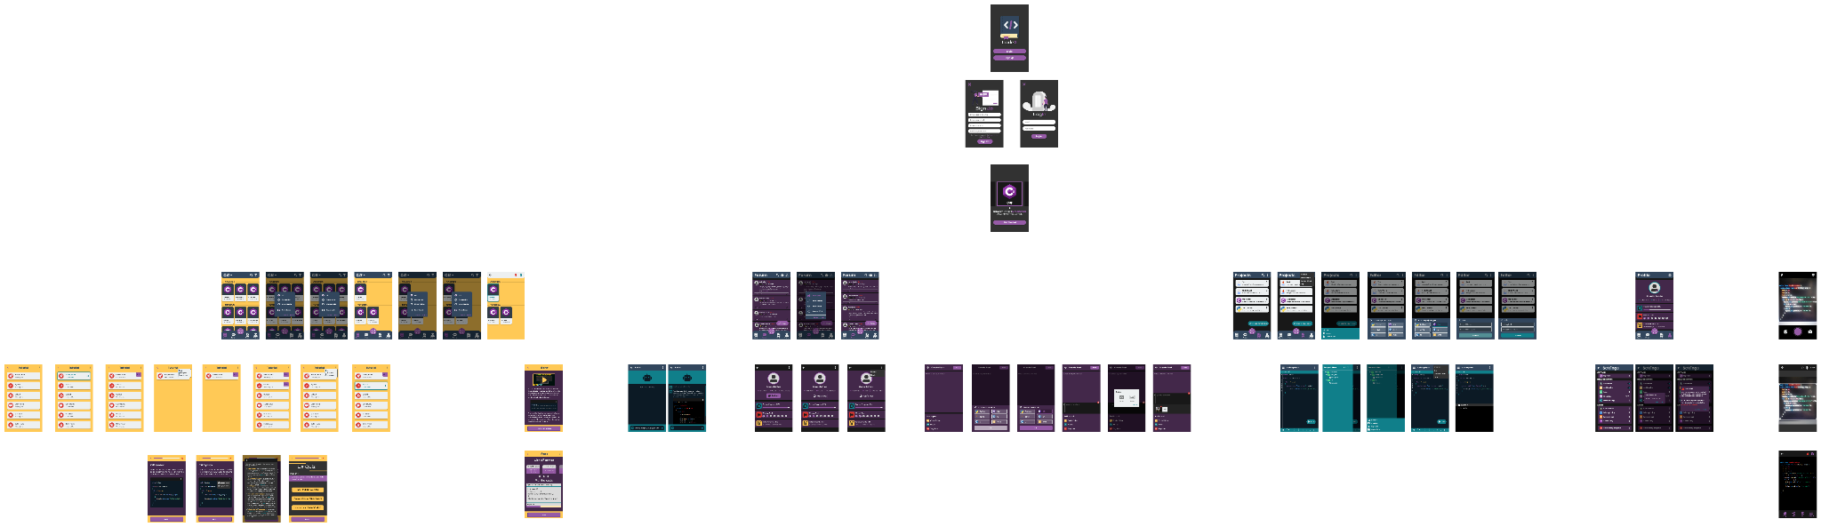

1. **Login, Sign-up, and Get Started**

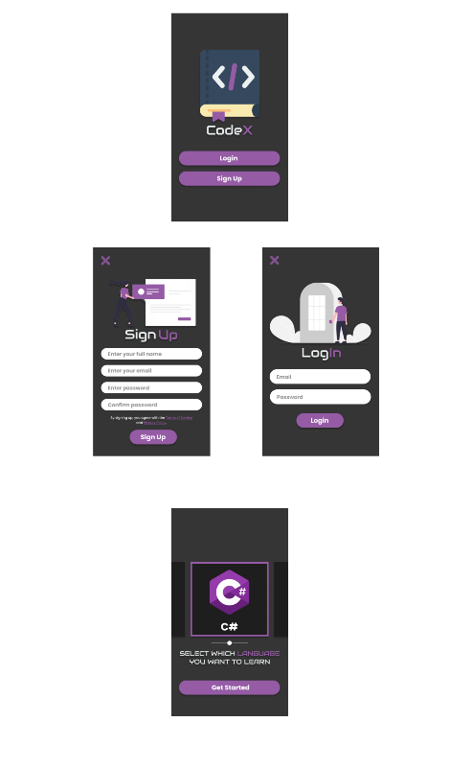

1. **Learn View**

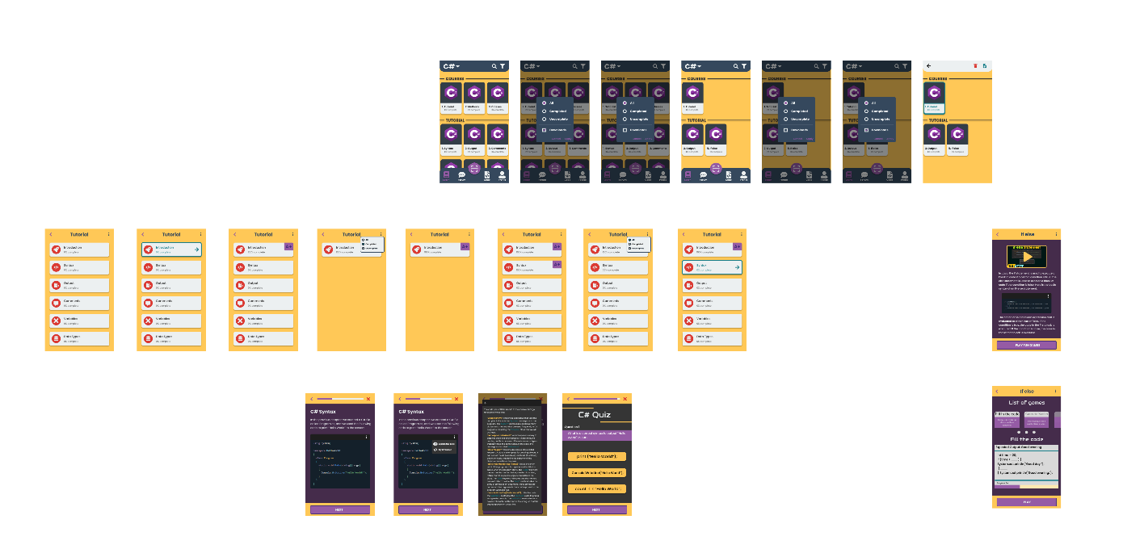

1. **Forum View**

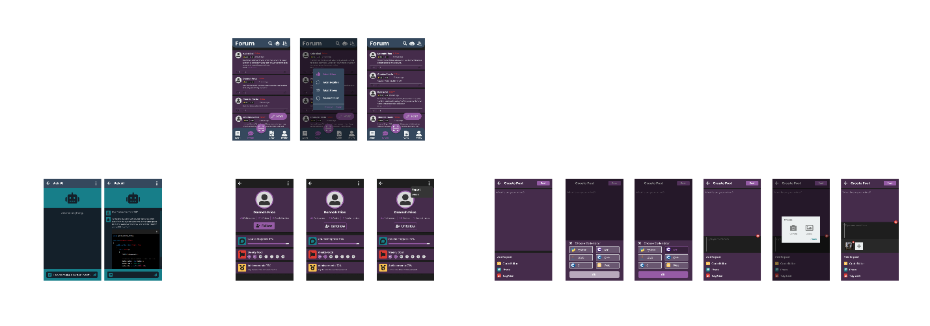

1. **Code View**

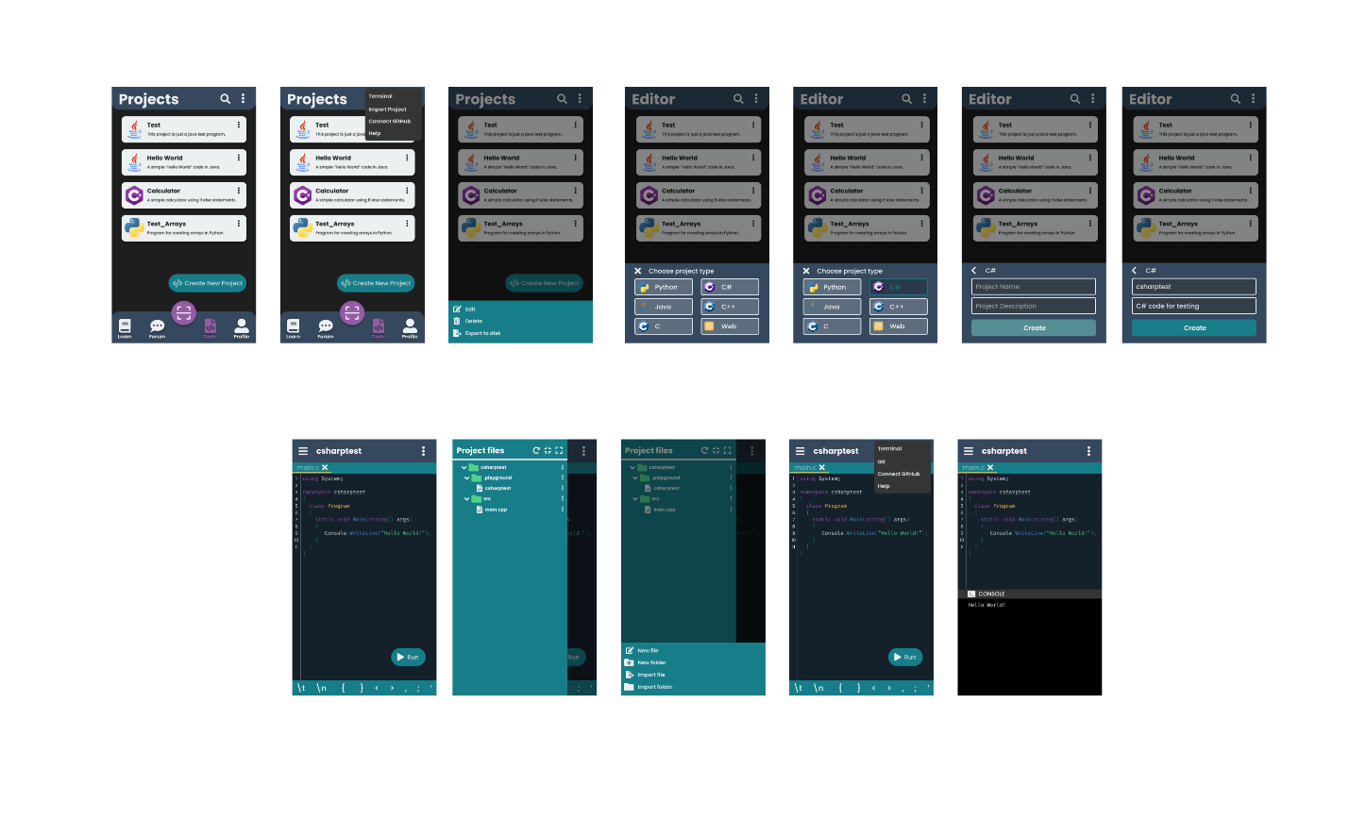

1. **Profile View**

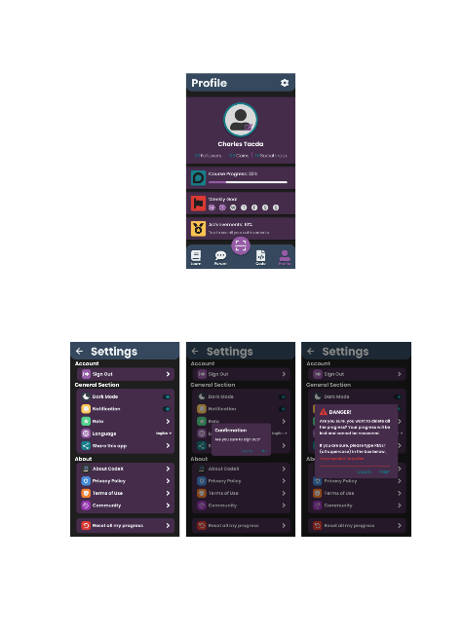

1. **Code Scanner View**

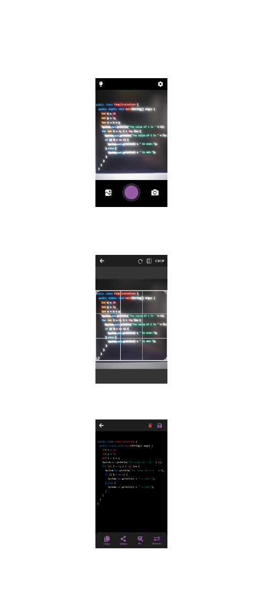

# UI & Graphics

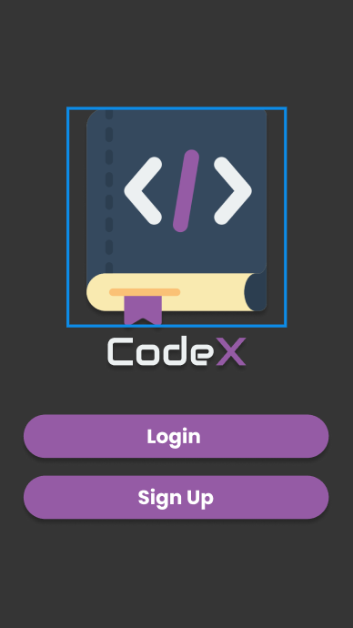

|  |
| --- |
| Loading Screen - This serves as the front page of the mobile application |

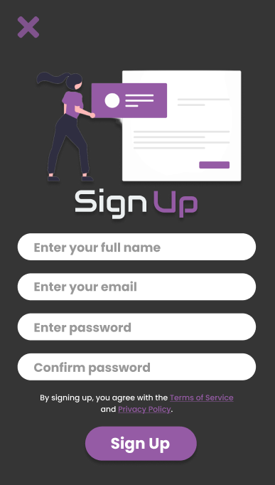

|  |
| --- |
| Sign-up screen- The user can create an account here to use the mobile application. |

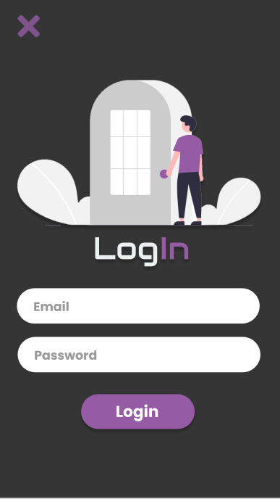

|  |
| --- |
| Log In screen- The user will input here their account to use the mobile application. |

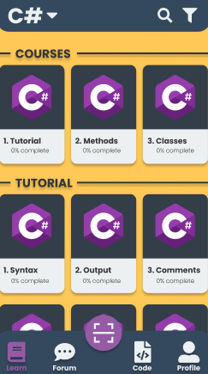

|  |
| --- |
| Lecture Screen- This part of the application contains a list of available resources about different topics. |

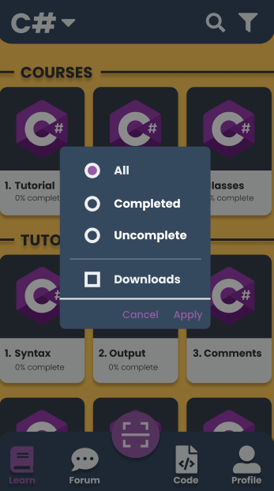

|  |
| --- |
| Filter Screen- this feature allows the user to filter lessons based on what they prefer. |

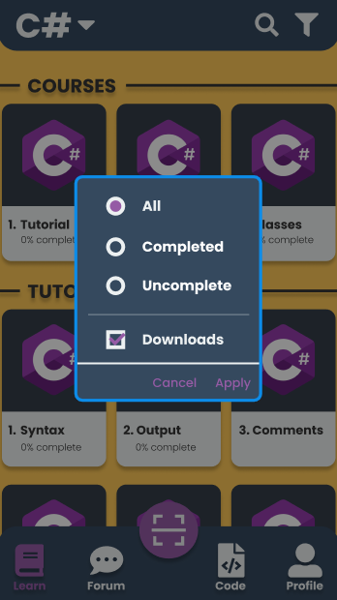

|  |
| --- |
| Filter Download Screen- this feature allows the user to download filtered lessons based on what they prefer. |

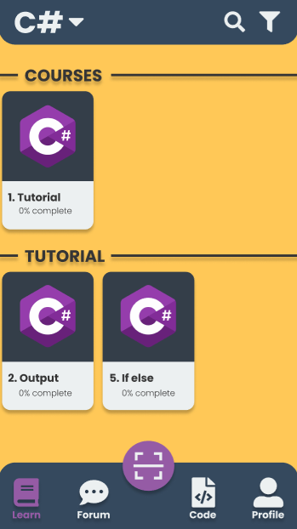

|  |
| --- |
| Lecture Screen-This part of the application contains a list of available resources about different topics. |

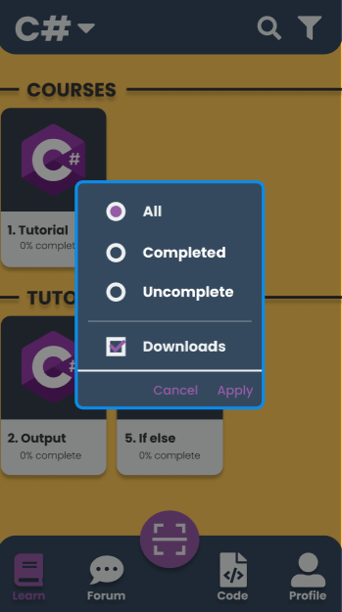

|  |
| --- |
| Lecture Download Screen- this feature allows the user to download filtered lessons based on what they prefer. |

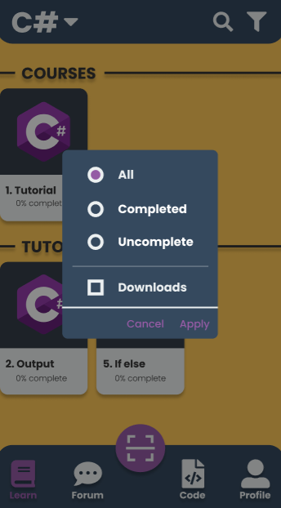

|  |
| --- |
| Lecture Filter Screen- this feature allows the user to download filtered lessons based on what they prefer. |

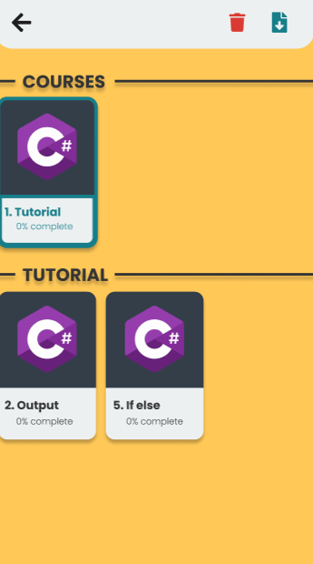

|  |
| --- |
| Lecture Edit Screen – this shows the edit options that can be apply to courses and tutorials |

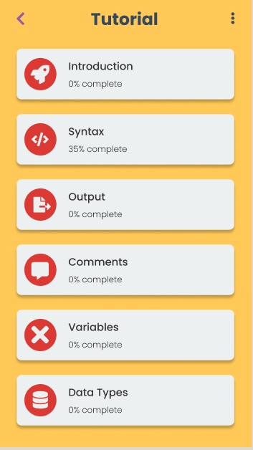

|  |
| --- |
| Course menu |

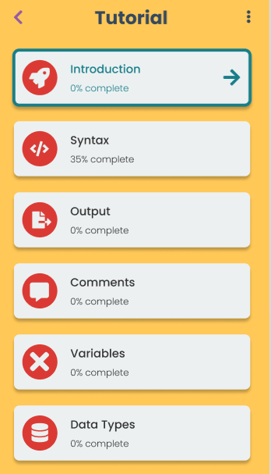

|  |
| --- |
| Course menu |

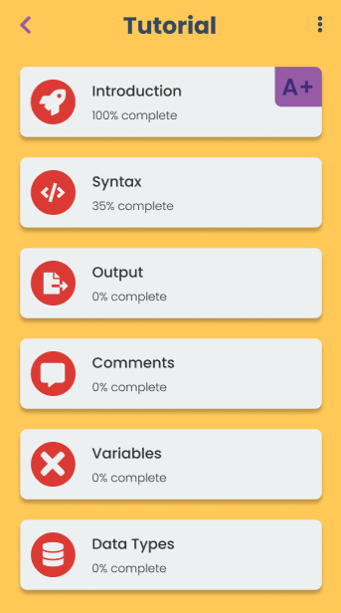

|  |
| --- |
| Course menu |

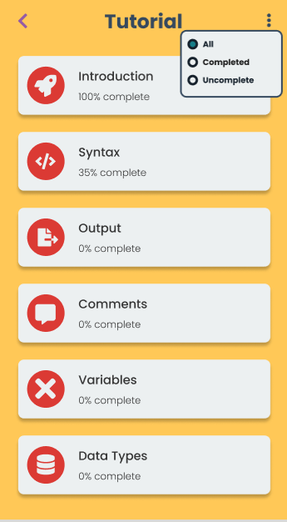

|  |
| --- |
| Course menu- this shows all the available tutorials |

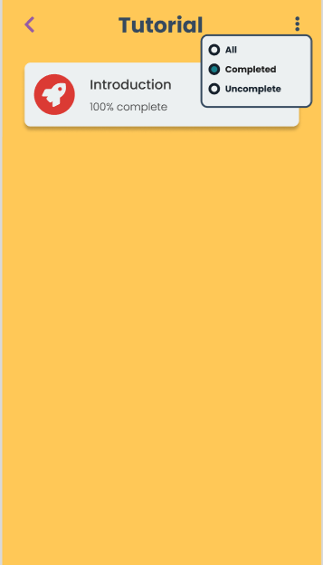

|  |
| --- |
| Course menu- this part shows the tutorials that have been completed. |

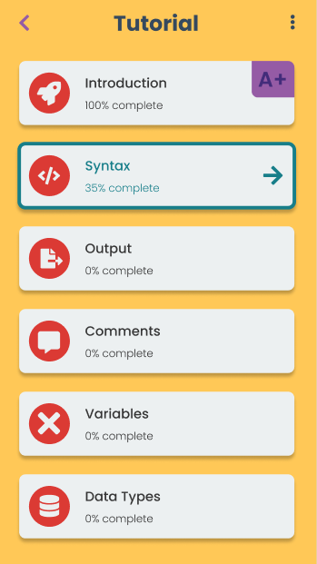

|  |
| --- |
| Course menu |

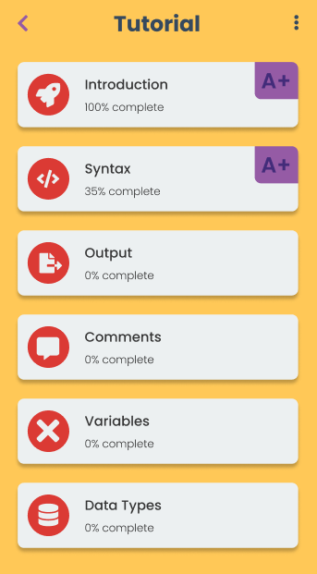

|  |
| --- |
| Course menu |

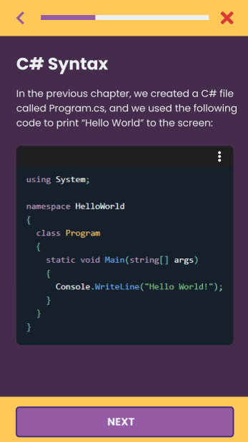

|  |
| --- |
| Course Screen |

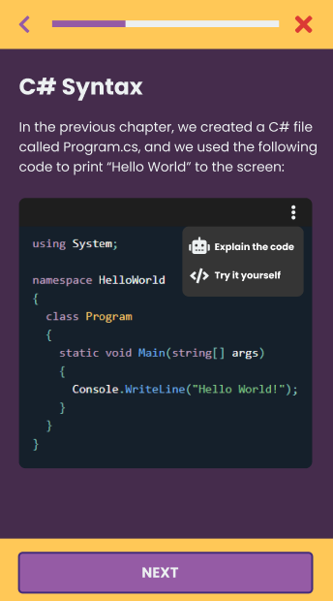

|  |
| --- |
| Course menu |

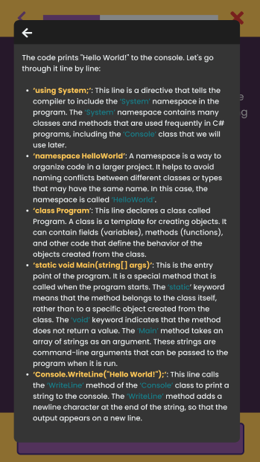

|  |
| --- |
| AI Assistance Screen- this feature displays short definitions of some terms and syntax. |

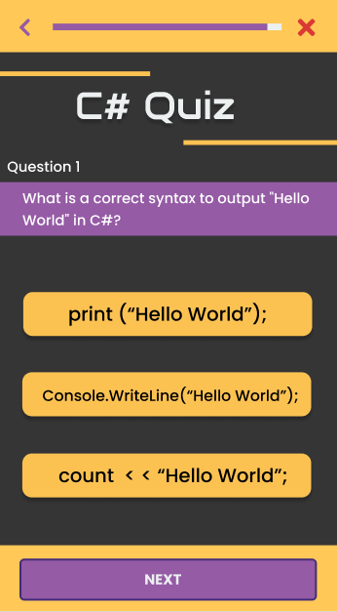

|  |
| --- |
| Quiz Screen- this feature tests the knowledge gained by the user about the topic that they take. |

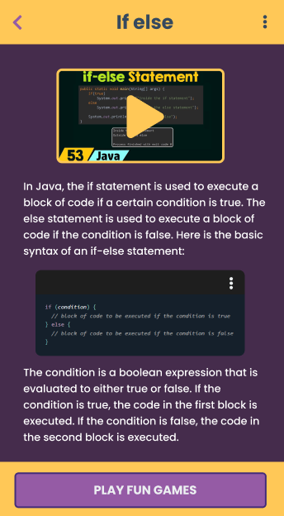

|  |
| --- |
| Tutorial Screen- this one contains lecture and video tutorial about a certain course/topic. |

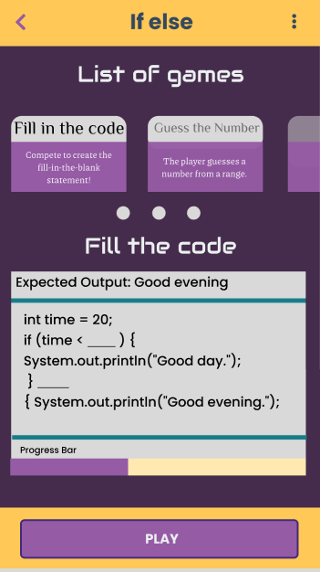

|  |
| --- |
| Game Screen- this game is also to test the knowledge of the user but in a more exciting and fun way. |

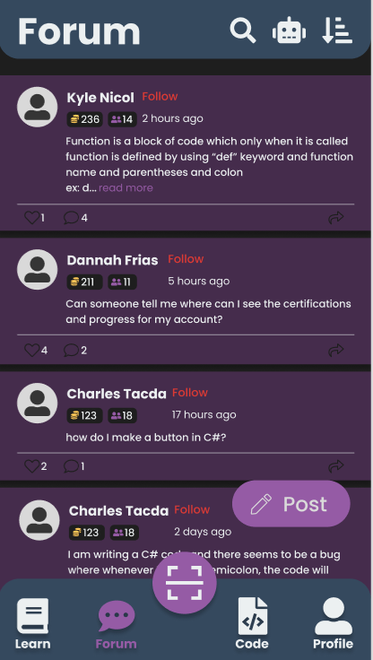

|  |
| --- |
| Forum Screen- this place is where different users can share their problem or thoughts with each other. |

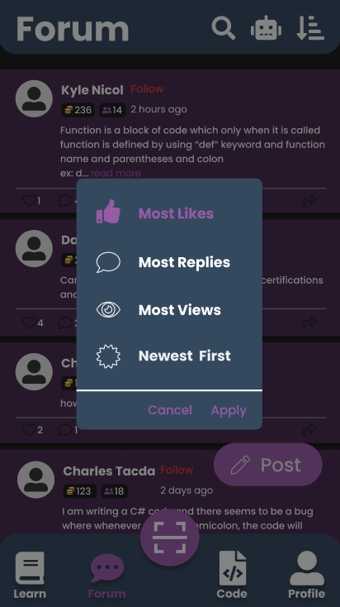

|  |
| --- |
| Sort screen- users can also filter what they can see / read in the forum. |

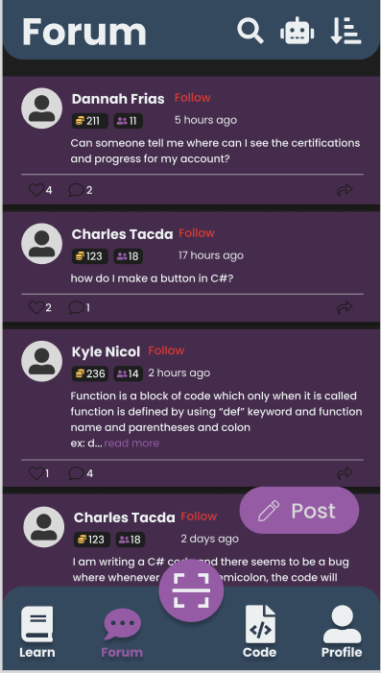

|  |
| --- |
| Sorted Screen- already filtered forum |

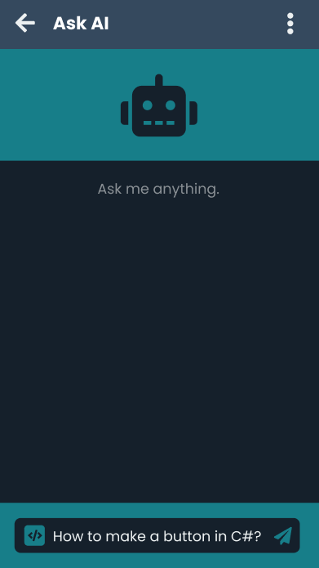

|  |
| --- |
| “Ask AI” Screen – feature where users can ask programming-related questions to an AI |

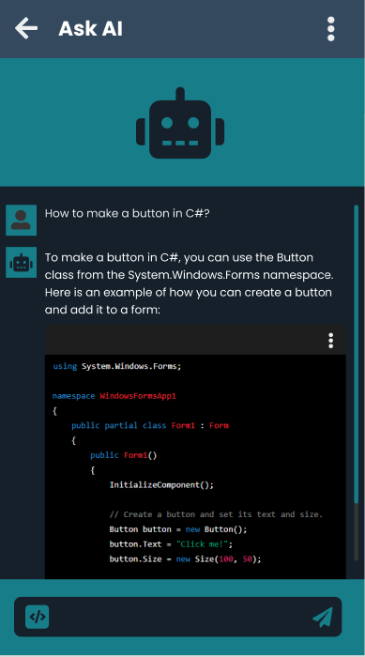

|  |
| --- |
| “Ask AI” Screen – the AI will provide an answer along with codes for the users |

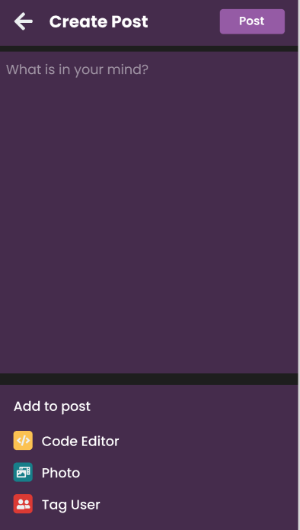

|  |
| --- |
| Create Post Screen- this is where user can enter their post for the forum |

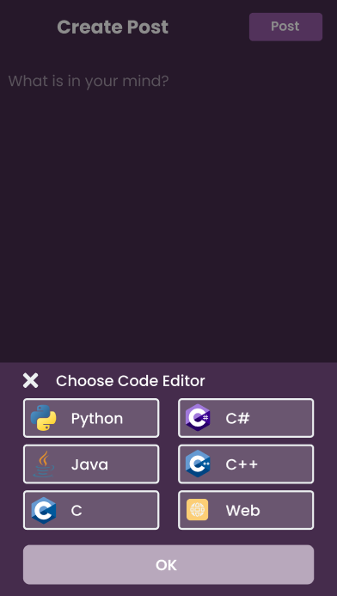

|  |
| --- |
| Post Code editor- the user can edit their code in this platform |

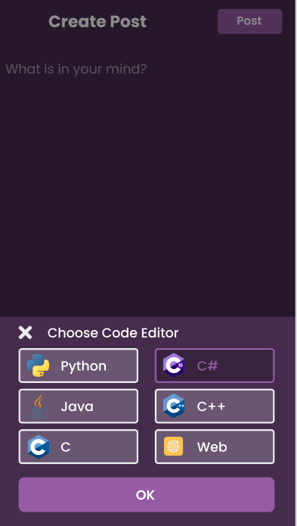

|  |
| --- |
| Post Code Choose Editor- the user can choose what language they prefer to use for their program |

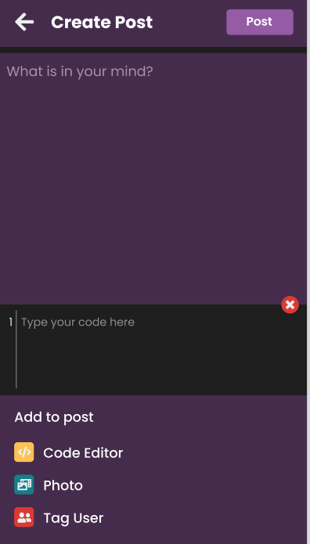

|  |
| --- |
| Post Code Screen- this part of the application is where the user can input and post their code. |

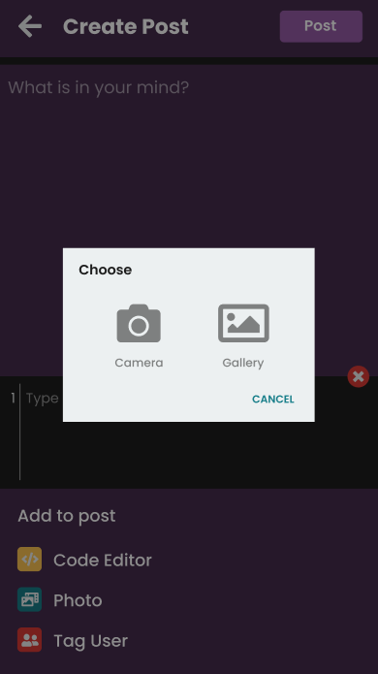

|  |
| --- |
| Post Photo Choose Screen- the user is also allowed to upload a picture in the forum |

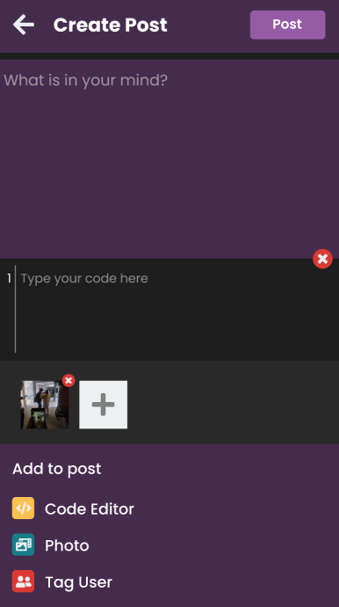

|  |
| --- |
| Post Photo Screen- this shows the process of uploading an image in the forum |

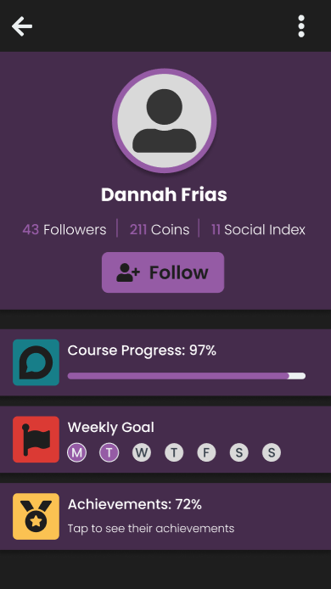

|  |
| --- |
| Other Profile Screen- the profile view of other users |

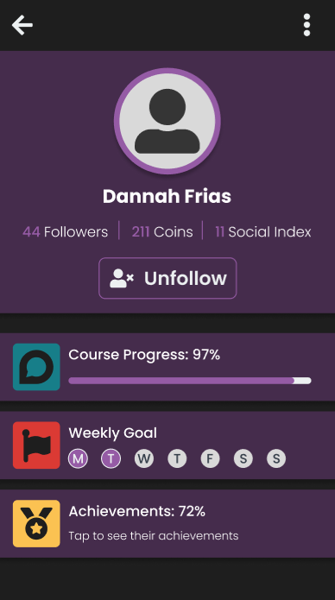

|  |
| --- |
| Followed Screen- the profile view of the user you follow |

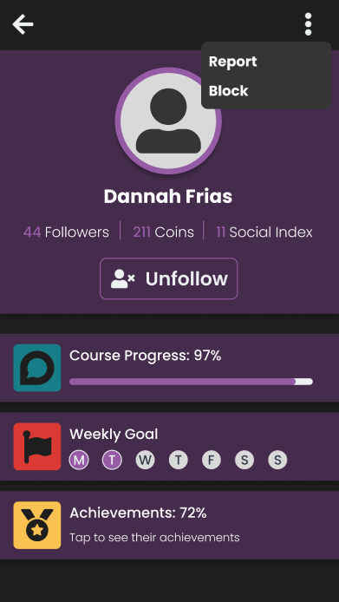

|  |
| --- |
| Unfollowed Screen- the profile view of the user you follow with settings |

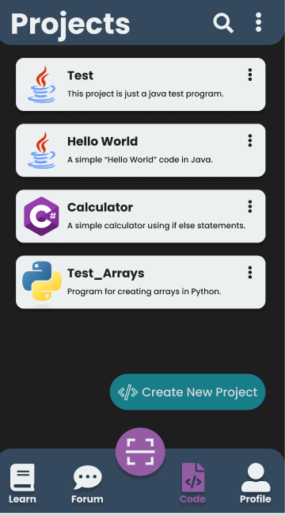

|  |
| --- |
| Code Screen- this part of the application is where you can resume or start new project |

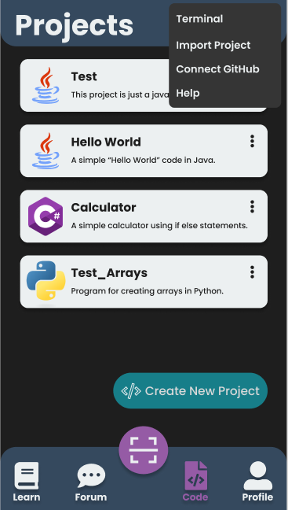

|  |
| --- |
| Code Screen- this part of the application is where you can resume or start new project with some options |

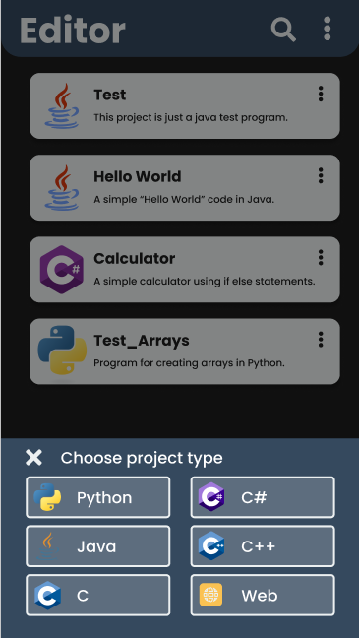

|  |
| --- |
| Code Editor Screen- users can choose what type of project they want to do |

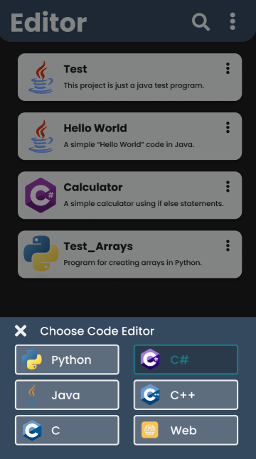

|  |
| --- |
| Code Selected Screen- this shows that the user chose C# |

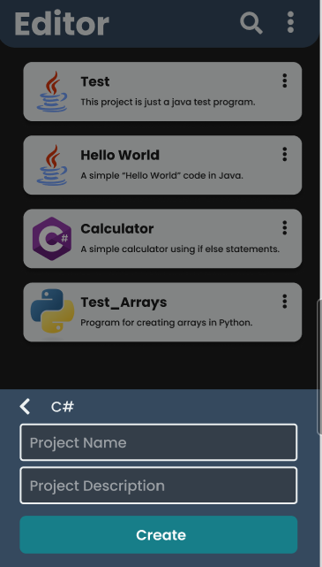

|  |
| --- |
| Code Selected Screen- user will input the project name and project description |

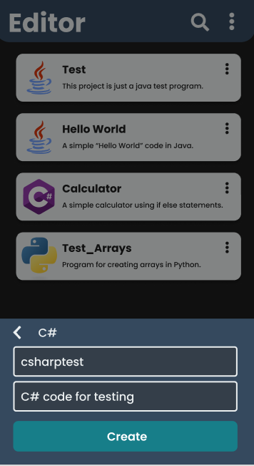

|  |
| --- |
| Code Selected Screen- example of the user’s preferred project |

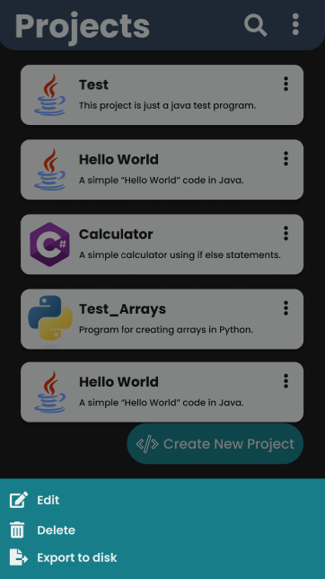

|  |
| --- |
| Code Screen- this shows some options for the user for their projects |

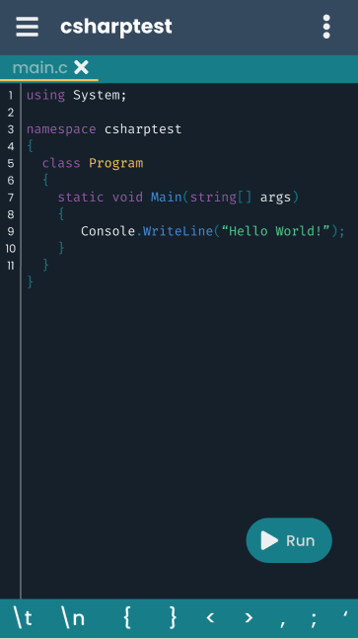

|  |
| --- |
| Create Post Screen- this shows the view for the users when they start to do their project |

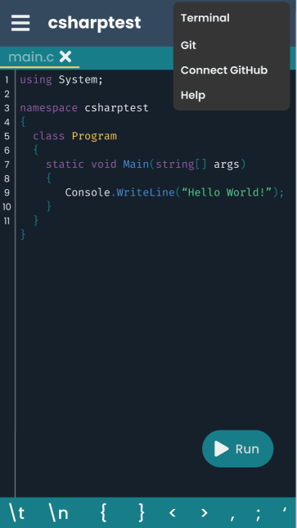

|  |
| --- |
| Create Post Screen- this shows the view for the users when they start to do their project with some options |

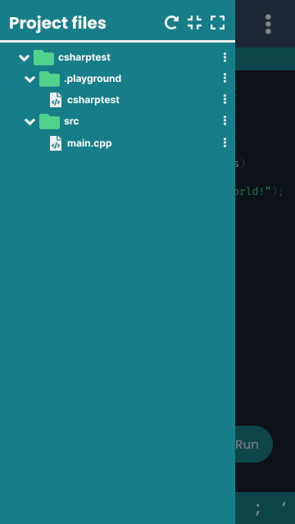

|  |
| --- |
| Create Post Screen- this is where some of the project files of the users will be displayed |

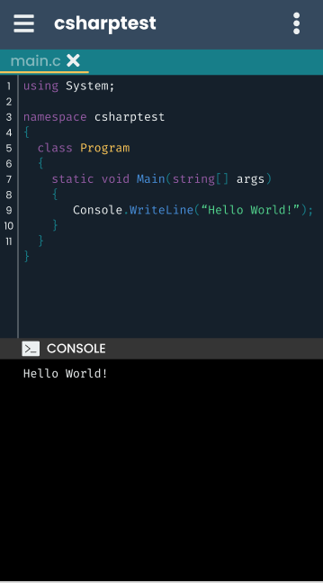

|  |
| --- |
| Create Post Screen- sample screen when the user run their program |

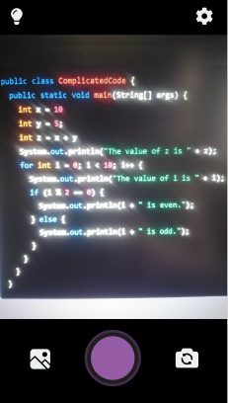

|  |
| --- |
| Scan Screen- user is allowed to scan pictures using their camera |

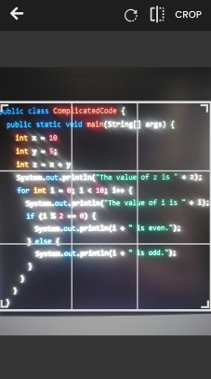

|  |
| --- |
| Crop Screen- sample picture of the scanned picture |

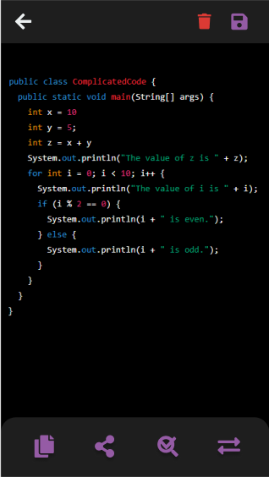

|  |
| --- |
| Evaluate Screen- this happens when the scanned picture was converted into text |

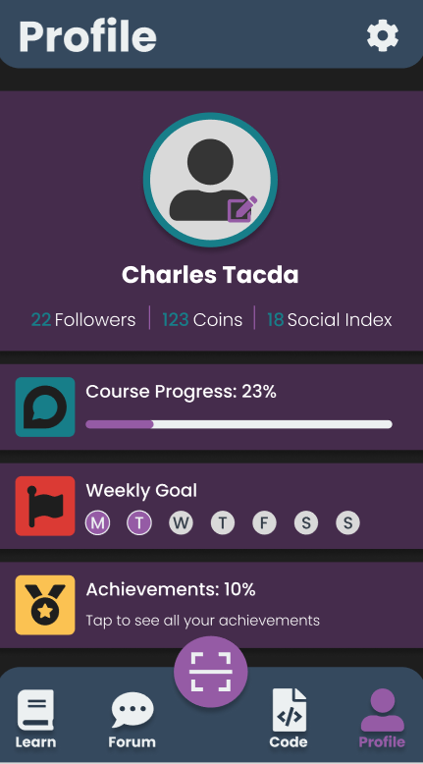

|  |
| --- |
| Profile Screen- profile view of the user’s own account |

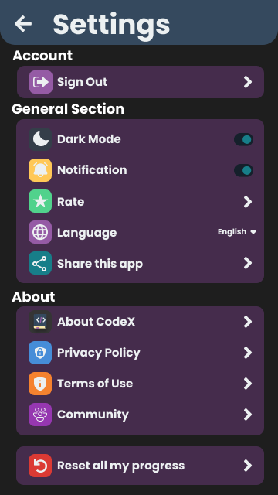

|  |
| --- |
| Setting Screen – where users can configure the app and adjust it based on their needs |