Project ideas

# First Idea:

* Our group wants to implement three different tabs (views). They are
  + List view – a list of files
  + Icon view – a icon view of files, includes small preview, name, and information about the files.
  + Column view- a column view of the files
* Two specific buttons (send and receives)
* Use Wi-Fi direct to sends files
* Or use parse.com as a server

# Second Idea:

* Having three different views is not necessary, so we want to focus on only one list view.
* Send and receive in one button.
* Have a separate intent for choosing target devices.
* History of sending and receiving
* Focus on UI
* May or may not do the actual sending or receiving features

# 

**Problem Scenarios**

**A Computer Science Study Group Working on Assignments Together**

After almost three years at UCSB, students have formed study groups and gained a social network of friends. Around the time before an assignment is due, the students realize that they are unsure whether their answers are truly correct. The students confirm with each other by sending documents or pictures of the assignments to each other. Students quickly browse through each other’s work to check both their friends’ work and their own work.

**A Computer Science Student Trying to Organize Files Downloaded**After almost three years at UCSB, students have most likely downloaded a bunch of pdf’s and documents pertaining to a project description or assignment description that have been outdated. However, students also store important personal information in their phones. Some of these data may be important, and some may not. The student wishes to organize all the files inside his or her phone efficiently. Furthermore, the student may wish to preview the document before deciding whether to delete it or not.

**A Businessman Who is in a Rush**

A Businessman who often travels a lot and rarely has time to sit down and open his laptop needs to send documents and pictures to his or her secretary. The user must efficiently send files within a timeframe or else he or she will miss the plane flying to LA.

**A Photographer Who Forgot his Camera**

A Photographer wants to go the Africa to take pictures of the indigenous tribes and giraffes. He did not bring his professional camera to take a picture of a beautiful scene on a particular moment of the day, so he decides to pull out his phone to take a picture. Now he wants to send the picture to a android tablet without taking that it out.

**User Analysis**

The users for our application and their characteristics are:

**College Students**

Characteristic:

* Attend classes on a daily basis
* Have many digital files
* Are experience smart phone users
* Are experience social media app users

Users goals:

* Share digital files with classmates, friends, and professors
* Want to perform the sharing tasks under one minute
* Want to access the files in a nice interface

Users knowledge:

* Smart phone experience
* Familiar with modern app interface

**Business People**

Characteristic:

* Spend most of their time on the plane
* Attend many meeting
* Read many digital documents
* Use smartphone for contacting and emailing

User goals:

* Share digit files with secretary, business partners, and other employees
* Want to perform the sharing tasks under one minute
* Want to access the files in a nice interface
* Want to sort the files easily
* Want to retrieve a specific file under 30 seconds

User knowledge:

* Basic smart phone experience
* Comfortable with modern app interface

**Photographers**

Characteristic:

* Take many digital photo
* Have a large library of photo
* Use smartphone to take casual pictures and view pictures
* Travel to different places

User goals:

* Directly share digit files from smart phone to tablet
* Want to perform the sharing tasks under one minute
* Want to have a consistent interface for both smart phone and tablet

User knowledge:

* Basic smart phone experience
* Comfortable with modern app interface
* Expert in using camera application

**Task Analysis**

Deleting a file

1. Click on an item in the list
2. Click on an item in the sub-list
3. Select the items to be deleted
4. Deselect items to not send (Optional)
5. Press the trash icon that appears on the action bar
6. Press on the reverse arrow to undo (Optional)

Sending a file

1. Click on an item in the list
2. Click on an item in the sub-list
3. Select the items to be sent
4. Deselect items to not send (Optional)
5. Press the up arrow symbol on the action bar
6. Select a device
7. Deselect a device (Optional)
8. Press the send button on the sending dialog

Receiving a file

1. Press on the down arrow symbol in the action bar

Searching a file

1. Click on the symbol with the magnifying glass in the action bar
2. Type in the text field to start to search
3. Press the plus icon to add the item to the dialog
4. Press the send button to send the files added to the dialog

**Prototypes (Initial Idea)**

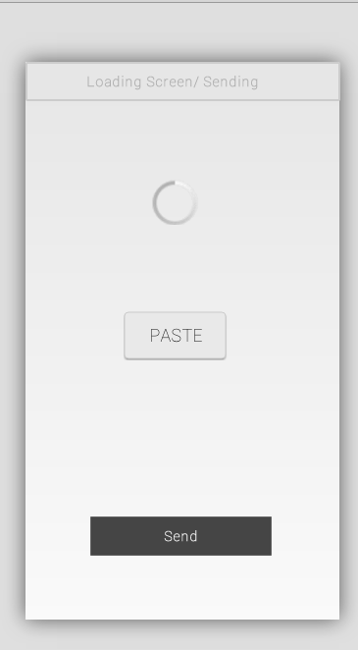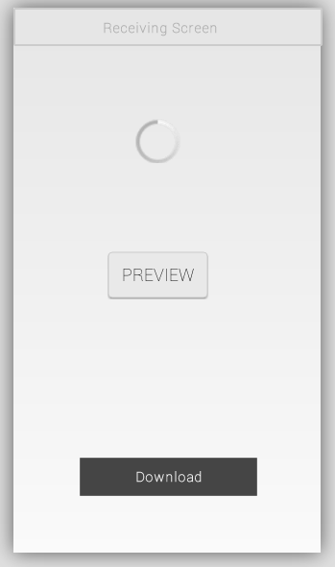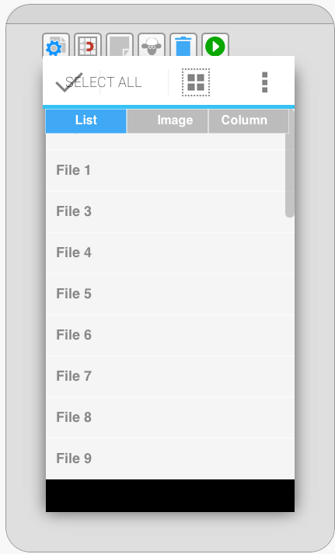

**Prototypes (Final Ideal)**

Main File Editing Screen

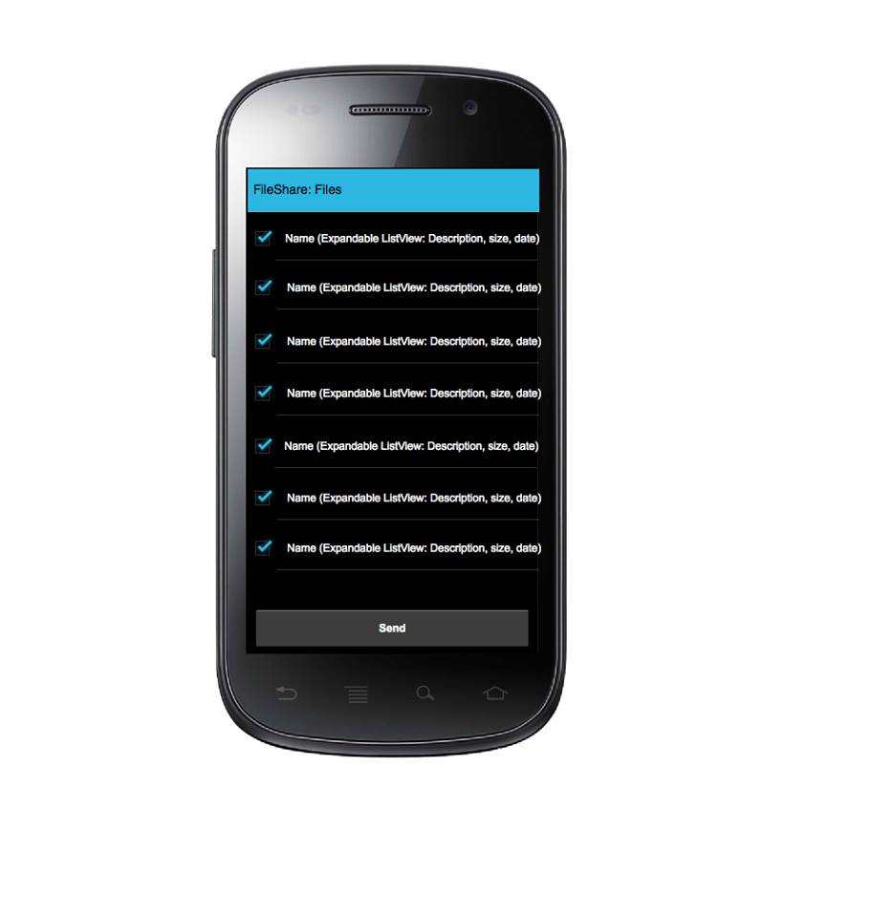

Device Selection Screen

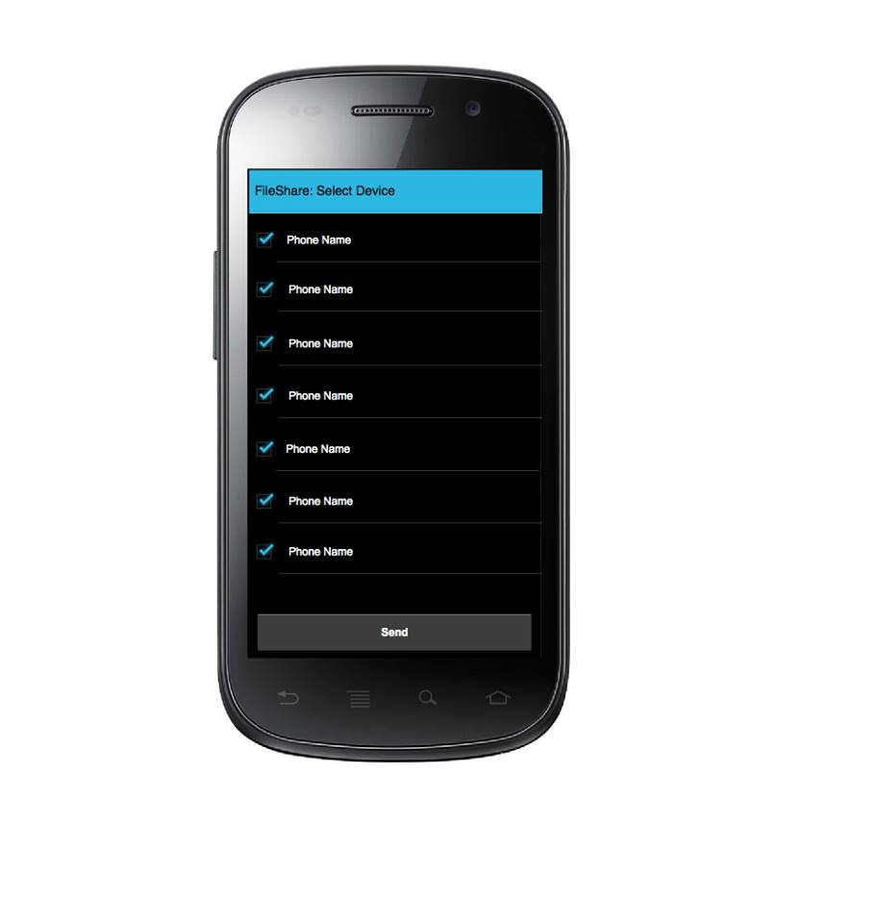

Receiving Data Screen

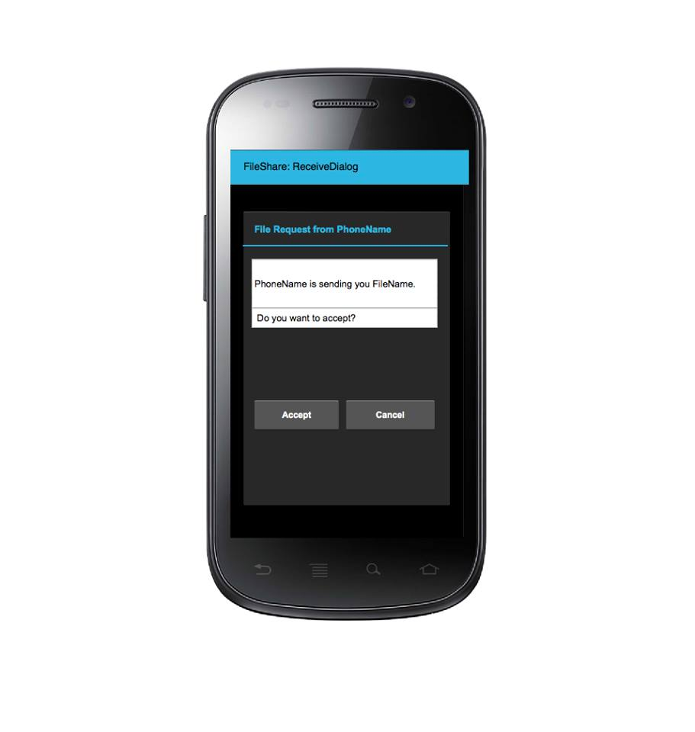

**Sources**

<http://stackoverflow.com/questions/8855791/how-to-create-standard-borderless-buttons-like-in-the-design-guidline-mentioned>

<http://www.javacodegeeks.com/2013/06/android-action-bar-with-tab.html>

<http://www.androidhive.info/2013/07/android-expandable-list-view-tutorial/>

<http://stackoverflow.com/questions/8855791/how-to-create-standard-borderless-buttons-like-in-the-design-guidline-mentioned>

<http://stackoverflow.com/questions/18525793/how-to-set-the-text-color-of-titlebar>

<http://stackoverflow.com/questions/5049852/android-drawing-separator-divider-line-in-layout>