**CS174a Project 3 Report – The Hospital**

**Task Division**

*Charles Weng*

* Set up the JDBC and while loop through messages ResultSet
* UI for initial load database (database selection, user name)
* Updating patient information
* Debugged NULL table values and threw error messages for constraint violations
* Last two queries of Admin interface

*Cameron McNair*

* Prepared statements inside the Hospital class
* UI for initial load database (password field)
* UI for the three interfaces
* Viewing the patient information
* Viewing and editing Allergy information
* First two queries of Admin interface

**Parts of Schemas that Changed Since Project 2**

* Changed the primary key from a tuple of (LabTestResultId, PatientVisitId) to just PatientVisitId, because LabTestResults cannot exist without a patient visit
* We deleted some NOT NULL’s due to the fact that some values can be NULL inside our table
* We added and moved some Foreign Key Constraints
* Moved Status inside our UML diagram to our Allergic_To
* Added several more constraints like Unique, Foreign Key, etc.

**How We Dealt With Constraints**

* Constraints such as Primary Key Constraints are outputted to the console
* Foreign Key Constraints are outputted onto the stack trace

**UML Diagram**

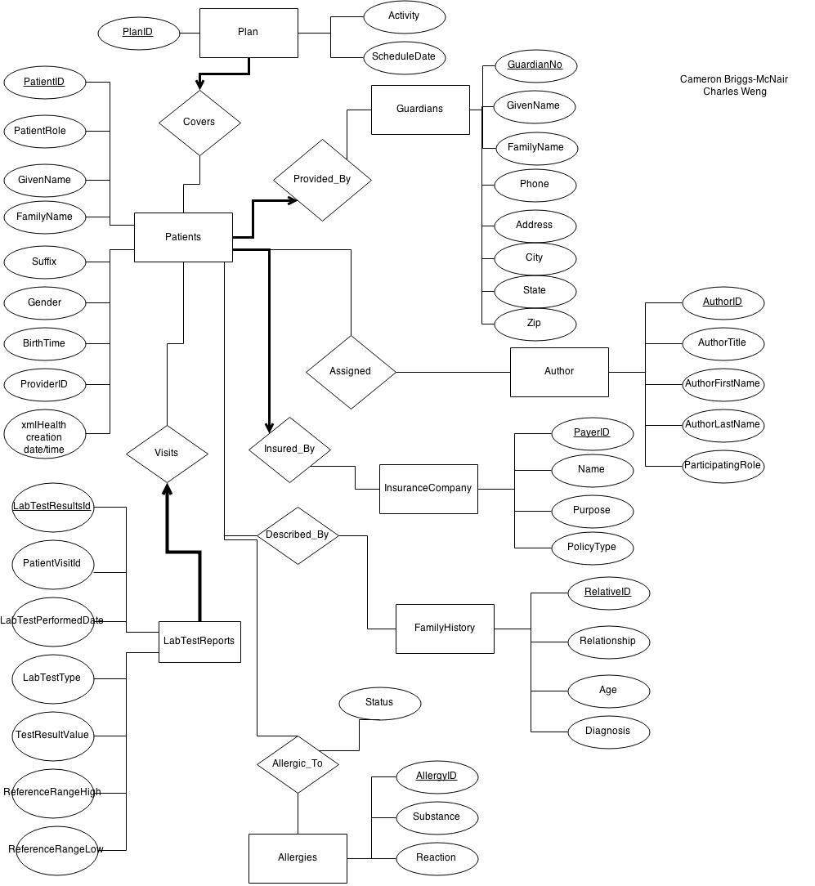

**Final Schema Definitions**

Formatted for easier readability!

CREATE TABLE IF NOT EXISTS guardians   
  (   
     guardianno *INT*,   
     firstname  *CHAR*(100),   
     lastname   *CHAR*(50),   
     phone      *CHAR*(20),   
     address    *CHAR*(100),   
     city       *CHAR*(50),   
     state      *CHAR*(20),   
     zip        *INT*,   
     PRIMARY KEY(guardianno)   
  );

CREATE TABLE IF NOT EXISTS insurancecompany   
  (   
     payerid    *INT*,   
     name       *CHAR*(50),   
     purpose    *CHAR*(50),   
     policytype *CHAR*(50),   
     PRIMARY KEY(payerid)   
  );

CREATE TABLE IF NOT EXISTS author   
  (   
     authorid          *INT*,   
     authortitle       *CHAR*(100),   
     authorfirstname   *CHAR*(50),   
     authorlastname    *CHAR*(50),   
     participatingrole *CHAR*(50),   
     PRIMARY KEY(authorid)   
  );

CREATE TABLE IF NOT EXISTS labtestreports   
  (   
     labtestresultsid     *INT*,   
     patientvisitid       *INT*,   
     labtestperformeddate *DATETIME*,   
     labtesttype          *CHAR*(50),   
     testresultvalue      *INT*,   
     referencerangehigh   *CHAR*(50),   
     referencerangelow    *CHAR*(50),   
     PRIMARY KEY(labtestresultsid),   
     UNIQUE(labtestresultsid, patientvisitid)   
  );

CREATE TABLE IF NOT EXISTS patient   
  (   
     patientid                 *INT*,   
     patientrole               *INT*,   
     givenname                 *CHAR*(100),   
     familyname                *CHAR*(50),   
     suffix                    *CHAR*(10),   
     gender                    *CHAR*(8),   
     birthtime                 *DATETIME*,   
     providerid                *CHAR*(50),   
     xmlhealthcreationdatetime *DATETIME*,   
     payerid                   *INT*,   
     PRIMARY KEY(patientid),   
     FOREIGN KEY(patientrole) REFERENCES guardians(guardianno),   
     FOREIGN KEY(payerid) REFERENCES insurancecompany(payerid)   
  );

CREATE TABLE IF NOT EXISTS assigned   
  (   
     patientid *INT*,   
     authorid  *INT*,   
     PRIMARY KEY(patientid, authorid),   
     FOREIGN KEY(patientid) REFERENCES patient(patientid),   
     FOREIGN KEY(authorid) REFERENCES author(authorid)   
  );

CREATE TABLE IF NOT EXISTS familyhistory   
  (   
     relativeid   *INT*,   
     relationship *CHAR*(50),   
     age          *INT*,   
     diagnosis    *CHAR*(100),   
     PRIMARY KEY(relativeid)   
  );

CREATE TABLE IF NOT EXISTS describedby   
  (   
     patientid  *INT*,   
     relativeid *INT*,   
     PRIMARY KEY(patientid, relativeid),   
     FOREIGN KEY(patientid) REFERENCES patient(patientid),   
     FOREIGN KEY(relativeid) REFERENCES familyhistory(relativeid)   
  );

CREATE TABLE IF NOT EXISTS allergies   
  (   
     allergyid *INT*,   
     patientid *INT* NOT NULL,   
     substance *CHAR*(50),   
     reaction  *CHAR*(50),   
     status    *CHAR*(20),   
     PRIMARY KEY(allergyid),   
     FOREIGN KEY(patientid) REFERENCES patient(patientid)   
  );

CREATE TABLE IF NOT EXISTS plan   
  (   
     planid       *INT*,   
     activity     *CHAR*(50),   
     scheduledate *DATETIME*,   
     patientid    *INT* NOT NULL,   
     PRIMARY KEY(planid),   
     FOREIGN KEY(patientid) REFERENCES patient(patientid)   
  );

CREATE TABLE IF NOT EXISTS visits   
  (   
     patientvisitid   *INT*,   
     patientid        *INT*,   
     labtestresultsid *INT*,   
     PRIMARY KEY(patientvisitid),   
     FOREIGN KEY(patientid) REFERENCES patient(patientid),   
     FOREIGN KEY(labtestresultsid) REFERENCES labtestreports(labtestresultsid)   
  );

**Queries Used**

Note: ‘?’ represents things that can be replaced depending on other factors in a query

*Patient*

* Update Patient set GivenName = ?, FamilyName = ?, Suffix = ?, Gender = ?, Birthtime = ?, ProviderID = ?, PayerID = ? where PatientID = ?
* select * from ( Patient join Guardians on Patient.PatientRole = Guardians.GuardianNo ) where PatientId = ?
* select * from Patient where PatientID = ?

*Doctor*

* Update Allergies set Substance = ?, Reaction = ?, Status = ? where PatientID = ?
* select * from Allergies where PatientID = ?
* select * from Plan where PatientID = ?

*Administrator*

* select count(*) from (SELECT distinct(substance) from allergies where substance is not null group by substance) a
* select distinct(substance), count(*) from allergies where substance is not null group by substance
* select PatientID, count(*) from allergies group by PatientID having count(*) > 1
* select count(*) from (select a.PatientID, count(*) from allergies a group by a.PatientID having count(*) > 1) AS MultiAllergy
* select * from Plan pl, Patient pt where pl.PatientID = pt.PatientID and DATE(pl.ScheduleDate) = DATE(CURDATE())
* select a.AuthorID, a.AuthorTitle, a.AuthorFirstName, a.AuthorLastName, a.ParticipatingRole from Author a where a.AuthorID in (select AuthorID from Assigned group by AuthorID having count(*) > 1)

**UI Description**

*Login Screen* - Initial login screen that preloads your database into your code

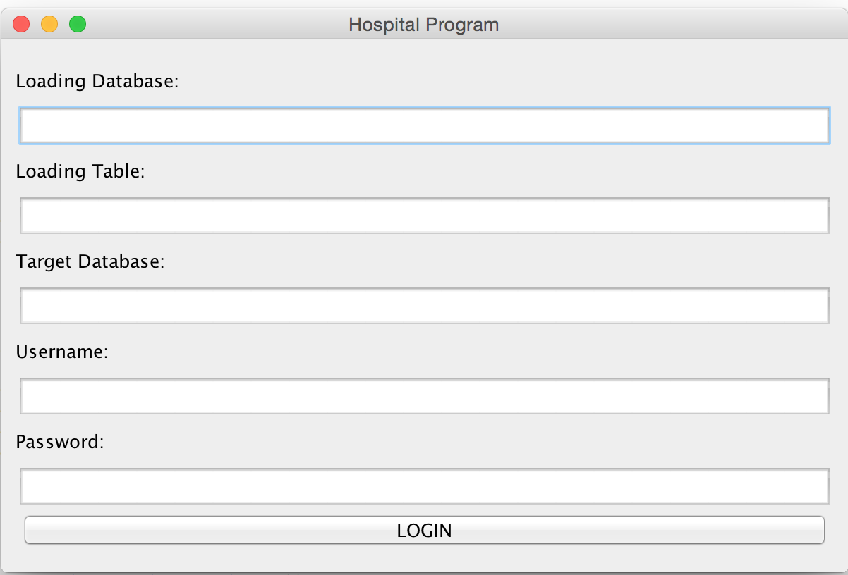

*Main Menu*

* Loads the DB given and puts it into our DB
* Start our Java Program that allows to edit and change info about Patients
* Exit exits our Main Menu

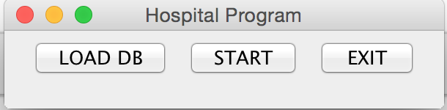

*Interface Selection Menu* – Choose Patient, Doctor, or Admin UI

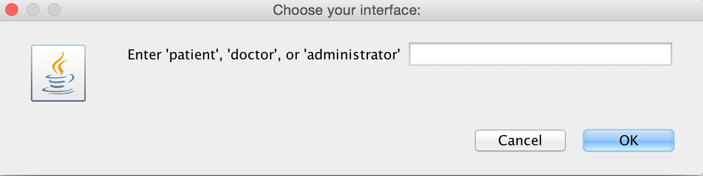

*Patient and Doctor Interfaces* – Figure 1 => Enter Patient ID

Figure 2 => View, Edit, Exit a Patient’s Info

Figure 3 => View

Figure 4 => Edit

Figure 1.

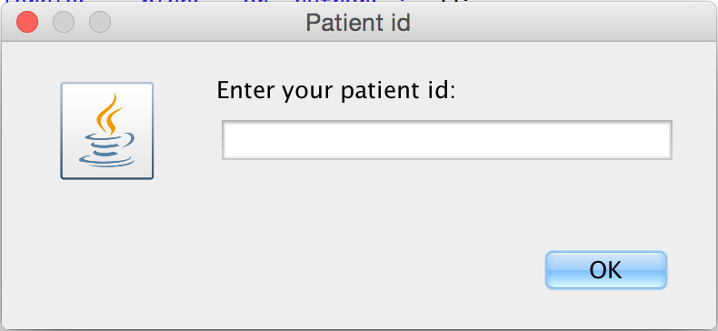

Figure 2.

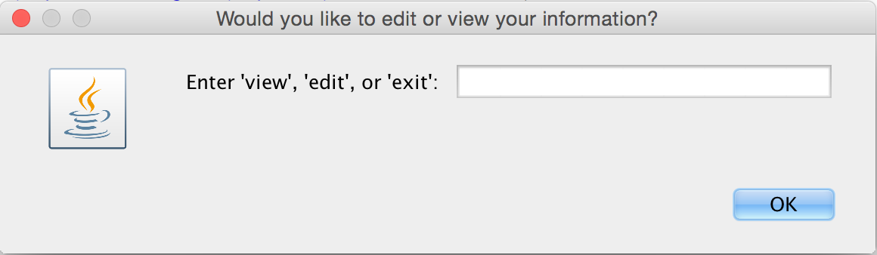

Figure 3.

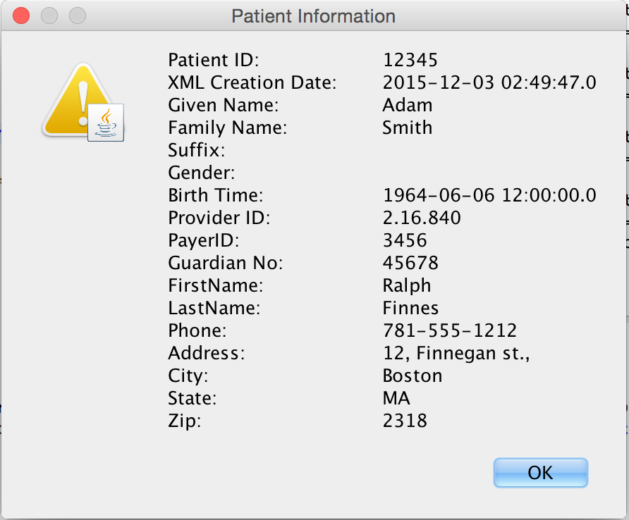

Figure 4.

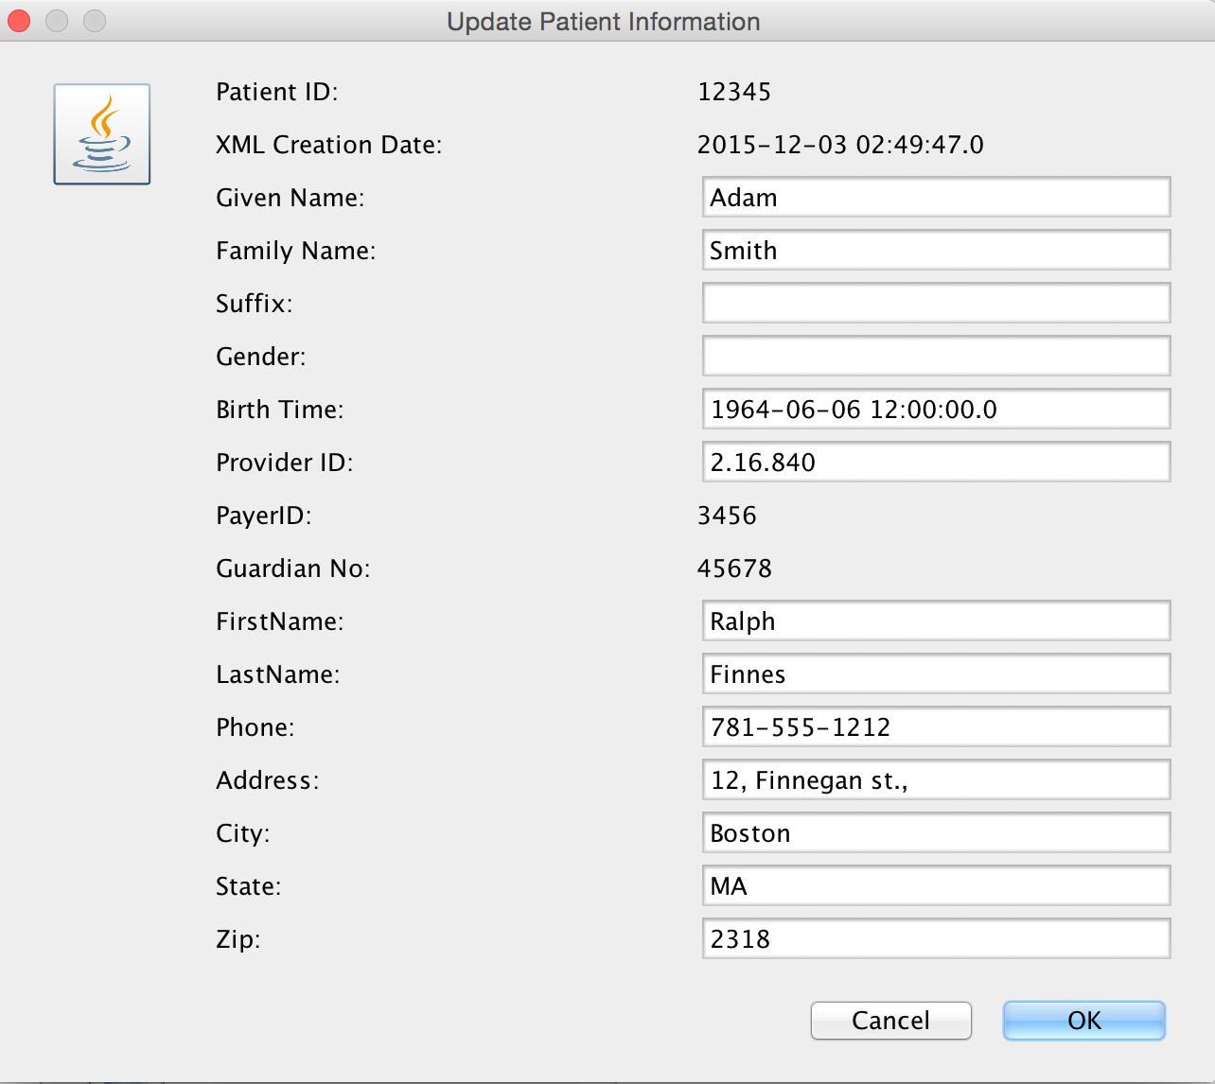

*Admin Interface* – Figure 1 => Four different types of views we can choose from

Figure 2 => Querying for counts of allergies of each

Figure 3 => Patients with multiple Allergies

Figure 4 => Plans for today

Figure 5 => Authors with multiple patients assigned

Figure 1.

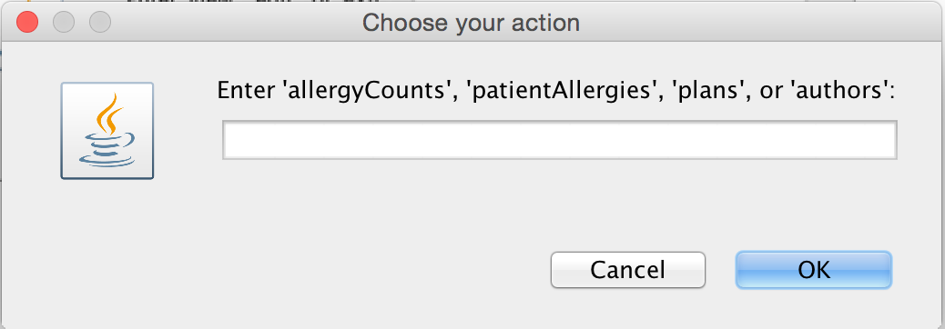

Figure 2.

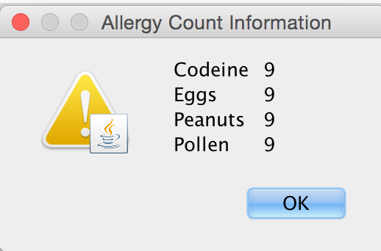

Figure 3.

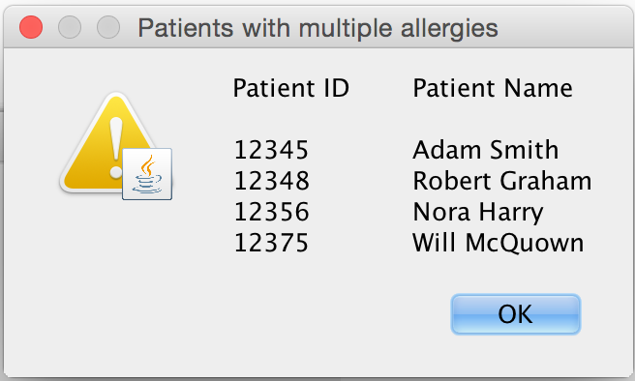

Figure 4.

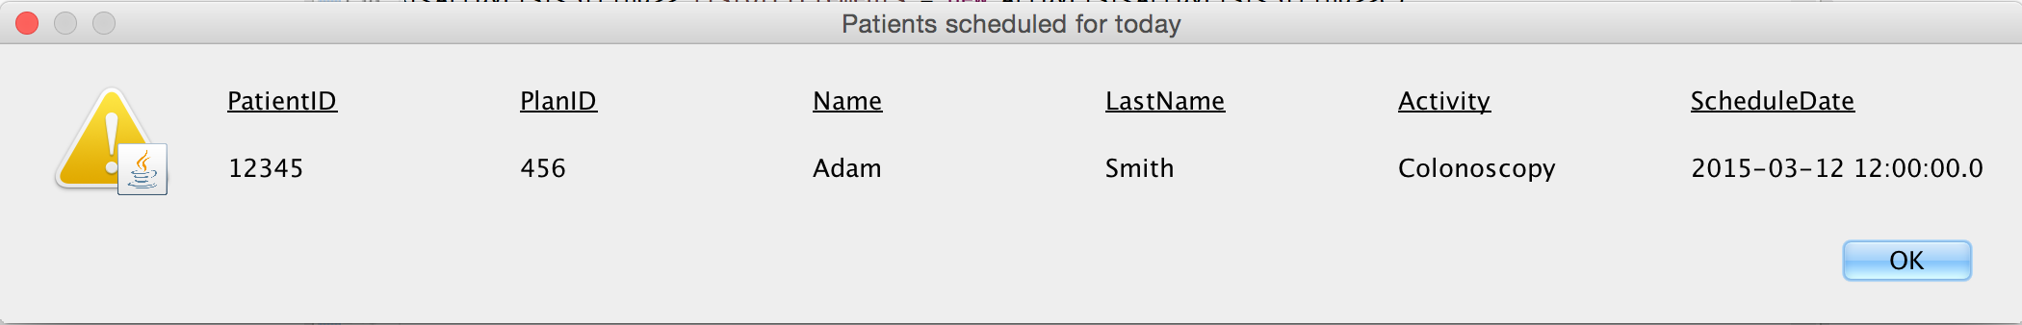

Figure 5.

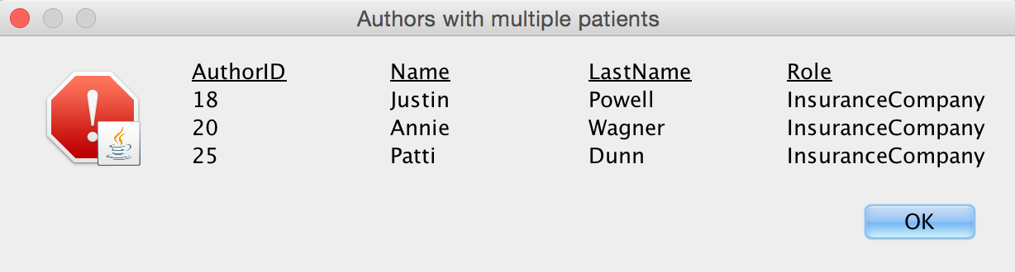

**Classes and Methods Implemented**

|  |  |
| --- | --- |
| Classes | Methods |
| MainMenu | MainMenu constructor – set up our UI  resetFrame – logic for loading db vs ui  doInterface – choosing between admin, patient, doctor  main – main thread where our ui is running |
| Hospital | Hospital constructor – loading db stuff into our own database  notNull – if null for primary keys we don’t insert into certain ones of our table |
| PatientInterface | PatientInterface – Choosing between view and edit patient info |
| DoctorInterface | DoctorInterface – choosing between viewing allergy counts and allergy info for each patient |
| AdminInterface | AdminInterface – combined querying and selections on admin |
| Patient | Patient – place where all the queries are made |
| Doctor | Doctor – place where all allergy queries are made |