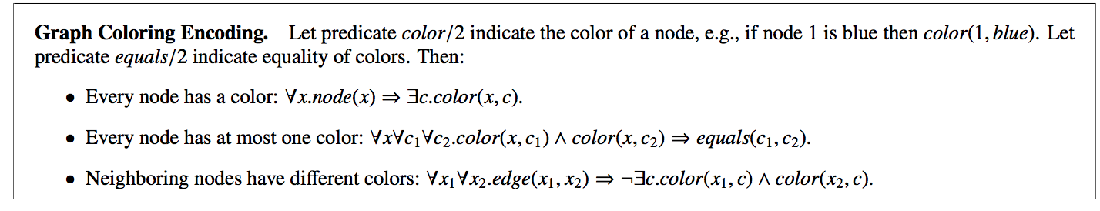

edge(x_1,x_2)=there is an edge from x_1 to x_2

color(x,c) = node x has color c

imperative programming -> all languages up to this point (say exactly how to get an answer)

declarative – say what an answer looks like

|-> Let the language search for the answer for you

A_1^……A_n => B_1 or …. Or B_n

|_____________| |_________________|

if you prove to one of this will be true

me all of there

But which one?

Definite horn clause

A_1&^…^A_n=>B

|__________________|

You want to show B?

Just show me A_1, …, A_n instead

SUDOKU  
Row – Column - Square