1. URL: <https://github.com/charlesxch/learning-about-version-control/commits/main>

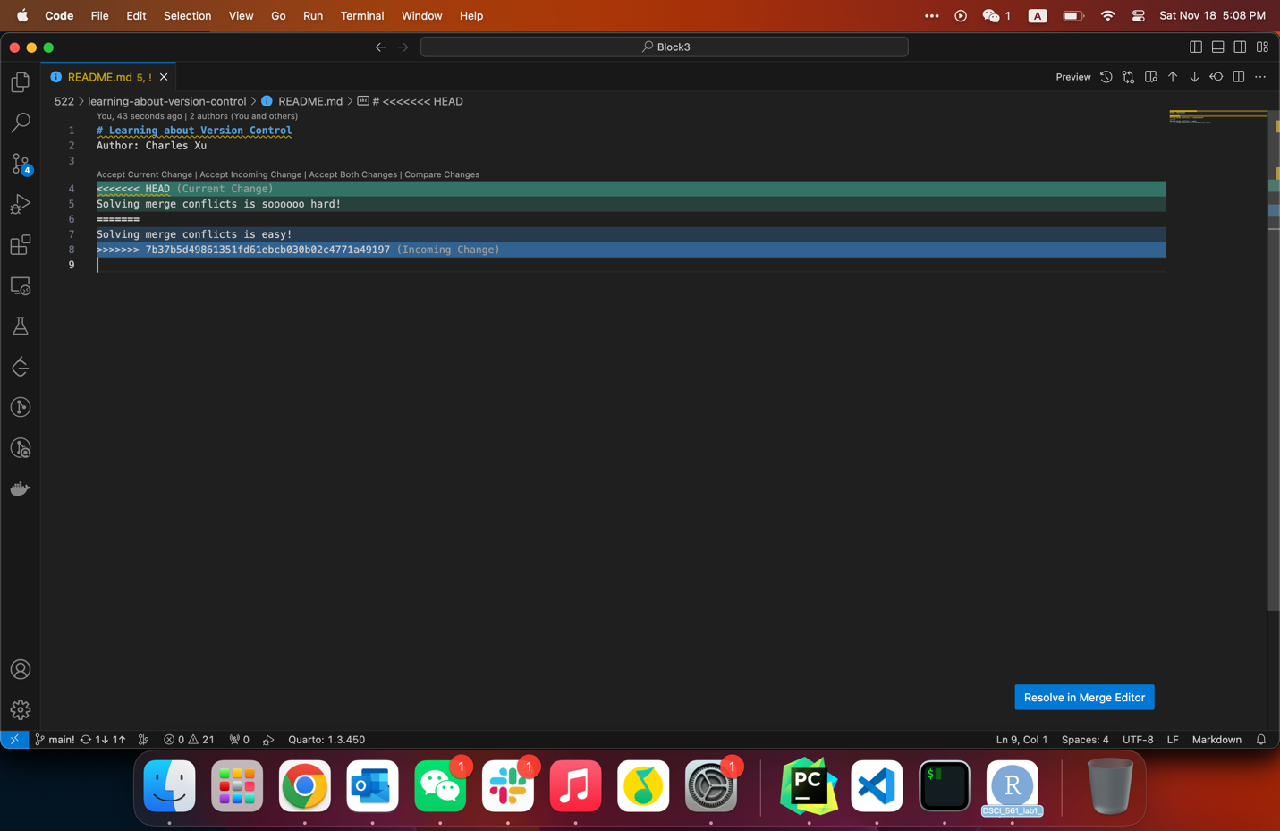

1. Explanation：Working in a branch-pull-request workflow provides a structured and collaborative approach to software development. It allows developers to work on isolated branches, making changes and testing without affecting the main branch. Pull requests serve as a mechanism for code review, enabling collaboration and ensuring that proposed changes meet quality standards before merging into the main branch.