AlphaVariant enables reinforcement learning-guided multisite optimization of
the industrial protease savinase
Xiaopeng Xu^{1,2,3†}, Hao Ye^{4†}, Ziqi Gao^{4†}, Ruochi Zhang⁵, Xinhai Zhou⁶, Guiting Zhang⁶, Tao Guo^{1,2,3}, Wenjia He^{1,2,3}, Chenjie Feng^{1,2,3}, Bin Xiao⁶, Feifei Hu⁶, Aixi Bai⁶, Xiao Zhang⁵,
Jie Wang^{4∗}, and Xin Gao^{1,2,3*}
¹Computer Science Program, Computer, Electrical and Mathematical Science and Engineering (CEMSE), King Abdullah University of Science and Technology (KAUST), Thuwal, 23955-6900, Kingdom of Saudi Arabia
²Center of Excellence for Smart Health, King Abdullah University of Science and Technology (KAUST), Thuwal, 23955-6900, Kingdom of Saudi Arabia
³Center of Excellence on GenAI, King Abdullah University of Science and Technology (KAUST), Thuwal, 23955-6900, Kingdom of Saudi Arabia
⁴Department of Chemistry, Southern University of Science and Technology, Shenzhen, 518055, China
⁵Syneron Opal, 10281, Cayman Island
⁶Bestzyme Biotech Inc., 860 Centennial Ave. Piscataway, NJ, 08854, USA
*Corresponding authors: xin.gao@kaust.edu.sa, wangjie@sustech.edu.cn.
†These authors contributed equally to this work.

Summary
Industrial enzyme engineering is limited by the difficulty of identifying beneficial combinations of mutations from large sequence spaces using small experimental datasets. Here we present AlphaVariant, a reinforcement learning framework that couples a generative protein sequence prior with low-N fitness predictors to prioritize multisite enzyme variants for experimental testing. Across eight benchmark protein fitness landscapes, AlphaVariant performed competitively with leading sequence-optimization methods and ranked strongest on larger multi-site oracle-guided landscapes. We then applied the framework to savinase, an industrial subtilisin protease. In two rounds of activity optimization, AlphaVariant-designed libraries achieved improvement rates of 75.4% and 83.8% among screened variants, and the best second-round variant showed more than four-fold higher activity than wild-type savinase. In a third round, we extended the reward function to jointly consider activity, thermostability, and patent rule-based IP-conflict avoidance, selecting 32 variants for experimental validation. Three variants outperformed a commercial benchmark in laboratory activity and thermostability assays and improved washing performance under the tested detergent conditions. These results show that reinforcement learning-guided sequence generation can efficiently enrich experimentally useful multi-site enzyme variants, while also highlighting the importance of curated mutational spaces, reliable fitness predictors, and rigorous experimental validation.

Main text

Introduction
Industrial enzymes are essential catalysts for sustainable manufacturing across sectors such as pharmaceuticals, agriculture, and materials science. Their high specificity and catalytic efficiency can reduce energy use, waste generation, and reliance on harsh chemical processes. Improving enzyme activity, stability, and application-specific performance is therefore an important goal for industrial biotechnology¹.
However, traditional enzyme engineering strategies face persistent challenges. Structure-based rational design remains constrained by limited structural data, challenges in predicting distal mutation effects, and pervasive epistatic interactions, restricting its application to well-characterized systems. Although directed evolution emerged as a revolutionary, structure-agnostic alternative that mimics natural selection through iterative mutagenesis, it is inherently bottlenecked by the vastness of the sequence space. Due to the experimental limitations of high-throughput screening and the cell transformation bottleneck , conventional directed evolution can only perform a highly sparse sampling of the protein landscape. Consequently, these resource-intensive optimization cycles suffer from an exceptionally low fraction of improved variants and are frequently impeded by rugged fitness landscapes, limiting their efficiency in exploring novel sequence space^{4,5}.
Machine learning has increasingly been used to improve directed evolution by learning relationships between protein sequence and experimentally measured fitness. Supervised predictors can rank candidate variants by estimating activity, stability, or other properties from available screening data, but their performance often declines when extrapolating beyond the measured sequence space⁶. Active learning addresses this limitation by iteratively selecting new variants for experimental testing, allowing each round of data to improve the next round of model-guided search⁷. More recently, generative design methods have been used to propose new protein sequences directly, expanding the search beyond simple ranking of predefined libraries⁸. Nevertheless, many current approaches remain limited in their ability to design coordinated multisite mutations and accurately capture epistatic interactions, restricting access to high-performance regions of sequence space that may require specific combinations of substitutions.
Recently, protein language models and generative artificial intelligence have expanded the toolkit for computational protein design⁹. Because these models are trained on large collections of natural protein sequences, they can capture evolutionary constraints, residue co-occurrence patterns, and sequence features associated with foldable or functional proteins¹⁰. In enzyme engineering, such models can therefore serve as a generative prior that biases sequence search toward biologically plausible regions, reducing the likelihood of sampling variants that are highly disruptive or nonfunctional. However, this prior alone does not directly optimize specific enzymatic properties, such as substrate activity, thermostability, or detergent compatibility. A key challenge is therefore to combine the evolutionary knowledge encoded by protein language models with task-specific reward signals, so that sequence generation remains constrained by natural protein-like features while being directed toward experimentally relevant functional objectives.
Reinforcement learning (RL) represents a particularly promising paradigm for enzyme engineering because it can optimize decisions through feedback rather than relying solely on large labeled datasets^{11,12}. In this setting, sequence design can be formulated as a sequential decision-making problem, in which an agent proposes mutations or variants and receives reward signals based on predicted or experimentally measured properties. This feedback-driven formulation is well suited to protein engineering, where the searchable sequence space is vast but experimentally labeled data are usually limited. By coupling reinforcement learning with a generative protein prior and task-specific fitness predictors, sequence generation can be directed toward variants that are both biologically plausible and enriched for desired enzymatic properties^{13,14}.
Here, we introduce AlphaVariant, a reinforcement-learning framework for low-N multisite enzyme optimization (Figure 1, Extended Data Fig. 1). AlphaVariant combines a generative protein sequence prior, a user-defined mutational space, and predictive fitness models that provide reward signals during sequence generation. This design allows the search to focus on experimentally tractable regions of sequence space while still exploring higher-order mutation combinations that are difficult to access through single-site or low-order library designs.
We evaluated AlphaVariant in two complementary settings. First, we benchmarked the method across eight published protein fitness landscapes to assess its search behavior relative to established sequence-optimization approaches. Second, we applied the framework to savinase, an industrial subtilisin protease used in detergent applications, where improvements in activity, stability, and patent-rule-based IP-conflict avoidance are practically relevant¹⁵. Through two rounds of activity optimization and one round of multi-objective optimization, we tested whether AlphaVariant could enrich experimentally improved multisite variants under realistic low-N experimental constraints.
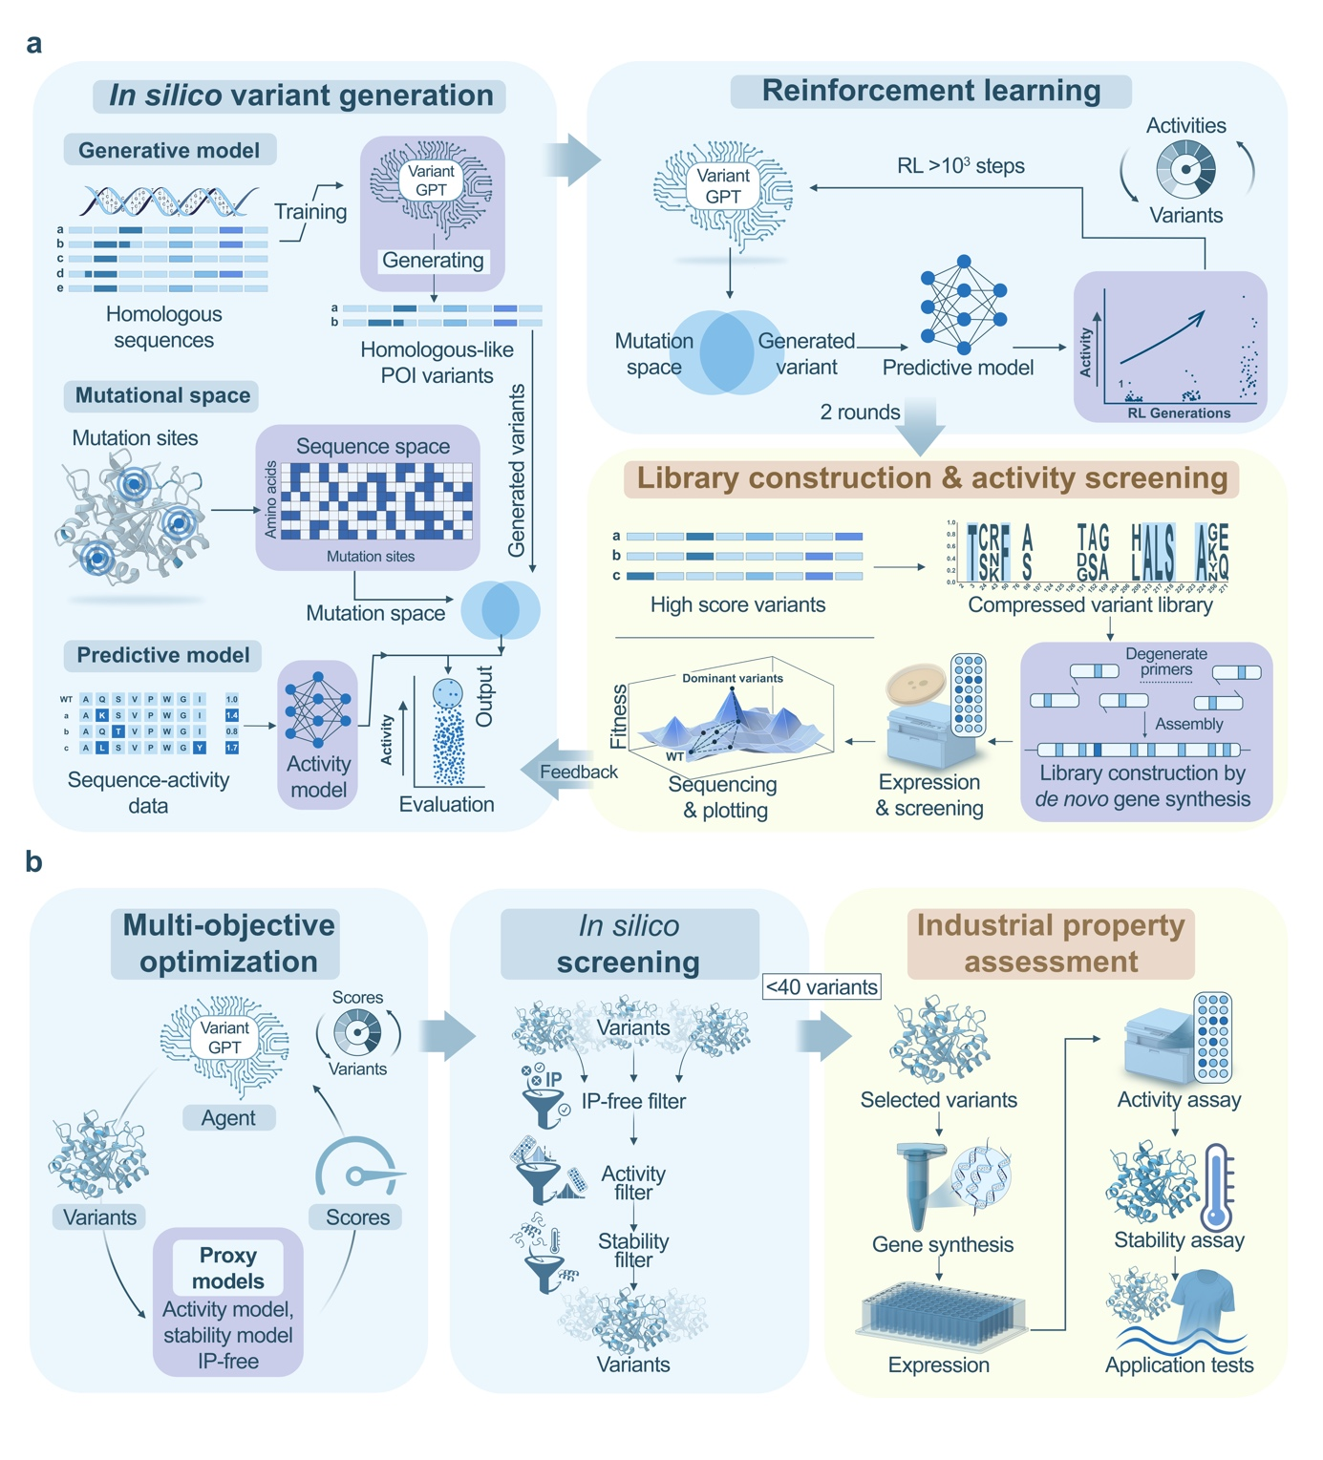

Figure 1 | AlphaVariant couples a generative sequence prior, dynamic mutational space definition, and reinforcement learning for low-N enzyme optimization.
a, Compressed library-based workflow to optimize activity. Left: Three components to execute reinforcement learning (RL) in AlphaVariant: a VariantGPT prior model trained on homologous sequences to generate variants; a mutational space defined on the basis of existing knowledge to constrain the sequence space; and an activity model trained from a sequence‒activity pair dataset to serve as feedback to the agent. Top right: RL process. In the RL process, the VariantGPT agent model was used to generate variants within the mutational space. The predictive model was used to score the variants and provide feedback to the agent. Through RL steps, the agent model generates multisite mutations with improved predicted activities. Bottom right: The experimental workflow used to assay activity. The high-score variants were used to design experimental libraries. In each library, fixed mutations were defined to establish a good starting point, and flexible sites were used to enable effective exploration. To synthesize the libraries, degenerate codons were used to construct the local fragments, which were assembled together via Gibson assembly. The libraries were then transformed into E. coli, which were selected on agar plates and expressed as B. subtilis. The variants were assayed with a microplate reader to obtain activities, and Sanger sequencing was used to obtain the sequences. The protein sequence‒activity paired data were used in the second round of optimization. b, Multi-objective optimization workflow for industrial application. In the third round, activity, stability, and intellectual property freedom (IP-free) were simultaneously co-optimized. Multiple predictors were added as feedback to the agent in the RL process. The generated variants were filtered via IP-free, activity, and stability filters to obtain 32 variants for extensive industrial tests.

Benchmarking AlphaVariant across protein fitness landscapes
To evaluate AlphaVariant against established sequence-optimization approaches, we assembled a benchmark of eight experimentally measured fitness landscapes spanning diverse protein families and five functional classes (Figure 2a): a binding domain (GB1¹⁶), a signaling kinase and an RNA-binding domain (PhoQ¹⁷, PAB1¹⁸), two enzymes (TrpB¹⁹, TEV²⁰), two fluorescent proteins (CreiLOV²¹, avGFP²²), and a viral-capsid assembly protein (AAV²³). The landscapes form two regimes that probe complementary capabilities. Four four-site combinatorial landscapes (GB1, PhoQ, TEV, TrpB; 140,517–159,132 measured variants) are near-complete 20⁴ libraries in which every candidate has a measured label, so the landscape is queried as an exact lookup table. Four multi-site landscapes (AAV, CreiLOV, GFP, PAB1; 15–233 variable positions) define combinatorial spaces of approximately 10³⁶ to >10¹⁸⁰ sequences that no experimental library covers, and were therefore queried through a learned surrogate of the landscape²⁴.
We compared AlphaVariant with nine published methods spanning four families (Figure 2b): basic search (Random, GreedyWalk); supervised and active-learning methods (ftMLDE²⁵, ALDE⁷, CLADE²⁶, EVOLVEpro²⁷, MULTI-evolve²⁸); a structure-guided method (AiCE⁸); and generative or policy-based search (AdaLead²⁴ and AlphaVariant). All methods used an identical campaign budget of 480 queries (96 sequences per round × 5 rounds), were run for 30 independent seeds, and were scored with two metrics: the normalized maximum fitness discovered and the top-128 mean fitness, a batch-quality metric that rewards recovering many high-fitness variants rather than a single outlier.
The four-site landscapes contain very few high-fitness variants: the fraction of sequences with normalized fitness ≥ 0.5 ranged from 0.007% (PhoQ) to 0.35% (TrpB) (Extended Data Fig. 2a). For PhoQ and TEV, a uniformly random campaign of 480 draws is not expected to recover any high-fitness variant, so success requires guided exploration.
On maximum fitness (Figure 2c), AlphaVariant was competitive with the strongest baselines on all four landscapes and achieved the highest median of max fitness on PhoQ, the sparsest landscape (median normalized maximum fitness 0.53). It reached the global optimum on GB1 (median 1.00, matching ALDE), and obtained 0.83 on TrpB and 0.38 on TEV. ALDE was the strongest four-site baseline (median maximum fitness 0.93 on TrpB and 1.00 on GB1), consistent with the suitability of ensemble Thompson sampling for densely labeled libraries. On top-128 mean fitness (Extended Data Fig. 2b), AlphaVariant remained in the leading group (0.47 GB1, 0.55 TEV, 0.55 TrpB, 0.12 PhoQ), trailing ALDE, CLADE and MULTI-evolve by small margins. Aggregating ranks across the four landscapes (Figure 2e, top), AlphaVariant placed third by mean rank, behind ALDE and MULTI-evolve. In this regime, in which exhaustive labels favor supervised surrogates, AlphaVariant performed comparably to the best methods without landscape-specific tuning.
The multi-site landscapes test optimization over sequence spaces too large to enumerate. We replaced the lookup table with a convolutional oracle trained on all measured variants of each protein (Methods); the oracles were accurate on held-out data (test Spearman ρ = 0.89 (AAV), 0.98 (CreiLOV), 0.86 (GFP), 0.90 (PAB1); n_test = 3,652–16,542; Extended Data Fig. 3a), and every queried sequence — including sequences distant from the measured set — was scored by the oracle.
In this regime AlphaVariant achieved the highest median maximum fitness on three of four landscapes — AAV (0.71), CreiLOV (0.99) and PAB1 (0.58) — and ranked second on GFP (0.93 versus 0.95 for AiCE; Fig. 2d). On top-128 mean fitness (Extended Data Fig. 3b), AlphaVariant was highest on AAV (0.65) and PAB1 (0.50) and close to the leaders on CreiLOV (0.90 versus 0.94 for AdaLead) and GFP (0.80 versus 0.85 for AiCE). Two-sided Wilcoxon signed-rank tests on paired per-seed values, Bonferroni-corrected for multiple comparisons (α = 0.05; Extended Data Fig. 3c), supported these differences: on AAV, AlphaVariant exceeded all nine baselines on both metrics (9/9 comparisons significant), and on PAB1 it was significant against 8/9 baselines for maximum fitness and 7/9 for top-128 mean fitness. Across the four multi-site landscapes AlphaVariant had the lowest mean rank (1.25; Figure 2e, bottom), ahead of GreedyWalk, AdaLead and AiCE.
Considered together, these results demonstrate that AlphaVariant's generative prior and policy-gradient optimization achieve performance comparable to the strongest supervised approaches on densely labeled four-site landscapes while ranking first among ten benchmarked methods on larger multi-site landscapes, all using a single configuration without landscape-specific tuning. These findings suggest that AlphaVariant can effectively navigate diverse protein fitness landscapes and that its generative priors and policy-guided exploration become particularly advantageous as the search space expands.
However, benchmark datasets represent controlled experimental settings and do not fully capture the practical challenges of enzyme engineering, including limited assay data, library construction errors, expression variability, and application-specific optimization objectives. To assess whether these advantages translate to real-world protein engineering, we next evaluated AlphaVariant in a wet-lab optimization campaign targeting savinase, an industrial alkaline protease.

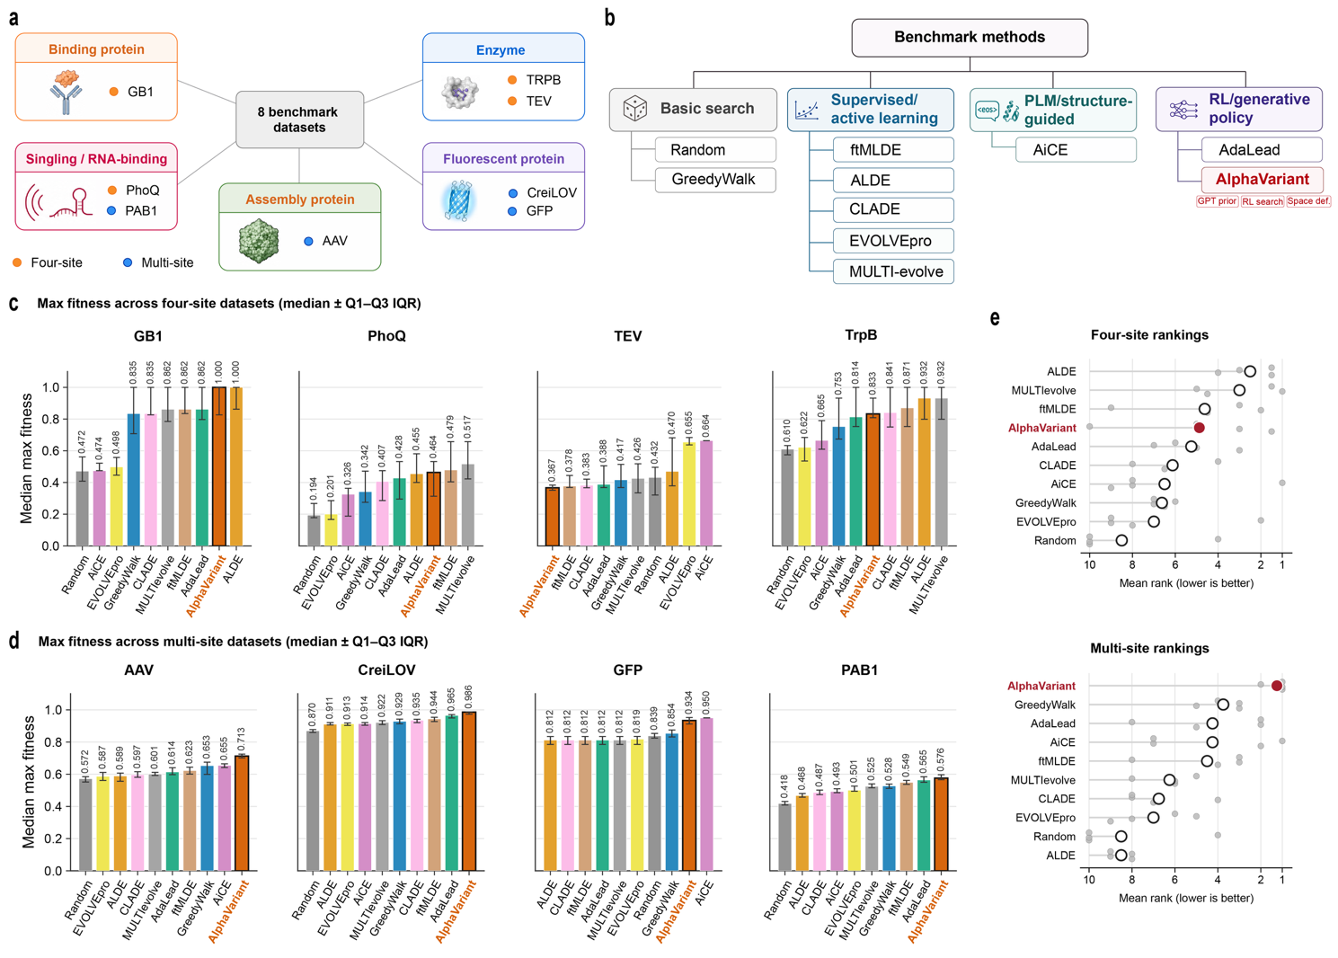

Figure 2 | Benchmarking AlphaVariant across diverse protein fitness landscapes.
a, Eight benchmark datasets spanning binding, signaling/RNA-binding, assembly, enzyme and fluorescent proteins, with four-site and multi-site landscapes indicated. b, Comparator methods grouped by search, supervised or active-learning, protein language model (PLM) or structure-guided design and reinforcement learning (RL) /generative strategies. c,d, Maximum normalized fitness achieved on four-site (c) and multi-site (d) datasets. Bars show medians and error bars denote the Q1–Q3 interquartile range. e, Aggregate rankings across four-site and multi-site benchmarks; points denote dataset-level ranks and open circles indicate mean rank, with lower values indicating better performance. AlphaVariant achieves consistently high fitness and best overall ranking on multi-site benchmark regime.

AlphaVariant prioritizes multisite savinase libraries from a constrained mutational space
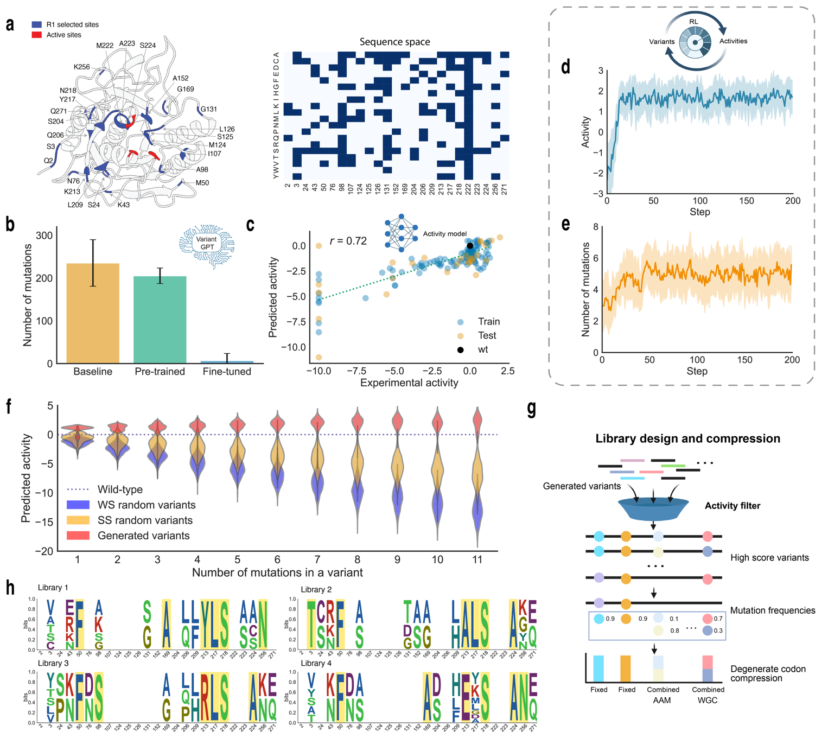

Figure 3 | AlphaVariant compresses an enormous multisite search space into experimentally testable activity-improving libraries in Savinase.
a, The mutation sites selected in the first round of optimization. Left: Twenty-five sites were selected for mutagenesis, as highlighted in blue. The active sites are highlighted in red. Right: the amino acids selected for exploration within the 25 sites. b, Number of mutations in the variants generated by the prior models. The distribution of the homology sequences is shown as the baseline. c, Evaluation of the activity model built from the publication dataset. A Spearman correlation of 0.72 was achieved on the test dataset. d, Optimization of activity in the RL process. e, The average number of mutations of variants generated in the RL process. f, Comparison of the predicted activities between the generated variants and the random variants. Two types of random variants were analyzed, including variants with random mutations in the whole sequence (WS) and in the selected sites (SS). g, Workflow used to design computational libraries from the generated variants. h, The four libraries in the first round.

Enzyme engineering has long been constrained by the combinatorial explosion of multisite optimization. Accessing the highest-performing regions of sequence space often requires coordinated mutations at multiple sites, a challenge that is intractable for conventional screening methods. AlphaVariant is an RL framework that learns to navigate this vast landscape. We first applied the AlphaVariant to the well-characterized subtilisin BPN' as a model system to establish the principles of our approach on the basis of abundant literature data.
Because publicly available activity data for savinase variants are limited, we first used experimentally characterized subtilisin BPN′ variants as a related-data source to initialize the first round of design. Mutation positions and substitutions reported for BPN′ were mapped to the savinase sequence by sequence alignment, and only aligned positions with clear correspondence were retained for library design. This transfer step was used to define an initial constrained mutational space, after which experimentally measured savinase variants were used to update the models and mutational space in subsequent rounds.
Our RL agent, guided by a specialized generative model (VariantGPT) and a predictive fitness model, was tasked with generating improved variants within a defined mutational space (Figure 3a, Extended Data Fig. 4). The VariantGPT model, pretrained on a large corpus of subtilase sequences and fine-tuned on BPN' variants, learned to generate focused, multisite variants with a mean of seven mutations, a significant deviation from the random, high-mutation variants generated without fine-tuning (Figure 3b). This agent was guided by an ev+onehot fitness model²⁹ that achieved a Spearman correlation of 0.72 on a held-out test set, providing reliable predictions of variant activity (Figure 3c).
The RL optimization achieved a remarkable breakthrough in multisite activity optimization. Within just 30 steps, the agent generated variants with enhanced predicted activities (Figure 3d) and multiple mutations (Figure 3e). A total of 42,117 unique improving variants were generated containing one to eleven coordinated mutations during the RL process. Critically, the agent learned to identify synergistic mutations, leading to a reversal of the typical relationship between mutation number and activity. Surprisingly, while randomly generated variants tend to lose activity with an increasing number of mutations, the variants generated by AlphaVariant showed a positive correlation between mutation count and predicted activity (Figure 3f), which indicates our model’s ability to effectively explore the combinatorial effects of individual mutations. This in silico result provides strong evidence that our RL framework can effectively navigate the complexities of multisite optimization and identify beneficial high-order mutation combinations, a capability that has been a long-standing challenge for protein design.
On the basis of the strength of these computational results, we proceeded with experimental validation. We designed four libraries of variants on the basis of computationally generated sequences, balancing predicted activity with sequence diversity to maximize the potential for discovering highly active enzymes in the wet laboratory (Figure 3g, h).

First-round experimental screening validates activity-enriched savinase libraries
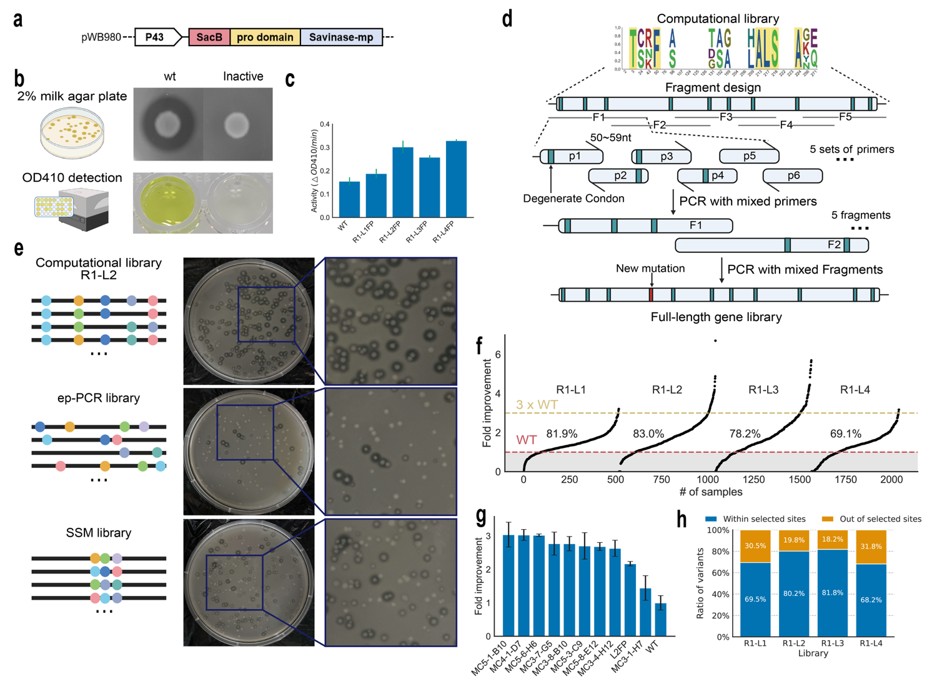

Figure 4 | AlphaVariant-designed libraries achieve high experimental activity-improvement rates in Savinase.
a, Illustration of the plasmid used to express the variants. b, Examples of 2% milk agar plates and OD 410 used to select and determine the variant activities. On agar plates, active variants, such as the wild type displayed here, are characterized by colonies surrounded by clear hydrolysis halos, whereas inactive mutants do not exhibit this clear halo. During OD410 assays, active variants catalyze the cleavage of AAPF, generating a colored product with a distinct absorption at 410 nm, whereas inactive variants show no color change. c, The catalytic activities of the fixed mutants in the four libraries and the wt savinase. d, Workflow used to construct the DNA libraries from the computational libraries. The gene was split into five fragments, each amplified by PCR with degenerate primers, and then assembled through overlap-PCR, allowing new mutations for diversity. e, Comparison of the computational library (MC2) with the error-prone PCR (ep-PCR) and site saturation mutagenesis (SSM) libraries. f, The catalytic activities of the variants in the constructed libraries. The success rates of obtaining variants with activities better than those of the wt savinase are shown on the curves. g, Activity improvements of the top 10 variants identified in the first round. Each variant was repeated three times. h, The ratio of variants containing mutations within and outside of the selected sites.

We next validated our computational predictions experimentally via the use of savinase, an industrial alkaline protease that serves as a stringent test case for enzyme engineering approaches. Savinase was selected for its extensive characterization in the literature, mature expression system, and direct industrial relevance, providing both a robust benchmark for comparison with traditional methods and immediate practical applicability for our results.
The computational designs of subtilisin BPN’ were adapted to savinase through sequence alignment, and four libraries were constructed for experimental testing (Figure 4, Extended Data Fig. 5). The plasmid pWB980 was used for cloning and expression. A plasmid framework was constructed with the sacB signal peptide, prodomain, and mature peptide (mp), enabling the protease to be constitutively expressed and secreted into the extracellular space in Bacillus subtilis WB600 under the control of the p43 promoter (Figure 4a). Active mutants could be selected on 2% milk agar plates, where single colonies secreting active protease form a milk hydrolysis cycle. Enzyme activity is detected via the substrate suc-AAPF-pNA, with active mutants cleaving the substrate and producing a colored product that absorbs at 410 nm (Figure 4b).
Initial validation confirmed the effectiveness of our approach: all four fixed mutation variants derived from the computational libraries showed improved activity compared with that of the wt savinase (Figure 4c). This result provided early evidence that our RL agent had successfully learned to identify beneficial multisite mutation combinations.
Next, we constructed DNA libraries by first constructing local fragments with primers having degenerate codons and then assembling these fragments together (Figure 4d, Extended Data Fig. 5). New mutations induced by primer assembly or PCR were allowed in the construction of DNA libraries. The active variants were first selected through 2% milk agar plates and then expressed as Bacillus subtilis (B. subtilis).
To evaluate the performance of our approach, we compared our computationally designed libraries with those of conventional enzyme engineering methods, including error-prone PCR and site saturation mutagenesis at positions 211, 212, and 216. Compared with these traditional approaches, the AlphaVariant-designed libraries presented substantially higher rates of active variants on selection plates (Figure 4e, Extended Data Fig. 6). Although the computational libraries also displayed inactive mutants on the plates, sequencing revealed that most of these clones were inactive because frameshift mutations (deletions and insertions) were introduced during the PCR assembly process. The AlphaVariant-designed libraries produced a higher fraction of active or improved variants than the ep-PCR and SSM libraries constructed and screened in parallel. Because success rates depend on library design, preselection, assay threshold, and expression system, we use these matched controls as the primary comparison rather than a universal directed-evolution baseline.
Among variants passing the screening workflow, 1,813 of 2,406 tested variants showed higher activity than wt savinase, corresponding to an improvement rate of 75.4% under this assay definition (Figure 4f). Each library contained variants with more than three-fold activity improvements, and the top-performing variants after rescreening are shown in Figure 4g.
Sequence analysis of the highest-performing variants revealed coordinated mutations spanning more than seven sites, confirming that our RL agent had learned to identify synergistic mutation networks across different structural regions. Additionally, 20–30% of the library sequences contained mutations introduced during PCR assembly, effectively expanding the explored sequence space beyond the original computational designs (Figure 4h). These experimental results, including both the activity data and mutation patterns, provided valuable feedback for subsequent optimization rounds.

Experimental feedback improves second-round activity optimization
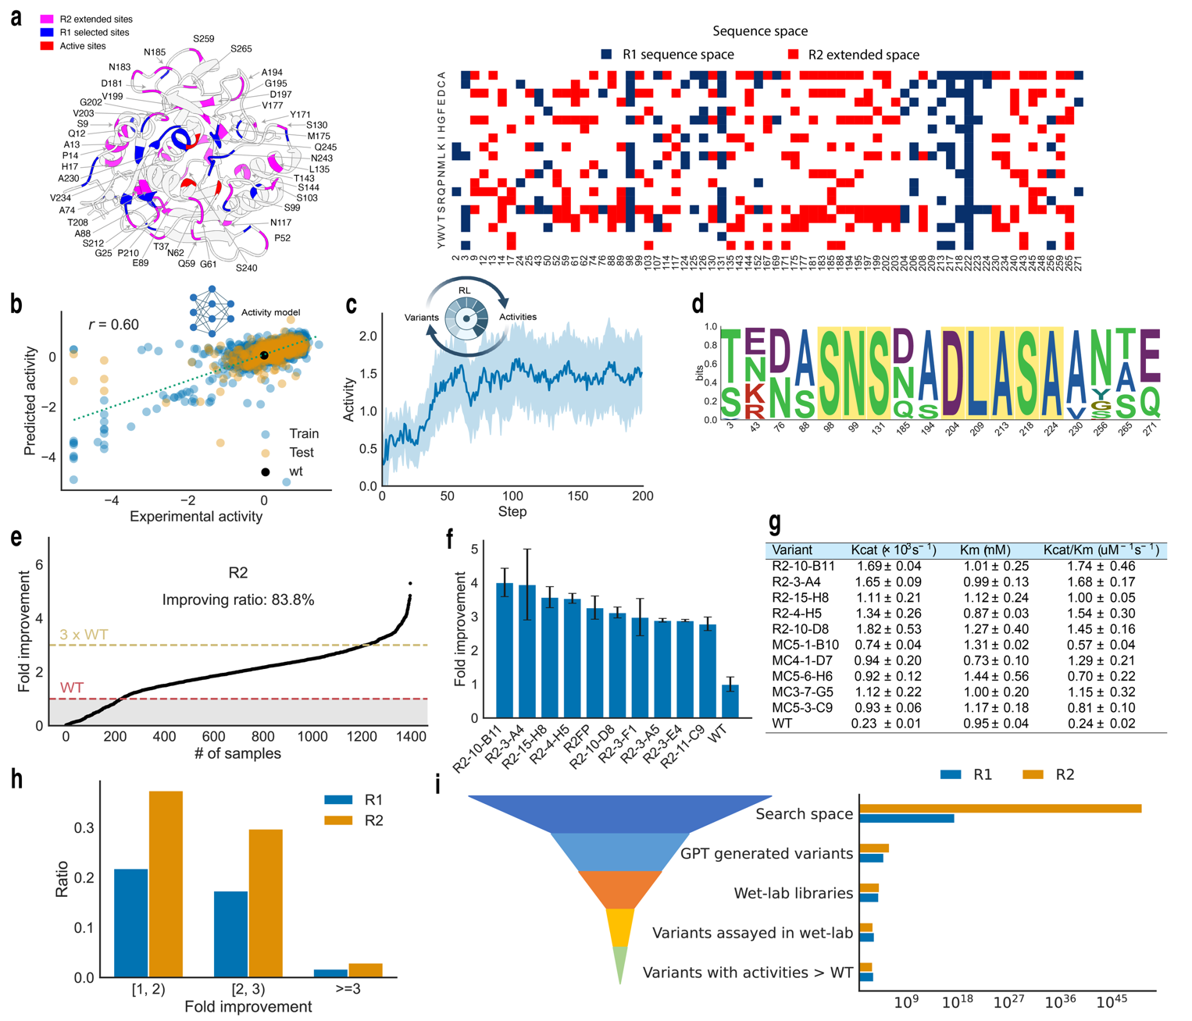

Figure 5 | Experimental feedback improves AlphaVariant’s second-round search efficiency and activity gains.
a, The mutation sites selected in the next round of optimization. Forty-three sites were selected for mutagenesis, as highlighted in blue. The active sites are highlighted in red. b, Evaluation of the Ev+onehot activity model built from the first-round experimental dataset. A Spearman correlation of 0.60 was achieved on the test dataset. c, Optimization of activity in the RL process. d, The library designed in the second round. e, Experimental catalytic activities of the variants in this library. A total of 83.8% of the variants presented better activities than did the wt savinase. f, Activity improvements of the top 10 variants identified in the first round. Each variant was repeated three times. g, Kinetic parameters of savinase and the top five mutants from the first and second rounds. h, Fold improvement ratios of the variants in the first and second rounds. i, The funnel of variant spaces explored in the two rounds of experiments.

The second round tested whether experimentally measured savinase variants could improve subsequent search. We used first-round sequence–activity data to identify additional candidate positions, retrain activity predictors, and initialize six optimization runs from the highest-performing first-round variants. This design allowed AlphaVariant to exploit experimentally validated beneficial regions while exploring expanded combinations of mutations.
Analysis of the first-round experimental data via Shapley³⁰ and statistical methods identified 43 additional mutation sites that contributed positively to enzyme performance (Figure 5, Extended Data Fig. 7). We expanded our mutational space to include these sites, incorporating the five most frequent amino acids from homologous sequences at each position. This data-driven expansion resulted in 68 mutation sites covering a sequence space of 1.71 × 10⁵⁰ while maintaining a focus on experimentally validated beneficial regions (Figure 5a).
We also enhanced our predictive models by systematically evaluating multiple protein language models (ESM-3B, ProT5-XL, and ProtAlbert) alongside the proven ev+onehot approach^{9,29,31–33}. After benchmarking, we selected the ev+onehot model for the RL process, which achieved a Spearman correlation of 0.60 for activity prediction (Figure 5b).
To explore multiple high-performance regions simultaneously, we implemented a multi-start strategy using the six best variants from our previous round as starting points for parallel optimization campaigns. This approach enabled systematic exploration of multiple high-performance regions simultaneously, with each RL agent converging to improved solutions within 60 steps (Figure 5c).
For experimental validation, we developed the DGC-libgen method to design efficient degenerate codon libraries (Extended Data Fig. 8). Analysis of amino acid patterns across optimization runs revealed similar preferences that enabled library consolidation without sacrificing sequence diversity, resulting in a single consolidated library for experimental testing (Figure 5d).
Experimental screening of approximately 1,500 colonies yielded a success rate of 83.8%, representing an improvement over the 75.4% achieved in the first round (Figure 5e). Compared with the wt savinase, the top-performing variant, R2-10-B11, presented a greater than four-fold increase in activity (Figure 5f). Kinetic characterization of the top five variants from both rounds confirmed consistent improvements in the k_{cat}/K_{M} ratios, with activity enhancements attributed primarily to increases in k_{cat} (Figure 5g).
A comparison of the two optimization rounds demonstrates the effectiveness of iterative learning. The second round achieved higher success rates while exploring a vastly expanded sequence space, indicating that the framework becomes more effective as it accumulates experimental data (Figure 5h, i). The identification of 14 novel beneficial sites and the construction of an activity landscape from both rounds provide a foundation for understanding the sequence‒function relationships in this enzyme system (Extended Data Fig. 9, SI Fig. 10).

Multi-objective optimization balances activity, thermostability, and IP-conflict avoidance
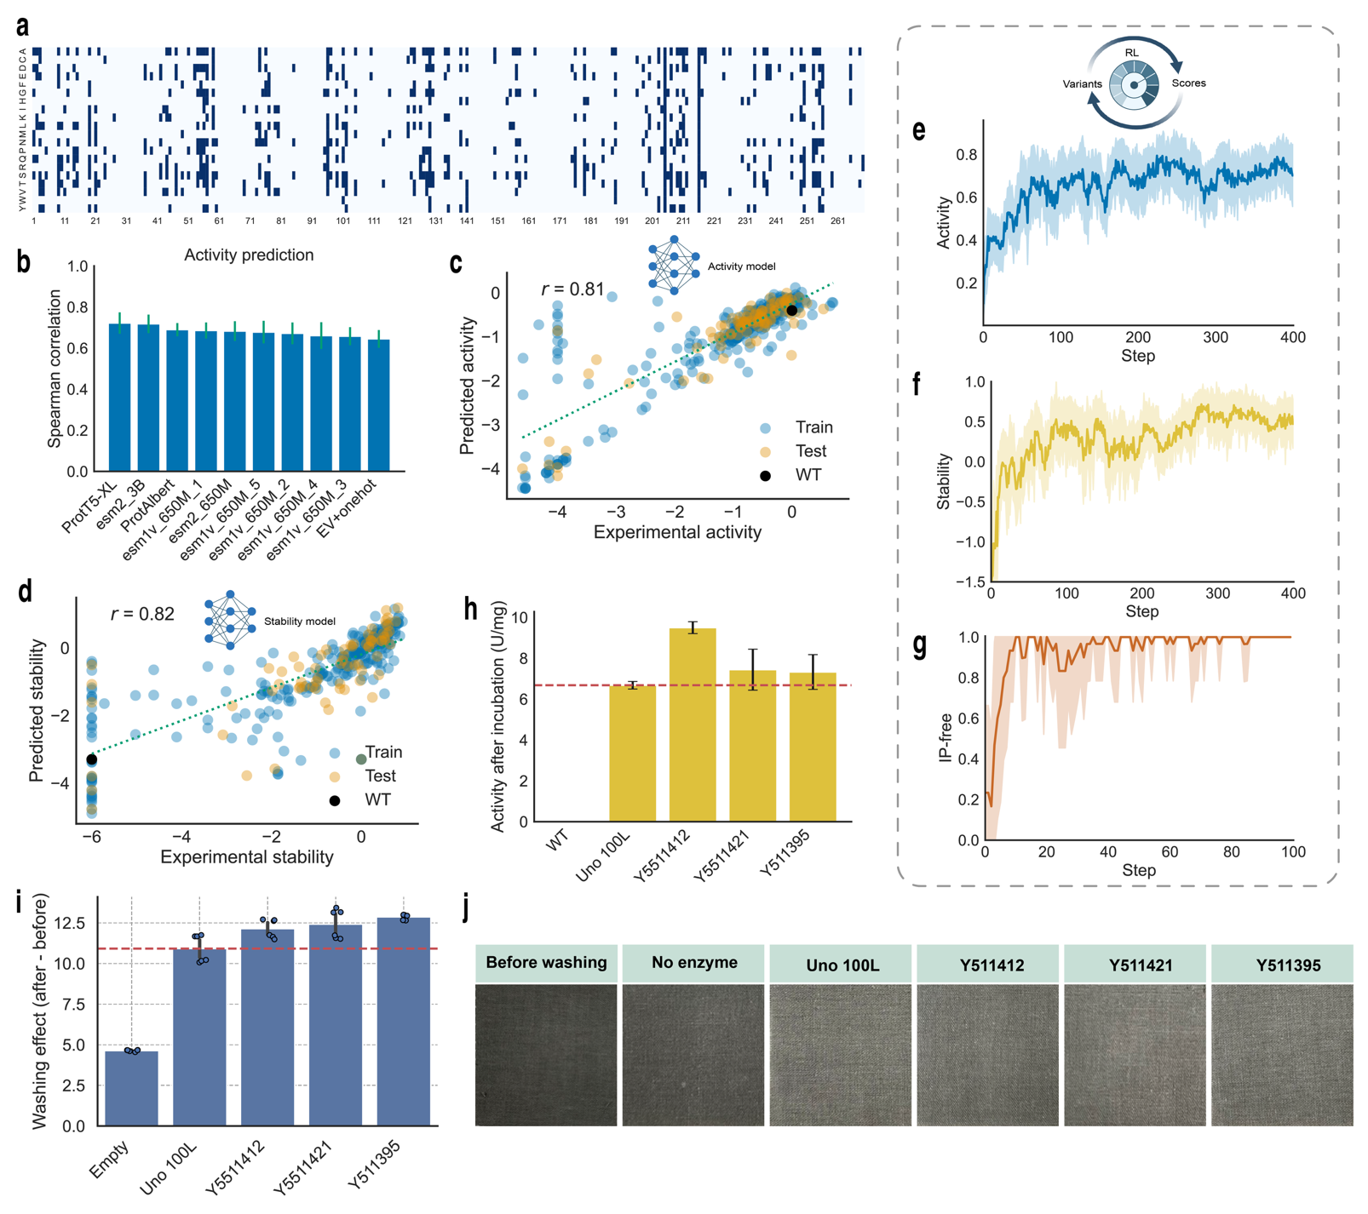

Figure 6 | AlphaVariant identifies industrially relevant Savinase variants through multi-objective reinforcement learning.
a, The mutational space in the third round. b, Evaluation of the predictive models on the basis of the variant-activity data with casein as the substrate. c, Evaluation of the ProtT5-XL-based activity model used in the RL process. d, Evaluation of the ProtT5-XL-based stability model used in the RL process. e-g, Improvements in activity, stability and IP-free properties in the RL process. h, Activity of the selected variants after thermo-incubation. i, Washing effects of the selected variants. j, Washing pictures of the selected variants.

Commercial enzyme development typically requires balancing catalytic activity, thermostability, and intellectual property freedom (IP-free) — properties that often exhibit complex trade-offs. For the third round, we extended AlphaVariant to a multi-objective setting by combining predicted activity, predicted thermostability, and a patent-rule-based IP-conflict score. The IP-conflict score was derived from manually curated mutation rules extracted from relevant patent claims and verified by an IP specialist. This score can be interpreted as an operational filter for avoiding predefined patent-claim conflicts. Our third optimization round tested whether AlphaVariant could navigate these competing objectives to identify variants suitable for industrial applications (Figure 1b).
For this multi-objective optimization, we expanded the mutational space to 116 sites by including high-perplexity sites and incorporating frequently observed amino acids from homologous sequences (Figure 6a, Extended Data Fig. 10a). We systematically benchmarked multiple protein language models (ProtT5-XL, ProtAlbert, ESM-2, and ESM-1v) alongside our ev+onehot approach to select optimal predictive models for each property (Figure 6b, Extended Data Fig. 10b, SI Fig. 11). ProtT5-XL embeddings provided the best performance for both activity and stability prediction and were selected for the RL process (Figure 6c, d).
A key innovation was the integration of IP-free optimization directly into the RL process. We developed an IP conflict detection method that quantifies potential patent overlaps and assigns scores to variants accordingly, rewarding those predicted to be IP-free. The enzyme engineering landscape is highly constrained by existing patents—over 60,000 patents collectively protect more than 140 mutational sites, with most residues critical for catalytic activity and structural stability already covered. Within this dense IP space, the RL agent successfully improved activity, stability, and IP freedom simultaneously within the first 100 steps, demonstrating its ability to navigate the complex trade-offs between these industrial properties (Figure 6e-g, Extended Data Fig. 10c).
The optimization process generated 513,048 variants, from which 235,098 IP-free candidates were identified through systematic filtering. Ensemble modeling with our top three activity and stability predictors identified the 200 most promising variants, which were further refined through molecular dynamics simulations to select 32 variants optimized for the high pH and high-temperature conditions required in detergent applications.
Experimental validation of the 32 selected variants revealed three that outperformed Uno 100 L, a leading commercial enzyme standard, in both activity and thermostability assays (Figure 6h, Extended Data Fig. 10d). These variants were tested via established protocols, including expression in B. subtilis, activity assays with casein substrate, and incubation at 85°C for three minutes for thermostability testing. Importantly, washing performance tests confirmed that, compared with Uno 100 L, all three variants presented improved cleaning efficacy under realistic application conditions (Figure 6i,j).

Discussion
This study demonstrates that reinforcement-learning-guided sequence generation can enrich experimentally improved multisite variants of an industrial protease under low-N data conditions. By coupling a generative sequence prior to predictive fitness models, AlphaVariant prioritized compact libraries that produced high fractions of activity-improved savinase variants across two experimental rounds. The third round further showed that the same framework can incorporate multiple application-relevant reward terms, including predicted activity, predicted thermostability, and patent-rule-based IP-conflict avoidance.
Protein fitness landscape diversity -> Microworld exploration? Tools and features useful.
A central finding of our work is the ability of the RL agent to identify synergistic, long-range epistatic interactions. The highest-performing variants contained between 3 and 17 mutations distributed across the protein structure, including sites distant from the active site. This underscores a key principle of protein function: optimal performance often emerges from a network of coordinated changes rather than from isolated, additive mutations. Traditional methods, which are often limited to exploring single mutations or small combinations, are ill equipped to discover these complex mutational landscapes. In contrast, our approach learns to identify these synergistic combinations, providing a more comprehensive and effective means of exploring sequence space.
The practical utility of this approach was demonstrated in our third optimization round, where we simultaneously targeted catalytic activity, thermostability, and intellectual property (IP) freedom. The resulting variants not only showed improved performance but also outperformed a leading commercial enzyme standard, Uno 100 L, in both laboratory assays and real-world washing performance tests. The fact that our computationally driven approach could identify novel, IP-free variants superior to a benchmark that has been refined over decades of industrial development suggests that even highly optimized enzymes may harbor significant potential for further improvement when explored with a global optimization strategy.
Several limitations should be considered when interpreting these results. First, AlphaVariant depends on a constrained mutational space defined from homologous sequences, literature, patents, and experimental feedback; therefore, the current workflow reduces but does not eliminate expert-guided design choices. Second, the predictive models used as reward functions showed moderate correlations with experimental activity, and model errors may bias the generated variants. Third, the multi-site benchmark relied on learned oracles for unmeasured sequences, which is useful for controlled comparison but does not replace experimental validation. Fourth, the wet-lab validation focused on savinase, and additional enzymes will be required to establish the experimental generality of the approach.
However, the performance of AlphaVariant is not without limitations. Two core challenges constrain the current framework: the selection of mutational space and the accuracy of predictive fitness models. Our approach relied on the selection of 25–68 mutation sites, which, while effective for savinase, may not capture all functionally important regions for less well-characterized enzymes. The choice of amino acid substitutions at each site was primarily on the basis of evolutionary frequency in homologous sequences, potentially missing beneficial mutations that are rare in nature but advantageous under specific conditions. Additionally, the success of the RL agent is fundamentally dependent on the accuracy of the predictive fitness models, which achieved Spearman correlations of 0.60–0.72 in our study. While we demonstrated successful transfer of knowledge from subtilisin BPN’ to savinase, the applicability of this framework to enzymes with sparse publicly available data remains an important area for future investigations. Furthermore, while our success rates were high, a fraction of the variants in each round were inactive. Sequencing revealed that many of these failures were due to frameshift mutations introduced during library construction, highlighting the need for continued improvements in DNA synthesis and assembly. Other failures may be attributed to inaccuracies in the predictive models, indicating that there is still room to improve model fidelity, perhaps by incorporating more sophisticated structural information or biophysical models.
Future work will focus on addressing these core limitations through several strategic directions. First, we will develop improved methods for mutational site identification by integrating structure-based approaches, including molecular dynamics simulations, residue interaction networks (RINs)³⁴, dynamic cross-correlation matrices (DCCM), and neural relational inference (NRI)³⁵, to identify functionally critical regions beyond those evident from sequence analysis alone. Second, we will enhance mutation selection through established inverse folding methods such as ProteinMPNN³⁶, ESM-IF³⁷, and LigandMPNN³⁸, combined with advanced protein language models (ProGen¹⁰, ESM⁹) and structure-based computational tools, including AlphaFold3³⁹ and MutCompute⁴⁰. These approaches should enable more informed selection of both mutation sites and specific amino acid substitutions. Third, we will implement explainable AI frameworks to interpret the synergistic combinations of amino acids identified by AlphaVariant, providing mechanistic insights into why certain multisite mutations work together and enabling more rational design principles. In addition, the development of more robust predictive models that can better capture the nuances of the sequence-function landscape will also be critical. Finally, in the longer term, coupling the AlphaVariant system with automated, high-throughput robotic platforms could enable a fully autonomous, closed-loop laboratory for enzyme design, dramatically accelerating the pace of biocatalyst development.
In conclusion, this work establishes reinforcement learning as a viable and highly efficient strategy for multi-objective enzyme optimization. By autonomously learning the complex rules of protein fitness landscapes, this approach provides a scalable and data-efficient alternative to traditional methods, opening new avenues for the design of high-performance biocatalysts for a wide range of industrial and therapeutic applications.
Overall, these results support AlphaVariant as a promising framework for data-efficient multisite enzyme optimization. Future work should test the approach across broader enzyme families, incorporate uncertainty-aware reward models, improve library synthesis fidelity, and integrate structure-based or biophysical constraints where they improve predictive reliability. Such developments could help convert reinforcement learning-guided protein design from a case-specific workflow into a more general platform for experimental enzyme engineering.

Methods

AlphaVariant framework architecture
The AlphaVariant framework integrates three core components to enable efficient protein optimization: a generative pretrained transformer (VariantGPT) that serves as a prior model for generating enzyme variants, a mutational space to constrain the search space of the agent, and low-N fitness models that predict protein properties from sequence information. This integrated architecture enables the autonomous exploration of protein sequence space while maintaining a focus on variants with a high probability of improved function.
The VariantGPT component was implemented as a transformer-based language model. The model architecture follows established transformer designs with multi-head attention mechanisms and positional encoding optimized for protein sequence generation tasks⁴¹.
The RL component implements a policy gradient algorithm that learns to generate improved variants through interaction with predictive fitness models⁴². The agent receives rewards on the basis of predicted protein properties, enabling it to iteratively refine its variant generation strategy without requiring extensive experimental feedback.
The reinvent loss function, defined by Equations 2–3, was used to update the agent model⁴². First, a sequence was sampled from the agent model, and the log-likelihood was calculated. This sequence was then passed to the prior model to calculate the prior log-likelihoods and to the activity model to obtain the score. The score was added to the prior log-likelihoods with a coefficient, resulting in augmented log-likelihood. The square error between the augmented log-likelihood and the agent log-likelihood was calculated as the loss to update the agent model. Prior log-likelihood was included to incorporate prior knowledge learned from subtilase sequences and subtilisin BPN’ variants. The agent model was trained for 2,500 steps, with 45 variants generated in each step.
$\log{p}{\left(A\right)}_{aug}=\log{p}{\left(A\right)}_{prior}+σS\left(A\right)$ (1)
$Loss={\left[\log{p}{\left(A\right)}_{aug}-\log{p}{\left(A\right)}_{agent}\right]}^{2}$ (2)

Benchmarking AlphaVariant on fitness landscape

Benchmark datasets
We evaluated all methods on eight experimentally measured protein-fitness landscapes (Figure 2a). Assay values were min–max normalized to [0, 1] within each landscape, so the global maximum maps to 1.0 and metrics are comparable across proteins. The landscapes were grouped into two regimes.
Four four-site combinatorial landscapes were used as exact lookup tables: GB1 (IgG-binding B1 domain, positions 39/40/41/54; 149,361 variants¹⁶), PhoQ (signaling histidine kinase; 140,517 variants ¹⁷), TEV (protease; 159,132 variants²⁰) and TrpB (tryptophan synthase β-subunit; 159,129 variants¹⁹) (Extended Data Table 1) . Each is a near-complete 20⁴ library in which every candidate has a measured fitness. The landscapes are sparse in high-fitness variants: the fraction of sequences with normalized fitness ≥ 0.5 was 0.13% (GB1), 0.007% (PhoQ), 0.05% (TEV) and 0.35% (TrpB) (Extended Data Fig. 2a).
Four multi-site landscapes were used with a learned oracle: AAV (capsid VP1 28-residue diversification region²³), CreiLOV (LOV-domain fluorescent protein, 119 aa, ~15 variable positions²¹), avGFP (237 aa, up to 233 variable positions²²) and PAB1 (RNA-recognition motif, 75 aa¹⁸) (Extended Data Table 2). These span combinatorial spaces of approximately 10³⁶ (AAV) to >10¹⁸⁰ (GFP) sequences. A lookup table returns zero for any unmeasured sequence, which collapses guided search; we therefore scored candidates with a trained oracle.

Learned oracle for multi-site landscapes
For each multi-site landscape we trained a sequence-to-fitness oracle using a length-agnostic convolutional architecture (1D convolution, 20→256 channels, kernel size 5; length-wise global max-pooling; linear regression head), matching the predictor used in AdaLead²⁴. Oracles were trained on all measured variants by minimizing mean-squared error (Adam, learning rate 1×10⁻⁴, weight decay 1×10⁻⁴, batch size 1,024, ≤100 epochs; PyTorch 2.1.1) with fitness-weighted sampling (weight ∝ 1/(target − min + 1)) to emphasize the rare high-fitness tail. The fitted min/max scaler was stored with each checkpoint and used to de-normalize predictions.
Oracles were accurate on held-out test variants (test Spearman ρ = 0.89/0.98/0.86/0.90 and R² = 0.78/0.95/0.80/0.78 for AAV/CreiLOV/GFP/PAB1; n_test = 4,412/16,542/5,171/3,652; Extended Data Fig. 3a). During optimization we used a pure-oracle policy: every queried sequence, including sequences far from the measured set, was scored by the oracle, and measured labels were used only to train the oracle. To detect oracle-exploitation artifacts we recorded the mutational novelty of selected sequences relative to the measured set (Extended Data Fig. 3a, bottom).

Optimization campaign
All methods ran an identical campaign: an initial random batch of 96 sequences followed by four model-guided rounds of 96, for 480 queries in total (96 × 5), the budget used in prior directed-evolution benchmarks⁷. On four-site landscapes a query was resolved by exact lookup; on multi-site landscapes it was scored by the trained oracle. For methods that select from a fixed enumerated library (ALDE, CLADE, ftMLDE), the multi-site candidate source was replaced by a mutate-from-elites generator so that all methods operated over the same non-enumerable space while retaining each method's own surrogate model and acquisition rule.

Compared methods
We benchmarked nine published methods alongside AlphaVariant, grouped by family (Figure 1b, Extended Data Table 3). Two basic search methods were tested, including Random (uniform sampling each round) and GreedyWalk (evaluation of single-mutation neighbors of the current best); five supervised and active-learning methods compose of ftMLDE²⁵ (cross-validated ensemble of pretrained predictors), ALDE⁷ (ensemble regressor with Thompson sampling), CLADE²⁶ (ensemble with cluster-stratified selection), EVOLVEpro²⁷ (ESM-2 embeddings with a random-forest head; facebook/esm2_t12_35M_UR50D) and MULTI-evolve²⁸ (bootstrap neural-network ensemble); one structure-guided design method, AiCE⁸, using ProteinMPNN structure-conditioned per-position amino-acid frequencies (1,000 samples, T = 0.5) blended with observed high-fitness frequencies; and two generative/policy-based search methods, AdaLead²⁴ (recombination with surrogate-guided mutation) and AlphaVariant. Each method was run in the configuration recommended by its authors and used the unified metric pipeline.

AlphaVariant settings
AlphaVariant was evaluated under two benchmark regimes: four-site landscapes scored by exact lookup tables and multisite landscapes scored by learned convolutional neural network oracles. The same overall optimization workflow was used in both regimes. In each campaign, AlphaVariant used a GPT-based sequence generator, an augmented-likelihood REINFORCE objective⁴², a five-model surrogate ensemble, SHAP⁴³-based alphabet pruning, and cluster-stratified batch selection. Unless otherwise stated, all benchmark runs used five optimization rounds, a batch size of 96 sequences per round, 500 REINFORCE updates per round and a reward scale of σ = 60, giving a total query budget of 480 sequences per campaign.
For the four-site benchmarks, fitness values were obtained directly from experimentally measured lookup tables. The sequence prior was initialized within each run without homolog pretraining. For the multi-site benchmarks, fitness was evaluated using a learned CNN oracle trained for each landscape, and the GPT prior was pretrained on aligned homologous sequences before reinforcement-learning optimization. In both benchmark regimes, the generator was a four-layer GPT model with four attention heads and an embedding dimension of 128; the context length was adjusted to the length of each benchmark sequence.
At each round after initialization, a surrogate ensemble was fitted using all sequences evaluated up to that point. The ensemble consisted of two ridge-regression models, one Bayesian ridge-regression model, one random-forest model and one gradient-boosting model. For the four-site benchmarks, surrogate input features comprised per-position one-hot amino acid encodings together with four physicochemical descriptors: side-chain volume, hydropathy, solvent-accessible surface area and polarity. For the multisite benchmarks, the same amino acid and physicochemical features were augmented with a standardized EVmutation⁴⁴ statistical-energy score.
The reinforcement learning objective followed an augmented-likelihood formulation adapted from REINVENT⁴². For a sampled sequence s = (s₁, …, sL), the agent and prior log-likelihoods were computed as summed autoregressive token log-probabilities:
$\log{π_{θ}}\left(s\right)=\sum_{t=1}^{L}{\log{π_{θ}}\left(s_{t} ∣ s_{<t}\right)}, \log{π_{0}}\left(s\right)=\sum_{t=1}^{L}{\log{π_{0}}\left(s_{t} ∣ s_{<t}\right)}$ (3)
The augmented likelihood was defined as:
$A\left(s\right)=\log{π_{0}}\left(s\right)+σR\left(s\right)$ (4)
where $π_{0}$ is the fixed prior model, $π_{θ}$ is the trainable agent, $R\left(s\right)$is the sequence reward and $σ$ controls the strength of reward-driven displacement from the prior. The per-batch training loss was:
$L\left(θ\right)=\frac{1}{N}\sum_{s}{{\left[A\left(s\right)-\log{π_{θ}}\left(s\right)\right]}^{2}}-β\frac{1}{N}\sum_{s}{\frac{1}{\log{π_{θ}}\left(s\right)}}$ (5)
with $β=5×{10}^{3}$. The squared-deviation term increases the likelihood of high-reward sequences while anchoring the agent to the prior distribution. The second term was used as an exploration regularizer to discourage collapse of the agent distribution during optimization.
For multi-site benchmarks, the reward was the surrogate-ensemble upper confidence bound:
$R\left(s\right)=μ\left(s\right)+2ζ\left(s\right)$ (6)
where $μ\left(s\right)$ and $ζ\left(s\right)$ denote the mean and standard deviation, respectively, of predictions from the five-model surrogate ensemble. Thus, the reward favoured sequences with high predicted fitness while retaining an uncertainty-driven exploration component. In the multisite benchmarks, EVmutation was used as the zero-shot feature in the surrogate model, the same reinforcement-learning reward was used.
Each campaign began with one diversity-based initialization round. Specifically, k-means clustering was applied to the sequence-feature representation, and 96 starting sequences were selected across 10 clusters to provide a diverse initial training set. No surrogate model, reinforcement learning reward or zero-shot score was used for this first-round selection. In rounds 2–5, AlphaVariant refitted the surrogate ensemble using all accumulated observations, optimized the GPT agent for 500 REINFORCE steps, sampled a proposal pool from the trained generator and selected the next batch of 96 sequences using cluster-stratified selection. Candidate proposals were first ranked by surrogate-predicted fitness, the top 1,000 candidates were retained, and clustering was then used to select high-ranking representatives while maintaining batch diversity.
SHAP-based alphabet pruning was applied in both benchmark regimes to restrict low-value amino acid choices at each mutable position. Pruning was enabled when at least 50 evaluated samples were available. Amino acid substitutions with SHAP values above 0 were retained, with a minimum alphabet size of 3 per position and a maximum of 10 retained amino acids per position. In the multisite benchmarks, the pruned alphabet was propagated into the generator, and proposals violating the pruned alphabet were filtered before selection. Multi-site proposals were additionally constrained to contain no more than two mutations from the reference sequence. In the four-site benchmarks, the pruned alphabet was used for analysis and candidate prioritization, but no explicit proposal-alphabet constraint or mutation-count cap was applied during generation.
The principal differences between the two benchmark regimes are summarized in Extended Data Table 4. Briefly, the four-site benchmarks used exact lookup-table fitness values, an in-run GPT prior, amino acid and physicochemical surrogate features, and a reward combining UCB with a decaying MutCompute term. The multisite benchmarks used learned CNN-oracle fitness values, homolog-pretrained GPT priors, surrogate features augmented with EVmutation statistical energy, UCB-only reinforcement-learning rewards, alphabet-constrained proposal filtering and a two-mutation cap from the reference sequence.

Evaluation metrics
We report two complementary metrics per campaign. Maximum fitness is the highest normalized fitness among the 480 queried sequences, the canonical directed-evolution objective. Top-128 mean fitness is the median fitness of the 128 highest-fitness discovered sequences, a batch-quality metric that rewards recovering many strong variants. Method rankings (Figure 2e) were computed per landscape (rank 1 = highest median; ties assigned the average rank) and averaged within each regime.

Statistics and reproducibility
Each method × landscape combination was run for n = 30 independent random seeds (the first 30 entries of a fixed seed list). Distributions across seeds are heavy-tailed and multimodal; we therefore summarized each combination by its median and interquartile range (Q1–Q3) rather than the mean (Figure 2c,d; Extended Data Fig. 2b, 3b). Pairwise differences between methods were assessed with two-sided Wilcoxon signed-rank tests on the paired per-seed values, with Bonferroni correction for multiple comparisons at α = 0.05 (Extended Data Fig. 3c). No data were excluded and seeds were fixed for reproducibility.

Implementation of AlphaVariant on Savinase optimization
In the savinase optimization project, the VariantGPT prior model was trained on homologous protein sequences from the Pfam subtilase family (PF00082) with 6 million parameters⁴⁵. The pretraining was performed on approximately 50,000 subtilase sequences to establish a strong evolutionary prior, followed by fine-tuning on experimentally characterized enzyme variants to adapt the model for specific optimization objectives.

The first round

Datasets
The datasets used in the first round include homology sequences, publication and patent data, and in-house activity and stability datasets. The homologous sequences of subtilisin BPN’ were collected from the Pfam subtilase family sequences (Pfam id: PF00082)⁴⁵. The variant activity data used to train an activity model were manually collected from publications. Only variant data with AAPF as the substrate and subtilisin BPN’ as the wild type were selected to build the model, which resulted in 150 records. The patent data were also manually collected. These patent and publication datasets were used to define the sequence space.

Defining the mutational space
The subtilisin BPN’ sequence consists of 275 positions, resulting in a vast mutational space to explore. To efficiently generate active variants, we utilized existing knowledge from the literature and patents to narrow down the search space by selecting specific positions for optimization, which we refer to as mutation sites. We identified 25 mutation sites on the basis of the positions reported to be present in variants with improved activity. Within each mutation site, both the wild-type amino acid and amino acids known to have improving effects were permitted. This narrows the sequence space to explore to a size of 2.80 × 10¹⁷.

Building predictive models
A low-N fitness model was built to predict the activity of subtilisin BPN’ variants following the protocol of Hsu et al.²⁹. The activity data of subtilisin BPN’ variants with AAPF as the substrate at room temperature (20 to 25°C) were obtained from publications. Variants with deletions or insertions were removed, resulting in 150 variant activity scores. These activity scores were normalized by dividing them by the wt subtilisin BPN’ activity and then transformed to a logarithmic scale. The ev+onehot model was used to build the activity model, with 80% of the variants used for training and 20% (30 variants) used for testing.

Training the AlphaVariant prior model
The VariantGPT model was pretrained and fine-tuned to generate subtilisin BPN’ variants. It is based on GPT2, with approximately 6 million parameters. The model was trained on a next token prediction task using protein sequences. It consists of input and positional embedding layers, eight decoder blocks, a linear layer with layer normalization, and an output layer with a Softmax function. Each decoder block contains a masked multihead self-attention layer and a fully connected feed-forward layer. Residual connections and layer normalization were applied to the layers within the decoder blocks. An embedding size of 256 was used in the blocks.
To generate subtilisin BPN’ variants, the VariantGPT model was first pretrained on the Pfam subtilase family sequences (Pfam id: PF00082) ⁴⁵. A total of 56,623 sequences within the range of 127–478 were used to train the model, with 90% used for training and 10% for testing. The model was pretrained for 20 epochs with a batch size of 128 and then fine-tuned on 150 Subtilisin BPN variants collected from publications for 10 epochs. Cross-entropy loss was used to train the VariantGPT model, and the AdamW optimizer was used with a learning rate of 1×10⁻⁴.

Optimizing activity through RL
RL was used to fine-tune the VariantGPT model to generate variants with improved activities. To propose variants within the mutation sites, the VariantGPT agent was constrained to generate permitted amino acids within mutation sites while wild-type amino acids were used for positions outside of the mutation sites.
In the RL process, the predicted scores to serve as feedback should be within the range of zero--one. Therefore, a sigmoid function was applied to the predicted activity scores to transform the scores into this range, as shown in Equation (1). Two and -1 were selected as the upper (h) and lower (l) bounds, respectively.
$Sigmoid\left(x,l,h\right)=\frac{1}{1+ {10}^{ - k *\frac{x-\left(h+l\right)/2}{h - l}}}$ (1)

Designing libraries from the improved variants
To design libraries for wet-lab experiments, we enumerated high-frequency mutation combinations (MCs) within activity-improving variants. An MC was defined as a set of mutations that were present in at least 10 improving variants. We iteratively examined the generated improving variants to identify all possible MCs. First, 36,406 MCs with one to eight mutations among the improving variants were obtained via a dynamic programming algorithm. The mutation sites for each MC were subsequently identified by enumerating the positions other than the fixed sites. If an MC involved more than ten mutation sites, the top ten mutation sites with the highest occurrence rates were retained. Finally, the permitted amino acids for each position other than the fixed position were determined by analyzing the covered variants and calculating their frequencies.
Once MCs were obtained, we ranked them to identify those with the highest potential to cover variants with high activities. A weighted score for each MC was calculated by ensembling the activity of the variant with fixed mutations, the mean activities of the covered variants, and the maximum activities of the covered variants. The scores were scaled from zero to one via the empirical cumulative distribution, with the average calculated value being the weighted score.
The top 10 MCs were selected to construct preliminary libraries. To reduce cost, we merged these top 10 MCs into four libraries by expanding MC-1, MC-2, MC-7, and MC-9 to cover the remaining MCs while introducing as few mutagenesis sites as possible. The final four expanded libraries were used as the libraries for wet-lab experiments.

The second round

Datasets
Extending from the first round, the homologous sequences of savinase were retrieved, and in-house sequence-activity datasets were utilized in the second round. The homologous sequences of savinase were obtained by querying with the wild-type sequences in the Uniref100 database via JackHmmer ^{46,47}.
The sequence-activity dataset was collected from the variants in the first round. Only variants with missense mutations were collected, resulting in 2,414 sequences.

Defining the mutational space
We extended the mutation sites by including new improving mutations and positions in the previous round. Statistical analysis and Shapley analysis were performed to obtain mutations with positive contributions in both analyses³⁰. Additionally, the mean activity of variants that contained a mutation was calculated, and mutations with mean activities lower than those of wt savinase were excluded. This resulted in 43 new positions, and the amino acids in these positions were extended to include the top five most frequent amino acids in savinase homology sequences. The new positions were merged with the sites in the previous round, resulting in 68 mutation sites covering a sequence space of 1.71 × 10⁵⁰.

Building the activity model
To build new activity models, we evaluated the nine protein language models in addition to the ev+onehot model using the data from the first round. We found that ev+onehot, ESM-3B, ProT5-XL, and ProtAlbert achieved the best performances on this dataset. The ev+onehot model achieved a Spearman correlation of 0.60 on the test dataset, as shown in Fig. 4b. Because ev+onehot is very fast in inference, it was selected as the predictive model in the RL process.
To identify the best performing model to predict activities, we evaluated nine protein language models (pLM) in addition to the Ev+onehot model on the activity data collected from the first round. For all pLM models, PCA embedding preprocessing and support vector regressors were found to yield good performance and were used in the prediction head. The activity data were split into training and test sets with 20 different seeds, and the Spearman correlation was calculated for each data split. The means and variances of the Spearman correlations were evaluated to prioritize the models.
We found that ev+onehot, ESM-3B, ProT5-XL, and ProtAlbert had the best performances on this dataset. They were selected to build the activity prediction models in the next round of optimization. Because ev+onehot has the best Spearman correlation and is very fast in inference, it was selected as the predictive model in the RL process.

Training the AlphaVariant prior model
The prior was trained on savinase homologous sequences and fine-tuned with the variant sequences collected from the first round.
Unlike the first round, which used subtilisin BPN’ as a template to generate variants, in the second round, savinase was used as a template to design variants. We queried homologous sequences of savinase in the Uniref100 dataset via Jackhmmer^{46,47}. The homology sequences were used to pretrain a VariantGPT prior model with 80% for training and 20% for testing. This model was pretrained for 20 epochs and fine-tuned on the variant dataset collected from the first round. The fine-tuned VariantGPT model was used as the prior model in the RL process.

Optimizing activity through RL
The RL process of the second round is similar to that of the first round. One main difference is that the top six variants with the best catalytic activities in the first round were selected as the starting sequences to train the agents. That is, we launched six RL tasks with the top six variants in the first round as the starting variant. Only mutations within the mutation sites were allowed for the agent model. The ev+onehot model was used as the activity model. Each agent model was trained for 3,000 steps with a batch size of 60. The variants generated through the RL process were collected for downstream analysis.

Design of the variant library
For each run, the top 10,000 variants with the highest predicted scores from the ev+onehot model were selected. These variants were scored by three protein language models, including ESM-2b, ProtT5-XL, and ProtAlbert. Then, they were ensemble ranked by taking the mean rank of the four predicted scores.
To design libraries efficiently for each of the runs, we developed a method called DGC-libgen, following the library design workflow in the first round. First, all unique positions among the top 10,000 variants were collected. For a position, if the frequency of an amino acid occurring in these variants is greater than 0.75, then this position is fixed with this amino acid. After that, if the frequency of an amino acid occurring in a position is less than 0.1, then this amino acid is removed from the position. Finally, DYNAMCC 0 was run in each position to convert the amino acids allowed in a position into DNAs, with degenerate codons allowed⁴⁸. After that, a WebLogo for each library was created to visualize the libraries.
We found that the six libraries were very similar. To reduce the wet-lab workload further, we compressed the six libraries into one library. All unique positions in the six libraries were identified and merged. For each position, the permitted amino acids in the libraries were also merged, and degenerate codons were calculated via DYNAMCC 0. This final library has a size of 17,280.
To design a degenerate codon library efficiently for each run, we developed a method called DGC-libgen. This method takes the top N (N = 10,000 here) variants with the highest activities to identify amino acid patterns among them. We created a WebLogo for each run and found them to be very similar (Extended Fig. 3g). To reduce the redundancy and reduce the experimental cost, we merged them into a single library. The final merged library is shown in Fig. 4d.

Identifying new mutations among the assayed variants
We conducted an analysis to obtain new mutations that contribute to the improvement of activities in savinase variants. The mutations that occurred in the variants whose activity improved by more than 2.5-fold were obtained. Mutations that were reported in publications and patents were removed. This resulted in 41 mutations that occurred at 32 positions.

The third round

Datasets
Extending from the second round, we collected in-house activity and stability datasets and patent claim data from the third round.
In this round, casein was used as the substrate. A sequence-activity variant dataset of 459 variants was collected from previous works where casein was used as the substrate. Among them, 358 variants were assayed for stability.
A total of 71 unique patents were analyzed, and their claims were extracted to define a patent rule to identify IP conflict variants. Regex-like matching rules were defined to conduct the matching. The rules were manually defined for each patent and verified by an IP expert.

Define mutational space
We extended the mutation sites by including new positions in the third round. All mutations that were explored in the in-house activity and stability datasets were included in the mutation sites. Mutations (21A, 56T, 82A, 129T, 195S, 251Q, 256 N, and 271Y) and positions (140, 165, 251, and 257) that showed negative effects from attribution analysis were removed from the mutational space. This results in 116 mutation sites covering a sequence space of 8.8 × 10⁷⁷.

Building activity and stability models
Similar to the second round, we evaluated nine pLMs and the ev+onehot model using the activity and stability data from the third round. PCA preprocessing and support vector regressor were selected as the head models for the pLM models. The datasets were split into training and test sets with 20 different seeds, and the Spearman correlation coefficient was calculated as the metric, with the mean and variance calculated to prioritize the models.
We found that ProT5-XL had the best performance for activity prediction and the third best performance for stability prediction. It was selected as the predictive model of the two properties in the RL process because it performed well but much faster than ESM-3B.

Training the AlphaVariant prior model
The AlphaVariant prior model in the third round is similar to that of the second round. The difference is that this prior model was fine-tuned on the sequence-activity data in the third round.

Multi-objective optimization with RL
In the third round, three properties, activity, stability, and IP-free, were set as the optimization goals in the RL process. These three scores were combined as a single score to be used in the reinvent loss (Equation 4). The activity and stability scores were predicted by the ProtT5-XL models and transformed into the range of zero to one. The IP score was evaluated via an IP conflict checking package, with one indicating an IP conflict and two indicating an IP conflict avoidance. The IP score was produced with the mean of the activity and stability scores to obtain the merged score.
$Score\left(A\right)=IP_score\left(A\right)*\left(Activity\left(A\right)+Stability\left(A\right)\right)/2$ (4)

In silico filtering of variants
In the third round, we collected all the variants generated by the agent and filtered them by IP-free, activity and stability models to obtain variants for experimental validation. A step-by-step filtering procedure was implemented with the IPfree, ProtT5-XL, and ev+onehot models utilized in the first step and an ensemble of three pLMs and ev+onehot in the second step. Finally, the MD simulations were run at pH 10.5 and 85°C for 100 ns, and 32 variants were selected as the experimental library.

Experimental protocol in the first two rounds of Savinase optimization

Strains and plasmids
The gene encoding the predomain and mature forms of savinase, with the SacB signal peptide, was cloned and inserted into the pWB980 vector under the control of the p43 promoter. The full plasmid sequence is provided in the supplementary data. The E. coli JM101 strain was used for cloning and library construction. The recombinant plasmid was then transformed into the Bacillus subtilis WB600 strain for protein expression.

Transformation of Bacillus subtilis
The WB600 strain was streaked onto LB agar plates without antibiotics and incubated at 37°C for 12 hours. A single colony was picked and inoculated into 2 mL of SPI medium, followed by incubation at 37°C in a shaking incubator for 12 hours. One hundred microliters of the overnight culture was transferred into 5 mL of fresh SPI medium and incubated at 37°C for 4–5 hours. Afterward, 200 µL of the culture was transferred into 2 mL of SPII medium and further incubated at 37°C with shaking at 220 rpm for 1.5 hours. Then, 0.1 mM EGTA was added to the culture, and the mixture was incubated at 37°C with shaking at 220 rpm for 10 minutes. The culture was then aliquoted into 1.5 mL microcentrifuge tubes, with 500 µL per tube. To each tube, 5–10 µL of a plasmid (verified by sequencing) was added. The tubes were incubated at 37°C with shaking at 220 rpm for 2 hours. After incubation, the cells were collected via centrifugation at 5000 rpm, and the resulting pellet was resuspended in 100 µL of the remaining liquid and plated onto 2% milk agar plates containing kanamycin. The plates were incubated at 37°C overnight. SPI medium (10 mL): 200 µL of CAYE solution, 200 µL of 50% glucose solution, 4.8 mL of SPA salt solution, and 4.8 mL of SPB salt solution. SPII medium (6 mL): 60 µL of 50 mM CaCl₂ solution, 60 µL of 250 mM MgCl₂ solution, and 5.88 mL of SPI medium. SPA Salt Solution: 0.4% (NH₄)₂SO₄, 2.8% K₂HPO₄·3H₂O, 1.2% KH₂PO₄, 0.2% trisodium citrate dihydrate. SPB Salt solution: 0.04% MgSO₄·7H₂O. CAYE Solution: 2% casein acid hydrolysate and 10% yeast extract.

Detection of the expression and activity of alkaline protease
A single colony exhibiting a hydrolysis cycle was picked from a 2% defatted milk agar plate and inoculated into 4 mL of LB medium (Kan+). The cultures were then grown in a shaking incubator at 37°C and 220 rpm for 24 h to allow protein expression in a constitutive manner. After expression, the culture was centrifuged at 4°C and 4000 rpm for 15 minutes to collect the supernatant. The supernatant was diluted 100-fold with borax-NaOH buffer (4.77 g/L Na₂B₄O₇·10H₂O, 1.72 g/L NaOH, 0.444 g/L CaCl₂, pH adjusted to 10.0). The reaction mixture was prepared in a transparent 384-well plate as follows: 5 µL of 40 mM AAPF, 35 µL of borax-NaOH buffer, and 10 µL of the diluted supernatant, for a total volume of 50 µL. The absorbance at 410 nm was immediately monitored via a microplate reader (Tecan) set to 40°C. Measurements were taken every 30 s for 40 cycles. The Δ OD410/min value of each sample was calculated, and the ratio of the sample value to the value of the wild-type enzyme was used as the specific activity.

Construction of the alkaline protease gene library
The primers used for library construction were ordered from GeneWiz, and 2× Fanta Flash Master Mix (Vazyme) was used for PCR assembly and library construction. The sequences of primers used are provided in the Supplementary Table 1–4. The computational library construction process (using the MC2 library as an example) was as follows: the primers with degenerate codons were mixed in groups of five in the following combinations: p1–p6, p5–p10, p9–p14, p13–p18, and p17–p22, and the proportion was adjusted according to the diversity (6×2 µL). The total reaction volume was 25 µL, and the PCR program consisted of the following conditions: 95°C for 30 s, followed by 35 cycles of 95°C for 10 s, 55°C for 10 s, and 72°C for 5 s. The PCR products were recovered via agarose gel electrophoresis to obtain fragments (F1–F6). The recovered fragments were divided into two groups (F1–F3, F3–F5) and mixed at an equimolar concentration of 10 µM. The total reaction volume was 50 µL, and the PCR program was as follows: 95°C for 30 s, followed by 35 cycles of 95°C for 10 s, 57°C for 10 s, and 72°C for 10 s. The PCR products were again recovered via agarose gel electrophoresis to obtain two long fragments. The two long fragments were mixed in equal amounts of 10 µM. Primers at both ends of the full-length gene were added at 2 µL each to the reaction mixture, and the total reaction volume was 50 µL. The PCR program was as follows: 95°C for 30 s, followed by 35 cycles of 95°C for 10 s, 57°C for 10 s, and 72°C for 15 s. The full-length gene library fragments were then recombined with the vector fragments via the ClonExpress Ultra One Step Cloning Kit V2 (Vazyme). The recombinant products were transformed into E. coli JM101 and plated on agar plates, and colonies were collected to extract plasmids, generating the library plasmid. Error-prone PCR was performed via the Controlled Error-prone PCR Kit (BTN160903) according to the manufacturer's instructions. Wild-type savinase was used as the template for random mutagenesis of the full-length gene. The error-prone PCR products were purified and then recombined with the vector, followed by transformation into E. coli JM101. The ep-PCR library plasmids were then extracted from the transformed colonies. The site saturation mutagenesis library (sites 211, 212, 216) was constructed using primers containing NNK codons for PCR amplification. A full-length plasmid fragment with homologous arms was obtained and subjected to homologous recombination. The recombinant plasmid was then transformed into E. coli JM101, and colonies were collected for plasmid extraction.

High-Throughput Screening of Alkaline Protease Variants
The constructed library was transformed into Bacillus subtilis WB600 competent cells as previously described. The transformants were plated on 2% skim milk agar plates supplemented with kanamycin to select for successful transformants, which were subsequently screened for halo formation. Single colonies exhibiting a clear halo were picked and inoculated into 500 μL of LB medium (Kan+) in 96-deep-well plates. The cultures were incubated at 37°C for 24 h on a high-speed shaker at 500 rpm. Following incubation, the plates were centrifuged at 4000 rpm for 10 min at 4°C, and the supernatants were collected. The supernatants were diluted 100-fold with borax-NaOH buffer in new 96-well plates. Protease activity was then determined by measuring the ΔOD410/min via the method described above. The activity of each mutant variant was compared to that of the wild-type enzyme. For the first round of directed evolution, approximately 1300 single colonies from each library were screened, and all single colonies were sent for Sanger sequencing by Genewiz. For the second round of directed evolution, approximately 1500 single colonies were screened, and the 150 variants with the highest activity were selected for Sanger sequencing. Samples with an activity value greater than 3 were selected for rescreening (with triplicate measurements) to confirm their activity.

Alkaline Protease Catalytic Kinetics Assay
To determine the high-activity samples' K_{m} and k_{cat} values, plasmids encoding the top 5 active samples (from both rounds of evolution, a total of 10 samples) with a 6×His-tag were constructed and transformed into the Bacillus subtilis WB600 strain. After 48 hours of expression at 37°C, the culture was centrifuged at 4000 rpm, and the supernatant was collected. The alkaline protease content in the supernatant was quantified via western blotting. For kinetic parameter estimation, the reaction rates were measured at a designated temperature (40°C) using a series of substrate concentrations (0.25, 0.5, 1, 2, and 4 mM). The initial velocity values at each specific substrate concentration were fitted to the Michaelis‒Menten equation via nonlinear regression. Each sample was measured in triplicate.

Experimental protocol in the third round of Savinase optimization

Bacterial strains, plasmids, and growth conditions
The expression of the wt Savinase gene and its engineered variants was driven by the amyE gene promoter derived from Bacillus subtilis ATCC 6051a. The terminator sequence was from the Bacillus amyloliquefaciens α-amylase gene (amyQ). A synthetic DNA fragment encompassing the full-length wt savinase gene and the amyQ terminator was commercially synthesized by GenScript. The pUC57-BsaI-free plasmid, which was created by introducing a point mutation to eliminate the BsaI restriction site in the original pUC57 plasmid, served as the foundational vector for all subsequent constructs.
Unless otherwise specified, all Bacillus subtilis strains were cultured in Luria–Bertani (LB) media (1% tryptone, 0.5% yeast extract, 1% NaCl) at 37°C with continuous shaking at 220 rpm. For the selection and screening of transformants, LB agar (1.5% agar) supplemented with 2% (w/v) skim milk and 5 µg/mL chloramphenicol was used.

Construction of the Integration Vector
The pUC57-BsaI-free plasmid was first linearized via enzymatic digestion with BamHI and HindIII. The resulting 2674 bp fragment was purified from an agarose gel. The upstream (amyE-5') and downstream (amyE-3') homologous arms of the amyE locus were amplified from the genomic DNA of Bacillus subtilis ATCC 6051a. The amplification of amyE-5' with the primers amyE-5'-F and amyE-5'-R yielded a 668 bp product, whereas the amplification of amyE-3' with the primers amyE-3'-F and amyE-3'-R produced a 671 bp product. These two amplicons, along with the linearized 2674 bp pUC57-BsaI-free fragment, were assembled via a three-fragment recombination reaction via the CloneZ enzyme kit (GenScript), yielding the plasmid pUC57-BsaI-free-amyE. This intermediate vector was designed with two BsaI restriction sites located between the amyE-5' and amyE-3' fragments to facilitate subsequent cloning steps.
To construct the final integration vector, pUC57-BsaI-free-amyE was linearized with BsaI, generating a 3876 bp fragment. The coding sequence for the subtilisin variant, including the Bacillus lentus subtilisin 309 signal peptide, propeptide, and mature peptide, along with the amyQ terminator, was amplified from the synthetic Sav-wt gene template via the primers Sav-F and Sav-R, resulting in a 1273 bp PCR product. A chloramphenicol resistance cassette (1264 bp) was amplified from the genomic DNA of Bacillus licheniformis ATCC 14580 via the primers Cm-F and Cm-R. These three DNA fragments (3876 bp, 1273 bp, and 1264 bp) were then assembled via the CloneZ recombination enzyme to generate the final integration plasmid, designated pUC57-Sav-Cm-amyE (Supplementary Information). The sequences of primers used for plasmid construction are detailed in Table 1. The amyE promoter, located at the 3' end of the amyE-5' fragment, is directly fused to the subtilisin 309 signal peptide to drive expression.

Construction of Bacillus subtilis expression strains
The host strain for protein expression, A164Δ4, was constructed as previously described (Genscript (Nanjing) Co., Ltd. Chinese Patent CN104073458A, 2014). The integration plasmid pUC57-Sav-Cm-amyE and its derivatives were introduced into competent A164Δ4 cells via a standard chemical transformation protocol for Bacillus subtilis. Following transformation, the cells were incubated in LB medium for 2 hours at 37°C with shaking at 200 rpm to allow for homologous recombination and expression of the resistance marker. The cell culture was then serially diluted, and 100 µL of a 10⁻² dilution was plated onto selective LB agar containing 2% skim milk and 5 µg/mL chloramphenicol. The plates were incubated overnight at 37°C. Colonies exhibiting a clear halo, indicative of protease activity, were selected for further analysis. The correct integration of the expression cassette into the amyE locus was confirmed by colony PCR and Sanger sequencing, resulting in the final wt and mutant expression strains.

Protein Production and Purification
For protein production, the wt savinase and mutant Bacillus subtilis strains were cultivated in shake flasks. Single colonies were used to inoculate 50 mL of LB seed medium in 250 mL flasks, which were incubated overnight at 37°C and 220 rpm. The overnight cultures were then used to inoculate 50 mL of AKP fermentation medium (10% glucose, 6% soybean meal, and 1% anhydrous Na₂HPO₄) in 250 mL flasks to an initial optical density at 600 nm (OD₆₀₀) of 0.1. Fermentation was conducted for 96 hours at 37°C with shaking at 220 rpm. After fermentation, the culture broth was harvested, and the cells were removed via centrifugation at 12,000 × g for 10 minutes at 4°C. The resulting supernatant, containing the secreted protease, was sterilized by passing it through a 0.22 µm filter. The clarified and sterile filtrate was then assayed for protease activity and stored at 4°C for subsequent characterization.

Industrial Performance Assays
To evaluate the industrial applicability of the engineered protease variants, a series of standardized assays were performed. The alkaline protease activity was quantified based on the method described in the Chinese National Standard GB 1886.174-2016 for enzyme preparations used in the food industry. The thermal stability of the proteases was assessed by measuring the residual activity after incubation at 85°C for 3 minutes. The cleaning performance was evaluated via a standardized detergency test (JB02) in a de-enzymed base detergent solution. The assay was performed with a protease concentration of 250 ppm for 20 minutes at 30°C. These characterization studies were designed to ensure that the engineered protease variants possess the requisite properties for demanding industrial applications.

References
1. Choi, J.-M., Han, S.-S. & Kim, H.-S. Industrial applications of enzyme biocatalysis: Current status and future aspects. Biotechnol. Adv. 33, 1443–1454 (2015).
2. Starr, T. N. & Thornton, J. W. Epistasis in protein evolution. Protein Sci. 25, 1204–1218 (2016).
3. Kiss, G., Çelebi-Ölçüm, N., Moretti, R., Baker, D. & Houk, K. N. Computational Enzyme Design. Angew. Chem. Int. Ed. 52, 5700–5725 (2013).
4. Turner, N. J. Directed evolution drives the next generation of biocatalysts. Nat. Chem. Biol. 5, 567–573 (2009).
5. Packer, M. S. & Liu, D. R. Methods for the directed evolution of proteins. Nat. Rev. Genet. 16, 379–394 (2015).
6. Wu, Z., Kan, S. B. J., Lewis, R. D., Wittmann, B. J. & Arnold, F. H. Machine learning-assisted directed protein evolution with combinatorial libraries. Proc. Natl. Acad. Sci. 116, 8852–8858 (2019).
7. Yang, J. et al. Active learning-assisted directed evolution. Nat. Commun. 16, 714 (2025).
8. Fei, H. et al. Advancing protein evolution with inverse folding models integrating structural and evolutionary constraints. Cell 0, (2025).
9. Rives, A. et al. Biological structure and function emerge from scaling unsupervised learning to 250 million protein sequences. Proc. Natl. Acad. Sci. 118, e2016239118 (2021).
10. Madani, A. et al. Large language models generate functional protein sequences across diverse families. Nat. Biotechnol. 41, 1099–1106 (2023).
11. Silver, D. et al. Mastering the game of Go with deep neural networks and tree search. Nature 529, 484–489 (2016).
12. Silver, D. et al. A general reinforcement learning algorithm that masters chess, shogi, and Go through self-play. Science 362, 1140–1144 (2018).
13. Xu, X. et al. AB-Gen: Antibody Library Design with Generative Pre-trained Transformer and Deep Reinforcement Learning. Genomics Proteomics Bioinformatics 21, 1043–1053 (2023).
14. Xu, X. et al. HELM-GPT: de novo macrocyclic peptide design using generative pre-trained transformer. Bioinformatics 40, btae364 (2024).
15. Contesini, F. J., Melo, R. R. de & Sato, H. H. An overview of Bacillus proteases: from production to application. Crit. Rev. Biotechnol. 38, 321–334 (2018).
16. Wu, N. C., Dai, L., Olson, C. A., Lloyd-Smith, J. O. & Sun, R. Adaptation in protein fitness landscapes is facilitated by indirect paths. eLife 5, e16965 (2016).
17. Podgornaia, A. I. & Laub, M. T. Pervasive degeneracy and epistasis in a protein-protein interface. Science 347, 673–677 (2015).
18. Melamed, D., Young, D. L., Gamble, C. E., Miller, C. R. & Fields, S. Deep mutational scanning of an RRM domain of the Saccharomyces cerevisiae poly(A)-binding protein. RNA 19, 1537–1551 (2013).
19. Johnston, K. E. et al. A combinatorially complete epistatic fitness landscape in an enzyme active site. Proc. Natl. Acad. Sci. 121, e2400439121 (2024).
20. Tu, B., Sundar, V. & Esvelt, K. M. An ultra-high-throughput method for measuring biomolecular activities. Preprint at https://doi.org/10.1101/2022.03.09.483646 (2024).
21. Chen, Y. et al. Deep Mutational Scanning of an Oxygen-Independent Fluorescent Protein CreiLOV for Comprehensive Profiling of Mutational and Epistatic Effects. ACS Synth. Biol. 12, 1461–1473 (2023).
22. Sarkisyan, K. S. et al. Local fitness landscape of the green fluorescent protein. Nature 533, 397–401 (2016).
23. Bryant, D. H. et al. Deep diversification of an AAV capsid protein by machine learning. Nat. Biotechnol. 39, 691–696 (2021).
24. Sinai, S. et al. AdaLead: A simple and robust adaptive greedy search algorithm for sequence design. Preprint at https://doi.org/10.48550/arXiv.2010.02141 (2020).
25. Wittmann, B. J., Yue, Y. & Arnold, F. H. Informed training set design enables efficient machine learning-assisted directed protein evolution. Cell Syst. 12, 1026-1045.e7 (2021).
26. Qiu, Y., Hu, J. & Wei, G.-W. Cluster learning-assisted directed evolution. Nat. Comput. Sci. 1, 809–818 (2021).
27. Jiang, K. et al. Rapid in silico directed evolution by a protein language model with EVOLVEpro. Science 387, eadr6006 (2024).
28. Tran, V. Q. et al. Rapid directed evolution guided by protein language models and epistatic interactions. Science 0, eaea1820 (2026).
29. Hsu, C., Nisonoff, H., Fannjiang, C. & Listgarten, J. Learning protein fitness models from evolutionary and assay-labeled data. Nat. Biotechnol. 40, 1114–1122 (2022).
30. Lundberg, S. & Lee, S.-I. A Unified Approach to Interpreting Model Predictions. Preprint at https://doi.org/10.48550/arXiv.1705.07874 (2017).
31. Meier, J. et al. Language models enable zero-shot prediction of the effects of mutations on protein function. in Advances in neural information processing systems vol. 34 29287–29303 (2021).
32. Elnaggar, A. et al. ProtTrans: Toward Understanding the Language of Life Through Self-Supervised Learning. IEEE Trans. Pattern Anal. Mach. Intell. 44, 7112–7127 (2022).
33. Lin, Z. et al. Evolutionary-scale prediction of atomic-level protein structure with a language model. Science 379, 1123–1130 (2023).
34. Del Conte, A. et al. RING 4.0: faster residue interaction networks with novel interaction types across over 35,000 different chemical structures. Nucleic Acids Res. 52, W306–W312 (2024).
35. Zhu, J., Wang, J., Han, W. & Xu, D. Neural relational inference to learn long-range allosteric interactions in proteins from molecular dynamics simulations. Nat. Commun. 13, 1661 (2022).
36. Sumida, K. H. et al. Improving Protein Expression, Stability, and Function with ProteinMPNN. J. Am. Chem. Soc. https://doi.org/10.1021/jacs.3c10941 (2024) doi:10.1021/jacs.3c10941.
37. Hsu, C. et al. Learning inverse folding from millions of predicted structures. 2022.04.10.487779 Preprint at https://doi.org/10.1101/2022.04.10.487779 (2022).
38. Dauparas, J. et al. Atomic context-conditioned protein sequence design using LigandMPNN. Nat. Methods 22, 717–723 (2025).
39. Abramson, J. et al. Accurate structure prediction of biomolecular interactions with AlphaFold 3. Nature 630, 493–500 (2024).
40. Shroff, R. et al. Discovery of Novel Gain-of-Function Mutations Guided by Structure-Based Deep Learning. ACS Synth. Biol. 9, 2927–2935 (2020).
41. Radford, A. et al. Language Models are Unsupervised Multitask Learners. in (2019).
42. Olivecrona, M., Blaschke, T., Engkvist, O. & Chen, H. Molecular de-novo design through deep reinforcement learning. J. Cheminformatics 9, 48 (2017).
43. Lundberg, S. & Lee, S.-I. A Unified Approach to Interpreting Model Predictions. Preprint at https://doi.org/10.48550/arXiv.1705.07874 (2017).
44. Hopf, T. A. et al. Mutation effects predicted from sequence co-variation. Nat. Biotechnol. 35, 128–135 (2017).
45. Mistry, J. et al. Pfam: The protein families database in 2021. Nucleic Acids Res. 49, D412–D419 (2021).
46. Johnson, L. S., Eddy, S. R. & Portugaly, E. Hidden Markov model speed heuristic and iterative HMM search procedure. BMC Bioinformatics 11, 431 (2010).
47. The UniProt Consortium. UniProt: the Universal Protein Knowledgebase in 2023. Nucleic Acids Res. 51, D523–D531 (2023).
48. Pines, G. et al. Codon Compression Algorithms for Saturation Mutagenesis. ACS Synth. Biol. 4, 604–614 (2015).

Data availability
The datasets for the figures and extended figures will be open-sourced together with the code. All experimental data supporting the conclusions of this article are available through the corresponding authors upon reasonable request. Computational models for the AlphaVariant framework will be made available through appropriate repositories following publication.

Code availability
Source codes of savinase design project and DCG-libgen package are publicly available on GitHub
(https://github.com/charlesxu90/savinase-engineering and https://github.com/charlesxu90/dgc-libgen). Code of AlphaVariant framework, including VariantGPT model, reinforcement learning algorithms, and predictive models will be made available as open-source software to enable reproducibility and facilitate broader adoption.

Author Contributions
X.X., H.Y., and Z.G. contributed equally to this work. X.X. developed the AlphaVariant framework, implemented the VariantGPT model and predictive algorithms, and conducted computational experiments. H.Y. and Z.G. designed and performed the experimental validation studies in the first and second rounds. X.Z., G.Z., M.H., B.X., F.Z., F.H., and A.B. contributed to the experimental design and industrial validation in the third round. T.G., W.H., and C.F. assisted with the computational infrastructure and data analysis. J.W. and X.G. supervised the project and provided strategic guidance. All the authors contributed to manuscript preparation and revision.

Competing Interests
The authors declare that they have no competing financial interests. Patent applications related to the AlphaVariant framework and optimized enzyme variants have been filed. We acknowledge the computational resources of the Supercomputing Laboratory at King Abdullah University of Science & Technology (KAUST). We thank Bestzyme for providing the industrial context and validation studies.

Extended Data

Extended Data Fig. 1 | Illustration of the computational workflow.
a, Illustration of the VariantGPT model. During training, a VariantGPT model was trained on homology sequences to predict the next token given the previous token; in inference, the model was given the start token to sample the next token. The newly sampled tokens were combined with the previous tokens to predict the next one. In protein sequences, the tokens are the 20 natural amino acids. b, Reinforcement learning (RL) process to optimize activity. The pretrained VariantGPT prior model was used to initiate an agent. In each RL step, the agent model was used to generate a batch of variants, which were scored by the activity model and the prior model to update the likelihoods. Through the RL process, the agent learns to generate variants of improved activities.

Extended Data Fig. 2 | Four-site benchmark landscape statistics and top-variant recovery.
a, Fitness distributions for the GB1, PhoQ, TEV and TrpB four-site landscapes. Top panels show variant counts across normalized fitness values on a logarithmic scale; dotted and dashed vertical lines indicate the median and 99th percentile, respectively. Bottom panels show the empirical probability of sampling a variant above fitness threshold x, with the horizontal dashed line marking one expected hit in 480 random draws. b, Mean fitness of the top 128 variants selected by each method across the four-site benchmarks. Bars show medians and error bars denote the Q1–Q3 interquartile range. AlphaVariant consistently enriches high-fitness variants and performs competitively across landscapes with distinct fitness distributions and hit rates.

Extended Data Fig. 3 | Multi-site benchmark oracle performance and top-variant recovery.
a, Oracle-predicted versus experimentally measured fitness for AAV, CreiLOV, GFP and PAB1 multi-site landscapes. Top panels show prediction accuracy for measured variants, with dashed lines indicating perfect agreement; bottom panels compare oracle-score distributions for measured test variants and novel unmeasured variants. b, Mean fitness of the top 128 variants selected by each method across the multi-site benchmarks. Bars show medians and error bars denote the Q1–Q3 interquartile range. c, Pairwise comparisons of method performance for each multi-site dataset, shown as −log10-transformed P values; asterisks indicate statistically significant differences. AlphaVariant consistently identifies high-scoring variants across multi-site landscapes and shows competitive or superior performance relative to existing search, learning-based and generative design strategies.

Extended Data Fig. 4 | Additional analysis of in silico design in the first round.
a, Selected sites in the first round. Thirteen sites are near the active sites (8 Å), eight sites are near the Ca²⁺ binding sites (<5 Å), and 17 sites are on the surface (solvent accessible surface area (SASA) > 20 Å²). b, Number of mutations of mutants in patents and publications. c, The ratio of novel sequences in each batch during the RL process. d, The top 10 most frequent mutations in publications, patents, and generated variants.

Extended Data Fig. 5 | Structure and sequence alignment of BPN’ and Savinase.
a, Front view of the structure alignment. b, Back view of the structure alignment. c, The sequence alignment. Red, the active sites; light blue, matched missense mutation sites in BPN’; blue, missense mutation sites in Savinase; green, BPN’ only sites, which are deleted in savinase.

Extended Data Fig. 6 | Gene-library assembly design for multiplex variant library construction.
Schematic of the pooled gene-library assembly workflow for Savinase library (MC2). Degenerate codons are introduced through short mutagenic primers, which are combined by PCR to generate sequence-defined fragments. Adjacent fragments are then mixed and extended by overlap PCR to assemble full-length gene-library inserts, followed by Gibson assembly and transformation. This strategy enables combinatorial incorporation of designed mutations across multiple positions while maintaining compatibility with the computational libraries.

Extended Data Fig. 7 | Agar plate display of computational libraries in the first round.
Representative colony plates from the first-round AlphaVariant-designed libraries, MC1–MC4. The computationally designed variant libraries were synthesized and assembled into experimental libraries, with zoomed regions showing individual transformant colonies for each condition. The resulting colony distributions indicate successful library construction and transformation for downstream screening.

Extended Data Fig. 8 | Additional results of in silico design in the second round.
a, Number of mutations in the variants generated by the prior models. b, Extended sites in the second round. Eight sites are near the active sites (<8 Å), seven sites are near the Ca²⁺ binding sites (<5 Å), and 30 sites are on the surface (SASA > 20 Å²). c, Shapley contribution analysis of variants in the first round. d, Benchmark protein fitness models on activity data collected from the first round. e, Number of mutations during the RL steps. f, Ratio of novel sequences during the RL steps.

Extended Data Fig. 9 | The workflow of DCG-Libgen to design degenerate codon libraries.
The workflow to design a degenerate codon (DGC) library from AI outputs includes the following steps: 1) filter the top K variants on the basis of AI scores; 2) obtain fixed and flexible sites by analyzing amino acid (AA) frequencies at each site, with an AA frequency greater than a threshold, Fix_freq, is fixed; 3) mutations with frequencies lower than the minimum frequency (Min_freq) are removed from flexible sites; 4) the amino acids are converted into codons via DYNAMCC_0; 5) the library size is calculated, and the parameters (Top K, Fix_freq, and Min_freq) are adjusted to fit the desired size; and 6) the final mutation sites with respective codons are used to design a wet-lab library.

Extended Data Fig. 10 | Analysis of the variants and mutations obtained from the first two rounds.
a. Novel mutations with positive contributions in the first two rounds. The novel mutations are not included in patents or publications and presented at least twice among the experimentally improved variants. b. Mutations in the top five variants from the first and second rounds. The mutations are highlighted in bold, with novel mutations highlighted in peach.

Extended Data Fig. 11 | Results from the third round.
a, Extended sites in the third round. Seven sites are near the active sites (<8 Å), and 54 sites are on the surface (SASA > 20 Å²). b, Benchmark protein fitness models on stability data. c, Number of mutations during the RL steps. c, Washing effects of the selected variants.

Extended Data Figures

Extended Data Fig. 1 | Illustration of the computational workflow.
a, Illustration of the VariantGPT model. During training, a VariantGPT model was trained on homology sequences to predict the next token given the previous token; in inference, the model was given the start token to sample the next token. The newly sampled tokens were combined with the previous tokens to predict the next one. In protein sequences, the tokens are the 20 natural amino acids. b, Reinforcement learning (RL) process to optimize activity. The pretrained VariantGPT prior model was used to initiate an agent. In each RL step, the agent model was used to generate a batch of variants, which were scored by the activity model and the prior model to update the likelihoods. Through the RL process, the agent learns to generate variants of improved activities.

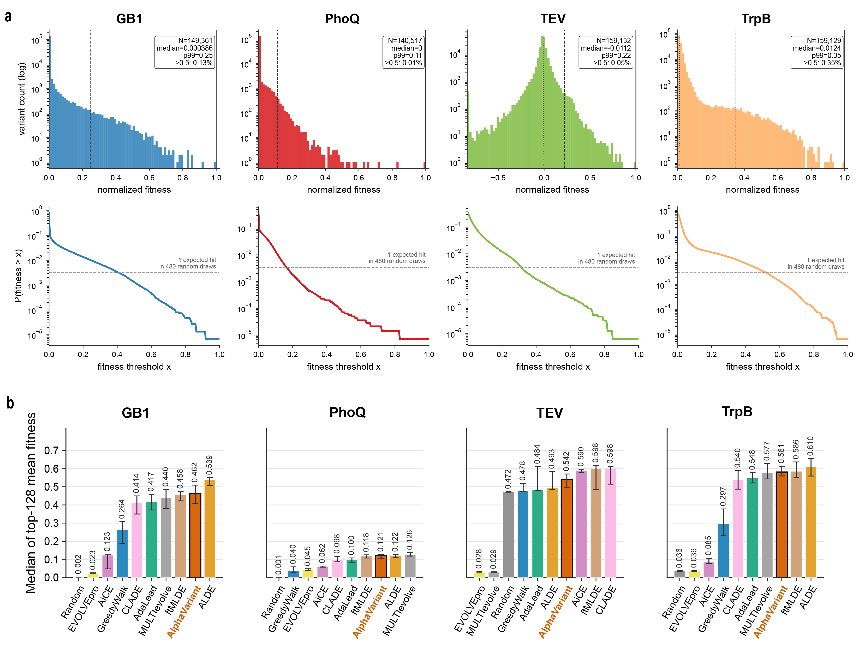

Extended Data Fig. 2 | Four-site benchmark landscape statistics and top-variant recovery.
a, Fitness distributions for the GB1, PhoQ, TEV and TrpB four-site landscapes. Top panels show variant counts across normalized fitness values on a logarithmic scale; dotted and dashed vertical lines indicate the median and 99th percentile, respectively. Bottom panels show the empirical probability of sampling a variant above fitness threshold x, with the horizontal dashed line marking one expected hit in 480 random draws. b, Mean fitness of the top 128 variants selected by each method across the four-site benchmarks. Bars show medians and error bars denote the Q1–Q3 interquartile range. AlphaVariant consistently enriches high-fitness variants and performs competitively across landscapes with distinct fitness distributions and hit rates.

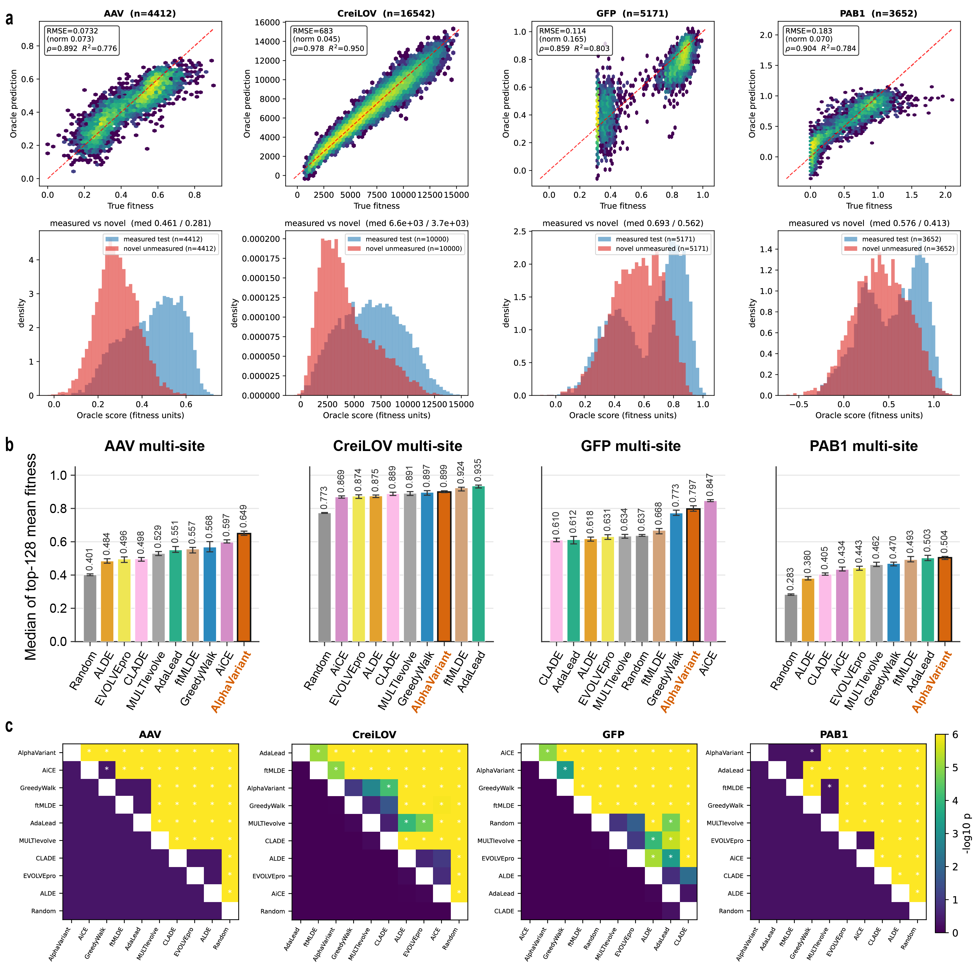

Extended Data Fig. 3 | Multi-site benchmark oracle performance and top-variant recovery.
a, Oracle-predicted versus experimentally measured fitness for AAV, CreiLOV, GFP and PAB1 multi-site landscapes. Top panels show prediction accuracy for measured variants, with dashed lines indicating perfect agreement; bottom panels compare oracle-score distributions for measured test variants and novel unmeasured variants. b, Mean fitness of the top 128 variants selected by each method across the multi-site benchmarks. Bars show medians and error bars denote the Q1–Q3 interquartile range. c, Pairwise comparisons of method performance for each multi-site dataset, shown as −log10-transformed P values; asterisks indicate statistically significant differences. AlphaVariant consistently identifies high-scoring variants across multi-site landscapes and shows competitive or superior performance relative to existing search, learning-based and generative design strategies.
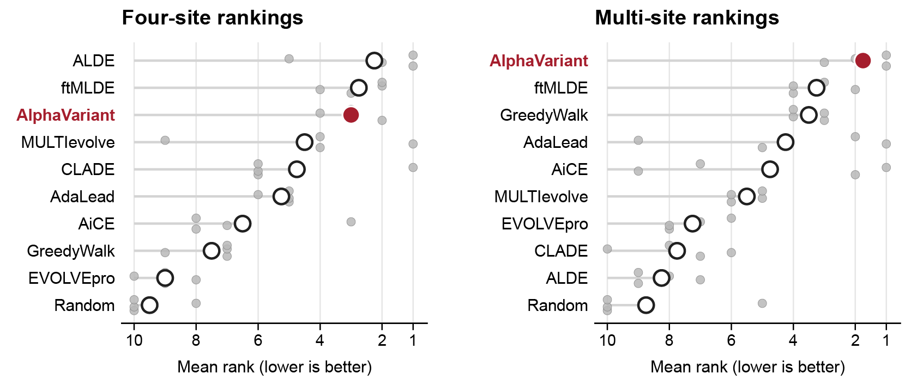

Extended Data Fig. 4 | Aggregate top 128 mean fitness rankings across four-site and multi-site benchmarks.
Left, the rankings on the four-site benchmarks, right, the rankings on multi-site benchmarks. Each points denote dataset-level ranks and open circles indicate mean rank, with lower values indicating better performance.

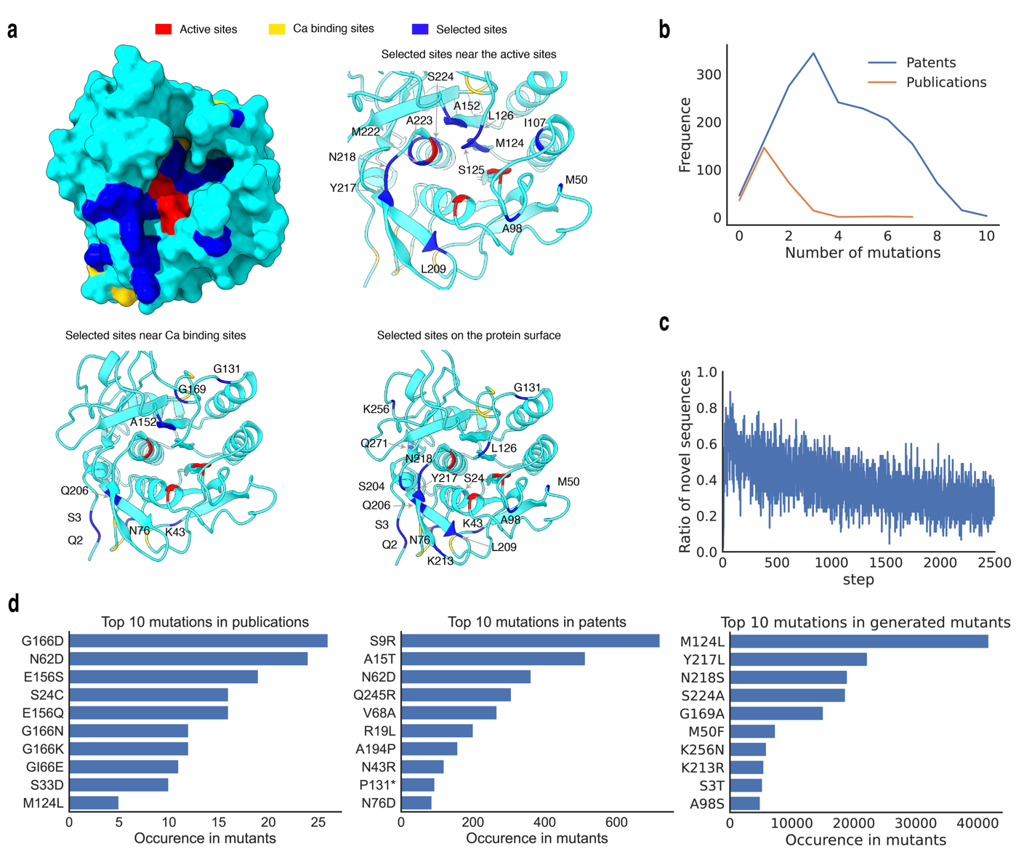

Extended Data Fig. 4 | Additional analysis of in silico design in the first round.
a, Selected sites in the first round. Thirteen sites are near the active sites (8 Å), eight sites are near the Ca²⁺ binding sites (<5 Å), and 17 sites are on the surface (solvent accessible surface area (SASA) > 20 Å²). b, Number of mutations of mutants in patents and publications. c, The ratio of novel sequences in each batch during the RL process. d, The top 10 most frequent mutations in publications, patents, and generated variants.
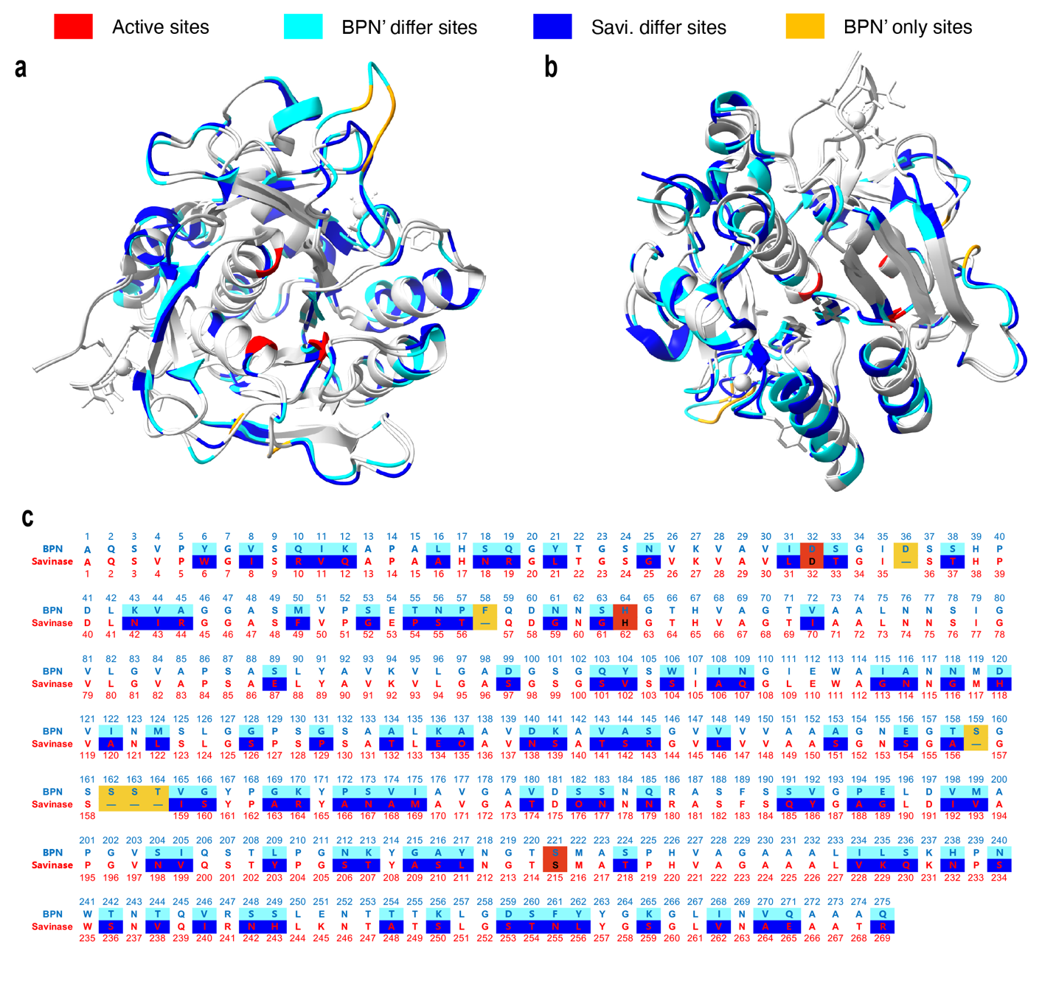

Extended Data Fig. 5 | Structure and sequence alignment of BPN’ and Savinase.
a, Front view of the structure alignment. b, Back view of the structure alignment. c, The sequence alignment. Red, the active sites; light blue, matched missense mutation sites in BPN’; blue, missense mutation sites in Savinase; green, BPN’ only sites, which are deleted in savinase.

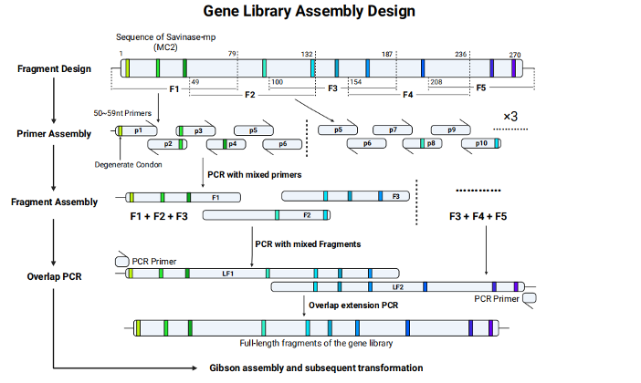

Extended Data Fig. 6 | Gene-library assembly design for multiplex variant library construction.
Schematic of the pooled gene-library assembly workflow for Savinase library (MC2). Degenerate codons are introduced through short mutagenic primers, which are combined by PCR to generate sequence-defined fragments. Adjacent fragments are then mixed and extended by overlap PCR to assemble full-length gene-library inserts, followed by Gibson assembly and transformation. This strategy enables combinatorial incorporation of designed mutations across multiple positions while maintaining compatibility with the computational libraries.

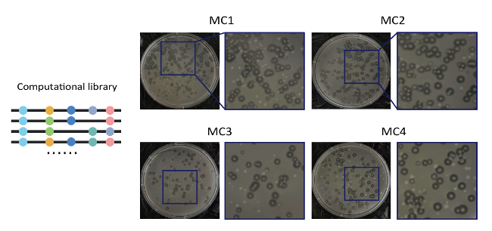

Extended Data Fig. 7 | Agar plate display of computational libraries in the first round.
Representative colony plates from the first-round AlphaVariant-designed libraries, MC1–MC4. The computationally designed variant libraries were synthesized and assembled into experimental libraries, with zoomed regions showing individual transformant colonies for each condition. The resulting colony distributions indicate successful library construction and transformation for downstream screening.

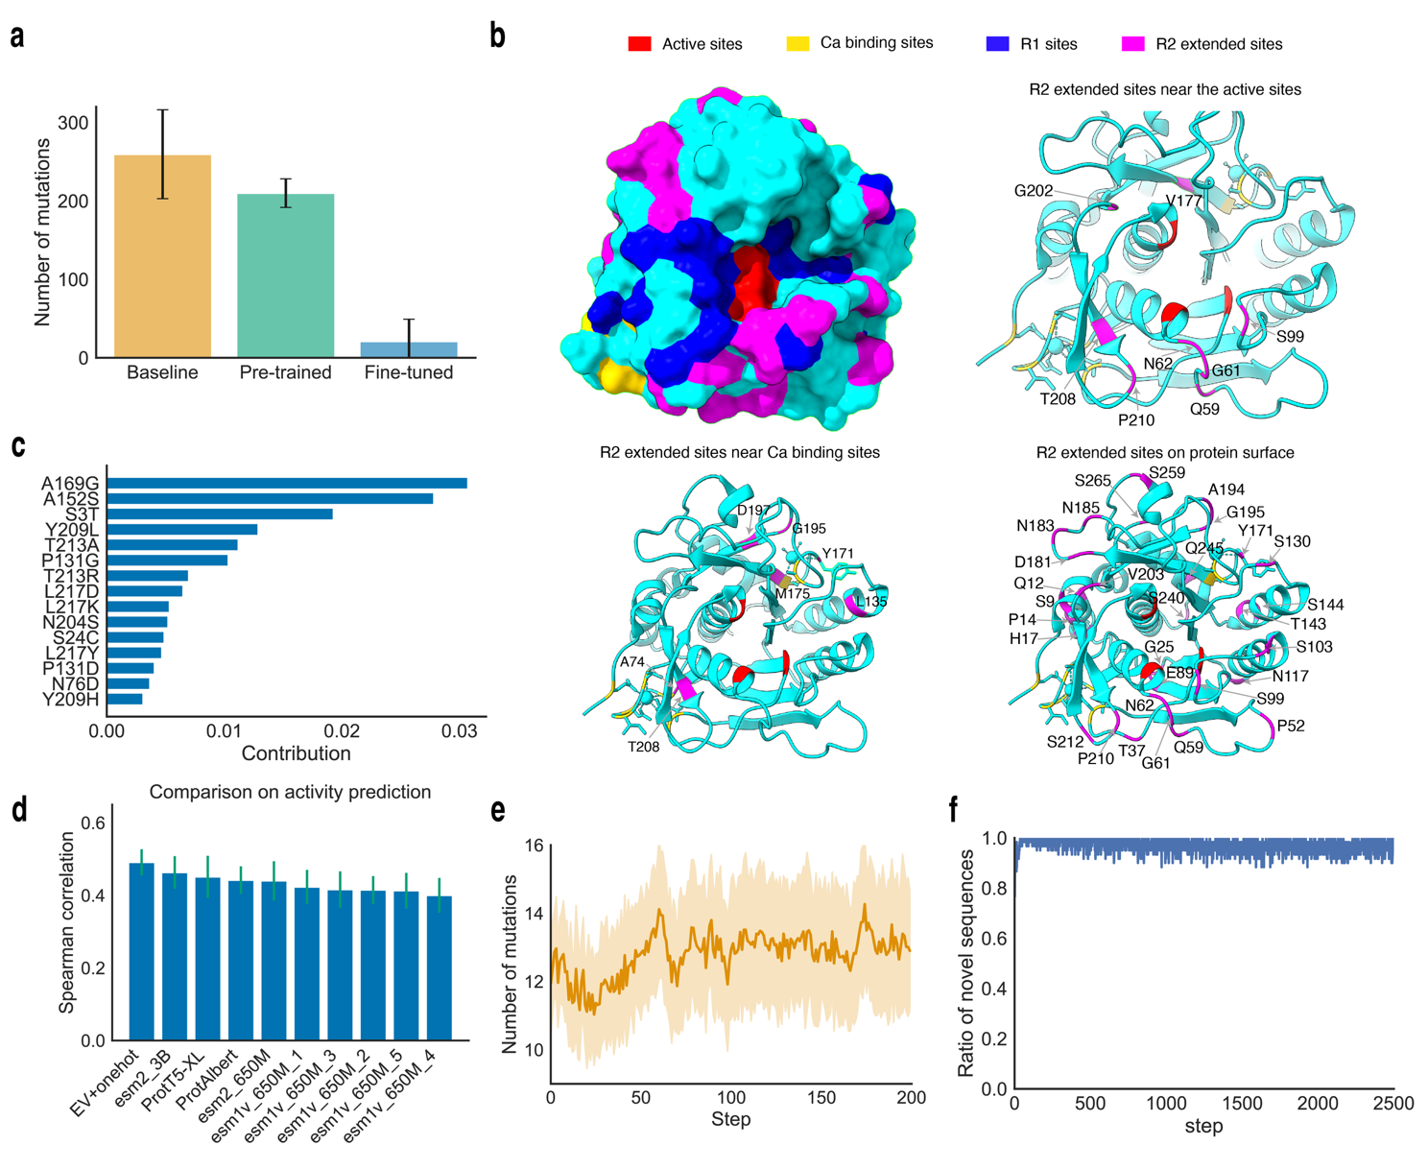

Extended Data Fig. 8 | Additional results of in silico design in the second round.
a, Number of mutations in the variants generated by the prior models. b, Extended sites in the second round. Eight sites are near the active sites (<8 Å), seven sites are near the Ca²⁺ binding sites (<5 Å), and 30 sites are on the surface (SASA > 20 Å²). c, Shapley contribution analysis of variants in the first round. d, Benchmark protein fitness models on activity data collected from the first round. e, Number of mutations during the RL steps. f, Ratio of novel sequences during the RL steps.

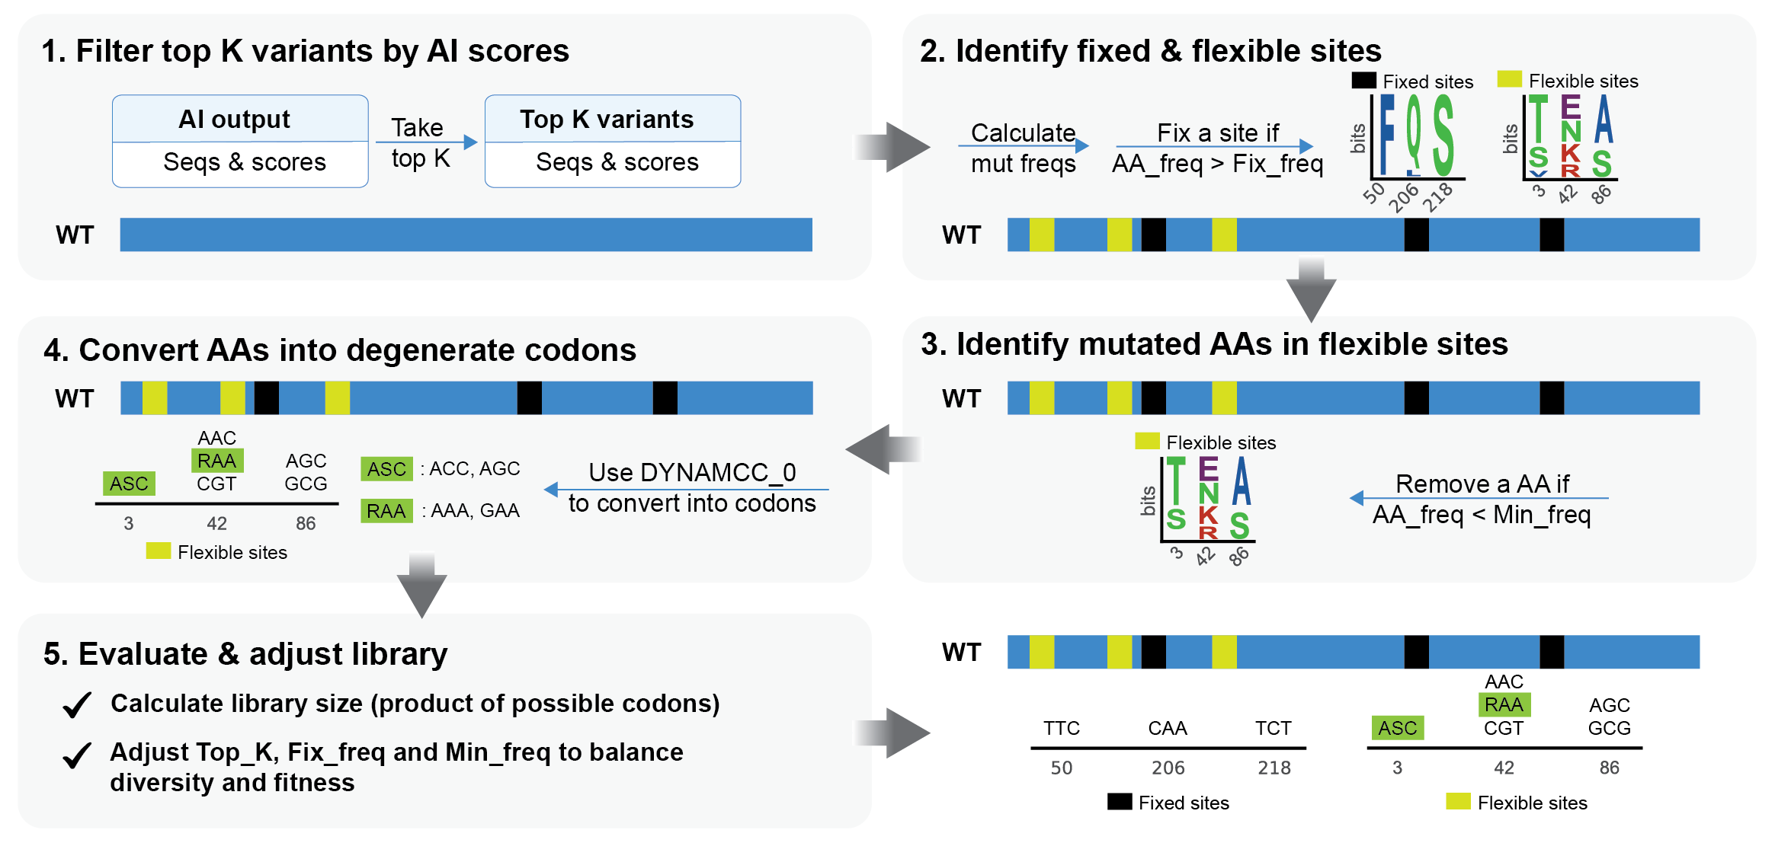

Extended Data Fig. 9 | The workflow of DCG-Libgen to design degenerate codon libraries.
The workflow to design a degenerate codon (DGC) library from AI outputs includes the following steps: 1) filter the top K variants on the basis of AI scores; 2) obtain fixed and flexible sites by analyzing amino acid (AA) frequencies at each site, with an AA frequency greater than a threshold, Fix_freq, is fixed; 3) mutations with frequencies lower than the minimum frequency (Min_freq) are removed from flexible sites; 4) the amino acids are converted into codons via DYNAMCC_0; 5) the library size is calculated, and the parameters (Top K, Fix_freq, and Min_freq) are adjusted to fit the desired size; and 6) the final mutation sites with respective codons are used to design a wet-lab library.

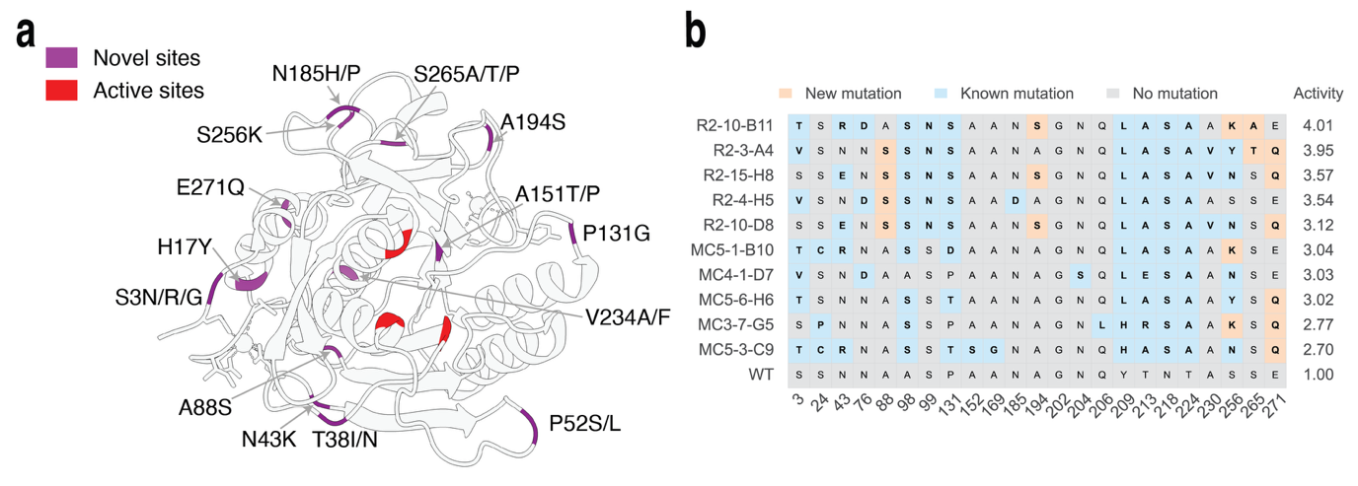

Extended Data Fig. 10 | Analysis of the variants and mutations obtained from the first two rounds.
a. Novel mutations with positive contributions in the first two rounds. The novel mutations are not included in patents or publications and presented at least twice among the experimentally improved variants. b. Mutations in the top five variants from the first and second rounds. The mutations are highlighted in bold, with novel mutations highlighted in peach.
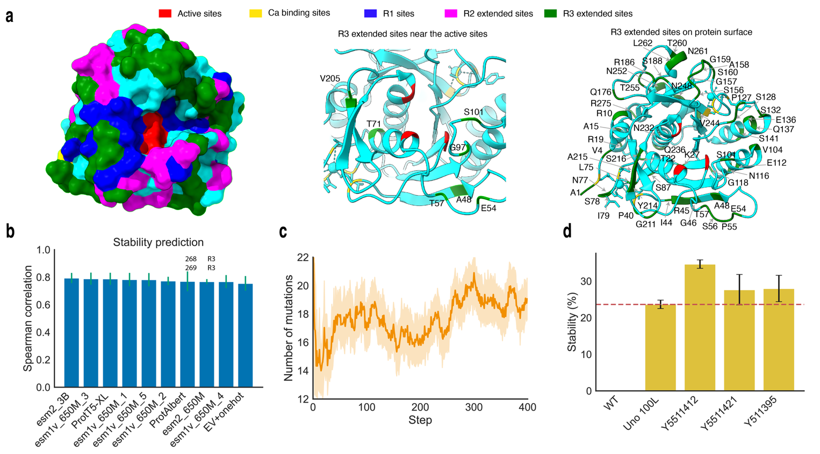

Extended Data Fig. 11 | Results from the third round.
a, Extended sites in the third round. Seven sites are near the active sites (<8 Å), and 54 sites are on the surface (SASA > 20 Å²). b, Benchmark protein fitness models on stability data. c, Number of mutations during the RL steps. c, Washing effects of the selected variants.

Extended Data Tables

Extended Data Table 1 | Characteristics of the four-site protein fitness landscape benchmark datasets.
Dataset | Protein (functional class) | Mutated sites | Combinatorial space | Measured variants | Variants ≥ 0.5 fitness
GB1¹⁶ | Igg-binding protein GB1 domain (binding) | 4 | 20⁴=160,000 | 149,361 | 0.13%
PhoQ¹⁷ | PhoQ histidine kinase (signaling) | 4 | 20⁴=160,000 | 140,517 | 0.01%
TEV²⁰ | Tobacco etch virus protease (enzyme) | 4 | 20⁴=160,000 | 159,132 | 0.05%
TrpB¹⁹ | Tryptophan synthase β-subunit (enzyme) | 4 | 20⁴=160,000 | 159,129 | 0.35%

Extended Data Table 2 | Characteristics of the multi-site protein fitness landscape benchmark datasets.
Dataset | Protein (functional class) | Length (aa) | Variable positions | Measured variants | Oracle ρ | Oracle R² | n-test​
AAV²³ | Adeno-associated virus capsid VP1 (viral assembly) | 28 | 28 | 44128 | 0.89 | 0.78 | 4412
CreiLOV²¹ | CreiLOV LOV-domain flavoprotein (fluorescent) | 119 | ~15 | 165428 | 0.98 | 0.95 | 16542
GFP²² | AvGFP (fluorescent) | 237 | up to 233 | 51715 | 0.86 | 0.80 | 5171
PAB1¹⁸ | Poly(a)-binding protein RRM (rna-binding) | 75 | 74 | 36522 | 0.90 | 0.78 | 3652

Extended Data Table 3 | Summary of the ten methods included in the protein fitness optimization benchmark.
Method | Family | Model / scoring | Candidate selection | Reference
Random | Basic search | — | Uniform random sampling each round | New in this work
Greedywalk | Basic search | Direct fitness/oracle evaluation | Hill-climbing over single-mutation neighbors of the best variant | New in this work
ftMLDE²⁵ | Supervised / active learning | Cross-validated ensemble of pretrained embedding predictors | Highest-predicted batch | Wittmann et al. (2021)
ALDE⁷ | Supervised / active learning | Ensemble regressor with uncertainty | Thompson sampling | Yang et al. (2025)
CLADE²⁶ | Supervised / active learning | Regressor ensemble | Cluster-stratified (best-per-cluster) selection | Qiu et al. (2021)
EVOLVEpro²⁷ | Supervised / active learning | Esm-2 embeddings → random-forest head (facebook/esm2_t12_35m_ur50d) | Highest-predicted batch | Jiang et al. (2024)
MULTI-evolve²⁸ | Supervised / active learning | Bootstrap neural-network ensemble | Highest-predicted batch | Tran et al. (2026)
AiCE⁸ | Structure-guided | ProteinMPNN structure-conditioned per-position amino-acid frequencies (1,000 samples, t=0.5), blended with observed high-fitness frequencies | Highest summed log-frequency | Fei et al. (2025)
AdaLead²⁴ | Generative / policy search | Ensemble surrogate-guided | Evolutionary recombination + mutation | Sinai et al. (2020)
Alphavariant | Generative / policy search | GPT sequence prior + reinforce; five-model surrogate-ensemble UCB reward, with mutcompute reward shaping and SHAP alphabet pruning | Policy-gradient sampling from the trained generator | This work

Extended Data Table 4 | AlphaVariant configurations used in four-site and multisite benchmark experiments.
The table summarizes the benchmark-specific AlphaVariant settings. Shared settings included a four-layer GPT generator with four attention heads and embedding dimension 128, an augmented-likelihood REINFORCE objective, a reward scale of σ = 60, five optimization rounds with 96 sequences per round, 500 REINFORCE steps per round, a five-model surrogate ensemble and SHAP-based alphabet pruning. The four-site and multisite campaigns differed in the source of fitness values, prior pretraining, surrogate features, reward definition and proposal constraints.
Setting | Four-site | Multi-site
Fitness landscape | Exact lookup table | Learned CNN oracle
Sequence prior | In-run GPT prior, no homolog pretraining | GPT prior pretrained on aligned homologs
Prior finetuning (per round) | On; 2014 finetuned on collected sequences each round | Off (uses the pretrained prior)
Generator | 4-layer GPT, 4 heads, embedding dim 128 | same
RL objective | Augmented-likelihood REINFORCE | same
Reward scale σ | 60 | 60 (same setting)
Rounds × batch (budget) | 5 × 96 = 480 | 5 × 96 = 480 (same setting)
REINFORCE steps per round | 500 | 500 (same setting)
Surrogate model | 5-model ensemble: 2 x ridge, Bayesian ridge, random forest, and gradient boosting | same
Surrogate features | aa+one-hot: per-position one-hot features and four physicochemical descriptors (volume, hydropathy, area, polarity) | aa+one-hot features and standardized EVmutation statistical-energy score
Reward R(s) | UCB = μ+2ς only | UCB = μ+2ς only
Zero-shot signal | None | EVmutation
SHAP alphabet pruning | Off | On (same settings) On; min alphabet 3, SHAP threshold 0, ≥ 50 samples, top-10 retained
Proposal alphabet constraint | Off | On — the pruned alphabet is propagated into the generator and proposals violating it are filtered before selection
Round-1 initialization | Cluster-based (k-means on features), 10 clusters, uniform difficulty | same
Per-round selection (rounds 2–5) | Cluster sampling of the GPT proposal pool, ranked by surrogate-predicted fitness; top-1,000 cutoff before clustering | same
Mutation cap | None | ≤ 2 mutations from the reference

Extended Data Table 5 | Ablation studies of AlphaVariant on multi-site datasets.
Leave-one-out ablation on the four multi-site (learned-oracle) landscapes. Each configuration removes one component from the shipped AlphaVariant configuration and re-runs the full 480-query campaign (96 × 5 rounds). Values are the mean across independent seeds with the standard deviation; Δ is the change in mean versus the full configuration on the same landscape. Fitness is min–max normalized to [0, 1] per landscape (oracle score). Higher is better.
Dataset | Configuration | n | Max fitness,  mean ± s.d. | Δ mean | Top-128 mean fitness, mean ± s.d. | Δ mean
CreiLOV | AlphaVariant (full) | 30 | 0.981 ± 0.007 |  | 0.900 ± 0.009
 | − EV features | 30 | 0.979 ± 0.007 | -0.001 | 0.899 ± 0.008 | -0.001
 | − SHAP / alphabet constraint | 30 | 0.980 ± 0.008 | -0.001 | 0.897 ± 0.008 | -0.003
 | − mutation cap | 30 | 0.976 ± 0.006 | -0.004 | 0.914 ± 0.002 | 0.014
 | − homolog prior | 30 | 0.986 ± 0.004 | 0.005 | 0.910 ± 0.008 | 0.010
AAV | AlphaVariant (full) | 30 | 0.712 ± 0.022 |  | 0.649 ± 0.018
 | − EV features | 30 | 0.710 ± 0.021 | -0.002 | 0.642 ± 0.020 | -0.007
 | − SHAP / alphabet constraint | 30 | 0.710 ± 0.018 | -0.002 | 0.651 ± 0.017 | 0.002
 | − mutation cap | 30 | 0.676 ± 0.024 | -0.036 | 0.399 ± 0.015 | -0.250
 | − homolog prior | 30 | 0.720 ± 0.018 | 0.008 | 0.647 ± 0.018 | -0.002
PAB1 | AlphaVariant (full) | 10 | 0.588 ± 0.017 |  | 0.514 ± 0.018
 | − EV features | 10 | 0.549 ± 0.021 | -0.039 | 0.460 ± 0.021 | -0.054
 | − SHAP / alphabet constraint | 10 | 0.580 ± 0.025 | -0.008 | 0.501 ± 0.016 | -0.013
 | − mutation cap | 10 | 0.405 ± 0.022 | -0.183 | 0.127 ± 0.015 | -0.387
 | − homolog prior | 10 | 0.586 ± 0.029 | -0.002 | 0.508 ± 0.027 | -0.006
GFP | AlphaVariant (full) | 5 | 0.960 ± 0.024 |  | 0.823 ± 0.030
 | − EV features | 5 | 0.943 ± 0.037 | -0.017 | 0.794 ± 0.024 | -0.030
 | − SHAP / alphabet constraint | 5 | 0.945 ± 0.037 | -0.015 | 0.814 ± 0.033 | -0.010
 | − mutation cap | 5 | 0.943 ± 0.038 | -0.018 | -0.038 ± 0.018 | -0.862
 | − homolog prior | 5 | 0.944 ± 0.039 | -0.017 | 0.712 ± 0.187 | -0.111
Seed counts reflect per-landscape compute cost (PAB1 and GFP use fewer seeds because per-seed runtime scales with sequence length). The mutation cap is the dominant component, and its effect on top 128 mean fitness tends to grow with the size of the variable region. EV-augmented features contribute on the larger, sparser landscapes (PAB1, GFP); the SHAP/alphabet constraint and the homolog-pretrained prior are approximately neutral throughout. The parameters can be further fine-grained to obtained better optimization performance on each of the multi-site benchmark datasets.

Extended Data Table 6 | Per-round dataset summary table in savinase optimization
Round | Target/ template | Dataset | Number of records | Substrate/ property | Model selected | Test performance | Use in workflow
First | Subtilisin BPN′ → savinase mapping | Literature activity data | 150 | AAPF activity | ev+onehot | Spearman ρ = 0.72 | Initial activity reward
Second | Savinase | First-round experimental data | 2,414 | AAPF activity | ev+onehot | Spearman ρ = 0.60 | Second-round activity reward
Third | Savinase | In-house activity/stability data | 459 activity; 358 stability | Casein activity; thermostability | ProtT5-XL/SVR | Report values | Multi-objective reward

Per-round mutational-space summary table in savinase optimization
Round | Number of mutation sites | Allowed amino acids | Estimated search space | Basis for inclusion | Basis for exclusion
First | 25 | Literature/patent-supported substitutions plus WT | 2.80 × 1017 | Published and patented improved variants | Ambiguous or unmapped positions
Second | 68 | Top homolog frequencies plus first-round positive mutations | 1.71 × 1050 | Shapley/statistical positive contributions | Mutations with mean activity below WT
Third | 116 | Homolog/in-house explored mutations | 8.8 × 1077 | Activity/stability datasets and high-perplexity sites | Negative attribution sites/mutations

