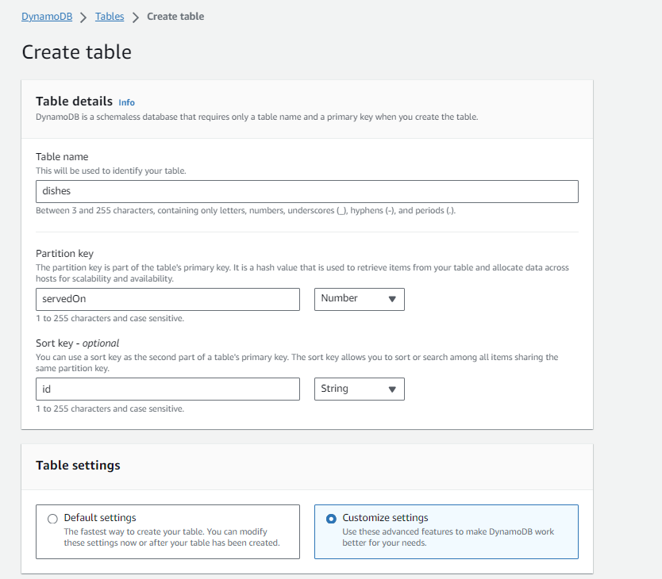

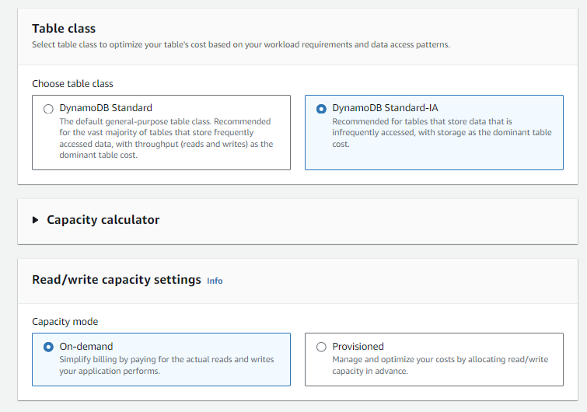

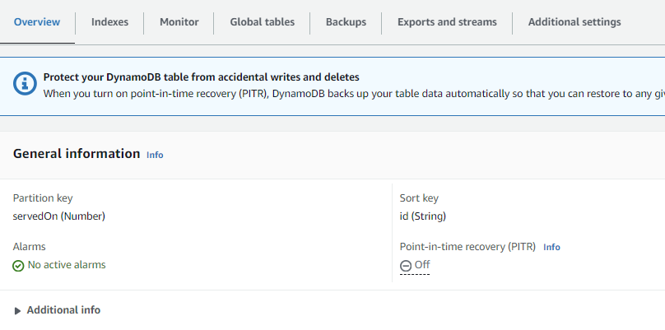

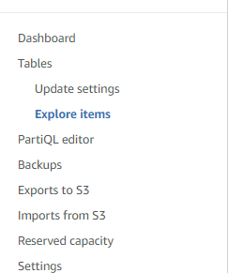 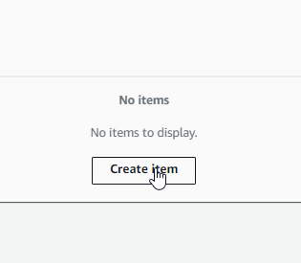

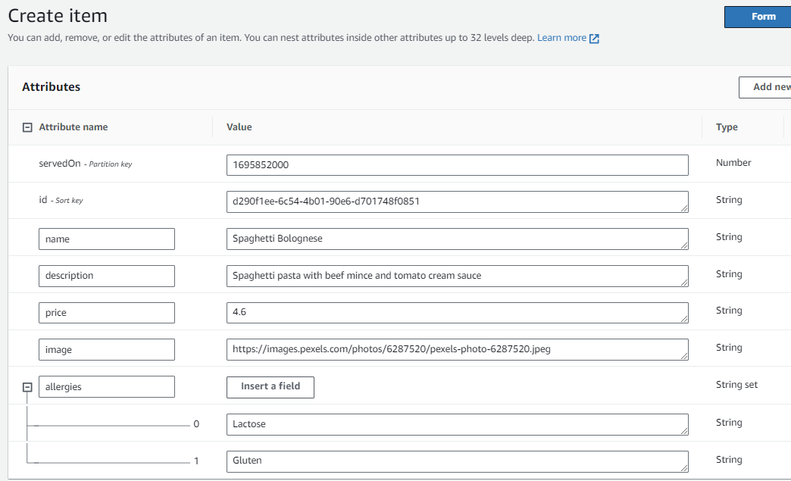

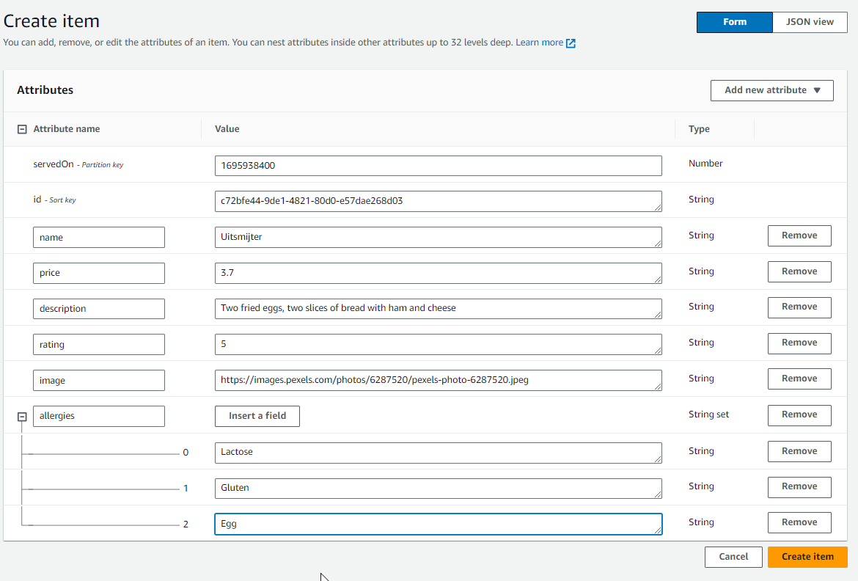

<https://docs.aws.amazon.com/amazondynamodb/latest/developerguide/Introduction.html>

<https://www.youtube.com/watch?v=2k2GINpO308>

<https://youtu.be/LM84N-E_b_M>

[GSI vs Scan - Amazon DynamoDB Nuggets | Amazon Web Services](https://www.youtube.com/watch?v=LM84N-E_b_M)

<https://docs.aws.amazon.com/amazondynamodb/latest/developerguide/bp-query-scan.html>

<https://docs.aws.amazon.com/amazondynamodb/latest/developerguide/Scan.html>

<https://docs.aws.amazon.com/amazondynamodb/latest/developerguide/DynamoDBMapper.QueryScanExample.html>