|  |
| --- |
|  |

**LAB 1: SQL and CRUD Opration**

|  |  |
| --- | --- |
| **Track** | Data & AI |
| **Role** | Data Analyst |
| **Course** | Enterprise Data Management |
| **Level** | Level 2 |
| **Scope** | * Install MySQL across platforms and learn basic SQL syntax for simple queries like selecting, filtering, and sorting data. * Execute CRUD operations (Create, Read, Update, Delete) in MySQL to manage data in tables. * Use practical examples to apply these operations effectively for database management. |
| **Prerequisite** | * Familiarity with setup and installing. * Basic knowledge of SQL. |

**Objective:**

Gain hands-on experience in installing SQL databases, writing basic SQL queries as performing CRUD operations with SQL databases.

**Tasks:**

1. **Installation and Crafting Simple SQL Queries**:

* Download mySQL community using website.
* Install MySQL workbench on system.
* Setting up Server in MySQL workbench.

1. **Executing CRUD Operations in MySQL**:

* Create schema of telecom1 using query.
* Add columns in the table such as customer_id, customer_name and city.
* Analysis the dataset and show the value of table “telecom1”.
* Modify city in the dataset and watch the changes.
* Alter one customer_name from the dataset.

|  |  |  |  |
| --- | --- | --- | --- |
| **telecom1** | | | |
| Column Name | Type of column | Length | Example |
| customer_id | Integer | - | 1 |
| customer_name | Varchar | 45 | ‘Roy’ |
| city | Varchar | 45 | ‘New York’ |

**Outcomes:**

* Familiarity with setting up and using MySQL databases.
* Proficiency in basic MySQL queries and CRUD operations.

**Solution:**

##### Installation and Crafting Simple SQL Queries:

* + Download MySQL Workbench:
* First, you need to go to the MySQL Community Website through the link here: with the help <https://dev.mysql.com/downloads/workbench/> of your browser.
* On the website you will see a Download button, click on it to download the MySQL Workbench for your system.

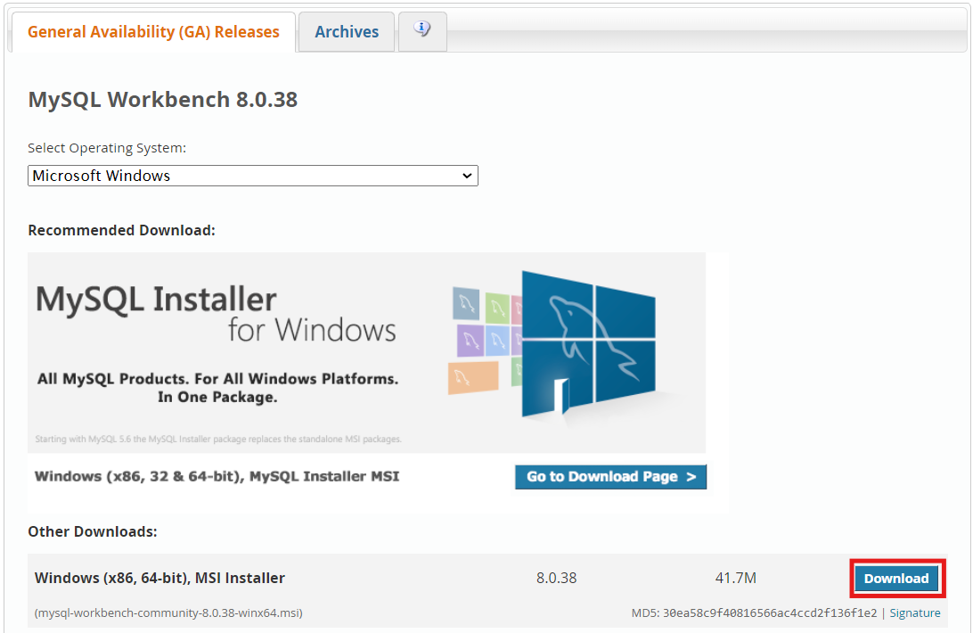

* Now click on “No thanks, just start my download” and then start download.

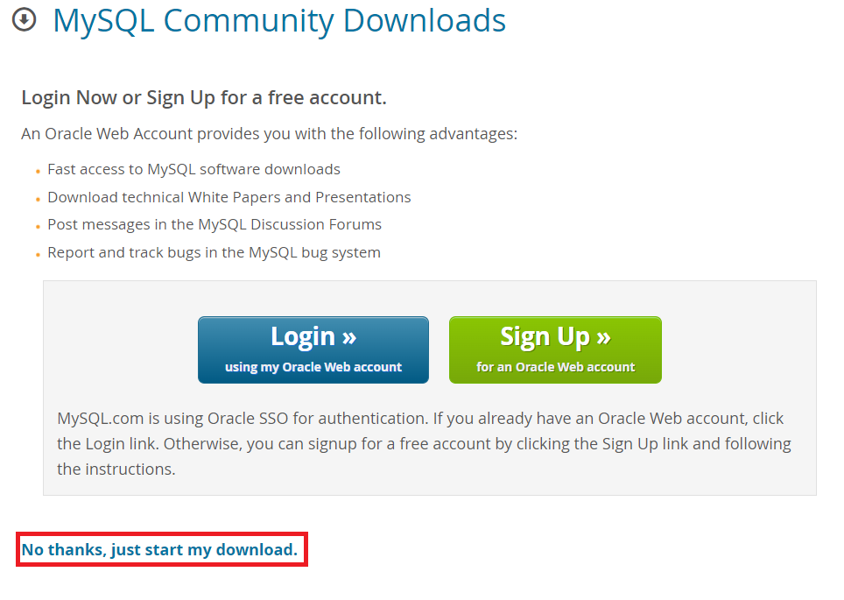

* + Run download:
* Click on downloaded file and run this file to start installing.
* Select setup type as custom and then click “Next” button.

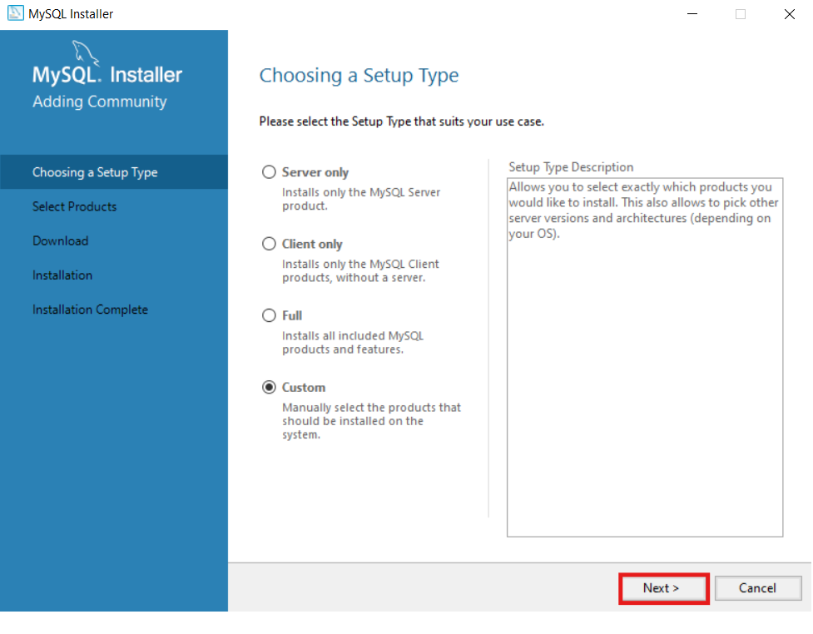



* Extend SQL servers and select MySQL Server and move to Product to be installed using right side arrow.

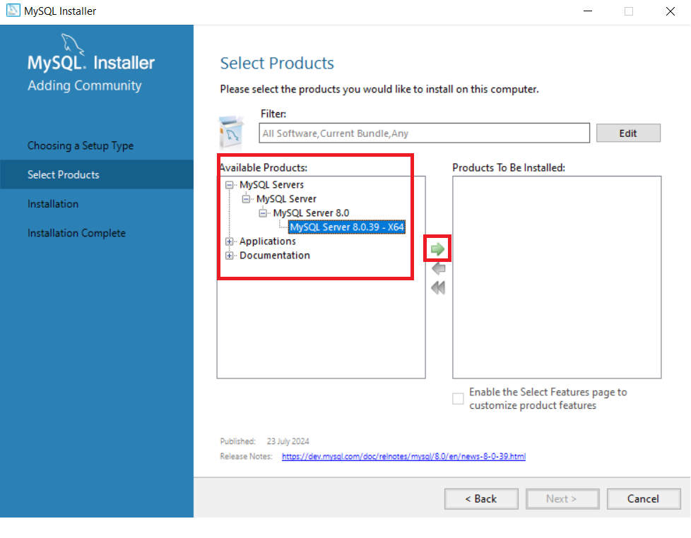

* Select MySQL workbench and also add MySQL shell to install and go to next button.

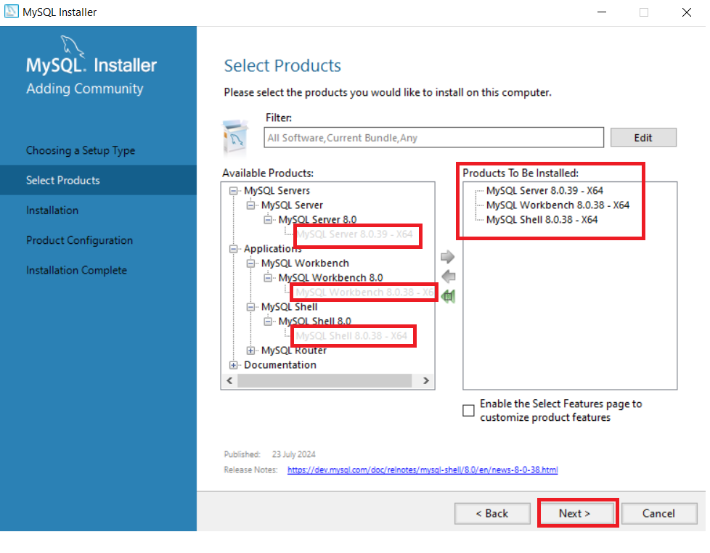

* In Path Conflicts section path is already given so direct click on “Next”.

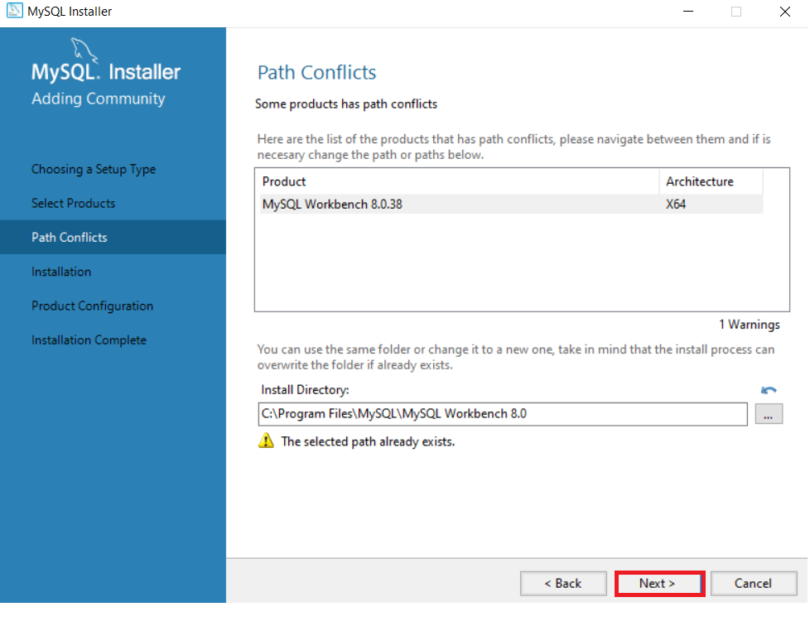

* Click on “Execute” button and start the installation after completing installation and go to “Next”.

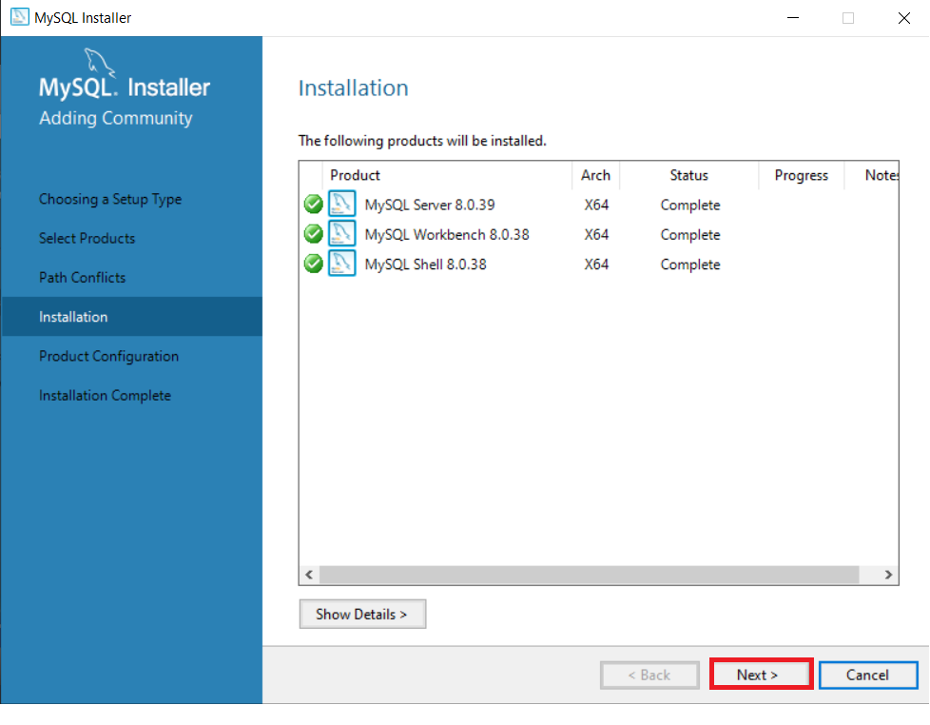

* In Product Configuration to click on “Next” button.

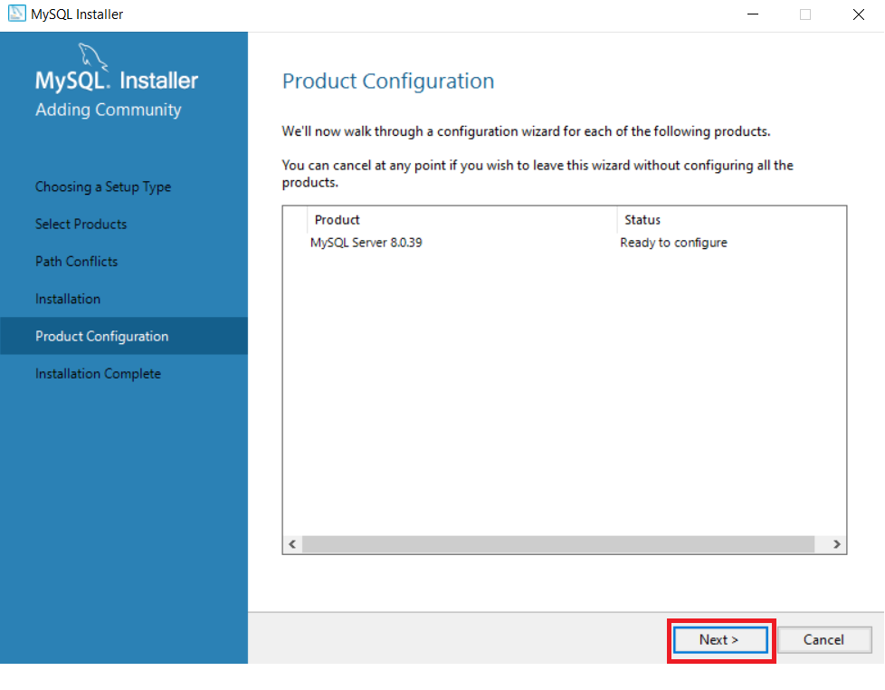

* In Type and Networking and Authentication Method tab to click on “Next” button and go to Accounts and Roles page.

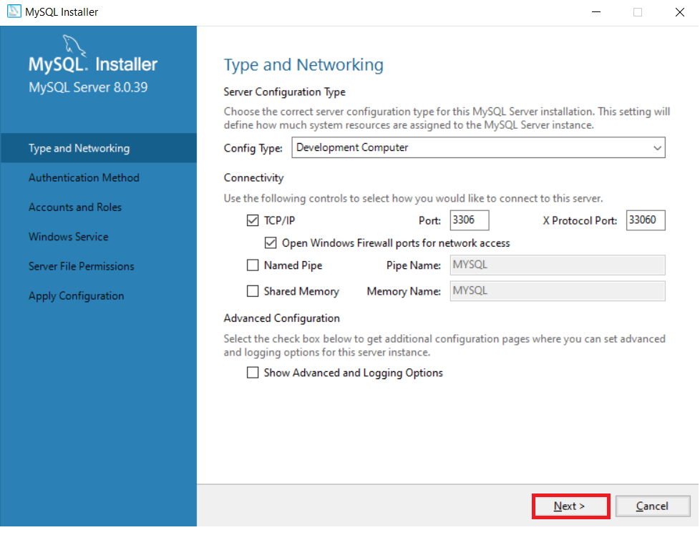

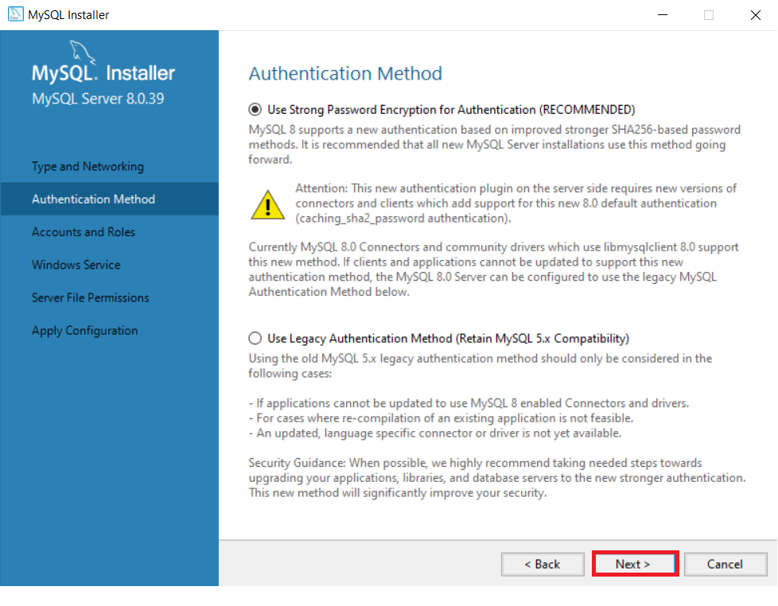

* Write Root Password and same password repeat in next text box in Accounts and Roles.
* After write password click “Next” button.

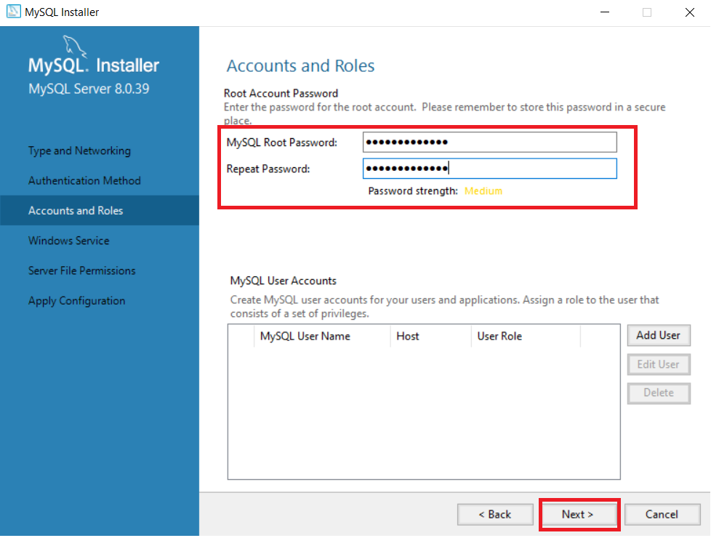

* Click on “Next” and go to Server File Permissions.

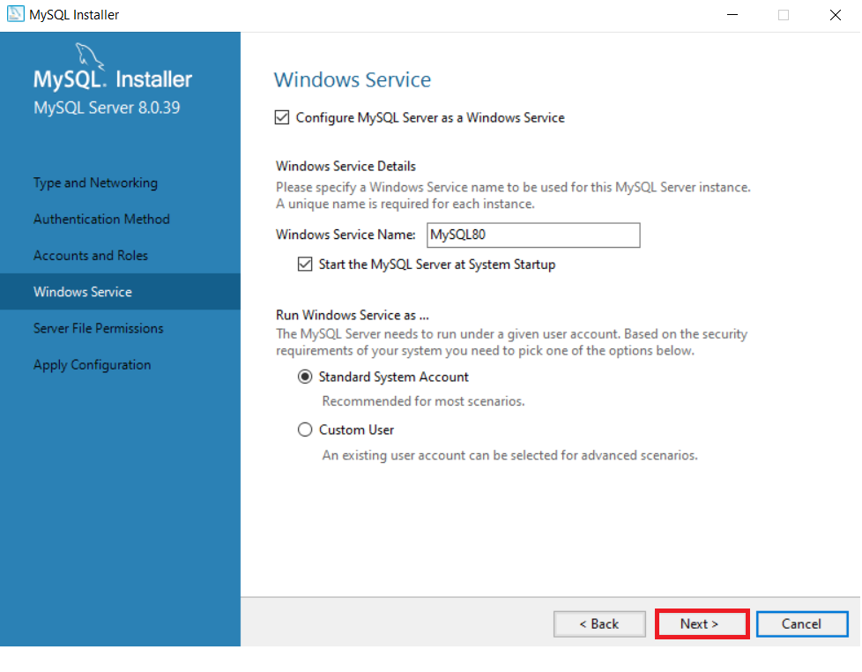

* In Server File Permissions check the grant access Yes and then go to next.

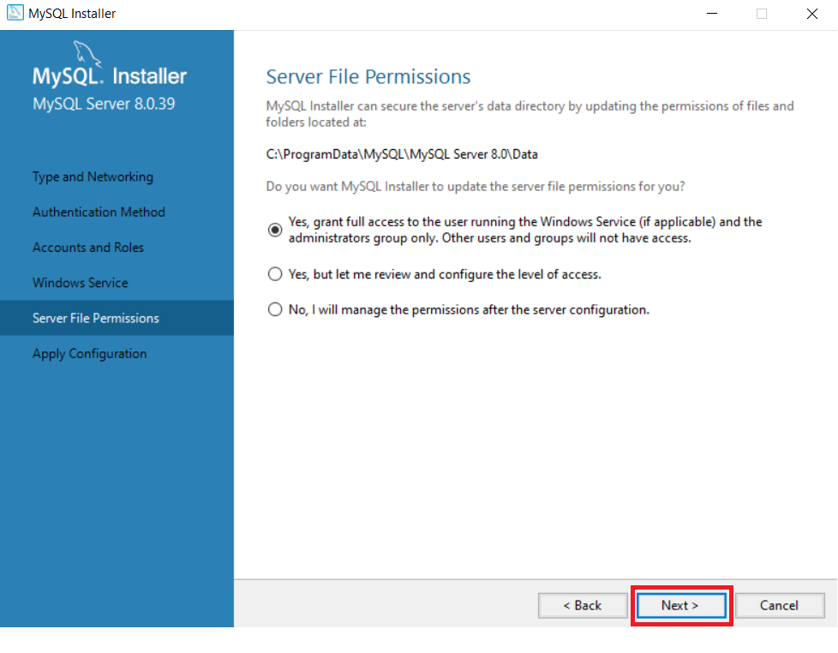

* In apply and Configuration click “Execute” to configure all items and then go to “Finish”.

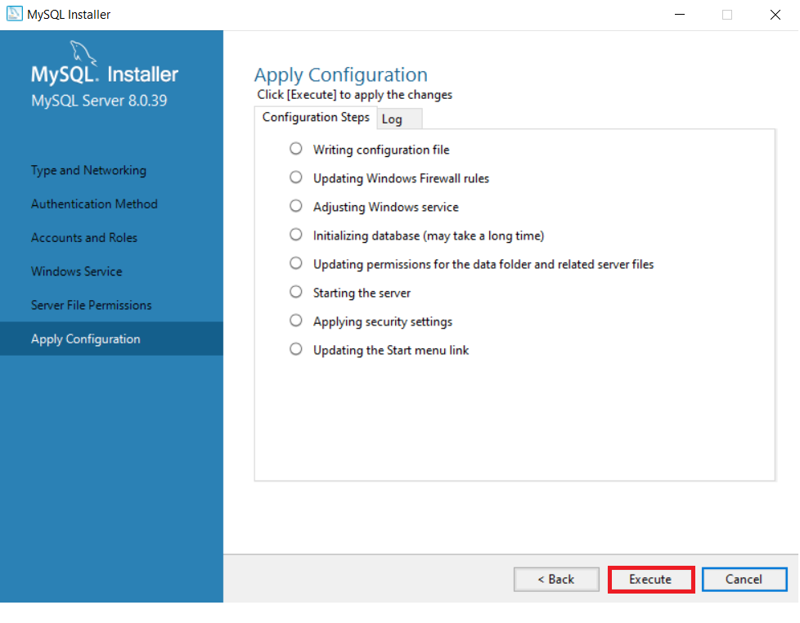

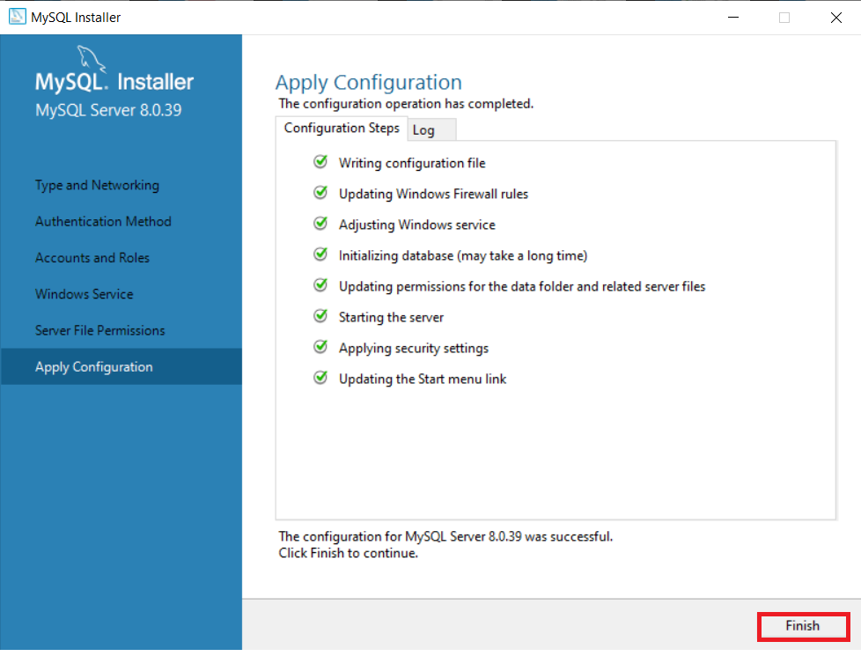

* In Product Configuration to click on “Next” And then “Finish” The installation Process.

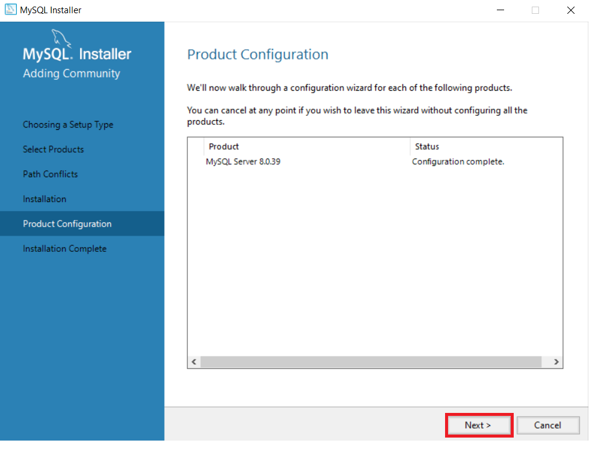

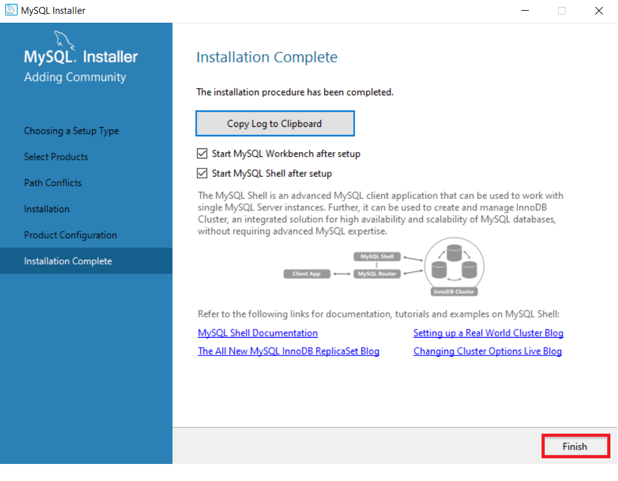

* Click on your connections and enter your password to start tour MySQL.

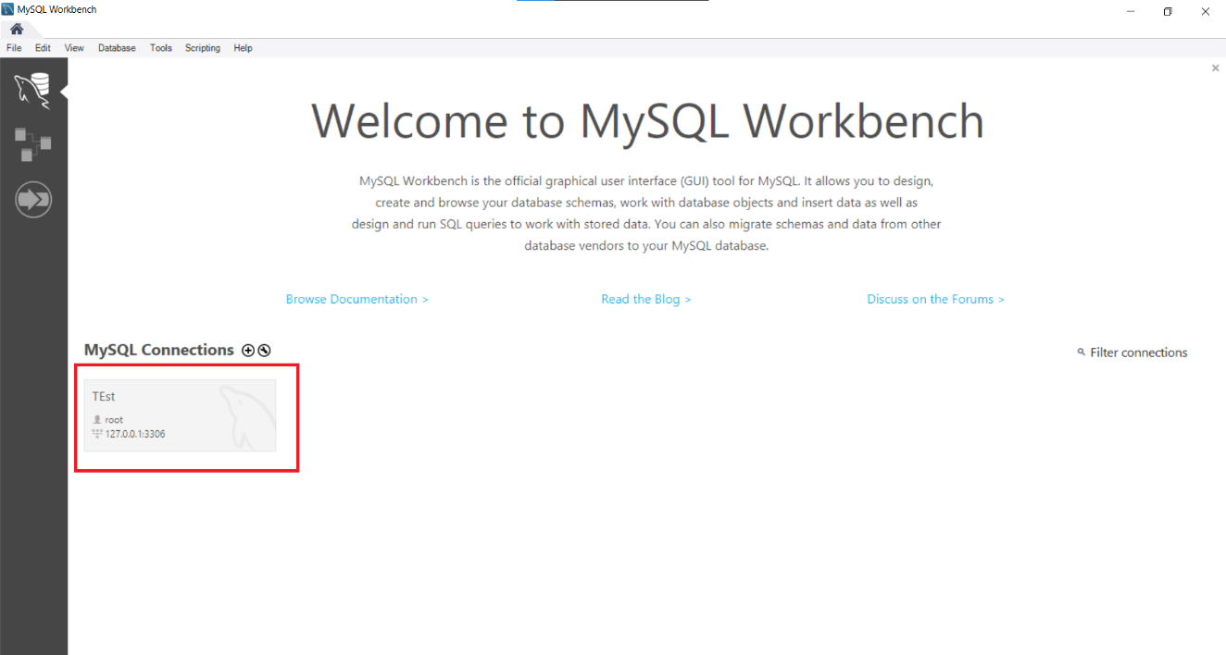

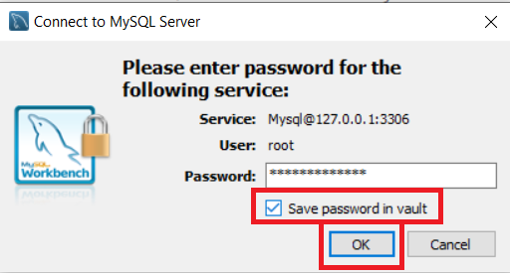

* + Now after few seconds to open workspace of MySQL.

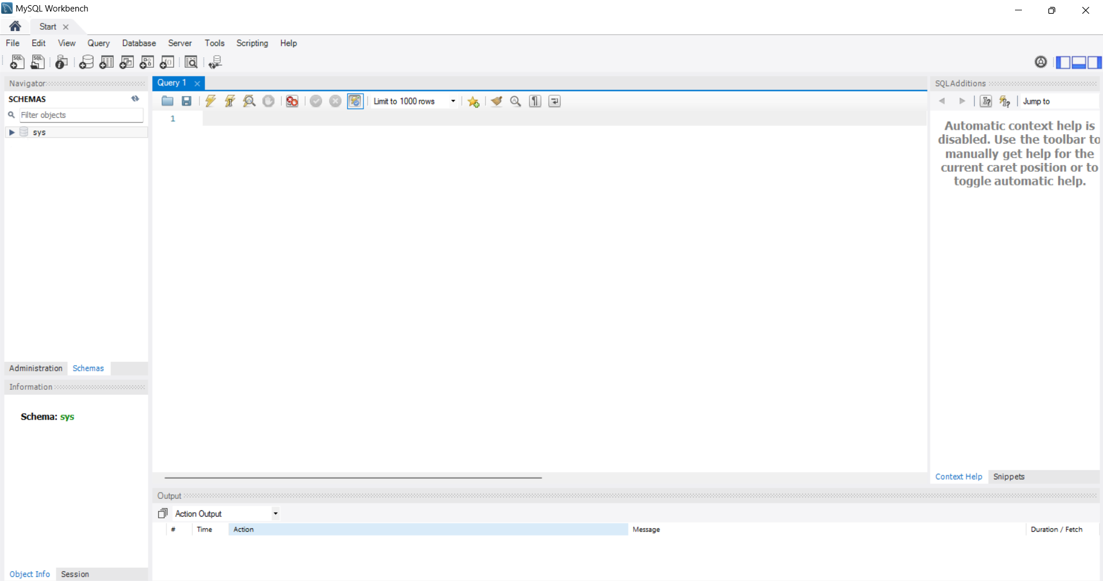

##### **Executing CRUD Operations in MySQL:**

* + Create schema of telecom1 using query.
* Write sql query to create schema in MySQL workspace.

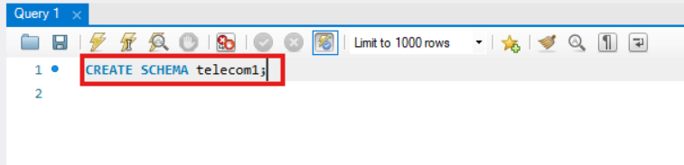

* Click on execute Button to run the sql.

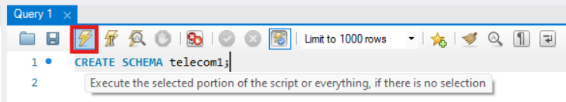

* Show the execution of the query in Output panel.



* Click on refresh button in SCHEMAS Panel at right side.

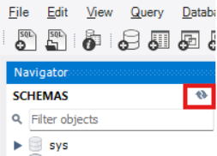

* Show the schema of “telecom1” is created in SCHEMA panel.

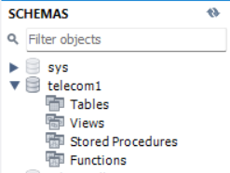

* Create table in this schema.

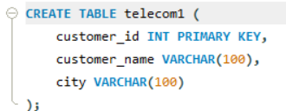

* Watch the table structure in SCHEMAS panel.

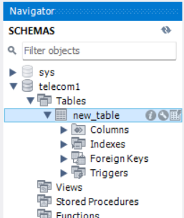

* + Adding data using INSERT formula to add the value into the table.

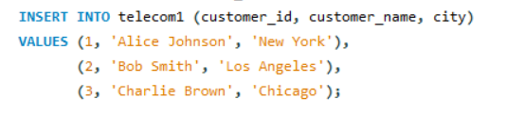

* Perform Read operation to watch the table structure in telecom1.



* Watch the result in Output panel of table create.

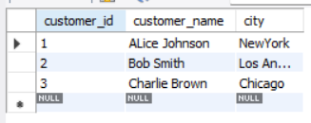

* Print customer_name into telecom dataset.



* Show result in output.

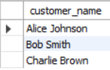

* Modify into city column to change New York to LA.
* Write proper sql query to change into dataset.

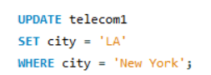

* Show the changes in table of telecom1.

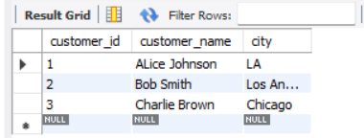

* Update customer city in telecom dataset.

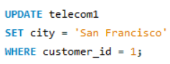

* Show the changes.

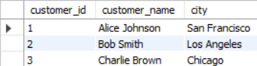

* Perform DELETE operation.
* Alter value to remove data from data set.

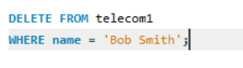

* Show the effect on table.

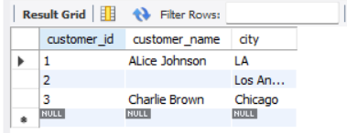

* Execute Delete operation to remove table.



* Show the table structure and execution of the query.



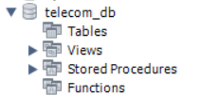

**(Additional) Task to do:**

1. Create a New Schema and Table:  
   Create a new schema named "telecom2".  
   In this schema, create a table called "customer_info" with the columns: customer_id, customer_name, city, phone_number, and email.
2. Insert Data into "customer_info":  
   Insert at least 5 records into the "customer_info" table, ensuring unique values for phone_number and email.
3. Query Data from "customer_info":  
   Retrieve all records from the "customer_info" table.  
   Write a query to retrieve only the customer_name and city from the table.
4. Update and Modify Data:  
   Update the phone_number for one customer in "customer_info".  
   Change the email of another customer and confirm the update by querying the data.
5. Delete a Record:  
   Delete a customer record based on customer_id and verify the record was removed by re-querying the table.