**Demo**

**Testing Different LLM Models**

**Objective:** To compare the performance of leading large language models—GPT-4, DeepSeek, Claude, Cohere, Copilot, and LLaMA—based on accuracy, response quality, and adaptability

**Tools required:** GPT-4, DeepSeek, Claude, Cohere, Copilot, and LLaMA

**Prerequisites:** None

**Steps to be followed:**

1. Testing GPT 4
2. Testing DeepSeek
3. Testing Claude
4. Testing Cohere
5. Testing Copilot
6. Testing LLaMA

**Step 1: Testing GPT 4**

* 1. Open ChatGPT with the link given: <https://chatgpt.com/>

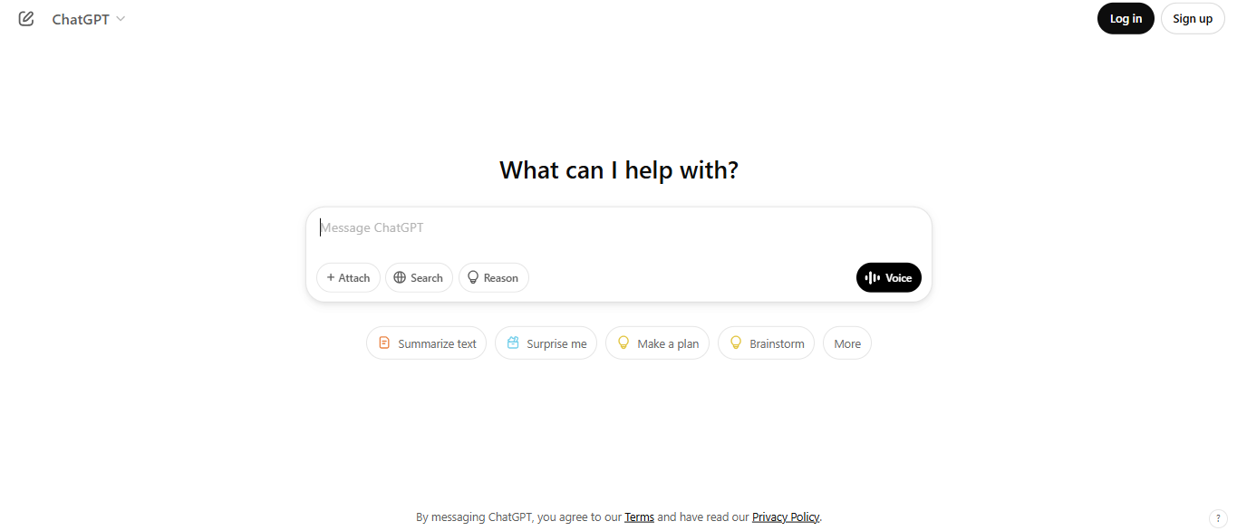

* 1. Write the prompt below to calculate how many students are only on the robotics team:

*A school has 240 students. One-third of the students are in the science club, and half of those in the science club also participate in the robotics team. Additionally, one-fourth of the total students are in the drama club, and 20% of those in the drama club also participate in the robotics team. How many students are only on the robotics team? Think step by step before giving the final answer.*

Output is as shown below:



**Step 2: Testing DeepSeek**

2.1 Open DeepSeek with the link given: <https://www.deepseek.com/>

2.2 Click on **Sign up**

2.3 Enter your details and click on **Sign up**

**Note:** Fill in your details, click on **Send code,** and then click on **Sign up**

2.4 Click on **Start Now**



2.5 Write the prompt below to calculate how many students are only on the robotics team:

*A school has 240 students. One-third of the students are in the science club, and half of those in the science club also participate in the robotics team. Additionally, one-fourth of the total students are in the drama club, and 20% of those in the drama club also participate in the robotics team. How many students are only on the robotics team? Think step by step before giving the final answer.*



Output is as shown below:

**Step 3: Testing Claude**

3.1 Open Claudewith the link given: <https://claude.ai>

**Note:** Follow the on-screen instructions and create your free account

3.2 Write the prompt below to calculate how many students are only on the robotics team:

*A school has 240 students. One-third of the students are in the science club, and half of those in the science club also participate in the robotics team. Additionally, one-fourth of the total students are in the drama club, and 20% of those in the drama club also participate in the robotics team. How many students are only on the robotics team? Think step by step before giving the final answer.*

Output is as shown below:

**Step 4: Testing Cohere**

4.1 Open Cohere with the link given: <https://cohere.com/>

Click on **Try the playground**, follow the on-screen instructions, and create your Cohere account

4.2 Click on the **Playground** option

4.3 Write the prompt below to calculate how many students are only on the robotics team:

*A school has 240 students. One-third of the students are in the science club, and half of those in the science club also participate in the robotics team. Additionally, one-fourth of the total students are in the drama club, and 20% of those in the drama club also participate in the robotics team. How many students are only on the robotics team? Think step by step before giving the final answer.*

Output is as shown below:

**Step 5: Testing Copilot**

5.1 Open Copilot with the link given: <https://copilot.microsoft.com/chats/PBoVYL2MR4sWjTqXWsSBw>

5.2 Write the prompt below to calculate how many students are only on the robotics team:

*A school has 240 students. One-third of the students are in the science club, and half of those in the science club also participate in the robotics team. Additionally, one-fourth of the total students are in the drama club, and 20% of those in the drama club also participate in the robotics team. How many students are only on the robotics team? Think step by step before giving the final answer.*

Output is as shown below:

**Step 6: Testing LLaMA**

* 1. Open LLaMA with the link given: <https://ai.meta.com/> and click on **Try Meta AI**



6.2 Write the prompt below to calculate how many students are only on the robotics team:

*A school has 240 students. One-third of the students are in the science club, and half of those in the science club also participate in the robotics team. Additionally, one-fourth of the total students are in the drama club, and 20% of those in the drama club also participate in the robotics team. How many students are only on the robotics team? Think step by step before giving the final answer.*

Output is as shown below:

**Conclusion:**

By following the above steps, you have successfully compared the performance of leading large language models like GPT-4, DeepSeek, Claude, Cohere, Copilot, and LLaMA based on accuracy, response quality, and adaptability.