Digital Design Prelab #9: Synchronous Counters
Charlie Coleman
2016 November 02

1A)

1XX → 000 → 010 → 001 → 011 → 000

1B)
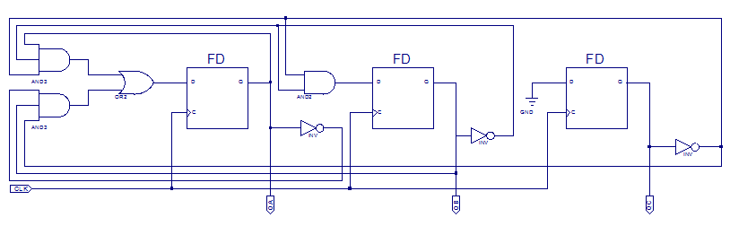

2A)
entity UpDownCounter is
Port ( CLK : in STD_LOGIC;
UpDown : in STD_LOGIC;
Q : inout STD_LOGIC_VECTOR(3 downto 0));

end UpDownCounter;

architecture Behavioral of UpDownCounter is

signal D : STD_LOGIC_VECTOR(3 downto 0);

begin
process(CLK)
begin
if(CLK' event and CLK = '1') then
case UpDown is
when '0' =>
case Q is
when "0001" => D <= "1111";
when "0011" => D <= "0001";
when "0101" => D <= "0011";
when "0111" => D <= "0101";
when "1001" => D <= "0111";
when "1011" => D <= "1001";
when "1101" => D <= "1011";
when "1111" => D <= "1101";
when others => D <= "0001";
end case;
when '1' =>
case Q is
when "0001" => D <= "0011";
when "0011" => D <= "0101";
when "0101" => D <= "0111";
when "0111" => D <= "1001";
when "1001" => D <= "1011";
when "1011" => D <= "1101";
when "1101" => D <= "1111";
when "1111" => D <= "0001";
when others => D <= "0001";
end case;
when others => D <= "XXXX";
end case;
Q <= D;
end if;
end process;
end Behavioral;

