Physics Lab #1: Electric Field
Charlie Coleman
Lab Partners: Alex Bielewicz, Tracey Jaron
2016 August 31

Abstract: In this lab, the electrical field lines were measured and plotted, and then lines of force were drawn according to the field. The lab was successful because the field lines behaved similar to the way they should in theory. There is not a numerical way to determine success, so success must be based on visuals of the graphs.

Theory: In this lab, the electric field around a charged body was measured. This electric field will exert a force on any charged body within the field. The movement of a positive charge is used to determine the direction of an electric field. A charge placed in the field would follow a line of force, which is perpendicular to the equipotential lines.

Objective: The objective of the lab is to measure and plot the equipotential lines of an electric field, and to find the lines of force.

Procedure: First, the power supply is attached to the mounting board and the probes are attached to the galvanometer. Then, the conductive paper is placed on the mounting board such that the contacts are on the silver strips. Then, the stationary probe is placed on point (8, 3) and the points where the galvanometer reads 0 are recorded. This is repeated for points (8, 4), (8, 5), (8, 6), (8, 7), (8, 8) and (8, 9). These points are graphed and then an arbitrary amount of lines of force are drawn. All of this is repeated for the second conductive sheet.

Setup:
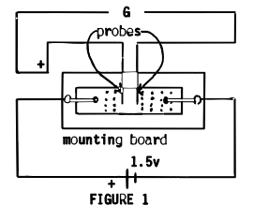

Data:
Straight electrodes:

T-shaped electrodes:

Calculations: N/A

Qualitative Error Analysis: The sheets did not have graph lines to tell where the galvanometer reached zero, so it was all estimation for coordinates more accurate than one significant digit. Another error could be that the stationary probe could have moved during the experiment.

Quantitative Error Analysis: N/A

Results:

Conclusion: Our lab was successful because the graphs of the electrical field look similar to how they are expected to look. There is no numerical way to determine success, so we can only go off of looks of the graphs.

