Physics Lab #4: Temperature Coefficient of Resistance
Charlie Coleman
Lab Partners: Alex Bielewicz, Tracy Jaron
2016 September 21

Abstract: The purpose of this lab was to calculate the temperature coefficient of a resistor and a thermistor. By using the known equations for resistance of a linear and an exponential resistance v temperature relationship, the coefficients were calculated from measured resistances in a Wheatstone bridge. Neither part of the lab was a success. The given error range for part one of the lab was 0.02%, while the calculated percent error was 19.19%, clearly greater than the range. In part two, the given error range was 2.27%, while the calculated percent error was 5.58%, much more than the given range.

Theory: In the real world, no resistor is perfectly Ohmic. This is because every material's resistance changes as it's temperature changes. Many conductors have a linear relationship between temperature and resistance, so the temperature coefficient of resistance can be defined aswhere Rt is the resistance at a temperature t, and R0 is the resistance at 0°C. If multiple points are graphed, resistance versus temperature, the slope of that equation will be.

Thermistors, on the other hand, have an exponential relationship between temperature and resistance. The equation for the resistance at a temperature t is given by the equationwhere Ra is the resistance at the lowest temperature ta. The temperature coefficient in this equation is β, typically a very large number. The coefficient can be solved for, giving this equation:.

To measure resistances very accurately, a special circuit called a Wheatstone bridge must be constructed. The way the circuit is put together makes it so that the current is equal to zero when the product of the opposite resistances are equal. The circuit used in class is a known resistance from a resistance box, a wire with known resistance per unit length, and the unknown resistance. The connection point to the galvanometer is moved along the wire until the current is 0, and that is the point recorded in order to calculate the resistance as temperature changes.

Objective: The objective of this lab was to find the temperature coefficients of a thermistor and a wire.

Procedure: First, the calorimetry cup was filled with water. Then, the thermometer and heating apparatus were placed in the cup with the object that was being measured for resistance. The circuit was then assembled. Ice was used to cool the water in the cup down about 5°C below room temperature. At 5°C intervals, the point on the wire was found where the galvanometer read 0A. This was repeated until the temperature of the water was around 70°C. Repeat all steps for the second resistor being measured.

Setup:
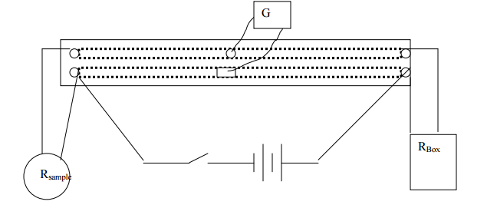

Data:

Part One:

Part Two:

Calculations:
Part One:
Unknown Resistance:

Slope and R0 were found using Excel
Temperature Coefficient of Resistance:

Part Two:
x:

β:

Averages and percent errors were calculated using Excel.

Qualitative Error Analysis: One error faced in this lab was that the temperature almost never remained constant. This especially came into effect in the second part of the lab, where a small change in temperature had a much more dramatic affect on the resistance than in part one. Another error is that

Quantitative Error Analysis:
Part One:
Percent Error: 19.19%
Part Two:
Percent Error: 5.58%

Results:
Part One:

Part Two:

Conclusion: This lab was not a success. In both parts one and two, the calculated coefficient was outside of the range given in the lab. The percent error found in part one was 19.19%, while the given error range was 0.02%, clearly the percent error found was considerably higher than allowed. In part two, the given error range was 2.27%, and the calculated percent error was 5.58%, which is greater than the given range. This failure could be attributed to the errors found in the lab, such as the fact that the temperature measured was never constant, and it was difficult to determine what temperature should be recorded for each data point.

