Physics Lab #5: Magnetic Fields and the Magnetic Dipole
Charlie Coleman
Lab Partners: Alex Bielewicz, Tracey Jaron
2016 September 28

Abstract: The objective of this lab was to measure the magnetic dipole moment with two different methods in order to verify the law. By using the equation for the magnetic field at a distance and the equation for the movement of a magnet in a field, two equations were derived for the magnetic dipole moment. This lab was not a success. Ranges for the moment were found for both parts of the lab, and the lab would be a success if the ranges overlapped. The range for the first part of the lab was 0.4094929 H/m < μ < 0.4206279 H/m. The range for the second part of the lab was 0.298898 H/m < μ < 0.3646308 H/m. These ranges did not overlap at all, and therefore the lab was a failure.

Theory: The electric field created by a magnetic ring is similar to the electric field of a dipole. Contrary to electricity, there is no single 'magnetic charge,' every magnetic charge is coupled with it's opposite. The equation for the field of a magnetic dipole along it's axis is found to be where . The movement of a magnet in the field is determined by the moment. The torque can be found to be , where I is the moment of inertia, Be is the external field, and alpha is the angular acceleration. At small angles, this equation becomes . Solving the differential equation, the equation . Through substitution, the equation is obtained.

Objective: The objective of this lab was to measure the magnetic dipole in two different ways.

Procedure: First, the datastudio program 'dipole2.ds' is run. The magnetic field is measured along the z-axis from 0.07m to 0.17m. Measure the field strength at one distance ten times to obtain an error range. Measure R1 and R2 and m to find the moment of inertia. Hang the ring magnet in between the Helmholtz coils. Use a timer to measure the time of fifty oscillations of the magnet. Measure the magnetic field without the magnet. Repeat for amperages ranging from 0.05A to 0.5A.

Setup:
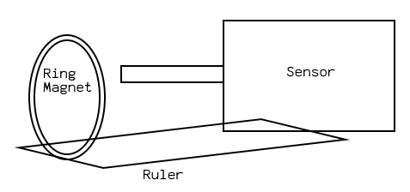
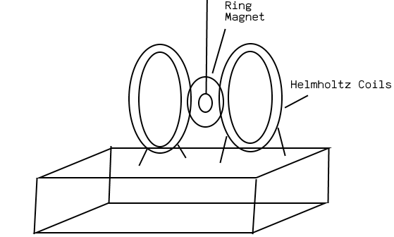

Data:

Part one:

Part Two:

Calculations:
Part One:
x Coordinates:

Worst Line Slope:

μ:

Part Two:
Period:

Angular Frequency Squared:

Error:

Moment:

μ:

Qualitative Error Analysis: One error in this lab was the inaccuracy of the time measurements. The reaction times affected the time measured for the 50 oscillation periods, so the angular frequency was lower than actual. Another error is that the magnetic affect of the magnet could not be completely avoided when taring the sensor. This would cause the magnetic field measured to be lower than actual, which would cause the calculated mu to be lower.

Quantitative Error Analysis:
Part One:

Range: 0.4094929 H/m < μ < 0.4206279 H/m
Part Two:
T error: 0.1s
Angular Frequency squared error: 12.48246 1/s^2
Range: 0.298898 H/m < μ < 0.3646308 H/m

Results:
Part One:

Part Two:

Conclusion: In this lab, the magnetic dipole moment of a ring magnet was found with two different methods. In part one, a range for mu of 0.4094929 H/m < μ < 0.4206279 H/m was obtained. The range for part two was 0.298898 H/m < μ < 0.3646308 H/m. These ranges did not overlap, therefore the law was not verified and the experiment was a failure. The failure could be attributed to the errors created by the timing, which could not be perfect as it was based on human reaction times. Another error source could

