Physics Lab #6: Current Balance
Charlie Coleman
Lab Partners: Alex Bielewicz, Tracey Jaron
2016 October 5

Abstract: The objective of this lab was to measure the force force produced by a current running in opposite directions on two parallel wires. This is done using a current balance. By using the equation for the force created by a current and the gravitational force on a mass, two force calculations could be done and compared. The range obtained from the mass calculations was 7.25x10^-6 N/A^2 <= Calculated Value <= 1.11x10^-5 N/A^2, where the calculated value was 1.64x10^-5 N/A^2. The calculated value did not fall within the range, and therefore the lab was a failure.

Theory: When a current is pushed through two parallel wires in opposite directions, two identical fields of repulsive force are produced. The force of the fields is given by the equation , where d is the distance between the rods' centers, L is the length of the wires, I is the current, and μ₀ is a constant.

Objective: The objective of this lab was to measure the force between two conductors while a current runs through them with a current balance.

Procedure: First, the Variac was plugged into the wall and the transformer was plugged into the Variac. The transformer output was hooked up to the rods and the ammeter in series. Next, the balance rods were balanced using the thumbscrews so that the top rod balanced a few mm over the lower rod. Next, the telescope was set-up on a vertical rod 1-2m away from the mirror on the current balance. Record the zero-mass equilibrium position and the position when the rod is pressed against the lower rod. Add mass in 50mg increments to the current balance and increase the current until the rod reaches the same position as the zero equilibrium point. Record the current and position of the telescope reading. Continue adding mass until the current exceeds 15-20A.

Setup:
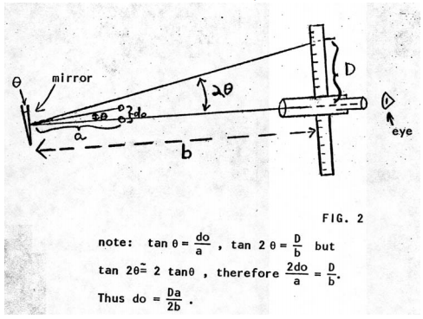

Data:

Calculations:
d0 (m):

d (m):

F (N):

Magnet F (N):

I^2 (A^2):

Error (N):

Worst Slope (NA^-2):

Comparison (NA^-2):

Qualitative Error Analysis: One of the errors in this lab was the fact that it was very difficult to measure the distance from the mirror to the telescope, as the distance was longer than a meter and we only had a meter stick. This would have changed our d0 values and therefore our d values, so the ideal value may be changed. Another source of error in this lab was that our balance rods didn't float perfectly, they seemed to be 'sticky,' which could cause the required current to be higher than actually, which would increase our I^2 values and decrease the worst line slopes.

Quantitative Error Analysis:

Mean % Difference: 38.6%
Force error: 0.000245N
Worst Slopes: 7.25x10^-6 N/A^2, 1.11x10^-5 N/A^2
Comparison Value: 1.64x10^-5 N/A^2

Results:

Conclusion: In this lab, the force of the magnetic field created by a current running through parallel wires was measured and compared to calculated values. The range 7.25x10^-6 N/A^2 <= Calculated Value <= 1.11x10^-5 N/A^2 was found in the experiment. The calculated value was 1.64x10^-5 N/A^2, and therefore the lab was not a success. The failure could have been caused by the fact that it was difficult to obtain an accurate measurement of the distance from mirror to telescope due to the fact that the meter stick was not long enough to measure the distance. The failure could also have been caused by the fact that our current balance seemed 'sticky,' like it did not turn freely as the current changed, which would increase the required current to achieve the desired distance.

