Physics Lab #7: Magnetic Induction
Charlie Coleman
Lab Partners: Alex Bielewicz, Tracey Jaron
2016 October 12

Abstract: The objective of this lab was to measure the EMF created by a changing magnetic field around a coil. By using the equation for EMF based on area of the conductor and the change in the field, the EMF could be calculated and compared to the measured values. The lab was a success, as the given error range was 50% for both parts of the lab and the error in part one was 0.28% and the error in part two was found to be 10.30%.

Theory: Electromotive forces are used in our everyday lives in many different forms. All EMFs produce a potential difference between two points, where the high potential point is marked with a + and the low potential point is marked with a -. EMFs can be measured by measuring their work, which is in Volts. The potential difference between points can induce a current.

In everyday life, our EMFs are often created by a chemical reaction in a battery, but this EMF is limited in strength and lifespan. Magnetic fields and conductors can produce varying strength EMFs. Considering a loop in a magnetic field, when the shape of the loop is changed or the strength of the magnetic field is changed, a current is induced in the conductor. We can find the equation of the EMF to be where epsilon is the EMF, phi is the flux, and t is time. Another equation for EMF is where B is the magnitude of the magnetic field, A is the area, and t is time. If the magnetic field is not constant, the equation can be found, where N is the number of loops, r is the radius, B is the field, and t is time.

Objective: The objective of this lab was to measure the EMF created by a changing magnetic field.

Procedure: First the sensor, magnet, and rod are setup as shown in the diagram below. Next, the magnet on the rod is spun such that it passes the sensor quickly. Record the data using datastudio and change the coefficient on the derivative graph so that it matches the voltage graph. For part two, spin the magnet very quickly and record the data until it stops completely. Using the last 10 spins for your data, record the maximum B, the time of rotation, and peak to trough voltage.

Setup:
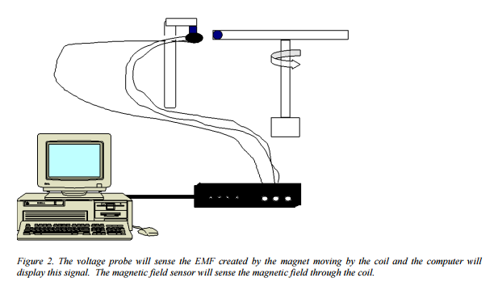

Data:

Part one multiplier: 1.1
Part two:

Bmax (H/m): 6.67*10^-4 H/m

Calculations:
Part one:
Ideal Multiplier:
Error:

Part two:
dt:
EMF:
Velocity:
Slope:
Error:

Qualitative Error Analysis: One error in this lab was that the sensor wasn't zeroed properly, as the magnet would have an effect on the sensor at any distance. Another error was that the sensor may not have been centered on the magnet.

Quantitative Error Analysis:
Part one: 0.28%
Part two: 10.30%

Results:
Part one:
Measured Multiplier: 1.1 m^2
Part two:

Measured slope: 0.0389645 H

Conclusion: In this lab, the magnetic induction from a varying magnetic field was measured. Our lab was a success because the error range given for both parts of the lab was 50%, and our calculated percent error was 0.28% for part one and 10.30% for part two. This error was likely caused by the difficulty in zeroing a magnetic field sensor in a room with many magnets. Another source of error is the difficulty in lining the center of the sensor up with the center of the magnet.

