Prelab #6: The Current Balance
Charlie Coleman
2016 October 05

Objective
The objective of this lab was to measure the force between two parallel electric currents with the current balance.

Theory
In the MKS system, the Ampere is defined as that unvarying current which, if present in each of two parallel conductors of infinite length and one meter apart in empty space, causes each conductor to experience a force exactly 2x10⁻⁷ newton per meter.
In figure 1, an alternating current in two conducting rods, A and B, both of the same length are connected in series electrically produces mutual repulsive forces of equal magnitude on the rods. The upward force on rod A is balanced by a weight placed upon the small pan W. The balance is observed with a telescope and scale.

d is the distance between the axes of the two rods when the balance is in the zero-current equilibrium position. So d=do+2r=distance between wires, r=radius of each wire measured in micrometers.
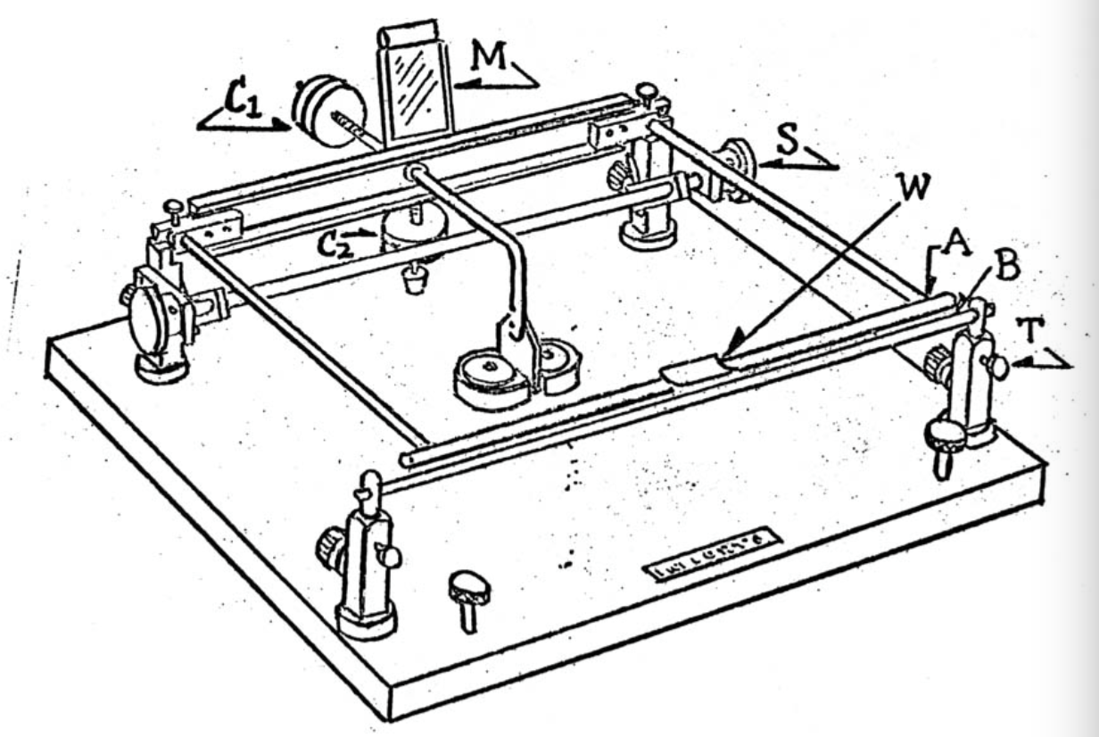

Procedure
We plugged the transformer into the Variac (we made sure the switch was off and the plug was disconnected). We connected the transformer output to the current balance rods and the AC ammeter in series. The wires were brought out perpendicular to the moving frame of the apparatus to minimize interaction between the wires and frame. Next, we made sure the rods, balance knife edges, and bearings were clean before moving on. We adjusted the current balance base firmly in a horizontal plane. Then the counterpoise C₁ was adjusted so that the frame oscillates freely to come to a rest with the horizontal bar a few millimeters above the other rod. The second counterpoise was adjusted so that the period of oscillation is between 1 and 2 seconds. Then we checked the alignments of the two rods by placing a small coin on the scale pan. We used thumb screws on the front posts and back posts to adjust the alignment of the rods. Next, the telescope and scale was set up 2 meters away from the mirror of the current balance. We took data of the zero current reading several times to find a mean of the reading. We measured the 2-meter stick equipped with caliper jaws the distance from the current mirror. We measured the distance from center to center. The separation of the rods when the balanced is in the zero-current equilibrium is calculated by d=do+2r. We made a series of measurements to determine the forces exerted by the currents. After placing a 50 mg weight on the pan, the Variac was plugged into the wall and the current was adjusted so that the scale reading is the same for the zero-current equilibrium position. This was repeated until we could obtain a mean value of i. We continued adding 50 mg of weight at a time and increasing the current each time by the mean until 15-20 amperes were reached. After each current adjustment, the Variac was turned off.

